D1.1 | POPD - Requirement No.1
  - MAIL: Identifying Marginal Lands in Europe and strengthening their contribution potentialities in a CO2 sequestration strategy

Project title | Identifying Marginal Lands in Europe and strengthening their contribution potentialities in a CO2 sequestration strategy
Call identifier | H2020 MSCA RISE 2018
Project acronym | MAIL
Starting date | 01.01.2019
End date | 31.12.2021
Funding scheme | Marie Skłodowska-Curie
Contract no. | 823805
Deliverable no. | D1.1
Document name | MAIL_D1.1.pdf
Deliverable name | POPD - Requirement No.1
Work Package | 1
Nature | R
Dissemination | CO
Editor | AUTH
Authors | Charalampos Georgiadis, Petros Patias (AUTH)
Contributors | All consortium partners
Date | 31-12-2019

MAIL Consortium
Aristotle University of Thessaloniki (AUTH) Greece | Industrieanlagen Betriebsgesellschaft MBH (IABG) Germany
Gounaris N. – Kontos K. OE (HOMEOTECH) Greece | Centrum Badan Kosmicznych Polskiej Akademii Nauk (CBK PAN) Poland
Universitat Politecnica de Valencia (UPV) Spain | Fundación Centro De Servicios Y Promoción Forestal Y de su Industria De Castilla y León (CESEFOR) Spain

Abbreviations
Term | Explanation
GDPR | General Data Protection Regulation
ISO | International Organization for Standardization
IT | Information Technology
MOOC | Massive Online Open Course

Contents

MAIL Consortium 3
Abbreviations 4
Executive Summary 6
1. Introduction 6
2. MAIL web services 7
2.1 Newsletter registration 7
2.2 Virtual room service 10
2.3 Massive Online Open Course (MOOC) service 12
2.4 Open research data pilot 15
2.5 MAIL WebGIS service 16
References 17
Annex II: Table of figures 18
Annex III: List of Tables 19

Executive Summary
Deliverable D1.1 “POPD - Requirement No.1” is an “ethic requirement” that the project must comply with. The description of the compliance requirement is the following: “The platform to be developed in the project may collect or expose personal data. The beneficiary must ensure that the necessary data protection precautions and legal compliance are taken into account. A report on the privacy and data protection risks of the platform must be submitted as a deliverable.”. The purpose of D1.1 is to identify the potential privacy and data protection risks and describe the implemented measures that ensure that all the necessary data protection precautions and legal compliance are taken into account.

Introduction
The web based system that it will be developed, and offered through MAIL’s webpage will include the following:
- The newsletter registration
- Virtual Room
- The Massive Online Open Course (MOOC)
- Open research data pilot
- WebGIS
Whenever user registration is needed the respective service will comply with the General Data Protection Regulation (GDPR). The collected data will be used only for the purposes of the project and only if the users consent to that. In the following sections the measures and workflows concerning personal data protection will be presented. Most of the platforms will be hosted by AUTH’s IT department. AUTH’s services are hosted in the university’s IT infrastructure center which is certified under ISO-9001. The IT center is currently being certified under ISO-27001, and the related policies are expected to be operational within the next 6-8 months.

MAIL web services
In this section the different approaches and measures that will be implemented in the various MAIL web services are going to be presented and analysed. More specifically the following webservices are going to be presented:
- The newsletter registration
- Virtual Room
- The Massive Online Open Course (MOOC)
- Open research data pilot
- WebGIS

Newsletter registration
The MAIL newsletter is part of the project’s dissemination and communication strategy. In total 6 e-newsletter are going to be published in the project’s lifetime. A part of the newsletter distribution strategy is the registration through the project’s dedicated webpage. In order to comply with the GDPR regulations the following procedure was implemented for the newsletter registration.
The marginal_lands_newsletter mailing list was created using the Aristotle University of Thessaloniki IT services. The mailing list is stored and managed the through AUTH’s IT center which guarantees the appropriate technical and organizational measures that ensure a level of security in accordance with the GDPR. A newsletter registration page was created in the project webpage (http://marginallands.eu/contact/newsletter-subscription/) (Figure 1).
Figure 1 MAIL’s Newsletter Registration webpage
The person that wants to register to the newsletter mailing list must enter its name and email and consent to the following:
“The purpose of the mailing list is the dissemination of the MAIL project Newsletter.
This mailing list and all the personal data processed in its context are kept in the IT center of the Aristotle University in Thessaloniki, Greece under the appropriate technical and organizational measures that ensure a level of security in accordance with the GDPR.
Where the controller Prof. Petros Patias intends to further process the personal data for a purpose other than that for which the personal data were initially collected, the controller shall provide you prior to that further processing with information on that other purpose and with any relevant further information. The controller does not intend to transfer personal data of this mailing list to a third country or international organization.
This mailing list will be deleted by the time that the purposes it serves are completed. With your subscription in this list you consent to receiving email/newsletter.
If you would prefer not to receive this email/newsletter, you can unsubscribe at any time here mailto:sympa@lists.auth.gr?subject=sig%20marginal_lands_newsletter
For any further information, you can contact the Data Protection Officer of the Aristotle University at data.protection@auth.gr”.
The collected information is being processed and the email addresses are added to the dedicated mailing list that is being stored and managed by the Aristotle University of Thessaloniki IT center. Following the successful registration, the following welcome message is sent to the user:
“Welcome to list marginal_lands_newsletter@lists.auth.gr
Your subscription email is harrisg@civil.auth.gr
Mailing list for the dissemination of MAIL newsletter
The purpose of the mailing list is the dissemination of the MAIL project Newsletter. This mailing list and all the personal data processed in its context are kept in the IT center of the Aristotle University in Thessaloniki, Greece under the appropriate technical and organizational measures that ensure a level of security in accordance with the GDPR.
Where the controller Prof. Petros Patias intends to further process the personal data for a purpose other than that for which the personal data were initially collected, the controller shall provide you prior to that further processing with information on that other purpose and with any relevant
further information. The controller does not intend to transfer personal data of this mailing list to a third country or international organization. This mailing list will be deleted by the time that the purposes it serves are completed.
With your subscription in this list you consent to receiving email/newsletter.
If you would prefer not to receive this email/newsletter, you can unsubscribe at any time here.
mailto:sympa@lists.auth.gr?subject=sig%20marginal_lands_newsletter
For any further information, you can contact the Data Protection Officer of the Aristotle University at data.protection@auth.gr
The list homepage: https://lists.auth.gr/sympa/info/marginal_lands_newsletter
General information about mailing lists: https://lists.auth.gr/sympa/help/introduction”
When a message needs to be disseminated to the mailing list the following text is added in every communication “You are receiving this email/newsletter because you have subscribed to our mailing list. If you would prefer not to receive this email/newsletter, you can unsubscribe at any time here.
mailto:sympa@lists.auth.gr?subject=sig%20marginal_lands_newsletter
For any further information, you can contact the Data Protection Officer of the Aristotle University at data.protection@auth.gr”, (Figure 2).
Figure 2 Dissemination email concerning the publication of the 1st MAIL newsletter
The MAIL newsletter mailing list will be erased when it has fulfilled its purpose which is the dissemination of the project’s newsletter.

Virtual room service
MAIL’s virtual classroom is going to be implemented using the open eclass platform (https://free.openeclass.org/index.php?localize=en), (Figure 3) which is hosted by the Greek Academic Network (GUnet).
Figure 3 The GUnet Free Open eClass webpage
The Terms of Use (https://free.openeclass.org/info/terms.php?localize=en) regarding the processing of personal data are the following:
“5. Personal Data Policy
The institution/ organization may collect and process personal data of users in order to be able to offer the services of its website to them.
In each case, any processing:
- complies with the law
- is for specified purposes and for time disclosed to the person before processing started
- requires the consent of the person or happens for any other legitimate purposes specified by law.
In case the user wishes to access the services of the website and participate in the continuous improvement of them, may be asked to provide personal data through the data collection form of the website. The Institution/ organization may use personal data for informational purposes or send e-mails or newsletters to the registered user/visitor.
The Institution / organization does not transfer or publish personal data of users/visitors of the website to third parties, unless otherwise is provided by law or if it is a contractual obligation or it is necessary for the proper operation of the website and the accomplishment of its functions.
The Institution / organization may process all or part of the information sent by the users for statistical and improvement purposes of the given services-information. The user can contact with the site administrator in order to check for the existence of a personal record, to correct, change, or delete it.
During the use of the website, personal and non personal identification of users may be collected using technologies, such as cookies and/or monitoring ip addresses and other similar technologies such as those resulting from the contact of the browser with the server. The cookies are small text files on the user’s hard disk that don’t take note of any document or file from his computer nor led to the identification of the computer with any person. They are used to facilitate user access in the use of specific services and/or pages of the website and to determine the areas which are useful or popular.
Non personal information may also include the type of the browser used by the user, the type of the computer, the operating system, the provider of web services (ISP) and other such information. The user of the website can set his browser in such a way as to warn him for the use of cookies on certain services or to refuse to accept the use of cookies in any case. If the visitor/user of the services and pages does not want to use “cookies” to identify himself may have limited access to some of the services, uses or functions provided by this website. The collection of all data, which fall into the category of personal data received by the institution through this website, either being sent, where appropriate, by users or being collected during navigation browsing and use of the website, is in accordance with the Law 2472/1997 (the amendments of Law.3625/2007) and Law 3471/2006 on the protection of personal data.”

Massive Online Open Course (MOOC) service
The created Massive Online Open Courses (MOOC) will be disseminated and made available to the general public through the Aristotle University of Thessaloniki Open Courses platform (https://opencourses.auth.gr/index.php?localize=en) (Figure 4), and the UPV’s MOOC platform UPVx (https://upvx.es/).
Figure 4 AUTH’s open courses platform

Figure 5 UPV’s open courses platform
AUTH’s open courses platform is being managed by the University’s IT center. The Terms of Use (https://opencourses.auth.gr/info/terms.php) regarding the processing of personal data are the following:
“5. Personal Data Policy
The institution/ organization may collect and process personal data of users in order to be able to offer the services of its website to them.
In each case, any processing:
- complies with the law
- is for specified purposes and for time disclosed to the person before processing started
- requires the consent of the person or happens for any other legitimate purposes specified by law.
In case the user wishes to access the services of the website and participate in the continuous improvement of them, may be asked to provide personal data through the data collection form of the website. The Institution/ organization may use personal data for informational purposes or send e-mails or newsletters to the registered user/visitor.
The Institution / organization does not transfer or publish personal data of users/visitors of the website to third parties, unless otherwise is provided by law or if it is a contractual obligation or it is necessary for the proper operation of the website and the accomplishment of its functions.
The Institution / organization may process all or part of the information sent by the users for statistical and improvement purposes of the given services-information. The user can contact with the site administrator in order to check for the existence of a personal record, to correct, change, or delete it.
During the use of the website, personal and non personal identification of users may be collected using technologies, such as cookies and/or monitoring ip addresses and other similar technologies such as those resulting from the contact of the browser with the server. The cookies are small text files on the user’s hard disk that don’t take note of any document or file from his computer nor led to the identification of the computer with any person. They are used to facilitate user access in the use of specific services and/or pages of the website and to determine the areas which are useful or popular.
Non personal information may also include the type of the browser used by the user, the type of the computer, the operating system, the provider of web services (ISP) and other such information. The user of the website can set his browser in such a way as to warn him for the use of cookies on certain services or to refuse to accept the use of cookies in any case. If the visitor/user of the services and pages does not want to use “cookies” to identify himself may have limited access to some of the services, uses or functions provided by this website. The collection of all data, which fall into the category of personal data received by the institution through this website, either being sent, where appropriate, by users or being collected during navigation browsing and use of the website, is in accordance with the Law 2472/1997 (the amendments of Law.3625/2007) and Law 3471/2006 on the protection of personal data.”
UPV’s open courses platform has the following terms of use regarding the processing of personal data:
“7. Protección de datos personales y uso de cookies
En cumplimiento de lo dispuesto en la Ley Orgánica 15/1999, de 13 de diciembre, de Protección de Datos de Carácter Personal, los datos personales (Nombre y apellidos, correo electrónico, ciudad, país, fecha de nacimiento, sexo y nivel de estudios) se incorporarán a un fichero titularidad de UPV, con la finalidad de gestionar la participación del Usuario en el SITIO WEB, así como, mantener al Usuario informado sobre las novedades de UPV y UPV[X]. El Usuario podrá ejercitar los derechos de acceso, rectificación, cancelación y oposición, en la siguiente dirección: http://upvx.es/contact y en la dirección de correo electrónico: admin@upvx.es
UPV puede utilizar cookies cuando un Usuario navega por los sitios y páginas web del SITIO WEB. Las cookies que se puedan utilizar en los sitios y páginas web del SITIO WEB se asocian únicamente con el navegador de un ordenador determinado (un Usuario anónimo), y no proporcionan por si el nombre y apellidos del Usuario.”

Open research data pilot
The open research pilot data will be published and made available to interested users through the zenodo platform (www.zenodo.org), (Figure 6).
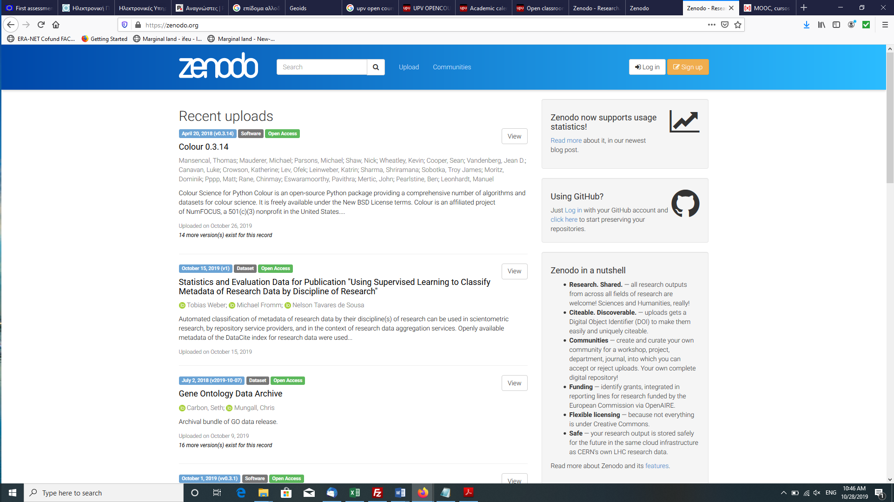
Figure 6 Zenodo web page
The following is the privacy policy of the zenodo website (https://about.zenodo.org/privacy-policy/).
“The Zenodo collaboration does not track, collect or retain personal information from users of Zenodo, except as otherwise provided herein. In order to enhance Zenodo and monitor traffic, non-personal information such as IP addresses and cookies may be tracked and retained, as well as log files shared in aggregation with other community services (in particular OpenAIREplus partners). User provided information, like corrections of metadata or paper claims, will be integrated into the database without displaying its source and may shared with other services.
Zenodo will take all reasonable measures to protect the privacy of its users and to resist service interruptions, intentional attacks, or other events that may compromise the security of the Zenodo website. If you have any questions about the Zenodo privacy policy, please contact us.”

MAIL WebGIS service
MAIL’s WebGIS service will publish the project’s data and will be available to anyone without registration. The users will have the ability to view process and download data in form of publishable custom designed maps without any need for registration.

References

Annex II: Table of figures
This is for the table of figures
Figure 1 MAIL’s Newsletter Registration webpage 8
Figure 2 Dissemination email concerning the publication of the 1st MAIL newsletter 10
Figure 3 The GUnet Free Open eClass webpage 11
Figure 4 AUTH’s open courses platform 13
Figure 5 UPV’s open courses platform 13
Figure 6 Zenodo web page 16

Annex III: List of Tables
No table of figures entries found.

R = Report, P = Prototype, D = Demonstrator, O = Other
PU = Public, PP = Restricted to other programme participants (including the Commission Services), RE = Restricted to a group specified by the consortium (including the Commission Services), CO = Confidential, only for members of the consortium (including the Commission Services).

