D5.2 | Guide on the financial social and technical aspects of the sustainable development of MLs, and report on the potentialities of emerging stock exchange markets for carbon transactions and proposed policies.
  - MAIL: Identifying Marginal Lands in Europe and strengthening their contribution potentialities in a CO2 sequestration strategy

Project title | Identifying Marginal Lands in Europe and strengthening their contribution potentialities in a CO2 sequestration strategy
Call identifier | H2020 MSCA RISE 2018
Project acronym | MAIL
Starting date | 01.01.2019
End date | 31.12.2021
Funding scheme | Marie Skłodowska-Curie
Contract no. | 823805
Deliverable no. | D5.2
Document name | MAIL_D5.2.pdf
Deliverable name | Guide on the financial social and technical aspects of the sustainable development of MLs, and report on the potentialities of emerging stock exchange markets for carbon transactions and proposed policies.
Work Package | 5
Nature | R
Dissemination | CO
Editor | AUTH
Authors | Charalampos Georgiadis (AUTH)
Contributors
Date | 30-11-2021

MAIL Consortium
Aristotle University of Thessaloniki (AUTH) Greece | Industrieanlagen Betriebsgesellschaft MBH (IABG) Germany
Gounaris N. – Kontos K. OE (HOMEOTECH) Greece | Centrum Badan Kosmicznych Polskiej Akademii Nauk (CBK PAN) Poland
Universitat Politecnica de Valencia (UPV) Spain | Fundacion Centro De Servicios Y Promocion FOrestral Y de su Industria De Castilla y Leon (CESEFOR) Spain

Abbreviations
Term | Explanation

Contents

MAIL Consortium 3
Abbreviations 4
Document description 6
Executive Summary 7
1. Introduction 7
2. Definitions and Terms in MLs and Carbon sequestration context 8
2.1 Sustainable development definition 8
2.2 Forest and carbon related sequestration definitions 11
2.3 Sustainable Forest Management 12
2.4 Sustainable forest management Criteria and Indicators 13
2.5 Pan European Guidelines for Afforestation and Reforestation 17
2.6 Funding 23
3. Methodology Development for assessing sustainable development of MLs as Carbon sinks 23
3.1 Area refinement 25
3.2 Eligibility Assessment 27
4. Financial Aspects of sustainability 28
5. Social Aspects of sustainability 40
6. Environmental Aspects of sustainability 49
7. Technological Aspects of sustainability 62
7.1 Marginal Land Detection 63
7.2 Augmentation of marginal land identification 64
7.3 Model for the estimation of sequestered carbon 64
7.4 Estimation of biomass volume 64
7.5 Estimation of carbon stock in forest products 65
7.6 Classification of MLs in carbon sequestration groups 65
7.7 Change detection and mapping of forest marginal lands 65
7.8 Software systems 65
7.9 Web application for the management of MLs 66
References 66
Annex II: Table of figures 70
Annex III: List of Tables 72

Document description
Document revision history
Version | Date | Modifications introduced
 |  | Modification reason | Modified by
1 | XX.XX.XXXX | First draft | X.XXXXXXXX
(to be removed in the version for submission)

Executive Summary

Introduction
One of the goals of the MAIL project is the use of marginal lands as potential carbon sinks. In order to achieve this objective MAIL is going to identify the potential marginal lands in a European level and provide a guide on how marginal lands can be exploited as carbon sinks. The main goal of this deliverable is to provide guides through dedicated workflows that will help assess the sustainability of marginal lands when used as carbon sinks, considering the financial, technological, environmental, and social aspects. D5.2 builds upon the work performed in Work package 2, 3, 4 and 5. More specifically the outputs of task 2.3 “Methodology development of m/sm MLs detection”, 2.5 “Existing models (IPCC, etc.) customization – evaluation – validation, considering, local aspects”, 2.6 “Estimation of biomass volume at low productivity m/sm MLs”, 2.7 m/sm MLs classification in Carbon sequestration capacity groups”, 3.4 “Accompanying Software systems”, 4.2 “Pilot case study 2: Quantification of carbon sequestration capacity in m/sm MLs”, 4.3 “Pilot case study 3: Estimation of carbon stock in forest products”, 4.4 “Pilot case 4: Change detection and mapping in forest MLs”, 5.1 “Best practices MLs monitoring using remote sensing techniques” and 5.3 “Potentialities of emerging stock exchange markets for carbon transactions and proposed polices” will be used in the proposed workflows.
Since the primary goal is the use of MLs as carbon sinks the most efficient way of achieving this is by transforming MLs to forests. As a result, the main focus of the sustainability/feasibility study will be the sustainable forest management of exploiting forests as carbon sinks.
In order to assess the sustainability of MLs as carbon sinks the technological, financial, environmental and social aspects were examined for the creation of the workflows and the preparation of the different guides. These aspects were examined in a spatial/temporal context in order to provide short- and long-term options in local, regional, and national level.
The remaining of the document has the following structure: Chapter 2 provides the basic definitions that are being used in the deliverable, chapter 3 examines and analyses the general approach and methodology design for the sustainability assessment of using marginal lands as carbon sinks, chapter 4 presents the financial aspects, chapter 5 the social aspects, chapter 6 the technical/technological aspects, chapter 5 the environmental aspects. It must be noted that all these aspects are interconnected since the influence on another.

Definitions and Terms in MLs and Carbon sequestration context
In this chapter we are going to provide an overview of the definitions that are going to be used during the remainder of the deliverable. The provided definitions are regarding sustainable development and sustainable forest management, since marginal lands are going to be used for afforestation projects.

Sustainable development definition
Tomislav K, 2018 provided an extensive review of the concept of sustainable development. The following tables provide an overview of activities relating to sustainable development and different definitions and meanings of it.
Year | Activities | Brief Description
1969 | UN published the report Man and His Environment or U Thant Report. | Activities focused to avoid global environmental degradation. More than 2,000 scientists were involved in creation of this report.
1972 | First UN and UNEP world Conference on the Human Environment, Stockholm, Sweden. | Under the slogan Only One Earth, a declaration and action plan for environmental conservation was published.
1975 | UNESCO conference on education about the environment, Belgrade, Yugoslavia. | Setting up a global environment educational framework, a statement known as the Belgrade Charter.
1975 | International Congress of the Human Environment (HESC), Kyoto, Japan. | Emphasized the same problems as in Stockholm in 1972.
1979 | The First World Climate Conference, Geneva, Switzerland. | Focused on the creation of the climate change research and programme monitoring.
1981 | The first UN Conference on Least Developed Countries, Paris, France. | A report with guidelines and measures for helping the underdeveloped countries.
1984 | Establishment of United Nations World Commission on Environment and Development (WCED). | The task of the Commission is the cooperation between developed and developing countries and the adoption of global development plans on environmental conservation.
1987 | WCED report Our Common Future or Brundtland report was published. | A report with the fundamental principles of the concept of sustainable development.
1987 | Montreal Protocol was published. | Contains results of the researches on harmful effects on the ozone layer.
1990 | The Second World Climate Conference, Geneva, Switzerland. | Further development of the climate change research and monitoring programme and the creation of global Climate Change Monitoring System.
1992 | United Nations Conference on Environment and Development (Earth Summit or Rio Conference), Rio de Janeiro, Brazil. | In the Rio Declaration and Agenda 21 Action Plan principles of sustainable development were established and the framework for the future tasks as well.
1997 | Kyoto Climate Change Conference, Kyoto, Japan. | The Kyoto Protocol was signed between countries to reduce CO2 and other greenhouse gas emissions, with commencement in 2005.
2000 | UN published Millennium declaration. | Declaration containing eight Millennium Development Goals (MDGs) set by 2015.
2002 | The World Summit on Sustainable Development, Johannesburg, South Africa. | Report with the results achieved during the time from the Rio Conference, which reaffirmed the previous obligations and set the guidelines for implementation of the concept in the future.
2009 | The Third World Climate Conference, Geneva, Switzerland. | Further development of the global Climate Change Monitoring System with the aim of timely anticipation of possible disasters.
2009 | World Congress Summit G20, Pittsburgh, USA. | G20 member states made an agreement on a moderate and sustainable economy.
2012 | UN conference Rio +20, Rio de Janeiro, Brasil. | Twenty years from the Rio conference, report The future we want renewed the commitment to the goals of sustainable development and encouraged issues of the global green economy.
2015 | UN Sustainable Development Summit 2015, New York, SAD. | The UN 2030 Agenda for Sustainable Development was published, setting up 17 Millennium Development Goals which should be achieved by 2030.
2015 | UN conference on climate change COP21Paris Climate change Conference, Paris, France. | Agreement on the reduction of greenhouse gases in order to reduce and limit global warming.
Table 1 Overview of activities connected to the sustainable development concept (Source: Tomislav K., 2018)

Author/Publication, Year | Meaning and Understanding of Sustainable development
WCED, 1987 | Sustainable development is a development that meets the needs of the present without compromising the ability of future generations to meet their own needs.
Pearce et al., 1989 | Sustainable development implies a conceptual socio-economic system which ensures the sustainability of goals in the form of real income achievement and improvement of educational standards, health care and the overall quality of life.
Harwood, 1990 | Sustainable development is unlimited developing system, where development is focused on achieving greater benefits for humans and more efficient resource use in balance with the environment required for all humans and all other species.
IUCN, UNDP & WWF, 1991 | Sustainable development is a process of improving the quality of human life within the framework of carrying capacity of the sustainable ecosystems.
Lele, 1991 | Sustainable development is a process of targeted changes that can be repeated forever.
Meadows, 1998 | Sustainable development is a social construction derived from the long-term evolution of a highly complex system – human population and economic development integrated into ecosystems and biochemical processes of the Earth.
PAP/RAC, 1999 | Sustainable development is development given by the carrying capacity of an ecosystem.
Vander-Merwe & Van-der-Merwe, 1999 | Sustainable development is a programme that changes the economic development process to ensure the basic quality of life, protecting valuable ecosystems and other communities at the same time.
Beck & Wilms, 2004 | Sustainable development is a powerful global contradiction to the contemporary western culture and lifestyle.
Vare & Scott, 2007 | Sustainable development is a process of changes, where resources are raised, the direction of investments is determined, the development of technology is focused and the work of different institutions is harmonized, thus the potential for achieving human needs and desires is increased as well.
Sterling, 2010 | Sustainable development is a reconciliation of the economy and the environment on a new path of development that will enable the long-term sustainable development of humankind.
Marin et al., 2012 | Sustainable development gives a possibility of time unlimited interaction between society, ecosystems and other living systems without impoverishing the key resources.
Duran et al., 2015 | Sustainable development is a development that protects the environment, because a sustainable environment enables sustainable development.
Table 2 Overview of the sustainable development meaning in the period 1987-2015 (Source: Tomislav K., 2018)
The most used definition of sustainable development is the one provided by the Our Common Future, 1987 report which states that “Sustainable development is a development that meets the needs of the present without compromising the ability of future generations to meet their own needs. It contains within it two key concepts:
· The concept of 'needs', in particular, the essential needs of the world's poor, to which overriding priority should be given; and
· The idea of limitations imposed by the state of technology and social organization on the environment's ability to meet present and future needs.”

Forest and carbon related sequestration definitions
The following chapter provides definitions for terms used in afforestation, forest management and carbon sequestration.
Afforestation: The direct human-induced conversion of land that has not been forested for a period of at least 50 years to forested land through planting, seeding and/or the human-induced promotion of natural seed sources. (Agostini et al, 2014)
Biomass: Organic material both above ground and below ground, and both living and dead, e.g., trees, crops, grasses, tree litter, roots etc. Biomass includes the pool definition for above – and below –ground biomass. (Agostini et al, 2014)
Carbon dioxide equivalent: Carbon dioxide equivalent describes how much global warming a given type and amount of greenhouse gas may cause, using the functionally equivalent amount or concentration of carbon dioxide (CO2) as the reference. (Agostini et al, 2014)
Carbon pool: A component of the climate system which has the capacity to store, accumulate or release carbon. Oceans, soils, atmosphere, and forests are examples of carbon pools. (Agostini et al, 2014)
Carbon stock: The absolute quantity of carbon held within a carbon pool at a specified time. (Agostini et al, 2014)
Forest: Land with tree crown cover (or equivalent stocking level) of more than 10 percent and area of more than 0.5 hectares (ha). The trees should be able to reach a minimum height of 5 meters (m) at maturity in situ. May consist either of closed forest formations where trees of various storeys and undergrowth cover a high proportion of the ground; or open forest formations with a continuous vegetation cover in which tree crown cover exceeds 10 percent. Young natural stands and all plantations established for forestry purposes which have yet to reach a crown density of 10 percent or tree height of 5 m are included under forest, as are areas normally forming part of the forest area which are temporarily unstocked as a result of human intervention or natural causes but which are expected to revert to forest. (Agostini et al, 2014)
Forest management: Any activity resulting from a system applicable to a forest and aimed at improving any ecological, economic or social function of the forest. (Agostini et al, 2014)
Greenhouse gases (GHG): Greenhouse gases are those gaseous constituents of the atmosphere, both natural and anthropogenic, that absorb and emit radiation at specific wavelengths within the spectrum of infrared radiation emitted by the Earth’s surface, the atmosphere and clouds. This property causes the greenhouse effect. Water vapour (H2O), carbon dioxide (CO2), nitrous oxide (N2O), methane (CH4), and ozone (O3) are the primary greenhouse gases in the Earth’s atmosphere. (Agostini et al, 2014)
Sequestration: The process of increasing the carbon content of a carbon pool other than the atmosphere. (Agostini et al, 2014)
Sink: The rate of build-up of CO2 in the atmosphere can be reduced by taking advantage of the fact that carbon can accumulate in vegetation and soils in terrestrial ecosystems. Any process, activity or mechanism which removes a greenhouse gas from the atmosphere is referred to as a "sink". (Agostini et al, 2014)
Thinnings: Trees removed during thinning operations, the purpose of which is to reduce stand density and enhance diameter growth and volume of the residual stand. Unacceptable growing stock which is defined as trees considered structurally weak or have low vigor and do not have the potential to eventually yield a 12 foot sawlog or survive for at least the next 10 years. Trees removed to reduce fire hazard are also included. (Agostini et al, 2014)

Sustainable Forest Management
Marginal lands are going to be used as carbon sinks, meaning that an afforestation project is going to be implemented and they are going to be transformed to forests. As a result, in order to define the sustainability of such an activity one must define and present the aspects of sustainable forest management.
According to FAO “Forest management is the process of planning and implementing practices for the stewardship and use of forests and other wooded land to meet specific environmental, economic, social and cultural objectives. It deals with the overall administrative, economic, legal, social, technical and scientific aspects related to natural and planted forests. It may involve varying degrees of deliberate human intervention, ranging from actions aimed at safeguarding and maintaining forest ecosystems and their functions, to those favouring specific socially or economically valuable species or groups of species for the improved production of forest goods and services.
A globally agreed definition of sustainable forest management (SFM) is impractical beyond a very general level because of the huge diversity of forest types, conditions and socioeconomic contexts worldwide. In general, however, SFM can be viewed as the sustainable use and conservation of forests with the aim of maintaining and enhancing multiple forest values through human interventions. People are at the centre of SFM because it aims to contribute to society’s diverse needs in perpetuity.
The UN describes sustainable forest management as: “[a] dynamic and evolving concept [that] aims to maintain and enhance the economic, social and environmental values of all types of forests, for the benefit of present and future generations.”
According to ITTO, 1992 “Sustainable forest management is the process of managing forest to achieve one or more clearly specified objectives of management with regard to the production of a continuous flow of desired forest products and services without undue reduction of its inherent values and future productivity and without undue undesirable effects on the physical and social environment.”
While Forest Europe defined sustainable forest management as “The stewardship and use of forest lands in a way and at a rate that maintains their productivity, biodiversity, productivity, regeneration capacity, vitality and their potential to fulfill now and in the future relevant ecological, economic and social functions at local, national and global levels and that does not cause damage to other ecosystems." (Forest Europe, Resolution H1, 1993).

Sustainable forest management Criteria and Indicators
Forest Europe started defining the pan-European Criteria and indicators for sustainable forest management” in Lisbon 1998. The current criteria and indicators were updated and endorsed in the Forest Europe 7th Ministerial Conference in Madrid 2015. In total 45 sustainable forest indicators are defined. 34 are quantitative indicators and 11 of them are qualitative. The following tables present the Pan European Criteria and indicators.

 | No. | Indicator
Forest policy and governance | 1 | National Forest Programmes or equivalent
 | 2 | Institutional frameworks
 | 3 | Legal/regulatory framework: National (and/or sub-national) and International commitments
 | 4 | Financial and economic instruments
 | 5 | Information and communication
Table 3 Forest Policy and governance Indicators. (Source: Forest Europe 7th Ministerial Conference, 2015)
Criteria | No. | Indicator | Full text
Criterion 1: Maintenance and Appropriate Enhancement of Forest Resources and their Contribution to Global Carbon Cycles | C.1 | Policies, institutions and instruments to maintain and appropriately enhance forest resources and their contribution to global carbon cycles
 | 1.1 | Forest area | Area of forest and other wooded land, classified by forest type and by availability for wood supply, and share of forest and other wooded land in total land area
 | 1.2 | Growing stock | Growing stock on forest and other wooded land, classified by forest type and by availability for wood supply
 | 1.3 | Age structure and/or diameter distribution | Age structure and/or diameter distribution of forest and other wooded land, classified by availability for wood supply
 | 1.4 | Forest carbon | Carbon stock and carbon stock changes in forest biomass, forest soils and in harvested wood products
Criterion 2: Maintenance of Forest Ecosystem Health and Vitality | C.2 | Criterion 2: Maintenance of Forest Ecosystem Health and Vitality
 | 2.1 | Deposition and concentration of air pollutants | Deposition and concentration of air pollutants on forest and other wooded land
 | 2.2 | Soil condition | Chemical soil properties (pH, CEC, C/N, organic C, base saturation) on forest and other wooded land related to soil acidity and eutrophication, classified by main soil types
 | 2.3 | Defoliation | Defoliation of one or more main tree species on forest and other wooded land in each of the defoliation classes
 | 2.4 | Forest damage | Forest and other wooded land with damage, classified by primary damaging agent (abiotic, biotic and human induced)
 | 2.5 | Forest land degradation | Trends in forest land degradation
Criterion 3: Maintenance and Encouragement of Productive Functions of Forests (Wood and Non-Wood) | C.3 | Policies, institutions and instruments to maintain and encourage the productive functions of forests
 | 3.1 | Increment and fellings | Balance between net annual increment and annual fellings of wood on forest available for wood supply
 | 3.2 | Roundwood | Quantity and market value of roundwood
 | 3.3 | Non-wood goods | Quantity and market value of non-wood goods from forest and other wooded land
 | 3.4 | Services | Value of marketed services on forest and other wooded land
Criterion 4: Maintenance, Conservation and Appropriate Enhancement of Biological Diversity in Forest Ecosystems | C.4 | Policies, institutions and instruments to maintain, conserve and appropriately enhance the biological diversity in forest ecosystems
 | 4.1 | Diversity of tree species | Area of forest and other wooded land, classified by number of tree species occurring
 | 4.2 | Regeneration | Total forest area by stand origin and area of annual forest regeneration and expansion
 | 4.3 | Naturalness | Area of forest and other wooded land by class of naturalness
 | 4.4 | Introduced tree species | Area of forest and other wooded land dominated by introduced tree species
 | 4.5 | Deadwood | Volume of standing deadwood and of lying deadwood on forest and other wooded land
 | 4.6 | Genetic resources | Area managed for conservation and utilisation of forest tree genetic resources (in situ and ex situ genetic conservation) and area managed for seed production
 | 4.7 | Forest fragmentation | Area of continuous forest and of patches of forest separated by non-forest lands
 | 4.8 | Threatened forest species | Number of threatened forest species, classified according to IUCN Red List categories in relation to total number of forest species
 | 4.9 | Protected forests | Area of forest and other wooded land protected to conserve biodiversity, landscapes and specific natural elements, according to MCPFE categories
 | 4.10 | Common forest bird species | Occurrence of common breeding bird species related to forest ecosystems
Criterion 5: Maintenance and Appropriate Enhancement of Protective Functions in Forest Management (notably soil and water) | C.5 | Policies, institutions and instruments to maintain and appropriately enhance of the protective functions in forest management
 | 5.1 | Protective forests – soil, water and other ecosystem functions - infrastructure and managed natural resources | Area of forest and other wooded land designated to prevent soil erosion, preserve water resources, maintain other protective functions, protect infrastructure and managed natural resources against natural hazards
Criterion 6: Maintenance of other Socioeconomic Functions and Conditions | C.6 | Policies, institutions and instruments to maintain other socioeconomic functions and conditions
 | 6.1 | Forest holdings | Number of forest holdings, classified by ownership categories and size classes
 | 6.2 | Contribution of forest sector to GDP | Contribution of forestry and manufacturing of wood and paper products to gross domestic product
 | 6.3 | Net revenue | Net revenue of forest enterprises
 | 6.4 | Investments in forests and forestry | Total public and private investments in forests and forestry
 | 6.5 | Forest sector workforce | Number of persons employed and labour input in the forest sector, classified by gender and age group, education and job characteristics
 | 6.6 | Occupational safety and health | Frequency of occupational accidents and occupational diseases in forestry
 | 6.7 | Wood consumption | Consumption per head of wood and products derived from wood
 | 6.8 | Trade in wood | Imports and exports of wood and products derived from wood
 | 6.9 | Wood energy | Share of wood energy in total primary energy supply, classified by origin of wood
 | 6.10 | Recreation in forests | The use of forests and other wooded land for recreation in terms of right of access, provision of facilities and intensity of use
Table 4 SFM Pan European Criteria and Indicators (Source: Forest Europe 7th Ministerial Conference, 2015)

Pan European Guidelines for Afforestation and Reforestation
The Pan European Guidelines for Afforestation and Reforestation with a special focus on the provision of the UNFCCC were adopted by the MCPFE Expert Level Meeting on 12-13 November 2008 and by the PEBLDS Bureau on behalf of the PEBLDS Council on 4 November, 2008.
Afforestation and reforestation are included in the Kyoto Protocol and Marrakesh Accords to the United Nations Framework Conventions on Climate change (UNFCCC) as possible measures to reduce CO2 level in the atmosphere and define respective mechanisms and modalities. Furthermore the convention on Biological Diversity (CBD) stresses that “carbon sequestration activities should be conducted in accordance with sustainable use and conservation of biological diversity.”
“The pan European Guidelines have been prepared for consideration of in afforestation and reforestation programmes that aim inter alia at carbon sequestration and reduction of CO2 emissions including biomass production” (Pan European Guidelines for Afforestation and Reforestation with a special focus on the provision of the UNFCCC, 2008).
The guidelines come as recommendations for voluntary use and can be applied by national authorities as well as by other relevant bodies and stakeholders. They focus on providing guidance for the implementation of economically viable, environmental sound, socially equitable, and culturally acceptable afforestation and reforestation projects.
General Guidelines
Pan-European Criteria and Indicators for Sustainable Forest Management (SFM) should be used as an overall framework for afforestation and reforestation programmes and all related measures should be consistent with SFM and the application of the Ecosystem Approach to forest ecosystems in the pan-European region.
The Pan-European Operational Level Guidelines for SFM should be used as a tool to promote and implement sustainable forest management at the management unit level.
Woody biomass production systems including short rotation/fast growing plantations should take into account economic, environmental, social and cultural aspects of sustainable management.
Synergies in the national and regional implementation of international commitments under UNFF, UNFCCC, CBD and UNCCD should be promoted when carrying out afforestation and reforestation activities.
These guidelines should be considered in national policies and programmes related to forests and forestry (e.g. National Forest Programmes), biodiversity (e.g. National Biodiversity Strategies and Action Plans), climate change, energy, land use planning and management, integrated water resources management and agriculture.
Clear administrative responsibilities within countries regarding afforestation and reforestation programmes should be established and effective information-sharing and cross-sectoral cooperation between relevant authorities and stakeholders involved should be provided.
Economic, environmental, social and cultural impacts of planned afforestation and reforestation programmes should be assessed, as appropriate, in accordance with environmental impact assessment procedures and in consultation with local communities and stakeholders.
Relevant traditional knowledge should be taken into account when preparing and establishing afforestation and reforestation programmes.
Afforestation and reforestation areas should be included in ongoing or planned national monitoring schemes to evaluate their economic, environmental, social and cultural impacts and respective carbon balances.
Afforestation and reforestation projects should contribute to the maintenance or improve the provision of ecosystem goods and services at the landscape level.
Afforestation and reforestation projects should be promoted that benefit climate change mitigation, biomass production, biodiversity conservation, soil and water protection, and erosion and desertification control.
Afforestation and reforestation projects should be used to mitigate against natural hazards, (wind, storms, landslides, etc.) and the impacts of these hazards on human settlements and infrastructure.
Afforestation and reforestation areas should be protected against potentially injurious pests and diseases.
The fire risk in an area of an intended afforestation/reforestation should be assessed and afforestation and reforestation programmes should take into account national or sub-national forest fire protection plans, accordingly.
Research on afforestation and reforestation, such as research on species and provenance adaptation to climate change, as well as inter-disciplinary research on related economic, environmental, social and cultural aspects should be encouraged.
Public awareness on sustainability issues related to afforestation and reforestation and on their potential environmental, social and economic benefits should be raised.
Ecological Guidelines
The precautionary principle should be applied in planning procedures for afforestation and reforestation programmes.
In planning procedures for site selection for afforestation and reforestation projects environmental impacts should be considered to avoid possible negative effects on areas of high ecological value, particularly the conversion of natural and semi-natural non-forest ecosystems and areas of high soil carbon stock (peatlands).
Native tree species, provenances and varieties or ecotypes that are well adapted to site conditions should be used for afforestation and reforestation where appropriate.
The need to consider adaptation to climate change should be taken into account when choosing species, provenances and varieties or ecotypes for afforestation and reforestation.
Species, provenances, varieties or ecotypes outside their natural range should only be used where their introduction would not endanger important and/or valuable indigenous ecosystems, flora and fauna. Those that are likely to be invasive should be avoided by using the CBD Guiding Principles for the Prevention, Introduction, and Mitigation of Impacts of Alien Species That Threaten Ecosystems, Habitats or Species.
A precautionary approach should be taken to the use of genetically modified trees. Ecological, socio-economic and cultural impacts, including long term effects should be analysed and a thorough, comprehensive and transparent risk assessment should be completed in accordance with the Cartagena Protocol on Biosafety. In this context, the potential impacts of genetically modified trees on native gene pools should be fully considered.
Species composition and structural diversity, reflecting the natural diversity at the landscape level, should be promoted.
Afforestation and reforestation activities that contribute to the improvement and restoration of ecological connectivity should be promoted.
Use of chemicals or other substances influencing soil, water resources and biological diversity in a harmful way should be avoided. Natural, biological and mechanical interventions should be promoted as an alternative option to chemicals whenever possible.
Afforestation and reforestation activities should aim to maintain and protect soil and ground and surface water resources in terms of quantity and quality.
Socio-economic and Cultural Guidelines
Afforestation and reforestation programmes that also support and enhance the economic and social well-being of indigenous and local communities, including landowners, operators, contractors and workers should be promoted.
Appropriate mechanisms, including legislation, should be provided for so that afforestation and reforestation follow sustainable management practices and take into account income generation, rural livelihoods and poverty alleviation.
Land tenure and access rights should be secured and responsibilities for management of resources as well as benefit sharing should be clarified when developing afforestation and reforestation programmes.
The development and enhancement of incentives for afforestation and reforestation programmes designed in accordance with these recommendations should be considered, where appropriate.
Cross-sectoral coherence between incentives for afforestation and reforestation programmes and projects in other relevant sectors, including rural development, energy, industry, agriculture, land use planning, water, environmental, and climate change policies should be promoted.
Public and private financial institutions and foundations funding relevant projects should be encouraged to use these guidelines as an evaluation tool to provide for economically viable, environmentally sound, socially equitable and culturally acceptable afforestation and reforestation.
Decisions regarding the implementation of afforestation and reforestation policies and programmes should include consultations with indigenous and local communities including landowners and other relevant stakeholders.
Landscape values, including maintenance of high value cultural landscapes, cultural heritage sites, both as defined by UNESCO, and sacred cultural sites, should be taken into account in the elaboration of policies and planning procedures for afforestation and reforestation activities.
Table 5 Pan European Guidelines for Afforestation and reforestation projects. (Source: Pan European Guidelines for Afforestation and Reforestation with a special focus on the provision of the UNFCCC, 2008)
The following table presents the legal regulatory instruments of EU and further non legally binding instruments related to forests.
Area of EU Activity related to forests | Legal / regulatory instruments of the EU and further non-legally binding instruments used
EU Forest Strategy | European Commission Communication COM(2013) 659, “A new EU Forest Strategy: for forests and the forest-based sector” and related Council conclusions on the new EU Forest Strategy (19 May 2014, 9944/14) European Parliament Report (A8-0126/2015) on ‘A new EU Forest Strategy: for forests and the forest based sector’ (2014/2223(INI), Committee on Agriculture and Rural Development (1 April 2015)  The Strategy is based on the principle of subsidiarity. It aims at establishing a framework for forest-related actions in support of sustainable forest management, based on the coordination of the forest policies of the Member States and EU policies and initiatives relevant to forests and forestry. The Strategy provides a holistic approach to forests and forestry addressing the economic, social and environmental dimensions of sustainable forest management. It also takes an integrated approach covering forestry and the forest-based value chains, considering the important contribution that the forest-based sector can make to growth and jobs in the EU, in particular in rural areas. This document provides strategic orientations related to eight interlinked priority areas, plus the 2020 target “To ensure and demonstrate that all forests in the EU are managed according to sustainable forest management principles”.
Forestry in rural development | Regulation (EU) nº 1303/2013 of the European Parliament and of the Council laying down common provisions on the European Regional Development Fund, the European Social Fund, The Cohesion Fund, The European Agricultural Fund for Rural Development and the European Maritime and Fisheries Fund covered by the Common Strategic Framework and laying down general provisions on the European Regional Funds, the European Social Fund and the Cohesion Fund repealing Regulation (EC) nº 1083/2006 (legally binding) Regulation (EU) nº 1305/2013 of the European Parliament and of the Council on support for rural development by the European Agricultural Fund for Rural Development (EAFRD) (legally binding) European Union Guidelines for State aid in the agricultural and forestry sectors and in rural areas 2014 to 2020, 2014/C 204/01
Forest-based and related industries | European Commission Blueprint for the EU forest-based industries SWD(2013) 343 final European Commission Communication COM(2012) 60 final Innovating for Sustainable Growth: A Bioeconomy for Europe European Commission Communication COM (2012) 582. A Stronger European Industry for Growth and Economic Recovery
Forests and biodiversity | EU Regulation 1293/2013 Programme for the Environment and Climate Action (LIFE) European Parliament resolution of 20 April 2012 on our life insurance, our natural capital: an EU biodiversity strategy to 2020 (2011/2307(INI)) Environmental Council (ENV) conclusions on the implementation of the EU 2020 biodiversity Strategy 19 December 2011. COM(2011) 244
Forest and climate change | Decision No 529/2013/EU of the European Parliament and of the Council of 21 May 2013 on accounting rules on greenhouse gas emissions and removals resulting from activities relating to land use, land-use change and forestry and on information concerning actions relating to those activities EU strategy on adaptation to climate change, 2013
Forest and research | EU Regulation 1291/2013 Horizon 2020 - the Framework Programme for Research and Innovation (2014-2020)
Table 6 Legal regulatory instruments of EU and further non legally binding instruments related to forests (Source: Forest Europe, 2015)

Funding
The FOREST EUROPE, 2015 denotes the following regarding funding opportunities: “Financial instruments and economic policy EU programmes are attracting the interest of the countries as financial instruments for research. The majority of reporting signatories (28 of 34) reported no significant changes in relation to financial instruments and economic policy since 2011. Nevertheless, 2 countries have increased allocations from state budget for research institutes, i.e. the Central-East and South- East European Regional Office of the European Forest Institute (Croatia), and the training and education of the employees of the Executive Forest Agency (Bulgaria). In addition, a few EU Member States also reported on the mobilisation of EU funds through the European Agricultural Fund for Rural Development (EUAFRD), LIFE +, the EU Framework Programme for Research and Innovation Horizon 2020, and the European Innovation Partnerships (EIP).”
At April 25th, 2019 “in his keynote speech, Commissioner Hogan announced the idea of a “1 hectare initiative”, which would be supported through the common agricultural policy (CAP). Under their future CAP Strategic Plans, Member States will have the option to reward farmers with payments per farm for the afforestation of one hectare. This afforestation should be done in a biodiversity-friendly way, contributing to climate and environmental objectives.
This initiative can be programmed through Rural Development funding and could help Member States to meet their climate and biodiversity objectives. It would be another practical example of farmers providing public goods with public support. In order to limit the administrative burden for beneficiaries and public authorities a lump-sum payment per year and per hectare could be offered to each participating farmer over the next budget period.
Such an initiative could significantly contribute to the creation of valuable ecosystem services, such as water retention and flood and soil erosion control. It would also provide significant biodiversity benefits, such as shelter and connectivity.
Commissioner Hogan encouraged Member States to take up this initiative as it would contribute to the achievement of environmental targets and help safeguard our public goods, including forests.”

Methodology Development for assessing sustainable development of MLs as Carbon sinks
In this chapter the general approach and the development of the methodology for the assessment of the usage of MLs as carbon sinks is being presented.
In task 2.3 the methodology and the identification of potential marginal lands in Europe has been realized. The work performed in T2.3 resulted in the production of maps in a European level that have detected the potential marginal lands (Figure 1).
Figure 1 Potential Marginal lands in Europe
The identification of the marginal lands was based on existing land over, land use classification augmented by using indicators considering the soil quality.
Task 2.7 produced thematic maps that classified the identified marginal lands to different carbon sequestration capacity groups.
Figure 2 Marginal Lands Carbon sequestration capacity groups classification
The MLs identified by T2.3, and the carbon sequestration capacity groups classification performed in T2.7 are the base upon which the sustainable development assessment is going to be performed.
Figure 3 presents the general overview of the sustainable development assessment of marginal lands that will be used as carbon sinks.
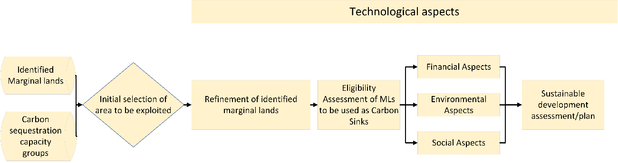
Figure 3 Sustainable development assessment workflow
The first step for the realization of feasibility/sustainable development study is the selection of the area that a carbon sequestration project is going to be implemented. The initial area selection will be performed using the identified marginal lands GIS layers in combination with the carbon sequestration capacity groups classification.
Following the initial selection of the area that a carbon sequestration project is going to be implemented a refinement of the area should be performed. Even though the accuracy in the detection of MLs reached a xxxxxxx, the results are based on datasets that are updated every xxxxx years, while the accuracy of the land use land cover classifications is xxxxxx. As a result current data should be used for the final identification and delineation of the marginal lands that is going to be exploited.
Since the marginal land is going to be used for the implementation of a carbon sequestration project, i.e. utilized as a carbon sink the next step is to assess the eligibility of the area. Following the eligibility assessment, the final feasibility/sustainability study will be performed in order to assess if the selected area can be used to implement a carbon sequestration project and define a sustainable management plan.
The final assessment and management plan will take into consideration the technological, financial, social and environmental components involved in the project’s implementation. The technological component is the one that covers all the aspects of the sustainability assessment and the management plan, providing insight and the tools that will help for the successful design of management plan and its implementation.
In addition since marginal lands will be used as carbon sinks, meaning they will be transformed to forest areas, the sustainable development assessment will use aspects used in sustainable forest management approaches.
In this chapter the refinement of the initially selected area and its eligibility are going to be analysed. The technological, financial, social, and environmental aspects are analysed in dedicated chapters.

Area refinement
The initially selected area should be more closely examined and accurately defined, since the initial detection of the potential marginal lands is based on the use of generic layers and possible older datasets.
To that end different approaches could be used including field work or use of additional indicators, satellite imagery, or local/regional datasets.
The most efficient and course of action is to utilize high resolution satellite images in order to refine the initial marginal land detection. To that end Sentinel – 2 images can be used. “The SENTINEL-2 Multispectral Instrument (MSI) samples 13 spectral bands: four bands at 10m, six bands at 20 metres and three bands at 60 meters”. The spatial resolutions of the different bands are presented in Figure 4.
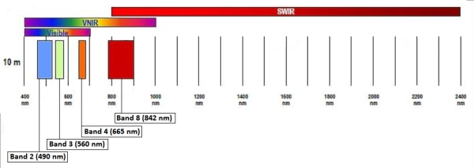
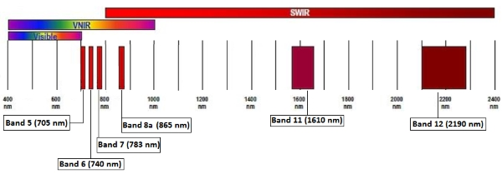
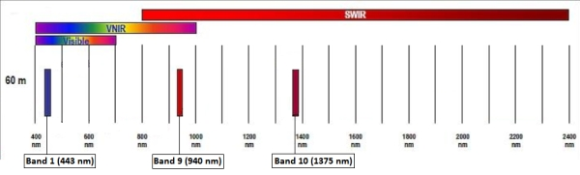
Figure 4 Sentinel spatial resolution (SENTINEL-2 10 m spatial resolution bands: B2 (490 nm), B3 (560 nm), B4 (665 nm) and B8 (842 nm) top, SENTINEL-2 20 m spatial resolution bands: B5 (705 nm), B6 (740 nm), B7 (783 nm), B8a (865 nm), B11 (1610 nm) and B12 (2190 nm), middle, SENTINEL-2 60 m spatial resolution bands: B1 (443 nm), B9 (940 nm) and B10 (1375 nm) , bottom), source ESA
“The Level-1C product is composed of 100x100 km2 tiles (ortho-images in UTM/WGS84 projection). The Level-1C product results from using a Digital Elevation Model (DEM) to project the image in cartographic geometry. Per-pixel radiometric measurements are provided in Top Of Atmosphere (TOA) reflectances along with the parameters to transform them into radiances. Level-1C products are resampled with a constant Ground Sampling Distance (GSD) of 10, 20 and 60 m depending on the native resolution of the different spectral bands. In Level-1C products, pixel coordinates refer to the upper left corner of the pixel.”
Level-1C products can be downloaded via the Copernicus Open Access Hub (SciHuB).
Since the definition of marginality is also based on the soil quality local or regional soil datasets should be used in order to augment the marginal land identification.
Furthermore multi temporal satellite images can be used for the assessment of the study’s area usage through the previous years.

Eligibility Assessment
Following the successful refinement of the initially selected marginal land area an eligibility assessment should be performed in order to investigate the suitability of the selected area to be used as a carbon sink. The developed projects could be exploited either by entering the voluntary or compliance carbon markets.
Voluntary markets (chapter xxx.) standards requires that offsets should be:
- Real: there will be evidence that the project removes or prevents emissions;
- Additional: the emissions reductions would not occur without those project activities;
- Measurable: the volume of emissions reductions can be accurately measured; and
- Verifiable: a neutral, third-party auditor has verified the emissions reductions.
Alternatively, such projects can be used in a national level for registration in the EU ETS, more information regarding the eligibility conditions and restrictions can be found in section xxxx .
The initial step in the eligibility assessment should be the additionality criterion. This criterion could be investigated and established by using multi temporal information provided by high resolution remote sensing images, that can define the land use, land cover of the study area through the years, and thus conclude if the project activities are going to offer emission reductions. This is the most crucial criterion for the initial selection of an area that will be used to act as a carbon sink.
Once the additionality criterion has been established an area could be considered as a potential candidate for the development of a carbon sequestration project.
The remaining criteria will be examined during the sustainability/feasibility study.

Financial Aspects of sustainability
One of the most crucial pillars of the sustainability of a marginal land used as Carbon Sink is the financial sustainability i.e. the ability to make financial profit during the project implementation. For the creation of the financial sustainability study guidelines and workflows the results of T2.5, T2.6, T2.7, T4.3, T4.3, and T5.3 were used.
In order to be able to assess the financial sustainability of using marginal lands as carbon sinks, a holistic approach that considers the full lifetime of the project implementation should be developed. The overall methodology for the financial assessment of a marginal land afforestation project focused on carbon sequestration is presented in Figure 5
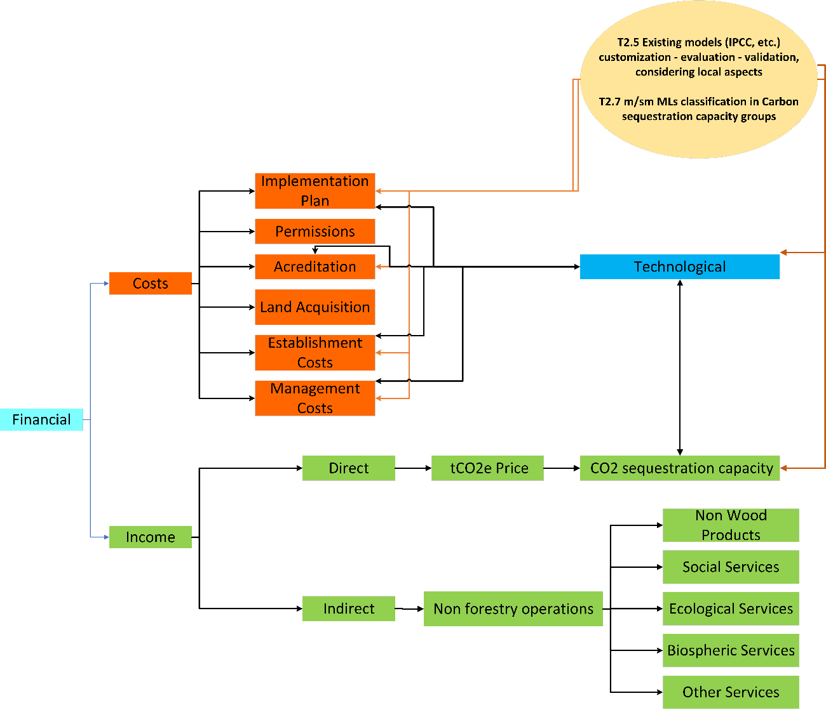
Figure 5 Financial sustainability assessment
The first step is the estimation of the associated costs for transforming and maintaining a marginal land area to a forest area.
The associated costs for the afforestation of a marginal land are the following:
- Permissions: This is an initial cost regarding the acquisition of all necessary permissions for the implementation of an afforestation project. This cost will be incurred during the start of the project.
- Accreditation: The accreditation cost is also an one time cost that is connected to the accreditation of the carbon units produced by the project.
- Afforestation implementation plan: This cost will be incurred at the start of the project and is for the creation of the afforestation plan that will be implemented.
- Land Acquisition or land rental costs: The cost for the acquisition of the area to be afforested or its rental. If the area is bought then it is a one time cost incurring in the start of the project, while if its rented its will be a yearly cost.
- Land preparation costs: This is a one time cost which will be incurred at the start of an afforestation project. It concerns the initial preparation of the site (cleaning, fertilization, etc.)
- Plant acquisition: It is the costs of acquiring the plants that will be used in the afforestation area. It is usually a one time cost incurred at the start of the project. In some cases some additional plant acquisition might be necessary to replace plants that were not successfully planted the first time.
- Planting costs: It is an one time cost incurred in the beginning of the project and concerns the actual planting of the trees.
- Maintenance/Management costs: Management/Maintenance costs are yearly costs dedicated to the management and maintenance of the afforested area, and also for the development of 10-year forest management plans

The following table presents a cost calculation workflow for the implementation of a 50-year afforestation project.
Type of cost | Frequency | Cost
Permissions | 1 Year
Accreditation | 1 Year
Afforestation implementation plan | 1 Year
Land Acquisition (per hectare) | 1 Year
Land rental (per hectare per year) | 1-50 Year
Establishment costs
Land preparation (per hectare) | 1 Year
Plant acquisition (per plant) | 1 Year
Planting (per hectare) | 1 Year
Management/Maintenance costs (per hectare per year) | 1-50 Year
Forest management plans | Every 10 years
Table 7 Implementation costs for an afforestation project
In addition to the costs detailed in Table 7 one must also consider additional costs linked to the associated risks of an afforestation projects. Such risks include the damage of the plants by pests, grazing, fires, extreme winds or the unsuccessful planting of the trees. Most of these risks can be mitigated by good forest management plans and a solid monitoring of the plantation that will help to alleviate the dangers.
Since the main objective is to transform marginal lands to carbon sinks the main source of income for such projects will be the price of a carbon unit. A carbon unit is defined as a tonne of CO2 equivalent tCO2e. Currently the price for a carbon unit is approximately 20 $ (Figure 6). The total income of an afforestation project dedicated to carbon sequestration could be calculated by its potential carbon sequestration capacity per hectare per year and the predicted carbon prices for each year for the whole lifetime of the project. The carbon sequestration capacity is connected to the type of tree species that are going to be used and their planting density. Furthermore, there is also a connection between the tree species and their ability to enhance the soil carbon pool.
Figure 6 IHS Markit Global Carbon Index (USD) (Source: https://indices.ihsmarkit.com/Carbonindex)
Additional income of afforestation projects can come from other non-forest related activities such as hunting licences, mushroom picking licenses, recreational activities, beehives and so on.
According the Forest Europe, 2015 report the total value of non-wood goods reported by 26 countries was almost 2.28 million €, while the total reported value for marketed services was around 723 million € (Figure 7).

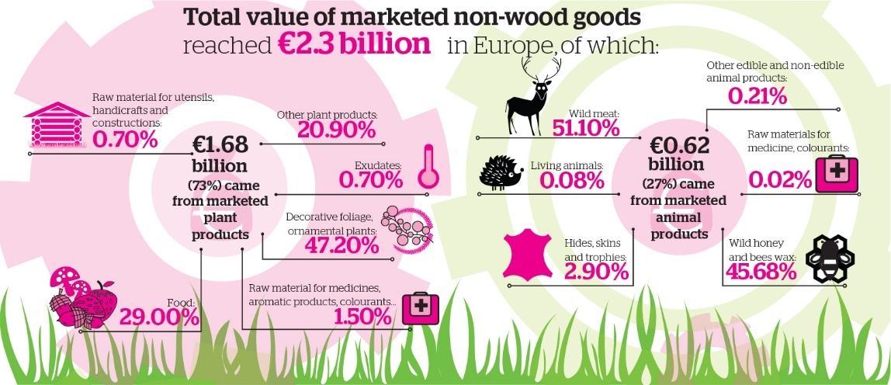
Figure 7 Total value of marketed non-wood goods (Source: Forest Europe, 2015)
The non wood goods are part of sustainable forest management indicator 3.3. More specifically the following were reported in Forest Europe, 2015:
- “Temperate and boreal forests are a traditional source of not only wood but also many other products that are extracted from forests, including resin, tannin, fodder, litter, medical and aromatic plants, fruits, nuts, roots, mushrooms, seeds, honey, ornamentals and exudates”
- “The value of forest products other than wood is being rediscovered on account of both their price dynamics and the increased demand associated wth tourism and recreation”
- “The socio-economic contribution of forests to livelihoods and the impact of their use on the environment are essential components of modern concepts for sustainable forest management. However, the integration of the assessment of Non-Wood Goods (NWGs) in extensive forest surveys causes problems as most NWGs are site-specific, dependent on spatial distribution and may be of solely local importance.”
- “This indicator covers the value and quantity of marketed NWGs from forest and other wooded land. For reasons of consistency, even if they could represent a substantial part of the total harvested NWGs, NWGs harvested for self-consumption and informal use at local level are excluded from the analysis. The main NWGs identified in the available data sets are: Christmas trees, mushrooms and truffles, fruits and berries, cork, ornamental plants, medicinal and colorant products, seeds of forest tree species, game products and honey.”
- “Quantities and/or values for marketed NWGs were provided by 28 countries. For food and ornamental plants the reported forest area amounts to 61% and 36% respectively; for all other categories of NWGs the reported forest area is far smaller. The available data sets are fragmentary for several reasons: the parameters use to assess quantity are not harmonised and render it difficult to compare data; in addition, the collection of data on NWGs is costly, the number of products is very large and no commonly accepted classification and priority list of NWGs are used by national statistical offices, including for the local significance of many products. For these reasons, it can be difficult to obtain an overview and comparable data for all types of NWGs across Europe. Nevertheless, the reported data clearly show that NWGs can be an important source of income at local level.”
- “Game comprises all hunted birds and mammals, such as partridge, pheasant, hare, deer, wild boar and chamois. The presented figures include game species whose habitats are forest-related or forest-dependent. Game that roams on farms is excluded. Data on game meat was reported by 10 countries in relation to quantity and 14 countries in relation to value. The commercial sale of game meat is an important economic activity in many countries. Among the reporting countries, Germany (EUR 195 million) Spain (EUR 73 million) and Austria (EUR 15 million) were by far the highest producers of game meat in terms of value. Finland and Sweden did not provide data on game meat. Among the reported value of non-wood products, game accounted for EUR 321 million (14% of NWGs) for all responding Forest Europe countries.”
Figure 8 presents the classification of European countries per region according to the Forest Europe report.
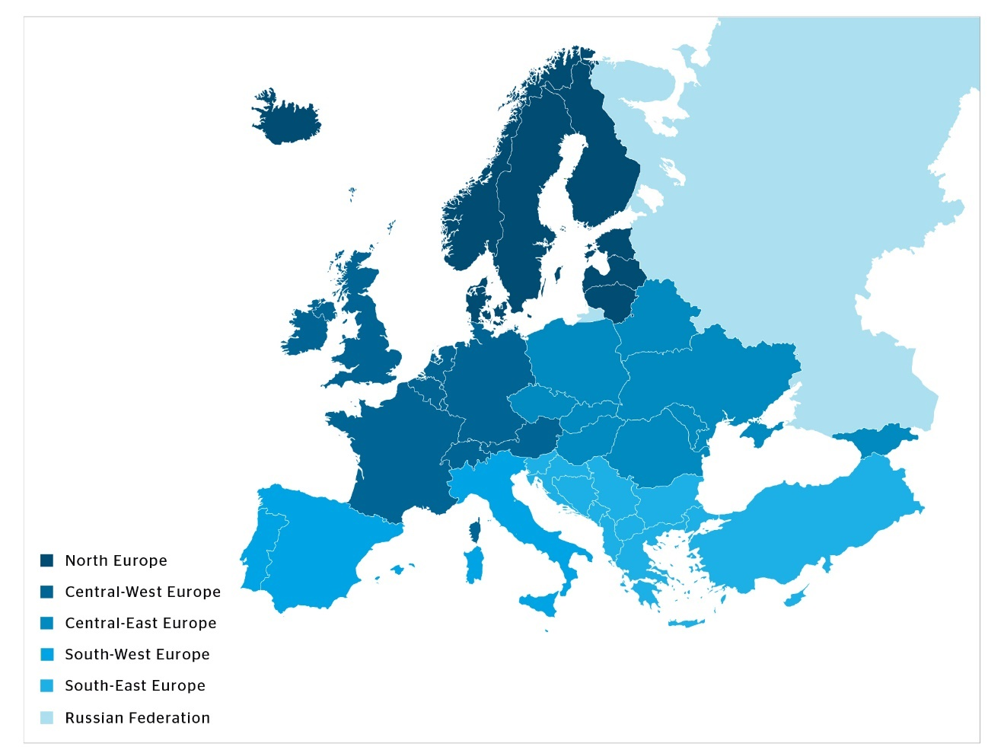
Figure 8 Classification of European Countries per region according to The Europe forest, 2015 (Source: Forest Europe, 2015)
The following figures, and tables present an overview of the Forest Europe, 2015 report finding related to non wood goods.
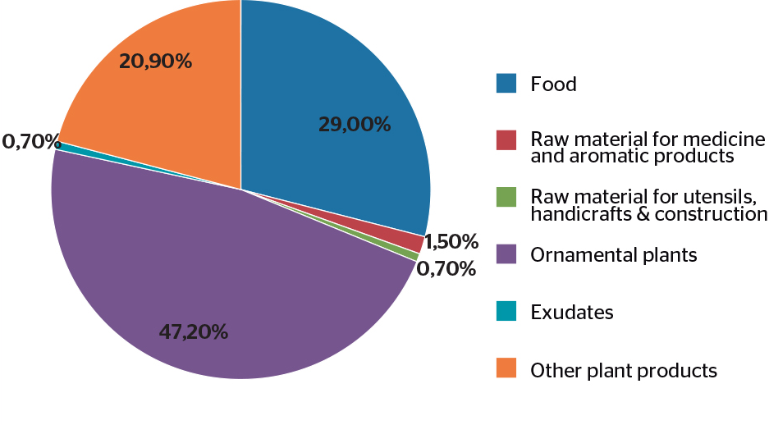
Figure 9 Total reported value of marketed NWGs accounted for by plant products (in percent) (Source: Forest Europe, 2015)
Region | Plants | Animals | Totals
 | 1,000 €
North Europe | 237,569 | 8,603 | 246,172
Central-West Europe | 717,527 | 337,052 | 1,054,579
Central-East Europe | 42,886 | 22,933 | 65,819
South-West Europe | 609,282 | 197,918 | 807,200
South-East Europe | 51,5111 | 51,724 | 103,235
EU-28 | 1,592,080 | 55,611 | 2,148,199
Europe | 1,658,775 | 618,229 | 2,277,004
Table 8 Value of marketed NWGs (Source: Forest Europe, 2015)
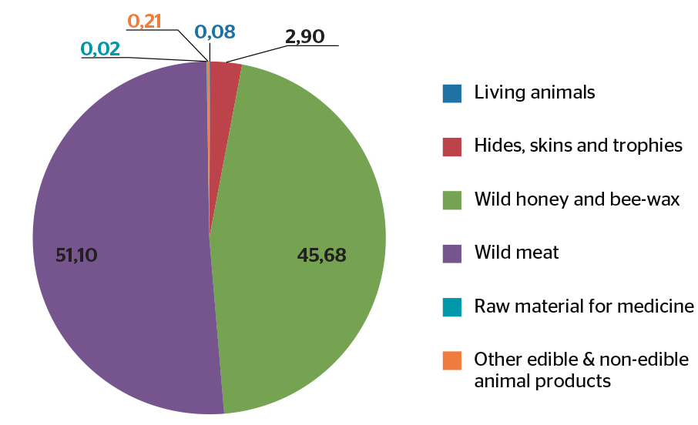
Figure 10 Shares of total value of marketed NWGs accounted for by animal products; absolute values specified in EUR 1,000 (Source: Forest Europe, 2015)

Region | Game meat |  | Living Animals |  | Pelts, Hide skins and trophies |  | Wild Honey and bee wax |  | Raw material for medicines, colorants |  | Other animal products
 | Quan.  tonnes | Value  1,000€ | Quan.  tonnes | Value  1,000€ | Quan.  tonnes | Value  1,000€ | Quan.  tonnes | Value  1,000€ | Quan.  tonnes | Value  1,000€ | Quan.  tonnes
North Europe | 3,117 | 7,147 | - | - | 59 | 529 | 141 | 780 | 20 | 147 | -
Central-West Europe | 9,227 | 217,113 | - | - | 287 | 6,738 | 15,750 | 111,861 | - | - | 1,340
Central-East Europe | 10,084 | 17,959 | 7 | 528 | 10 | 4,445 | - | - | - | - | -
South-West Europe | - | 73,228 | - | - | - | - | 36,199 | 124,690 | - | - | -
South-East Europe | 700 | 5,565 | - | - | 4 | 6,537 | 554 | 39,623 | - | - | -
EU-28 | 23,080 | 317,013 | 7 | 528 | 351 | 3,312 | 52,090 | 237,330 | 20 | 147 | 1,340
Europe | 23,127 | 321,012 | 7 | 528 | 361 | 18,249 | 52,664 | 276,953 | 20 | 147 | 1,340
Table 9 Quantity and value of different types of marketed animal products (Source: Forest Europe, 2015)
Region | Game meat  Value €/ha | Living animals  Value €/ha | Pelts, hides skins and trophies Value €/ha | Wild honey and bee wax Value €/ha | Raw material for  medicine, colorants  Value €/ha | Other animal  products Value €/ha
North Europe | 0.92 | - | 0.04 | 0.23 | 0.07 | -
Central-West Europe | 13.3 | - | 1.75 | 3.53 | - | 0.35
Central-East Europe | 1.59 | 0.27 | 0.53 | - | - | -
South-West Europe | 4.01 | - | - | 5.8 | - | -
South-East Europe | 0.83 | - | 0.97 | 9.18 | - | -
Table 10 Average value of the marketed services per hectar for countries that reported positive values for the various service (Source: Forest Europe, 2015)
Additional income to an afforestation project can also come from other marketed ecosystem services. According to Forest Europe, 2015 the total reported value for marketed services was around 723 million € (Figure 11). In general, marketed services can fall in one of the following 4 categories: Ecological services, Biospheric services, Social services, and other services (Table 11).
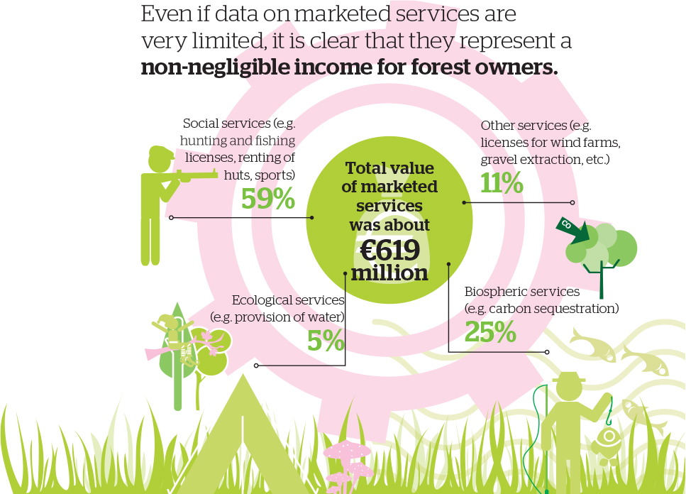
Figure 11 Total value of marketed services (Source: Forest Europe, 2015)
Ecological Services | Marketed ecological services include soil, water and other environmental functions as well as infrastructure and managed natural resources, which are often on a voluntary contractual basis with compensation or other payments from private or public bodies. (Forest Europe, 2015)
BIospheric Services | Marketed biospheric services include services related to in-situ or ex-situ gene conservation of genetic resources and protected forest areas, e.g. nature protection on a voluntary contractual basis with compensation or other payments from private or public bodies. Nature protection contract schemes are increasingly discussed and applied as a measure for the promotion of ecological services of forests. (Forest Europe, 2015)
Social Services | Marketed social services include hunting and fishing licenses, the renting of huts and houses, forest-based leisure, sports, and outdoor activities, and educational activities that are not free of charge to the consumers (e.g. public and schools). Amenity services include those related to spiritual, cultural and historical functions, e.g. sacred, religious or other forms of spiritual inspiration, sites of worship, landscape features (mountains and waterfalls), ‘memories’’ in the landscape from past cultural ties, aesthetic enjoyment and inspiration, and historical artefacts. (Forest Europe, 2015)
Other services | Other marketed services include payments to woodland owners for licenses that regulate land use for gravel extraction, telecommunication masts, wind farms and electricity distribution, among others. Depending on national laws, these marketed services of the forest may add directly to the income of forest owners and thus contribute to the economic viability of sustainable forest management. (Forest Europe, 2015)
Table 11 Definition of forest services (Source: Forest Europe, 2015)
Figure 12 presents the proportion of the marketed services provided by the reporting countries.
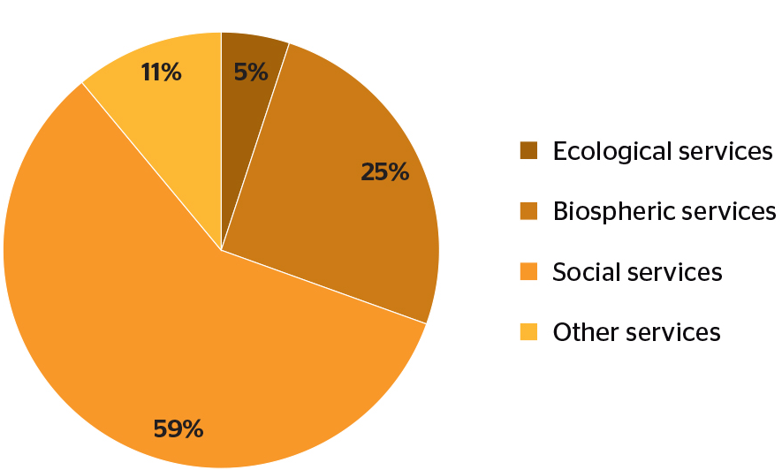
Figure 12 Proportion of marketed services provided by reporting countries (Source: Forest Europe, 2015)
According to the same report “Although the marketed forest-related services are well identified, the volume of income derived from these services is not known or registered or covers only part of the forest sector (e.g. private versus public ownership). As we can see, the biospheric and social services dominate the reported data as does the residual category of ‘other services’.” It also denotes that hunting and fishing licenses are the best documented marketed services, although data are missing from several countries. Data about hunting licenses and other income related to hunting was reported by approximately half of the reporting countries, since it is one of the most traditional services. It is obvious that hunting licenses and related products can provide a significant income to for both public and private landowners. Table 12 presents the values for other forest ecosystem services reported by country groups. In addition to hunting licensing, mushroom picking license can also provide a significant source of income to landowners.
Region | Total reported across services Value 1,000 €
North Europe | 171,118
Central-West Europe | 204,864
Central-East Europe | 185,582
South-West Europe | 29,636
South-East Europe | 22,215
EU-28 | 546,341
Europe | 619,415
Table 12 Total values for other marketed forest ecosystem services reported by country groups (Source: Forest Europe, 2015)
The following table summarizes the potential sources of income for an afforestation project dedicated to carbon sequestration.
Potential Income | Frequency | Income
Carbon Units | Project lifetime
Non-Wood Goods | Yearly
Services | Yearly
Biospheric | Yearly
Social | Yearly
Ecological | Yearly
Other services | Yearly
Table 13 Potential Sources of Income
The following table presents a generic financial assessment calculation and monitoring for the implementation of an afforestation project.
Costs (-) |  | Income (+)
Type | Value | Type | Value
Permissions |  | Carbon Units
Accreditation |  | Non-Wood Goods
Afforestation implementation plan |  | Biospheric Services
Land Cost |  | Social Services
Establishment |  | Ecological Services
Management/Maintenance costs |  | Other Services
Total
Project Income
Table 14 Generic Financial Assessment

Social Aspects of sustainability
The social aspects of sustainability are closely related to both environmental and financial aspects. The include among others employment, health and well-being, recreation, education, etc. Some of the social sustainability aspects were presented in the section 4, under services (Table 11). Such series can include hunting, fishing, outdoor activities, forest-based leisure, mushroom picking etc. The main social aspects/benefits of implementing an afforestation project are shown in Figure 13.
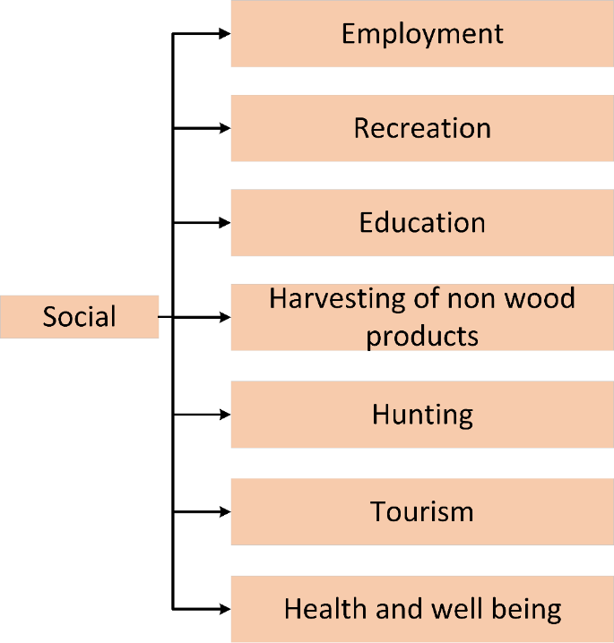
Figure 13 Social aspects of sustainability
According to FOREST EUROPE, 2015:
- “The socio-economic contribution of forests to livelihoods and the impact of their use on the environment are essential components of modern concepts for sustainable forest management.”
- “High numbers of public forests management employees are employed in countries with large public forests and in which citizens expect extensive social services from forests.”
- “Higher numbers of public staff per ha tend to be employed in countries in which citizens expect extensive social and environmental services, particularly recreation,....”
- “Regarding policy objectives, around 70% of countries reported “no changes”. Only 4 signatories reported positive changes, e.g. a systematic vision, strategic goals, priorities and activities which will lead to sustainable schemes for the development and management of tourism activities (Bulgaria); clearly defined objectives (Cyprus); new Monumental Trees Protection Act (Portugal); and boosting the social use of forest areas by promoting rural tourism, natural green paths and other cultural elements (Spain). However, the absence of changes does not necessarily imply a low level of interest if the country already has appropriate policies in place as is the case, for example, in Norway.”
- “Privately-owned forest area has slowly but steadily increased. The number of publically-owned forest holdings has been relatively constant or decreasing. While the number of private forest holdings is much higher than public holdings, the majority of private holdings are forests of less than 10 ha in size.(Figure 14)”
- “Expenditures for services remain constant, while revenues from services are increasing. Governments in Europe currently spend more than €3 billion on forest services, with an average of €37 per ha. Expenditures were stable during the period 2000-2010. However, there is considerable variability across individual regions. Government revenue from forest products and services reached at least €1.8 billion in 2010, with an average of €40 per ha. Revenue steadily increased during the decade 2000-2010 in all regions of Europe.”
- “Forest sector still plays an important role in relation to employment. In most European countries, the number of people employed in the forest sector has decreased. There is a huge diversity of qualifications, with pronounced differences between regions. Despite that, the forest sector in Europe provided jobs and income for at least 3 million people, plus an unaccounted number of people in informal employment, which is not reflected in the reported data. Therefore, the forest sector plays an enormous role in the livelihood of rural areas. The forest sector is still a “male domain”.”
- “Most forests in Europe are accessible for recreation. 75% of countries report that in 2010, at least 90% of their forests and other wooded land provided access to the public for recreational purposes. Two thirds of countries report that less than 6% of their forests and other wooded land has recreational use as a main management goal.”
- “Ownership is assumed to be a key factor that influences forest land management and protection (Siry et al. 2010). The number of forest holdings, the size of landholdings and nature of ownership are assumed to have implications for forest management and various other socio-economic circumstances.”
- “For many countries, the number of forest holdings is unavailable completely or in part, which makes it difficult to describe the exact status of the various regions. Generally, the number of private forest holdings is much higher than that of public holdings, especially in the smaller size classes. The number of private forest holdings is especially high in some countries, e.g. France, Poland and Croatia. By far the majority of these holdings are in the size class of less than 10 ha. The lack of a harmonised minimum holding size in the national statistics also makes it difficult to compare countries directly.”
- “Although the numbers of people employed in the forest sector have been reduced in recent decades, the sector still plays an important role in relation to employment. In the reference year 2010, the entire forestry sector in Europe provided jobs and income for at least three million people, plus the unknown number of people in informal employment who are not covered by the reported data. Hence, the forest sector makes a huge contribution to the livelihood of rural areas.”
- “The following analysis shows that the forestry workforce in many parts of Europe, which is mainly employed in micro-enterprises, has achieved a very high level of productivity. The efficient organisation of labour and technological development is leading to lower labour intensity in all branches of the forest sector. A very high degree of variability between regions in Europe can be observed in this regard. While regions exist in which the level of mechanisation is up to 100%, the potential for further rationalisation remains very high in other regions. This will be accompanied by an increasing demand for the competencies and skills of workers, staff and entrepreneurs. The biggest challenge for the forest sector in overcoming the threat of a lack of workers with the necessary skills and desire to work in the sector lies in maintaining the necessary capacities in the workforce and motivating young entrants.”
- “Based on the officially reported figures for 2010, the entire forest sector in Europe provides employment and income for around 3 million people in the forestry, wood manufacturing and paper industries. At 1.4 million, the biggest share of the jobs is provided by the wood manufacturing sector. The paper industry accounts for 790,000 jobs, and 620,000 jobs are reported for forestry itself. In the case of forestry, in particular, the reported figures are obviously not indicative of the total number of people working in the sector. A huge amount of forest work is carried out by private forest owners and their family members and by members of local communities, none of whom feature in the official employment statistics. Hence, the sector provides income and jobs for a considerably higher number of people than indicated by the statistics.”
- “Access to forests enables people to benefit from the recreational value of forests, which, in turn, contributes to the quality of life. This value includes health benefits (both physical and mental) and the enjoyment of recreational activities. Accessibility for recreation is granted through a legal right of access, customary rights and other de facto forms of access. The intensity of use (measured in million visits per annum) can provide an indication of the value of these benefits, however the value may also depend on the nature and duration of the visits.”
- “A total of 32 countries out of 43 reported on the area of forest and other wooded land available to the public for recreational purposes. In the majority of these countries, the public had access to at least 90% of their forest and other wooded land for recreational purposes in 2010. In terms of regional distribution, the reported data provide quite an accurate reflection of the situation in North and Central-West Europe where the majority of countries reported these data. In contrast, the data for Central- East, South-East and, particularly, South-West Europe are incomplete and should be treated with caution. (Table 15).”
- “Forest area with public access for recreational purposes has been increasing steadily since 1990 in most countries, however the changes in the period 2005- 2010 were very marginal. The forest area with recreational use as a main management goal has steadily increased since the 1990s in most countries; the increase has been more pronounced since 2005, particularly in countries in the North Europe and South-East Europe regions. The data on the intensity of use (number of visits) relies on different sources, methodologies and reference years, hence it is difficult to draw reliable conclusions about the related trends.”
- “According to the national data on employment reported by the Forest Europe signatories, maintaining and/or increasing employment levels in the forest sector are the main forest policy objectives in over the half of the reporting countries (18 of 34) for the years to come. Several countries adopted forest policy objectives that support the more sustainable development of the labour force, including the improvement of working conditions (Croatia, Italy and Slovak Republic) and maintenance of safety and health conditions in the forest sector (Latvia, Sweden and Switzerland). Other countries (Bulgaria, Portugal and United Kingdom) are targeting the improvement of qualifications and professional skills. Compared to previous SoEF reports, the current data suggest that maintaining and/or increasing the levels of employment in the forest sector have become a priority and have overtaken the quality issues that predominated in 2011 and 2007. The current trend in forest policy objectives is to tackle the decline in employment numbers triggered by the recent financial crises and economic decline, which have had a negative impact on the majority of countries.”
- “Most signatories (26 of 34) reported specifically formulated objectives in relation to research, training and education. As was the case in 2010, many countries7 (17 of 34) explicitly highlighted the further promotion and intensification of research activities, particularly in relation to the competitiveness of the forest sector, ecosystem monitoring, forest and climate change, sustainable forest management, close-to-nature forest management, and forest-related ecological, technological, and social issues. Compared to the 2011 report, a slight trend towards greater emphasis on cross-sector research, technological development, innovation and knowledge management can be observed. Several countries currently aim to improve the international transfer of knowledge and technology relating to sustainable forest management (Austria), technological developments relating to the competitiveness of the forest sector (Czech Republic, Slovak Republic), the streamlining of forest-related research and scientific innovation (Romania, United Kingdom), and integration of cross-sectoral disciplines such as agriculture, fisheries, natural resources (Finland, Hungary, Slovenia).”
Furthermore according to FOREST EUROPE, 2019 forest have a significant impact in improving health:
- Health and well-being benefits and other social functions of forests, such as recreation, tourism, forest education, aesthetic appreciation or spiritual experience, are today an increasingly important part of the values people derive from forests.
- Forests and trees have a positive impact on air quality through the deposition of pollutants to the vegetation canopy, reduction of summertime air temperatures, and a decrease in ultraviolet radiation.
- The contribution of forests and other types of natural and semi-natural habitats to human health and well-being is increasingly understood within science. In the literature, five key mechanisms for the health benefits of forests have been identified and discussed within the research field:
  - Reduced exposure to noise and air pollution
  - Stress reduction and psychological and physiological restoration
  - Strengthening the immune system through contact with nature
  - Increased physical activity and reduction in obesity rates
  - Better social contacts
Figure 14, Figure 15, Figure 16, and Figure 17 present the status and the trends in forest ownership in Europe.
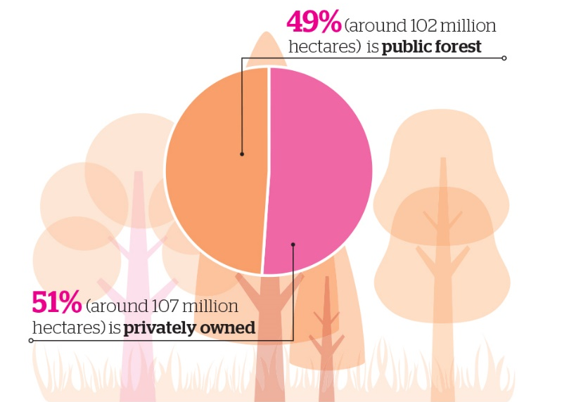
Figure 14 Forest ownership in Europe (Source: Forest Europe, 2015)

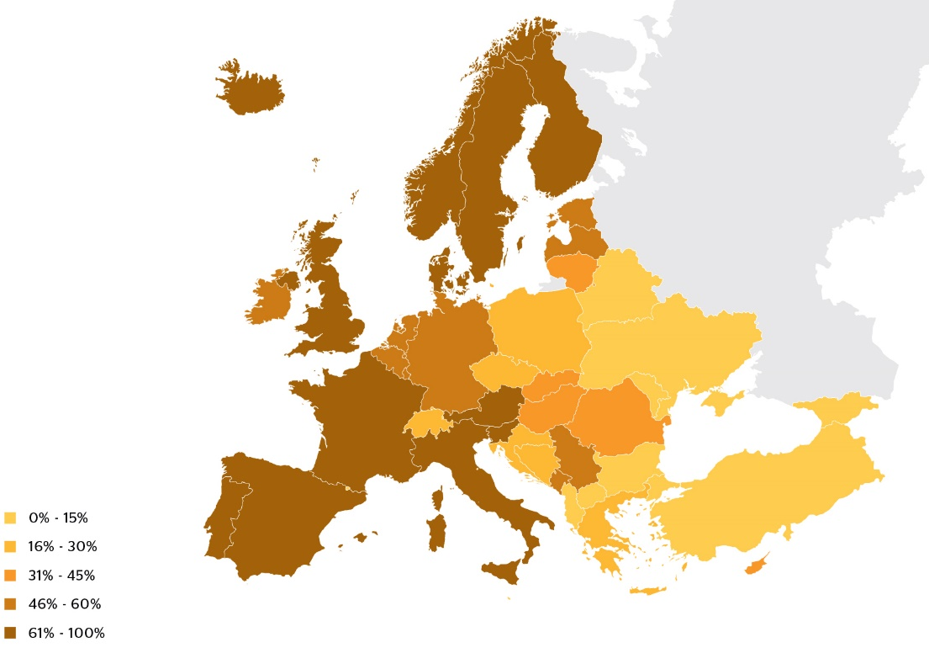
Figure 15 Area of privately owned forest as a percentage of total forest (2010) (Source: Forest Europe, 2015)
Figure 16 Distribution of forest area in 2010 by ownership classes and region (Forest Europe, 2015)
Figure 17 Private forest area 1990 - 2010 by region (Forest Europe, 2015)
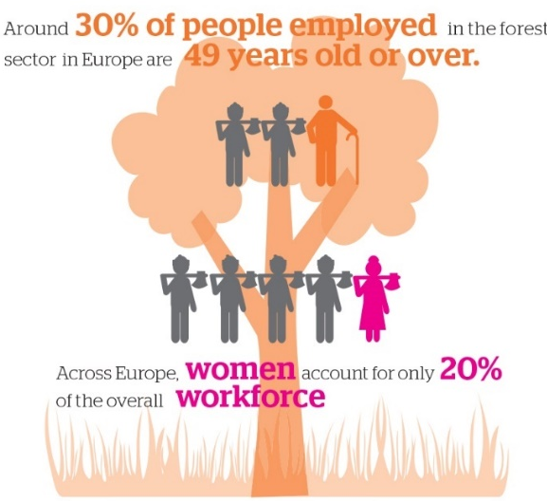
Figure 18 Forest employment distribution (Source: Forest Europe, 2015)
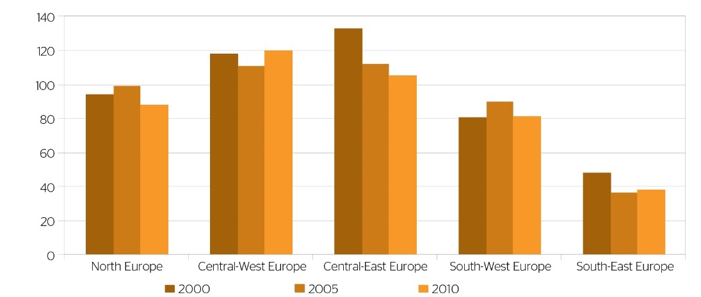
Figure 19 Development of forest-related employment from 2000-2010 (Forest Europe, 2015)
Figure 18, and Figure 19 present the forest related employment status in Europe.
Region | Area with access available to the public for recreational purposes (2010) |  | Percentage of forest and other wooded land area with recreational use as a main management goal (2010)
 | Percentage of forest and other wooded land area with access available to the public for recreational purposes (2010) | Data coverage expressed as percentage of total forest and other woodland area of the region
North Europe | 98.0 | 100 | 4.6
Central-West Europe | 57.3 | 96.6 | 2.0
Central-East Europe | 69.1 | 77.3 | 8.3
South-West Europe | N/A | 0 | N/A
South-East Europe | 95.8 | 32.8 | 7.7
EU-28 | 68.6 | 83.9 | 4.6
Europe | 82.3 | 65.9 | 5.7
Table 15 Area with public access and area managed for recreational use by region (Forest Europe, 2015)
The implementation of an afforestation project can provide new working positions in the area. The new positions could be related directly to forestry operations or to other activities that might get a boost from the afforestation project, like tourism, hunting or fruit picking services. For the implementation of a project an initial study and plan will have to be created which will result in the providing work opportunities for forest service companies in the area. Furthermore during the initial phase of the project jobs will be created that have to do with the preparation of the area and the actual planting of the trees.
The implementation of a forest management dedicated to leaving the forest to grow without any major interventions like harvesting can create the potential for the development of forest tourism in the implementation areas. Recent studies have shown that under certain circumstances the financial benefits from a forest tourism driven approach can be more for the benefits gained from the exploitation of the forest. Ahtikoski et all, 2011 performed a study in Finland comparing the benefits of nature based tourism and forestry examining three different forest management scenarios. Their study indicates that if a total of 440 more tourists per year are attracted to the area for a period of 30 years then the benefits from tourism (financial and employment generation) are outweighing the ones coming from forestry.
In addition an afforestation project will have a positive impact in improving health and well-being in the area. The newly created forest will provide an area for recreation and leisure, and education.
When the forest will grow older it will have an impact in biodiversity it can also provide access to hunting and mushroom picking activities.

Environmental Aspects of sustainability
Implementing an afforestation project in marginal lands will have a great environmental impact in the area. In this chapter we are going to study the potential improvements and benefits that will emerge and also provide guidelines for the sustainable environmental aspects of such an action.
In general, marginal lands are lands of low productivity and are located in environmentally deteriorated areas, thus any afforestation project will have in general positive environmental impacts.
Forests provide a lot of environmental benefits spanning from soil and erosion protection to climate change mitigation and protection of infrastructure. The following figure presents a general overview of the environmental impact that an afforestation project can have in an area.
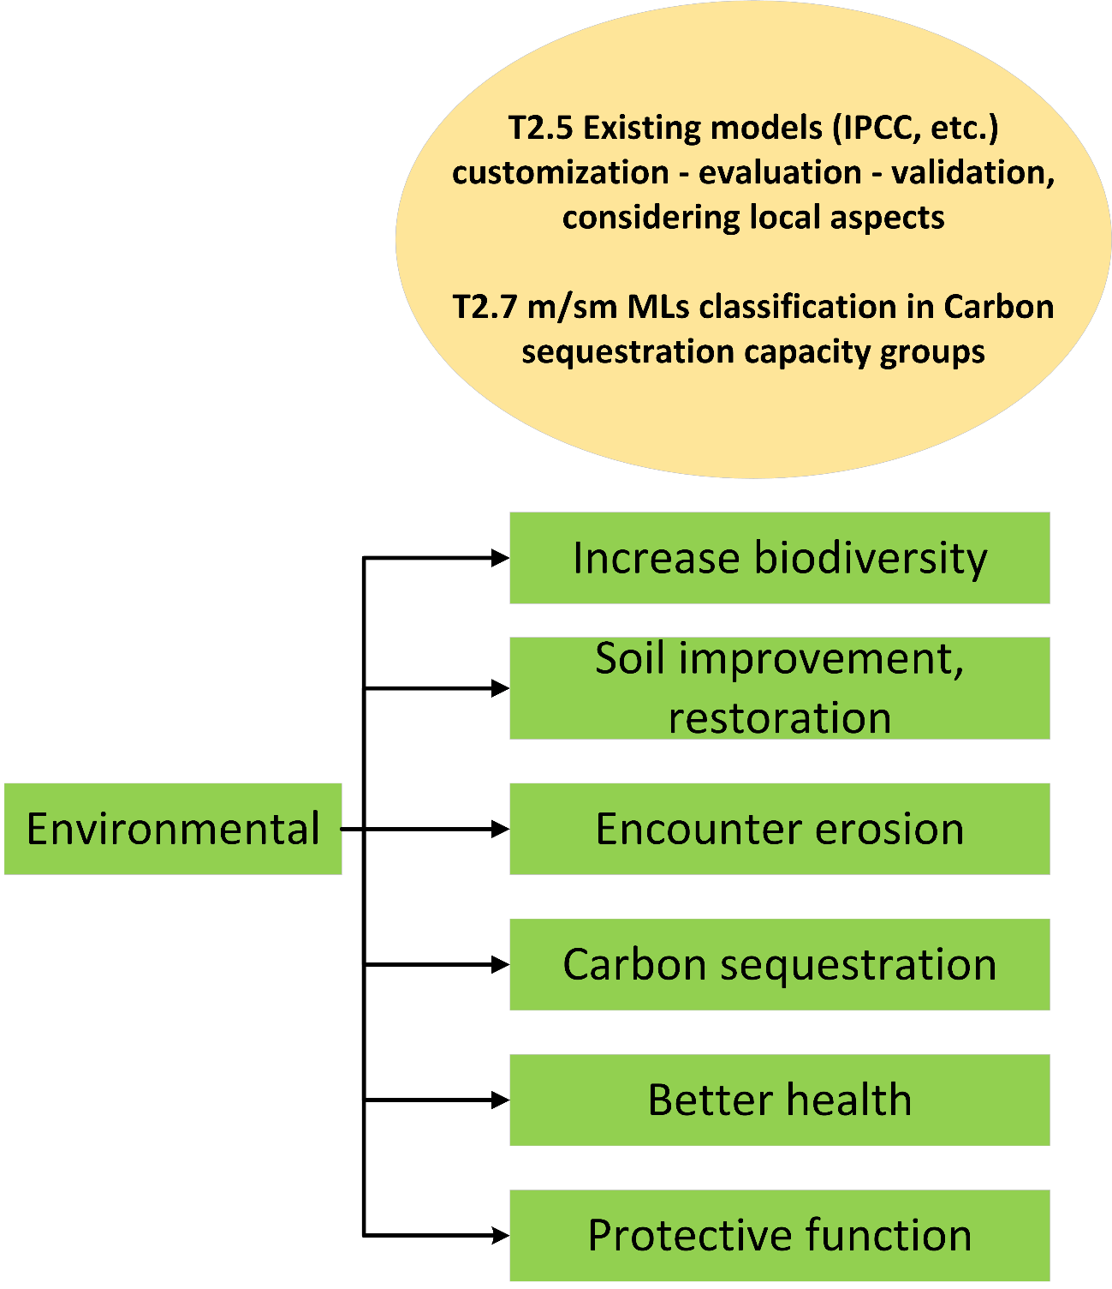
Figure 20 Environmental aspects of sustainability

The most significant environmental impact that an afforestation project is going to have is that will act as a carbon sink for the lifetime of the project, sequestering carbon and also increasing the soil carbon sequestration. In addition, forests can also have other environmental impacts. Forests help to improve the soil quality and also act as a protection for erosion and watershed. Biodiversity and landscape protection is another function of forested areas. According to FOREST EUROPE, 2015:
- “The most reported policy objectives in relation to land use and forest area within the FOREST EUROPE countries are: afforestation of agricultural land unsuitable for agricultural use in countries where national laws do not prevent a change in land use; the management of erosion-sensitive mountainous areas improvements in the stability, productivity, diversity and naturalness of forests through an integrative forest management approach.”
- “More than 25 million ha of forests in Europe are designated for the protection of water supplies, the prevention of soil erosion and the provision of other important ecosystem services.”
- “Around 30 million ha of forests in Europe are designated for the protection for infrastructures and managed natural resources. Often the protective role of forests covers a wide range of aspects, including infrastructures and managed natural resources, but also other services such as water, soil and ecosystem protection. Most protective forests are in the Central-East European region. They are also highly relevant in countries with steep terrain (e.g. Switzerland or Italy).”
- “The main policy objectives related to the protective functions of forests, namely the protection of soils, water resources and biodiversity have remained unchanged since 2007. This shows a long-term commitment to maintain and enhance the protective functions of forests. Most reporting countries identified soil protection as a main policy objective, with particular attention given to mitigating and preventing soil erosion, and about one third of countries identified protection of water resources as a priority. Institutional and regulatory frameworks as well as financial instruments and informational means provide a solid basis for the implementation of related policies.”
- “Forests can play a vital role in preventing soil erosion, protecting water supplies and maintaining other specific ecosystem functions”
- “The majority of the reporting signatories (26 of 34) declared specifically formulated policy objectives in relation to protective forests. Most of the reporting signatories (Belgium, Bulgaria, Croatia, Cyprus, Estonia, Finland, Germany, Hungary, Iceland, Italy, Latvia, Norway, Poland, Portugal, Slovak Republic, Slovenia, Sweden, Ukraine, UK) focus on further maintaining and enhancing the protective functions of forests for preventing soil erosion (19 countries) and improving water quality and quantity (16 countries). The third most visible policy objective relates to the protection of biodiversity (10 countries). Several of the reporting signatories also flagged the prevention of natural hazards and floods, climate change, the protection of landscapes and infrastructure, and the enhancement of human health and recreational functions as policy objectives.”
- “Almost half of the reporting signatories (15 of 34) mentioned the implementation of key measures on protective forests. The most frequently reported key measures were implemented through national and regional forest programmes, action plans, strategic programmes, guidelines (Austria, Finland, Hungary, Slovak Republic, Spain, Turkey, Ukraine, United Kingdom), and national forest or forest relevant legislation (Bulgaria, Czech Republic, Cyprus, Ireland, Slovenia). The use of research programmes and projects (Finland, Romania) and the mobilization of EU funds through the national rural development programmes were also reported. Ireland identified opportunities for converting and restructuring commercial forests into low intensity native woodland in order to protect sensitive water systems and habitats, Spain maintained the Spanish forest catalogue of protective forests, Slovak Republic initiated investments in flood prevention, Turkey launched a National Afforestation and Combating Erosion Action Plan Campaign, and the European Commission introduced the new EU Forest Strategy for implementing the identified policy objectives.”
- “More than 30 million ha of European forests are protected with the main objective to conserve biodiversity or landscape.”
- “Biodiversity remains an important topic for forest policy and management in Europe. Compared to the previous reporting period, biodiversity-related forest policy objectives have been maintained. Regulatory instruments continue to play an essential role in the conservation of biodiversity in forests and have been reinforced by new financial and informational measures. The EU’s biodiversity policy is a major trigger for change relating to informational, financial and legislative instruments at the national level.”
- “The majority of reporting signatories in the FOREST EUROPE region (23 out of 34) reported no changes in the national economic policy on forests (public and private) since 2011. In nearly half of the reporting FOREST EUROPE signatories (16 out of 34), the management of state-owned forests is financially selfsufficient or profit-oriented. As reported by 23 countries, total public expenditure by government on all forest related activities for the last reporting period was EUR 3,234,750,019. This total sum amounts to an average of around EUR 17.9 per hectare of total public expenditure on forest and other wooded land per year. Subsidies are the most common financial instrument used to influence private forest management (used by 22 out of 34 signatories). Transfer payments are most frequently used for the conservation of forest biodiversity, followed by support for forest inventory and planning, and soil and water protection.”
- “Over the last 15 years, the area of forest in Europe designated for biodiversity and landscape protection increased by half a million hectares annually. Around 12.2% (or 29.9 million ha) of European forests are protected with the main objective of conserving biodiversity. Around 7% have the protection of landscapes representing an area of 19 million ha as a main objective. The strictness of protection for biodiversity varies considerably within Europe: while restrictive protection with minimal or no intervention dominates in North Europe and some East European countries, active management in protected areas is more common in Central and South European countries.”
- “Biodiversity remains an important topic for forest policy and management in Europe. Biodiversity-related forest policy objectives have been maintained since the previous reporting period. Regulatory instruments continue to play an essential role in conserving biodiversity in forests and have been fostered using new financial, informational measures. The EU’s biodiversity policy is a major trigger for changes related to informational, financial and legislative instruments at national level.”
- “Species diversity and the dynamics of forest ecosystems differ considerably throughout Europe. This is reflected by the broad range of forest types found there, from boreal forest in North Europe to broadleaved evergreen forests in the Mediterranean region. These forest types are differentiated by unique key factors related to structural, compositional (including tree species composition) and functional forest ecosystem components, such as biotic and abiotic disturbance factors and forest management. Mixed forests and other wooded land, composed of several tree species, are often richer in biodiversity than those comprising 1 tree species. However, some natural forest ecosystems are dominated by only 1 or 2 species, e.g. natural boreal pine forests on dry sites, natural sub-alpine spruce stands and beech forests growing in favourable conditions on lowlands.”
- “Natural regeneration contributes to conserving the diversity of the genotypes and to maintaining the natural tree species composition, structure and ecological dynamics. However, natural regeneration may not always be suitable for achieving biodiversity conservation goals. For example, to convert forests from introduced tree species to native tree species, planting is necessary in most cases, and restoration activities may require the elimination of naturally regenerating trees growing outside their natural range. Furthermore, the occasional replanting programmes made necessary by heavy storms or insect calamities may influence the proportion of regeneration methods used, and, consequently, the statistics.”
- “As European forests have been managed for long periods of time, the late development phases are missing or scarce. Because of the lack of deadwood in many forests, several of the deadwood-dependent species are endangered. Indeed, increasing the amount of deadwood in forests is considered one of the potential management options for enhancing biodiversity in most of Europe’s forest types. On the other hand, in some circumstances, the accumulated fresh dying deadwood can create a risk of insect outbreaks.”
- “A total of 501,567 ha were managed for the in situ genetic conservation of forest trees in 38 countries in 2015. The total area managed for ex situ conservation is 11,553 ha in 37 countries; for seed production it is 1,027,434 ha in 38 countries. A total of 145 tree species (including subspecies and hybrids) were reported for this indicator. However, these species are not managed equally for genetic conservation (in situ and ex situ) and seed production. A large proportion of the trees targeted for in situ genetic conservation are widely occurring stand-forming tree species, which are important for forestry. A group of five economically relevant tree species (Abies alba, Fagus sylvatica, Picea abies, Pinus sylvestris and Pinus pinaster) alone account for 55% of the total area managed for in situ genetic conservation, while in the case of many other economically important tree species, only small areas are managed for the same purpose. Furthermore, very few genetic conservation areas are managed for scattered tree species (e.g. Populus nigra, Sorbus domestica, Tilia platyphyllosand, Ulmus laevis), which are often considered of low importance. However, while these species may not be economically important, they have a high value in terms of maintaining forest biodiversity and ensuring ecosystem stability.”
- “The most noticeable form of biodiversity depletion is the loss of plant and animal species. Slowing down the rate of species extinction due to anthropogenic factors is a key objective of biodiversity conservation. This is very much reflected in the corresponding international, European and national initiatives and actions. Examples of these include the Convention on Biological Diversity, the European 2020 targets, which were agreed on at the FOREST EUROPE Ministerial Conference in Oslo 2011, the EU Biodiversity Strategy 2020, and national and regional biodiversity strategies which express their ambitions through set targets (link to Indicator B6). It is further highlighted by the fact that threatened forest species are seen also as indicators of change in forest ecosystems.”
- “The relationships between threatened species, forest composition and habitat structures are complex but often of crucial importance. However, threats to a certain species can often be the result of multiple factors, making it difficult to determine clear causalities. In particular, the required amount and quality of deadwood is a topic that requires continuing research support. Many species are dependent on small key biotopes, habitats or habitat structures available in both protected forest areas and managed forests. To provide science-based input for raising awareness of the need to integrate biodiversity considerations into forest management, further attention needs to be focused on these elements by research and monitoring.”
- “...forest management practices are developing towards the greater integration of biodiversity issues. Such integrated forest management approaches may give rise to improved habitat conditions for threatened species e.g. through increasing the amount of standing and lying dead wood, designating stepping stones and habitat trees, and preserving habitat structures and allowing for their development. However, the effects of biodiversity-oriented forest management practices will become evident only with time. Therefore, in addition to such long-term commitments, the continuation of efforts in relation to the monitoring of the development of threatened forest-occurring species will be crucial.”
  - “Biodiversity remains an important dimension of forest management in Europe. The majority of reporting signatories (31 of 34) reported specifically formulated policies (objectives) in relation to biodiversity. The key objectives and instruments of these policies are:
  - To increase protected forest areas (Albania, Belgium, Latvia, Luxemburg, Montenegro, Norway), inter alia in conjunction with the implementation of Natura 2000 network of protected areas under the European Union’s Habitats and Birds Directives (Bulgaria, Croatia, Hungary, Italy, Slovak Republic, Slovenia, Serbia).
  - To practise multifunctional or close-to-nature forest management (many countries).
  - To protect rare and endangered species and deal with issues relating to invasive alien species (Austria, Cyprus, Czech Republic, Finland, Italy, Latvia, Romania, Switzerland, United Kingdom).
  - To protect forest genetic resources (Bulgaria, Italy, United Kingdom).
  - To preserve natural environments of cultural or aesthetic value (Estonia, Sweden).
  - To improve knowledge about forest biodiversity and management through research and communication (Germany, Iceland, Latvia) and also (new) monitoring (Austria, Turkey)”

Region | Total Forest | Protective Forest | Percentage of forest area
 | 1,000 hectares |  | In percent %
North Europe | 70,832 | 523 | 0.7
Central-West Europe | 38,582 | 900 | 2.3
Central-East Europe | 44,494 | 7,988 | 18.0
South-West Europe | 30,913 | 13,156 | 42.6
South-East Europe | 30,442 | 2,837 | 9.3
EU-28 | 215,267 | 25,405 | 11.8
Europe | 161,082 | 20,946 | 13.0
Table 16 Forest land reported for the protection of soil, water and other ecosystem services in 2015 by region (Source: Forest Europe, 2015)
Table 16 presents the forest land report for protection. It must be noted that several countries commented that, while forests fulfil protective functions, their primary aim is “multiple use”, hence they do not qualify for reporting as solely used for protection (Forest Europe, 2015).
The issues covered by the main policy objectives considering protective forests and other wooded land are presented in Figure 21.
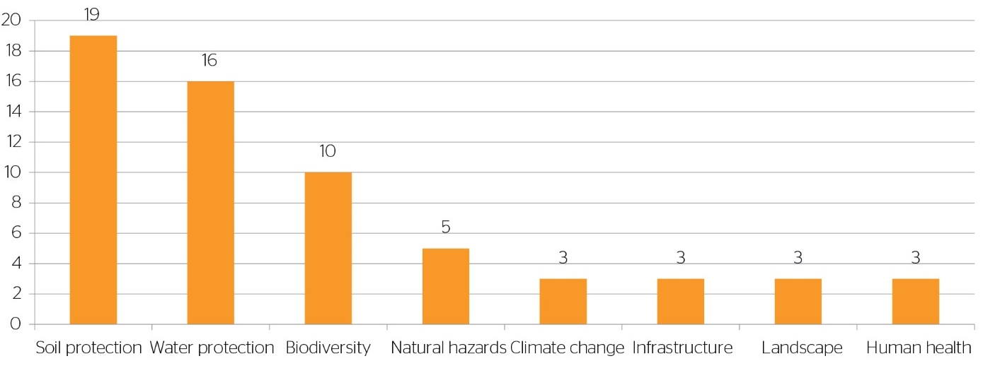
Figure 21 Issues covered by the main policy objectives relating to protective forests and other wooded land for the period 2011-2014 (Source: Forest Europe, 2015)
Table 17 shows the share of forest area by regeneration type in the European region.
Region | Natural regeneration and natural expansion |  | Afforestation and regeneration by planting and seeding |  | Coppicing
 | Million ha | % of forest area | Million ha | % of forest area | 1000 ha | % of forest area
North Europe | 48.4 | 68 | 22.4 | 32 | n.s. | 0
Central-West Europe | 22.3 | 64 | 10.6 | 30 | 20 | 6
Central-East Europe | 16.1 | 52 | 13.0 | 42 | 21 | 7
South-West Europe | 26.1 | 86 | 3.3 | 11 | 11 | 4
South-East Europe | 19.9 | 72 | 4.0 | 14 | 36 | 13
EU-28 | 132.8 | 68 | 53.2 | 27 | 8.8 | 5
Europe | 98.5 | 68 | 38.8 | 27 | 5.4 | 5
Table 17 Share (percentage and million ha) of forest area (uneven-aged and even-aged) by regeneration types in the European regions, 2010 (based on the available data) (Source: Forest Europe, 2015)
Table 18 and Table 19 present the number of threatened and extinct species respectively.
Country | Tree species | Birds | Mammals | Other vertebrates | Other invertebrates | Vascular Plants | Fungi
Albania | 32 | - | - | - | - | - | -
Austria | 11 | 18 | 13 | 18 | - | 267 | 97
Belarus | 3 | 57 | 14 | 13 | 75 | 153 | 105
Belgium | 4 | - | 13 | 4 | - | 34 | -
Bulgaria | 0 | 12 | 8 | 17 | 6 | 0 | 0
Croatia | 3 | 26 | 5 | 1 | 11 | 32 | 257
Cyprus | 4 | 6 | 1 | 2 | - | 102 | -
Czech Republic | 15 | 248 | 31 | 47 | - | 771 | 582
Denmark | 6 | 20 | 9 | 6 | 372 | 54 | 818
Estonia | 2 | 12 | 2 | 1 | 5 | 37 | 36
Finland | 5 | 13 | 8 | 2 | 599 | 48 | 337
France | 5 | 20 | 5 | 2 | 6 | 512 | -
Germany | 7 | 14 | - | - | - | 208 | 1475
Hungary | 9 | 2 | 0 | 0 | 5 | 264 | 166
Iceland | 1 | 0 | 0 | - | - | 1 | -
Ireland | 1 | 3 | 1 | - | 10 | 7 | 2
Italy | 2 | 16 | 21 | 3 | - | - | -
Latvia | 3 | 19 | 9 | 2 | 46 | 76 | 28
Liechtenstein | 0 | - | - | - | - | - | -
Lithuania | 0 | 0 | 2 | - | 4 | - | -
Netherlands | 0 | 0 | 0 | 0 | 0 | 0 | 0
Norway | 0 | 10 | 9 | 0 | 571 | 43 | 501
Slovak Republic | 8 | 20 | 22 | 30 | 644 | 242 | 100
Slovenia | 2 | 43 | 23 | 30 | 227 | - | 82
Spain | 3 | 44 | 17 | 32 | 21 | 142 | -
Sweden | 7 | 12 | 8 | 3 | 373 | 57 | 525
Switzerland | 3 | 29 | 23 | 85 | 85 | 109 | 981
Turkey | - | - | 4 | - | - | - | -
Ukraine | - | 95 | 69 | 88 | 290 | 500 | 148
United Kingdom | 13 | 0 | 0 | 0 | 51 | 29 | 79
Table 18 Numbers of threatened forest-occurring tree species, birds, mammals, other vertebrates, other invertebrates, vascular plants and fungi (number of reporting countries: 30) (Source: Forest Europe, 2015)
Region | Trees | Birds | Mammals | Other vertebrates | Oher invertebrates | Vascular plants | Fungi
North Europe | 0 | 6 | 2 | 1 | 117 | 9 | 61
Central-West Europe | 2 | 5 | 6 | 5 | 4 | 14 | 214
Central-East Europe | 1 | 0 | 7 | 3 | 13 | 28 | 39
South-West Europe | 0 | 1 | 0 | 0 | 0 | 0 | 0
South-East Europe | 1 | 10 | 4 | 1 | 16 | 12 | 0
EU-28 | 3 | 21 | 12 | 3 | 145 | 48 | 300
EU 28 (number of countries reporting) | 19 | 20 | 20 | 18 | 16 | 16 | 15
Forest area of EU 28 covered (in %) | 73 | 74 | 67 | 65 | 63 | 63 | 55
Europe | 4 | 22 | 19 | 10 | 150 | 63 | 314
Europe (number of countries reporting) | 25 | 25 | 25 | 21 | 17 | 19 | 18
Forest area in Europe covered (in %) | 61 | 66 | 66 | 59 | 53 | 52 | 52
Table 19 Numbers of extinct forest-occurring tree species, birds, mammals, other vertebrates, other invertebrates, vascular plants and fungi by regions, EU 28 and Europe (number of reporting countries: 45) (Source: Forest Europe, 2015)
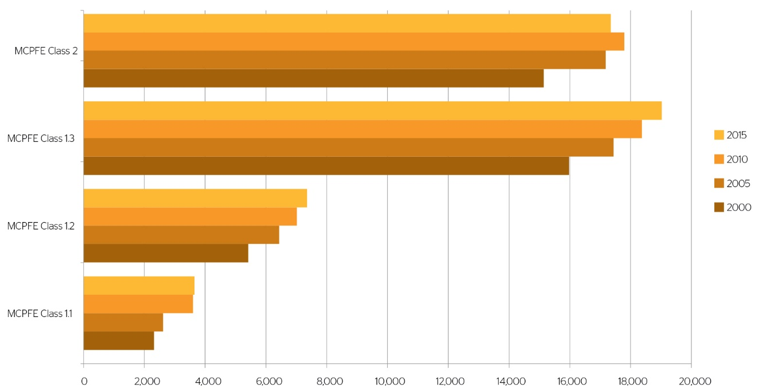
Figure 22 Area of protected forest (1,000 ha) in Europe by MCPFE class (1.1–1.3 and 2) in 2000, 2010 and 2015 (based on available data) (Source: Forest Europe, 2015)
Figure 22 presents the evolution of the protected forest area in Europe by different classes in 2000, 2010, and 2015.
While Table 20 presents objectives of EU Biodiversity strategy to 2020 relevant to forests.
Selected objectives of the EU Biodiversity Strategy to 2020 of relevance to forests
1) Halting the loss of biodiversity and the degradation of ecosystem services in the EU by 2020 and restoring them in so far as feasible.

2) Putting forest management plans or equivalent instruments in place for all forests that are publicly owned and for forest holdings above a certain size so as to bring about a measurable improvement in the conservation status of species and habitats that depend on or are affected by forestry and in the provision of related ecosystem services as compared to the EU 2010 baseline.

3) Fully implementing the Birds and Habitats Directives with a view to improving conservation status through the implementation of 100 percent more habitat assessments and 50 percent more species assessments under the Habitats Directive and establishing secure or improved status through the implementation of 50 percent more species assessments under the Birds Directive.
Table 20 Selected objectives of the EU biodiversity strategy to 2020 relevant to forests
It is obvious that forests have a significant ecological environmental role connected to them. From a sustainability point of view during the assessment of the environmental aspects of the implementation of an afforestation project the following issues should be considered both during the planning phase and the management phase of a project.
Biodiversity: During the planning site an initial assessment of the tree species used for the afforestation project should be performed in order to increase the biodiversity protection and also the successful implementation of the project. During the planning stage native tree species and varieties that all well adapted to the site should be considered. In addition, species that can adapt to climate change should be preferred. Furthermore, species composition and structural diversity should reflect the natural diversity of the area should be selected and if its is applicable the reforestation project should contribute to the improvement and restoration of ecological connectivity.
During the management phase of the project the ecological impact of the project should be closely monitored in order to asses its biodiversity effects. Corrective measures that increase the biodiversity like the presence of dead wood, or the conservation of certain tree species that enhance gene conservations should be considered. In addition the presence of flora and fauna that is present in the newly afforested site should be monitored in order to provide input for the environmental assessment.
Protective functions: During the planning phase the reforestation activities should aim to maintain and protect soil and ground and surface water resources both in terms of quality and quantity. Also, during the planning phase an assessment of the protective functions that the afforestation project could fulfil must be performed. Such protective functions can include the protection of infrastructure, soil erosion, protection of water sources, restitution of soil, etc.
During the management phase an assessment of the protective functions if any of the afforestation project should be performed in conjunction with forest management plans.

Technological Aspects of sustainability
Technology is going to provide the tools and means that will help and enhance the financial, social, and environmental sustainability aspects of using marginal lands as carbon sinks. In this chapter we are going to present the tools and methodologies that were developed during the MAIL project and also provide information of potential technological advancements or workflows that will help to enhance the sustainability aspects. Figure 23 presents an overview of the technological tools that can be used to enhance sustainability.
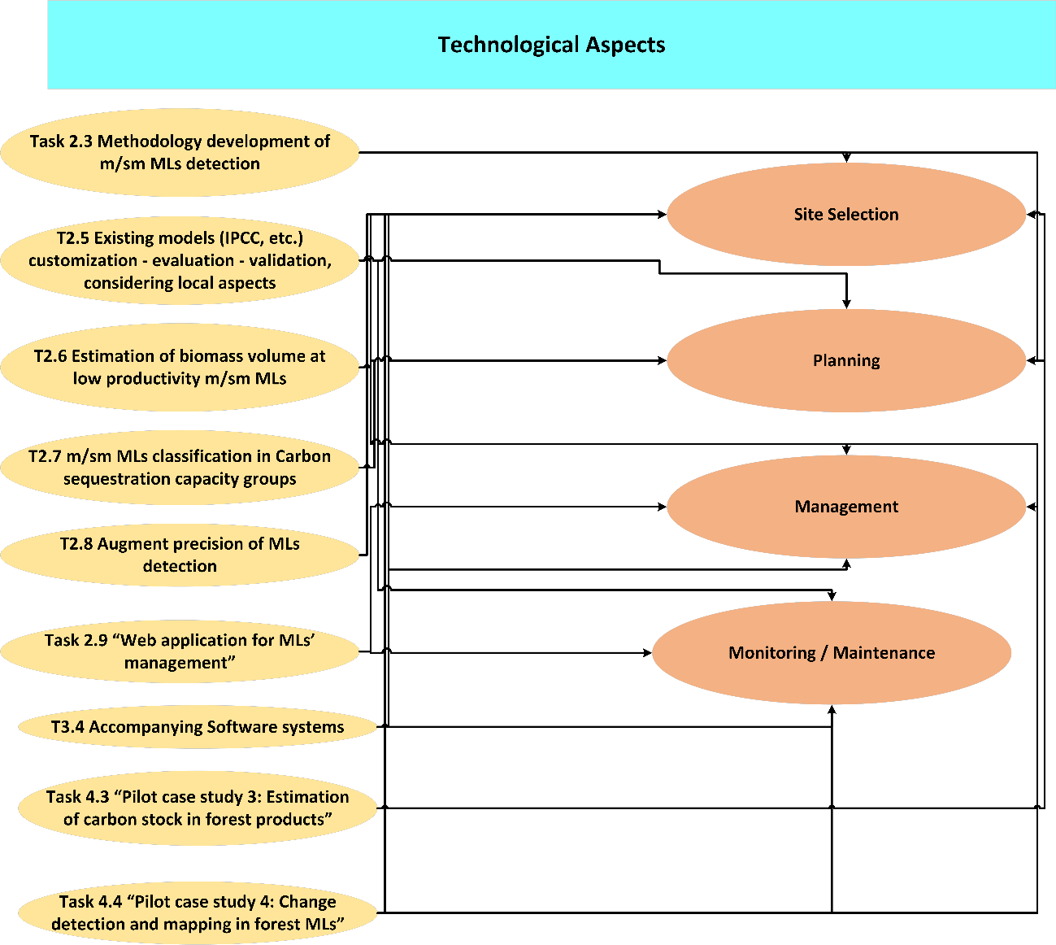
Figure 23 Technological aspects for the enhancement of sustainability
During the implementation of MAIL project is series of various technological tools and approaches has been developed. A brief presentation and analysis of the developed products and their use in the sustainability assessment is going to be presented in the following sections.

Marginal Land Detection
The detection of marginal land was the main objective of task 2.3 “Methodology development of s/sm MLs detection”. The work performed in this task provided the workflows and the methodology for the detection of marginal lands using existing land cover, land use layers and a series of indicators in order to detect potential marginal land in the European area. The result of this task is a pan European digital map implemented in a WebGIS that displays the potential marginal lands.
This map layer will be the starting point for a sustainability assessment. The potential marginal land layer can be used in combination with other existing local, regional, national, or European layers by interested parties (potential inventors) to identify areas of interested that are suitable for the implementation of afforestation projects or estimate a suitability metric.

Augmentation of marginal land identification
Task 2.8 “Augment precision of MLs detection” provided the tools and methodologies for the augmentation of marginal land detection. The developed methodology provides a workflow using free multi temporal satellite data to improve the detection of marginal lands.
The results of task 2.8 can be used in the selection of suitable areas for the implementation of an afforestation project. Following the preliminary selection of areas of interested using the maps produced in task 2.3 the methodology developed in task 2.8 will be applied to these areas in order to enhance the marginal land detection and provide additional information regarding their suitability to be used as carbon sinks.

Model for the estimation of sequestered carbon
During the implementation of task 2.5 “Existing models (IPCC, etc.) customization - evaluation - validation, considering local aspects” different models for the estimation carbon storage in different tree species were developed. The models take into account the above ground biomass, the below ground biomass, the litter, dead wood, and the soil organic carbon along with the local characteristics of an area in order to estimate the total sequestered carbon.
The developed models will be used for the estimation of biomass in an afforestation project but also for the estimation/prediction of the potential carbon storage capacity that an afforestation project can yield.
As a result, they can be used both in the planning phase and in the monitoring phase of an afforestation project.

Estimation of biomass volume
In task 2.6 “Estimation of biomass volume at low productivity m/sm MLs” algorithm and methodologies were developed for the estimation of biomass using SAR satellite images and LIDAR data. The developed approaches can be used to estimate the existing biomass in an implemented afforestation project, and thus the potential carbon sequestration achieved in the project. Such estimation can be produced every 3-5 years providing a powerful tool for the monitoring of an afforestation project.

Estimation of carbon stock in forest products
During the implementation of task 4.3 “Pilot case study 3: Estimation of carbon stock in forest products” a methodology and a tool for the estimation of carbon stock in forest products along with their degradation and life values was developed. The developed methodology and tools will be used for the assessment of carbon stock in produced forest products of an afforestation project. This tool can be used both during the planning and monitoring phase of an afforestation project.

Classification of MLs in carbon sequestration groups
Task 2.7 “m/sm MLs classification in Carbon sequestration capacity groups” produced a classification of the detected marginal lands in different carbon sequestration groups based on the following indicators ………………… The produced layer can be used in the selection of suitable areas, and tree species for the implementation of an afforestation project.

Change detection and mapping of forest marginal lands
Task 4.4 “Pilot case study 4: Change detection and mapping in forest MLs” developed an approach for the multi temporal monitoring and suitability assessment of marginal lands. The results of the task can be used during the implementation phase of an afforestation project and provide a powerful tool for the successful management of such a project.

Software systems
The following software….…………… was developed during the implementation of task 3.4 “Accompanying Software systems”. Tool xxxxx uses a set of rules to provide a short term forecast of trends relating to marginal lands and the progress of an implemented afforestation project. While tool xxxxxxx is a decision support system that can help with critical decisions during the management and implementation phase of a project using marginal lands as carbon sinks.

Web application for the management of MLs
Task 2.9 “Web application for MLs’ management” implemented a webgis service that will be able to produce thematic maps and provide information based on specific layers considering the management of marginal lands. The webgis tools include the following modules:
Xxxxx
Xxxx
xxxx
xxxx

References
- Agostini, A., Giuntoli, J., Boulamanti, A., & Marelli L. (2014). Carbon accounting of forest bioenergy: conclusions and recommendations from a critical literature review. Publications Office of the European Union. http://dx.doi.org/10.2788/29442.
- Beck, U. & Wilms, J. (2004). Conversations with Ulrich Beck. Cambridge: Polity Press. In Duran, C.D., Gogan, L.M., Artene, A. & Duran, V. (2015). The components of sustainable development - a possible approach. Procedia Economics and Finance, 26, 806-811.
- Copernicus, High Resolution Layers, HRL. (2012, 2015). Retrieved August 08, 2019, from https://land.copernicus.eu/pan-european/high-resolution-layers
- Duran, C.D., Gogan, L.M., Artene, A. & Duran, V. (2015). The components of sustainable development - a possible approach. Procedia Economics and Finance, 26, 806-811.
- FOREST EUROPE 7th Ministerial Conference Madrid 20-21 October 2015 Expert Level Meeting 30 June – 2 July 2015, Madrid, Spain. https://foresteurope.org/wp-content/uploads/2016/11/III.-ELM_7MC_2_2015_MinisterialDeclaration_adopted-2.pdf#page=5
- FOREST EUROPE, 2015: State of Europe’s Forests 2015 (https://www.foresteurope.org/docs/fullsoef2015.pdf)
- FOREST EUROPE, Liaison Unit Bratislava, 2019: Human Health and Sustainable Forest Management by, Marušáková Ľ. and Sallmannshoferet M., et al. FOREST EUROPE Study. ISBN 978 - 80 - 8093 - 266 – 4.
- Forest Europe, Resolution H1, 1993. Available at: www.foresteurope.org/docs/MC/MC_helsinki_resolutionH1.pdf (last accessed on 25.11.2019).
- Grassi, G., Cescatti, A., Matthews, R., Duveiller, G., Camia, A., Federici, S., … Vizzarri, M. (2019). On the realistic contribution of European forests to reach climate objectives. Carbon Balance and Management, 14(1), 8. https://doi.org/10.1186/s13021-019-0123-y
- Harwood, R.R. (1990). The history of sustainable agriculture. In C.A. Edwards et al. (Eds.). Sustainable Farming Systems, (pp. 3-19). In Duran, C.D., Gogan, L.M., Artene, A. & Duran, V. (2015). The components of sustainable development - a possible approach. Procedia Economics and Finance, 26, 806-811.
- ITTO (1992). Criteria for the measurement of sustainable tropical forest management. International Tropical Timber Organization Policy Development. Series No. 3. Yokohama, Japan.
- IUCN, UNDP & WWF, International Union for Conservation of Nature and Natural Resources, United Nations Environmental Programme & World Wildlife Fund (1991). Caring for the Earth. A Strategy for Sustainable Living.
- Lele, S.M. (1991). Sustainable development: A Critical Review. World Development, 19(6), 607-621. DOI: 10.1016/0305-750X(91)90197-P.
- Marin, C., Dorobanțu, R., Codreanu, D. & Mihaela, R. (2012). The Fruit of Collaboration between Local Government and Private Partners in the Sustainable Development Community Case Study: County Valcea. Economy Transdisciplinarity Cognition, 2, 93–98. In Duran, C.D., Gogan, L.M., Artene, A. & Duran, V. (2015). The components of sustainable development - a possible approach. Procedia Economics and Finance, 26, 806-811.
- Meadows, D.H. (1998). Indicators and Information Systems for Sustainable Development. A report to the Balaton Group 1998. The Sustainability Institute.
- O’Driscoll, D. (2018). Carbon Abatement Potential of Reforestation. K4D Helpdesk, Brighton, UK: Institute of Development Studies.
- Pan European Guidelines for Afforestation and Reforestation with a special focus on the provision of the UNFCCC, 2008. https://www.foresteurope.org/docs/other_meetings/2008/Geneva/Guidelines_Aff_Ref_ADOPTED.pdf
- PAP/RAC, Priority Actions Programme, in framework of Regional Activity Centre Mediterranean Action Plan (1999). Coastal Area Management Programme (CAMP) Fuka-Matrouh – Egypt. Carrying capacity assessment for tourism development. Split: Regional Activity Centre.
- Pearce, D. (1989). Tourism Development. London: Harlow.
- Siry, J.P, Cubbage, F.W & Newman, D.H. 2009: Global Forest Ownership: Implications for Forest Production, Management and Protection. In: Proceedings of the XIII World Forestry Congress (18-23 Oct. 2009), Buenos Aires, Argentina.
- Sterling, S. (2010). Learning for resilience, or the resilient learner? Towards a necessary reconciliation in a paradigm of sustainable education. Environmental Education Research, 16, 511-528. DOI: 10.1080/13504622.2010.505427.
- Vander-Merwe, I. & Van-der-Merwe, J. (1999). Sustainable development at the local level: An introduction to local agenda 21. Pretoria: Department of environmental affairs and tourism. In Duran, C.D., Gogan, L.M., Artene, A. & Duran, V. (2015). The components of sustainable development - a possible approach. Procedia Economics and Finance, 26, 806-811.
- Vare, P. & Scott, W. (2007). Learning for a change exploring the relationship between educationand sustainable development. Journal of Education for Sustainable Development, 1, 191-198.
- WCED, United Nations World Commission on Environment and Development (1987). Our Common Future. Retrieved November 5,2019 https://sustainabledevelopment.un.org/content/documents/5987our-common-future.pdf.

Annex II: Table of figures
This is for the table of figures
Figure 1 Potential Marginal lands in Europe 23
Figure 2 Marginal Lands Carbon sequestration capacity groups classification 24
Figure 3 Sustainable development assessment workflow 24
Figure 4 Sentinel spatial resolution (SENTINEL-2 10 m spatial resolution bands: B2 (490 nm), B3 (560 nm), B4 (665 nm) and B8 (842 nm) top, SENTINEL-2 20 m spatial resolution bands: B5 (705 nm), B6 (740 nm), B7 (783 nm), B8a (865 nm), B11 (1610 nm) and B12 (2190 nm), middle, SENTINEL-2 60 m spatial resolution bands: B1 (443 nm), B9 (940 nm) and B10 (1375 nm) , bottom), source ESA 26
Figure 5 Financial sustainability assessment 29
Figure 6 IHS Markit Global Carbon Index (USD) (Source: https://indices.ihsmarkit.com/Carbonindex) 31
Figure 7 Total value of marketed non-wood goods (Source: Forest Europe, 2015) 32
Figure 8 Classification of European Countries per region according to The Europe forest, 2015 (Source: Forest Europe, 2015) 34
Figure 9 Total reported value of marketed NWGs accounted for by plant products (in percent) (Source: Forest Europe, 2015) 34
Figure 10 Shares of total value of marketed NWGs accounted for by animal products; absolute values specified in EUR 1,000 (Source: Forest Europe, 2015) 35
Figure 11 Total value of marketed services (Source: Forest Europe, 2015) 37
Figure 12 Proportion of marketed services provided by reporting countries (Source: Forest Europe, 2015) 38
Figure 13 Social aspects of sustainability 41
Figure 14 Forest ownership in Europe (Source: Forest Europe, 2015) 46
Figure 15 Area of privately owned forest as a percentage of total forest (2010) (Source: Forest Europe, 2015) 46
Figure 16 Distribution of forest area in 2010 by ownership classes and region (Forest Europe, 2015) 47
Figure 17 Private forest area 1990 - 2010 by region (Forest Europe, 2015) 47
Figure 18 Forest employment distribution (Source: Forest Europe, 2015) 47
Figure 19 Development of forest-related employment from 2000-2010 (Forest Europe, 2015) 48
Figure 20 Environmental aspects of sustainability 50
Figure 21 Issues covered by the main policy objectives relating to protective forests and other wooded land for the period 2011-2014 (Source: Forest Europe, 2015) 57
Figure 22 Area of protected forest (1,000 ha) in Europe by MCPFE class (1.1–1.3 and 2) in 2000, 2010 and 2015 (based on available data) (Source: Forest Europe, 2015) 60
Figure 23 Technological aspects for the enhancement of sustainability 63

Annex III: List of Tables
Table 1 Overview of activities connected to the sustainable development concept (Source: Tomislav K., 2018) 9
Table 2 Overview of the sustainable development meaning in the period 1987-2015 (Source: Tomislav K., 2018) 10
Table 3 Forest Policy and governance Indicators. (Source: Forest Europe 7th Ministerial Conference, 2015) 14
Table 4 SFM Pan European Criteria and Indicators (Source: Forest Europe 7th Ministerial Conference, 2015) 17
Table 5 Pan European Guidelines for Afforestation and reforestation projects. (Source: Pan European Guidelines for Afforestation and Reforestation with a special focus on the provision of the UNFCCC, 2008) 21
Table 6 Legal regulatory instruments of EU and further non legally binding instruments related to forests (Source: Forest Europe, 2015) 23
Table 7 Implementation costs for an afforestation project 30
Table 8 Value of marketed NWGs (Source: Forest Europe, 2015) 35
Table 9 Quantity and value of different types of marketed animal products (Source: Forest Europe, 2015) 36
Table 10 Average value of the marketed services per hectar for countries that reported positive values for the various service (Source: Forest Europe, 2015) 36
Table 11 Definition of forest services (Source: Forest Europe, 2015) 38
Table 12 Total values for other marketed forest ecosystem services reported by country groups (Source: Forest Europe, 2015) 39
Table 13 Potential Sources of Income 40
Table 14 Generic Financial Assessment 40
Table 15 Area with public access and area managed for recreational use by region (Forest Europe, 2015) 48
Table 16 Forest land reported for the protection of soil, water and other ecosystem services in 2015 by region (Source: Forest Europe, 2015) 56
Table 17 Share (percentage and million ha) of forest area (uneven-aged and even-aged) by regeneration types in the European regions, 2010 (based on the available data) (Source: Forest Europe, 2015) 58
Table 18 Numbers of threatened forest-occurring tree species, birds, mammals, other vertebrates, other invertebrates, vascular plants and fungi (number of reporting countries: 30) (Source: Forest Europe, 2015) 59
Table 19 Numbers of extinct forest-occurring tree species, birds, mammals, other vertebrates, other invertebrates, vascular plants and fungi by regions, EU 28 and Europe (number of reporting countries: 45) (Source: Forest Europe, 2015) 60
Table 20 Selected objectives of the EU biodiversity strategy to 2020 relevant to forests 61

R = Report, P = Prototype, D = Demonstrator, O = Other
PU = Public, PP = Restricted to other programme participants (including the Commission Services), RE = Restricted to a group specified by the consortium (including the Commission Services), CO = Confidential, only for members of the consortium (including the Commission Services).
http://www.fao.org/forestry/sfm/85084/en/
Requires to be further developed and checked under which Criterion (2 or 5) better fits
Requires to be further developed and tested.
Requires further development and testing for consideration.
https://ec.europa.eu/info/news/commissioner-hogan-announces-1-hectare-initiative-forestry-conference-2019-apr-25_en
https://sentinel.esa.int/web/sentinel/user-guides/sentinel-2-msi/overview
https://sentinel.esa.int/web/sentinel/user-guides/sentinel-2-msi/resolutions/spatial
https://sentinel.esa.int/web/sentinel/user-guides/sentinel-2-msi/product-types/level-1c
Excluding the Russian Federation
The information is not summarized for South-West Europe as the reported data cover less than 5% of the region’s total Forest and Other Wooded Land (FOWL).
Threatened forest-occurring species include the IUCN Red List categories “vulnerable”, “endangered” and “critically endangered”.

