

|  |  |
| --- | --- |
| D6.1 | Report on Info days, Newsletters and dissemination activities: events participation, proceedings of the final conference |
|  | |
| **MAIL**: Identifying Marginal Lands in Europe and strengthening their contribution potentialities in a CO2 sequestration strategy | |

MAIL project has received funding from the European Union’s Horizon 2020 research and innovation programme under the Marie Skłodowska-Curie grant agreement No 823805; [H2020 MSCA RISE 2018]

|  |  |
| --- | --- |
| Project title | Identifying Marginal Lands in Europe and strengthening their contribution potentialities in a CO2 sequestration strategy |
| Call identifier | H2020 MSCA RISE 2018 |
| Project acronym | MAIL |
| Starting date | 01.01.2019 |
| End date | 31.31.2021 |
| Funding scheme | Marie Skłodowska-Curie |
| Contract no. | 823805 |
|  | |
| Deliverable no. | 6.1 |
| Document name | MAIL_D6.1.pdf |
| Deliverable name | Report on Info days, Newsletters and dissemination activities: events participation, proceedings of the final conference |
| Work Package | WP6 |
| Nature[1] | Report |
| Dissemination[2] | PU |
| Editor | Charalampos Georgiadis (AUTH) |
| Authors | Michał Krupiński (CBK PAN), Edyta Woźniak (CBK PAN) |
| Contributors | All consortium partners |
| Date | 30.12.2021 |

# MAIL Consortium

|  |  |
| --- | --- |
| Aristotle University of Thessaloniki (AUTH) Greece | Industrieanlagen Betriebsgesellschaft MBH (IABG) Germany |
| Gounaris N. – Kontos K. OE (HOMEOTECH) Greece | Centrum Badan Kosmicznych Polskiej Akademii Nauk (CBK PAN) Poland |
| Universitat Politecnica de Valencia (UPV) Spain | Fundacion Centro De Servicios Y Promocion FOrestral Y de su Industria De Castilla y Leon (CESEFOR) Spain |

# Abbreviations

|  |  |
| --- | --- |
| **Term** | **Explanation** |
| **MLs** | Marginal Lands |
| **LULUCF** | Land Use, Land-Use Change & Forestry |
| **EU** | European Union |
| **EC** | European Commission |
| **EO** | Earth Observation |
| **KPI** | Key Performance Indicator |

Contents

MAIL Consortium 3

Abbreviations 4

Executive Summary 6

1. Introduction 6

2. Communication channels 6

3. Project website 6

4. Social media 9

5. Newsletters 13

6. Press releases 15

7. Scientific publications 17

8. events organization 18

8.1 Workshops 19

8.2 Final Conference 20

9. Participation in events 20

10. Key Performance Indicators 21

Annex I: Table of Figures 23

Annex II: List of Tables 24

# Executive Summary

The scope of this report is to describe all the activities related to dissemination of the MAIL project. It contains information about project website, social media accounts, events organized by project consortium and events where MAIL project was presented. Finally, the Key Performance Indicators – planned and achieved are compared.

# Introduction

The principal objective of the MAIL project is to induce the utilization of MLs as potential Carbon Sinks, to increase sequestration of CO2 in the LULUCF sector without any impact on agri-food sector. To increase the impact and to achieve the highest visibility of MAIL project accurate dissemination, communication and exploitation plans are needed. Dissemination, communication and exploitation activities will add value to the project with the scope to achieve a multiplying effect and sustainable impact (i.e. sustainable cooperation links/ bonds with stakeholders) in relation with project results. These activities will be carried out during and after the project’s lifetime.

# Communication channels

Various communication channels have been established to disseminate the progress and the results of MAIL project. The main platform for these activities was dedicated project website: <http://marginallands.eu>. Moreover, social media platforms like twitter, Facebook, Instagram and YouTube were used.

# Project website

Project website was developed and maintained by one of project partners – HOMEOTECH. It was regularly updated to provide all news related with project activities. Some sections had constant content and included information about:

* Project: Overview, Objectives, Methodology, Expected Impact
* Partners: AUTH, HOMEOTECH, UPV, IABG, CBK PAN, CESEFOR
* Dissemination: Deliverables, Media, Events
* MOOC
* MAIL Map Portal
* Contact

The website had also dedicated space restricted for consortium partners, were all relevant files were stored. During the whole project lifetime, the website reached more than 43 thousand of unique visitors. More detailed statistics are presented on Figure 2, Figure 3 and Figure 4.

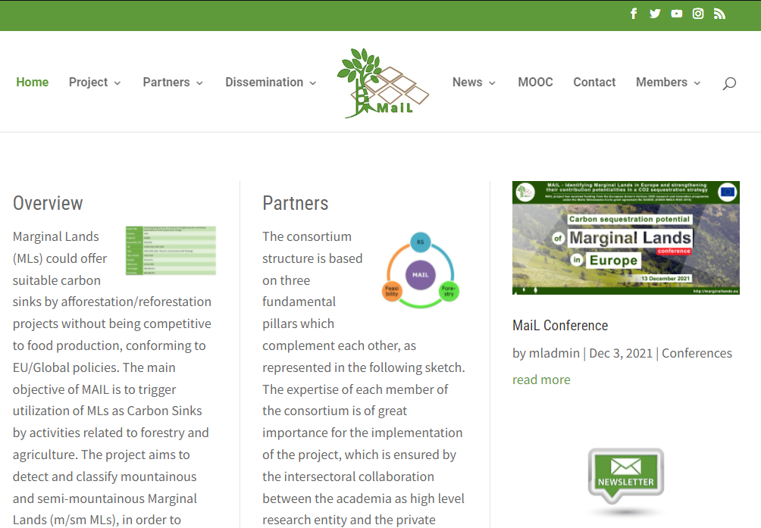

Figure 1. Main page of MAIL project website.

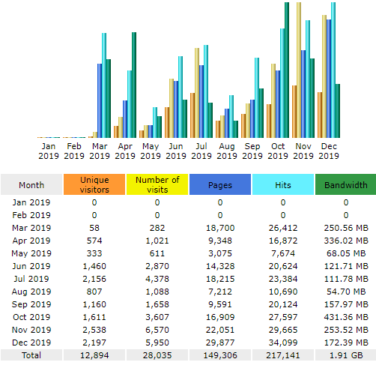

Figure 2. Number of visits on MAIL project website in 2019.

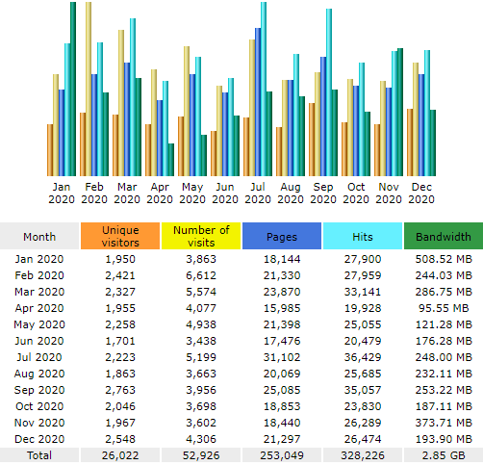

Figure 3. Number of visits on MAIL project website in 2020.

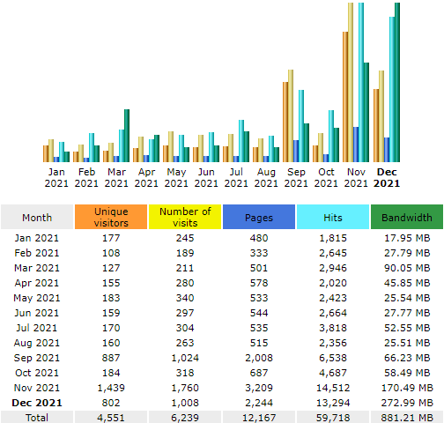

Figure 4. Number of visits on MAIL project website in 2021 [values until 29.12.2021].

# Social media

MAIL project accounts were created on four different platforms:

* Facebook: <https://www.facebook.com/MarginalLands/>
* Twitter: <https://twitter.com/MarginalLands>
* Instagram: <https://www.instagram.com/marginal_lands/>
* YouTube: <https://www.youtube.com/channel/UCbgyJ_cZ03V0KE4jU5QZaDw>
* Research Gate: <https://www.researchgate.net/project/MAIL-Identifying-Marginal-Lands-in-Europe-and-strengthening-their-contribution-potentialities-in-a-CO2-sequestration-strategy>

Each of them offers different parameters related to users’ activities, like parameter called “reach” on Facebook. It is defined as a number of people who have seen a post, at least once. Figure 5 presents five posts which scored the highest value of reach parameter on MAIL project Facebook profile. In case of twitter, number of “Impressions” is counted, which means also number of times when the tweet was seen. Figure 7 presents top 5 tweets published MAIL project twitter account within last 3 months of the project. Analytics provided by twitter allow to analyse maximum 90 days periods at once. Most of top tweets from this period is related with final workshop and conference of MAIL project. Twitter was the most frequently used from all social media profiles created for MAIL project. During 3 years, MAIL tweets reached more than 80 thousands of views.

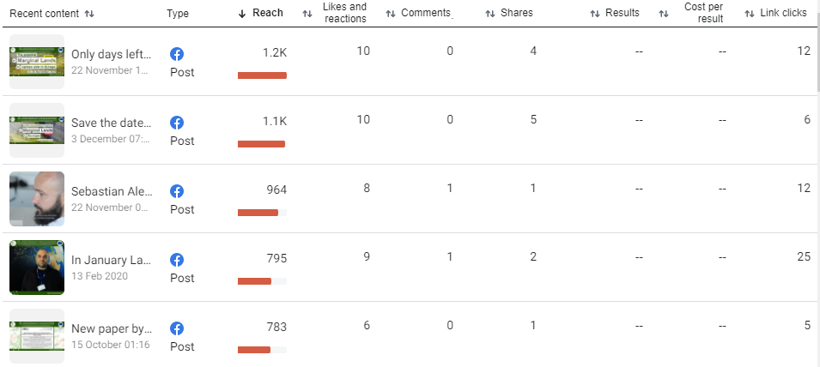

Figure 5. Top 5 posts on Facebook according to reach parameter value.

In some cases, the insight about audience contain information about age and gender, for example on Instagram (Figure 8). All parameters and values reached by MAIL project are summarized in Table 1.

YouTube channel was used mostly to publish and disseminate the testimonial videos which were recording during each of secondments. Testimonial videos present Secondee who describes his/her tasks performed during secondment and shares his/her experience about cooperation with hosting organization. In total, 55 videos were published during 3 years of the project. Besides testimonial videos, YouTube channel was also used to share the recordings of online events, like workshop and final project conference. All materials were seen almost 3 thousand times, mostly (81%) by unsubscribed users.

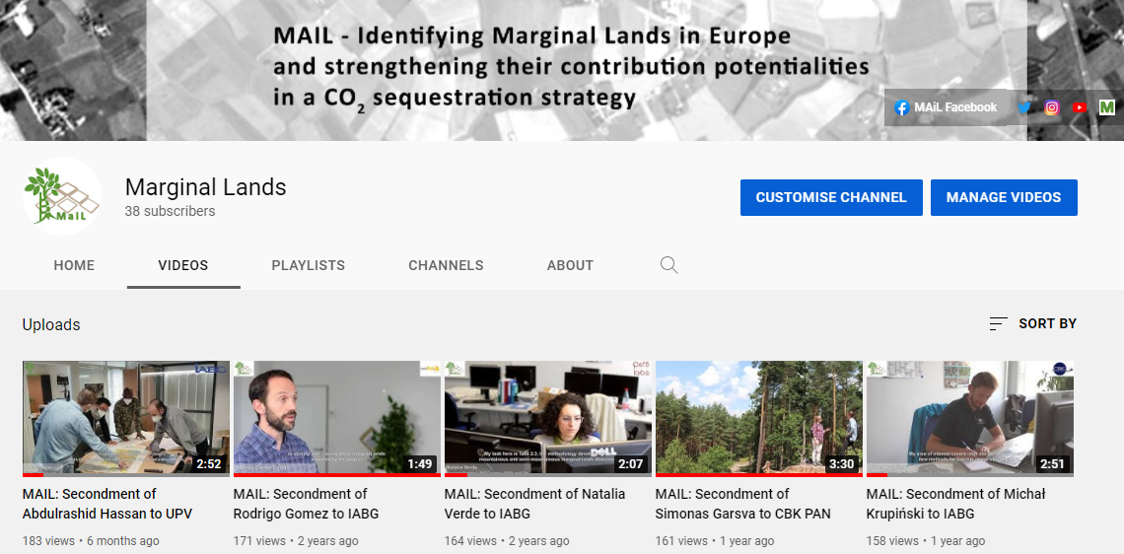

Figure 6. MAIL project YouTube channel.

|  |  |
| --- | --- |
| **Platform** | **Analytics** |
| Facebook | Facebook Page reach: 2,637  Facebook Page likes: 97 |
| Twitter | Followers: 551  Impressions: 81,900 (2019: 11.9k 2020:45.1k 2021: 24.9k) |
| Instagram | Instagram Followers: 133 |
| YouTube | Published videos: 55  Views: 2,945  Time of watching: 43.5h  Subscribers: 38 |
| Research Gate | Followers: 3  Reads: 43 |

Table 1. Summary of outreach gained with various social media accounts of MAIL project.

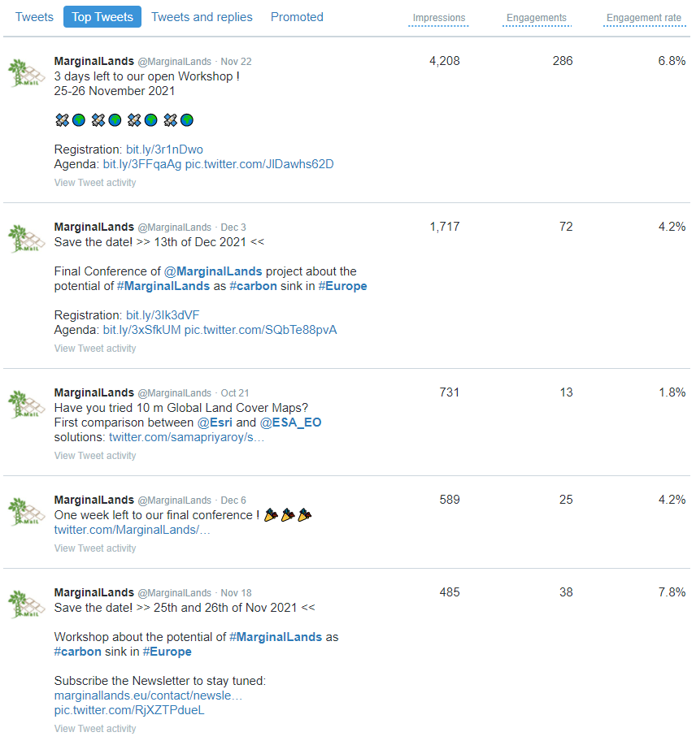

Figure 7. Top 5 tweets of MAIL project twitter profile within last 3 months.

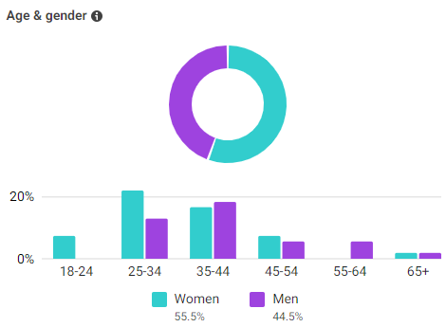

Figure 8. Instagram followers insight.

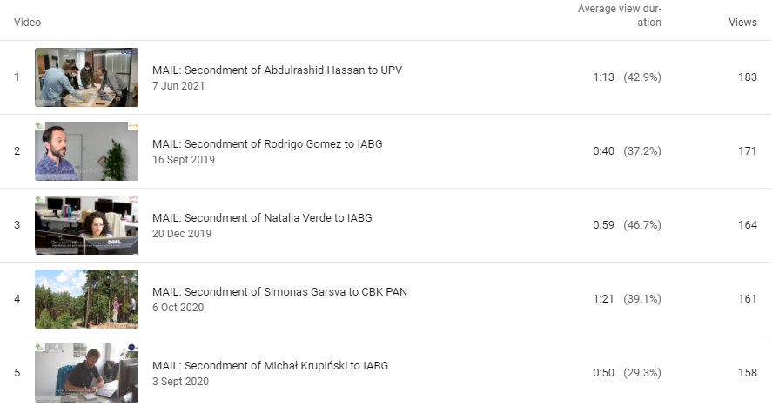

Figure 9. Top 5 YouTube videos on MAIL project channel.

# Newsletters

Six issues of online MAIL project newsletters have been prepared and distributed within the project lifetime. Each issue was prepared in English and translated into Greek, German, Spanish and Polish to facilitate the outreach by various user groups from countries of consortium partners. All issues followed the same template designed for the first issue: few pages A4 with three colours (#225204, #5e4405, #570518). Examples of the first issue is on Figure 10. The main characteristics and links to all issues are gathered in Table 2.

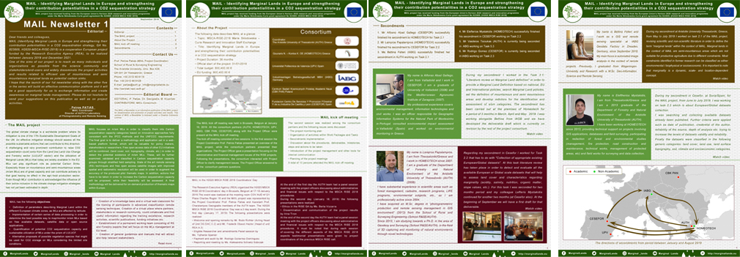

Figure 10. Example of the first issue of MAIL project Newsletter.

|  |  |  |  |
| --- | --- | --- | --- |
| **Issue** | **Publication date** | **Content** | **Pages** |
| [1](http://marginallands.eu/1st-newsletter/) | September 2019 | Editorial, project overview, project objectives, project kick-off meeting, Secondments of Alfosno Abad Gallego (CESEFOR), Lampros Papalampros (HOMEOTECH), Bettina Felten (IABG), Elefterios Mystakidis (HOMEOTECH), Vasileios Tsioukas (AUTH), Rodrigo Gomez (CESEFOR) | 4 |
| [2](http://marginallands.eu/2nd-newsletter/) | February 2020 | Editorial, project overview, 1st Project Meeting, Definition of Marginal Lands, Datasets collection, Secondments of Rodrigo Gomez (CESEFOR), Anna Argyroudi (HOMEOTECH), Nikolaos Gounaris (HOMEOTECH), Vasileios Tsioukas (AUTH), Natalia Verde (AUTH), Charalampos Georgiadis (AUTH) | 5 |
| [3](http://marginallands.eu/3rd-newsletter/) | January 2021 | Editorial, project overview, Midterm review meeting, Secondments of Maria Tassopoulou (AUTH), Anastasios Stamnas (AUTH), Lampros Papalampros (HOMEOTECH), Eleni Loukaki Gkountara (HOMEOTECH), Simonas Garsva (IABG), Reawanth Ravindran (IABG), Jesus Torralba Perez (UPV), Michał Krupiński (CBK PAN), Ewa Gromny (CBK PAN), Sebastian Aleksandrowicz (CBK PAN), Juan Pedro Carbonell Ribera (UPV) | 6 |
| [4](http://marginallands.eu/4th-newsletter/) | September 2021 | Editorial, project overview, Map of Marginal Lands in Europe, Carbon stock estimation methods, Carbon sequestration potential, Secondments of Anna Argyroudi (HOMEOTECH), Abdulrashid Hassan (IABG), Jesus Torralba Perez (UPV), Michał Krupiński (CBK PAN), Mateus Mendes (IABG), Dzhaner Emin (IABG), Ewa Gromny (CBK PAN), Alfonso Abad (CESEFOR), Dissemination acvtities | 7 |
| [5](http://marginallands.eu/5th-newsletter/) | November 2021 | Editorial, project overview, MAIL MOOC, Dissemination, Secondments of Fernardo Bezares (CESEFOR), Marta Milczarek (CBK PAN), Ashwini Trivedi (IABG), Elisa Bender (IABG), Francisco Gallego (CESEFOR), Ino Vasileia Korompoki (HOMEOTECH), Samuel Nyarko (IABG), Eleni Loukaki Gkountara (HOMEOTECH), Archontoula Sakellariou (HOMEOTECH), Pablo Crespo Peremach (UPV) | 6 |
| [6](http://marginallands.eu/6th-newsletter/) | December 2021 | Editorial, project overview, Outcomes of the project, Final Workshop and Conference, Secondments of Nikolaos Gounaris (HOMEOTECH), Ino Vasileia Korompoki (HOMEOTECH), Lampros Papalampros (HOMEOTECH), Jesús Torralba Pérez (UPV), Juan Pedro Carbonell Rivera (UPV), Laura Martin Collado (CESEFOR), Eleftherios Mystakidis (HOMEOTECH), Marta Milczarek (CBK PAN), Ewa Gromny (CBK PAN), Michal Krupiński (CBK PAN), Ashwini Trivedi (IABG), Zoi Touludi (AUTH), Georgios Spanos (AUTH) | 7 |

Table 2. Summary of six MAIL project Newsletters.

# Press releases

Another form of dissemination were press releases about MAIL project. During 3 years, 24 of them (21 online and 3 printed) were published in English, Spanish, Greek and Polish. The full list with links is presented in Table 3.

|  |  |  |
| --- | --- | --- |
| **DATE** | **MEDIA** | **TITLE** |
| 20.04.2019 | Agencia ICAL | [Cesefor participa en una investigación para convertir las áreas desarboladas en bosques sumideros de carbono](http://www.icalnews.com/Mostrar.cfm/noticias/I/cesefor/participa/investigacion/convertir/areas/desarboladas/bosques/sumideros/carbono/454595) |
| 22.04.2019 | El Mundo. Heraldo-Diario de Soria | Convertir áreas desarboladas en bosques sumideros de carbon [printed] |
| 23.04.2019 | diariodeleon.es | [Oportunidad en los árboles](https://www.diariodeleon.es/noticias/innova/oportunidad-arboles_1329948.html) |
| 17.05.2019 | Newsletter Indforma | [Nuevas tecnologías para la lucha contra el cambio climático en tierras marginales](http://cesefor.com/noticias/nuevas-tecnologias-para-la-lucha-contra-el-cambio-climatico-en-tierras-marginales) |
| 03.06.2019 | sorianoticias.com | [Cesefor inicia un nuevo proyecto europeo contra el cambio climático](http://sorianoticias.com/noticia/2019-06-03-cesefor-inicia-un-nuevo-proyecto-europeo-cambio-climatico-58781) |
| 03.06.2019 | desdesoria.es | [Tecnologías para la lucha contra el cambio climático en tierras marginales, nuevo proyecto de Cesefor](https://www.desdesoria.es/2019/06/03/tecnologias-para-la-lucha-contra-el-cambio-climatico-en-tierras-marginales-nuevo-proyecto-de-cesefor/) |
| 03.06.2019 | elmirondesoria.es | [Nuevo proyecto europeo para Cesefor](https://elmirondesoria.es/soria/capital/nuevo-proyecto-europeo-para-cesefor) |
| 03.06.2019 | eldiadezamora.es | [Nuevas tecnologías para la lucha contra el cambio climático en tierras marginales](http://eldiadezamora.es/art/19284/nuevas-tecnologias-para-la-lucha-contra-el-cambio-climatico-en-tierras-marginales) |
| 03.06.2019 | campocyl.es | [Nuevas tecnologías para combatir el cambio climático en tierras marginales](https://www.campocyl.es/category/sector/nuevas-tecnologias-para-combatir-el-cambio-climatico-en-tierras-marginales/) |
| 03.06.2019 | zamoranews.com | [Nuevas tecnologías para la lucha contra el cambio climático en tierras marginales](https://zamoranews.com/castilla-y-leon/item/45128-nuevas-tecnologias-para-la-lucha-contra-el-cambio-climatico-en-tierras-marginales) |
| 04.06.2019 | energetica21.com | [Nuevo proyecto para incrementar la absorción de CO2 en tierras marginales de Europa](http://www.energetica21.com/noticia/nuevo-proyecto-para-incrementar-la-absorcion-de-co2-en-tierras-marginales-de-europa) |
| 04.06.2019 | agronewscastillayleon.com | [Nuevas tecnologías para la lucha contra el cambio climático en tierras marginales](https://www.agronewscastillayleon.com/nuevas-tecnologias-para-la-lucha-contra-el-cambio-climatico-en-tierras-marginales) |
| 06.06.2019 | El Mundo. Heraldo-Diario de Soria | Jaque al cambio climático en tierras marginales [printed] |
| 18.06.2019 | Boletín COIM. Número 91 | [Nuevas tecnologías para combatir el cambio climático en tierras marginales](https://www.ingenierosdemontes.org/boletines/20190618.html) |
| 24.06.2019 | Newsletter EFIMed | [New technologies to fight climate change in marginal lands](https://medforest.net/2019/06/24/new-technologies-to-fight-climate-change-in-marginal-lands/) |
| 13.09.2019 | Newsletter Indforma | [Cesefor desarrolla en Alemania un proyecto de investigación para la detección automática de áreas potenciales para forestaciones masivas](http://cesefor.com/noticias/cesefor-desarrolla-en-alemania-un-proyecto-de-investigacion-para-la-deteccion-automatica-de) |
| 17.09.2020 | Newsletter Indforma | [Comienzan los estudios de clasificación de tierras marginales como potenciales sumideros de carbono](http://www.cesefor.com/noticias/comienzan-los-estudios-de-clasificacion-de-tierras-marginales-como-potenciales-sumideros-de) |
| 16.07.2020 | desdesoria.es | [El CEDER coordina un proyecto europeo para la obtención de bioproductos en tierras marginales](https://www.desdesoria.es/2020/07/16/el-ceder-coordina-un-proyecto-europeo-para-la-obtencion-de-bioproductos-en-tierras-marginales/) |
| 16.07.2020 | elmirondesoria.es | [El Céder coordina proyecto europeo sobre bioproductos](https://elmirondesoria.es/soria/capital/el-ceder-coordina-proyecto-europeo-sobre-bioproductos) |
| 16.07.2020 | TVE edición CyL | [El CEDER de Lubia (Soria) y el CESEFOR de Castilla y León colaborarán en el proyecto europeo BeonNAT, dotado con 5 millones de euros para potenciar el valor añadido de la biomasa.](https://twitter.com/RTVEcyl/status/1283841329743761408?s=20) |
| 16.07.2020 | sorianoticias.com | [Europa pone 5M€ para obtener rendimiento de tierras marginales y el Ceder de Lubia coordina el proyecto](https://sorianoticias.com/noticia/2020-07-16-el-ceder-lubia-coordina-un-proyecto-europeo-que-pretende-sacar-rendimiento-tierras-marginales-69699) |
| 17.07.2020 | El Mundo - Diario de Soria | CEDER y Cesefor aúnan fuerzas en un proyecto de 5,6M€ para cultivos alternativos rentables [printed] |
| 11.02.2021 | Space24 | [Wspieranie natury w usuwaniu CO2. Nieużytki rolne a zmiany klimatu](https://space24.pl/nauka-i-edukacja/wspieranie-natury-w-usuwaniu-co2-nieuzytki-rolne-a-zmiany-klimatu) |
| 24.11.2021 | dasarxeio.com | [Συνέδριο του έργου MaiL: “The potential of Marginal Lands as carbon sink in Europe”](https://dasarxeio.com/2021/11/23/105190/) |

Table 3. List of press releases about MAIL project.

# Scientific publications

The results of research performed within MAIL project, 5 scientific papers have been published – 2 papers and 3 conference papers:

Carbonell-Rivera, Juan Pedro, Estornell, Javier, Ruiz, Luis. Á., Torralba Pérez, Jesús & Crespo-Peremarch, Pablo (2020), *Classification of UAV-based photogrammetric point clouds of riverine species using machine learning algorithms: a case study in the Palancia river, Spain,* Int. Arch. Photogramm. Remote Sens. Spatial Inf. Sci., XLIII-B2-2020, XXIV ISPRS Congresse. 659–666 - [link](https://doi.org/10.5194/isprs-archives-XLIII-B2-2020-659-2020)

Carbonell-Rivera, Juan Pedro, Estornell, Javier, Ruiz, Luis. Á., Torralba Pérez, Jesús & Crespo-Peremarch, Pablo (2021), *Machine learning applied to the classification of riverine species using UAV-based photogrammetric point clouds*, First International Conference on Smart Geoinformatics Applications (ICSGA), 33-36 - [link](http://cgat.webs.upv.es/wp-content/uploads/2021/06/ICSGA-2021-Proceedings.pdf)

Torralba Pérez, Jesús, Ruiz, Luis Á., Georgiadis, Charalampos, Patias, Petros, Conejo, Rodrigo, Verde, Natalia, Tassopoulou, Maria, Bezares, Fernando, Gromny, Ewa, Aleksandrowicz, Sebastian, Krätzschmar, Elke, Krupiński, Michał & Carbonell-Rivera, Juan Pedro (2021), *Methodological proposal for the identification of marginal lands with remote sensing-derived products and ancillary data*, 3rd Congress on Geomatics Engineering, Valencia, Spain - [link](http://dx.doi.org/10.4995/CiGeo2021.2021.12729)

Carbonell-Rivera, Juan Pedro, Estornell, Javier, Ruiz, Luis Á., Abad, Alfonso, Felten, Bettina & Torralba Pérez, Jesús (2021), *A review of the use of remote sensing for monitoring and quantifying carbon sequestration in marginal lands*, 3rd Congress on Geomatics Engineering, Valencia, Spain – [link](https://dx.doi.org/10.4995/CiGeo2021.2021.12694)

Theofanous, Nikos, Chrysafis, Irene, Mallinis, Giorgos, Domakinis, Christos, Verde, Natalia & Siahalou, Sofia (2021), *Aboveground Biomass Estimation in Short Rotation Forest Plantations in Northern Greece Using ESA’s Sentinel Medium-High Resolution Multispectral and Radar Imaging Missions,* Forests 12, no. 7: 902 - [link](https://doi.org/10.3390/f12070902)

All of them are available via MAIL project profile on [Research Gate](https://www.researchgate.net/project/MAIL-Identifying-Marginal-Lands-in-Europe-and-strengthening-their-contribution-potentialities-in-a-CO2-sequestration-strategy) platform.

# events organization

According to the project proposal, in each consortium MS open short workshops were planned after the first year of the project. During project meetings consortium agreed that it is too soon to present the results and decided to postpone the workshops until 2020.

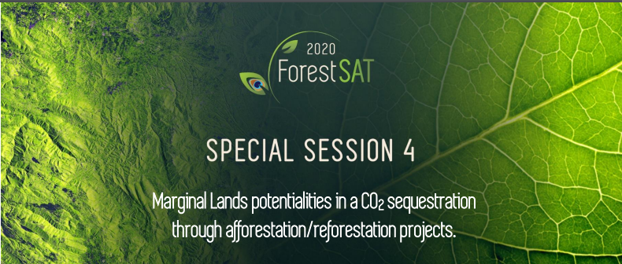

Figure 11. Dedicated session planned as a part of ForestSAT 2020 – the biggest international forestry conference.

Some of the workshops were planned as a part of bigger national and international events:

* dedicated session during ForestSAT 2020. Because of COVID-19 pandemic, the organizers of the conference postponed the whole event until 2022 (after the end of MAIL project duration).
* workshop for Spanish users during 8th Spanish Forest Congress 2020. Because of COVID-19 pandemic, the organizers postponed the event until 2021.
* Workshop for Polish users during Remote Sensing Conference 2020. Because of COVID-19 pandemic, the organizers postponed the event until 2021.

Another event planned for each consortium MS was a scientific conference in the last months of the project. I was organized online in December 2021.

## Workshops

To overcome different restrictions introduced by various countries and changing dynamically, consortium members decided to join national workshops into one final international workshops, were all users identified in MS9 from Greece, Germany, Spain and Poland were directly invited. The workshop was organized by UPV, online and divided into two days: 25th and 26th of November 2021.

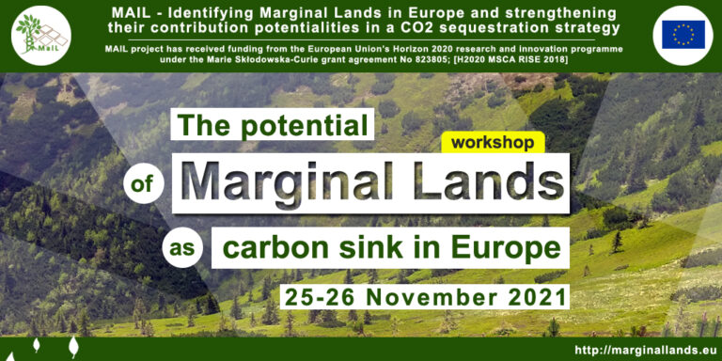

Figure 12. Banner prepared for social media with invitation for workshop.

During the first day, presentations given by consortium members and invited speakers were given. The second day was focused on practical presentation of solutions developed within MAIL project. More than 100 attendees participated in the event. All of them received digital certificate of participation afterwards.

Recordings of speeches are available on: [www.marginallands.eu/dissemination/media](http://www.marginallands.eu/dissemination/media).

All presentations are available on: <http://marginallands.eu/mail-workshop>.

More details about workshop can be found in Deliverable 3.2.

## Final Conference

The final scientific conference of MAIL project was organized online on 13th of December 2021 by AUTH. All presentations (17 in total) have been given by MAIL Secondees who were involved in specific tasks. There were 51 participants of the event.

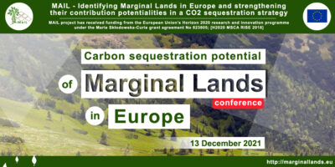

Figure 13. Banner prepared for social media with invitation for final conference.

Recordings of speeches are available on: [www.marginallands.eu/dissemination/media](http://www.marginallands.eu/dissemination/media).

All presentations are also available on the MAIL project website. More details about the final conference can be found in Deliverable 3.2.

# Participation in events

MAIL project was promoted also via presentations and posters on national (4 Jena, Copernicus DE, infoDay PL, CGEO) and international (2, ISPRS, DG_CLIMA) events. Three of them were scientific and three dedicated to the users.

|  |  |  |
| --- | --- | --- |
| **Date** | **Event** | **Activity** |
| 7.02.2020 | *20 Years of Remote Sensing at Friedrich-Schiller-University Jena* | Poster |
| 31.08-2.09.2020 | XXIV ISPRS Congress | Presentation – online |
| 23-24.03.2021 | *National Copernicus Day* in Germany | Poster – online |
| 31.03-1.04.2021 | Info Day for Polish users during *The Use of Satellite Data and Copernicus Programme in Administration and Private Sector* | Presentation – online |
| 15.06.2021 | *Developing Support for Monitoring and Reporting of GHG Emissions and Removals from Land Use, Land Use Change and Forestry* | Presentation – online |
| 7-8.07.2021 | *Tercer Congreso en Ingeniería Geomática* | 2 presentations – online |

Table 4. List of events and activities where MAIL project was presented.

# Key Performance Indicators

In the first moths of the project, Key Performance Indicators (KPIs) have been defined, together with values of success indicators. The summary of planned and reached scores is presented in Table 5.

|  |  |  |  |
| --- | --- | --- | --- |
| **KPI** | **Tool** | **Success indicators** | **Final score** |
| **KPI – 1** | MAIL webpage | >3000 accesses/year | >10 000/year |
| **KPI – 2** | Press echoes | 5 | 3 |
| **KPI – 3** | Online magazines and newspapers | 10 | 21 |
| **KPI – 4** | Journal publications | >5 | 5 |
| **KPI – 5** | MAIL participation in conferences | >5 | 6 |
| **KPI – 6** | MAIL organization of workshops | >5 | 1 |
| **KPI – 7** | MAIL on social media | >5 tweets/month | 48 tweets/month |
| **KPI – 8** | Co-operation with other initiatives | >2 | 2 |
| **KPI – 9** | MOOC participation | >30 persons | ? |

Table 5. Key Performance Indicators of MAIL project.

In four of nine KPIs, project consortium reached scores which overcome the planned success indicators. The big success of the project is that we managed to reach three times higher number of unique visitors on project website, than planned. Number of online press release (21) is double of planned score, but in the same time, we reached online 3 of planned 5 printed releases. Another big success is ten times higher number of tweets per months, than originally planned. It resulted in high number of Followers (>550) without any type of paid advertisements. We participated in 6 events, giving 7 presentations (or presenting posters) and organized one big international workshop instead of originally planned workshops in every consortium MS. We established informal cooperation with at least initiatives: EU project *MAGIC*, and FPA project - *Developing support for monitoring and reporting of GHG emissions and removals from land use, land use change and forestry*. Only the number of MOOC participants in not known in December 2021, because MAIL MOOC is just being released.

# Annex I: Table of Figures

Figure 1. Main page of MAIL project website. 7

Figure 2. Number of visits on MAIL project website in 2019. 8

Figure 3. Number of visits on MAIL project website in 2020. 8

Figure 4. Number of visits on MAIL project website in 2021 [values until 29.12.2021]. 9

Figure 5. Top 5 posts on Facebook according to reach parameter value. 10

Figure 6. MAIL project YouTube channel. 11

Figure 7. Top 5 tweets of MAIL project twitter profile within last 3 months. 12

Figure 8. Instagram followers insight. 12

Figure 9. Top 5 YouTube videos on MAIL project channel. 13

Figure 10. Example of the first issue of MAIL project Newsletter. 13

Figure 11. Dedicated session planned as a part of ForestSAT 2020 – the biggest international forestry conference. 18

Figure 12. Banner prepared for social media with invitation for workshop. 19

Figure 13. Banner prepared for social media with invitation for final conference. 20

# 

# Annex II: List of Tables

Table 1. Summary of outreach gained with various social media accounts of MAIL project. 11

Table 2. Summary of six MAIL project Newsletters. 15

Table 3. List of press releases about MAIL project. 17

Table 4. List of events and activities where MAIL project was presented. 21

Table 5. Key Performance Indicators of MAIL project. 21

1. **R** = Report, **P** = Prototype, **D** = Demonstrator, **O** = Other
2. **PU** = Public, **PP** = Restricted to other programme participants (including the Commission Services), **RE** = Restricted to a group specified by the consortium (including the Commission Services), **CO** = Confidential, only for members of the consortium (including the Commission Services).