

D5.2 | Guide on the financial social and technical aspects of the sustainable development of MLs, and report on the potentialities of emerging stock exchange markets for carbon transactions and proposed policies.
  - MAIL: Identifying Marginal Lands in Europe and strengthening their contribution potentialities in a CO2 sequestration strategy

MAIL project has received funding from the European Union’s Horizon 2020 research and innovation programme under the Marie Skłodowska-Curie grant agreement No 823805; [H2020 MSCA RISE 2018]

Project title | Identifying Marginal Lands in Europe and strengthening their contribution potentialities in a CO2 sequestration strategy
Call identifier | H2020 MSCA RISE 2018
Project acronym | MAIL
Starting date | 01.01.2019
End date | 31.12.2021
Funding scheme | Marie Skłodowska-Curie
Contract no. | 823805
Deliverable no. | D5.2
Document name | MAIL_D5.2.pdf
Deliverable name | Guide on the financial social and technical aspects of the sustainable development of MLs, and report on the potentialities of emerging stock exchange markets for carbon transactions and proposed policies.
Work Package | WP5
Nature | R
Dissemination | CO
Editor | Dzhaner Emin (IABG), Charalampos Georgiadis (AUTH)
Authors | Charalampos Georgiadis (AUTH), Fernando Bezares Sanfelip (CESEFOR), Zoi Touloudi (AUTH), Francisco Gallego (CESEFOR), Vassilios Tsioukas (AUTH)
Contributors | All Project Partners
Date | 30.12.2021

MAIL Consortium
  Aristotle University of Thessaloniki (AUTH) Greece |   Industrieanlagen Betriebsgesellschaft MBH (IABG) Germany
  Gounaris N. – Kontos K. OE (HOMEOTECH) Greece |   Centrum Badan Kosmicznych Polskiej Akademii Nauk (CBK PAN) Poland
  Universitat Politecnica de Valencia (UPV) Spain |   Fundacion Centro De Servicios Y Promocion FOrestral Y de su Industria De Castilla y Leon (CESEFOR) Spain

Abbreviations
Term | Explanation
AAUs | Assigned Amount Units
ACCUs | Australian Carbon Credit Units
AEA | Annual Emission Allocations
AFOLU | Agriculture, Forestry and Other Land Use
ARR | Afforestation, Reforestation, and revegetation
ARP | Afforestation/Reforestation Project
CAP | Common Agricultural Policy
CAT | Climate Action Tracker
CBD | Convention on Biological Diversity
CDM | Clean Development Mechanism
CEC | Cation-Exchange Capacity
CEE | Central Eastern Europe
CER | Certified Emission Reduction
DEM | Digital Elevation Model
DOE | Designated Operational Entity
DOP | Domestic Offset Projects
DG CLIMA | Directorate General for Climate Action
DG JRC | Directorate
EAFRD | European Agricultural Fund for Rural Development
EC | European Commission
EFFIS | European Forest Fire Information System
EIAH | European Investment Advisory Hub
ER | Emission Reductions
ERDF | European Regional Development Fund
ERUs | Emission Reduction Units tone of CO2
EU | European Union
EUAs | European Union Allowances
EU ETS | European Union Emission Trading System
FAO | Food and Agriculture Organization of the United Nations
FCPF | Forest Carbon Partnership Facility
FISE | Forest Information System for Europe
FMP | Forest Management Plan
GDP | Gross Domestic Product
GEE | Google Earth Engine
GFCF | Gross Fixed Capital Formation
GHG | Greenhouse Gases
GS | Gold Standard
GSD | Ground Sampling Distance
GVA | Gross Value Added
HESC | Human Environment
ICAP | International Carbon Action Partnership
ICAO | International Civil Aviation Organization
INDC | Intended Nationally Determined Contribution
IPCC | Intergovernmental Panel on Climate Change
ITEA | International Emissions Trading Association
ITMO | Internationally Transferrable Mitigation Outcomes
ITTO | International Tropical Timber Organization
IUCN | International Union for Conservation of Nature
JI | Joint Implementation
JRC | Joint Research Centre
LAU | Local Administrative Units
LCl | Labour Cost level
LULUCF | Land Use, Land-Use Change and Forestry
MDG | Millennium Development Goals
MSI | Multispectral Instrument
MRV | Monitoring Reporting Verification
MtCO2e | Metric tons of carbon dioxide equivalent
NDC | Nationally Determined Contributions
NE | North Europe
NGO | Non-Governmental Organization
NWG | Non-Wood Goods
NWP | Non-Wood Products
OECD | Organization for Economic Co
PAP/RAC | Priority Actions Programme/Regional Activity Centre
PDD | Project Design Document
PEBLDS | Pan-European Biological and Landscape Diversity Strategy
PES | Paid for Ecosystem Services
PoA | Program of activities
PVC | Plan Vivo Certificate
QA/QC | Quality Assessment/Quality Control
RBCF | Results-Based Climate Financing
REDD+ | Reduce Emissions from Deforestation and forest Degradation
RMU | Removal Units
SBSTA | Subsidiary Body for Scientific and Technological Advice
SDGs | Sustainable Development Goals
SE | Southern Europe
SFM | Sustainable Forest Management
SoEF | State of Europe's Forests
SWD | Staff Working Document
tCO2e | Tonnes of carbon dioxide equivalent
TOA | Top Of Atmosphere
UN | United Nation
UNCCD | United Nations Convention to Combat Desertification
UNDP | United Nations Development Programme
UNEP | United Nation Environment Programme
UNESCO | United Nations Educational, Scientific and Cultural Organization
UNFCCC | United Nations Framework Convention on Climate Change
UNFF | United Nations Forum on Forests
USDA | United States Department of Agriculture
WCED | Western Cape Education Department
VCS | Verified Carbon Standard
VCU | Verified Carbon Unit
VER | Verified Emission Reduction
VVB | Validation and Verification Body
WE | Western Europe
WWF | World Wildlife Fund

Contents

MAIL Consortium 3
Abbreviations 4
Executive Summary 13
1. Introduction 16
2. Definitions and Terms in MLs and Carbon sequestration context 18
2.1. Sustainable development definition 18
2.2. Forest and carbon related sequestration definitions 21
2.3. Sustainable Forest Management 23
2.4. Sustainable forest management Criteria and Indicators 24
2.5. Pan European Guidelines for Afforestation and Reforestation 27
2.6. Funding 33
3. Methodology Development for assessing sustainable development of MLs as Carbon sinks 37
3.1. Area refinement 39
4. Eligibility Assessment 41
5. Financial Aspects of sustainability 42
6. Social Aspects of sustainability 53
7. Environmental Aspects of sustainability 62
8. Technological Aspects of sustainability 75
8.1. Marginal Land Detection 76
8.2. Augmentation of marginal land detection 76
8.3. Model for the estimation of sequestered carbon 76
8.4. Estimation of biomass volume 77
8.5. Estimation of carbon stock in forest products 77
8.6. Classification of MLs in carbon sequestration capacity groups 77
8.7. Change detection and mapping of forest marginal lands 77
8.8. Software systems 78
8.9. Web application for the management of MLs 78
9. Feasibility analysis 79
9.1. Economical afforestation model in Marginal Lands 83
9.1.1. Base Price Calculation 83
9.1.2. Data Collection and Discount Rates 83
9.2. Results of the economical model 85
9.3. Discussion 88
10. Analysis of identified sustainable development indicators and aspects in marginal lands 89
10.1. Data representation and normalization 96
10.2. Financial 97
10.2.1. Implementation plan (Costs) 97
10.2.2. Management Cost 99
10.2.3. Non wood products (Income) 101
10.2.4. Services (Income) 102
10.3. Social 103
10.3.1. Employment 104
10.3.2. Recreation 105
10.4. Environmental 105
10.4.1. Increase biodiversity 105
10.4.2. Erosion 107
10.4.3. Protective function 108
11. Increasing Carbon Sequestration Strategies 109
11.1. Sustainable raw wood and non-wood materials and products for a sustainable climate-neutrality 110
11.2. Skills development and empowerment for a sustainable forest-based bioeconomy 111
11.3. Protecting, restoring and enlarging EU’s forests to combat climate change 112
11.4. Afforestation and reforestation of biodiverse forests 113
11.4.1. Site Selection 113
11.4.2. Species Selection and Site Management 114
11.4.3. Long-Term Management of Carbon in Trees 116
11.5. Forest management 118
11.6. Forest monitoring, reporting and data collection 118
12. Carbon Trade Markets 121
12.1. Compliance Carbon Markets 122
12.1.1. History of Emission Trade Markets 123
12.1.2. Current compliance Emission’s Trade systems 124
12.2. Carbon Offsets 125
12.2.1. Clean Development Mechanism (CDM) 126
12.2.2. Joint Implementation (JI) 126
12.3. Voluntary Carbon Markets 128
12.3.1. What is a Carbon Voluntary Market? 128
12.3.2. Project developers, wholesalers, brokers, and retailers in voluntary markets 130
12.3.3. Problems of voluntary markets 130
13. EU commitment: Emissions Trading Scheme, effort sharing and LULUCF 132
13.1. EU Emission Trading System (EU ETS) 132
13.2. Effort sharing 140
13.3. LULUCF and United Nations Framework Convention on Climate Change (UNFCCC) 144
13.3.1. Reporting of the LULUCF sector 145
13.4. LULUCF and the Paris Agreement 148
13.5. LULUCF and CO₂ Emissions in the European Union 149
14. International and national carbon accounting standards in the LULUCF sector 154
14.1. Carbon accounting under UNFCCC 154
14.2. EU carbon accounting 157
14.3. Accounting emissions under the CDM 160
14.4. Voluntary Markets Accounting Standards 162
14.4.1. ACR 162
14.4.2. Plan Vivo 164
14.4.3. VERRA (old VCR) Standard 165
14.4.4. Gold Standard 166
14.4.5. Emissions Reduction Fund 166
14.4.6. Climate Action Reserve (Reserve) 168
14.4.7. Greenhouse gas protocol 170
14.4.8. The Panda standard 172
14.4.9. ISO 14064-1:2006 Greenhouse gases -- Part 1: Specification with guidance at the organization level for quantification and reporting of greenhouse gas emissions and removals 173
14.4.10. WWF report on forest carbon accounting standards 174
15. Carbon offset and absorption projects: public and private initiatives 176
15.1. Public initiatives 176
15.2. CDM Projects 178
15.3. Private initiatives - Voluntary Carbon Offset Projects 183
16. New methodologies and research not included in current standards 190
16.1. Carbon Offsetting and Reduction Scheme for International Aviation – CORSIA 190
17. Result-Based Climate Financing 192
17.1. UN REDD Program 193
17.2. Activities out of the box 194
18. Implementation of sustainable management for MLs 196
18.1. Carbon offset Projects 196
18.2. Implementation of offset Project 198
18.3. Carbon offset Programs 200
18.3.1. The Gold Standard 201
18.3.2. Plan Vivo 205
18.3.3. The Verified Carbon Standard 208
19. Future of voluntary carbon markets 210
References 212
Annex I: List of figures 229
Annex II: List of Tables 233
Annex III The ENDS Carbon Offset Providers Directory 236

Executive Summary
This document is a guide to the financial, social, environmental and technical aspects of Marginal Lands (MLs) sustainable development. Its purpose is to identify and analyse the indicators and aspects of sustainable development of MLs and to suggest development strategies to increase the carbon sequestration capacity in marginal lands. The second half of the document (Chapter 12 onwards) describes the potentialities of emerging stock exchange markets for carbon transaction and proposed policies There is plethora of definitions about sustainable development as well as definitions related to forest and carbon sequestration. Furthermore, criteria and indicators for forest sustainable management are listed. European guidelines for afforestation and reforestation and European and international programmes for Carbon Emission trading are described.
In order develop a methodology for assessing sustainable development of MLs as carbon sink, the selection of a suitable area for a carbon sequestration project is required. This area should be refined and the eligibility of the area should be assessed. Following the eligibility assessment, a final sustainability analysis should be conducted to determine whether the chosen location can be used to undertake a carbon sequestration project and create a long-term management strategy. The technological, financial, social, and environmental aspects of the project's implementation must be considered in the final assessment and management plan. The technological component encompasses all parts of the sustainability assessment and management plan, giving insight and tools to aid in the design and implementation of a sustainable management plan.
An Economical afforestation model is developed in this task based on specific factors indicating a European average price of 11,000 euros for planting one thousand trees in one hectare.
Moreover, a temporal analysis of the sustainability variables using Eurostat as the database reference to reflect those key variables was undertaken. Once related each variable with a dataset we evaluated the evolution of each variable/indicator over time for four European regions: Northern Europe, central- Eastern Europe, southern Europe and Western Europe.
Concerning the strategies for increasing carbon sequestration, the forest plantation should occur in the correct area. The land cover, the geomorphology and the soil properties are some of the factors that should be considered. The species selection is also a critical strategy to consider as well as the long-term management and the monitoring of the afforested area.
Giving a price on the effects from the use of fossil fuels releasing CO₂ and other greenhouse gases (GHG) into the atmosphere was one of the most important actions of the United Nations (UN) joint action to tackle the problem of global warming. International conventions, notably the Kyoto Protocol and the Paris Agreement, have established the foundations for the principle of recording both GHG emissions from large industrial installations and many polluting human activities in order to be offset by their absorption from the natural environment processes and mainly from forests.
Experts have set the goal of reducing the planet's temperature by 1.5ºC compared to a past reference year, and most parts of the UN have accepted their responsibility. The first steps to tackle Climate Change were carbon pricing. Climate Change cannot be mitigated unless the economic consequences of offsetting the negative impact of fossil fuels is not calculated. Thus, any process that produces CO₂ emissions must record what amount (in absolute values) of CO₂ or other GHG generates in order to be sequestrated by Offset Projects. One such action is tree planting but not so simplistic as it seems. Carbon markets were created to trade CO₂ emissions or in other words allowances to produce CO₂ emissions equal to those sequestrated from the atmosphere by other procedures. These procedures (Carbon Offset Projects) can therefore permit emissions and can be investment or ecological actions such as tree planting. Reforestation that mitigates CO₂ emissions can be applied to Marginal Lands.
The latter part of this document (MAIL Task 5.3 Chapter 12 onwards) deals with existing carbon markets. The carbon markets are divided into two categories. The compliance or obligatory and the voluntary markets. The compliance markets began after the Kyoto Protocol and the first to be created with the most significant emission rate covered is the European Trade System (ETS). The operation of markets is based on cap-and-trade concept. Each industry or polluting entity has a cap for a certain amount of emissions and if it exceeds this cap, they must purchase the respective allowances from someone else who has not exceeded their allowances. In case of non-compliance, the state imposes fines. The operating conditions of the markets vary from country to country, as well as the cost of a metric unit which is a ton of equivalent CO₂ (tCO₂e). The prices for 1 tCO₂e is varying among the separate public entities who are running the markets. The average price for 1 tCO₂e is currently about 14.51€/tCO₂e and at the last update of September 2021 the price was 64,32€/tCO₂e (ICAP,2021). Specialists from all around the world have calculated that the price of 40$/tCO₂e is the minimum to achieve the Paris Agreement reduction of the temperature by 1.5ºC. It is described below the concept of Carbon Offset Projects as well as the Kyoto Protocol mechanisms that were created to apply carbon trade to other regions. Countries not belonging to the European Union could not participate in ETS, therefore other CO₂ trading mechanisms had to be created. One of them and very effective was the Clean Development Mechanism (CDM). It operated under the Kyoto Protocol and many of the CO₂ absorption programs involved forestation of Marginal Lands. The Joint Implementation (JI) Mechanism it has also similar characteristics but involving countries from the former Soviet Union.
Apart from compliance markets, there are also the voluntary markets which involve companies that were not obliged to but invest in Offset Projects to mitigate their CO₂ emissions. Usually, the obtain a certificate of environment friendly company. The voluntary markets are numerous, and many financial organizations publish annual reports on them giving their CO₂ trade volume and tCO₂e price. This report is dedicated to the description of the European Trade System (ETS) and the future mechanism of EU which is the Effort Sharing mechanism and its connection with LULUCF. It is also dedicated to accounting standards of CO₂ emissions and allowances and is devoted to public offset projects that are operating in Germany, Spain, Greece and Poland and private offset projects (mostly applying voluntary accounting standards). This report gives other actions that cannot be categorized as compliance or voluntary markets but can be combined with Carbon Offset Projects. Carbon Offsetting and Reduction Scheme for International Aviation - CORSIA is one such major initiative that will begin its operation in the near future and will cover emissions from the international aviation sector. These actions are not directly referred to the Marginal Lands but they can be related to them and moreover these private initiatives show the current trend. The process of a project's integration into the voluntary carbon market is described as well as the role of stakeholders in the project from the development to implementation, and the steps and stages that the project must go through to enter the carbon market.

- Introduction
One of the goals of the MAIL project is the use of marginal lands as potential carbon sinks. In order to achieve this objective MAIL is going to identify the potential marginal lands in a European level and provide a guide on how marginal lands can be exploited as carbon sinks. The main goal of this deliverable is to provide guides through dedicated workflows that will help assess the sustainability of marginal lands when used as carbon sinks, considering the financial, technological, environmental, and social aspects. D5.2 builds upon the work performed in Work package 2, 3, 4 and 5. More specifically the outputs of task 2.3 “Methodology development of m/sm MLs detection”, 2.5 “Existing models (IPCC, etc.) customization – evaluation – validation, considering, local aspects”, 2.6 “Estimation of biomass volume at low productivity m/sm MLs”, 2.7 m/sm MLs classification in Carbon sequestration capacity groups”, 3.4 “Accompanying Software systems”, 4.2 “Pilot case study 2: Quantification of carbon sequestration capacity in m/sm MLs”, 4.3 “Pilot case study 3: Estimation of carbon stock in forest products”, 4.4 “Pilot case 4: Change detection and mapping in forest MLs”, 5.1 “Best practices MLs monitoring using remote sensing techniques” and 5.3 “Potentialities of emerging stock exchange markets for carbon transactions and proposed polices” will be used in the proposed workflows.
Since the primary goal is the use of MLs as carbon sinks the most efficient way of achieving this is by transforming MLs to forests. As a result, the focus of the sustainability/feasibility study will be the sustainable forest management of exploiting forests as carbon sinks.
In order to assess the sustainability of MLs as carbon sinks the technological, financial, environmental and social aspects were examined for the creation of the workflows and the preparation of the different guides. These aspects were examined in a spatial/temporal context in order to provide short- and long-term options in local, regional, and national level.
Carbon pricing is a tool designed to assess the disastrous consequences from the use of fossil fuels that produce other than CO₂ more greenhouse gases. Carbon pricing estimates the (negative) results of the emissions that we pay as a global community to repair damages that come from the use of fossil fuels, for example, the costs of health care from heat waves and droughts, land loss from floods, rising levels of pollution of the sea, etc. All these negative effects of using fossil fuels are linked to the causes of emissions through a price, usually in the form of carbon dioxide (CO₂) gas. A carbon price aims to shift the responsibility for the damage back to those who cause it and can mitigate it. Instead, than mandating who and how to cut emissions, a carbon price sends an economic signal to polluters, allowing them to choose whether to stop polluting, reduce emissions, or continue polluting and pay the price. As a result, the overall environmental aim is met in the most flexible and cost-effective manner possible for society. The carbon price also encourages clean technology and market innovation, resulting in the development of new, low-carbon economic growth engines.
Carbon pricing can take many forms and refers to specific initiatives that clearly determine the magnitude and impact of greenhouse gas (GHG) emissions. A value for each GHG is usually given as a value per ton of carbon dioxide equivalent (tCO2e). Emissions trading systems (ETS) and carbon taxes are the two main types of carbon pricing. An ETS, also known as a cap-and-trade system, sets a limit on total greenhouse gas emissions and permits low-emitting companies to sell their extra allowances to higher-emitting industries. An ETS establishes a market price for greenhouse gas emissions by creating supply and demand for emission allowances. The cap ensures that the requisite emission reductions are made in order for emitters to stay within their pre-allocated carbon budget (in aggregate). A carbon tax places a direct price on carbon by imposing a tax on greenhouse gas emissions or, more typically, the carbon content of fossil fuels. It differs from an ETS in that the carbon tax's emission reduction effect is not pre-determined, but the carbon price is. The instrument chosen will be determined by the country's and economy's situation. Fuel taxes, the elimination of fossil fuel subsidies, and laws that may include a "social cost of carbon" are all indirect ways of more precisely pricing carbon. Payments for emission reductions can also be used to price greenhouse gas emissions. Emission reductions can be purchased by private entities or sovereigns to compensate for their own emissions (so-called offsets) or to fund mitigation efforts through results-based financing. Carbon pricing methods are already in use in more than 40 countries and more than 20 cities, states, and provinces, with more planning to implement them in the future. The current carbon price schemes cover roughly half of their emissions, or about 13% of annual global greenhouse gas emissions (World Bank, 2021).
The escalation of greenhouse gas emission reductions while reducing mitigation costs is vital to solving the problem of climate change but without reducing growth indices, especially for developing countries. Given the size and urgency of the climate challenge, all necessary measures must be taken immediately, and carbon pricing is one of them.
The remaining of the document has the following structure: Chapter 2 provides the basic definitions that are being used in the deliverable, chapter 3 examines and analyses the general approach and methodology design for the sustainability assessment of using marginal lands as carbon sinks, chapter 4 describes the eligibility conditions, chapter 5 presents the financial aspects, chapter 6 the social aspects, chapter 7 the environmental aspects and chapter 8 the technical/technological aspects. It must be noted that all these aspects are interconnected since the influence on another. Chapter 9 describes the feasibility analysis and the development of the economical afforestation model, chapter10 analyses the sustainable development indicators and aspects in marginal land and chapter 11 suggests strategies for increasing carbon sequestration. Chapters 12 to 18 provide an extensive overview of the current European and International carbon market landscape, including variety of mechanisms, standards, and trading schemes (Chapters 12-13), public and private initiatives (Chapter 14), as well as financing and project implementation guidelines (Chapters 15-18).
- Definitions and Terms in MLs and Carbon sequestration context
In this chapter an overview of the definitions that are going to be used during the remainder of the deliverable is provided. The provided definitions are regarding sustainable development and sustainable forest management, since marginal lands are going to be used for afforestation projects.
- Sustainable development definition
Tomislav K, 2018 provided an extensive review of the concept of sustainable development. The following tables provide an overview of activities relating to sustainable development and different definitions and meanings of it.

Table 1 Overview of activities connected to the sustainable development concept (Source: Tomislav K., 2018)
Year | Activities | Brief Description
1969 | UN published the report Man and His Environment or U Thant Report. | Activities focused to avoid global environmental degradation. More than 2,000 scientists were involved in creation of this report.
1972 | First UN and UNEP world Conference on the Human Environment, Stockholm, Sweden. | Under the slogan Only One Earth, a declaration and action plan for environmental conservation was published.
1975 | UNESCO conference on education about the environment, Belgrade, Yugoslavia. | Setting up a global environment educational framework, a statement known as the Belgrade Charter.
1975 | International Congress of the Human Environment (HESC), Kyoto, Japan. | Emphasized the same problems as in Stockholm in 1972.
1979 | The First World Climate Conference, Geneva, Switzerland. | Focused on the creation of the climate change research and programme monitoring.
1981 | The first UN Conference on Least Developed Countries, Paris, France. | A report with guidelines and measures for helping the underdeveloped countries.
1984 | Establishment of United Nations World Commission on Environment and Development (WCED). | The task of the Commission is the cooperation between developed and developing countries and the adoption of global development plans on environmental conservation.
1987 | WCED report Our Common Future or Brundtland report was published. | A report with the fundamental principles of the concept of sustainable development.
1987 | Montreal Protocol was published. | Contains results of the researches on harmful effects on the ozone layer.
1990 | The Second World Climate Conference, Geneva, Switzerland. | Further development of the climate change research and monitoring programme and the creation of global Climate Change Monitoring System.
1992 | United Nations Conference on Environment and Development (Earth Summit or Rio Conference), Rio de Janeiro, Brazil. | In the Rio Declaration and Agenda 21 Action Plan principles of sustainable development were established and the framework for the future tasks as well.
1997 | Kyoto Climate Change Conference, Kyoto, Japan. | The Kyoto Protocol was signed between countries to reduce CO2 and other greenhouse gas emissions, with commencement in 2005.
2000 | UN published Millennium declaration. | Declaration containing eight Millennium Development Goals (MDGs) set by 2015.
2002 | The World Summit on Sustainable Development, Johannesburg, South Africa. | Report with the results achieved during the time from the Rio Conference, which reaffirmed the previous obligations and set the guidelines for implementation of the concept in the future.
2009 | The Third World Climate Conference, Geneva, Switzerland. | Further development of the global Climate Change Monitoring System with the aim of timely anticipation of possible disasters.
2009 | World Congress Summit G20, Pittsburgh, USA. | G20 member states made an agreement on a moderate and sustainable economy.
2012 | UN conference Rio +20, Rio de Janeiro, Brasil. | Twenty years from the Rio conference, report The future we want renewed the commitment to the goals of sustainable development and encouraged issues of the global green economy.
2015 | UN Sustainable Development Summit 2015, New York, SAD. | The UN 2030 Agenda for Sustainable Development was published, setting up 17 Millennium Development Goals which should be achieved by 2030.
2015 | UN conference on climate change COP21Paris Climate change Conference, Paris, France. | Agreement on the reduction of greenhouse gases in order to reduce and limit global warming.
Table 2 Overview of the sustainable development meaning in the period 1987-2015 (Source: Tomislav K., 2018)
Author/Publication, Year | Meaning and Understanding of Sustainable development
WCED, 1987 | Sustainable development is a development that meets the needs of the present without compromising the ability of future generations to meet their own needs.
Pearce et al., 1989 | Sustainable development implies a conceptual socio-economic system which ensures the sustainability of goals in the form of real income achievement and improvement of educational standards, health care and the overall quality of life.
Harwood, 1990 | Sustainable development is unlimited developing system, where development is focused on achieving greater benefits for humans and more efficient resource use in balance with the environment required for all humans and all other species.
IUCN, UNDP & WWF, 1991 | Sustainable development is a process of improving the quality of human life within the framework of carrying capacity of the sustainable ecosystems.
Lele, 1991 | Sustainable development is a process of targeted changes that can be repeated forever.
Meadows, 1998 | Sustainable development is a social construction derived from the long-term evolution of a highly complex system – human population and economic development integrated into ecosystems and biochemical processes of the Earth.
PAP/RAC, 1999 | Sustainable development is development given by the carrying capacity of an ecosystem.
Vander-Merwe & Van-der-Merwe, 1999 | Sustainable development is a programme that changes the economic development process to ensure the basic quality of life, protecting valuable ecosystems and other communities at the same time.
Beck & Wilms, 2004 | Sustainable development is a powerful global contradiction to the contemporary western culture and lifestyle.
Vare & Scott, 2007 | Sustainable development is a process of changes, where resources are raised, the direction of investments is determined, the development of technology is focused and the work of different institutions is harmonized, thus the potential for achieving human needs and desires is increased as well.
Sterling, 2010 | Sustainable development is a reconciliation of the economy and the environment on a new path of development that will enable the long-term sustainable development of humankind.
Marin et al., 2012 | Sustainable development gives a possibility of time unlimited interaction between society, ecosystems and other living systems without impoverishing the key resources.
Duran et al., 2015 | Sustainable development is a development that protects the environment, because a sustainable environment enables sustainable development.
The most used definition of sustainable development is the one provided by the Our Common Future, 1987 report which states that “Sustainable development is a development that meets the needs of the present without compromising the ability of future generations to meet their own needs. It contains within it two key concepts:
· The concept of 'needs', in particular, the essential needs of the world's poor, to which overriding priority should be given; and
· The idea of limitations imposed by the state of technology and social organization on the environment's ability to meet present and future needs.”
- Forest and carbon related sequestration definitions
The following chapter provides definitions for terms used in afforestation, forest management and carbon sequestration.
Afforestation: The direct human-induced conversion of land that has not been forested for a period of at least 50 years to forested land through planting, seeding and/or the human-induced promotion of natural seed sources. (Agostini et al, 2014)
Biomass: Organic material both above ground and below ground, and both living and dead, e.g., trees, crops, grasses, tree litter, roots etc. Biomass includes the pool definition for above – and below –ground biomass. (Agostini et al, 2014)
Carbon dioxide equivalent: Carbon dioxide equivalent describes how much global warming a given type and amount of greenhouse gas may cause, using the functionally equivalent amount or concentration of carbon dioxide (CO2) as the reference. (Agostini et al, 2014)
Carbon pool: A component of the climate system which has the capacity to store, accumulate or release carbon. Oceans, soils, atmosphere, and forests are examples of carbon pools. (Agostini et al, 2014)
Carbon stock: The absolute quantity of carbon held within a carbon pool at a specified time. (Agostini et al, 2014)
Forest: Land with tree crown cover (or equivalent stocking level) of more than 10 percent and area of more than 0.5 hectares (ha). The trees should be able to reach a minimum height of 5 meters (m) at maturity in situ. May consist either of closed forest formations where trees of various storeys and undergrowth cover a high proportion of the ground; or open forest formations with a continuous vegetation cover in which tree crown cover exceeds 10 percent. Young natural stands and all plantations established for forestry purposes which have yet to reach a crown density of 10 percent or tree height of 5 m are included under forest, as are areas normally forming part of the forest area which are temporarily unstocked as a result of human intervention or natural causes but which are expected to revert to forest. (Agostini et al, 2014)
Forest management: Any activity resulting from a system applicable to a forest and aimed at improving any ecological, economic or social function of the forest. (Agostini et al, 2014)
Greenhouse gases (GHG): Greenhouse gases are those gaseous constituents of the atmosphere, both natural and anthropogenic, that absorb and emit radiation at specific wavelengths within the spectrum of infrared radiation emitted by the Earth’s surface, the atmosphere and clouds. This property causes the greenhouse effect. Water vapour (H2O), carbon dioxide (CO2), nitrous oxide (N2O), methane (CH4), and ozone (O3) are the primary greenhouse gases in the Earth’s atmosphere. (Agostini et al, 2014)
Sequestration: The process of increasing the carbon content of a carbon pool other than the atmosphere. (Agostini et al, 2014)
Sink: The rate of build-up of CO2 in the atmosphere can be reduced by taking advantage of the fact that carbon can accumulate in vegetation and soils in terrestrial ecosystems. Any process, activity or mechanism which removes a greenhouse gas from the atmosphere is referred to as a "sink". (Agostini et al, 2014)
Thinnings: Trees removed during thinning operations, the purpose of which is to reduce stand density and enhance diameter growth and volume of the residual stand. Unacceptable growing stock which is defined as trees considered structurally weak or have low vigor and do not have the potential to eventually yield a 12 foot sawlog or survive for at least the next 10 years. Trees removed to reduce fire hazard are also included. (Agostini et al, 2014)
- Sustainable Forest Management
Marginal lands are going to be used as carbon sinks, meaning that an afforestation project is going to be implemented and they are going to be transformed to forests. As a result, in order to define the sustainability of such an activity one must define and present the aspects of sustainable forest management.
According to FAO “Forest management is the process of planning and implementing practices for the stewardship and use of forests and other wooded land to meet specific environmental, economic, social and cultural objectives. It deals with the overall administrative, economic, legal, social, technical and scientific aspects related to natural and planted forests. It may involve varying degrees of deliberate human intervention, ranging from actions aimed at safeguarding and maintaining forest ecosystems and their functions, to those favoring specific socially or economically valuable species or groups of species for the improved production of forest goods and services.
A globally agreed definition of sustainable forest management (SFM) is impractical beyond a very general level because of the huge diversity of forest types, conditions and socioeconomic contexts worldwide. In general, however, SFM can be viewed as the sustainable use and conservation of forests with the aim of maintaining and enhancing multiple forest values through human interventions. People are at the center of SFM because it aims to contribute to society’s diverse needs in perpetuity.
The UN describes sustainable forest management as: “[a] dynamic and evolving concept [that] aims to maintain and enhance the economic, social and environmental values of all types of forests, for the benefit of present and future generations.”
According to ITTO, 1992 “Sustainable forest management is the process of managing forest to achieve one or more clearly specified objectives of management with regard to the production of a continuous flow of desired forest products and services without undue reduction of its inherent values and future productivity and without undue undesirable effects on the physical and social environment.”
While Forest Europe defined sustainable forest management as “The stewardship and use of forest lands in a way and at a rate that maintains their productivity, biodiversity, productivity, regeneration capacity, vitality and their potential to fulfill now and in the future relevant ecological, economic and social functions at local, national and global levels and that does not cause damage to other ecosystems." (Forest Europe, Resolution H1, 1993).
- Sustainable forest management Criteria and Indicators
Forest Europe started defining the pan-European Criteria and indicators for sustainable forest management” in Lisbon 1998. The current criteria and indicators were updated and endorsed in the Forest Europe 7th Ministerial Conference in Madrid 2015. In total 45 sustainable forest indicators are defined. 34 are quantitative indicators and 11 of them are qualitative. The following tables present the Pan European Criteria and indicators.
Table 3 Forest Policy and governance Indicators. (Source: Forest Europe 7th Ministerial Conference, 2015)
 | No. | Indicator
Forest policy and governance | 1 | National Forest Programmes or equivalent
 | 2 | Institutional frameworks
 | 3 | Legal/regulatory framework: National (and/or sub-national) and International commitments
 | 4 | Financial and economic instruments
 | 5 | Information and communication
Table 4 SFM Pan European Criteria and Indicators (Source: Forest Europe 7th Ministerial Conference, 2015)
Criteria | No. | Indicator | Full text
Criterion 1: Maintenance and Appropriate Enhancement of Forest Resources and their Contribution to Global Carbon Cycles | C.1 | Policies, institutions and instruments to maintain and appropriately enhance forest resources and their contribution to global carbon cycles
 | 1.1 | Forest area | Area of forest and other wooded land, classified by forest type and by availability for wood supply, and share of forest and other wooded land in total land area
 | 1.2 | Growing stock | Growing stock on forest and other wooded land, classified by forest type and by availability for wood supply
 | 1.3 | Age structure and/or diameter distribution | Age structure and/or diameter distribution of forest and other wooded land, classified by availability for wood supply
 | 1.4 | Forest carbon | Carbon stock and carbon stock changes in forest biomass, forest soils and in harvested wood products
Criterion 2: Maintenance of Forest Ecosystem Health and Vitality | C.2 | Criterion 2: Maintenance of Forest Ecosystem Health and Vitality
 | 2.1 | Deposition and concentration of air pollutants | Deposition and concentration of air pollutants on forest and other wooded land
 | 2.2 | Soil condition | Chemical soil properties (pH, CEC, C/N, organic C, base saturation) on forest and other wooded land related to soil acidity and eutrophication, classified by main soil types
 | 2.3 | Defoliation | Defoliation of one or more main tree species on forest and other wooded land in each of the defoliation classes
 | 2.4 | Forest damage | Forest and other wooded land with damage, classified by primary damaging agent (abiotic, biotic and human induced)
 | 2.5 | Forest land degradation | Trends in forest land degradation
Criterion 3: Maintenance and Encouragement of Productive Functions of Forests (Wood and Non-Wood) | C.3 | Policies, institutions and instruments to maintain and encourage the productive functions of forests
 | 3.1 | Increment and fellings | Balance between net annual increment and annual fellings of wood on forest available for wood supply
 | 3.2 | Roundwood | Quantity and market value of roundwood
 | 3.3 | Non-wood goods | Quantity and market value of non-wood goods from forest and other wooded land
 | 3.4 | Services | Value of marketed services on forest and other wooded land
Criterion 4: Maintenance, Conservation and Appropriate Enhancement of Biological Diversity in Forest Ecosystems | C.4 | Policies, institutions and instruments to maintain, conserve and appropriately enhance the biological diversity in forest ecosystems
 | 4.1 | Diversity of tree species | Area of forest and other wooded land, classified by number of tree species occurring
 | 4.2 | Regeneration | Total forest area by stand origin and area of annual forest regeneration and expansion
 | 4.3 | Naturalness | Area of forest and other wooded land by class of naturalness
 | 4.4 | Introduced tree species | Area of forest and other wooded land dominated by introduced tree species
 | 4.5 | Deadwood | Volume of standing deadwood and of lying deadwood on forest and other wooded land
 | 4.6 | Genetic resources | Area managed for conservation and utilisation of forest tree genetic resources (in situ and ex situ genetic conservation) and area managed for seed production
 | 4.7 | Forest fragmentation | Area of continuous forest and of patches of forest separated by non-forest lands
 | 4.8 | Threatened forest species | Number of threatened forest species, classified according to IUCN Red List categories in relation to total number of forest species
 | 4.9 | Protected forests | Area of forest and other wooded land protected to conserve biodiversity, landscapes and specific natural elements, according to MCPFE categories
 | 4.10 | Common forest bird species | Occurrence of common breeding bird species related to forest ecosystems
Criterion 5: Maintenance and Appropriate Enhancement of Protective Functions in Forest Management (notably soil and water) | C.5 | Policies, institutions and instruments to maintain and appropriately enhance of the protective functions in forest management
 | 5.1 | Protective forests – soil, water and other ecosystem functions - infrastructure and managed natural resources | Area of forest and other wooded land designated to prevent soil erosion, preserve water resources, maintain other protective functions, protect infrastructure and managed natural resources against natural hazards
Criterion 6: Maintenance of other Socioeconomic Functions and Conditions | C.6 | Policies, institutions and instruments to maintain other socioeconomic functions and conditions
 | 6.1 | Forest holdings | Number of forest holdings, classified by ownership categories and size classes
 | 6.2 | Contribution of forest sector to GDP | Contribution of forestry and manufacturing of wood and paper products to gross domestic product
 | 6.3 | Net revenue | Net revenue of forest enterprises
 | 6.4 | Investments in forests and forestry | Total public and private investments in forests and forestry
 | 6.5 | Forest sector workforce | Number of persons employed and labour input in the forest sector, classified by gender and age group, education and job characteristics
 | 6.6 | Occupational safety and health | Frequency of occupational accidents and occupational diseases in forestry
 | 6.7 | Wood consumption | Consumption per head of wood and products derived from wood
 | 6.8 | Trade in wood | Imports and exports of wood and products derived from wood
 | 6.9 | Wood energy | Share of wood energy in total primary energy supply, classified by origin of wood
 | 6.10 | Recreation in forests | The use of forests and other wooded land for recreation in terms of right of access, provision of facilities and intensity of use
- Pan European Guidelines for Afforestation and Reforestation
The Pan European Guidelines for Afforestation and Reforestation with a special focus on the provision of the UNFCCC were adopted by the MCPFE Expert Level Meeting on 12-13 November 2008 and by the PEBLDS Bureau on behalf of the PEBLDS Council on 4 November, 2008.
Afforestation and reforestation are included in the Kyoto Protocol and Marrakesh Accords to the United Nations Framework Conventions on Climate change (UNFCCC) as possible measures to reduce CO2 level in the atmosphere and define respective mechanisms and modalities. Furthermore, the convention on Biological Diversity (CBD) stresses that “carbon sequestration activities should be conducted in accordance with sustainable use and conservation of biological diversity.”
“The pan European Guidelines have been prepared for consideration of in afforestation and reforestation programmes that aim inter alia at carbon sequestration and reduction of CO2 emissions including biomass production” (Pan European Guidelines for Afforestation and Reforestation with a special focus on the provision of the UNFCCC, 2008).
The guidelines come as recommendations for voluntary use and can be applied by national authorities as well as by other relevant bodies and stakeholders. They focus on providing guidance for the implementation of economically viable, environmental sound, socially equitable, and culturally acceptable afforestation and reforestation projects.
Table 5 Pan European Guidelines for Afforestation and reforestation projects. (Source: Pan European Guidelines for Afforestation and Reforestation with a special focus on the provision of the UNFCCC, 2008)
General Guidelines
Pan-European Criteria and Indicators for Sustainable Forest Management (SFM) should be used as an overall framework for afforestation and reforestation programmes and all related measures should be consistent with SFM and the application of the Ecosystem Approach to forest ecosystems in the pan-European region.
The Pan-European Operational Level Guidelines for SFM should be used as a tool to promote and implement sustainable forest management at the management unit level.
Woody biomass production systems including short rotation/fast growing plantations should take into account economic, environmental, social and cultural aspects of sustainable management.
Synergies in the national and regional implementation of international commitments under UNFF, UNFCCC, CBD and UNCCD should be promoted when carrying out afforestation and reforestation activities.
These guidelines should be considered in national policies and programmes related to forests and forestry (e.g. National Forest Programmes), biodiversity (e.g. National Biodiversity Strategies and Action Plans), climate change, energy, land use planning and management, integrated water resources management and agriculture.
Clear administrative responsibilities within countries regarding afforestation and reforestation programmes should be established and effective information-sharing and cross-sectoral cooperation between relevant authorities and stakeholders involved should be provided.
Economic, environmental, social and cultural impacts of planned afforestation and reforestation programmes should be assessed, as appropriate, in accordance with environmental impact assessment procedures and in consultation with local communities and stakeholders.
Relevant traditional knowledge should be taken into account when preparing and establishing afforestation and reforestation programmes.
Afforestation and reforestation areas should be included in ongoing or planned national monitoring schemes to evaluate their economic, environmental, social and cultural impacts and respective carbon balances.
Afforestation and reforestation projects should contribute to the maintenance or improve the provision of ecosystem goods and services at the landscape level.
Afforestation and reforestation projects should be promoted that benefit climate change mitigation, biomass production, biodiversity conservation, soil and water protection, and erosion and desertification control.
Afforestation and reforestation projects should be used to mitigate against natural hazards, (wind, storms, landslides, etc.) and the impacts of these hazards on human settlements and infrastructure.
Afforestation and reforestation areas should be protected against potentially injurious pests and diseases.
The fire risk in an area of an intended afforestation/reforestation should be assessed and afforestation and reforestation programmes should take into account national or sub-national forest fire protection plans, accordingly.
Research on afforestation and reforestation, such as research on species and provenance adaptation to climate change, as well as inter-disciplinary research on related economic, environmental, social and cultural aspects should be encouraged.
Public awareness on sustainability issues related to afforestation and reforestation and on their potential environmental, social and economic benefits should be raised.
Ecological Guidelines
The precautionary principle should be applied in planning procedures for afforestation and reforestation programmes.
In planning procedures for site selection for afforestation and reforestation projects environmental impacts should be considered to avoid possible negative effects on areas of high ecological value, particularly the conversion of natural and semi-natural non-forest ecosystems and areas of high soil carbon stock (peatlands).
Native tree species, provenances and varieties or ecotypes that are well adapted to site conditions should be used for afforestation and reforestation where appropriate.
The need to consider adaptation to climate change should be taken into account when choosing species, provenances and varieties or ecotypes for afforestation and reforestation.
Species, provenances, varieties or ecotypes outside their natural range should only be used where their introduction would not endanger important and/or valuable indigenous ecosystems, flora and fauna. Those that are likely to be invasive should be avoided by using the CBD Guiding Principles for the Prevention, Introduction, and Mitigation of Impacts of Alien Species That Threaten Ecosystems, Habitats or Species.
A precautionary approach should be taken to the use of genetically modified trees. Ecological, socio-economic and cultural impacts, including long term effects should be analysed and a thorough, comprehensive and transparent risk assessment should be completed in accordance with the Cartagena Protocol on Biosafety. In this context, the potential impacts of genetically modified trees on native gene pools should be fully considered.
Species composition and structural diversity, reflecting the natural diversity at the landscape level, should be promoted.
Afforestation and reforestation activities that contribute to the improvement and restoration of ecological connectivity should be promoted.
Use of chemicals or other substances influencing soil, water resources and biological diversity in a harmful way should be avoided. Natural, biological and mechanical interventions should be promoted as an alternative option to chemicals whenever possible.
Afforestation and reforestation activities should aim to maintain and protect soil and ground and surface water resources in terms of quantity and quality.
Socio-economic and Cultural Guidelines
Afforestation and reforestation programmes that also support and enhance the economic and social well-being of indigenous and local communities, including landowners, operators, contractors and workers should be promoted.
Appropriate mechanisms, including legislation, should be provided for so that afforestation and reforestation follow sustainable management practices and take into account income generation, rural livelihoods and poverty alleviation.
Land tenure and access rights should be secured and responsibilities for management of resources as well as benefit sharing should be clarified when developing afforestation and reforestation programmes.
The development and enhancement of incentives for afforestation and reforestation programmes designed in accordance with these recommendations should be considered, where appropriate.
Cross-sectoral coherence between incentives for afforestation and reforestation programmes and projects in other relevant sectors, including rural development, energy, industry, agriculture, land use planning, water, environmental, and climate change policies should be promoted.
Public and private financial institutions and foundations funding relevant projects should be encouraged to use these guidelines as an evaluation tool to provide for economically viable, environmentally sound, socially equitable and culturally acceptable afforestation and reforestation.
Decisions regarding the implementation of afforestation and reforestation policies and programmes should include consultations with indigenous and local communities including landowners and other relevant stakeholders.
Landscape values, including maintenance of high value cultural landscapes, cultural heritage sites, both as defined by UNESCO, and sacred cultural sites, should be taken into account in the elaboration of policies and planning procedures for afforestation and reforestation activities.
The following table presents the legal regulatory instruments of EU and further non legally binding instruments related to forests.
Table 6 Legal regulatory instruments of EU and further non legally binding instruments related to forests (Source: Forest Europe, 2015)
Area of EU Activity related to forests | Legal / regulatory instruments of the EU and further non-legally binding instruments used
EU Forest Strategy | European Commission Communication COM(2013) 659, “A new EU Forest Strategy: for forests and the forest-based sector” and related Council conclusions on the new EU Forest Strategy (19 May 2014, 9944/14) European Parliament Report (A8-0126/2015) on ‘A new EU Forest Strategy: for forests and the forest based sector’ (2014/2223(INI), Committee on Agriculture and Rural Development (1 April 2015)  The Strategy is based on the principle of subsidiarity. It aims at establishing a framework for forest-related actions in support of sustainable forest management, based on the coordination of the forest policies of the Member States and EU policies and initiatives relevant to forests and forestry. The Strategy provides a holistic approach to forests and forestry addressing the economic, social and environmental dimensions of sustainable forest management. It also takes an integrated approach covering forestry and the forest-based value chains, considering the important contribution that the forest-based sector can make to growth and jobs in the EU, in particular in rural areas. This document provides strategic orientations related to eight interlinked priority areas, plus the 2020 target “To ensure and demonstrate that all forests in the EU are managed according to sustainable forest management principles”.
Forestry in rural development | Regulation (EU) nº 1303/2013 of the European Parliament and of the Council laying down common provisions on the European Regional Development Fund, the European Social Fund, The Cohesion Fund, The European Agricultural Fund for Rural Development and the European Maritime and Fisheries Fund covered by the Common Strategic Framework and laying down general provisions on the European Regional Funds, the European Social Fund and the Cohesion Fund repealing Regulation (EC) nº 1083/2006 (legally binding) Regulation (EU) nº 1305/2013 of the European Parliament and of the Council on support for rural development by the European Agricultural Fund for Rural Development (EAFRD) (legally binding) European Union Guidelines for State aid in the agricultural and forestry sectors and in rural areas 2014 to 2020, 2014/C 204/01
Forest-based and related industries | European Commission Blueprint for the EU forest-based industries SWD(2013) 343 final European Commission Communication COM(2012) 60 final Innovating for Sustainable Growth: A Bioeconomy for Europe European Commission Communication COM (2012) 582. A Stronger European Industry for Growth and Economic Recovery
Forests and biodiversity | EU Regulation 1293/2013 Programme for the Environment and Climate Action (LIFE) European Parliament resolution of 20 April 2012 on our life insurance, our natural capital: an EU biodiversity strategy to 2020 (2011/2307(INI)) Environmental Council (ENV) conclusions on the implementation of the EU 2020 biodiversity Strategy 19 December 2011. COM(2011) 244
Forest and climate change | Decision No 529/2013/EU of the European Parliament and of the Council of 21 May 2013 on accounting rules on greenhouse gas emissions and removals resulting from activities relating to land use, land-use change and forestry and on information concerning actions relating to those activities EU strategy on adaptation to climate change, 2013
Forest and research | EU Regulation 1291/2013 Horizon 2020 - the Framework Programme for Research and Innovation (2014-2020)
- Funding
The effort involved in tree planting will require continual, significant investment, from seedlings to workforce costs for afforestation, land preparations and planting activities, to regular monitoring procedures. This work could be financed or co-financed using some of the EU financing channels available. The list, which is not full, provides an overview of some of the EU financing programs that could be used.
Table 7 EU financial programs
Directly  managed EU  funding  programs | EU funding  programs  under shared  management | Project  development  assistance | Financial  institution  instruments | Support  services | Other
- LIFE  - Horizon  Europe | - ERDF  - Interreg  - Cohesion Fund  - EAFRD | - Horizon  Europe  Project  Development  Assistance | - Natural  Capital  Financing  Facility | - Technical  Support  Instrument  - European  Investment  Project Portal  - fi-compass  - EIAH | National  Funds and  State aids
LIFE is the EU's environmental and climate action funding program. Depending on the project's aim, tree planting has been supported under both the environment and climate action sub-programmes. The program's 'Environment' section is divided into three sections: environment and resource efficiency, nature and biodiversity, and environmental governance and information. Climate change mitigation, adaptation, and climate governance and information are all covered in the 'Climate Action' section. The program is open to government agencies, corporations, and non-governmental organizations. The program will be renewed for the period 2021-2027, with a budget of EUR 5.45 billion. LIFEterra, LIFE 4 oak woodlands, and LIFE Baccata are some of the continuing LIFE tree-planting projects. Previous LIFE initiatives are also highly valuable since they provide expertise with tree planting and ex post monitoring of tree survival rates (European Commission, 2021d).
By expanding scientific knowledge on restoration, afforestation, and reforestation, Cluster 6 (Food, Bio-economy, Natural Resources, Agriculture, and Environment) of the Horizon Europe research and innovation financing programme will promote the planting of 3 billion trees. By improving practical knowledge on forest composition and forest management practices that support the goals of climate change mitigation, adaptation, biodiversity, and bioeconomy in newly established or restored forests, research and innovation will contribute to the initiative and increase its impact. Synergies should be maximized while trade-offs should be minimized. Experience and lessons obtained from current or former funded research initiatives like B4EST or MAIL could be used to establish a knowledge foundation to support the endeavour. Research and innovation will also study the potential of agroforestry systems and their contribution to sustainable food and feed / non-food biomass production by leveraging the results of past and continuing EU-funded research projects under Horizon 2020 (e.g. AGFORWARD, AFINET, MIXED, AGROMIX) (European Commission, 2021d).
The Cohesion Policy Funds are funds established to carry out the European Union's regional policy. They want to narrow regional income, wealth, and disparities. The poorer regions of Europe receive the majority of the aid, however all European regions are eligible for funding through the many funds and programs available. Member states can determine how to spend these resources through national cooperation agreements, which are subsequently carried out through regional programs, including sub-regional and city-level initiatives. They can also use the funding to support cross-border, transnational, and interregional cooperation programs, utilizing the coordination and cooperation frameworks offered by EU macro-regional plans as needed. Planting trees could fall under the category of natural catastrophe risk mitigation and restoration. Each Member State must invest a minimum of 8% of its European Regional Development Fund resources in priorities and projects chosen by cities and based on their own sustainable urban development strategy. In metropolitan locations, this can include tree planting as part of a larger integrated development strategy (European Commission, 2021d).
European Agricultural Fund for Rural Development (EAFRD): Member States can choose to give funds to assist tree planting as part of the rural development program, with the priority of restoring, preserving, and enhancing ecosystems associated to agriculture and forestry. This can involve disaster restoration and agricultural land ecosystem enhancement. Afforestation and woodland production, as well as the development of agroforestry systems, can all be supported (European Commission, 2021d).
Carbon farming: According to the Farm to Fork plan, the Commission will launch a new EU carbon farming project by the third quarter of 2021 to encourage carbon sequestration as a new green economic model. Carbon farming was identified in the 2030 climate target plan as a way to generate direct incentives for farmers and forest managers to take climate action, helping the EU meet its goal of cutting greenhouse gas emissions by at least 55% by 2030, compared to 1990 levels. The Commission will also support carbon farming for land-based carbon removals and establish financial incentives to implement nature-based solutions, according to the adaptation strategy. Planting new forests, restoring degraded forests, improving the management of existing forests, supplying biomass for the production of long-lasting bio-based products, and planting trees in agricultural land as part of sustainable agroforestry systems are all examples of carbon farming incentives. Carbon farming might thus assist in the creation of the necessary financial incentives, such as planting 3 billion extra trees in the EU by 2030. To make carbon farming a viable economic model, however, land managers will need better advising services, as well as a monitoring, reporting, and verification system based on cutting-edge digital and satellite technologies (European Commission, 2021d).
State aid: Under EU State aid laws, tree planting can also be sponsored through national financing. Member States may grant aid for two types of measures under those rules, which are particularly relevant for the planting of additional trees on previously non-forested areas: aid for afforestation and woodland creation, and aid for the establishment, regeneration, or renovation of agroforestry systems. Subsidies for forest upkeep costs may also be included in such aid programs. Member states can also use EU State assistance regulations to subsidize tree planting in urban and peri-urban regions. The present forestry State aid rules are being revised. Based on the results of the consultations, it appears that the new guidelines will maintain or even expand these funding options. The new rules are set to take effect on January 1st of 2023 (European Commission, 2021d).
To meet the aim and leverage the finances needed for planting and monitoring, the private sector must be involved. The commercial sector has expressed a strong desire to contribute to the pledge (banks and private fund managers, corporations, green bonds, airlines, energy infrastructure operators, etc.). Banks and fund managers are progressively establishing specialist green investing branches, where the revenue is derived from the image it portrays. Energy infrastructure operators might possibly be crucial partners for the 3 billion tree pledge, given the vast hectares of EU territory involved. To avoid greenwashing, it will be crucial to establish explicit rules and requirements (i.e. planting trees in addition to other action, not instead of other action). It should also ensure that consumption that has a negative impact on natural resources (air travel, SUVs, red meat, and so on) is not labelled as sustainable by simply planting trees to offset carbon emissions (European Commission, 2021d).
- Methodology Development for assessing sustainable development of MLs as Carbon sinks
In this chapter the general approach and the development of the methodology for the assessment of the usage of MLs as carbon sinks is being presented.
In task 2.3 the methodology and the identification of potential marginal lands in Europe has been realized. The work performed in T2.3 resulted in the production of maps in a European level that have detected the potential marginal lands (Figure 1).
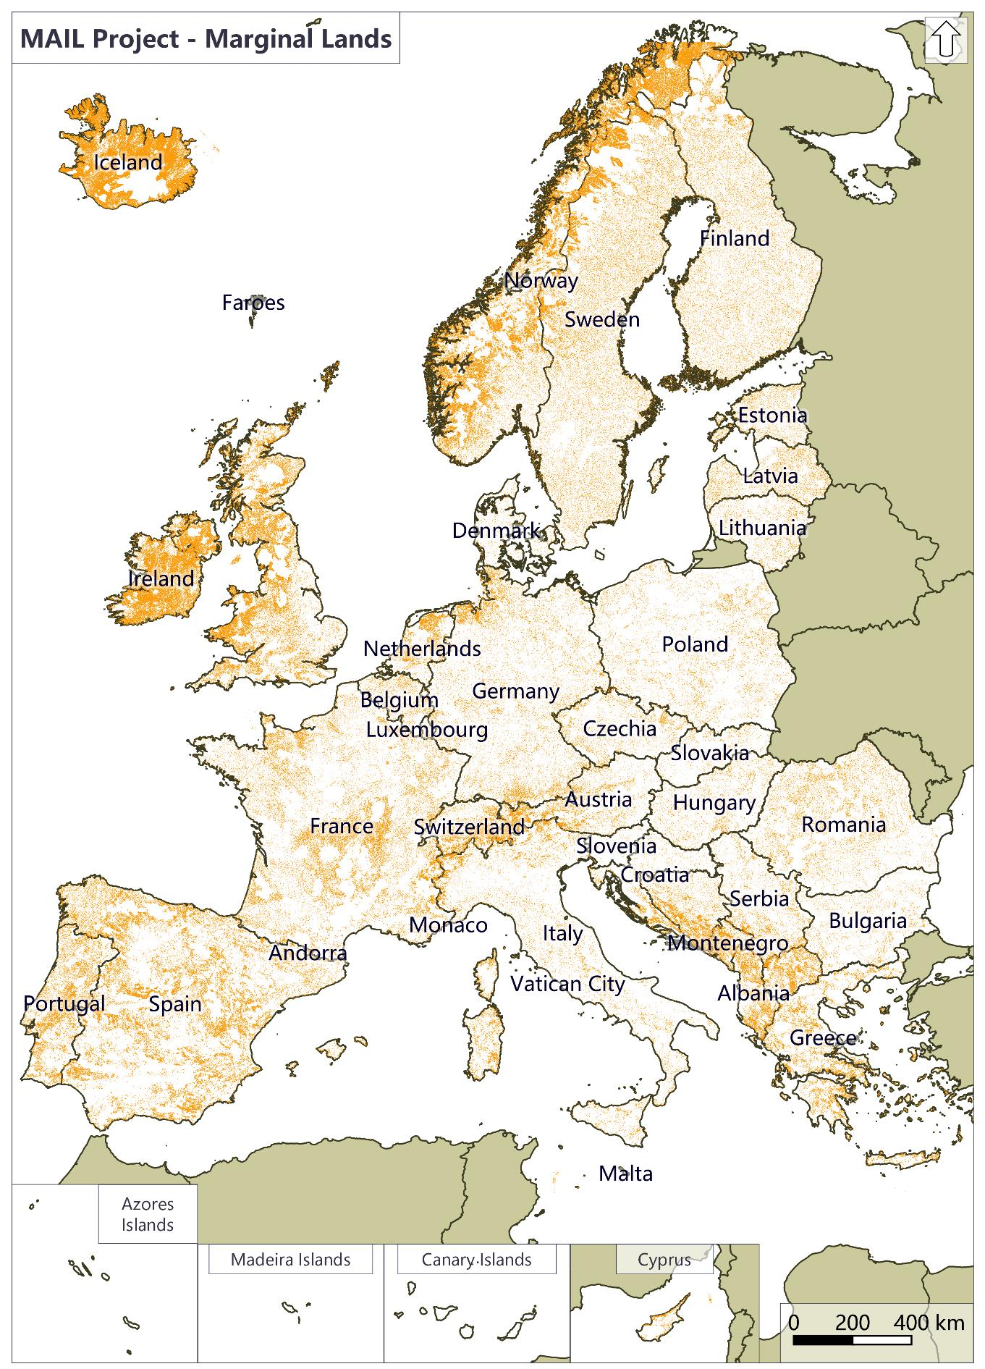
Figure 1 Potential Marginal lands in Europe, Layer "ML_Hard" for Europe where the orange colors represent the areas defined as marginal excluding land use "impervious", "croplands", "forest", "protected areas" and "changed". (Source: personal compilation of Jesús Torralba Pérez)
The identification of the marginal lands was based on existing land cover, land use classification augmented by using indicators considering the soil quality.
The MLs identified by T2.3, and the carbon sequestration capacity groups classification performed in T2.7 are the base upon which the sustainable development assessment is going to be performed.
Figure 2 presents the general overview of the sustainable development assessment of marginal lands that will be used as carbon sinks.
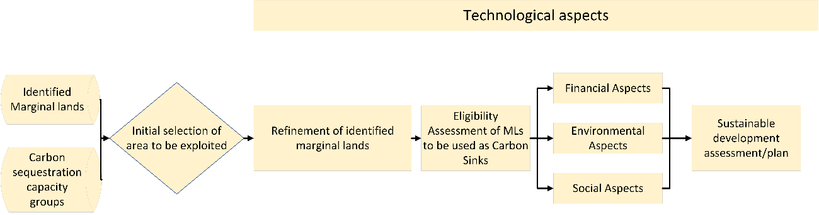
Figure 2 Sustainable development assessment workflow
The first step for the realization of a feasibility/sustainable development study is the selection of the area that a carbon sequestration project is going to be implemented. The initial area selection will be performed using the identified marginal lands GIS layers in combination with the carbon sequestration capacity groups classification.
Following the initial selection of the area that a carbon sequestration project is going to be implemented a refinement of the area should be performed. As a result, current data should be used for the final identification and delineation of the marginal lands that is going to be exploited.
Since the marginal land is going to be used for the implementation of a carbon sequestration project, i.e. utilized as a carbon sink the next step is to assess the eligibility of the area. Following the eligibility assessment, the final feasibility/sustainability study will be performed in order to assess if the selected area can be used to implement a carbon sequestration project and define a sustainable management plan.
The final assessment and management plan will take into consideration the technological, financial, social, and environmental components involved in the project’s implementation. The technological component is the one that covers all the aspects of the sustainability assessment and the management plan, providing insight and the tools that will help for the successful design of management plan and its implementation.
In addition, since marginal lands will be used as carbon sinks, meaning they will be transformed to forest areas, the sustainable development assessment will use aspects used in sustainable forest management approaches.
In this chapter the refinement of the initially selected area and its eligibility are going to be analysed. The technological, financial, social, and environmental aspects are analysed in dedicated chapters.
- Area refinement
The initially selected area should be more closely examined and accurately defined, since the initial detection of the potential marginal lands is based on the use of generic layers and possible older datasets.
To that end different approaches could be used including field work or use of additional indicators, satellite imagery, or local/regional datasets.
The most efficient and course of action is to utilize high resolution satellite images in order to refine the initial marginal land detection. To that end Sentinel – 2 images can be used. “The SENTINEL-2 Multispectral Instrument (MSI) samples 13 spectral bands: four bands at 10m, six bands at 20 metres and three bands at 60 meters”. The spatial resolutions of the different bands are presented in Figure 3.
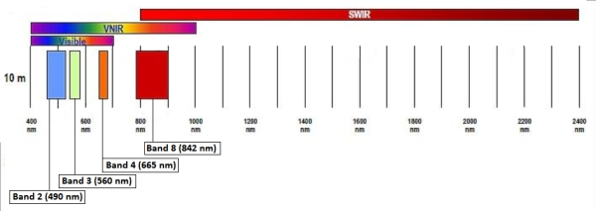
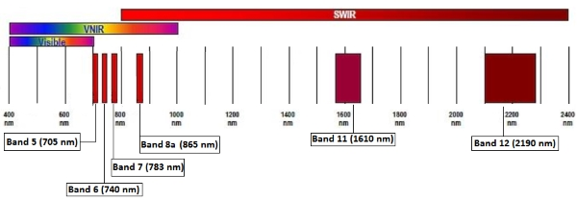
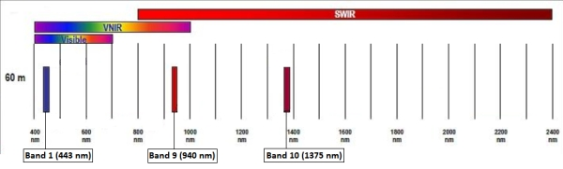
Figure 3 Sentinel spatial resolution (SENTINEL-2 10 m spatial resolution bands: B2 (490 nm), B3 (560 nm), B4 (665 nm) and B8 (842 nm) top, SENTINEL-2 20 m spatial resolution bands: B5 (705 nm), B6 (740 nm), B7 (783 nm), B8a (865 nm), B11 (1610 nm) and B12 (2190 nm), middle, SENTINEL-2 60 m spatial resolution bands: B1 (443 nm), B9 (940 nm) and B10 (1375 nm) , bottom), source ESA
“The Level-1C product is composed of 100x100 km2 tiles (ortho-images in UTM/WGS84 projection). The Level-1C product results from using a Digital Elevation Model (DEM) to project the image in cartographic geometry. Per-pixel radiometric measurements are provided in Top Of Atmosphere (TOA) reflectance along with the parameters to transform them into radiances. Level-1C products are resampled with a constant Ground Sampling Distance (GSD) of 10, 20 and 60 m depending on the native resolution of the different spectral bands. In Level-1C products, pixel coordinates refer to the upper left corner of the pixel.”
Level-1C products can be downloaded via the Copernicus Open Access Hub (SciHuB).
Since the definition of marginality is also based on the soil quality local or regional soil datasets should be used in order to augment the marginal land identification.
Furthermore, multi temporal satellite images can be used for the assessment of the study’s area usage through the previous years.
- Eligibility Assessment
Following the successful refinement of the initially selected marginal land area an eligibility assessment should be performed in order to investigate the suitability of the selected area to be used as a carbon sink. The developed projects could be exploited either by entering the voluntary or compliance carbon markets.
Voluntary markets standards requires that offsets should be:
- Real: there will be evidence that the project removes or prevents emissions;
- Additional: the emissions reductions would not occur without those project activities;
- Measurable: the volume of emissions reductions can be accurately measured; and
- Verifiable: a neutral, third-party auditor has verified the emissions reductions.
Alternatively, such projects can be used in a national level for registration in the EU ETS, more information regarding the eligibility conditions and restrictions can be found in Chapter 18.
The initial step in the eligibility assessment should be the additionality criterion. This criterion could be investigated and established by using multi temporal information provided by high resolution remote sensing images, that can define the land use, land cover of the study area through the years, and thus conclude if the project activities are going to offer emission reductions. This is the most crucial criterion for the initial selection of an area that will be used to act as a carbon sink.
Once the additionality criterion has been established an area could be considered as a potential candidate for the development of a carbon sequestration project.
The remaining criteria will be examined during the sustainability/feasibility study.
- Financial Aspects of sustainability
One of the most crucial pillars of the sustainability of a marginal land used as Carbon Sink is the financial sustainability i.e. the ability to make financial profit during the project implementation. For the creation of the financial sustainability study guidelines and workflows, the results of T2.5, T2.6, T2.7, T4.3, T4.3, and T5.3 were used.
In order to be able to assess the financial sustainability of using marginal lands as carbon sinks, a holistic approach that considers the full lifetime of the project implementation should be developed. The overall methodology for the financial assessment of a marginal land afforestation project focused on carbon sequestration is presented in Figure 4
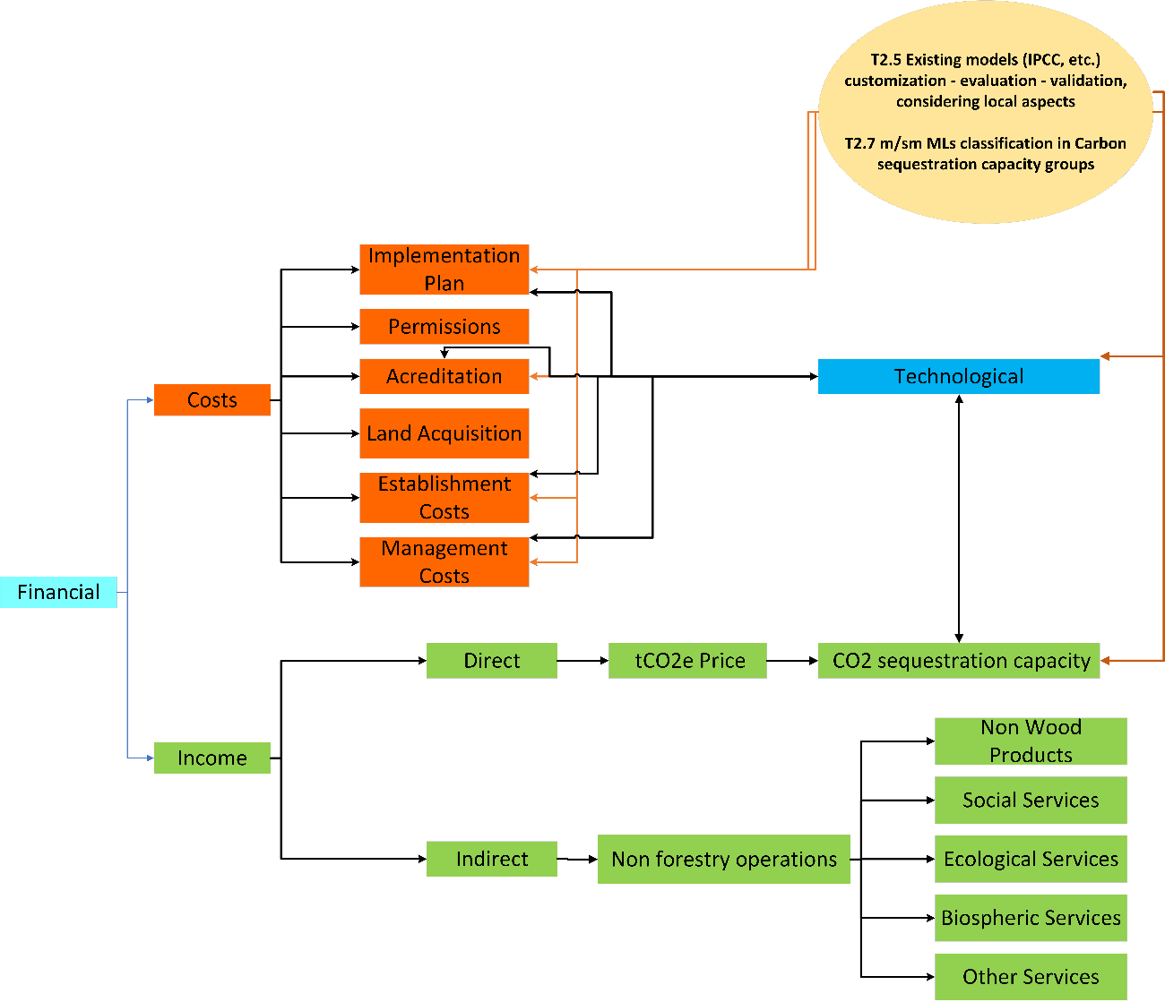
Figure 4 Financial sustainability assessment
The first step is the estimation of the associated costs for transforming and maintaining a marginal land area to a forest area.
The associated costs for the afforestation of a marginal land are the following:
- Permissions: This is an initial cost regarding the acquisition of all necessary permissions for the implementation of an afforestation project. This cost will be incurred during the start of the project.
- Accreditation: The accreditation cost is also an one time cost that is connected to the accreditation of the carbon units produced by the project.
- Afforestation implementation plan: This cost will be incurred at the start of the project and is for the creation of the afforestation plan that will be implemented.
- Land Acquisition or land rental costs: The cost for the acquisition of the area to be afforested or its rental. If the area is bought then it is a one time cost incurring in the start of the project, while if its rented its will be a yearly cost.
- Land preparation costs: This is a one time cost which will be incurred at the start of an afforestation project. It concerns the initial preparation of the site (cleaning, fertilization, etc.)
- Plant acquisition: It is the costs of acquiring the plants that will be used in the afforestation area. It is usually a one time cost incurred at the start of the project. In some cases some additional plant acquisition might be necessary to replace plants that were not successfully planted the first time.
- Planting costs: It is an one time cost incurred in the beginning of the project and concerns the actual planting of the trees.
- Maintenance/Management costs: Management/Maintenance costs are yearly costs dedicated to the management and maintenance of the afforested area, and also for the development of 10-year forest management plans
The following table presents a cost calculation workflow for the implementation of a 50-year afforestation project.
Table 8 Implementation costs for an afforestation project
Type of cost | Frequency | Cost
Permissions | 1 Year
Accreditation | 1 Year
Afforestation implementation plan | 1 Year
Land Acquisition (per hectare) | 1 Year
Land rental (per hectare per year) | 1-50 Year
Establishment costs
Land preparation (per hectare) | 1 Year
Plant acquisition (per plant) | 1 Year
Planting (per hectare) | 1 Year
Management/Maintenance costs (per hectare per year) | 1-50 Year
Forest management plans | Every 10 years
In addition to the costs detailed in the previous table one must also consider additional costs linked to the associated risks of an afforestation projects. Such risks include the damage of the plants by pests, grazing, fires, extreme winds, or the unsuccessful planting of the trees. Most of these risks can be mitigated by good forest management plans and a solid monitoring of the plantation that will help to alleviate the dangers.
Since the main objective is to transform marginal lands to carbon sinks the main source of income for such projects will be the price of a carbon unit. A carbon unit is defined as a tonne of CO₂ equivalent tCO₂e. Currently the price for a carbon unit is approximately 20 $ (Figure 5). The total income of an afforestation project dedicated to carbon sequestration could be calculated by its potential carbon sequestration capacity per hectare per year and the predicted carbon prices for each year for the whole lifetime of the project. The carbon sequestration capacity is connected to the type of tree species that are going to be used and their planting density. Furthermore, there is also a connection between the tree species and their ability to enhance the soil carbon pool.

Figure 5 IHS Markit Global Carbon Index (USD) (Source: https://indices.ihsmarkit.com/Carbonindex)
Additional income of afforestation projects can come from other non-forest related activities such as hunting licences, mushroom picking licenses, recreational activities, beehives and so on.
According to the Forest Europe, 2015 report the total value of non-wood goods reported by 26 countries was almost 2.28 million €, while the total reported value for marketed services was around 723 million € (Figure 6).

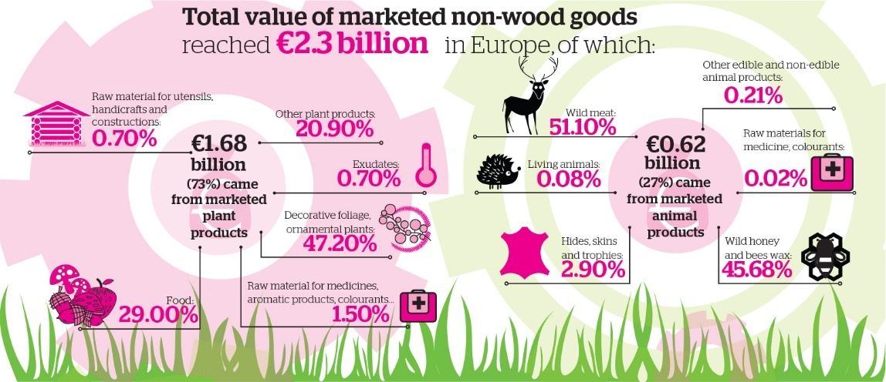
Figure 6 Total value of marketed non-wood goods (Source: Forest Europe, 2015)
The non wood goods are part of sustainable forest management indicator 3.3. More specifically the following were reported in Forest Europe, 2015:
- “Temperate and boreal forests are a traditional source of not only wood but also many other products that are extracted from forests, including resin, tannin, fodder, litter, medical and aromatic plants, fruits, nuts, roots, mushrooms, seeds, honey, ornamentals and exudates”
- “The value of forest products other than wood is being rediscovered on account of both their price dynamics and the increased demand associated wth tourism and recreation”
- “The socio-economic contribution of forests to livelihoods and the impact of their use on the environment are essential components of modern concepts for sustainable forest management. However, the integration of the assessment of Non-Wood Goods (NWGs) in extensive forest surveys causes problems as most NWGs are site-specific, dependent on spatial distribution and may be of solely local importance.”
- “This indicator covers the value and quantity of marketed NWGs from forest and other wooded land. For reasons of consistency, even if they could represent a substantial part of the total harvested NWGs, NWGs harvested for self-consumption and informal use at local level are excluded from the analysis. The main NWGs identified in the available data sets are: Christmas trees, mushrooms and truffles, fruits and berries, cork, ornamental plants, medicinal and colorant products, seeds of forest tree species, game products and honey.”
- “Quantities and/or values for marketed NWGs were provided by 28 countries. For food and ornamental plants the reported forest area amounts to 61% and 36% respectively; for all other categories of NWGs the reported forest area is far smaller. The available data sets are fragmentary for several reasons: the parameters use to assess quantity are not harmonised and render it difficult to compare data; in addition, the collection of data on NWGs is costly, the number of products is very large and no commonly accepted classification and priority list of NWGs are used by national statistical offices, including for the local significance of many products. For these reasons, it can be difficult to obtain an overview and comparable data for all types of NWGs across Europe. Nevertheless, the reported data clearly show that NWGs can be an important source of income at local level.”
- “Game comprises all hunted birds and mammals, such as partridge, pheasant, hare, deer, wild boar and chamois. The presented figures include game species whose habitats are forest-related or forest-dependent. Game that roams on farms is excluded. Data on game meat was reported by 10 countries in relation to quantity and 14 countries in relation to value. The commercial sale of game meat is an important economic activity in many countries. Among the reporting countries, Germany (EUR 195 million) Spain (EUR 73 million) and Austria (EUR 15 million) were by far the highest producers of game meat in terms of value. Finland and Sweden did not provide data on game meat. Among the reported value of non-wood products, game accounted for EUR 321 million (14% of NWGs) for all responding Forest Europe countries.”
Figure 7 presents the classification of European countries per region according to the Forest Europe report.
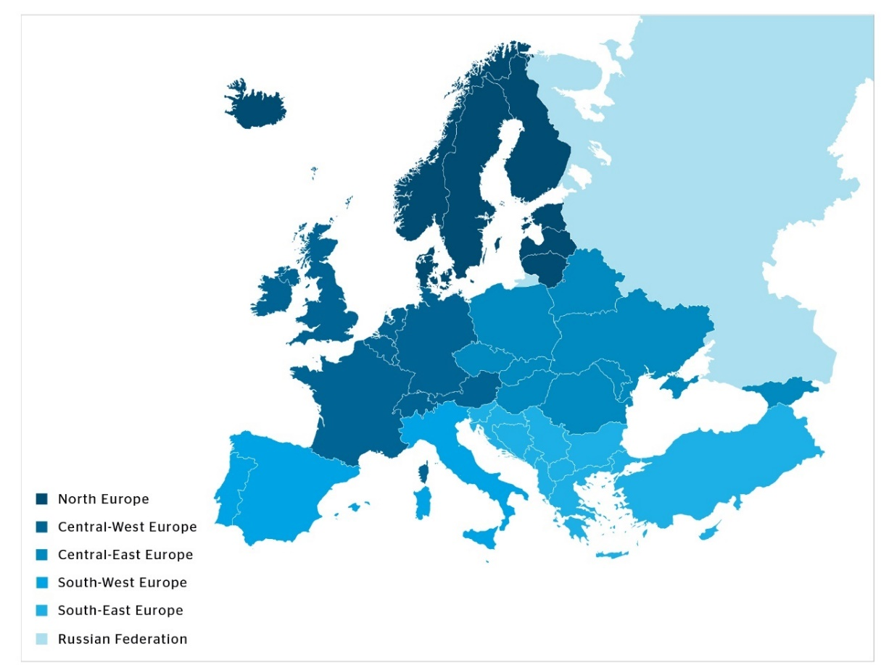
Figure 7 Classification of European Countries per region according to The Europe Forest, 2015 (Source: Forest Europe, 2015)
The following figures, and tables present an overview of the Forest Europe, 2015 report finding related to non wood goods.
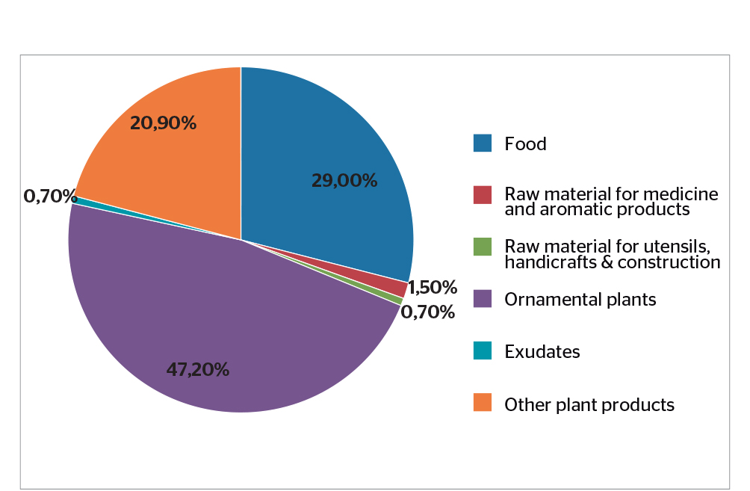
Figure 8 Total reported value of marketed NWGs accounted for by plant products (in percent) (Source: Forest Europe, 2015)
Table 9 Value of marketed NWGs (Source: Forest Europe, 2015)
Region | Plants | Animals | Totals
 | 1,000 €
North Europe | 237,569 | 8,603 | 246,172
Central-West Europe | 717,527 | 337,052 | 1,054,579
Central-East Europe | 42,886 | 22,933 | 65,819
South-West Europe | 609,282 | 197,918 | 807,200
South-East Europe | 51,5111 | 51,724 | 103,235
EU-28 | 1,592,080 | 55,611 | 2,148,199
Europe | 1,658,775 | 618,229 | 2,277,004

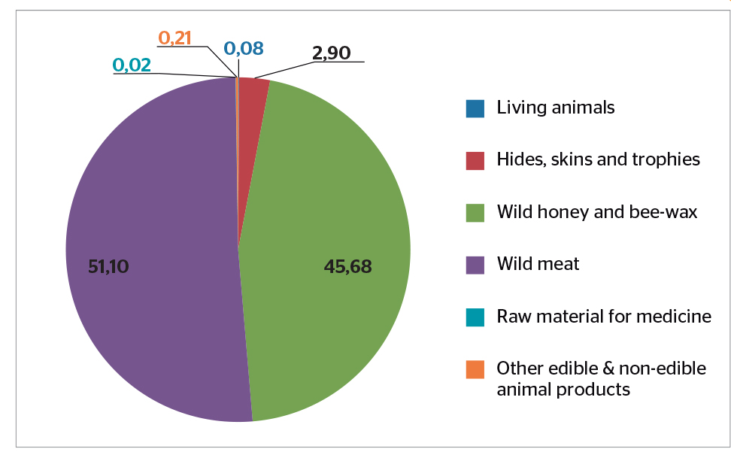
Figure 9 Shares of total value of marketed NWGs accounted for by animal products; absolute values specified in EUR 1,000 (Source: Forest Europe, 2015)

Table 10 Quantity and value of different types of marketed animal products (Source: Forest Europe, 2015)
Region | Game meat |  | Living Animals |  | Pelts, Hide skins and trophies |  | Wild Honey and bee wax |  | Raw material for medicines, colorants |  | Other animal products
 | Quan.  tonnes | Value  1,000€ | Quan.  tonnes | Value  1,000€ | Quan.  tonnes | Value  1,000€ | Quan.  tonnes | Value  1,000€ | Quan.  tonnes | Value  1,000€ | Quan.  tonnes
North Europe | 3,117 | 7,147 | - | - | 59 | 529 | 141 | 780 | 20 | 147 | -
Central-West Europe | 9,227 | 217,113 | - | - | 287 | 6,738 | 15,750 | 111,861 | - | - | 1,340
Central-East Europe | 10,084 | 17,959 | 7 | 528 | 10 | 4,445 | - | - | - | - | -
South-West Europe | - | 73,228 | - | - | - | - | 36,199 | 124,690 | - | - | -
South-East Europe | 700 | 5,565 | - | - | 4 | 6,537 | 554 | 39,623 | - | - | -
EU-28 | 23,080 | 317,013 | 7 | 528 | 351 | 3,312 | 52,090 | 237,330 | 20 | 147 | 1,340
Europe | 23,127 | 321,012 | 7 | 528 | 361 | 18,249 | 52,664 | 276,953 | 20 | 147 | 1,340
Table 11 Average value of the marketed services per hectare for countries that reported positive values for the various service (Source: Forest Europe, 2015)
Region | Game meat  Value €/ha | Living animals  Value €/ha | Pelts, hides skins and trophies Value €/ha | Wild honey and bee wax Value €/ha | Raw material for  medicine, colorants  Value €/ha | Other animal  products Value €/ha
North Europe | 0.92 | - | 0.04 | 0.23 | 0.07 | -
Central-West Europe | 13.3 | - | 1.75 | 3.53 | - | 0.35
Central-East Europe | 1.59 | 0.27 | 0.53 | - | - | -
South-West Europe | 4.01 | - | - | 5.8 | - | -
South-East Europe | 0.83 | - | 0.97 | 9.18 | - | -
Additional income to an afforestation project can also come from other marketed ecosystem services. According to Forest Europe, 2015 the total reported value for marketed services was around 723 million € (Figure 10). In general, marketed services can fall in one of the following 4 categories: Ecological services, Biospheric services, Social services, and other services (Table 12).
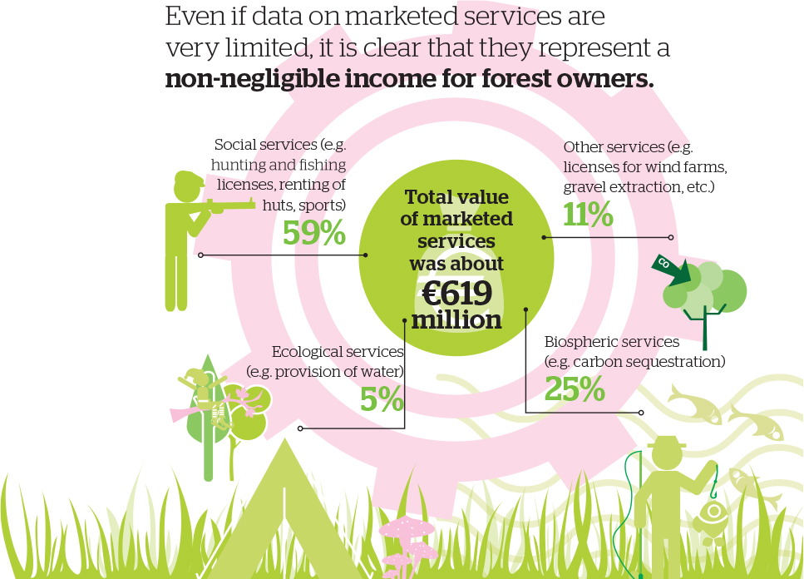
Figure 10 Total value of marketed services (Source: Forest Europe, 2015)
Table 12 Definition of forest services (Source: Forest Europe, 2015)
Ecological Services | Marketed ecological services include soil, water and other environmental functions as well as infrastructure and managed natural resources, which are often on a voluntary contractual basis with compensation or other payments from private or public bodies. (Forest Europe, 2015)
BIospheric Services | Marketed biospheric services include services related to in-situ or ex-situ gene conservation of genetic resources and protected forest areas, e.g. nature protection on a voluntary contractual basis with compensation or other payments from private or public bodies. Nature protection contract schemes are increasingly discussed and applied as a measure for the promotion of ecological services of forests. (Forest Europe, 2015)
Social Services | Marketed social services include hunting and fishing licenses, the renting of huts and houses, forest-based leisure, sports, and outdoor activities, and educational activities that are not free of charge to the consumers (e.g. public and schools). Amenity services include those related to spiritual, cultural and historical functions, e.g. sacred, religious or other forms of spiritual inspiration, sites of worship, landscape features (mountains and waterfalls), ‘memories’’ in the landscape from past cultural ties, aesthetic enjoyment and inspiration, and historical artefacts. (Forest Europe, 2015)
Other services | Other marketed services include payments to woodland owners for licenses that regulate land use for gravel extraction, telecommunication masts, wind farms and electricity distribution, among others. Depending on national laws, these marketed services of the forest may add directly to the income of forest owners and thus contribute to the economic viability of sustainable forest management. (Forest Europe, 2015)
Figure 11 presents the proportion of the marketed services provided by the reporting countries.
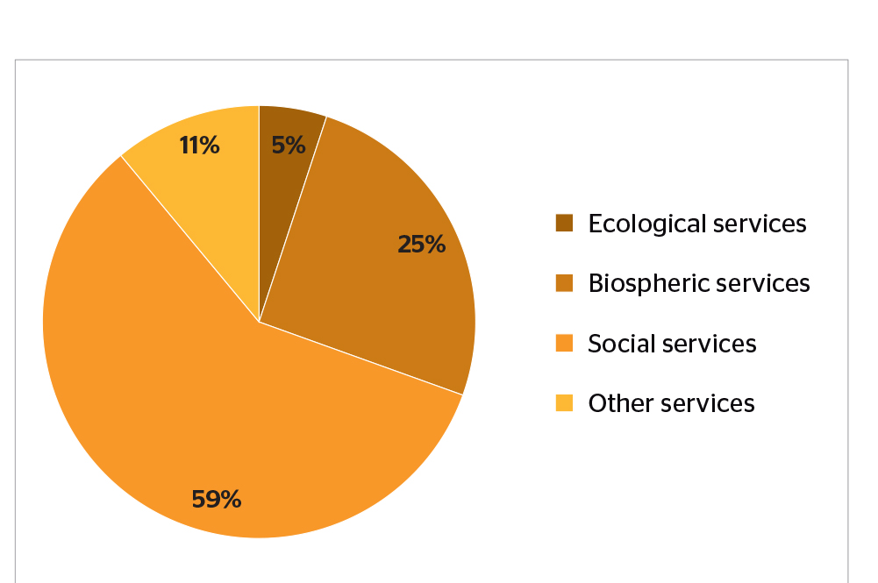
Figure 11 Proportion of marketed services provided by reporting countries (Source: Forest Europe, 2015)
According to the same report “Although the marketed forest-related services are well identified, the volume of income derived from these services is not known or registered or covers only part of the forest sector (e.g. private versus public ownership). As we can see, the biospheric and social services dominate the reported data as does the residual category of ‘other services’.” It also denotes that hunting and fishing licenses are the best documented marketed services, although data are missing from several countries. Data about hunting licenses and other income related to hunting was reported by approximately half of the reporting countries, since it is one of the most traditional services. It is obvious that hunting licenses and related products can provide a significant income to for both public and private landowners. Table 13 presents the values for other forest ecosystem services reported by country groups. In addition to hunting licensing, mushroom picking license can also provide a significant source of income to landowners.
Table 13 Total values for other marketed forest ecosystem services reported by country groups (Source: Forest Europe, 2015)
Region | Total reported across services Value 1,000 €
North Europe | 171,118
Central-West Europe | 204,864
Central-East Europe | 185,582
South-West Europe | 29,636
South-East Europe | 22,215
EU-28 | 546,341
Europe | 619,415
The following table summarizes the potential sources of income for an afforestation project dedicated to carbon sequestration.
Table 14 Potential Sources of Income
Potential Income | Frequency | Income
Carbon Units | Project lifetime
Non-Wood Goods | Yearly
Services | Yearly
Biospheric | Yearly
Social | Yearly
Ecological | Yearly
Other services | Yearly
The following table presents a generic financial assessment calculation and monitoring for the implementation of an afforestation project.
Table 15 Generic Financial Assessment
Costs (-) |  | Income (+)
Type | Value | Type | Value
Permissions |  | Carbon Units
Accreditation |  | Non-Wood Goods
Afforestation implementation plan |  | Biospheric Services
Land Cost |  | Social Services
Establishment |  | Ecological Services
Management/Maintenance costs |  | Other Services
Total
Project Income
- Social Aspects of sustainability
The social aspects of sustainability are closely related to both environmental and financial aspects. They include among others employment, health and well-being, recreation, education, etc. Some of the social sustainability aspects were presented in section 4, under services (Table 12). Such series can include hunting, fishing, outdoor activities, forest-based leisure, mushroom picking etc. The main social aspects/benefits of implementing an afforestation project are shown in Figure 12.
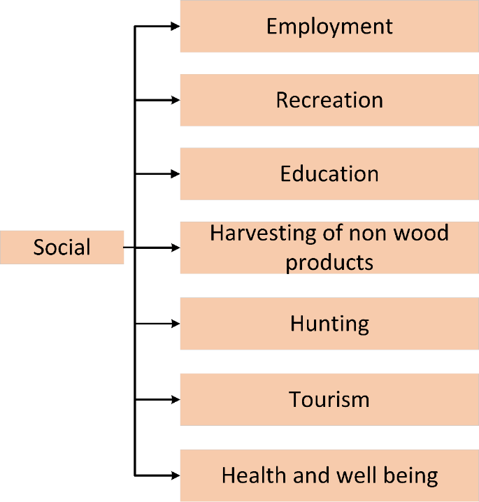
Figure 12 Social aspects of sustainability
According to FOREST EUROPE, 2015:
- “The socio-economic contribution of forests to livelihoods and the impact of their use on the environment are essential components of modern concepts for sustainable forest management.”
- “High numbers of public forests management employees are employed in countries with large public forests and in which citizens expect extensive social services from forests.”
- “Higher numbers of public staff per ha tend to be employed in countries in which citizens expect extensive social and environmental services, particularly recreation,....”
- “Regarding policy objectives, around 70% of countries reported “no changes”. Only 4 signatories reported positive changes, e.g. a systematic vision, strategic goals, priorities and activities which will lead to sustainable schemes for the development and management of tourism activities (Bulgaria); clearly defined objectives (Cyprus); new Monumental Trees Protection Act (Portugal); and boosting the social use of forest areas by promoting rural tourism, natural green paths and other cultural elements (Spain). However, the absence of changes does not necessarily imply a low level of interest if the country already has appropriate policies in place as is the case, for example, in Norway.”
- “Privately-owned forest area has slowly but steadily increased. The number of publically-owned forest holdings has been relatively constant or decreasing. While the number of private forest holdings is much higher than public holdings, the majority of private holdings are forests of less than 10 ha in size. (Figure 13)”
- “Expenditures for services remain constant, while revenues from services are increasing. Governments in Europe currently spend more than €3 billion on forest services, with an average of €37 per ha. Expenditures were stable during the period 2000-2010. However, there is considerable variability across individual regions. Government revenue from forest products and services reached at least €1.8 billion in 2010, with an average of €40 per ha. Revenue steadily increased during the decade 2000-2010 in all regions of Europe.”
- “Forest sector still plays an important role in relation to employment. In most European countries, the number of people employed in the forest sector has decreased. There is a huge diversity of qualifications, with pronounced differences between regions. Despite that, the forest sector in Europe provided jobs and income for at least 3 million people, plus an unaccounted number of people in informal employment, which is not reflected in the reported data. Therefore, the forest sector plays an enormous role in the livelihood of rural areas. The forest sector is still a “male domain”.”
- “Most forests in Europe are accessible for recreation. 75% of countries report that in 2010, at least 90% of their forests and other wooded land provided access to the public for recreational purposes. Two thirds of countries report that less than 6% of their forests and other wooded land has recreational use as a main management goal.”
- “Ownership is assumed to be a key factor that influences forest land management and protection (Siry et al. 2010). The number of forest holdings, the size of landholdings and nature of ownership are assumed to have implications for forest management and various other socio-economic circumstances.”
- “For many countries, the number of forest holdings is unavailable completely or in part, which makes it difficult to describe the exact status of the various regions. Generally, the number of private forest holdings is much higher than that of public holdings, especially in the smaller size classes. The number of private forest holdings is especially high in some countries, e.g. France, Poland and Croatia. By far the majority of these holdings are in the size class of less than 10 ha. The lack of a harmonised minimum holding size in the national statistics also makes it difficult to compare countries directly.”
- “Although the numbers of people employed in the forest sector have been reduced in recent decades, the sector still plays an important role in relation to employment. In the reference year 2010, the entire forestry sector in Europe provided jobs and income for at least three million people, plus the unknown number of people in informal employment who are not covered by the reported data. Hence, the forest sector makes a huge contribution to the livelihood of rural areas.”
- “The following analysis shows that the forestry workforce in many parts of Europe, which is mainly employed in micro-enterprises, has achieved a very high level of productivity. The efficient organisation of labour and technological development is leading to lower labour intensity in all branches of the forest sector. A very high degree of variability between regions in Europe can be observed in this regard. While regions exist in which the level of mechanisation is up to 100%, the potential for further rationalisation remains very high in other regions. This will be accompanied by an increasing demand for the competencies and skills of workers, staff and entrepreneurs. The biggest challenge for the forest sector in overcoming the threat of a lack of workers with the necessary skills and desire to work in the sector lies in maintaining the necessary capacities in the workforce and motivating young entrants.”
- “Based on the officially reported figures for 2010, the entire forest sector in Europe provides employment and income for around 3 million people in the forestry, wood manufacturing and paper industries. At 1.4 million, the biggest share of the jobs is provided by the wood manufacturing sector. The paper industry accounts for 790,000 jobs, and 620,000 jobs are reported for forestry itself. In the case of forestry, in particular, the reported figures are obviously not indicative of the total number of people working in the sector. A huge amount of forest work is carried out by private forest owners and their family members and by members of local communities, none of whom feature in the official employment statistics. Hence, the sector provides income and jobs for a considerably higher number of people than indicated by the statistics.”
- “Access to forests enables people to benefit from the recreational value of forests, which, in turn, contributes to the quality of life. This value includes health benefits (both physical and mental) and the enjoyment of recreational activities. Accessibility for recreation is granted through a legal right of access, customary rights and other de facto forms of access. The intensity of use (measured in million visits per annum) can provide an indication of the value of these benefits, however the value may also depend on the nature and duration of the visits.”
- “A total of 32 countries out of 43 reported on the area of forest and other wooded land available to the public for recreational purposes. In the majority of these countries, the public had access to at least 90% of their forest and other wooded land for recreational purposes in 2010. In terms of regional distribution, the reported data provide quite an accurate reflection of the situation in North and Central-West Europe where the majority of countries reported these data. In contrast, the data for Central- East, South-East and, particularly, South-West Europe are incomplete and should be treated with caution. (Table 14).”
- “Forest area with public access for recreational purposes has been increasing steadily since 1990 in most countries, however the changes in the period 2005- 2010 were very marginal. The forest area with recreational use as a main management goal has steadily increased since the 1990s in most countries; the increase has been more pronounced since 2005, particularly in countries in the North Europe and South-East Europe regions. The data on the intensity of use (number of visits) relies on different sources, methodologies and reference years, hence it is difficult to draw reliable conclusions about the related trends.”
- “According to the national data on employment reported by the Forest Europe signatories, maintaining and/or increasing employment levels in the forest sector are the main forest policy objectives in over the half of the reporting countries (18 of 34) for the years to come. Several countries adopted forest policy objectives that support the more sustainable development of the labour force, including the improvement of working conditions (Croatia, Italy and Slovak Republic) and maintenance of safety and health conditions in the forest sector (Latvia, Sweden and Switzerland). Other countries (Bulgaria, Portugal and United Kingdom) are targeting the improvement of qualifications and professional skills. Compared to previous SoEF reports, the current data suggest that maintaining and/or increasing the levels of employment in the forest sector have become a priority and have overtaken the quality issues that predominated in 2011 and 2007. The current trend in forest policy objectives is to tackle the decline in employment numbers triggered by the recent financial crises and economic decline, which have had a negative impact on the majority of countries.”
- “Most signatories (26 of 34) reported specifically formulated objectives in relation to research, training and education. As was the case in 2010, many countries7 (17 of 34) explicitly highlighted the further promotion and intensification of research activities, particularly in relation to the competitiveness of the forest sector, ecosystem monitoring, forest and climate change, sustainable forest management, close-to-nature forest management, and forest-related ecological, technological, and social issues. Compared to the 2011 report, a slight trend towards greater emphasis on cross-sector research, technological development, innovation and knowledge management can be observed. Several countries currently aim to improve the international transfer of knowledge and technology relating to sustainable forest management (Austria), technological developments relating to the competitiveness of the forest sector (Czech Republic, Slovak Republic), the streamlining of forest-related research and scientific innovation (Romania, United Kingdom), and integration of cross-sectoral disciplines such as agriculture, fisheries, natural resources (Finland, Hungary, Slovenia).”
Furthermore according to FOREST EUROPE, 2019 forest have a significant impact in improving health:
- Health and well-being benefits and other social functions of forests, such as recreation, tourism, forest education, aesthetic appreciation or spiritual experience, are today an increasingly important part of the values people derive from forests.
- Forests and trees have a positive impact on air quality through the deposition of pollutants to the vegetation canopy, reduction of summertime air temperatures, and a decrease in ultraviolet radiation.
- The contribution of forests and other types of natural and semi-natural habitats to human health and well-being is increasingly understood within science. In the literature, five key mechanisms for the health benefits of forests have been identified and discussed within the research field:
  - Reduced exposure to noise and air pollution
  - Stress reduction and psychological and physiological restoration
  - Strengthening the immune system through contact with nature
  - Increased physical activity and reduction in obesity rates
  - Better social contacts
Figure 13, Figure 14, Figure 15, and Figure 16 present the status and the trends in forest ownership in Europe.
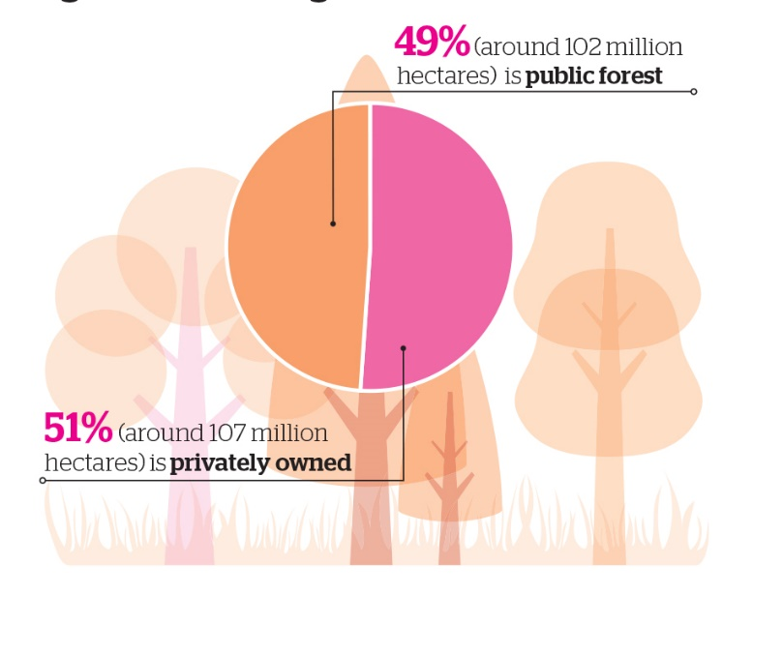
Figure 13 Forest ownership in Europe (Source: Forest Europe, 2015)
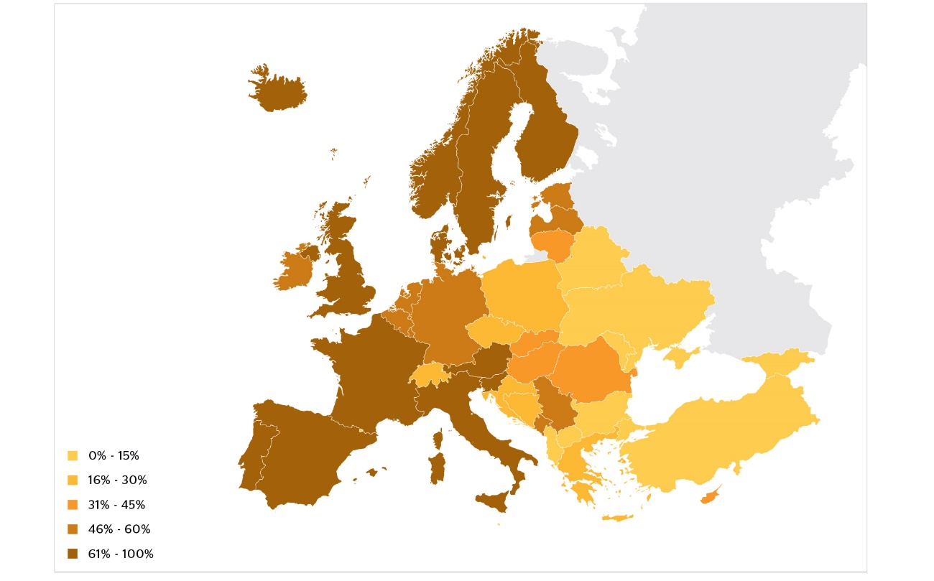
Figure 14 Area of privately owned forest as a percentage of total forest (2010) (Source: Forest Europe, 2015)
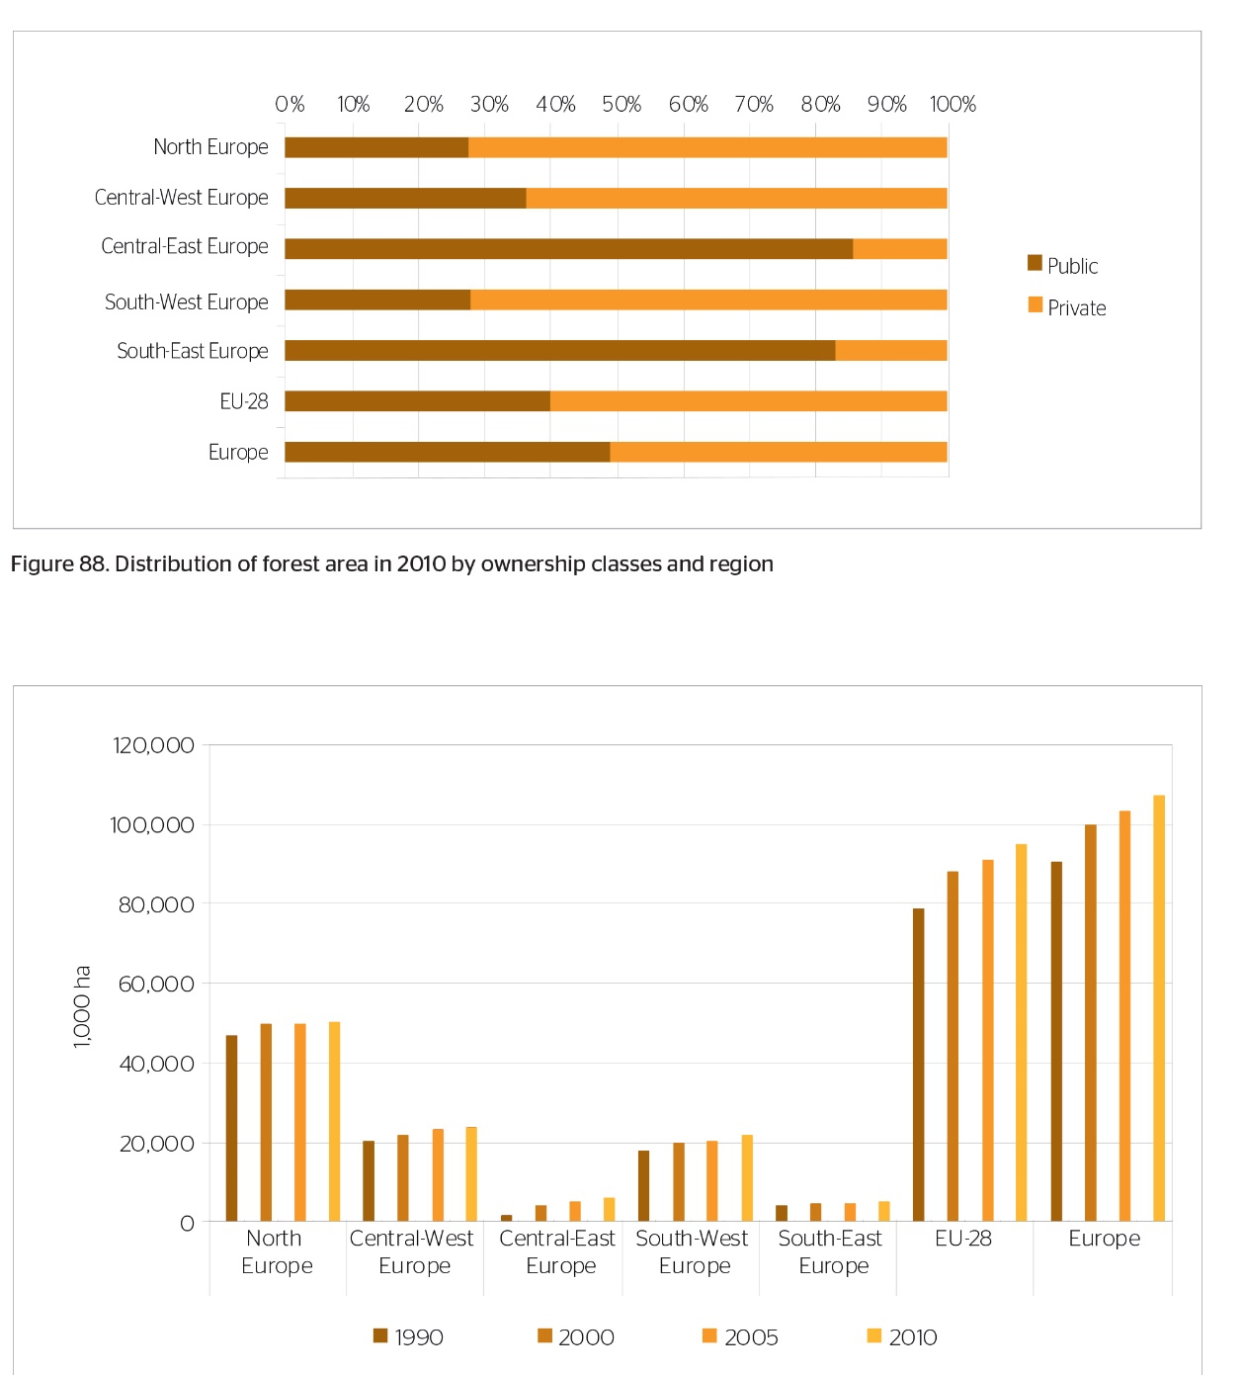
Figure 15 Distribution of forest area in 2010 by ownership classes and region (Forest Europe, 2015)
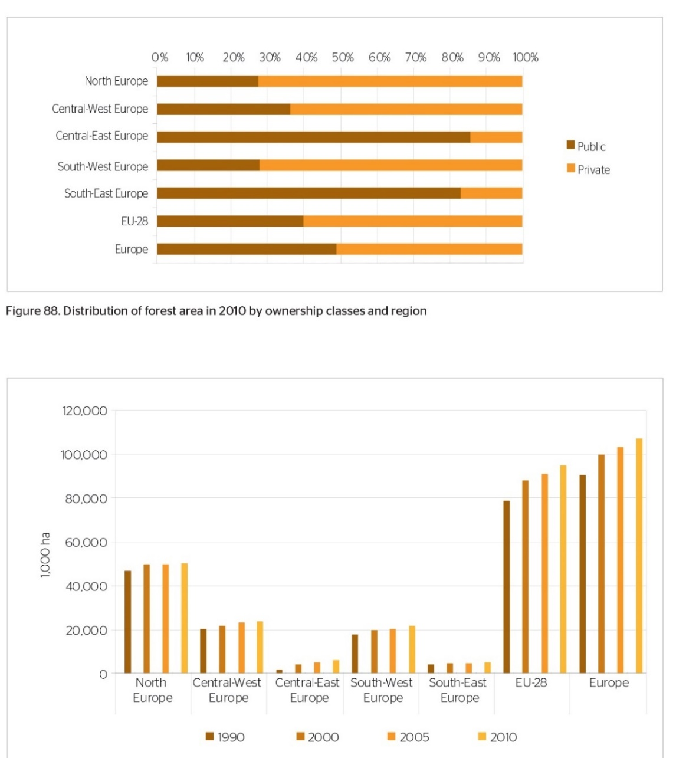
Figure 16 Private Forest area 1990 - 2010 by region (Forest Europe, 2015)
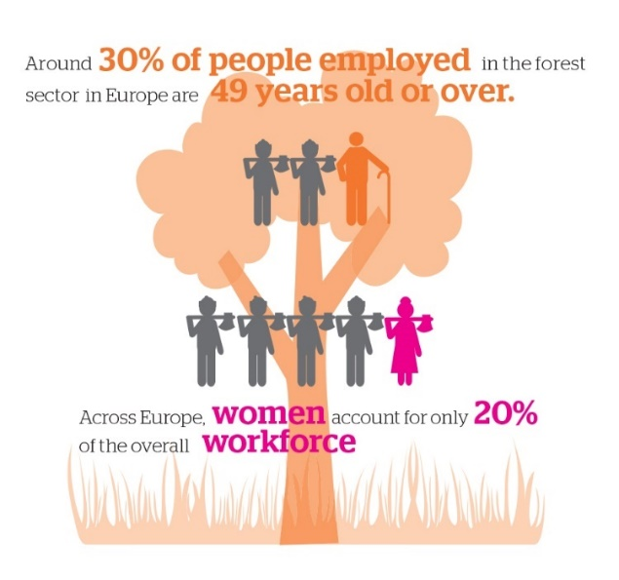
Figure 17 Forest employment distribution (Source: Forest Europe, 2015)
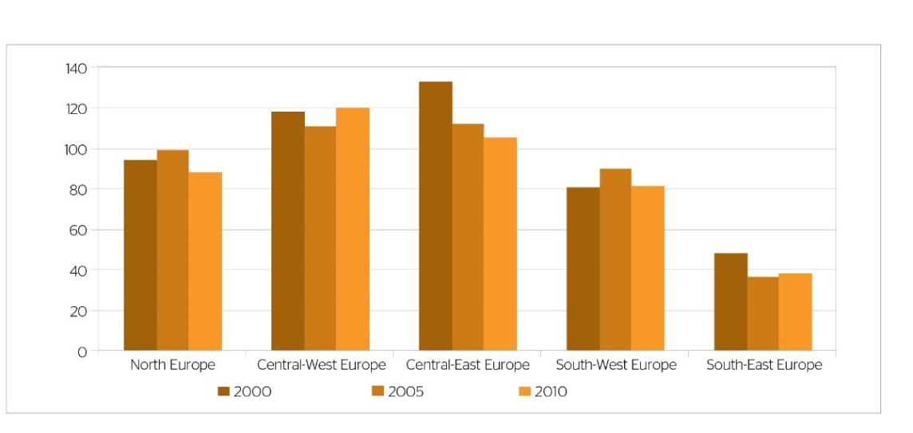
Figure 18 Development of forest-related employment from 2000-2010 (Forest Europe, 2015)
Figure 17, and Figure 18 present the forest related employment status in Europe.
Table 16 Area with public access and area managed for recreational use by region (Forest Europe, 2015)
Region | Area with access available to the public for recreational purposes (2010) |  | Percentage of forest and other wooded land area with recreational use as a main management goal (2010)
 | Percentage of forest and other wooded land area with access available to the public for recreational purposes (2010) | Data coverage expressed as percentage of total forest and other woodland area of the region
North Europe | 98.0 | 100 | 4.6
Central-West Europe | 57.3 | 96.6 | 2.0
Central-East Europe | 69.1 | 77.3 | 8.3
South-West Europe | N/A | 0 | N/A
South-East Europe | 95.8 | 32.8 | 7.7
EU-28 | 68.6 | 83.9 | 4.6
Europe | 82.3 | 65.9 | 5.7
The implementation of an afforestation project can provide new working positions in the area. The new positions could be related directly to forestry operations or to other activities that might get a boost from the afforestation project, like tourism, hunting or fruit picking services. For the implementation of a project an initial study and plan will have to be created which will result in providing work opportunities for forest service companies in the area. Furthermore, during the initial phase of the project jobs will be created that have to do with the preparation of the area and the actual planting of the trees.
The implementation of a forest management dedicated to leaving the forest to grow without any major interventions like harvesting can create the potential for the development of forest tourism in the implementation areas. Recent studies have shown that under certain circumstances the financial benefits from a forest tourism driven approach can be more for the benefits gained from the exploitation of the forest. Ahtikoski et all, 2011 performed a study in Finland comparing the benefits of nature based tourism and forestry examining three different forest management scenarios. Their study indicates that if a total of 440 more tourists per year are attracted to the area for a period of 30 years, then the benefits from tourism (financial and employment generation) are outweighing the ones coming from forestry.
In addition, an afforestation project will have a positive impact in improving health and well-being in the area. The newly created forest will provide an area for recreation and leisure, and education.
When the forest will grow older it will have an impact in biodiversity it can also provide access to hunting and mushroom picking activities.
- Environmental Aspects of sustainability
Implementing an afforestation project in marginal lands will have a great environmental impact in the area. In this chapter we are going to study the potential improvements and benefits that will emerge and also provide guidelines for the sustainable environmental aspects of such an action.
In general, marginal lands are lands of low productivity and are located in environmentally deteriorated areas, thus any afforestation project will have in general positive environmental impacts.
Forests provide a lot of environmental benefits spanning from soil and erosion protection to climate change mitigation and protection of infrastructure. The following figure presents a general overview of the environmental impact that an afforestation project can have in an area.
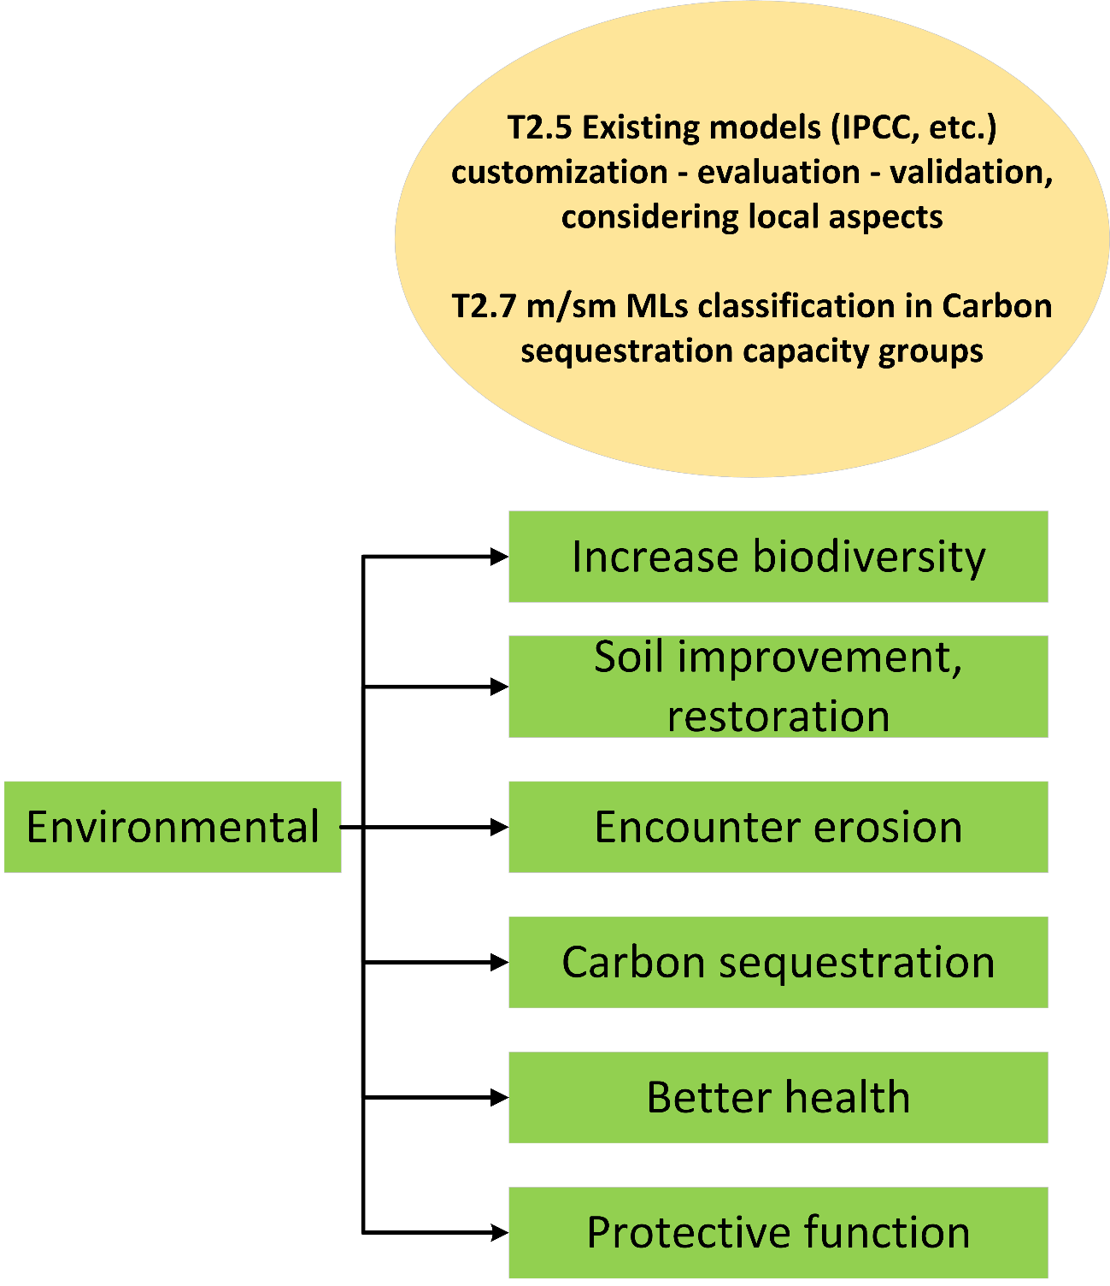
Figure 19 Environmental aspects of sustainability

The most significant environmental impact that an afforestation project is going to have is that will act as a carbon sink for the lifetime of the project, sequestering carbon and also increasing the soil carbon sequestration. In addition, forests can also have other environmental impacts. Forests help to improve the soil quality and also act as a protection for erosion and watershed. Biodiversity and landscape protection is another function of forested areas. According to FOREST EUROPE, 2015:
- “The most reported policy objectives in relation to land use and forest area within the FOREST EUROPE countries are: afforestation of agricultural land unsuitable for agricultural use in countries where national laws do not prevent a change in land use; the management of erosion-sensitive mountainous areas improvements in the stability, productivity, diversity and naturalness of forests through an integrative forest management approach.”
- “More than 25 million ha of forests in Europe are designated for the protection of water supplies, the prevention of soil erosion and the provision of other important ecosystem services.”
- “Around 30 million ha of forests in Europe are designated for the protection for infrastructures and managed natural resources. Often the protective role of forests covers a wide range of aspects, including infrastructures and managed natural resources, but also other services such as water, soil and ecosystem protection. Most protective forests are in the Central-East European region. They are also highly relevant in countries with steep terrain (e.g. Switzerland or Italy).”
- “The main policy objectives related to the protective functions of forests, namely the protection of soils, water resources and biodiversity have remained unchanged since 2007. This shows a long-term commitment to maintain and enhance the protective functions of forests. Most reporting countries identified soil protection as a main policy objective, with particular attention given to mitigating and preventing soil erosion, and about one third of countries identified protection of water resources as a priority. Institutional and regulatory frameworks as well as financial instruments and informational means provide a solid basis for the implementation of related policies.”
- “Forests can play a vital role in preventing soil erosion, protecting water supplies and maintaining other specific ecosystem functions”
- “The majority of the reporting signatories (26 of 34) declared specifically formulated policy objectives in relation to protective forests. Most of the reporting signatories (Belgium, Bulgaria, Croatia, Cyprus, Estonia, Finland, Germany, Hungary, Iceland, Italy, Latvia, Norway, Poland, Portugal, Slovak Republic, Slovenia, Sweden, Ukraine, UK) focus on further maintaining and enhancing the protective functions of forests for preventing soil erosion (19 countries) and improving water quality and quantity (16 countries). The third most visible policy objective relates to the protection of biodiversity (10 countries). Several of the reporting signatories also flagged the prevention of natural hazards and floods, climate change, the protection of landscapes and infrastructure, and the enhancement of human health and recreational functions as policy objectives.”
- “Almost half of the reporting signatories (15 of 34) mentioned the implementation of key measures on protective forests. The most frequently reported key measures were implemented through national and regional forest programs, action plans, strategic programs, guidelines (Austria, Finland, Hungary, Slovak Republic, Spain, Turkey, Ukraine, United Kingdom), and national forest or forest relevant legislation (Bulgaria, Czech Republic, Cyprus, Ireland, Slovenia). The use of research programs and projects (Finland, Romania) and the mobilization of EU funds through the national rural development programs were also reported. Ireland identified opportunities for converting and restructuring commercial forests into low intensity native woodland in order to protect sensitive water systems and habitats, Spain maintained the Spanish forest catalogue of protective forests, Slovak Republic initiated investments in flood prevention, Turkey launched a National Afforestation and Combating Erosion Action Plan Campaign, and the European Commission introduced the new EU Forest Strategy for implementing the identified policy objectives.”
- “More than 30 million ha of European forests are protected with the main objective to conserve biodiversity or landscape.”
- “Biodiversity remains an important topic for forest policy and management in Europe. Compared to the previous reporting period, biodiversity-related forest policy objectives have been maintained. Regulatory instruments continue to play an essential role in the conservation of biodiversity in forests and have been reinforced by new financial and informational measures. The EU’s biodiversity policy is a major trigger for change relating to informational, financial and legislative instruments at the national level.”
- “The majority of reporting signatories in the FOREST EUROPE region (23 out of 34) reported no changes in the national economic policy on forests (public and private) since 2011. In nearly half of the reporting FOREST EUROPE signatories (16 out of 34), the management of state-owned forests is financially selfsufficient or profit-oriented. As reported by 23 countries, total public expenditure by government on all forest related activities for the last reporting period was EUR 3,234,750,019. This total sum amounts to an average of around EUR 17.9 per hectare of total public expenditure on forest and other wooded land per year. Subsidies are the most common financial instrument used to influence private forest management (used by 22 out of 34 signatories). Transfer payments are most frequently used for the conservation of forest biodiversity, followed by support for forest inventory and planning, and soil and water protection.”
- “Over the last 15 years, the area of forest in Europe designated for biodiversity and landscape protection increased by half a million hectares annually. Around 12.2% (or 29.9 million ha) of European forests are protected with the main objective of conserving biodiversity. Around 7% have the protection of landscapes representing an area of 19 million ha as a main objective. The strictness of protection for biodiversity varies considerably within Europe: while restrictive protection with minimal or no intervention dominates in North Europe and some East European countries, active management in protected areas is more common in Central and South European countries.”
- “Biodiversity remains an important topic for forest policy and management in Europe. Biodiversity-related forest policy objectives have been maintained since the previous reporting period. Regulatory instruments continue to play an essential role in conserving biodiversity in forests and have been fostered using new financial, informational measures. The EU’s biodiversity policy is a major trigger for changes related to informational, financial and legislative instruments at national level.”
- “Species diversity and the dynamics of forest ecosystems differ considerably throughout Europe. This is reflected by the broad range of forest types found there, from boreal forest in North Europe to broadleaved evergreen forests in the Mediterranean region. These forest types are differentiated by unique key factors related to structural, compositional (including tree species composition) and functional forest ecosystem components, such as biotic and abiotic disturbance factors and forest management. Mixed forests and other wooded land, composed of several tree species, are often richer in biodiversity than those comprising 1 tree species. However, some natural forest ecosystems are dominated by only 1 or 2 species, e.g. natural boreal pine forests on dry sites, natural sub-alpine spruce stands and beech forests growing in favorable conditions on lowlands.”
- “Natural regeneration contributes to conserving the diversity of the genotypes and to maintaining the natural tree species composition, structure and ecological dynamics. However, natural regeneration may not always be suitable for achieving biodiversity conservation goals. For example, to convert forests from introduced tree species to native tree species, planting is necessary in most cases, and restoration activities may require the elimination of naturally regenerating trees growing outside their natural range. Furthermore, the occasional replanting programs made necessary by heavy storms or insect calamities may influence the proportion of regeneration methods used, and, consequently, the statistics.”
- “As European forests have been managed for long periods of time, the late development phases are missing or scarce. Because of the lack of deadwood in many forests, several of the deadwood-dependent species are endangered. Indeed, increasing the amount of deadwood in forests is considered one of the potential management options for enhancing biodiversity in most of Europe’s forest types. On the other hand, in some circumstances, the accumulated fresh dying deadwood can create a risk of insect outbreaks.”
- “A total of 501,567 ha were managed for the in situ genetic conservation of forest trees in 38 countries in 2015. The total area managed for ex situ conservation is 11,553 ha in 37 countries; for seed production it is 1,027,434 ha in 38 countries. A total of 145 tree species (including subspecies and hybrids) were reported for this indicator. However, these species are not managed equally for genetic conservation (in situ and ex situ) and seed production. A large proportion of the trees targeted for in situ genetic conservation are widely occurring stand-forming tree species, which are important for forestry. A group of five economically relevant tree species (Abies alba, Fagus sylvatica, Picea abies, Pinus sylvestris and Pinus pinaster) alone account for 55% of the total area managed for in situ genetic conservation, while in the case of many other economically important tree species, only small areas are managed for the same purpose. Furthermore, very few genetic conservation areas are managed for scattered tree species (e.g. Populus nigra, Sorbus domestica, Tilia platyphyllosand, Ulmus laevis), which are often considered of low importance. However, while these species may not be economically important, they have a high value in terms of maintaining forest biodiversity and ensuring ecosystem stability.”
- “The most noticeable form of biodiversity depletion is the loss of plant and animal species. Slowing down the rate of species extinction due to anthropogenic factors is a key objective of biodiversity conservation. This is very much reflected in the corresponding international, European and national initiatives and actions. Examples of these include the Convention on Biological Diversity, the European 2020 targets, which were agreed on at the FOREST EUROPE Ministerial Conference in Oslo 2011, the EU Biodiversity Strategy 2020, and national and regional biodiversity strategies which express their ambitions through set targets (link to Indicator B6). It is further highlighted by the fact that threatened forest species are seen also as indicators of change in forest ecosystems.”
- “The relationships between threatened species, forest composition and habitat structures are complex but often of crucial importance. However, threats to a certain species can often be the result of multiple factors, making it difficult to determine clear causalities. In particular, the required amount and quality of deadwood is a topic that requires continuing research support. Many species are dependent on small key biotopes, habitats or habitat structures available in both protected forest areas and managed forests. To provide science-based input for raising awareness of the need to integrate biodiversity considerations into forest management, further attention needs to be focused on these elements by research and monitoring.”
- “...forest management practices are developing towards the greater integration of biodiversity issues. Such integrated forest management approaches may give rise to improved habitat conditions for threatened species e.g. through increasing the amount of standing and lying dead wood, designating stepping stones and habitat trees, and preserving habitat structures and allowing for their development. However, the effects of biodiversity-oriented forest management practices will become evident only with time. Therefore, in addition to such long-term commitments, the continuation of efforts in relation to the monitoring of the development of threatened forest-occurring species will be crucial.”
  - “Biodiversity remains an important dimension of forest management in Europe. The majority of reporting signatories (31 of 34) reported specifically formulated policies (objectives) in relation to biodiversity. The key objectives and instruments of these policies are:
  - To increase protected forest areas (Albania, Belgium, Latvia, Luxemburg, Montenegro, Norway), inter alia in conjunction with the implementation of Natura 2000 network of protected areas under the European Union’s Habitats and Birds Directives (Bulgaria, Croatia, Hungary, Italy, Slovak Republic, Slovenia, Serbia).
  - To practise multifunctional or close-to-nature forest management (many countries).
  - To protect rare and endangered species and deal with issues relating to invasive alien species (Austria, Cyprus, Czech Republic, Finland, Italy, Latvia, Romania, Switzerland, United Kingdom).
  - To protect forest genetic resources (Bulgaria, Italy, United Kingdom).
  - To preserve natural environments of cultural or aesthetic value (Estonia, Sweden).
  - To improve knowledge about forest biodiversity and management through research and communication (Germany, Iceland, Latvia) and also (new) monitoring (Austria, Turkey)”
Table 17 Forest land reported for the protection of soil, water and other ecosystem services in 2015 by region (Source: Forest Europe, 2015)
Region | Total Forest | Protective Forest | Percentage of forest area
 | 1,000 hectares |  | In percent %
North Europe | 70,832 | 523 | 0.7
Central-West Europe | 38,582 | 900 | 2.3
Central-East Europe | 44,494 | 7,988 | 18.0
South-West Europe | 30,913 | 13,156 | 42.6
South-East Europe | 30,442 | 2,837 | 9.3
EU-28 | 215,267 | 25,405 | 11.8
Europe | 161,082 | 20,946 | 13.0

Table 15 presents the forest land report for protection. It must be noted that several countries commented that, while forests fulfil protective functions, their primary aim is “multiple use”, hence they do not qualify for reporting as solely used for protection (Forest Europe, 2015).
The issues covered by the main policy objectives considering protective forests and other wooded land are presented in Figure 20.
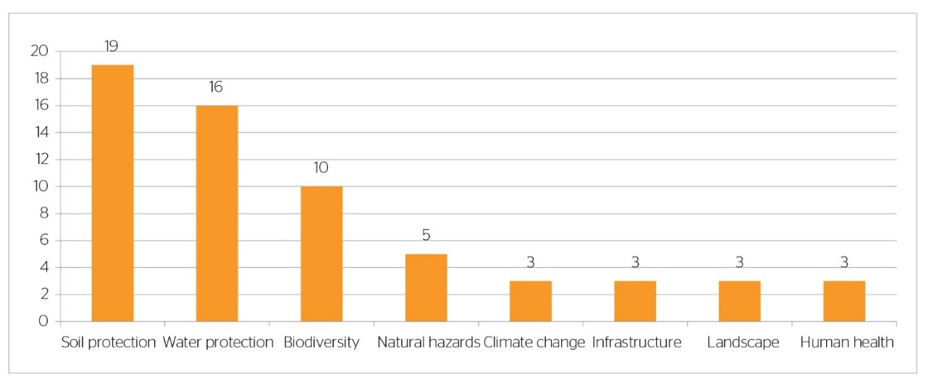
Figure 20 Issues covered by the main policy objectives relating to protective forests and other wooded land for the period 2011-2014 (Source: Forest Europe, 2015)
Table 18 shows the share of forest area by regeneration type in the European region.
Table 18 Share (percentage and million ha) of forest area (uneven-aged and even-aged) by regeneration types in the European regions, 2010 (based on the available data) (Source: Forest Europe, 2015)
Region | Natural regeneration and natural expansion |  | Afforestation and regeneration by planting and seeding |  | Coppicing
 | Million ha | % of forest area | Million ha | % of forest area | 1000 ha | % of forest area
North Europe | 48.4 | 68 | 22.4 | 32 | n.s. | 0
Central-West Europe | 22.3 | 64 | 10.6 | 30 | 20 | 6
Central-East Europe | 16.1 | 52 | 13.0 | 42 | 21 | 7
South-West Europe | 26.1 | 86 | 3.3 | 11 | 11 | 4
South-East Europe | 19.9 | 72 | 4.0 | 14 | 36 | 13
EU-28 | 132.8 | 68 | 53.2 | 27 | 8.8 | 5
Europe | 98.5 | 68 | 38.8 | 27 | 5.4 | 5
Table 19 and Table 20 present the number of threatened and extinct species respectively.
Table 19 Numbers of threatened forest-occurring tree species, birds, mammals, other vertebrates, other invertebrates, vascular plants and fungi (number of reporting countries: 30) (Source: Forest Europe, 2015)
Country | Tree species | Birds | Mammals | Other vertebrates | Other invertebrates | Vascular Plants | Fungi
Albania | 32 | - | - | - | - | - | -
Austria | 11 | 18 | 13 | 18 | - | 267 | 97
Belarus | 3 | 57 | 14 | 13 | 75 | 153 | 105
Belgium | 4 | - | 13 | 4 | - | 34 | -
Bulgaria | 0 | 12 | 8 | 17 | 6 | 0 | 0
Croatia | 3 | 26 | 5 | 1 | 11 | 32 | 257
Cyprus | 4 | 6 | 1 | 2 | - | 102 | -
Czech Republic | 15 | 248 | 31 | 47 | - | 771 | 582
Denmark | 6 | 20 | 9 | 6 | 372 | 54 | 818
Estonia | 2 | 12 | 2 | 1 | 5 | 37 | 36
Finland | 5 | 13 | 8 | 2 | 599 | 48 | 337
France | 5 | 20 | 5 | 2 | 6 | 512 | -
Germany | 7 | 14 | - | - | - | 208 | 1475
Hungary | 9 | 2 | 0 | 0 | 5 | 264 | 166
Iceland | 1 | 0 | 0 | - | - | 1 | -
Ireland | 1 | 3 | 1 | - | 10 | 7 | 2
Italy | 2 | 16 | 21 | 3 | - | - | -
Latvia | 3 | 19 | 9 | 2 | 46 | 76 | 28
Liechtenstein | 0 | - | - | - | - | - | -
Lithuania | 0 | 0 | 2 | - | 4 | - | -
Netherlands | 0 | 0 | 0 | 0 | 0 | 0 | 0
Norway | 0 | 10 | 9 | 0 | 571 | 43 | 501
Slovak Republic | 8 | 20 | 22 | 30 | 644 | 242 | 100
Slovenia | 2 | 43 | 23 | 30 | 227 | - | 82
Spain | 3 | 44 | 17 | 32 | 21 | 142 | -
Sweden | 7 | 12 | 8 | 3 | 373 | 57 | 525
Switzerland | 3 | 29 | 23 | 85 | 85 | 109 | 981
Turkey | - | - | 4 | - | - | - | -
Ukraine | - | 95 | 69 | 88 | 290 | 500 | 148
United Kingdom | 13 | 0 | 0 | 0 | 51 | 29 | 79
Table 20 Numbers of extinct forest-occurring tree species, birds, mammals, other vertebrates, other invertebrates, vascular plants and fungi by regions, EU 28 and Europe (number of reporting countries: 45) (Source: Forest Europe, 2015)
Region | Trees | Birds | Mammals | Other vertebrates | Oher invertebrates | Vascular plants | Fungi
North Europe | 0 | 6 | 2 | 1 | 117 | 9 | 61
Central-West Europe | 2 | 5 | 6 | 5 | 4 | 14 | 214
Central-East Europe | 1 | 0 | 7 | 3 | 13 | 28 | 39
South-West Europe | 0 | 1 | 0 | 0 | 0 | 0 | 0
South-East Europe | 1 | 10 | 4 | 1 | 16 | 12 | 0
EU-28 | 3 | 21 | 12 | 3 | 145 | 48 | 300
EU 28 (number of countries reporting) | 19 | 20 | 20 | 18 | 16 | 16 | 15
Forest area of EU 28 covered (in %) | 73 | 74 | 67 | 65 | 63 | 63 | 55
Europe | 4 | 22 | 19 | 10 | 150 | 63 | 314
Europe (number of countries reporting) | 25 | 25 | 25 | 21 | 17 | 19 | 18
Forest area in Europe covered (in %) | 61 | 66 | 66 | 59 | 53 | 52 | 52

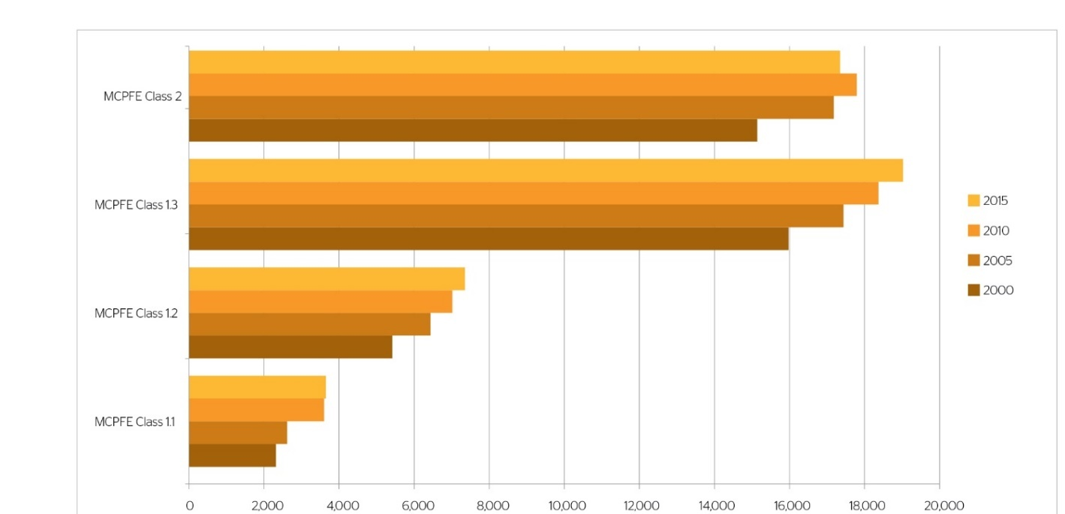
Figure 21 Area of protected forest (1,000 ha) in Europe by MCPFE class (1.1–1.3 and 2) in 2000, 2010 and 2015 (based on available data) (Source: Forest Europe, 2015)
Figure 21 presents the evolution of the protected forest area in Europe by different classes in 2000, 2010, and 2015.While Table 21 presents objectives of EU Biodiversity strategy to 2020 relevant to forests.
Table 21 Selected objectives of the EU biodiversity strategy to 2020 relevant to forests
Selected objectives of the EU Biodiversity Strategy to 2020 of relevance to forests
1) Halting the loss of biodiversity and the degradation of ecosystem services in the EU by 2020 and restoring them in so far as feasible.

2) Putting forest management plans or equivalent instruments in place for all forests that are publicly owned and for forest holdings above a certain size so as to bring about a measurable improvement in the conservation status of species and habitats that depend on or are affected by forestry and in the provision of related ecosystem services as compared to the EU 2010 baseline.

3) Fully implementing the Birds and Habitats Directives with a view to improving conservation status through the implementation of 100 percent more habitat assessments and 50 percent more species assessments under the Habitats Directive and establishing secure or improved status through the implementation of 50 percent more species assessments under the Birds Directive.
It is obvious that forests have a significant ecological environmental role connected to them. From a sustainability point of view during the assessment of the environmental aspects of the implementation of an afforestation project the following issues should be considered both during the planning phase and the management phase of a project.
Biodiversity: During the planning site an initial assessment of the tree species used for the afforestation project should be performed in order to increase the biodiversity protection and also the successful implementation of the project. During the planning stage native tree species and varieties that all well adapted to the site should be considered. In addition, species that can adapt to climate change should be preferred. Furthermore, species composition and structural diversity should reflect the natural diversity of the area should be selected and if its is applicable the reforestation project should contribute to the improvement and restoration of ecological connectivity.
During the management phase of the project the ecological impact of the project should be closely monitored in order to assess its biodiversity effects. Corrective measures that increase the biodiversity like the presence of dead wood, or the conservation of certain tree species that enhance gene conservations should be considered. In addition, the presence of flora and fauna that is present in the newly afforested site should be monitored in order to provide input for the environmental assessment.
Protective functions: During the planning phase the reforestation activities should aim to maintain and protect soil and ground and surface water resources both in terms of quality and quantity. Also, during the planning phase an assessment of the protective functions that the afforestation project could fulfil must be performed. Such protective functions can include the protection of infrastructure, soil erosion, protection of water sources, restitution of soil, etc.
During the management phase an assessment of the protective functions if any of the afforestation project should be performed in conjunction with forest management plans.
- Technological Aspects of sustainability
Technology is going to provide the tools and means that will help and enhance the financial, social, and environmental sustainability aspects of using marginal lands as carbon sinks. In this chapter we are going to present the tools and methodologies that were developed during the MAIL project and also provide information of potential technological advancements or workflows that will help to enhance the sustainability aspects. Figure 22 presents an overview of the technological tools that can be used to enhance sustainability.
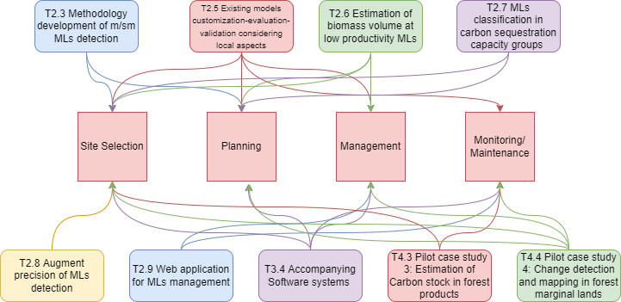
Figure 22 Technological aspects for the enhancement of sustainability
During the implementation of the MAIL project a series of various technological tools and approaches has been developed. A brief presentation and analysis of the developed products and their use in the sustainability assessment is going to be presented in the following sections.
- Marginal Land Detection
The detection of marginal land was the main objective of task 2.3 “Methodology development of s/sm MLs detection”. The work performed in this task provided the workflows and the methodology for the detection of marginal lands using existing land cover, land use layers and a series of indicators in order to detect potential marginal land in the European area. The result of this task is a pan European digital map implemented in a WebGIS that displays the potential marginal lands.
This map layer will be the starting point for a sustainability assessment. The potential marginal land layer can be used in combination with other existing local, regional, national, or European layers by interested parties (potential inventors) to identify areas of interested that are suitable for the implementation of afforestation projects or estimate a suitability metric.
- Augmentation of marginal land detection
Task 2.8 “Augment precision of MLs detection” provided the tools and methodologies for the augmentation of marginal land detection. The developed methodology provides a machine learning classification workflow using free multi temporal satellite data to improve the detection of marginal lands.
Like the results of Task 2.3, the results of task 2.8 can also be used in the selection of suitable areas for the implementation of an afforestation project (Decision Support System). Using the map that delineates all the potentially suitable MLs for an afforestation project produced in Task 2.3, and by harnessing the temporal capabilities of satellite data, the tool developed in Task 2.8 will be able to extend the functionality of the initial MLs detection to future dates.
- Model for the estimation of sequestered carbon
During the implementation of task 2.5 “Existing models (IPCC, etc.) customization - evaluation - validation, considering local aspects” different methodologies for the estimation carbon storage in different tree species were reviewed. The reviewed methods for calculation of carbon sequestration are direct and indirect in which biomass and allometric equations along with Remote sensing are found. Moreover, IPCC guidelines consulted summarized and explained. From IPCC guidelines the Tier 1 is proposed, by this task, to be used which mainly uses default values by LULUCF type and it is most suitable for nations with limited inventory and remote-sensing capabilities. Tier 1 has a simple first order approach but large uncertainties. Finally, in Task 4.2 the Tier 3 is applied which is based on inventory and process-based models and it includes methods that represent more demanding technical capabilities, accuracy, and data requirements. Tier 3 has higher order methods and lower uncertainties.
- Estimation of biomass volume
In task 2.6 “Estimation of biomass volume at low productivity m/sm MLs” algorithm and methodologies were developed for the estimation of biomass using SAR satellite images and LIDAR data. The developed approaches can be used to estimate the existing biomass in an implemented afforestation project, and thus the potential carbon sequestration achieved in the project. Such estimation can be produced every 3-5 years providing a powerful tool for the monitoring of an afforestation project.
- Estimation of carbon stock in forest products
During the implementation of task 4.3 “Pilot case study 3: Estimation of carbon stock in forest products” a methodology and a tool for the estimation of carbon stock in forest products along with their degradation and life values was developed. The developed methodology and tools will be used for the assessment of carbon stock in produced forest products of an afforestation project. This tool can be used both during the planning and monitoring phase of an afforestation project.
- Classification of MLs in carbon sequestration capacity groups
Task 2.7 “m/sm MLs classification in Carbon sequestration capacity groups” produced a classification of the detected marginal lands in different carbon sequestration groups based on the following indicators Carbon Carrying Capacity (CCC) input from task 4.2 and the Current Carbon Sequestration (CCS). The CSC (carbon sequestration capacity) was defined as CCC-CCS and it is applied at two resolution levels. The produced layer can be used in the selection of suitable areas, and tree species for the implementation of an afforestation project.
- Change detection and mapping of forest marginal lands
Task 4.4 “Pilot case study 4: Change detection and mapping in forest MLs” developed an approach for the multi temporal monitoring and suitability assessment of marginal lands. The results of the task can be used during the implementation phase of an afforestation project and provide a powerful tool for the successful management of such a project.
This Task is going to consider three different scenarios. The first one is the “Deforestation” scenario in which the user can detect whether a sudden deforestation event has happened in a given forested area of interest. The second scenario is the “Afforestation” one, in which the user monitors the progress of a recently afforested area. Lastly, the third is the “Stable” scenario in which the user can observe the state of a healthy forest.
- Software systems
A software “Marginal Land Toolbox” was developed during the implementation of task 3.4 “Accompanying Software systems”. Tool “Identification of Marginal Lands” uses a set of rules to provide a short-term forecast of trends relating to marginal lands and the progress of an implemented afforestation project. While tool “Decision Support System” is a decision support system that can help with critical decisions during the management and implementation phase of a project using marginal lands as carbon sinks.
- Web application for the management of MLs
Task 2.9 “Web application for MLs’ management” implemented a webgis service that will be able to produce thematic maps and provide information based on specific layers considering the management of marginal lands. The webgis tools include the following modules:
Marginal land identification at European Scale, you can find:
• Exclude areas by Land Cover
• Exclude areas by productivity values
• Factor importance selection
• Marginal land Classes
Decision Support System:
• Carbon calculator
• Carbon predictor
• Afforestation cost calculator
Upcoming features:
• Change monitoring based on LandTrendr
• Specie selection wizard
• Selection of areas for afforestation
- Feasibility analysis
Feasibility analysis is a pre-start-up and strategic planning tool used throughout the development of a business plan. A feasibility analysis evaluates the viability of a proposed plan or project by taking into account a variety of criteria such as economic, technical, legal, and scheduling to see if it can be implemented. The cost and return on investment of a project might determine whether it is feasible or not. A feasibility analysis requires collecting and evaluating data before the beginning of a new project, and then the usage of the knowledge gained to build the business plan itself. Performing a detailed feasibility analysis as part of the project planning process indicates how the development will operate under a certain set of assumptions that takes into account all economic and non-economic elements (Castrogiovanni, 1996; Currie et al., 2009; Matson, 2000; Saito & Rehmsmeier, 2015).
In this chapter an economical model is created calculating the cost of plantation of one single tree. This model takes into account specific factors that influence the cost of the plantation such as the soil texture, the slope of the area, the manual or the mechanical way of the plantation, the accessibility to cities and the labor cost level of the countries in EU. After the ML detection from the Task 2.3 the areas with high suitability for forestry are used for the calculation of the price.
The concentration of CO₂ and other greenhouse gases (GHGs) in the atmosphere has increased dramatically over the last century and is expected to continue to rise, with the majority of the increase caused by the burning of fossil fuels and the conversion of tropical forests to agricultural land (Paustian et al., 2000). Since 1750, atmospheric CO₂ concentrations have increased by 30%, with a sharp increase in the previous 50 years (IPCC, 2001). One of the feasible choices for neutralizing the gases emitted by fossil fuel combustion and minimizing the potential effects of global warming is to invest in the forestry sector to store carbon in trees and forests. In regional, national, and worldwide greenhouse gas balances, perennial vegetation, particularly forests, plays a critical role. The protection of existing forests and woodlands, as well as the establishment of new ones, will aid in the reduction of greenhouse gas emissions (Jose & Bardhan, 2012). Simultaneously helping biodiversity conservation, floral and faunal diversity, solving issues such as soil degradation and salinity, and in certain cases earning money from timber and other goods, as well as carbon rights.
The EU's biodiversity policy for 2030, known as the European Green Deal, addresses the protection and restoration of nature by setting a number of particular pledges and targets. One of the pledges is to plant at least 3 billion additional trees in Europe by 2030, all while adhering to ecological principles. A path for action to achieve this commitment will be included in the EU forest strategy. This commitment will not, by itself, solve the climate or biodiversity problems. Additional worldwide or European planting pledges much exceeding the 3 billion are required, as are other ambitious efforts on forest and tree conservation, environmental and biodiversity protection, and significant greenhouse gas emission reductions in other sectors. Carbon sequestration's impacts will only become obvious in the following decades. However, because trees take decades to grow, immediate action is required to achieve the additional carbon sequestration that will be needed in the future. Planting new trees is a supplement to broader conservation efforts, not an alternative for preserving existing trees (European Commission, 2021d).
The Commission lays out a number of broad conditions and resources that can be utilized to help particular projects succeed by ensuring that they follow EU guidelines and allowing them to carry the 'EU 3 billion trees' label. By providing adequate financing, the EU should enable planting projects. Furthermore, the EU should offer policy and technical support, create a visual identity for the pledge, increase communication about it, help in capacity building, and encourage the exchange of best practices. Finally, the Commission should establish a system to monitor the progress toward the goal, as well as an "EU tree counter" to visualize this progress (European Commission, 2021d).
The Commission will establish recommendations on biodiversity-friendly afforestation and reforestation, as well as sustainable forestry practices, in collaboration with Member State experts, forestry stakeholders, and NGOs, as indicated in the biodiversity strategy for 2030. Regarding the goal to plant 3 billion trees, the guidelines will promote planting that maximizes biodiversity and climate benefits. The Working Group Forest and Nature is working on developing guidelines for biodiversity-friendly afforestation and reforestation. Agroforestry and trees in agricultural areas, as well as urban trees, will be addressed. All tree-planting projects receiving EU funds should adhere to these guidelines (European Commission, 2021d).
In order to count towards the pledge, tree-planting initiatives will need to fulfil the following conditions:
- Comply with the principle of additionality.
- Benefit biodiversity and the climate in line with the do no significant harm principle, in particular excluding the planting of invasive alien species.
- Plant only native tree species, unless it can be demonstrated that they are no longer adapted to projected climatic and pedo-hydrological conditions.
The work involved in tree planting will require continual, significant investment, from seedlings to workforce costs for afforestation, land preparations and planting activities, to regular monitoring procedures. This work could be financed or co-financed using some of the EU financing mechanisms available. Under the Horizon Europe research and innovation financing initiative, Cluster 6 (Food, Bioeconomy, Natural Resources, Agriculture, and Environment) will promote the planting of 3 billion trees through expanding scientific understanding on restoration, afforestation, and reforestation. By improving practical knowledge on forest composition and forest management practices that support the objectives of climate change mitigation, adaptation, biodiversity, and bioeconomy of newly established or restored forests, research and innovation will contribute to the initiative and increase its impact. The goal is to increase synergies while minimizing trade-offs. Experience and lessons learnt from current or prior funded research programs, such as B4EST or MAIL, could be leveraged to create a knowledge base to support the initiative (European Commission, 2021d).
Due to technical, political, and socioeconomic factors such as difficulties in establishing measurement methodologies, non-permanence of carbon in forests, high land opportunity costs, and transaction costs generated by a weak and complex climate agreement in the Land Use Land Use Change and Forestry (LULUCF) sector, the use of carbon sequestration projects to mitigate climate change is limited to a small fraction of their potential biological capacity (Dixon et al., 1993; K. Richards & Andersson, 2001). Furthermore, when costing carbon sequestration initiatives, the use of multiple methods, concepts, and terms has made comparing estimates from different projects and research difficult (K. R. Richards & Stokes, 2004). Market-based procedures are applied, with the goal of achieving an optimal allocation of limited resources by determining the carbon price through a demand-supply equilibrium. The application of market processes could result in a win–win situation in which buyers and sellers get the surpluses of consumers and producers, respectively, creating incentives for both groups of actors to participate. Afforestation/Reforestation Projects (ARP) are being developed in both the compliance (Kyoto Protocol obligations) and voluntary carbon markets, but despite the tremendous potential for implementation, participation is low (Torres et al., 2010).
The costing of ARPs is a complicated procedure. Costs are commonly reported in the range of 1 to 8 $/ton-C, however extreme amounts have been reported in studies ranging from 0 to 1,778 $/ton-C or even 6,070 $/ton-C. According to Richards and Stokes (2004), estimates were difficult to compare due to inconsistencies in definitions, assumptions, and methodologies. To model carbon sequestration, they use the flow summation approach, average storage method, and discounting method (K. R. Richards & Stokes, 2004; Van Kooten et al., 2007). To make comparisons easier, according to Richards and Stokes, studies should describe the practices to be implemented as well as the long-term sequestration pathway; the baseline without the project, the geographical scope, and a description of the costs; and all information and assumptions connected to the methodology. Furthermore, they understand that the opportunity cost of land is the most essential factor and difficult in costing estimation (K. R. Richards & Stokes, 2004).
Demand for Afforestation/Reforestation Projects should be increased in order to generate incentives for their implementation. Given that reduced costs may mean lower revenues for landowners in marginal areas, the major tactics for improving Afforestation/Reforestation Projects implementation should focus on negotiating greater carbon payments, investing in high-quality baselines to facilitate landowner participation, and lowering transaction costs. Up-front carbon payments to landowners and lower transaction costs in the voluntary market, it is believed, create more realistic conditions for Afforestation/Reforestation Projects development in marginal rural regions than the existing CDM system (Torres et al., 2010).
- Economical afforestation model in Marginal Lands
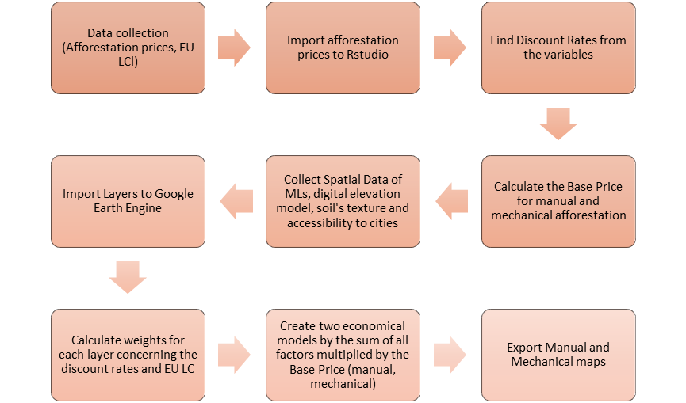
Figure 23 Methodology’s Workflow of the economical afforestation model of ML
    - Base Price Calculation
Using as reference site the Spanish website ‘Tarifas Tragsa’, the prices for forest plantation were calculated. Three basic operations as the opening a hole on the ground (manually or mechanically), the plantation of one tree and the covering of the ground hole were taken into account in order to define the base price of planting a single tree. Since there were many factors that influence the price such as the slope of the ground (<50% or >50 %), the density of the trees (<700 or >700), the consistence of the soil (loose, transit, rocky) and the dimension of the hole (60x60x60 cm), an RStudio-script was created for the definition of the base price and the percentage by which each factor influences the base price.
After running the script, the outcoming result was the base price by a manual way of planting a tree was 16.51 euros and the mechanical way was 5.28 euros.
    - Data Collection and Discount Rates
While the aim of this procedure is to illustrate the factors that influence the price of tree plantation in marginal lands, the factors that were taken into account from the above process were the slope and the soil consistence. When slope is less or equal to 50% influences the price at -9% and when it is above 50% at 9%. When the soil is loose the price is influenced at -60%, when it is transit at 16% and when it is rocky at 45%.
Google Earth Engine (GEE) was used for the economical model creation. First of all, the most important map of Marginal Lands which produced in task 2.3 of MAIL Project, imported in the platform of Google Earth Engine. Spatial data such as Digital Elevation Model (GTOPO30: Global 30 Arc-Second Elevation), Accessibility to Cities 2015 (Travel time to the nearest densely populated area), Texture of the soil by USDA Systems, were collected from Google Earth Engine’s data Catalog. Moreover, due to the fact that the price of labor differs from country to country, Labor Cost level (LCl) which concerns compensation of employees plus taxes minus subsidies, (more analytically, industry, construction and services, except public administration, defense, compulsory social security) collected from Eurostat. The countries prices estimated as weights using as base country the Spain since the data for the computation of the base price came from there. In order to spatialize the LCl prices Nuts 0 shapefile was also collected by Eurostat and combined, by the join tool in ArcMap, with LCl values.
ML’s map has four classes, class 0, 1, 2 and 3, where 0 marginal land does not exist, 1 defined as Marginal lands with high plantation suitability, 2 as Marginal lands with low plantation suitability and 3 as potentially unsuitable lands. Since the aim of the model is the afforestation, ML map reclassified as binary map considering 0, 2 and 3 classes as 0 and class 1 as 1. This binary ML map multiplied by the base prices (manual and mechanical).
Furthermore, for the calculation of the distance of any ML to the nearest populated city, weights had to been calculated using the following equation:
$$W_{acc}=1-\frac{b_{i}}{b_{max}}$$
Where, W_{acc} is the weight of the accessibility to cities, b_{i} is each value of accessibility to cities map (defined in hours) and b_{max} is the maximum value of accessibility to cities map. This new layer came out from the above equation multiplied with the ML binary map.
The Nuts level 0 shapefile with the weights of the LCl rasterized in GEE and the multiplied as well with the ML binary map.
From the Digital Elevation Model, the slope was estimated by the function of Terrain.slope in GEE and converted from degrees to percentage. The slope reclassified into two categories of less than equal to 50% and greater than 50% and revalued as -0.09 and 0.09, respectively.
The Texture of the soil USDA layer is separated by twelve classes: clay, silty clay, sandy clay, silty clay loam, clay loam, sandy clay loam, silt, silt loam, loam, sandy loam, loamy sand and sand. These classes were reclassified to three, so clay, silty clay, sandy clay and silty clay loam assumed as loose soil and got the value of -0.6, the classes clay loam, sandy clay loam, silt and silt loam assumed as transit soil and got the value of 0.16 and the last loam, sandy loam, loamy sand and sand classes assumed as rocky soil and got the value of 0.45.
The European economic model for the forestation planting was calculated by the following equations for manual and mechanical way of plantation:
$$manual={bp}_{man}*W_{acc}+{bp}_{man}*W_{LCl}+{bp}_{man}*W_{sl}+{bp}_{man}*W_{soil}$$
$$mechanical={bp}_{mec}*W_{acc}+{bp}_{mec}*W_{LCl}+{bp}_{mec}*W_{sl}+{bp}_{mec}*W_{soil}$$

Where, bp_{man} and bp_{mec} are the manual and the mechanical base prices, respectively, W_{acc} is the weight of the accessibility to cities, W_{LCl} is the weight of LCl based on Spain, W_{sl} is the weight of slope and W_{soil} is the weight of soil texture.
It should be noted that this model does not take into account the cost of seedling, the different tree species, the maintenance of the trees after planting, any biological condition of the soil or local conditions.
- Results of the economical model
The results of the economical model are illustrated in the two figures below. The first figure shows the cost by manual soil preparation. The redder the color the more expensive is the planting. The second figure represents the cost of mechanical soil preparation. The second figure shows a clear difference in the price comparing to the first figure. The model estimates the cost of planting trees based on the distance of the cities and the labor cost of each country and this is the reason why some isolated areas, as well as the wealthier countries, are presented more expensive in both maps.
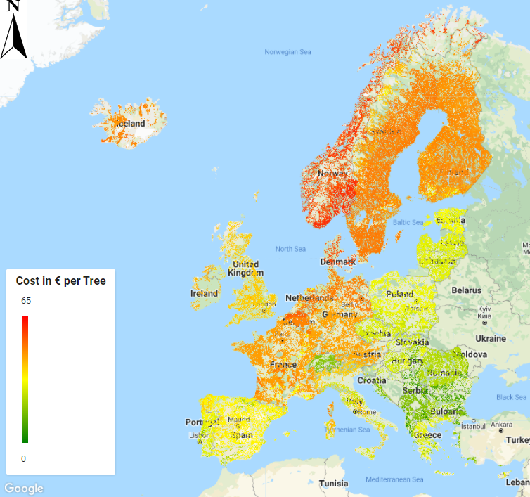
Figure 24 Cost of manual soil preparation
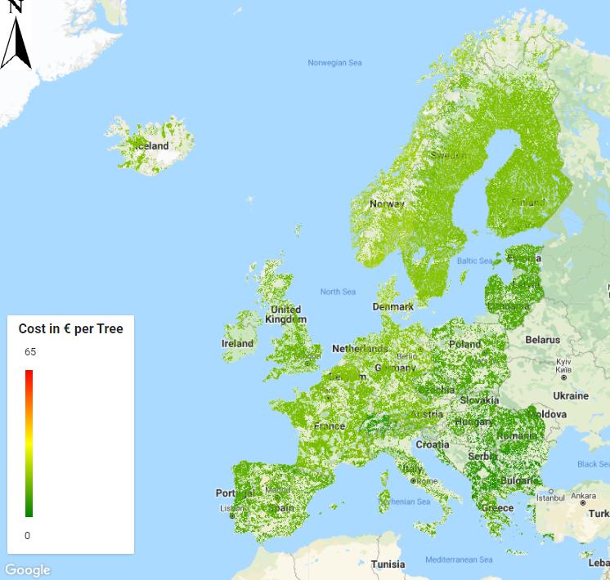
Figure 25 Cost of mechanical soil preparation
The table below shows the average price, in euros, per European country for planting 1,000 trees per hectare. It represents the cost of tree plantation (opening a hole, planting, covering the hole) in a mechanical and manual way using as parameters the slope of the terrain, the soil texture and labor cost of each country and the distance from the cities. The difference on the price between those two methods of planting (manual and mechanical) is significant. The average price in Europe for the manual planting is approximately 32,500 € and for the mechanical planting 11,000 €.
Table 22 Average prices, in euros, per European country for planting 1,000 trees per ha
Countries | Average Price (€) of Manual Planting of 1000 trees | Average Price (€) of Mechanical Planting of 1000 trees
Albania | 13,667 | 4,638
Andorra | 43,675 | 14,823
Austria | 43,474 | 14,755
Belgium | 48,458 | 16,446
Bosnia and Herzegovina | 16,207 | 5,501
Bulgaria | 18,844 | 6,396
Croatia | 19,154 | 6,501
Cyprus | 26,616 | 9,033
Czech Republic | 27,715 | 9,406
Denmark | 55,646 | 18,886
Estonia | 30,764 | 10,441
Finland | 45,649 | 15,493
France | 44,664 | 15,159
Germany | 45,161 | 15,327
Greece | 26,582 | 9,022
Hungary | 24,206 | 8,216
Iceland | 48,468 | 16,450
Ireland | 42,582 | 14,452
Italy | 35,490 | 12,045
Latvia | 28,744 | 9,756
Liechtenstein | 18,398 | 6,244
Lithuania | 28,177 | 9,563
Luxembourg | 48,856 | 16,581
Monaco | 37,795 | 12,827
Montenegro | 15,814 | 5,367
Netherlands | 43,516 | 14,769
Norway | 54,338 | 18,442
Poland | 27,360 | 9,286
Portugal | 29,916 | 10,153
Romania | 21,885 | 7,428
Serbia | 15,307 | 5,195
Slovakia | 26,655 | 9,047
Slovenia | 30,044 | 10,197
Spain | 33,400 | 11,336
Sweden | 45,303 | 15,376
Switzerland | 17,457 | 5,925
The former Yugoslav Republic of Macedonia | 15,325 | 5,201
- Discussion
The expenses of planting 3 billion trees through artificial regeneration/afforestation were assessed by the European Commission. For the first 15-20 years, cost estimates for soil preparation, planting, and care are based on a previous study (Di Fulvio et al., 2016) that has been scaled to all EU Member States. Estimates were produced based on a density of 1,500 trees per hectare, requiring two million hectares of land and a seedling price of 0.52 EUR. The costs are for the year 2020, and there are no assumptions about the species or leaf type, biogeographic conditions, or local situations. In practice, costs can vary greatly depending on site characteristics like as terrain and access, water availability, proper species selection, soil conditions, and preparation and maintenance methods. The figures in the tables below are approximations based on ideal planting and tree development conditions. These costs are lower than the EU average of 4,000 EUR per hectare under CAP (European Commission, 2019). Costs can increase to and even exceed 10,000 EUR per hectare in certain circumstances (European Economic Interest Grouping, 2018).
Table 23 Planting cost estimation by European Commission (Source: European Commission, 2021d)
Member State | Soil  preparation  [€] | Minimum  for planting  & thinning  [€] | Maximum  for planting  & thinning  [€] | Total  average  minimum,  [€/ha] | Total  average  maximum,  [€/ha]
Austria | 650 | 1,016 | 2,084 | 2,446 | 3,514
Belgium | 512 | 1,080 | 1,483 | 2,373 | 2,775
Bulgaria | 455 | 382 | 537 | 1,618 | 1,773
Croatia | 493 | 575 | 809 | 1,849 | 2,083
Cyprus | 650 | 687 | 1,321 | 2,118 | 2,752
Czechia | 447 | 575 | 809 | 1,802 | 2,036
Denmark | 463 | 998 | 1,366 | 2,242 | 2,610
Estonia | 400 | 571 | 782 | 1,752 | 1,962
Finland | 499 | 1,067 | 1,501 | 2,346 | 2,780
France | 564 | 1,019 | 2,093 | 2,364 | 3,437
Germany | 526 | 940 | 1,929 | 2,246 | 3,235
Greece | 612 | 680 | 1,396 | 2,072 | 2,789
Hungary | 439 | 487 | 667 | 1,707 | 1,887
Ireland | 536 | 808 | 1,139 | 2,124 | 2,455
Italy | 659 | 862 | 1,770 | 2,301 | 3,209
Latvia | 409 | 561 | 768 | 1,751 | 1,957
Lithuania | 387 | 505 | 691 | 1,673 | 1,859
Luxembourg | 510 | 1,064 | 1,498 | 2,355 | 2,789
Malta | - | - | - | 781 | 781
Netherlands | 463 | 988 | 1,350 | 2,232 | 2,594
Poland | 421 | 453 | 637 | 1,654 | 1,838
Portugal | 497 | 579 | 816 | 1,856 | 2,093
Romania | 463 | 398 | 816 | 1,642 | 2,060
Slovakia | 470 | 563 | 792 | 1,814 | 2,043
Slovenia | 566 | 682 | 1,400 | 2,029 | 2,747
Spain | 528 | 722 | 1,483 | 2,031 | 2,791
Sweden | 527 | 1,248 | 1,757 | 2,555 | 3,064
The parameters that the European Commission considered for the afforestation cost estimation are significantly different with the parameters of this Task. As it is referred before, the costs can increase to and even exceed 10,000 EUR per hectare which is very close to the results of the mechanical way of planting. In the model that has been developed in this Task there might be an overestimation of the prices, but this was the first approach for this economical model with specific and limited parameters. This can be a base for further analysis and research.
- Analysis of identified sustainable development indicators and aspects in marginal lands
In this chapter, the sustainability aspects identified in chapters 4,5,6 are analysed in a temporal scale for Europe. Each aspect was related with several indicators that monitor the evolution of the sustainable development in the marginal lands. Seemingly, the indicators selected to identify each sustainability aspect can be related with economic, environmental and social variables. Next the indicators identified for the sustainability aspects are summarised:
Table 24. Indicators identified for the sustainability aspects.
Aspect | Indicator
Financial | Costs | Implementation plan
 |  | Permissions
 |  | Accreditation
 |  | Land acquisition
 |  | Establishment Costs
 |  | Management Costs
 | Income | tCO2 e Price
 |  | Non Wood Products
 |  | Social services
 |  | Ecological services
 |  | Biosphere services
Social | Employment
 | Recreation
 | Education
 | Harvesting of non wood products
 | Hunting
 | Tourism
 | Health and well being
Environmental | Increase biodiversity
 | Soil improvement, restoration
 | Erosion
 | Carbon sequestration
 | Better health
 | Protective function
The dataset selected to identify the variables for the indicators of sustainability development aspects was Eurostat. To find indicator related variables the Eurostat dataset was explored using the Eurostat R package. Here, the indicator names were used to search for meaningful datasets. However, this method did not retrieve a satisfying output, as few datasets existed containing the indicator names. In addition, among the different findings, usually there were repetitions of a given dataset in different resolutions. Therefore, this method was not useful to extract the desired information.
The results for the queries are reflected in Table 25,
Title | Code | Type | Last Update Of Data | Last Table Structure Change | Data Start | Data End | Values
Estimated soil erosion by water, by erosion level, land cover and NUTS 3 regions (source: JRC) | aei_pr_soiler | dataset | 18.12.2019 | 08.02.2021 | 2000 | 2016 | NA
Estimated soil erosion by water, by erosion level, land cover and NUTS 3 regions (source: JRC) | aei_pr_soiler | dataset | 18.12.2019 | 08.02.2021 | 2000 | 2016 | NA
Estimated soil erosion by water - area affected by severe erosion rate (source: JRC) | t2020_rn300 | table | 08.02.2021 | 08.02.2021 | 2000 | 2016 | NA
Estimated soil erosion by water - area affected by severe erosion rate (source: JRC) | sdg_15_50 | table | 08.02.2021 | 08.02.2021 | 2000 | 2016 | NA
Estimated soil erosion by water - area affected by severe erosion rate (source: JRC) | sdg_15_50 | table | 08.02.2021 | 08.02.2021 | 2000 | 2016 | NA
Average carbon dioxide emissions per km from new passenger cars | t2020_rk330 | table | 08.02.2021 | 08.02.2021 | 2000 | 2017 | NA
Table 26 and Table 27; one for each sustainability aspect:
Table 25 Environmental datasets found in the Eurostat database
Title | Code | Type | Last Update Of Data | Last Table Structure Change | Data Start | Data End | Values
Estimated soil erosion by water, by erosion level, land cover and NUTS 3 regions (source: JRC) | aei_pr_soiler | dataset | 18.12.2019 | 08.02.2021 | 2000 | 2016 | NA
Estimated soil erosion by water, by erosion level, land cover and NUTS 3 regions (source: JRC) | aei_pr_soiler | dataset | 18.12.2019 | 08.02.2021 | 2000 | 2016 | NA
Estimated soil erosion by water - area affected by severe erosion rate (source: JRC) | t2020_rn300 | table | 08.02.2021 | 08.02.2021 | 2000 | 2016 | NA
Estimated soil erosion by water - area affected by severe erosion rate (source: JRC) | sdg_15_50 | table | 08.02.2021 | 08.02.2021 | 2000 | 2016 | NA
Estimated soil erosion by water - area affected by severe erosion rate (source: JRC) | sdg_15_50 | table | 08.02.2021 | 08.02.2021 | 2000 | 2016 | NA
Average carbon dioxide emissions per km from new passenger cars | t2020_rk330 | table | 08.02.2021 | 08.02.2021 | 2000 | 2017 | NA
Table 26 Social datasets found in the Eurostat database
Title | Code | Type | Last Update Of Data | Last Table Structure Change | Data Start | Data End | Values
Public expenditure on culture, recreation and religion | cult_gov | folder | NA | NA | NA | NA | NA
Public expenditure on recreation and sport | sprt_gov | folder | NA | NA | NA | NA | NA
HICP - recreation and culture | teicp090 | table | 17.03.2021 | 17.03.2021 | 2020M03 | 2021M02 | NA
HICP - recreation and culture | teicp090 | table | 17.03.2021 | 17.03.2021 | 2020M03 | 2021M02 | NA
Tourism statistics by coastal areas (LAU2) | mare | folder | NA | NA | NA | NA | NA
Tourism | degurb_tour | folder | NA | NA | NA | NA | NA
Tourism | med_to | folder | NA | NA | NA | NA | NA
Tourism | tour | folder | NA | NA | NA | NA | NA
Tourism | t_tour | folder | NA | NA | NA | NA | NA
Table 27 Financial datasets found in the Eurostat database
Title | Code | Type | Last Update Of Data | Last Table Structure Change | Data Start | Data End | Values
Selling prices of animal products (absolute prices) - annual price (from 2000 onwards) | apri_ap_anouta | dataset | 11.05.2020 | 08.02.2021 | 2000 | 2019 | NA
Selling prices of animal products (absolute prices) - annual - old codes - data from 1969 to 2005 | apri_ap_haouta | dataset | 26.03.2009 | 08.02.2021 | 1969 | 2006 | NA
Selling prices of animal products (absolute prices) - monthly - old code - data from 1969 to 2006 | apri_ap_haoutm | dataset | 26.03.2009 | 08.02.2021 | 1969M01 | 2006M09 | NA
Organic production of animal products (from 2012 onwards) | org_aprod | dataset | 16.12.2020 | 08.02.2021 | 2012 | 2019 | NA
Organic production of animal products (until 2011) | org_aprod_h | dataset | 30.03.2016 | 08.02.2021 | 2002 | 2011 | NA
Producer price indices, animals and animal products | tag00050 | table | 08.02.2021 | 08.02.2021 | 1997 | 2008 | NA
As mentioned before, not only repeated variables were found in most of the tables but referred to the same dataset in different aggregation levels. In addition, most of the sustainable indicators could not be matched with a variable in this way. Moreover, the identification of a data by a given name did not guarantee the connection of the dataset with the forest sector or sustainable development. Therefore, some variables could be identified (Tourism, recreation…) but were not related with the forest sector. As a consequence, the search method was changed and the Eurostat databased was manually consulted. As a result, a table was generated relating the Eurostat variables with the indicators found. To organize the result of the query, the datasets were divided depending on the units used to express the variables. Therefore, economic datasets were only used for the financial aspect, whereas variables expressing surface values were typically related with the environmental aspects and social parameters, for instance number of workers were associated with the social aspect of sustainability in economic units. The classification of the datasets is shown in Table 28, where the name of the Eurostat dataset is stated, the variable of interest, the indicators and the sustainability aspect that the variable and indicator refer to.
Table 28.Variables found on Eurostat dataset for both indicators and sustainability aspects

Sustainability aspect | Indicators | Folder | Eurostat related dataset |  | Eurostat code | Variable of interest | Variable code
Financial | (Costs) Implementation plan | forestry (for) |  | Economic aggregates of forestry | for_eco_cp | Other gross fixed capital formation
 |  |  |  |  |  | GFCF - equipment and buildings | P51G_EQBL
 |  |  |  |  |  | GFCF - planting of trees for regular income | P51G_PTR
 | (Costs) Permissions | Not found
 | (Costs) Accreditation
 | (Costs) Land acquisition |  |  | Economic accounts for forestry - values at current prices | for_eaf01 | Costs linked to the purchase of land and production rights | G_OCOS
 |  | forestry (for) |  | Economic aggregates of forestry | for_eco_cp | Consumption of fixed capital | P51C
 | (Costs) Establishment Costs |  |  | Economic accounts for forestry - values at current prices | for_eaf01 | Maintenance of materials | C_MAT
 |  |  |  |  |  | Maintenance of buildings | C_BLD
 |  | forestry (for) |  | Economic aggregates of forestry | for_eco_cp | Compensation of employees | D1
 | (Income) tCO2 e Price | Not found -
 | (Income) Non Wood Products |  |  | Supply and use of products within forestry | for_sup_cp | Non-wood products | P1_NW
 | (Income) Social services |  |  | Economic accounts for forestry - indices: volume, price, values | for_eaf04 | Forestry services output | O_SER
 |  |  |  |  |  | Forestry services | C_SER
 |  |  |  |  |  | Other goods and services | C_OTH
 | (Income) Ecological services | Not found
 | (Income) Biosphere services
 | (Income) Other services |  |  | Telecommunication masts |  | wind farms and electricity distribution among others.
Social | Employment | forestry (for) |  | Annual work units in forestry and logging | for_awu
 |  |  |  | Employment in forestry and forest-based industry | for_emp_lfs
 |  |  |  | Employment in forestry and forest-based industry - Nace Rev.1.1 | for_emp_lfs1
 | Recreation |  |  | Time spent, participation time and participation rate in the main activity by sex and educational attainment level (tus_00educ) | tus_00educ | Walking and hiking | AC611
 | Education | Not found
 | Harvesting of non wood products
 | Hunting
 | Tourism
 | Health and well being
Environmental | Increase biodiversity | Biodiversity (t_env_biodiv) |  | Surface of terrestrial sites designated under Natura 2000 (source: DG ENV, EEA) | sdg_15_20
 | Soil improvement, restoration | Not Found
 | Erosion |  |  | Estimated soil loss by water erosion by land cover type (source: JRC) | tai10
 | Carbon sequestration | Not found
 | Better health
 | Protective function | forestry(for) |  | Environmental functions (for_sfmen) | for_profn | Protective functions of forests
 |  |  |  |  | for_proct | Protected forests and forests under Natura 2000

The manual search increased the number of findings of meaningful variables for the three sustainable development aspects. Particularly, the Eurostat dataset offered extensive information on economic data. On the other hand, many forest related variables were not found for the social aspects (education, harvesting of non-wood products, hunting, tourism, health and wellbeing) and only data for the employment and the recreation indicators could be reported.
- Data representation and normalization
Once the variables were identified for each indicator, the data had to be represented over time for the European Union countries. However, the interpretation of the temporal evolution of the variables for more than 20 countries can be difficult. Therefore, the information was aggregated in regional groups following the classification of EuroVoc, that divides Europe in 4 regions, Central and Easter Europe (CEE), Northern Europe (NE), Southern Europe (SE) and Western Europe (WE).
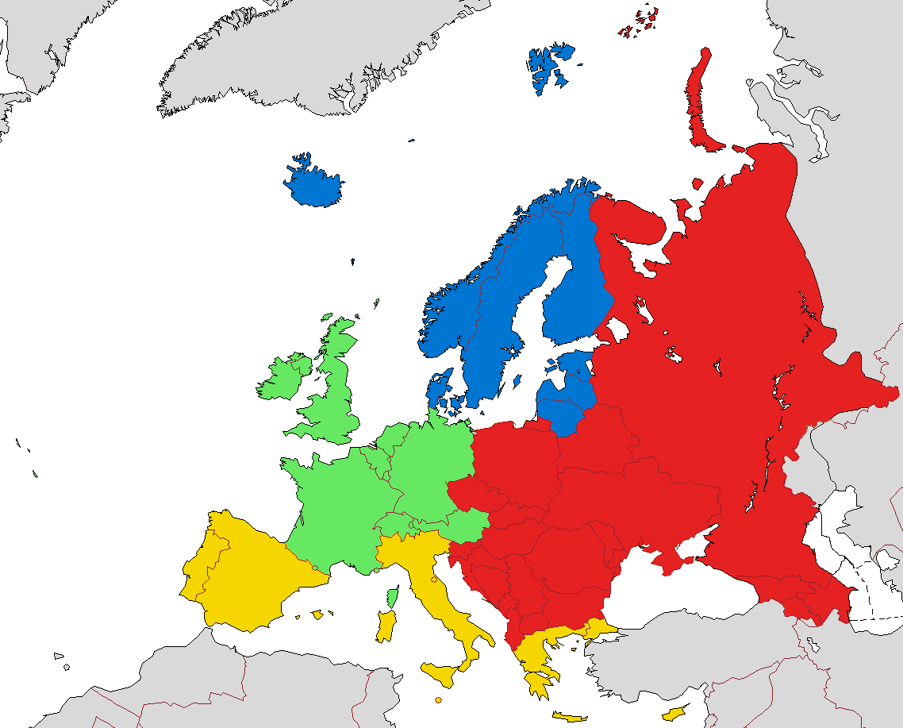
Central and Eastern Europe
Northern Europe
Southern Europe
Western Europe

Figure 26. European regional groups by EuroVoc. Map by Samotny Wędrowiec based on this design: https://commons.wikimedia.org/wiki/File:Map_of_Europe_(political).png, CC BY-SA 3.0, https://en.wikipedia.org/w/index.php?curid=42792537.
When aggregating the data in groups, the dimensionality of the data is changed and the comparison between groups becomes confusing. To compare the different groups, the data must be normalized according to a given unit or factor. The unit or factor to normalize by was selected depending on the nature of the data. Given that the sustainability aspects are 3: Social, Environmental and Financial, those same 3 categories were used for selecting the datasets. In addition, the datasets chosen for data normalization were grouped by regional groups and countries.
- For environmental data normalization, the forest area is introduced as one of the key factors to determine how the environmental aspects are distributed in the forested area of the regional groups
- The social aspects will be normalized majorly with the number of workers associated to a given economic activity. These datasets are used as well in the normalization of economic data.
- Economic data are normalized by the Gross Value Added (GVA) of the forest sector, which is the contribution of the forest sector to the Gross Domestic Product (GDP).
- Financial
In this section the indicators are referred to the economical aspect of the sustainability, and they are categorized in Costs and Income. Therefore, the data gathered in this section is economic and the variables are expressed in euros.
    - Implementation plan (Costs)
The datasets related to the implementation costs of an environmental project were found in a forest economic aggregate dataset where equipment and tree plantation are considered. These datasets were normalized by the GVA of the forestry sector.

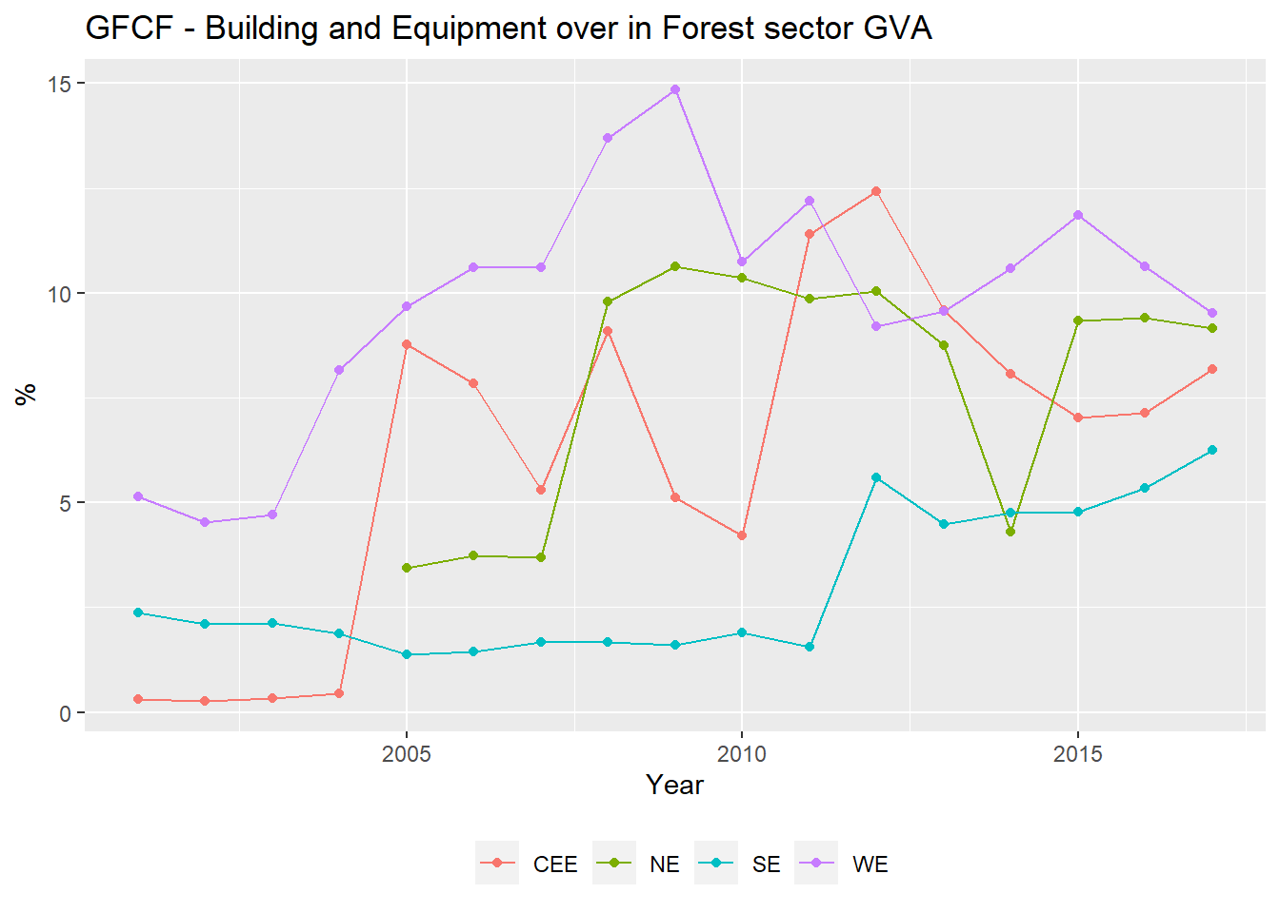
Figure 27 Costs. GFCG Building and Equipment over Forest Sector GVA
The percentage of the gross fixed capital formation destined to building and equipment has experienced an increase for the whole European region, ranging from 0 to 5% in the beginning of the 2000s to 5% to almost 10%. The investment on the fixed capital has evolved steadily for Southern Europe from the ten first years of the 21st century, from this point on the trend has increased, surpassing the 5% of the GVA in the forestry sector. The evolution of the Central and Eastern Europe has evolved erratically, presenting abrupt changes from 2005 to 2010. Northern Europe fluctuated around the 10% of the GVA, with a big drop of its contribution (5%) in 2014. Finally, Western Europe incremented his expenditure on Building and Equipment ten perceptual points between 200 and 2009. Next years, it was reduced to approximately the 10%.
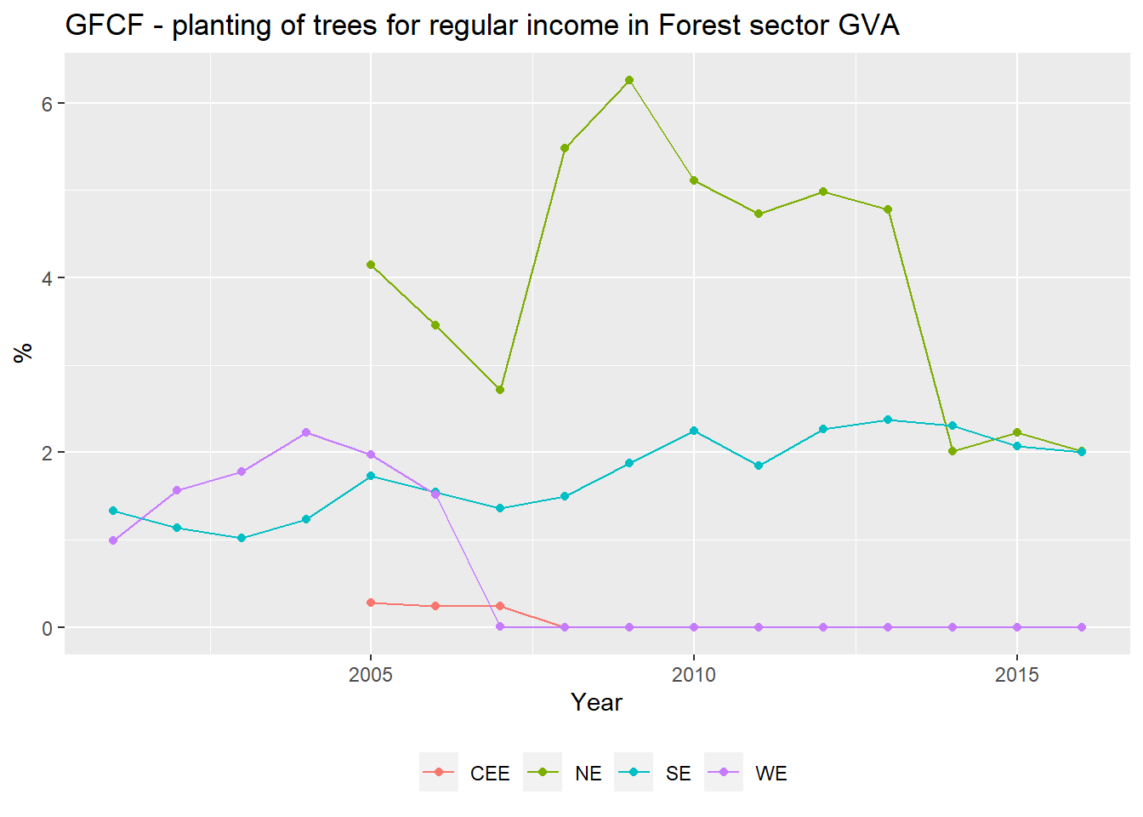
Figure 28 Costs. GFCF planting of trees for regular income in Forest sector GVA
The GFCF of the planting trees for the regular income in the Forest sector is harder to interpret for Western and Central and Eastern Europe as the reporting rate of their countries is low and, as of 2008, there is no data recorded for these countries. On one hand, Southern Europe have increased its GFCF participation over the GVA has slowly increased, stabilizing its value in 2%. On the other hand, Northern Europe has decreased their plating trees cost from its maximum value, 6% in 2009, to 2% in 2016.
    - Management Cost
The management cost was acquired from two different datasets: ‘Economic accounts for forestry - values at current prices’ from which the maintenance of materials was considered and ‘Economic aggregates of forestry’ where the economic compensation for forestry workers was regarded.
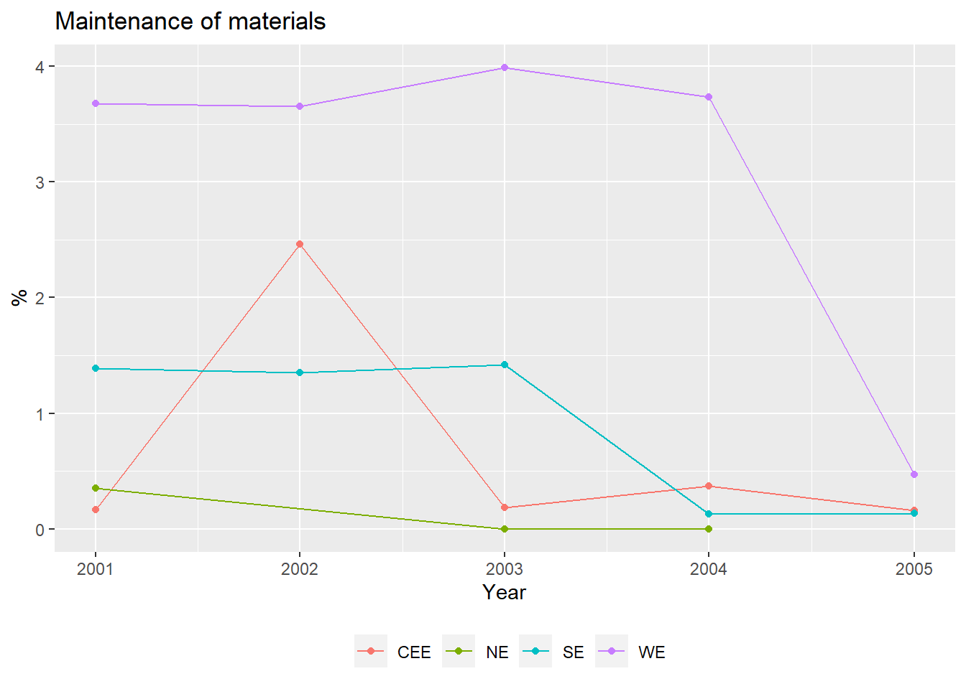
Figure 29. Costs. Maintenance of materials in the Forest sector GVA
The material maintenance does not represent a meaning full portion of the GVA of the forestry sector occupying a less than a 4% in Europe. Finally, it drops down to less than 1%. The short temporal resolution does not allow further interpretation of the data.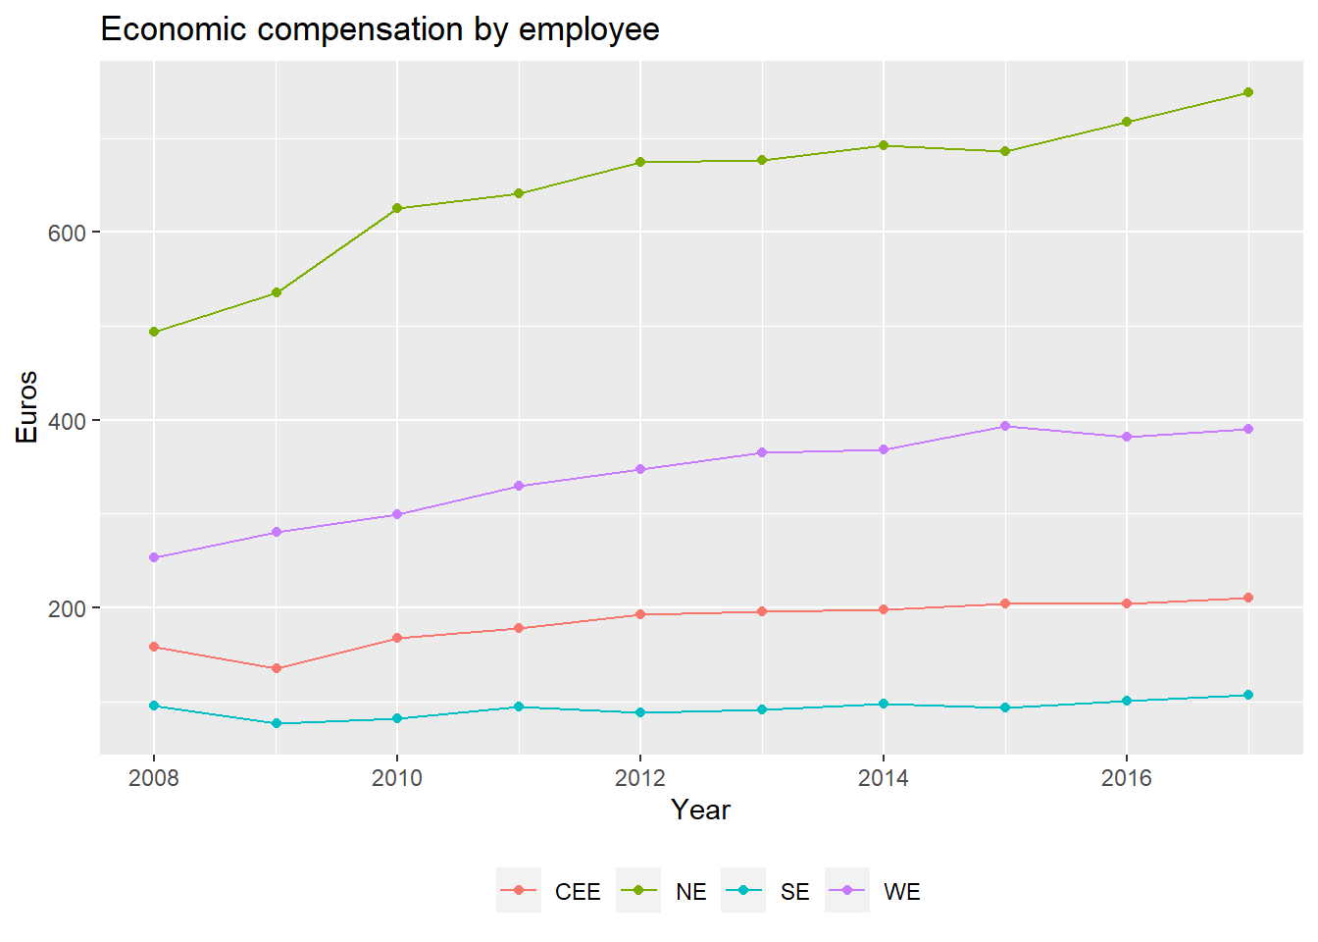
Figure 30. Costs. Economic compensation by employee.
The economic compensation by employee was represented using the economic compensation values (in million euros) and it was distributed for all the workers in the forestry sector. In Figure 30, it is shown how the economic compensation has remained almost constant for 2 regional groups, Eastern and central Europe and Southern Europe, whereas for both, Western and Northern Europe, the trend is to increase the compensation rates by worker. In case of Western Europe, the values have almost doubled since 2008, from 250 to 400 euros, whereas in Northern Europe the increment ranges from 500 euros to 750 euros.
    - Non wood products (Income)
The income obtained from noon wood products was obtained from the Eurostat indicator ‘Supply and use of products within forestry’ and it was normalized by the GVA of the forest sector.
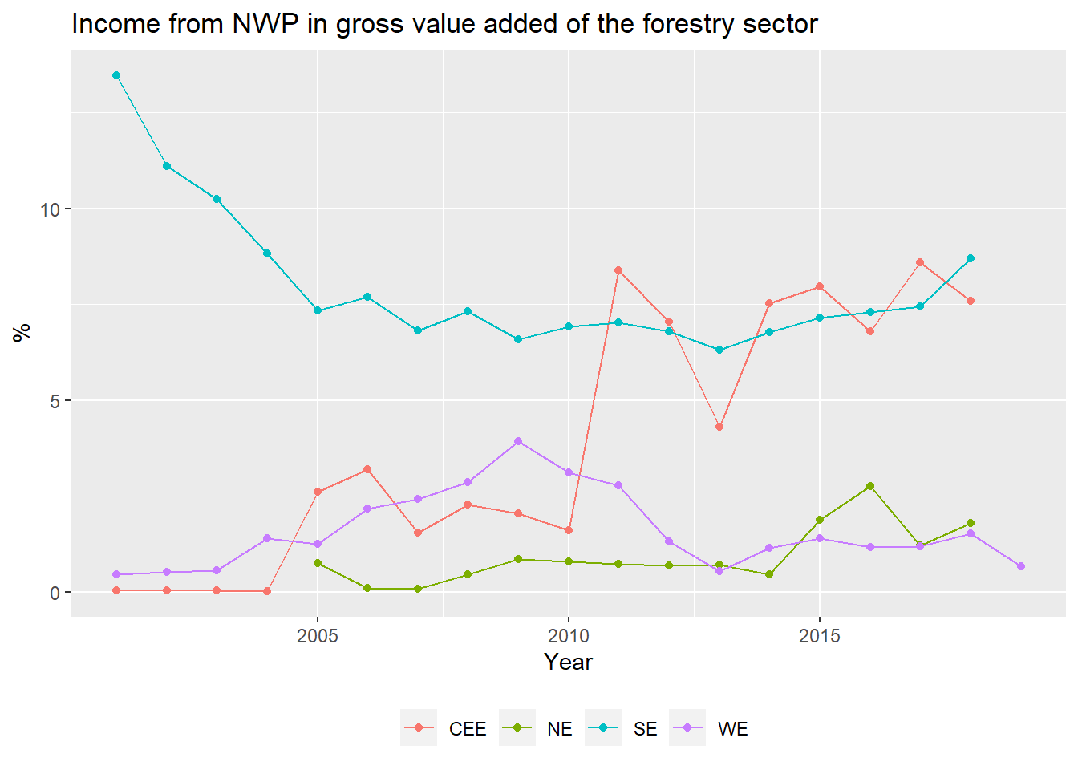
Figure 31. income from NWP in gross value added of the forestry sector
Figure 31 represents the contribution of the Non Wood Products to the total GVA of the forestry sector. For Central and Easter Europe the participation of the NWP on the GVA has increased up to a 10% in 20 years. On the other hand, Southern Europe NWP’s contribution to the GVA has decreased in the first five years of the 2000’s to finally stabilize around 7%, whereas in Western and Northern Europe the share of NWP in The GVA is almost nonexistent with shares lower than 2%. The low values on the NWP for Western Europe and Northern Europe can be meaningful to identify a future source of income and revalorization of the forest froducts.
    - Services (Income)
The income from services derived from forestry are considered in ‘Economic accounts for forestry - values at current prices. Two services were found: forest services (environmental or social) and other services. Plotting the income of forest services and other services by forest surface (in thousands of ha). The normalization is performed using the area values in thousands of hectares over the services are referred by the million euros. Therefore, multiplying by 1000 we obtain the value Euros by ha. The results are shown in Table 29:
Table 29. Income provided by forest services by hectare for the regional groups. Forest Area is represented in thousands of hectares. Forest services in Millions of Euros.
Time | Regional Group | Forest Services | Forest Area | Euros/ha
1990-01-01 | Northen Europe | 122.1432 | 75678.80 | 1.6140
1990-01-01 | Southern Europe | 41.0005 | 46101.94 | 0.8893
1990-01-01 | Western Europe | 352.1945 | 37330.30 | 9.4345
2000-01-01 | Central and Eastern Europe | 3.9726 | 31986.50 | 0.1242
2000-01-01 | Northern Europe | 340.0000 | 76413.32 | 4.4495
2000-01-01 | Southern Europe | 42.9749 | 48335.84 | 0.8891
2000-01-01 | Western Europe | 1113.1617 | 38466.78 | 28.9382
Given there were only two dates, instead of presenting the data in a graph it was presented in a table. Table 29 represents the value of the forest area for the regional groups in thousands of hectares and the millions of euros in forest services. Dividing the Forest services by forest area and multiplying by 1,000 then we obtain the forest services in euros by hectare. The table shows that Northern and Western Europe have increased the value of the forest services per ha in the period 1990 – 2000, from 1.614 to 4.449 euros by ha. On the other hand, the values for southern Spain have remained constant for the given period. Alternatively, the same phenomenon is appreciated for the countries regarding the other forest services. Increase for Northern and Western Europe, where in Southern Europe remains almost constant, although here a slight increase is appreciated.
Table 30 Income provided by other forest services by hectare for the regional groups
Time | Reg_Groups | Other Services | Forest Area | Euro/ha
1990-01-01 | Southern Europe | 31.7622 | 46101.94 | 0.6890
1990-01-01 | Western Europe | 447.3426 | 37330.30 | 11.9837
2000-01-01 | Central and Eastern Europe | 0.1586 | 31986.50 | 0.0049
2000-01-01 | Northern Europe | 232.1000 | 76413.32 | 3.0374
2000-01-01 | Southern Europe | 43.1349 | 48335.84 | 0.8924
2000-01-01 | Western Europe | 1009.2137 | 38466.78 | 26.2360
Table 30 contains the economic contribution of other forest economic services by area of forest for the different regional groupings of Europe. As, Table 29 the data was presented in tabular format because of the small number of data points. The information provided is only for the period between 1990 and 2000. For that period, Western Europe experienced an increment in the income provided by the other services in the forest (from 11.98 euros/ha to 26.24 euros/ha) whereas Southern Europe did not significantly change the income by their forest services during that period (0.68-0.89 euros/ha). For Central and Easter Europe and Northern Europe, data for the year 2000 was provided. Thus, no comparison between dates can be performed.
- Social
The analysis on the social aspects of sustainability focused on employment and recreational variables. The variables were extracted from the forestry folder of the Eurostat database. The Eurostat datasets were:
- Employment in forestry and forest-based industry
- Employment in forestry and forest-based industry - Nace Rev.1.1
- Time spent, participation time and participation rate in the main activity by sex and educational attainment level (tus_00educ). For the creation database.
The variables inside the aforementioned datasets were reported in terms of number of workers and hours
    - Employment
The employment datasets described the work units for the different forest activities and the number of people employed in the different forest sector activities by sex and level of education. Next the distribution of the employment in the forest sector is described.
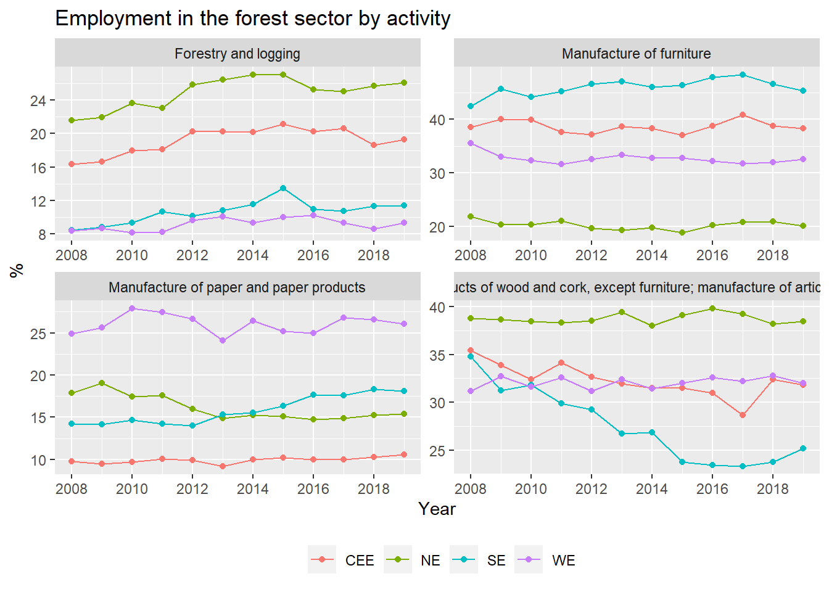
Figure 32. Employment in the forest sector by activity
The employment in the forest sector is divided according to Eurostat in 4 groups: Forestry and logging, manufacture of furniture, manufacture of paper and paper products and products of wood and cork. For Forestry and logging all the regional groups follow the same trend: a soft increase in the employment for the last year. The employment in the manufacture of furniture has remained constant of all the regional groups. Similarly, the same process is appreciated in the manufacture of the paper and paper products. However, here we see that Southern Europe increased the employees in the sector (5%), whereas in Northern Europe this sector shown a loss of employees of 5%. More fluctuations are appreciated in the products of wood and cork sector. First, the strong decrease of the percentage of employees in Southern Europe where the 10% of the employees were lost. This 10% can be explained by the increment of the employment rate in the other forest sectors. Second, Central and Eastern Europe also experienced a decreased in the employment in this sector. However, this decrease was not as steep as the one observed in Southern Spain (10%). Finally, Northern Europe and Western Europe have remained constant.
    - Recreation
Table 31 Mean participation rate in recreational activities in the regional groups
Unit | Time | Reg_Groups | Values
Participation rate (%) | 2000-01-01 | Central and Eastern Europe | 18.3412
Participation rate (%) | 2000-01-01 | Northern Europe | 16.0643
Participation rate (%) | 2000-01-01 | Southern Europe | 26.4818
Participation rate (%) | 2000-01-01 | Western Europe | 12.9158
Participation rate (%) | 2010-01-01 | Central and Eastern Europe | 13.0696
Participation rate (%) | 2010-01-01 | Northern Europe | 19.1375
Participation rate (%) | 2010-01-01 | Southern Europe | 19.1409
Participation rate (%) | 2010-01-01 | Western Europe | 14.3706
The participation rate in the recreation activities (hiking and walking) is described in Table 31. As there are not may data points, a table is presented. Analyzing the table, two trends are observed: increase in the participation rate for Northern (16.1% to 19.1%) and Western Europe (12.9% to 14.4%) and decrease for the Southern Europe (26.48% to 19.44%) and Central and Eastern Europe (18.34% to 13.07%).
- Environmental
The environmental datasets concern the state of conservation of natural areas and the ecosystem functions that they provide. The state of conservation refers to the surface declared as protected and the reason for conservation, as well as the erosion rate by land cover. On the other hand, the ecosystem functions account for the percentage of protected areas that are actually providing of a protective ecosystem function.
    - Increase biodiversity
Surface of terrestrial sites designated under Natura 2000 in % or km² by country following the Sustainable Development Goal 15.2
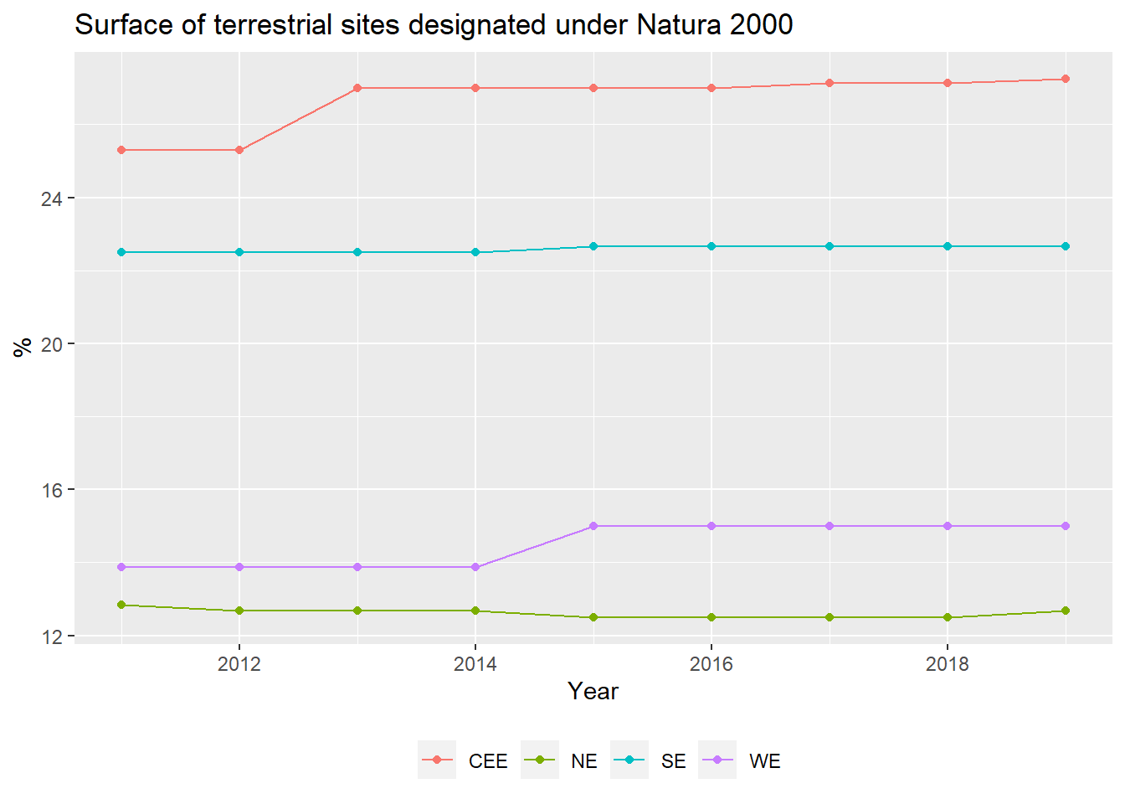
Figure 33 Surface of terrestrial sites designated under Natura 2000
Figure 33 shows that the surface designated under Natura 2000, has not changed meaningfully in the period between 2011 and 2019. There was only a small increment in the area under Natura 2000 for Central and Easter Europe and Western Europe.
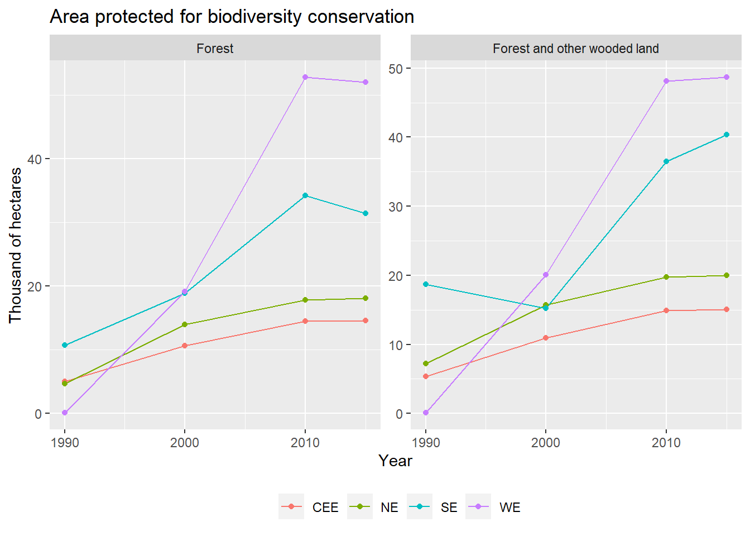
Figure 34. Area protected for biodiversity conversion
The terrestrial biodiversity protected areas designed under the Natural 2000 network have remained almost constant for the period between 2012 and 2020. Only small area increment was appreciated in 2013 for Central and Easter Europe and in 2015 for Western Europe. On the other hand, Southern Europe and Western Europe, greatly increased their protected areas for biodiversity conservation in the period 2000-2010. Increasing a15% of the forest protected area for SE and above a 30% for WE.
    - Erosion
The erosion evolution over time was estimated as the soil loss by water in two land cover types. The information was found in the dataset ‘Estimated soil loss by water erosion by land cover type (source: JRC)’ of the Eurostat database.
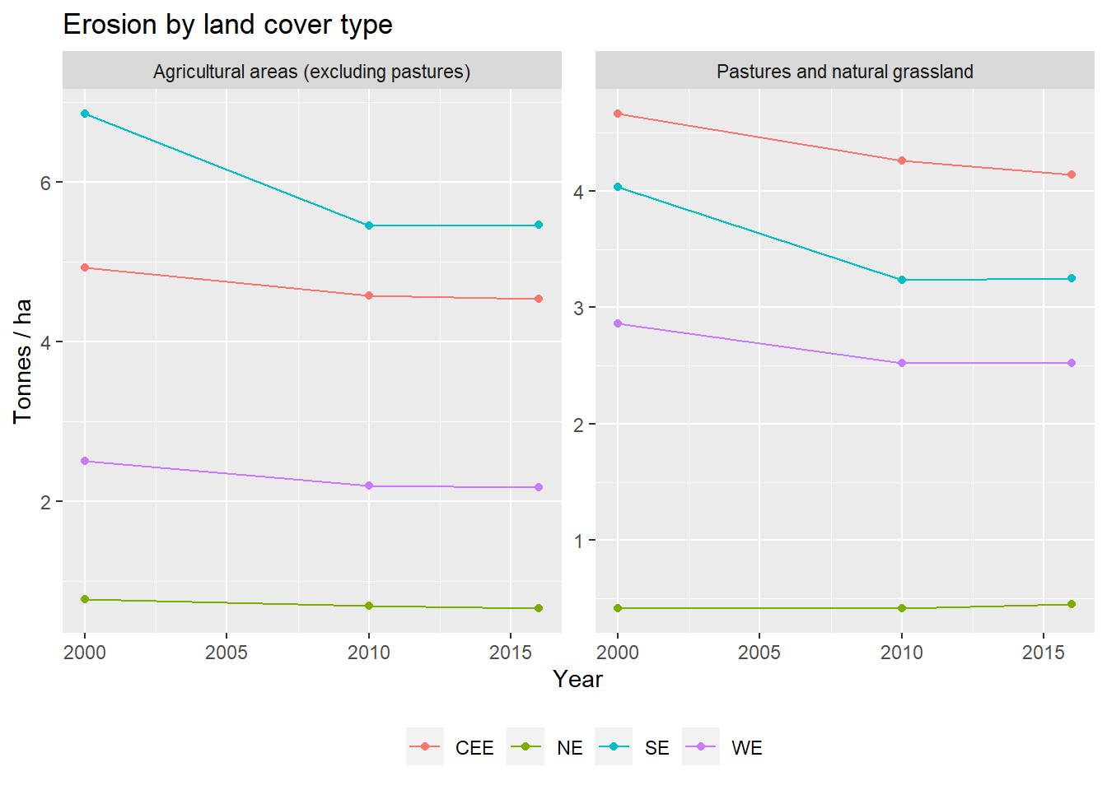
Figure 35 Erosion by land cover type
The erosion rates are represented by land cover type for the different regional groups, the land covers selected were the agricultural lands and the natural grasslands or pastures. Comparing the erosion values between the two different types of land cover we observe that for Western Europe and Central and Eastern Europe the erosion rates for natural pastures and grasslands are higher than for agricultural land, whereas in Northern Europe and Southern Europe agricultural areas are the ones holding the highest rates of erosion. In the Southern European scenario it can be explained by the big influence of dry crops, such as the olive tree crops or the vineyards.
    - Protective function
The datasets identified offer information about the area of forest with protective function in Europe and the area of protected forest in Europe, both datasets refer the information by country and in thousands of hectares The variables were found in the Eurostat forestry folder in the Environmental functions dataset.
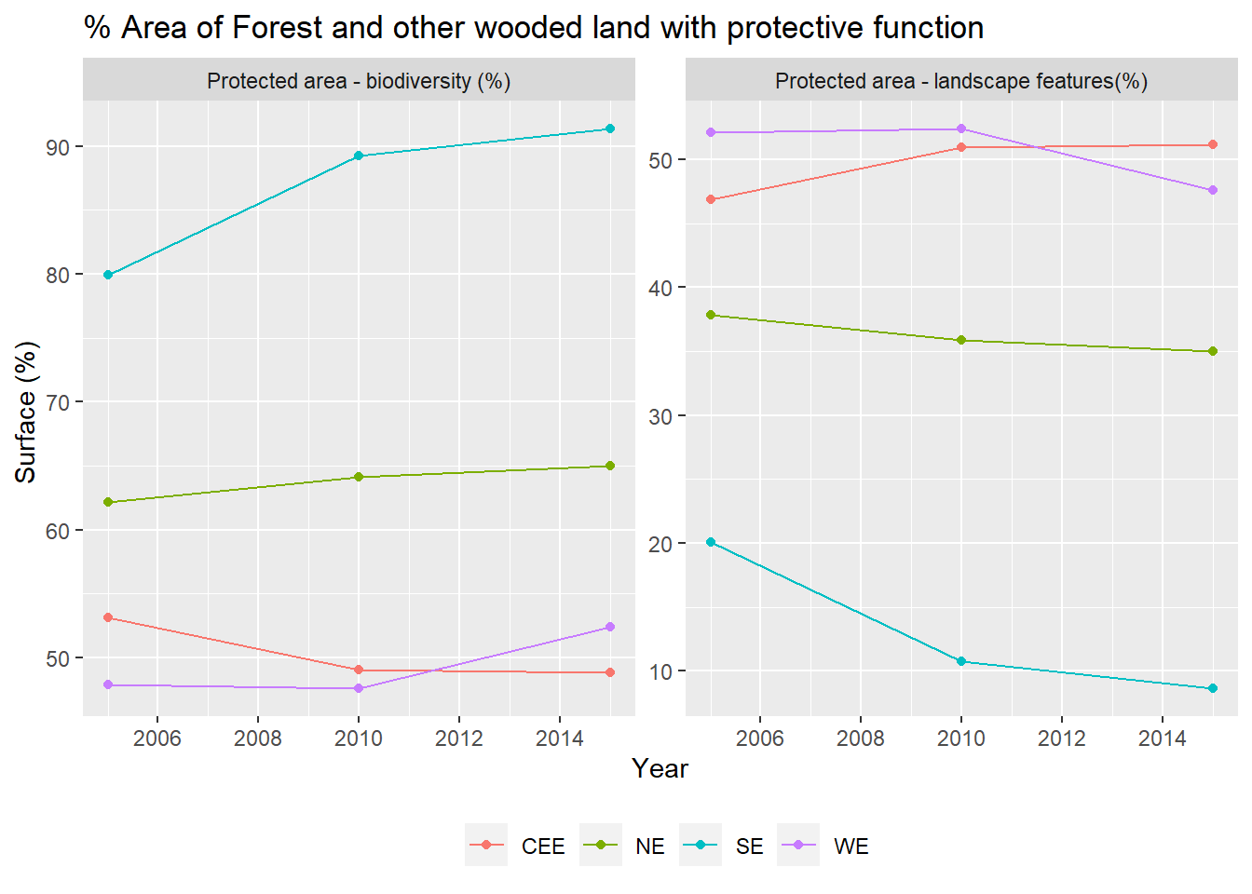
Figure 36 Share of forest and other wooded land that provides a protective function
Figure 36 represents the percentage of protected areas over time in the different regional groups. The percentage of protected areas is divided in protected area for biodiversity purposes and protected area for landscape features. Thus, the aggregation of both curves makes the 100% of the protected area for the regional group. Comparing the two graphs, we can appreciate that for all the regional groups area protection is destined more to the biodiversity protection. In Southern Europe this value surpasses the 90% in 2014, maybe indicating that more biodiversity efforts are being considered in area protection. For the rest of regional groups, the surfaces of protected area are more balanced between the biodiversity or the landscape driven protection oscillating around the 50% (the 65% and 48%) of distribution, between biodiversity protected area and the landscape features.
- Increasing Carbon Sequestration Strategies
Forests have long played a vital role in our economy and culture, supplying jobs as well as food, medicines, materials, and clean water. Forests have been a prospering hub for cultural heritage and craftsmanship, tradition, and creativity for ages. However, they are as vital for our future as they were in the past. Forests are a natural ally in coping with and combating climate change, and they will be critical in making Europe the first carbon-neutral continent by 2050. The risk of zoonotic diseases and global pandemics is reduced when forest ecosystems are protected. As a result, sustaining healthy, biodiverse, and resilient forests across Europe and the world is critical to guaranteeing a healthy future for people, planet, and prosperity. Despite this necessity, European forests are under increasing stress, due to natural processes as well as rising human activity and pressures. While forest area has grown in recent decades as a result of natural processes, afforestation, sustainable management, and active restoration, and while this has resulted in several upward trends, forest conservation status should be greatly improved, particularly in the 27 % of EU forest area that is protected and should be the healthiest (European Commission, 2021a).
Climate change continues to have a severe impact on European forests, notably in places with mono-specific and even-aged forest stands, but not exclusively. Climate change has also revealed previously unknown vulnerabilities, exacerbating other destructive pressures such as pests, pollution, and diseases, as well as affecting forest fire regimes, resulting in conditions where the extent and intensity of forest fires in the EU will increase in the coming years (Costa et al., 2020). Because of harsh weather occurrences and increased harvesting for various economic purposes, tree cover loss has accelerated in the recent decade (Grassi et al., 2021).
According to the Climate Law, the relevant EU institutions and Member States must prioritize rapid and predictable emission reductions while also enhancing natural sink removals in order to meet the 2030 target and the climate neutrality aim. Forests and forest products will play a critical part in meeting the Union's ambitious net removal objective of -310 million tonnes of carbon dioxide equivalents, as outlined in the proposal for a new Regulation on Land Use, Land Use Change, and Forestry (LULUCF) (European Commission, 2021c).
- Sustainable raw wood and non-wood materials and products for a sustainable climate-neutrality
Sustainably produced and long-lived wood-based products can aid in climate neutrality by storing carbon and substituting fossil-based products, particularly through their embodied carbon, which contributes to carbon removal that would otherwise occur through biological processes (European Commission, 2020). Trees emit carbon into the atmosphere at the time of harvest or natural death, for example, through fires, burning for energy, incineration, or natural decaying processes. When converting woody biomass into wood materials and products with a long-life cycle, the carbon removal period can be greatly extended. The LULUCF Regulation (Regulation 841/2018) ensures that Member States record and account for changes in carbon stocks in harvested wood products carbon pools, which will be reinforced under the amended rule proposed as part of the Fit-for-55 package. Harvested wood products in the EU constitute an active net carbon sink of roughly -40 MtCO2e/year, with values ranging from -18 to -43 MtCO2e/year, while also delivering climate benefits through a material substitution impact (Grassi et al., 2021). The longer a product lasts, the better it is for climate mitigation, which is represented in greater net removals under Member States' LULUCF reporting and accounting, as well as indirectly reported and accounted for as reduced emissions in other sectors due to substitution effects.
For forest resilience, climate adaptation, and forest multifunctionality, wood product supply should work in tandem with improving the conservation status of European and worldwide forests, as well as protecting and restoring biodiversity. Wood with high ecological value should not be utilized, and the wood-based bioeconomy should stay within sustainable bounds and be compatible with the EU's 2030 and 2050 climate and biodiversity goals. According to recent studies (Grassi et al., 2021), the possible additional benefits from harvested wood products and material substitution are unlikely to compensate for the loss in the net forest sink associated with increasing harvesting in the short to medium term, i.e. until 2050. Member states should be aware of this risk, which falls within their jurisdiction under applicable legislation (European Commission, 2021b).
Forests provide a number of equally vital secondary products and services, ranging from food to ecotourism, that support the economies and social fabric of rural regions in addition to the wood-based economy. The annual value of all harvested non-wood products in Europe is estimated to be EUR 19.5 billion. This equals approximately to EUR 77,80 per hectare per year. Moreover, 86% of forest products gathered are for personal consumption (Lovrić et al., 2020). The EU Forest Strategy acknowledges and aims to strengthen the overall sustainable forest bioeconomy in order to support the EU's increasing climate and biodiversity goals.
- Skills development and empowerment for a sustainable forest-based bioeconomy
People with a wide range of expertise are behind the delivery of the many services that forests provide. Experts in enhanced sustainable forest management practices, including adaptive reforestation and afforestation and restoration, architects, engineers and designers, food experts, data specialists, chemists, and ecotourism facilitators will be required to play an increasingly multifunctional role in the transition to a sustainable and climate neutral future.
The case for nature-based tourism has a lot of room for expansion. COVID-19 has had a particularly negative impact on the European tourism business, but the pandemic has also stimulated demand for proximity-based tourism and less congested locations in nature and the open air. The growing trend of nature tourism and nature-based wellbeing services offers an opportunity to accelerate the green transition of the tourism sector, provide significant income opportunities in rural areas, and improve rural welfare, while also promoting biodiversity conservation and carbon stock preservation, as long as it adheres to environmental carrying capacity and relevant legislation. The Commission will foster collaboration between the tourism sector, forest owners, and environment protection services, as well as rules and regulations for eco-tourism activities, in order to increase EU forest ecotourism. The tourism sector should collaborate closely with forest management to develop sustainable tourism products that benefit human health while minimizing negative impacts on the natural values of the destinations, particularly in protected areas (European Commission, 2021b).
The Commission will also encourage forestry stakeholders to sign up for the Pact for Skills (European Commision, 2021). The goal of the Pact is to mobilize and incentivize commercial and public sector stakeholders to take action. Commitments from relevant forestry stakeholders, both public and private, to upskill and reskill people for the forestry sector could take a variety of forms, including large-scale collaborations, regional/local partnerships, tripartite agreements, or single-entity commitments. Under the Pact, forest and forestry stakeholders would collaborate to adapt forester education and training to the problems and needs of today's realities. Apprenticeships, especially job-based learning, are critical for attracting young people to the forest bioeconomy and equipping them with the skills they need to work in a sustainable forest bioeconomy. The Commission will continue to foster cooperation and connect learners, students, teachers, and stakeholders on the role of forests, particularly the benefits of outdoor learning, through the Education for Climate Coalition.
- Protecting, restoring and enlarging EU’s forests to combat climate change
Adaptive forest restoration and ecosystem-based management techniques that increase the resilience of EU forests are urgently needed in light of climate change and biodiversity loss. This is a must for forests to continue to fulfil their socioeconomic and environmental duties for future generations, as well as to support a thriving forest-based bioeconomy for decades. But it's also about avoiding rising socioeconomic costs from forest disasters, protecting people, land, and homes from floods, fires, and landslides, and preserving the carbon stock and sink function, as well as other ecosystem services provided by forests that are essential for human health and well-being, such as clean air, water regulation, and habitat for the diverse living species they support.
To promote forest resilience and adaptability, forest biodiversity must be protected and restored, and biodiversity-friendly forest management methods must be used. If forest owners and managers are adequately supported during the transition, this is also a wonderful economic opportunity. Forest protection, restoration, and sustainable management, according to the World Economic Forum, may produce EUR 190 billion in economic prospects and 16 million employments globally by 2030 (Max Hall Public Engagement & Russo, 2020).
Furthermore, in the face of enormous uncertainty about the future of forests, it is required comprehensive risk-reduction strategies. Forest change is a result of climate change. The vegetation zones of Europe have begun to migrate higher and northwards, causing forest ecosystems to change in most areas. This suggests that only a small percentage of forests will be unaffected by climate change or will not require rapid treatment to lessen their sensitivity to climate change. Forest owners and managers all around Europe are well aware of climate change and concerned about its consequences. This awareness must be turned into sufficient and practical adaptation activities and resilience-enhancing forest management practices on a more regular basis. Technical expertise and information, as well as appropriate regulatory and financial incentives and support, must be generated in order to accomplish this. This Strategy intends to address these concerns by assisting forest owners and managers in their efforts, scaling up best practices, and ensuring a long-term increase in the amount and quality of the EU's forest cover (European Commission, 2021b).
- Afforestation and reforestation of biodiverse forests
The main force driving the expansion of forested areas in EU is spontaneous forest regrowth through natural succession, which is largely related with the abandonment of agricultural and rural areas. However, active and sustainable reforestation and afforestation, as well as tree planting, have the potential to increase forest and tree coverage throughout the EU. Enhancing afforestation is also one of the most effective climate change and disaster risk mitigation strategies in the forest sector, and it has the potential to offer substantial job opportunities.
Forests created by reforestation and afforestation can improve the terrestrial carbon sink, decreasing CO₂ accumulation in the atmosphere. The potential quantity of carbon uptake by newly planted trees, on the other hand, is a highly debated question. Although land and water needs are generally substantial, reforestation and afforestation compare favorably to other negative emissions technologies in terms of carbon absorption potential (Smith et al., 2016). Forests also provide valuable ecosystem services and provide wood products that may be used instead of more fossil-fuel-intensive components. However, achieving these co-benefits, requires site-specific forest management approaches and careful consideration of new forest landscape context.
Three important elements determine the efficiency of tree-planting initiatives to establish new forests: (1) site selection; (2) species selection and site management; and (3) Long-Term Management of Carbon in Trees.
    - Site Selection
Land is a finite resource and subject to competition for use. Therefore, the land chosen for planting must be suitable. The conversion of land with a high value for climate or biodiversity must be avoided, as should pressure on agricultural land, except in the case of agroforestry, where trees are part of the production system. Another significant consideration is ensuring connectivity benefits; afforestation should be done at the landscape level to improve connectivity with natural or semi-natural regions (forests, agricultural landscape). For the correct functioning of forest, agroforestry, and urban forest ecosystems, land planning is also required to connect habitats in space and time, particularly through green infrastructure and ecological corridors. Forest aesthetics are sometimes neglected in policy and legislation, but they have a significant cultural and spiritual importance for residents and future generations. Overall, the EU has enough territory to meet its goal of 3 billion trees. The fundamental concern is whether the area is suited for tree growth and whether it is ecologically significant. Wetlands, peatlands, permanent grasslands, and land with significant carbon or biodiversity should all be avoided. Where applicable, the albedo impact should also be considered. Regarding carbon stocks, afforestation on former agriculture increases soil organic carbon, which contributes with carbon sequestration. Afforestation on pastures and natural grasslands, on the other hand, did not result in any substantial changes in soil organic carbon, hence these regions should be avoided. Furthermore, the tree species chosen is essential, with broadleaved forests producing the greatest increase in soil organic carbon and coniferous forests producing the same amount of soil organic carbon as the previous land usage (European Commission, 2021d).
Planting trees in some non-forest ecosystems, oddly, can actually increase carbon emissions and warming. Low-lying natural flora is frequently covered in reflecting snow at high latitudes, but taller, darker trees absorb more solar radiation and cause warming (Smith et al., 2016; Winckler et al., 2019). Peat bogs are frequently drained and reforested, resulting in large losses of carbon from the soil organic matter, which can outweigh carbon capture in newly planted trees (Sloan et al., 2018). Planting trees in grasslands and savannas may increase the risk of fire, resulting in the loss of carbon from vegetation and soils (Skidmore et al., 2019). Reforestation operations in tropical locations that have traditionally sustained forests, to the contrary, are anticipated to be the most successful in lowering CO2 levels in the atmosphere (Griscom et al., 2020; Lewis et al., 2019).
    - Species Selection and Site Management
Tree density, the number of trees planted per unit of land or the distance between tree trunks, is critical for estimating the total acreage necessary for the endeavor. The density of trees is determined by the species, local-to-regional geographic and bioclimatic conditions, land use, and the age of the trees. Newly planted trees and saplings have a higher density than older trees. Tree density can be reduced artificially by thinning to provide room for new growth, or naturally when trees grow, and various species take over. Hedges are also planted according to particular criteria, with multiple trees per metre and possibly in parallel rows, depending on the purpose. Planting costs are also affected by the number of saplings and the level of land preparation (European Commission, 2021d).
The selection of ecologically sensitive species will aid in the optimization of ecosystem services in planted forests. In the last 50 years, monocultures have made up the great majority (>99%) of new planted forests (Nichols et al., 2006). Plantations are dominated by a few fast-growing trees such as eucalypts, pines, and poplars across the world. Despite the prevalence of monocultures, there is considerable evidence that increased diversification would enhance carbon sequestration in the long run. It has been found that tree mixtures had higher survival rates and quicker development rates, which improve stand-scale carbon sequestration (Grossman et al., 2018; Liang et al., 2016; Liu et al., 2018). Polycultures may improve other important ecosystem services even when species diversity and productivity are not substantially associated (Ratcliffe et al., 2017). Greater species richness, for example, commonly buffers carbon capture from inter-annual climatic variability, enhancing landscape-scale resilience to disturbance (Osuri et al., 2020; Paquette et al., 2018). This is important because disturbance events, particularly in new plantations, can cancel out the carbon stored over time. Polycultures in plantations can help maintain biodiversity: in the world's biggest reforestation initiative, China's "Grain-for-Green" program, mixed species plantings increase avian variety over monocultures (Hua et al., 2016).
The effect of species identity in mediating environmental services offered by plantations is also important. For decades, provenance experiments have been used to discover tree kinds that are best suited to the specific environmental constraints of a given location (Koskela et al., 2014). Recognizing that most established forests will confront increased climate variability, a growing corpus of research uses genetic approaches to investigate the adaptation capability of tree species and genotypes in agroforestry plantations (Alfaro et al., 2014). The trajectory of forest recovery is determined by the interaction between prior land use and the identity of planted species (César et al., 2018). Species selection is especially important in the context of ecological restoration. Furthermore, native tree species are linked to better biodiversity in plantations than exotic species (Bremer & Farley, 2010).
The soil and the tree are inextricably linked: they feed off one another, adapt to one another, and in some cases, suffer together. A healthy soil is necessary for a tree to grow old and healthy. As a result, soil properties must be thoroughly examined in order to select tree species with the best chances of survival and/or to create the best soil conditions for the target species. The following soil parameters must be checked and/or improved according to each species' requirements to guarantee seeds germinate and/or seedlings survive soil oxygen, nutrients, organic matter, pH, moisture capacity, root-able soil volume, and compactness are all factors to consider. Nitrogen, Phosphorus, Potassium, and Calcium are some of the most vital nutrients for tree growth. Organic carbon in the soil is used as a measure of biological activity. The diversity and composition of earthworm species are also indicators of soil quality. Non-compacted, well-aerated, moist soil with good drainage is ideal for trees. Root-associated fungus inoculation is indicated to help tree roots get all of the critical nutrients they need from the soil for healthy development and nutrient uptake and resilience.
Each tree species has specific needs in terms of soil type, pH, climate, and water. As a result, in the decision-making process, it is critical to understand and deal with the environmental peculiarities of each tree species. The tree species, location, and purpose/functionality must all be carefully examined. A suitable tree species necessitates a suitable seed source. It is critical to ensure that high-quality seeds are available in sufficient quantities, which is why forest genetic resources must be conserved in key forest areas. Planting and cultivating a wide variety of trees with diverse genetic elements allows for natural selection of the most suitable individual, which is critical for resilient ecosystems in the context of climate change. Mixed-species forest plantings are far more adapted to this than single-species plantations for achieving this (European Commission, 2021d).
    - Long-Term Management of Carbon in Trees
The destiny of carbon collected in growing trees has a significant impact on both natural and planted forest carbon capture. Some of the carbon stored in tree biomass will eventually be absorbed into the soil via litterfall and rhizodeposition, where it might stay for centuries or millennia (Hemingway et al., 2019). Because soils hold more carbon than terrestrial plants and the atmosphere combined, even minor changes in the amount of this pool will have a significant influence on the forest carbon sink's strength. Although reforestation and afforestation typically have beneficial impacts on soil carbon accumulation over decadal timescales (Nave et al., 2018; Xiang et al., 2017), tree planting can sometimes result in carbon loss, particularly in high carbon soils like peatlands and many grasslands (Berthrong et al., 2009; Chen et al., 2016; Pogson et al., 2016).
A Recent study is altering perceptions about forest long-term carbon storage. It was originally widely believed, for example, that the chemical composition of substrates added to soils determined their lifetime. Specific biomolecules, including lignin, are known to be lost during the production of soil organic matter (Schmidt et al., 2011). Instead, the physiology of decomposer microorganisms and their interactions with soil minerals determine the fate of plant-derived carbon in soils. This new information emphasizes the importance of better understanding soil qualities if carbon storage is to be maximized (Hemingway et al., 2019). Forest management can also have a significant influence on soil carbon turnover. To maximize production, ancient and light-textured sandy soils, for example, frequently require large nitrogen inputs (Adams & Pfautsch, 2018). Fertilizers, in turn, can have an impact on the cycling and stability of soil organic matter (Averill & Waring, 2018). It is really crucial to consider what happens to the wood harvested from plantations. Wherever possible, substituting wood products for fossil-fuel intensive steel and cement can reduce the construction sector's climate impacts, which accounts for roughly one-fifth of global greenhouse gas emissions (Leskinen et al., 2018; Lippke et al., 2011). In general, using wood instead of steel, stone, or concrete reduces carbon emissions by 1 to 3 tons per ton of wood carbon, and contributes to an urban carbon sink in buildings and other infrastructure (Pomponi et al., 2020; Sathre & O’Connor, 2010). The potential for climate mitigation can be further enhanced by replacing fossil fuels with wood biomass energy. However, some caution is recommended because there are several cases where poor land use decisions or insufficient attention to long-term management can easily outweigh the benefits. Tree plantations for bioenergy are land-intensive and frequently managed in ways that are incompatible with biodiversity protection; bioenergy production from wood scraps may be a more environmentally friendly option (Martha J Groom et al., 2008). Finally, more rigorous application of long-known understanding of forest growth and structure will aid efforts to extend the lifecycle of wood products. Thinning, for example, allows for the distribution of net primary production across fewer but larger trees. Larger portfolios of wood products, particularly longer-life products, are among the side effects (Braun et al., 2016). A steady supply of wood products will bring in money for the local, generally rural people, which can then be used to develop the forest.
- Forest management
Forest management as a climate mitigation technique necessitates weighing many trade-offs. Policymakers and land managers must choose between conserving current forests and growing new ones. In plantations, management approaches must balance timber harvest optimization vs. carbon sequestration (Waring et al., 2020). Forest plantations require attention and a well-trained workforce to manage for timber and carbon. The physical qualities of wood products that can be substituted for steel, concrete, and aluminum are often related to log size and species (Oliver et al., 2014). The trade-off between forest age and wood yield is well-known, and it must be carefully considered when determining rotational efficiency. Furthermore, good management can lessen the vulnerability of young forests to disturbances like wildfires and storm damage, which are expected to become more common and severe in many parts of the world (Pechony & Shindell, 2010; Seidl et al., 2017). Establishment of homogeneous, even-aged forests throughout broad areas of the terrain, for example, might raise fire hazards, which can be minimized by fuel reduction treatments and switching to uneven-aged woods (Shive et al., 2014). Predicted changes in ecosystem fire regimes, as well as species tolerance to fires of variable severity, should be considered in reforestation effort (Stephens et al., 2013).
- Forest monitoring, reporting and data collection
The condition of forests in the EU, their social and economic importance, the pressures they face, and the ecosystem services they provide are all patchy at the moment. There have been no extensive reporting requirements since 2007, when the Forest Focus Regulation (2152/2003) expired. Furthermore, there are difficulties in using remote sensing data together with ground-based data. In addition, there is a lack of forest planning that would address the multifunctionality of forests in the EU in a coordinated manner and provide a comprehensive picture, particularly in terms of climate mitigation and adaptation, forest ecological condition, forest damage prevention and control, and forest biomass demand and supply for various socio-economic purposes. When combined with the requirement for more specific sustainable forest management indicators and thresholds on particular climate and biodiversity elements, Member States have agreed at EU level to rely heavily on forests and forest-based bioeconomy in the EU's transition to a climate-neutral economy (European Commission, 2021a).
However, there is a number of disparate monitoring and reporting mechanisms, but no strategic framework that would bring them all together and allow the EU to demonstrate, comprehensively and in collaboration with Member States, that the EU is on the right track and that forests can actually meet their multiple demands and functions. Strategic forest planning at the national and regional levels in all EU Member States, based on accurate monitoring and data, open governance, and coordinated sharing at the EU level, is required to enable the fulfilment of the common EU objectives. This is especially true in terms of the transition to a climate-neutral economy and the accomplishment of biodiversity and circular economy goals, as well as the removal objectives outlined in the proposal for a revised LULUCF Regulation (European Commission, 2021a).
To this purpose, the Commission will propose a legal framework for forest observation, reporting, and data collection, which will be subject to an impact assessment. This will develop an EU-wide integrated forest monitoring framework, which will increase monitoring accuracy by combining remote sensing technology and geospatial data with ground-based monitoring. This would include Strategic Plans for Forests to be created by competent national or, where relevant, regional authorities, subject to an impact assessment and consultation and in full observance of the subsidiarity principle. This proposal will build a framework for more efficient action coordination while fully respecting Member States' competencies in this sector.
Building on existing indicators and monitoring schemes at national and EU levels, for example the European Forest Fire Information System (EFFIS), and respecting the Once-Only Principle as set out in the Single Digital Gateway regulation, a list of parameters relevant for harmonised EU monitoring would be defined, and data would be collected and reported. Options for new monitoring parameters and indicators would be evaluated and examined through consultations with Member States, expert support, research, and other methods, and would then be implemented into the monitoring system when they were available. The EU Destination Earth (DestinE) initiative, which can be considered a significant step-change for Earth system modeling and data assimilation across diverse but interconnected thematic areas, could also benefit the new monitoring framework in the form of a specific digital twin (European Commission, 2021a).
The Forest Information System for Europe (FISE) will be improved so that it can serve as the foundation for harmonised forest data across Europe. As a result, the integrated forest monitoring system will be defined under this information system, and its results will be made available through it. The EU Observatory on Deforestation, Forest Degradation, Changes in Global Forest Cover, and Related Drivers (European Comission, 2019) of the European Commission will develop Earth-Observation-based forest monitoring tools that could be operationalized by Copernicus and adopted by FISE as part of the integrated forest monitoring system. For indicators that are readily available, such as those from remote sensing data, a dashboard on key indicators will be created and updated annually. Forest disturbances and updated risk assessments will be included in the annual reports, taking into account the hazards and quickly changing situation in EU forests. For those metrics that require longer time to consolidate, a dashboard will be created every six years. This will also help with regular monitoring processes like the United Nations Sustainable Development Goals, the 8th Environment Action Program, and the European Semester. These reports will be prepared with the help of the future European forest scientific partnership. All of the FISE reports mentioned above will have lay summaries available. It is critical to ensure that all people have access to science-based knowledge and information(European Commission, 2021a).
Forest owners and managers, society organizations, and local action groups are encouraged to use these publications and hold public education sessions in their nations or towns to promote awareness about European forests. Through the website MapMyTree, citizens and communities will be able to track the trees planted as part of the vow to plant at least 3 billion more trees by 2030. On a dedicated platform, practical information on tree planting and care will be offered. The Strategic Plans would be created by national or regional administrations in Member States, in accordance with the principle of subsidiarity. These would set out Member States' strategic visions for their forests and forest-based industries over the next 50 years (European Commission, 2021a).
The plans would not require Commission approval but would include common elements and a general structure that would be developed in collaboration with Member States and subject to an impact assessment and stakeholder engagement in order to allow for comparability and provide a comprehensive picture of the state, evolution, and future developments of forests in the EU as envisioned by Member States. Furthermore, in accordance with the EU 2030 Biodiversity Strategy, forest management plans (FMPs) should cover all managed public forests as well as an expanding amount of private forests (European Commission, 2013b). This would aid forest owners and managers in effectively translating EU, national, and regional policy aims and strategic priorities into reality on the ground. Forest-related risk assessment and management should be included in FMPs, as well as better integration of biodiversity-related data. In preparation for the new legislative instrument on EU forest monitoring, the Commission will conduct a comparative assessment of requirements and criteria included in FMPs, building on the experience of the previous EU forest strategy (European Commission, 2013a), and consider setting additional criteria in close collaboration with Member States to ensure that FMPs meet the strategy's climate, biodiversity, bio-economy, social, and rural development objectives. In addition, the assessment will evaluate how to assist and advise foresters in developing these strategies. The new legislative framework will be accompanied by a comprehensive governance system as part of an updated, more inclusive, and coherent EU forest governance framework. A dedicated group involving key experts and networks on forest monitoring and planning will be established as part of the latter to help with identifying and defining the common list of monitoring methods and indicators, defining work programs, and identifying research needs and progress (European Commission, 2021a).
- Carbon Trade Markets
CO₂ trading has emerged as a necessity mainly following pressure from the United States not to impose an "environmental pollution" tax on major polluters. So, both the CO₂ tax and the carbon markets coexist worldwide at the moment, with the aim of reducing CO₂ emissions and other greenhouse gases on the one hand and not burdening the cost of acquiring goods in consuming based societies such as energy, and products directly related to its production (i.e., all industrial goods in the world market). Any increase in the cost of purchasing basic commodities (food, water, etc.) and consumer products will inevitably lead to a decrease of demand and thus to negative growth indices. Growth indices are more susceptible to changes in developing countries than in developed countries, and the negative effect of imposing a tax system on coal production would have a greater impact on developing countries.
As also mentioned earlier, there exists two types of carbon markets: compliance (or obligatory) and voluntary markets. The compliance market is used by companies and governments that by law have to account for their GHG emissions. It is regulated by mandatory national, regional, or international carbon reduction regimes. On the voluntary market the trade of carbon credits is on a voluntarily basis. The size of the two markets differs considerably. In 2008, on the regulated market US$119 billion were traded, and on the voluntary market US$704 million (Hamilton et al., 2009).
- Compliance Carbon Markets
Prior to the introduction of carbon trading systems, the world economic model used other measures to reduce environmental pollution. That was the Command and Control (CAC or C2) model which was characterized as regulatory, interventionist, and top-down approach that is opposite to both the carbon trading system and the carbon tax levied on industries of the world market. Carbon tax and carbon trading system are characterized as market based or environmental incentive (Singhal, 2018). Market based measures enable polluter to decide the means to reduce GHG and in many cases the actions to be taken are of an investment nature (e.g., introduction of new technology to reduce pollutants or energy production through Renewable Energy technology etc.) In the case of command and control there is a (public) body that defines maximum limit for polluters' emissions to reach and a penalty for non-compliance.
Unlike ETS are using two approaches: Cap and trade and baseline and credit financial models. In the Cap-and-Trade approach the maximum emission limit is set, and polluters can choose to limit their pollutants in the most economically advantageous way or buy emissions from others who have enough allowances. In general emissions’ permits are auctioned or provided (in some cases for free) to participants based on an emissions reduction target. For example, in the European ETS a big number of emission allowances were given for free (“grandfathered”) in the first phases of the ETS operation, but later state countries sold or auctioned their permits. Polluters were free to offer their bids and obtain Assigned Amount Units (AAUs) (OECD, 2019).
In the baseline and credit ETSs, on the other hand, governments (or any other regulator) are setting a baseline for maximum emissions for certain categories of pollutants and their overall productions. Credits are created for activities that achieve emissions intensities below the baseline and activities that have emissions intensities above the baseline must buy such credits. The ability to generate credits from emissions reductions relative to baseline and the pressure to avoid having to buy permits for emissions in excess of the baseline provide incentives for participants. They have to find lower emission production processes to minimize their permit liabilities and thereby reduce emissions.
There are certain differences among the two models but most of the compliance ETSs are using the cap-and-trade approach. There are certain advantages and disadvantages using either one of the systems (McLennan Magasanik Associates, 2019). However, both systems are market based and help mitigate climate change effects in the most effective way leading to green growth. The Organization for Economic Co-operation and Development (OECD) has been analyzing and promoting the use of marked-based instruments for many years. Most of the work was carried out under the auspices of the Working Party on Integration of Environment and Economic Policies. Part of the work has also been done under the auspices of the Joint Meetings of Tax and Environment Experts, where experts primarily from ministries of finance and of environment come together twice a year. These meetings are being served by OECD’s Centre for Tax Policy and Analysis and Environment Directorate, with contributions also from other parts of the organization.
Emission trading systems contributes to economic efficiency by facilitating emission reductions where it is cheapest to achieve them. Polluters who would find it costly to reduce their emission can buy emission allowances from polluters that can abate at lower costs. In a ‘perfectly’ working market, the costs of reducing an additional unit of emissions would be equalized, and total costs of reaching a given environmental target would be minimized.
In general, the OECD recommends that the permits or emission allowances in cap-and-trade systems be auctioned rather than handed out for free (“grandfathered”). Auctioning makes sure that the rents linked to environmental policies goes to public authorities, instead of being captured by the existing polluters. However, in practice, most permits have so far been distributed for free (OECD, 2019).
    - History of Emission Trade Markets
But the idea of CO₂ trading did not start with the Kyoto Treaty but had been used in the US and most particularly since 1977, when polluters had to act and prove in practice that their emissions were lower than the top limit, or lower than those of previous years. However, the application of the first emission trade market was not successful as expected and did not produce the desired results in terms of environmental protection.
After that there was the ACID program (1995) which used an emission ceiling on stationary SO₂ polluters to save on acid rain, and the RECLAIM program (1985-2003) for the reduction of SO₂ and NO₂ emissions. The later managed to reduce mitigation costs up to 42%.
Another effort that had begun before the Kyoto agreement was signed was the lead phasedown program and was set up by the EPA (Environmental Protection Agency) of US in 1985 to reduce lead levels in gasoline. It was the first of its free trading systems and was therefore successful in achieving its creation goals (Tietenberg, Grubb, Michaelowa, Swift, & Zhang, 1999).
A pilot program for activities implemented jointly that reduce or sequester greenhouse gases was established under article 4.2(a) of the Framework Convention on Climate Change at the first Conference of the Parties (COP) of UN in 1995. While not strictly comparable to other credit trading programs as investors gained no formal crediting for the tons purchased, experience with this program was useful in indicating procedures for determining the "additionality" of emissions reductions, which is also required for trades under articles 6 and 12 of the Convention. Results from this program indicate that a greenhouse gas credit trading program which requires a showing of additionality can involve even higher transaction costs and uncertainty than has been the case with other credit trading programs (Tietenberg, Grubb, Michaelowa, Swift, & Zhang, 1999).
    - Current compliance Emission’s Trade systems
In 2005 the European ETS was implemented under the Kyoto Treaty. Several others, both of National and Regional type, have been established and are operating worldwide. The reader can find a detailed report of the existing, scheduled and under consideration ETSs (Partnership, 2019) (Ramstein , Dominioni, & Ettehad, 2019) as well as a map of showing the global distribution of them (Figure 37).
International Carbon Action Partnership (ICAP) is running a website providing all relevant information about compliance ETS. There is also the possibility to compare several ETSs in terms of sectors covered (heavy industry, transportation, heating, etc.), GHG covered, carbon price, trading period, allocation procedure, participants, linking to other ETSs, and so on.
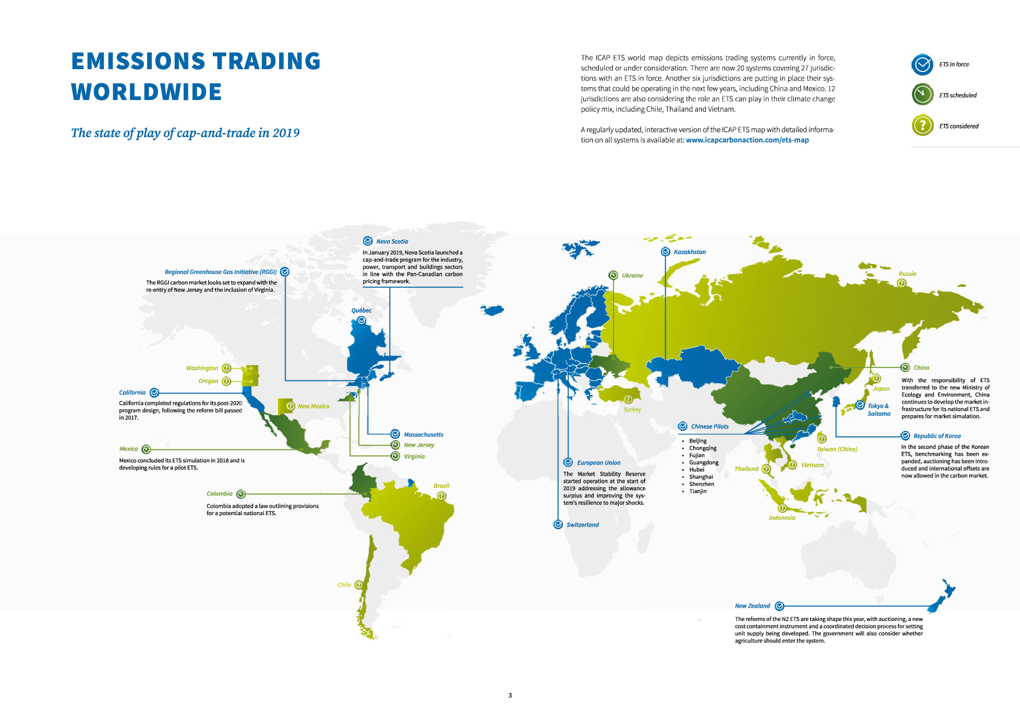
Figure 37 Emission Trade worldwide. The map. Source: https://icapcarbonaction.com/en/?option=com_attach&task=download&id=637

- Carbon Offsets
Before describing the current state of the art in the Voluntary we must define Carbon Offsets and their use in the Clean Development Mechanism (CDM) and Joint Implementation (JI) that were introduced by the Kyoto Treaty for the emissions’ trade by parties (countries and industries) that could not participate in the newly established EU ETS, or other compliance markets.
Carbon Offsets refer to absorbance of CO₂ that prevent either further emissions of GHGs or sequestrate GHGs in the soil or in vegetation. Such projects can be using new technologies i.e., to filter better the emissions of GHGs (from big polluters) in the atmosphere or generating power through renewable energy sources or even protecting forests in the Amazon and planting trees in developing countries.
Carbon Offsets are produced by projects that carry out on-the-ground emissions reduction activities and are typically measured in metric tons of carbon dioxide equivalents, or tCO₂e. They can either be traded on the voluntary markets, where buyers and sellers trade on their own volition, or as part of a compliance market (e.g., CDM), where government regulations require emitters to either reduce their emissions or purchase offsets.
    - Clean Development Mechanism (CDM)
The Clean Development Mechanism (CDM) and the Joint Implementation (JI) that were introducing by the Kyoto Protocol as alternatives to ETS tools. Both mechanisms use Carbon Offset Projects to mitigate negative climate change effects.
The CDM allows Annex III (developed) countries to partly meet their Kyoto targets by financing carbon emission reductions through carbon offsets that are produced within projects in developing countries. Such projects are arguably more cost effective than projects implemented in richer nations because developing countries have on average lower energy efficiencies, lower labor costs, weaker regulatory requirements, and less advanced technologies. The CDM is also meant to deliver sustainable development benefits to the host country that they are also named co-benefits. CDM projects generate emissions credits called Certified Emissions Reductions or CERs – one CER is equal to one ton of carbon dioxide equivalent – which are then bought and traded (Carbon Offset Research and Education, 2019).
    - Joint Implementation (JI)
Joint Implementation works similarly to CDM, with the exception that the host country is not a developing nation but another Annex III country. The tradable units from JI projects are called Emissions Reductions Units (ERUs). It is not strictly a baseline-and-credit system since it also has aspects of a cap-and-trade system, and, notably, both participants have an overall reduction target (Carbon Offset Research and Education, 2019).

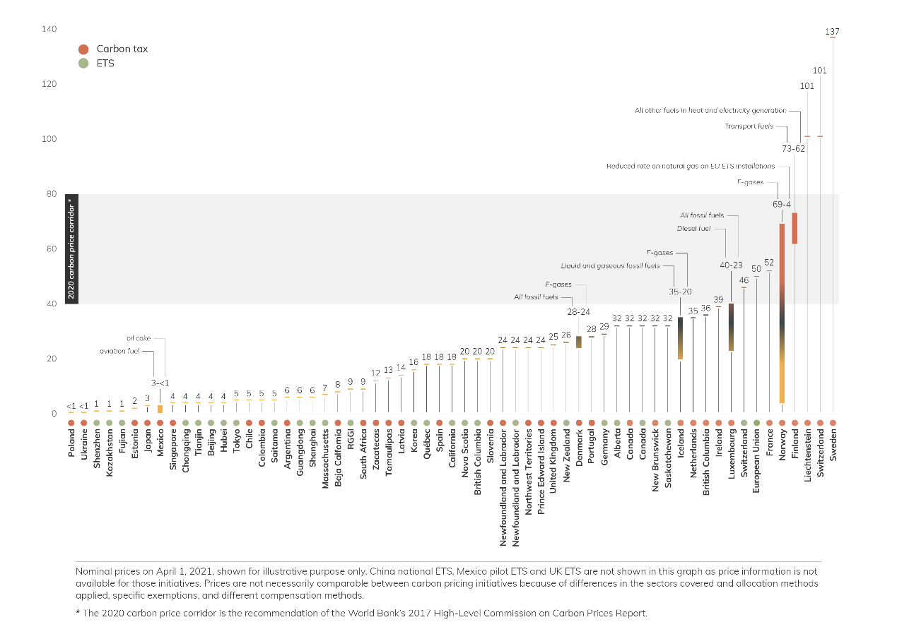
Figure 38 Shares of several ETSs in world carbon markets. Source: World Bank, 2021: State and Trends of Carbon Pricing. Online available at: https://openknowledge.worldbank.org/handle/10986/35620
Both mechanisms have been operating for a long time until now and they have managed to sequestrate mostly though renewable energy technologies and also many reforestation projects. Additionally, CDM Projects assist developing countries in achieving sustainable development (Clean Development Mechanism, 2019). Additionally, projects in developing countries earn a saleable credit for each ton of greenhouse gas they reduce or avoid. The incentive has led to the registration of more than 8,100 projects and programs in 111 countries and the issuance of more than 1.9 billion CERs. (CDM Can Inspire, Inform, Outfit Any New Mechanism under Paris Agreement, 2018).
During the Paris conference of parties and within its agreement there has been no decision about the future of CDM (and JI) but since it has been a success story the UNFCCC has decided to take advantage of the experience that was gained from CDM implementation (CDM Can Inspire, Inform, Outfit Any New Mechanism under Paris Agreement, 2018). As it was reported in the relevant news article:
The CDM is a “credible tool” whose rules, modalities and procedures have been “built over decades,” said El Hadji Mbaye Diagne, a climate negotiator from Senegal and a member of the CDM Executive Board. “The CDM has a track record of managing pace and scale of mitigation action.”
- Voluntary Carbon Markets
    - What is a Carbon Voluntary Market?
The voluntary carbon markets function outside of the compliance market, and they enable big polluters (energy companies, big industries, as well as governments) to offset their emissions by purchasing permits through the voluntary market. The emission allowances are defined as Verified or Voluntary Emissions Reductions (VERs). Compared to the compliance market, trading volumes in the voluntary market are much smaller because demand is created only by voluntary buyers to buy offsets whereas in a compliance market, demand is created by a regulatory instrument. Because there is lower demand and because VERs cannot be used in compliance markets, VERs tend to be cheaper than those credits sold in the compliance market (Carbon Offset Research and Education, 2019).
BOX 1
Advantages of linking of all ETS (compliance and voluntary)
A bigger (linked) market opens up more reduction options, which in turn decreases the overall mitigation costs for the linked market. It also creates a level playing field for companies across the linked market and signals climate change leadership (Santikarn, Li, La Hoz Theuer, & Haug, 2018).

Unlike under the Clean Development Mechanism (CDM), there are no established rules and regulations for the voluntary carbon market. On the positive side, voluntary markets can serve as a testing field for new procedures, methodologies and technologies that may later be included in regulatory schemes. After all, the final goal of all stakeholders working in Emission Trade markets is to link all markets together under a regulatory scheme (BOX 1). So far, some regulatory markets have already been linked. Since 2019, there is an agreement to link the EU ETS with the Switzerland’s ETS that will take force from 2010. Additionally, the future development of CORSIA will use offset from voluntary markets to reduce emissions from international aviation (Ecosystem Marketplace).
Voluntary markets allow for experimentation and innovation because projects can be implemented with fewer transaction costs than CDM or other compliance market projects. Voluntary markets also serve a niche for micro projects that are too small to warrant the administrative burden of CDM or for projects currently not covered under compliance schemes. On the negative side, the lack of quality control has led to the production of some low quality VERs, such as those generated from projects that appear likely to have happened anyway. Therefore, several standards have been introduced to certify quality assurance/quality control the VERs.
Most projects adhere to methodologies set out by one of several voluntary standards. These standards require projects to submit to third-party validation and verification to ensure projects have achieved their stated emissions reductions (see chapter 8). Standards can differ by which project activities and types are allowed, where projects may be located, and what regulations projects must adhere to (Hamrick & Gallant, Voluntary Carbon Markets Insights: 2018 Outlook and First-Quarter Trends, 2018).
However, all voluntary standards require that offsets be:
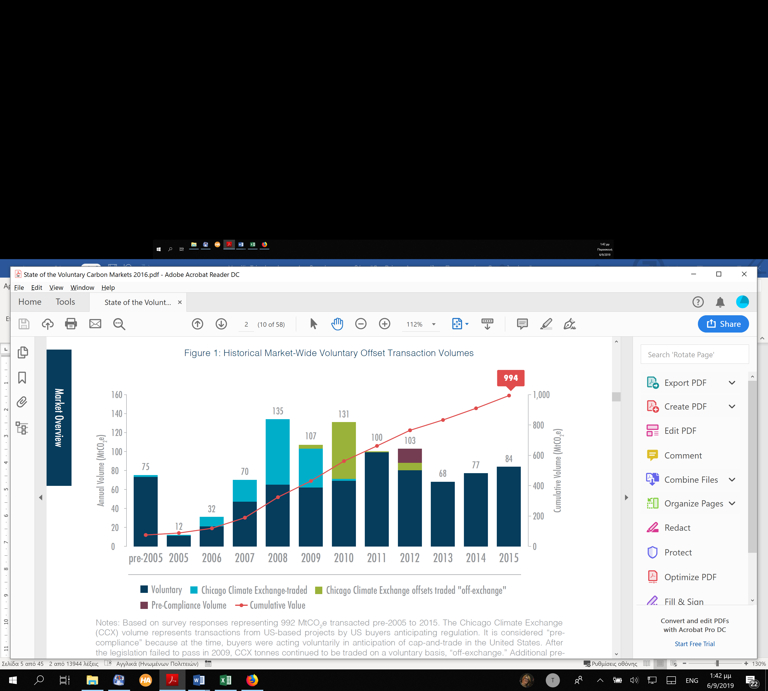
Figure 39 Historical Market-Wide Voluntary Offset Transaction Volumes. Source: (Hamrick & Goldstein, Raising Ambition - State of the Voluntary Carbon Markets 2016, 2016)
Overall, the size of the voluntary market is much smaller than the compliance market; as of the first quarter of 2018, more than 2,000 projects have issued over 430 MtCO2e of voluntary credits since 2005 (Figure 39). More than 75 percent of the issuances came from the two largest voluntary standards—Verra’s Voluntary Carbon Standard (VCS) and the Gold Standard. In terms of pricing, voluntary credit prices can change dramatically due to the various preferences of voluntary credit buyers. The transacted prices of voluntary credits during the first quarter of 2018 ranged from under US $0.1/tCO2e to just over US $70/tCO2e, but roughly half of the voluntary credits were transacted at under 1 US$/tCO2e (World Bank Group, 2019).
    - Project developers, wholesalers, brokers, and retailers in voluntary markets
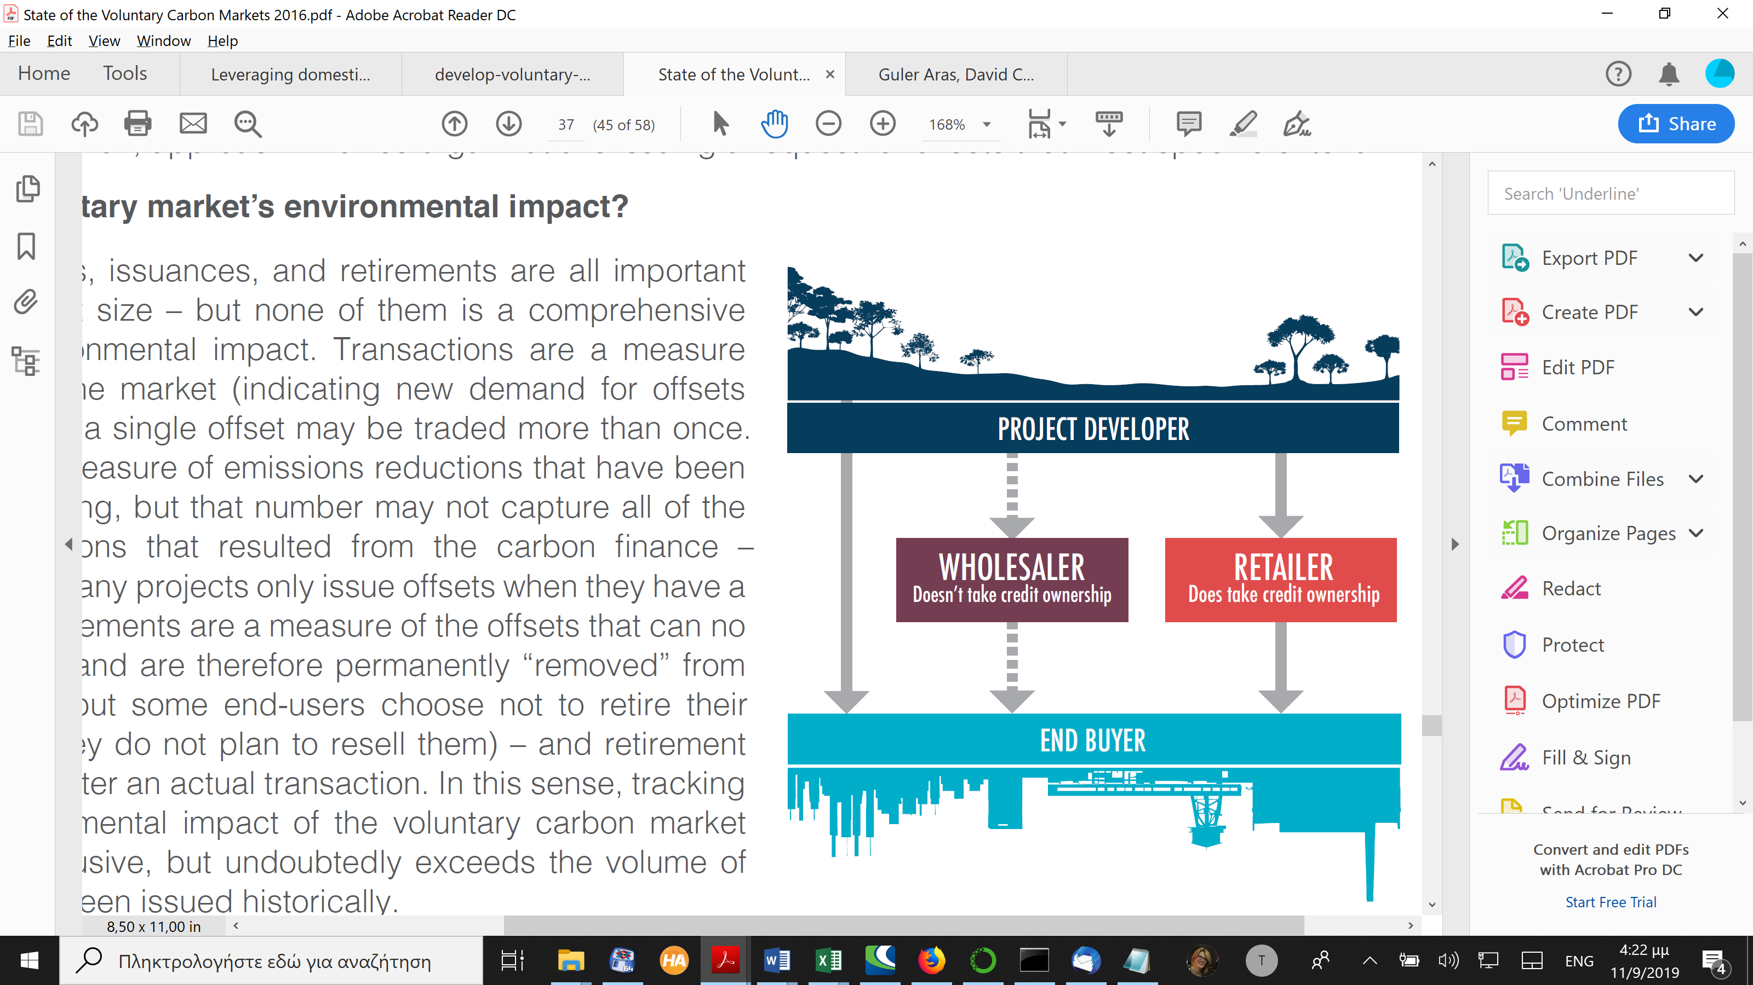
Figure 40 Types of Carbon Offset traders. Source: (Hamrick & Goldstein, Raising Ambition - State of the Voluntary Carbon Markets 2016, 2016)
Within a voluntary market there exist different types of entities selling Carbon Offsets. The interaction among the 3 major types of traders with the Allowances’ buyers are very well given in Figure 40. A Project developer can create a Carbon Offset Project and sell Emission Allowances to industries, while a Wholesaler acquires Emission Allowances from the Project Developers and sell them to industries (without taking credit of their ownership). Retailers can buy Emission Allowances and sell them to industries but with the exception that they are taking credit of their ownership. Finally, a Carbon Offset broker as well as in all other trading activities is a middle man to arrange the deal among buyers and sellers and receive a reward for this trade.
    - Problems of voluntary markets

Double counting
According to a report which is investigating the voluntary markets future in the light of the Paris Agreement double counting is the most serious problem concerning the integrity and reality of voluntary markets. Double counting is referred as a risk that the same activity or effect to reduce or remove GHG emissions is accounted for twice (or multiple times). Double counting can occur in different forms. A common typology differentiates four types of double counting. Double selling occurs where an issued unit is sold more than once to different actors. Double issuance means the scenario in which a unit is credited twice under two different standards or in two different registries or in which it is duplicated in the same registry. Double claiming occurs where two entities ‘claim’ the environmental benefit of the exact same reduction or removal unit. Double monetization, finally, refers to the situation in which the same GHG emission reduction effort is monetized multiple times, e.g., once by the government at an intergovernmental level and by a company in a private transaction (German Emissions Trading Authority (DEHSt) at the German Environment Agency, 2018).
Unsold allowances
According to the recent report of Ecosystem Marketplace (Hamrick & Goldstein, Raising Ambition - State of the Voluntary Carbon Markets 2016, 2016) a lot of AAUs from the voluntary markets have not been sold. There are several reasons why a tonne might remain unsold in a supplier’s portfolio. Suppliers (35 of them) behind of the orphaned portfolio volume claimed they tried to sell the offsets in 2015 but were unsuccessful. However, nearly half of the offsets in 2015 suppliers’ portfolios remained unsold because suppliers opted to hold onto them, either because they were awaiting higher prices (21 suppliers), more favorable contract terms (4 suppliers), or an expansion of the market (4 suppliers). Ten suppliers behind 8.8 MtCO2e in unsold volume said they had a prospective buyer but were still in negotiations with them at the end of the year. Another 17 suppliers held onto 1.5 MtCO₂e simply because it is unnecessary from a financial perspective to sell all the offsets in their portfolio in any given year. Most specifically, at the End of 2015, 56 million Orphaned Offsets Remained in Suppliers’ Portfolios – and Even More Supply is on the Way.
- EU commitment: Emissions Trading Scheme, effort sharing and LULUCF
- EU Emission Trading System (EU ETS)
ETSs was created to trade GHG in the 28 EU Member States and three European Economic Area-European Free Trade Association (EEA-EFTA) states: Iceland, Liechtenstein, and Norway. It is the oldest and still largest (in terms of traded emissions) ETS for GHGs operating worldwide (Figure 38). It limits emissions from around 10,000 installations in the power sector and manufacturing industry, as well as airlines operating between these countries. Moreover, it covers around 40% of the EU's greenhouse gas emissions. Introduced in 2005 and now in its third phase, the system has gone through several reforms and will change again with the start of phase 4 in January 2021 (European Union, 2015).
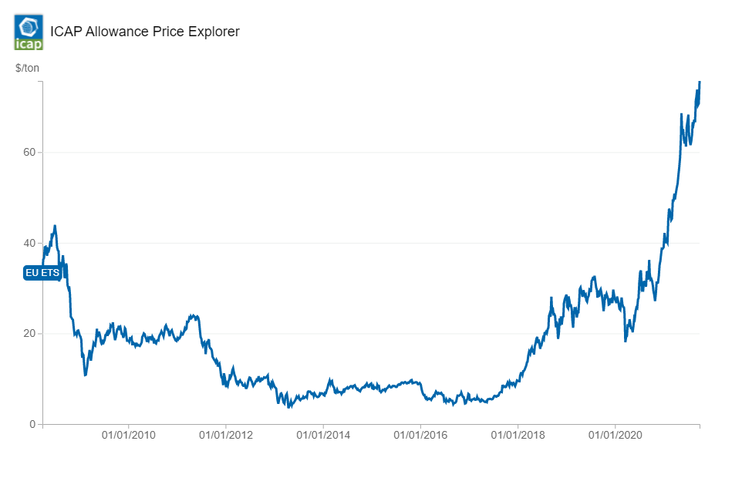
Figure 41 Carbon price of EU ETS. Source: https://icapcarbonaction.com/en/ets-prices
After more than two years of negotiations, in February 2018, the EU Council of Ministers formally approved the reform of the EU ETS for phase 4 (2021-2030). The revised EU ETS Directive entered into force in April 2018.
Phase 4 will see a steeper pace of annual emissions cuts required from the covered sectors, from 1.74% to 2.2%. In addition, during phase 4 mechanism to reduce the surplus of allowances in the carbon market (Market Stability Reserve MSR) will be introduced to improve the EU ETS’s resilience to future shocks. Member States may also invalidate a portion of allowances to reflect additional policies in the energy sector, e.g., a coal phase out. Other changes for phase 4 include provisions to better target free allocation to address carbon leakage, as well as new financial support mechanisms to promote low-carbon innovation and to support modernization efforts in the industry and the power sectors of lower-income Member States. Steps will be taken within 2019 to ratify the Linking Agreement between Switzerland and the EU, which could see the markets linked from 1 January 2020.
The Overall GHG emissions (excluding LULUCF) that have been traded so far (2016) are 4,353 MtC0₂e (2016) and not only of CO₂ but also N₂O, PFCs.
The GHG emission reduction target has been set
By 2030: At least 55% below 1990 GHG levels proposed (European Green Deal), to be set in the Climate Law
By 2050: Climate neutrality target proposed (European Green Deal), to be set in the Climate Law
Both updated targets (2030 and 2050) recently have been endorsed by the European Parliament and European Council, and are currently in the process of being enshrined into the European Climate Law.
The current Carbon Price is €24.76 (USD 28.28)/tC0₂e (average 2020 secondary market spot price from EEX exchange). The carbon price in the EU ETS has changed dramatically thought out the years of its operation. Due to financial crisis and the existence of surplus the lowest price fell below €5/tC0₂e in 2013.
The system covers emissions from the sectors of power, industry, and aviation, with the aviation sector being limited to flights within the European Economic Area (EEA).
More specifically the different phases of the ETS cover different sectors:
PHASE 1 (2005-2007): Power stations and other combustion installations with >20MW thermal rated input (except hazardous or municipal waste installations), industry (various thresholds) including oil refineries, coke ovens, iron and steel plants, as well as production of cement, glass, lime, bricks, ceramics, pulp, paper, and board.
PHASE 2 (2008-2012): Aviation was introduced in 2012 (>10,000 tCO2/year for commercial aviation; >1,000 tCO2/year for non-commercial aviation since 2013) (see below). Nitrous oxide emissions from the production of nitric acid were included by several countries. The EU ETS also expanded to include Iceland, Liechtenstein, and Norway.
PHASE 3 (2013-2020): Carbon Capture and Storage installations, production of petrochemicals, ammonia, nonferrous and ferrous metals, gypsum, aluminum, as well as nitric, adipic, and glyoxylic acid (various thresholds) were introduced.
PHASE 4 (2021-2030): Based on the current legislation, no changes to the scope have been agreed on for Phase 4. Changes are being considered as part of the review of the ETS foreseen under the 2030 Climate Target Plan.
Moreover, for the International Aviation sector, emissions were included in the EU ETS in 2012. In November 2012, the EU temporarily suspended enforcement of the EU ETS requirements for flights operating from or to non-EEA countries (“stop the clock”) while continuing to apply the legislation to flights within and between countries in the EEA. Exemptions for operators with low emissions have also been introduced.
Considering the progress made under the International Civil Aviation Organization (ICAO) towards a global measure to reduce emissions from the aviation sector (the Carbon Offsetting and Reduction Scheme - CORSIA), the EU will maintain the intra-EEA scope for the ETS Aviation until 31 December 2023. A further review and assessment will be carried out once there is clarity surrounding the content and nature of CORSIA, as well as the extent of participation by Europe’s international partners.
More than 11,000 liable entities are participating in EU ETS e.g., power plants and manufacturing installations. Aircraft operators are covered for all flights. However, a temporary exemption applies to flights between the EEA and a third country.
During the different phases of its operation, Cap emissions has been set to the following values:
PHASE 1 (2005-2008) and PHASE 2 (2009-2012): Decentralized cap-setting – the EU cap resulted from the aggregation of the National Allocation Plans of each Member State. Phase 1 started with a cap of 2,096 MtCO2e in 2005, phase 2 with a cap of 2,049 MtCO2e in 2009.
PHASE 3 (2013-2020): Single EU-wide cap for stationary sources: 2,084 MtCO2e in 2013, which is annually reduced by a constant linear reduction factor (currently 1.74% or ~38.3 million allowances). This amounts to 1,855 MtCO2e in 2019.
Aviation Sector Cap: Emissions for intra-EEA aviation in 2021 are capped at 38 million allowances and will decrease each year by the linear reduction factor of 2.2%. The aviation sector cap was set in 2012 at 210 MtCO2e/year. This cap was meant to reflect the initial inclusion of all flights from, to, and within the EEA in the EU ETS. However, following the “stop the clock” temporary suspension until the end of 2016, the number of aviation allowances put into circulation in 2013-2016 was reduced to 38 million allowances annually and set considerably below verified intra-EEA aviation emissions. In 2017, the intra-EEA scope for aviation was prolonged until 2023. The adjusted annual aviation cap applies up to 2021 and decreases thereafter.
PHASE 4 (2021-2030): A single EU-wide cap for stationary installations set for 2021 at 1,572 MtCO2e. A linear cap reduction factor of 2.2% (of 2008-2012 baseline emissions) applies to both stationary sources and the aviation sector each year. This translates into a year-on-year reduction of the cap by 43 million allowances. The linear reduction factor does not have a sunset clause and the cap will continue to decline beyond 2030. Starting 2021, emissions from UK entities previously covered by the EU ETS are no longer considered in the cap. 
Figure 42 EU ETS trading periods. Source: https://ec.europa.eu/clima/sites/clima/files/docs/ets_handbook_en.pdf
The allocation of AAUs is also given in different ways during the operational phases.
PHASE 1 (2005-2007): Allocation established through the Member State National Allocation Plans. Nearly 100% free allocation through grandfathering. Some Member States used auctioning and some used benchmarking.
PHASE 2 (2008-2012): Similar to Phase 1 with ~90% of allowances allocated for free. Some benchmarking for free allocation and some auctioning in eight Member States (Germany, United Kingdom, The Netherlands, Austria, Ireland, Hungary, Czech Republic, and Lithuania), constituting ~3% of total allowances.
PHASE 3 (2013-2020): Over the entire trading period, 57% of allowances will be auctioned, while the remaining allowances are available for free allocation.
Electricity Sector: 100% auctioning with optional derogation for the modernization of the electricity sector in certain Member States. Those Member States whose GDP per capita was below 60% of the EU average in 2013 may continue to make use of this optional free allocation in phase 4.
Manufacturing Sector: Free allocation is based on product-based benchmarks. Benchmarks are based on activity levels in 2007-2008 and are set at the average of the 10% most efficient installations in the (sub)sector.
Subsectors deemed at risk of carbon leakage receive free allocation at 100% of the predetermined benchmarks. Subsectors deemed not at risk of carbon leakage have free allocation phased out gradually from 80% of the benchmarks in 2013 to 30% by 2020. In the event that free allocation exceeds the amount reserved for free allocation, a cross-sectoral correction factor is applied.
Carbon leakage risk is assessed against criteria of emissions intensity and trade exposure.
Aviation Sector: In 2012, 85% of allowances were allocated for free, based on benchmarks. In phase 3, 15% of allowances are auctioned and 82% allocated for free, based on benchmarks. The remaining 3% constitute a special reserve for new entrants and fast-growing airlines. As a consequence of the temporary derogation applying to flights with third countries, the allocation is adjusted to the intra-EEA scope.
Backloading: Taken as a short-term measure to address a growing surplus in the EU ETS, it was agreed to postpone the auctioning of 900 million allowances from 2014-2016 to 2019-2020. Auction volumes were reduced by 400 million allowances in 2014, 300 million in 2015, and by 200 million in 2016. In line with the decision to create an MSR, the back-loaded allowances will be placed in the MSR.
New Entrants Reserve: 5% of the total allowances are set aside to assist new installations coming into the EU ETS or covered installations whose capacity has significantly increased since their free allocation was determined.
PHASE 4 (2021-2030): One of the central components of the phase 4 revision package is to ensure that the declining number of free allowances is distributed in the most effective and efficient way. To this end, in phase 4:
- Benchmark values will be updated twice during the phase to reflect technological progress in the different sectors.
- Free allocation may be updated annually to mirror sustained changes in production (if the change is more than 15% compared to the initial level, on the basis of a two-year rolling average).
- Carbon leakage rules will be more robust, as the number of sectors classified at risk of carbon leakage will be reduced, and the free allocation for other sectors will be discontinued by 2030 (except district heating).
- Carbon leakage will be assessed against a composite indicator of trade intensity and emissions intensity.
- As an additional safeguard for industry, the agreement foresees a “free allocation buffer” of over 450 million allowances initially earmarked for auctioning, to be made available if the initial free allocation is fully absorbed (thereby avoiding or reducing a correction factor).
In addition, two new multi-billion Euro funds will be established to help the industry and the power sectors meet the innovation and investment challenges of the transition to a low-carbon economy (for more, see Use of Revenue).
Unlimited banking has been allowed since 2008. Borrowing of AAUs is not allowed.
Considering offsets and credits the policy was also different throughout the years of its operations:
PHASE 1 (2005-2007): Unlimited use of Clean Development Mechanism (CDM) credits and Joint Implementation credits (JI) was provided for in the Directive. In practice, no credits were used in phase 1.
PHASE 2 (2008-2012):
Qualitative Limits: Most categories of CDM/JI credits were allowed, no credits from LULUCF and nuclear power sectors. Strict requirements for large hydro projects exceeding 20 MW.
Quantitative Limits: In phase 2 (2008-2012), operators were allowed to use JI and CDM credits up to a certain percentage limit determined in the respective country’s National Allocation Plans. Unused entitlements were transferred to phase 3 (2013-2020).
PHASE 3 (2013-2020):
Qualitative Limits: Newly generated (post-2012) international credits may only come from projects in Least Developed Countries. Credits from CDM and JI projects from other countries are eligible only if registered and implemented before 31 December 2012. Projects from industrial gas credits (projects involving the destruction of HFC-23 and N2O) are excluded regardless of the host country. Credits issued for emission reductions that occurred in the first commitment period of the Kyoto Protocol were no longer accepted after 31 March 2015.
Quantitative Limits: The total use of credits for phase 2 and phase 3 may amount up to 50% of the overall reduction under the EU ETS in that period (~1.6 Gt CO2e).
PHASE 4 (2021-2030):
The use of offsets is not envisaged.
To provide Market Stability a mechanism is introduced in 2019. More specifically the Market Stability Reserve (MSR) started operating in January 2019. It aims to neutralize the negative impacts of the existing allowance surplus and to improve the system’s resilience to future shocks.
Cancellations: As of phase 4, a Member State may also cancel allowances from their auction share in the event that they take additional measures that result in closure of electricity generation capacity. The quantity of allowances invalidated shall not exceed the average verified emissions of the installation from five years preceding the closure.
The compliance period starts in January 1st and ends in April, 30th of the next year (16 months).
One of the most important stages of an ETS is the Monitoring, Reporting, Verification (MRV) procedures:
REPORTING FREQUENCY: Annual self-reporting based on harmonized electronic templates prepared by the European Commission.
VERIFICATION: Verification by independent accredited verifiers is required before 31 March each year.
MRV FRAMEWORK: the MRV framework for the EU ETS has been further harmonized. European Commission regulations now apply for emissions monitoring and reporting, as well as verification and accreditation of verifiers. A monitoring plan is required for every installation and aircraft operator.
NON COMPLIANCE: In the case of non-compliance entities must pay an "excess emissions penalty" of EUR 100/tCO2 (USD 118/tCO2) for each tCO2 emitted for which no allowance has been surrendered. The name of the noncompliant operator is also published. Different penalties exist at the national level for other forms of noncompliance.
LINKING WITH OTHER ETS: The European Commission has concluded negotiations with Switzerland on linking the EU ETS with the Swiss ETS. In November 2017, the EU and Switzerland signed the Agreement to link their ETS. The Agreement will enter into force on 1 January of the year following the exchange of the instruments of ratification by the Parties.
The European Commission publishes annual reports on the functioning of the European carbon market (Eurpean Union, 2018).
Two major EU ETS reviews – before phase 3 and before phase 4 – have been conducted to date, resulting in changes in system design. The directive establishing the EU ETS stipulates that the system be kept under review considering the implementation of the Paris Agreement and the development of carbon markets in other major economies.
Since beginning of the program an amount of EUR 35.9 billion (USD 42.4 billion) has been collected from the member states while in 2018 there was a revenue of EUR 14.2 billion (USD 16.8 billion). EU ETS revenues from auctioning accrue to EU Member States. At least 50% of revenues should be used for climate and energy-related purposes. Member States are obliged to inform the Commission about how they use the revenues. According to information submitted, they spend ~80% for domestic and international climate-related purposes.
The implementing legislation is based on the consolidated version of Directive 2003/87/EC of the European Parliament and of the Council establishing a scheme for GHG emission allowance trading within the Community and amending Council Directive 96/61/EC (8 April 2018)
Decision concerning the establishment and operation of a market stability reserve for the Union GHG emission trading scheme and amending Directive 2003/87/EU (6 October 2015)
Consolidated Auctioning Regulation (25 February 2014): Commission Regulation EU No 176/2014 amending Regulation (EU) No 1031/2010 in particular to determine the volumes of GHG emission allowances to be auctioned in 2013-2020 (25 February 2014).
All other legislation and more related documentation can be found here: https://icapcarbonaction.com/en/?option=com_etsmap&task=export&format=pdf&layout=list&systems%5B%5D=43
The European Union is supporting through a detailed registry of the participants in the current EU-ETS but also for the future operating Effort sharing mechanism. Any anonymous user (no login is necessary) can log in the system and search for allocations issued in past dates to stationary installations/aviation or check for compliance.
The system provides complete transparency and visibility of all accounting data related to CO2 emissions and AAUs in order to supply effective Monitoring and Reporting and Verification (MRV) for all participating entities in the trading mechanism.
The system has already been prepared to host future transactions under the Effort Sharing Decision Mechanism.
- Effort sharing
The Effort Sharing legislation establishes binding annual greenhouse gas emission targets for Member States for the periods 2013–2020 and 2021–2030. These targets concern emissions from most sectors not included in the EU Emissions Trading System (EU ETS), such as transport, buildings, agriculture, and waste (European Union, 2019).
The Effort Sharing legislation forms part of a set of policies and measures on climate change and energy that will help move Europe towards a low-carbon economy and increase its energy security.
The national targets will collectively deliver a reduction of around 10% in total EU emissions from the sectors covered by 2020 and of 30% by 2030, compared with 2005 levels.
Together with a 21% cut in emissions covered by the EU ETS by 2020 and 43% by 2030, this will allow the EU to achieve its climate targets for 2020 and 2030.
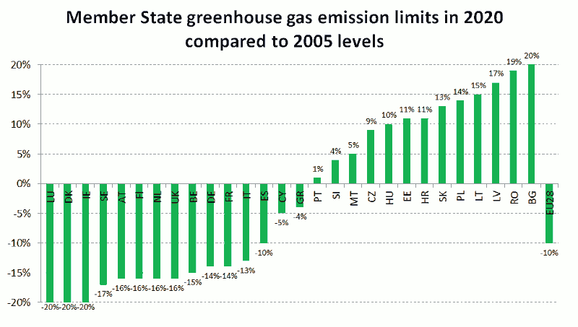
Figure 43 Member states GHG emissions in 2020 compared to 2005. Source: https://ec.europa.eu/clima/policies/effort_el#tab-0-0

Emission reductions target by 2020: -10% (Figure 43)
The Effort Sharing Decision forms part of the EU's climate and energy policy framework for 2020.
It sets national emission targets for 2020, expressed as percentage changes from 2005 levels. It also lays down how the Annual Emission Allocations (AEAs) in tonnes for each year from 2013 to 2020 are to be calculated and defines flexibilities.
The national targets are based on Member States’ relative wealth, measured by gross domestic product (GDP) per capita.
Less wealthy countries have less ambitious targets because their relatively higher economic growth is likely to be a stronger emission driver and they have relatively lower investment capacities.
The national emission targets for 2020 range from a 20% reduction by 2020 (from 2005 levels) for the richest Member States to a 20% increase for the least wealthy one, Bulgaria. Croatia, which joined the EU on 1 July 2013, can increase emissions by 11%.
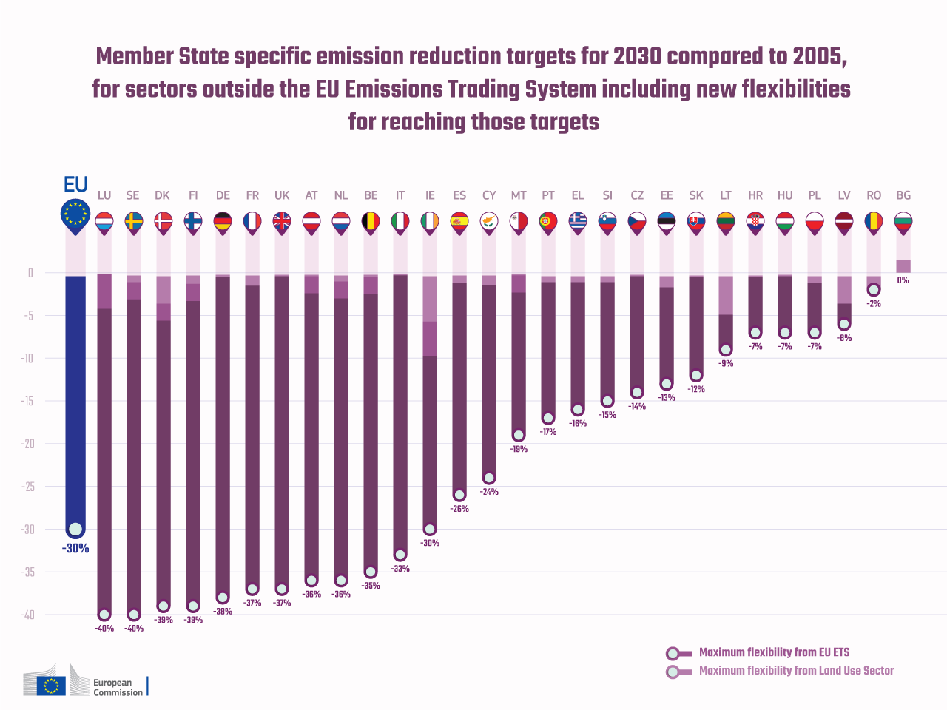
Figure 44 Member state emission reduction targets for 2030 compared to 2005, for sectors outside of EU-ETS including new flexibilities to reaching these targets. Source: https://ec.europa.eu/clima/policies/effort_el#tab-0-0

Emission reductions target by 2030: -30% (Figure 44)
The Regulation on binding annual emission reductions by Member States from 2021 to 2030 (Effort Sharing Regulation) adopted in 2018 is part of the Energy Union strategy and the EU's implementation of the Paris Agreement.
It sets national emission reduction targets for 2030 for all Member States, ranging from 0% to -40% from 2005 levels.
In contrast to sectors in the EU ETS, which are regulated at EU level, Member States are responsible for national policies and measures to limit emissions from the sectors covered by Effort Sharing legislation.
Examples of potential policies and measures include:
- reducing transport needs
- promoting public transport
- a shift away from transport based on fossil fuels
- support schemes for retrofitting buildings
- more efficient heating and cooling systems
- renewable energy for heating and cooling
- more climate-friendly farming practices
- conversion of livestock manure to biogas.
Measures taken at EU level will help Member States to reduce emissions. For example:
- CO₂ emission standards for new cars and vans will cut emissions from road transport
- Emission reductions from buildings will be aided by measures to improve the energy performance of buildings, eco-design requirements for energy-related products, and energy labelling systems to inform consumers
- Restrictions on fluorinated industrial gases (F-gases) and implementation of other EU environmental policies, e.g., on soil protection and waste, will also contribute to reaching the national targets.
The Effort Sharing Decision covers the six greenhouse gases controlled by the Kyoto Protocol during its first commitment period (2008-2012):
- Carbon dioxide (CO₂)
- Methane (CH₄)
- Nitrous oxide (N₂O)
- Hydrofluorocarbons (HFCs)
- Perfluorocarbons (PFCs)
- Sulphur hexafluoride (SF₆).
The Effort Sharing Regulation adds to those nitrogen trifluoride (NF₃), which is a very small source in the EU.
The targets apply to domestic greenhouse gas emissions from IPCC source categories of energy, industrial processes and product use, agriculture, and waste.
They do not apply to emissions covered by the EU ETS and emissions and removals from land use, emission and removals from land use change and forestry (LULUCF), which are covered by the Kyoto Protocol and from 2021 by the LULUCF Regulation.
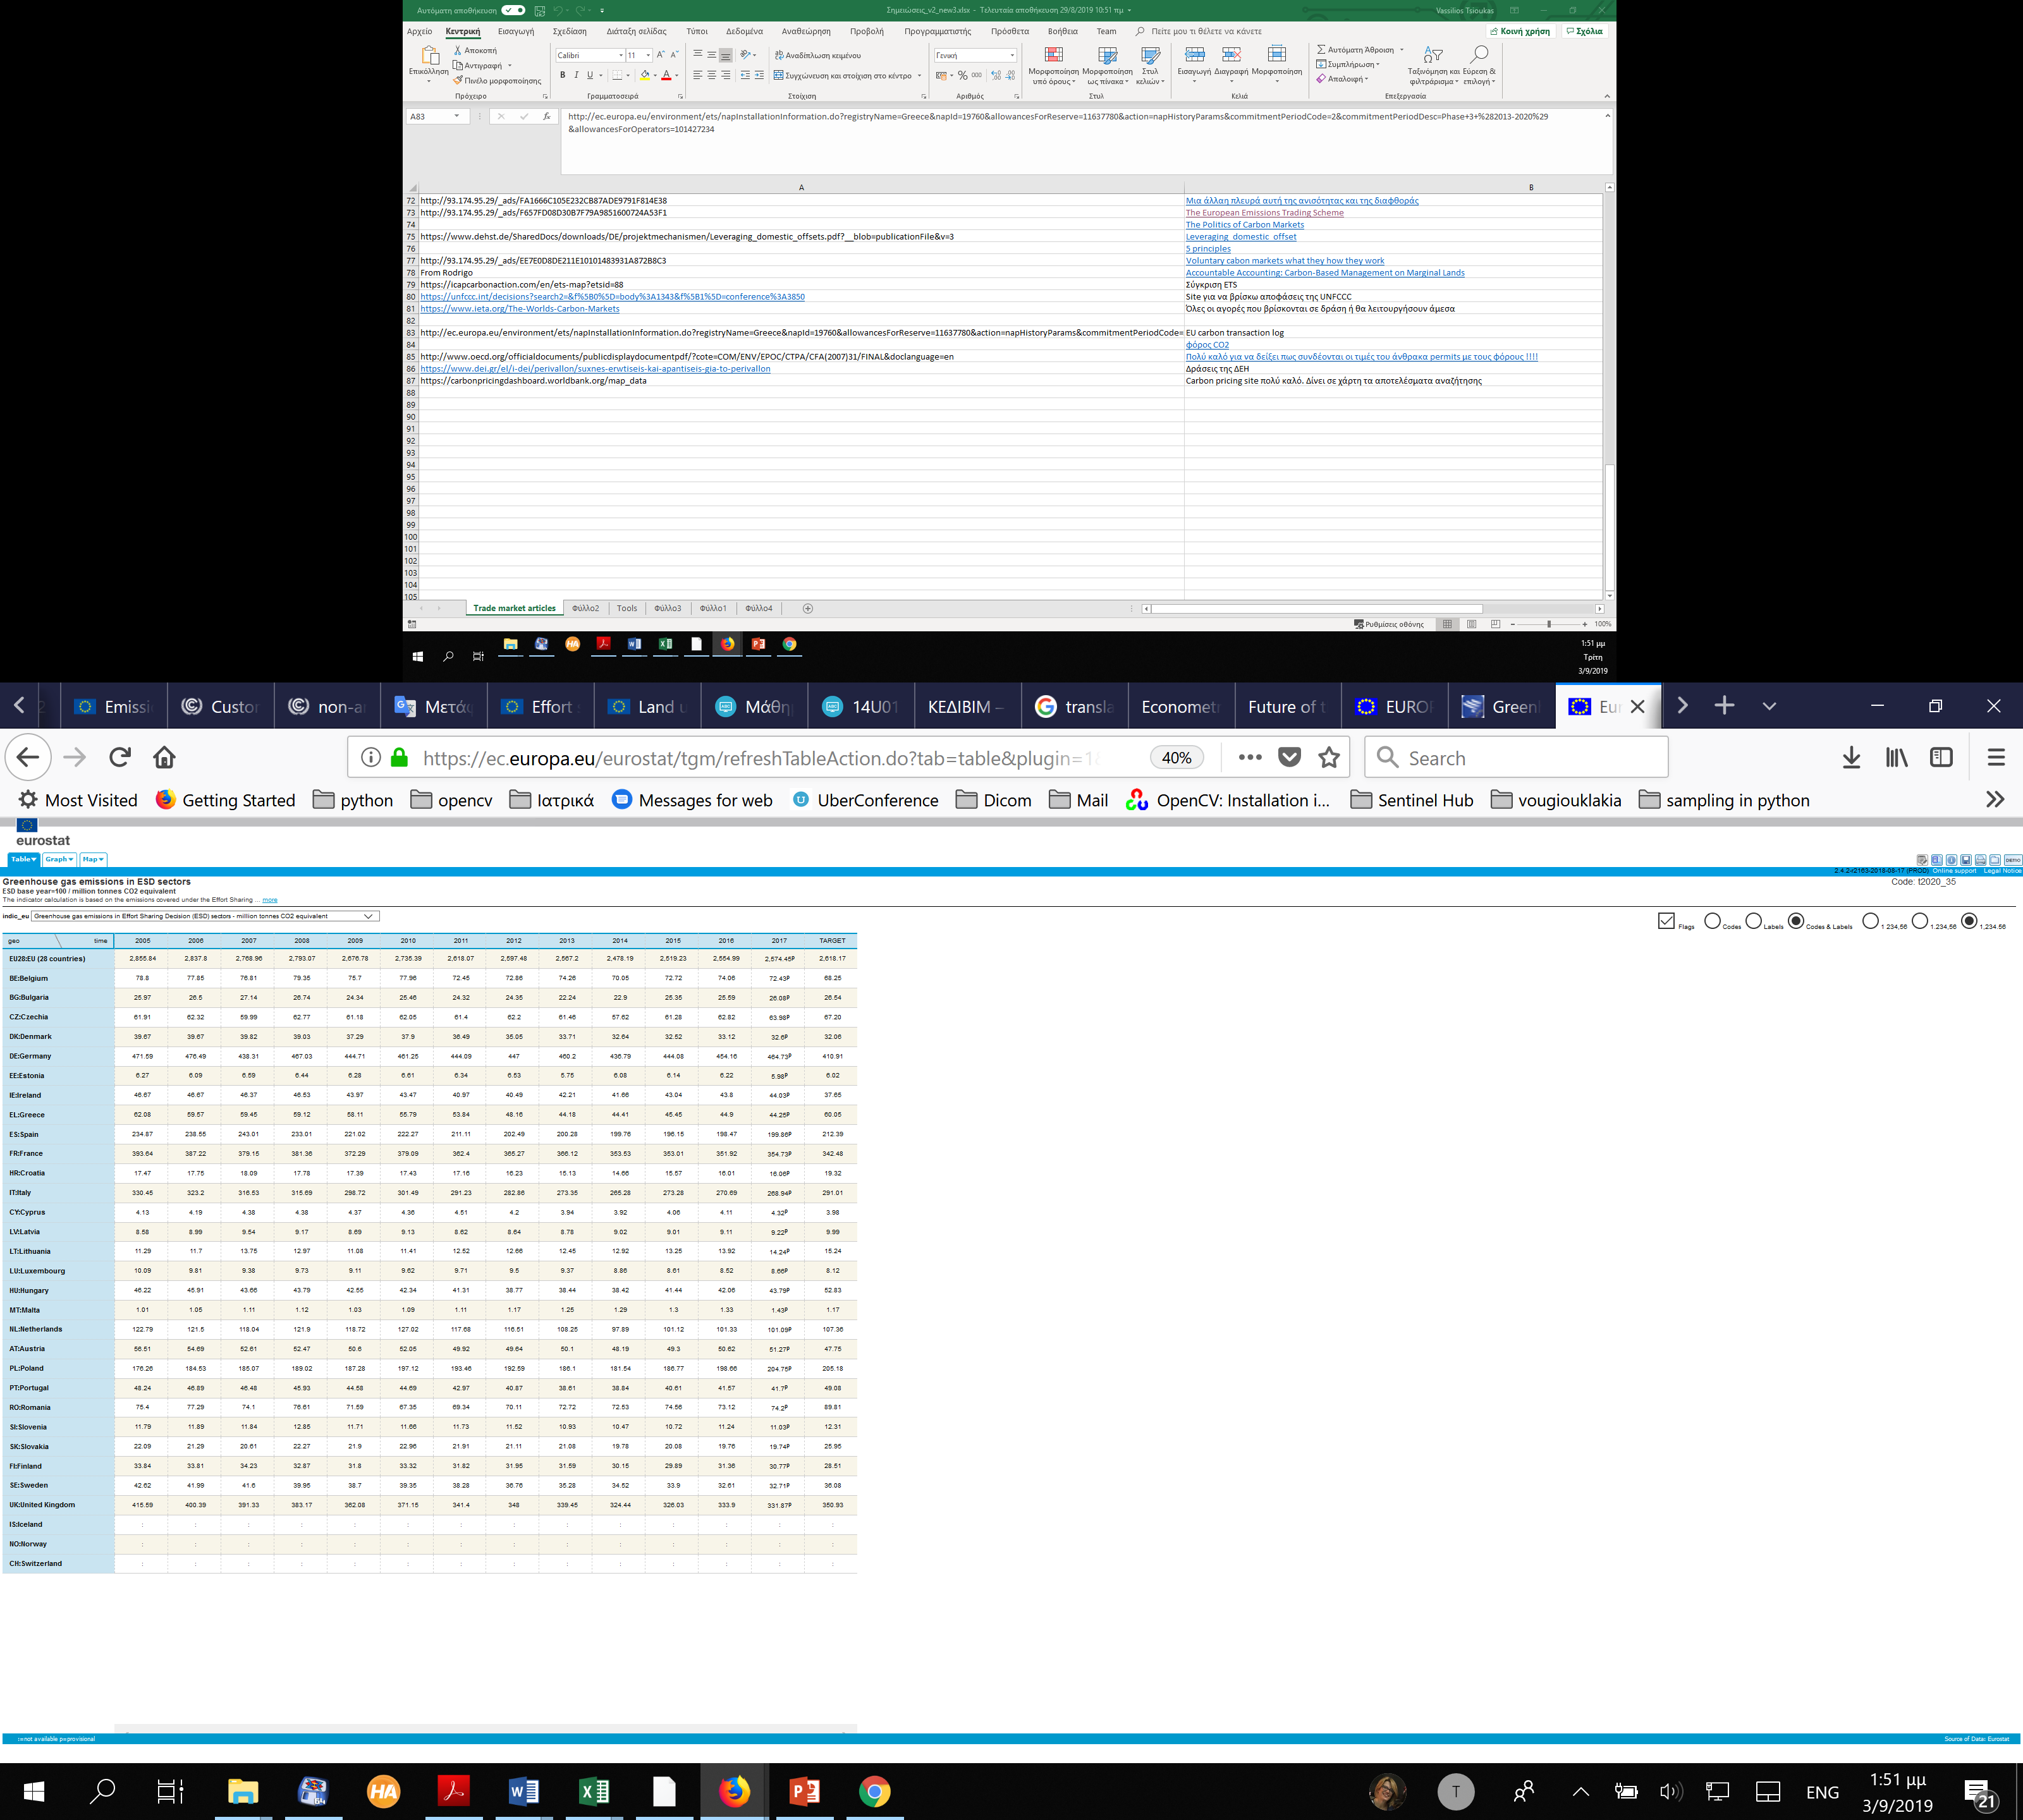
Figure 45 Greenhouse gas emissions in ESD sectors. Source: Eurostat, https://ec.europa.eu/eurostat/tgm/refreshTableAction.do?tab=table&plugin=1&pcode=t2020

- LULUCF and United Nations Framework Convention on Climate Change (UNFCCC)
It is well documented that the rate of build-up of CO₂ in the atmosphere can be reduced by taking advantage of the fact that atmospheric CO₂ can accumulate as carbon in vegetation and soils in terrestrial ecosystems. Under the United Nations Framework Convention on Climate Change any process, activity or mechanism which removes a greenhouse gas from the atmosphere is referred to as a "sink". Human activities impact terrestrial sinks, through land use, land-use change and forestry (LULUCF) activities, consequently, the exchange of CO2 (carbon cycle) between the terrestrial biosphere system and the atmosphere is altered.
The role of LULUCF activities in the mitigation of climate change has long been recognized. Mitigation can be achieved through activities in the LULUCF sector that increase the removals of greenhouse gases (GHGs) from the atmosphere or decrease emissions by sources leading to an accumulation of carbon stocks. An important feature of LULUCF activities in this context is their potential reversibility hence, non-permanence of the accumulated carbon stocks.
Forests present a significant global carbon stock accumulated through growth of trees and an increase in soil carbon. Estimates made for Global Forest Resources Assessment 2010 (FRA 2015) show that the world's forests and other wooded lands store more than 485 gigatons (1 Gt=1 billion tones) of carbon, 260 Gt in the biomass (53 percent), 37 Gt in dead wood and litter (8 percent) and 189 Gt in soil (39 percent). While sustainable management, planting and rehabilitation of forests can conserve or increase forest carbon stocks. Deforestation, degradation, and poor forest management do reduce carbon stocks. For the world, carbon stocks in forest biomass decreased by an estimated 0.22 Gt annually during the period 2011-2015. This was mainly because of a reduction in the global forest area. The 2019 Forest wildfires in Amazon but also in Africa and all around the world has decreased even more the carbon sinks (Amazon rainforest fires: How it affects the world and you).
Topics relating to LULUCF
Article 4 of the United Nations Framework Convention on Climate Change (UNFCCC) identifies commitments of all Parties, taking into account their common but differentiated responsibilities and their specific national and regional development priorities, objectives and circumstances. Article 4, paragraph 1(d) identifies commitment to promote sustainable management, and promote and cooperate in the conservation and enhancement, as appropriate, of sinks and reservoirs of all GHGs not controlled by the Montreal Protocol, including biomass, forests, and oceans as well as other terrestrial, coastal and marine ecosystems. Article 4, paragraph 1(a) identifies further commitment to develop, periodically update, publish and make available to the Conference of the Parties, in accordance with Article 12, national inventories of anthropogenic emissions by sources and removals by sinks of all greenhouse gases not controlled by the Montreal Protocol, using comparable methodologies to be agreed upon by the Conference of the Parties. This commitment applies also to inventories of GHG emissions and removals from land use change and forestry, and land use for Parties included in Annex IIIError! Reference source not found..
    - Reporting of the LULUCF sector
The UNFCCC reporting guidelines on annual inventories for Parties included in Annex III to the Convention (Decision 24/CP.19) provide, among others, guidance on the estimation and reporting of anthropogenic emissions by sources and removals by sinks of greenhouse gases not controlled by the Montreal Protocol caused by activities relating to land use, land use change and forestry. The guidance stipulates that reporting under the UNFCC covers all anthropogenic emissions and removals from the lands included in the LULUCF sector. In principle, this approach applies a wall-to-wall comprehensive inventory of anthropogenic sources and sinks of greenhouse gases over the land units subject to activities relating to land use, land use change and forestry.
Box 2
Monitoring Reporting and Verification, is a triplet of actions for the proper management not only of carbon sink inventories especially in developing countries (United Nations Framework Convention on Climate Change, 2014) where the mechanisms are not productive, but for all the installations that emit GHGs. The European Union published all the regulations that the state member countries should follow to provide Monitor and Reporting in their annual reports and Accreditation and Verification that will certify compliance to the regulations.
MRV plays also an important role in carbon markets. CDM and all voluntary markets should establish mechanisms to support MRV processes for all their offset projects.
Depending on the reporting year, the preparation of GHG inventories that are transparent, consistent, complete, comparable, and accurate should be consistent with methodologies from the following IPCC guidance and guidelines documents (Intergonvermental Panel on Climate Change, 2019).
The literature that is providing guidelines, best practice guidance is huge. Just a fraction of this literature was taken from the UNFCCC site and is provided below:
The Intergovernmental Panel on Climate Change (IPCC) has developed in 2006 a set of guidelines for the creation, by the UN countries, of their GHG inventories (Intergovernmental Panel on Climate Change, 2019). It provides methodologies for estimating national inventories not only of the anthropogenic emissions of GHGs but also of their removals from the atmosphere through “sinks”. These guidelines have been revised in 2019 with the aim to provide an updated and sound scientific basis for supporting the preparation and continuous improvement of national greenhouse gas inventories (Intergovernmental Panel on Climate Change). Additionally, IPCC provided also the Good Practice Guidance for LULUCF. The report provides good practice guidance to assist countries in producing inventories that are neither over nor underestimates so far as can be judged, and in which uncertainties are reduced as far as practicable. To this end, it supports the development of inventories that are transparent, documented, consistent over time, complete, comparable, assessed for uncertainties, subject to quality control and quality assurance, and efficient in the use of resources.
This report does not revise or replace the revised 1996 IPCC Guidelines for National Greenhouse Gas Inventories but provides a reference that complements and is consistent with those guidelines (Intergovernmental Panel on Climate Change, 2019).
The 2013 Supplement to the 2006 IPCC Guidelines for National Greenhouse Gas Inventories: Wetlands (Wetlands Supplement) extends the content of the 2006 IPCC Guidelines by filling gaps in coverage and providing updated information reflecting scientific advances, including updating emission factors (The Intergovernmental Panel on Climate Change).
Table 32 Related decisions of UNFCCC to LULUCF
Related decisions of UNFCCC to LULUCF
Decision 18/CP.8 | Guidelines for the preparation of national communications by Parties included in Annex I to the Convention
Decision 13/CP.9 | Good practice guidance for land use, land-use change and forestry in the preparation of national greenhouse gas inventories under the Convention
Decision 24/CP.19 | Revision of the UNFCCC reporting guidelines on annual inventories for Parties included in Annex I to the Convention
LULUCF activities under the Kyoto Protocol
Unlike the Convention, which includes all emissions and removals from LULUCF of a Party total emission, the Kyoto Protocol restricts the accounting of the LULUCF sector to emissions and removals from specific activities that are defined under Article 3, paragraphs 3 and 4, of the Protocol. Article 3, paragraph 3, covers direct, human-induced, afforestation, reforestation, and deforestation activities. Accounting of these is mandatory: each Annex I Party must account for emissions and removals in the commitment period on lands on which these activities have occurred. Article 3, paragraph 4, activities are restricted to forest land management, cropland management, grazing land management and/or revegetation. In the second commitment period article 3, paragraph 4, activities also include wetland drainage and rewetting. Accounting of these activities differs between the first and the second commitment period. For activities that are elective each Party must choose whether to account for emissions and removals from each such activity during the commitment period.
Net removals from LULUCF activities result in the issuance of additional emission allowances, called removal units or RMUs, which a Party may add to its assigned amount; Parties must account for any net emissions from LULUCF activities by cancelling Kyoto Protocol units. Calculation of the quantity of emission allowances to be issued or cancelled is subject to specific rules, which differ for each LULUCF activity.
Depending on the reported commitment period, accounting of the LULUCF activities under the Kyoto Protocol shall apply guidelines contained in the following decisions:
The annex to decision 16/CMP.1: Land use, land-use change and forestry provides rules for accounting of LULUCF activities under KP in the first commitment period. In particular it contains:
- Definitions (Forest, afforestation, reforestation, deforestation, revegetation, forest management, cropland management and grazing land management).
- Modalities, rules, and guidelines for accounting of LULUCF activities under Articles 3.3 and 3.4 of the Kyoto Protocol in the first commitment period
- Principles to govern LULUCF project activities under Article 12 of the Kyoto Protocol
More information on accounting of LULUCF activities under the Kyoto Protocol in the first commitment period is contained in the Kyoto Protocol Reference Manual.
The annex to decision 2/CMP.7: Land use, land-use change and forestry provides rules for accounting of LULUCF activities under KP in the second commitment period. In particular it contains:
- Definitions (Natural disturbances and Wetland drainage and rewetting) and confirms that definitions contained in annex to decision 16/CMP.1 (Forest, afforestation, reforestation, deforestation, revegetation, forest management, cropland management and grazing land management) shall be the same in the second commitment period.
- Modalities, rules, and guidelines for accounting of LULUCF activities under Articles 3.3 and 3.4 of the Kyoto Protocol in the second commitment period.
- Principles to govern LULUCF project activities under Article 12 of the Kyoto Protocol.
- LULUCF and the Paris Agreement
The Climate Action Tracker (CAT) is an independent science-based assessment, which tracks Government emission commitments and actions. In preparation for the adoption of the Paris Agreement in December, the CAT analyzed governments’ Intended Nationally Determined Contributions (INDCs) and assessed whether they are consistent with a fair share effort to holding warming to below 2°C.
The CAT methodology for assessing and rating INDCs focuses on CO₂ and other GHG emissions from fossil fuel combustion, industry, agriculture, and waste sources, which account for 93% of global GHG emissions in 2010. CO₂ and other GHG emissions from land-use, land use change and forestry (LULUCF), which account for around 7% of global GHG emissions, are not included in the effort sharing ranking system.
In analyzing INDCs, the CAT estimates and reports both historical and likely future emissions from both broad sources of GHG emissions and, where significant, elaborates on LULUCF issues in the overall assessment of government action. This note serves to shed light on the reasoning behind this approach and why it matters when being concerned with holding warming to below 2 and 1.5°C.
There are several inter-related factors that lead to the approach in which CAT rates all governments’ INDCs against their fair share contribution towards reducing emissions from fossil fuel combustion, industry, agriculture and waste sources—in effect on their contribution towards long-term decarbonization—excluding LULUCF. In summary, the CAT assesses INDCs without emissions from LULUCF because of:
- The importance of the need to decrease CO₂ and other GHG emissions from fossil fuel combustion, industry, agriculture, and waste sources in order to meet the 1.5° and 2°C limits.
- Large data uncertainty around LULUCF emissions data.
- The need to compare “like with like” between INDCs, and to disentangle diverse approaches to LULUCF accounting in order to understand trends in decarbonization.
- The need to increase transparency about the adequacy of targets
Methodological constraints with fair share literature predominantly based on GHG emissions excluding LULUCF and with very different drivers and dynamics between fossil fuel and industrial GHG emissions and LULUCF.
- LULUCF and CO₂ Emissions in the European Union
Under EU legislation adopted in May 2018, EU Member States must ensure that greenhouse gas emissions from land use, land use change or forestry are offset by at least an equivalent removal of CO₂ from the atmosphere in the period 2021 to 2030.
The Regulation on the inclusion of greenhouse gas emissions and removals from land use, land use change and forestry (LULUCF) into the 2030 climate and energy framework was adopted by the Council on 14 May 2018, following the European Parliament vote on 17 April 2018.
The Regulation implements the agreement between EU leaders in October 2014 that all sectors should contribute to the EU's 2030 emission reduction target, including the land use sector.
It is also in line with the Paris Agreement, which points to the critical role of the land use sector in reaching our long-term climate mitigation objectives.
The Regulation sets a binding commitment for each Member State to ensure that accounted emissions from land use are entirely compensated by an equivalent removal of CO₂ from the atmosphere through action in the sector. This is known as the “no debit” rule.
Although Member States already partly undertook this commitment individually under the Kyoto Protocol up to 2020, the Regulation enshrines the commitment for the first time in EU law for the period 2021-2030.
Moreover, the scope is extended from only forests today to all land uses (and including wetlands by 2026).
The new rules provide Member States with a framework to incentivize more climate-friendly land use, without imposing new restrictions or red tape on individual actors.
This will help farmers to develop climate-smart agriculture practices and support foresters through greater visibility for the climate benefits of wood products, which can store carbon sequestered from the atmosphere and substitute for emission-intensive materials.
Emissions of biomass used in energy will be recorded and accounted towards each Member State's 2030 climate commitments, through the correct application of accounting in LULUCF.
This breakthrough addresses the earlier broad criticism that emissions from biomass in energy production were not accounted for under previous EU law.
As forest management is the main source of biomass for energy and wood production, more robust accounting rules and governance for forest management will provide a solid basis for Europe's future renewables policy after 2020.
The LULUCF Regulation simplifies and upgrades the current accounting methodology under Decision No 529/2013/EU and establishes a new EU governance process for monitoring how Member States calculate emissions and removals from actions in their forests broadens the scope of accounting to cover all managed land within the EU, using more recent benchmarks for performance – and thereby improving accuracy of the accounts (EUROPEAN PARLIAMENT AND THE COUNCIL OF THE EUROPEAN UNION, 2013).
The Regulation allows some flexibility for Member States. For instance, if a Member State has net emissions from land use and forestry, they can use allocations from the Effort Sharing Regulation to satisfy the "no debit" commitment.
Box 3
The emissions that are covered so far within the EU ETS and the forthcoming Effort Sharing Decision are not including those coming from Agricultural and Forest activities. Their contribution to Climate Change is not negligible as it captures huge amount of CO₂ and other GHGs emissions annually. According to EUROSTAT LULUCF emissions per country and in total for the whole of Europe (and associated countries e.g., Turkey, Norway, Iceland and Lichtenstein) is quite promising (Figure 46Figure 46).
Moreover, Member States can buy and sell net removals from and to other Member States. This can encourage Member States to increase CO₂ removals beyond their own commitment.
On the other hand, a Member State may choose to enhance removals or reduce emissions in the LULUCF sector, thereby helping compliance of the agriculture sector in the Effort Sharing Regulation where emissions from fertilizer and livestock are accounted.
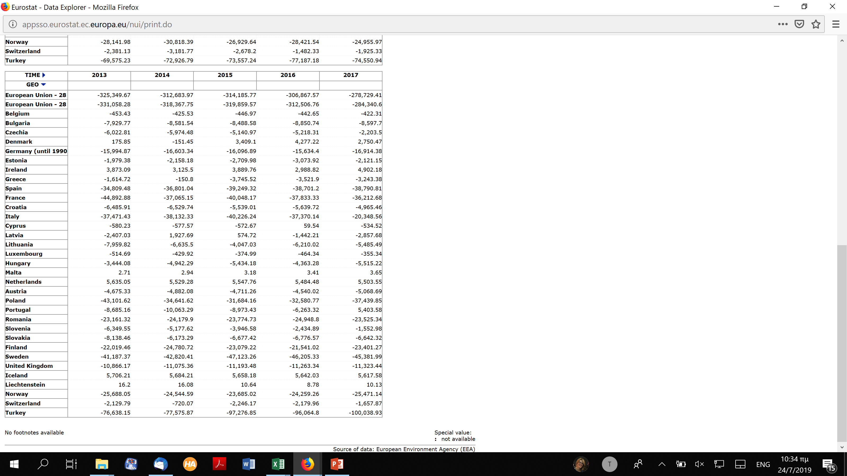
Figure 46 Gas CO2 Emissions LULUCF

Table 33 EU Legislation and related documents
EU Legislation and related documents
18/06/2019 - SWD/2019/213 | Commission staff working document: Assessment of the National Forestry Accounting Plans, accompanying the document Communication from the Commission: United in delivering the Energy Union and Climate Action - Setting the foundations for a successful clean energy transition
19/06/2018 - Regulation (EU) 2018/841 | Inclusion of greenhouse gas emissions and removals from land use, land use change and forestry in the 2030 climate and energy framework, and amending Regulation (EU) No 525/2013 and Decision No 529/2013/EU
21/05/2013 – Decision No 529/2013/EU | Accounting rules on greenhouse gas emissions and removals resulting from activities relating to land use, land-use change and forestry and on information concerning actions relating to those activities
20/07/2016 - COM/2016/479 | Proposal on the inclusion of greenhouse gas emissions and removals from land use, land use change and forestry into the 2030 climate and energy framework and amending Regulation No 525/2013 of the European Parliament and the Council on a mechanism for monitoring and reporting greenhouse gas emissions and other information relevant to climate change
20/07/2016 - SWD/2016/246 | Executive Summary of Impact Assessment
20/07/2016 - SWD/2016/249 | Impact Assessment
12/03/2012 - COM/2012/93 | Proposal for a Decision on accounting rules and action plans on greenhouse gas emissions and removals resulting from activities related to land use, land use change and forestry
12/03/2012 - COM/2012/94 | Communication on accounting for land use, land use change and forestry (LULUCF) in the Union's climate change commitments
12/03/2012 - SWD/2012/41 | Impact Assessment on the role of land use, land use change and forestry (LULUCF) in the EU's climate change commitments
12/03/2012 - SWD/2012/40 | Executive summary of the impact assessment on the role of land use, land use change and forestry (LULUCF) in the EU's climate change commitments
12/03/2012 - Press Release | Commission proposes to improve common greenhouse gas accounting rules for forestry and agriculture
12/03/2012 - MEMO/12/176 | Q&A on accounting rules and action plans on greenhouse gas emissions and removals resulting from activities related to land use, land use change and forestry (LULUCF)
24/07/2018 | Guidance on developing and reporting Forest Reference Levels in accordance with Regulation (EU) 2018/841
11/2011 | Policy options for including LULUCF in the EU reduction commitment and policy instruments for increasing GHG mitigation efforts in the LULUCF and agriculture sectors - Synthesis report
10/09/2010 | Public consultation on the role of EU agriculture and forestry in achieving the EU's climate change commitments
 | Mainstreaming climate change into rural development policy post 2013
 | Agriculture and LULUCF in the 2030

- International and national carbon accounting standards in the LULUCF sector
Carbon accounting collects information relevant for an organization (either this is a Party of UN or a big company/polluter) and its links to society and the natural environment in the context of climate. Climate accounting thus includes greenhouse gas and carbon accounts which document the extent of the effects and problems, help to create awareness and provide reference points for political, economic and corporate accounts. In this view entities can take account of their climate change impacts (i.e., of the ‘bad’ effects contributing to un-sustainability), which provide direction for improvement measures and for planning, implementing, and accounting for how effective their mitigation measures are (Schaltegger, Zvezdov, Guenther, Csutora , & Alvarez, 2015).
- Carbon accounting under UNFCCC
The basic step to account CO₂ and other GHG emissions and their removal from the atmosphere is set by the UNFCCC regulations in 2006 and recently the 2019 Refinement to the 2006 IPCC Guidelines for National Greenhouse Gas Inventories (2019 Refinement) was prepared by the Intergovernmental Panel on Climate Change (IPCC) Task Force on National Greenhouse Gas Inventories in accordance with the decision taken at the 44th Session of IPCC in Bangkok, Thailand, in October 2016. The 2019 Refinement was adopted and accepted at the 49th Session of the IPCC in May 2019.
The refinement of the 2006 IPCC Guidelines was developed in order to provide an updated and sound scientific basis for supporting the preparation and continuous improvement of national greenhouse gas inventories of emissions by sources and removals by sinks, considering scientific and other technical advances that had matured sufficiently since 2006.
The 2019 Refinement has built upon the work of the previous IPCC GHG inventory guidelines as well as on inventory experts’ experiences in using the IPCC inventory guidelines and the contribution of over 280 experts worldwide.
The advanced version of the overview chapter and the underlying chapters of the 2019 Refinement including the glossary as adopted/accepted on 12 May 2019 are available on the TFI website.
The structure of the 2019 Refinement is the same as that of the 2006 IPCC Guidelines to make it easier for inventory compilers to use the new 2019 Refinement based on the 2006 IPCC Guidelines. It comprises of an Overview Chapter and the following five volumes.
- Volume 1: General Guidance and Repo
- Volume 3: Industrial Processes and Product Use (IPPU)
- Volume 4: Agriculture, Forestry and Other Land Use (AFOLU)
- Volume 5: Waste
- Volume 2: Energy
Volume 4 is closely connected with LULUCF and is consisting of an introduction, 12 chapters and 2 annexes. In the Guidelines document, the AFOLU term is used instead of the LULUCF term.
Greenhouse gas fluxes in the AFOLU Sector can be estimated in two ways: 1) as net changes in C stocks over time (used for most CO2 fluxes) and 2) directly as gas flux rates to and from the atmosphere (used for estimating non-CO2 emissions and some CO2 emissions and removals). The use of C stock changes to estimate CO2 emissions and removals, is based on the fact that changes in ecosystem Carbon stocks are predominately (but not exclusively) through CO2 exchange between the land surface and the atmosphere (i.e., other Carbon transfer process such as leaching are assumed to be negligible). Hence, increases in total Carbon stocks over time are equated with a net removal of CO2 from the atmosphere and decreases in total Carbon stocks (less transfers to other pools such as harvested wood products) are equated with net emission of CO2. Non-CO2 emissions are largely a product of microbiological processes (i.e., within soils, animal digestive tracts and manure) and combustion of organic materials. Emission and removal processes in the AFOLU are described for the major ecosystem stocks and processes, organized by ecosystem components, i.e., 1) biomass, 2) dead organic matter, 3) soils and 4) livestock.
To prepare inventories for the AFOLU Sector, emissions and removals of CO₂ and non-CO₂ greenhouse gases are estimated separately for each of six land-use categories. Other CO₂ emission and non-CO₂ categories, such as livestock related emissions, emissions from soil Nitrogen management, soil liming emissions and harvested wood products, may be estimated at the national scale, since often only aggregate data are available. However, they can be broken out according to land-use category if data are available.
The six land-use categories in the 2006 IPCC Guidelines are:
- Forest Land
- Cropland
- Grassland
- Wetlands
- Settlements
- Other Land (which can include Marginal Lands)
The main steps to prepare an inventory estimate is given in the introductory document:
- Divide all land into managed and unmanaged.
- Develop a national land classification system applicable to all six land-use categories (Forest Land, Cropland, Grassland, Wetlands, Settlements and Other Land) and further subdivide by climate, soil type and/or ecological regions (i.e., strata) appropriate for the country.
- Compile data on the area of land and the change in area of land in each land-use category (by category) if available. Categorize land area by specific management systems defined for each land-use category (by category), which is based on combinations of management practices (e.g., tillage and fertilizer management in Croplands). This categorization provides the basis for assigning emission factors and stock change factors, required for a particular estimation approach.
- Compile national-level statistics for livestock, manure management systems, soil N management, crop yields, biochar Carbon, liming and urea application.
- Estimate CO₂ emissions and removals and non-CO₂ emissions at the appropriate tier level in support of a key category analysis.
- Estimate uncertainties and complete QA/QC procedures (which are initiated at Step 1) using the methods provided in Volume 1 Chapter 6, along with additional guidance provided in Chapters 2 to 12 of this Volume.
- Sum CO₂ emissions and removals and non-CO₂ emissions over the inventory period for each source category by land use and stratum, as well as emissions from livestock, manure, and Nitrogen management (if not analyzed separately for each land-use category).
- Transcribe summary information into reporting tables, converting Carbon stock changes to emissions or removals of CO₂ and entering non-CO₂ greenhouse gas emissions, by land-use categories, if available.
- Document and archive all information used to produce an inventory, including activity and other input data, emission factors, sources of data and metadata documentation, methods descriptions and model software or code, QA/QC procedures and reports, in addition to the results for each source category.
- Set priorities for future inventories in AFOLU Sector based on completeness of current inventories, uncertainties, and issues arising during QA/QC. Revise key category analysis based on the newly completed inventory to aid in decisions regarding future priorities.
- EU carbon accounting
As parties to the UNFCCC and its Kyoto Protocol, the EU and its member countries are required to report to the UN:
- annually on their greenhouse emissions ('greenhouse gas inventories').
- regularly on their climate change policies & measures and progress towards the targets ('biennial reports' and 'national communications').
All EU countries are required to monitor their emissions under the EU's greenhouse gas monitoring mechanism, which sets the EU's own internal reporting rules on the basis of internationally agreed obligations.
The reporting covers:
- emissions of 7 greenhouse gases (the greenhouse gas inventory) from all sectors: energy, industrial processes, land use, land use change & forestry (LULUCF), waste, agriculture, etc.
- projections, policies & measures to cut greenhouse emissions
- national measures to adapt to climate change.
- low-carbon strategies
- financial & technical support for developing countries, and similar commitments under the 2009 Copenhagen Accord and 2010 Cancún Agreements
- national governments' use of revenues (estimated at around €11bn in 2013) from the auctioning of allowances in the EU emissions trading system (they have committed to spend at least half of these revenues on climate measures in the EU and abroad)
Greenhouse gas inventories
The EU's greenhouse gas inventory is prepared by the European Commission, closely assisted by the European Environment Agency each spring.
The period covered by the inventory starts in the base year (mostly 1990) and runs up until 2 years before the current year (i.e., in 2014 the inventories cover emissions up to 2012).
The EU inventory is a compilation of national inventories, based on the emissions reported under the EU greenhouse gas monitoring mechanism.
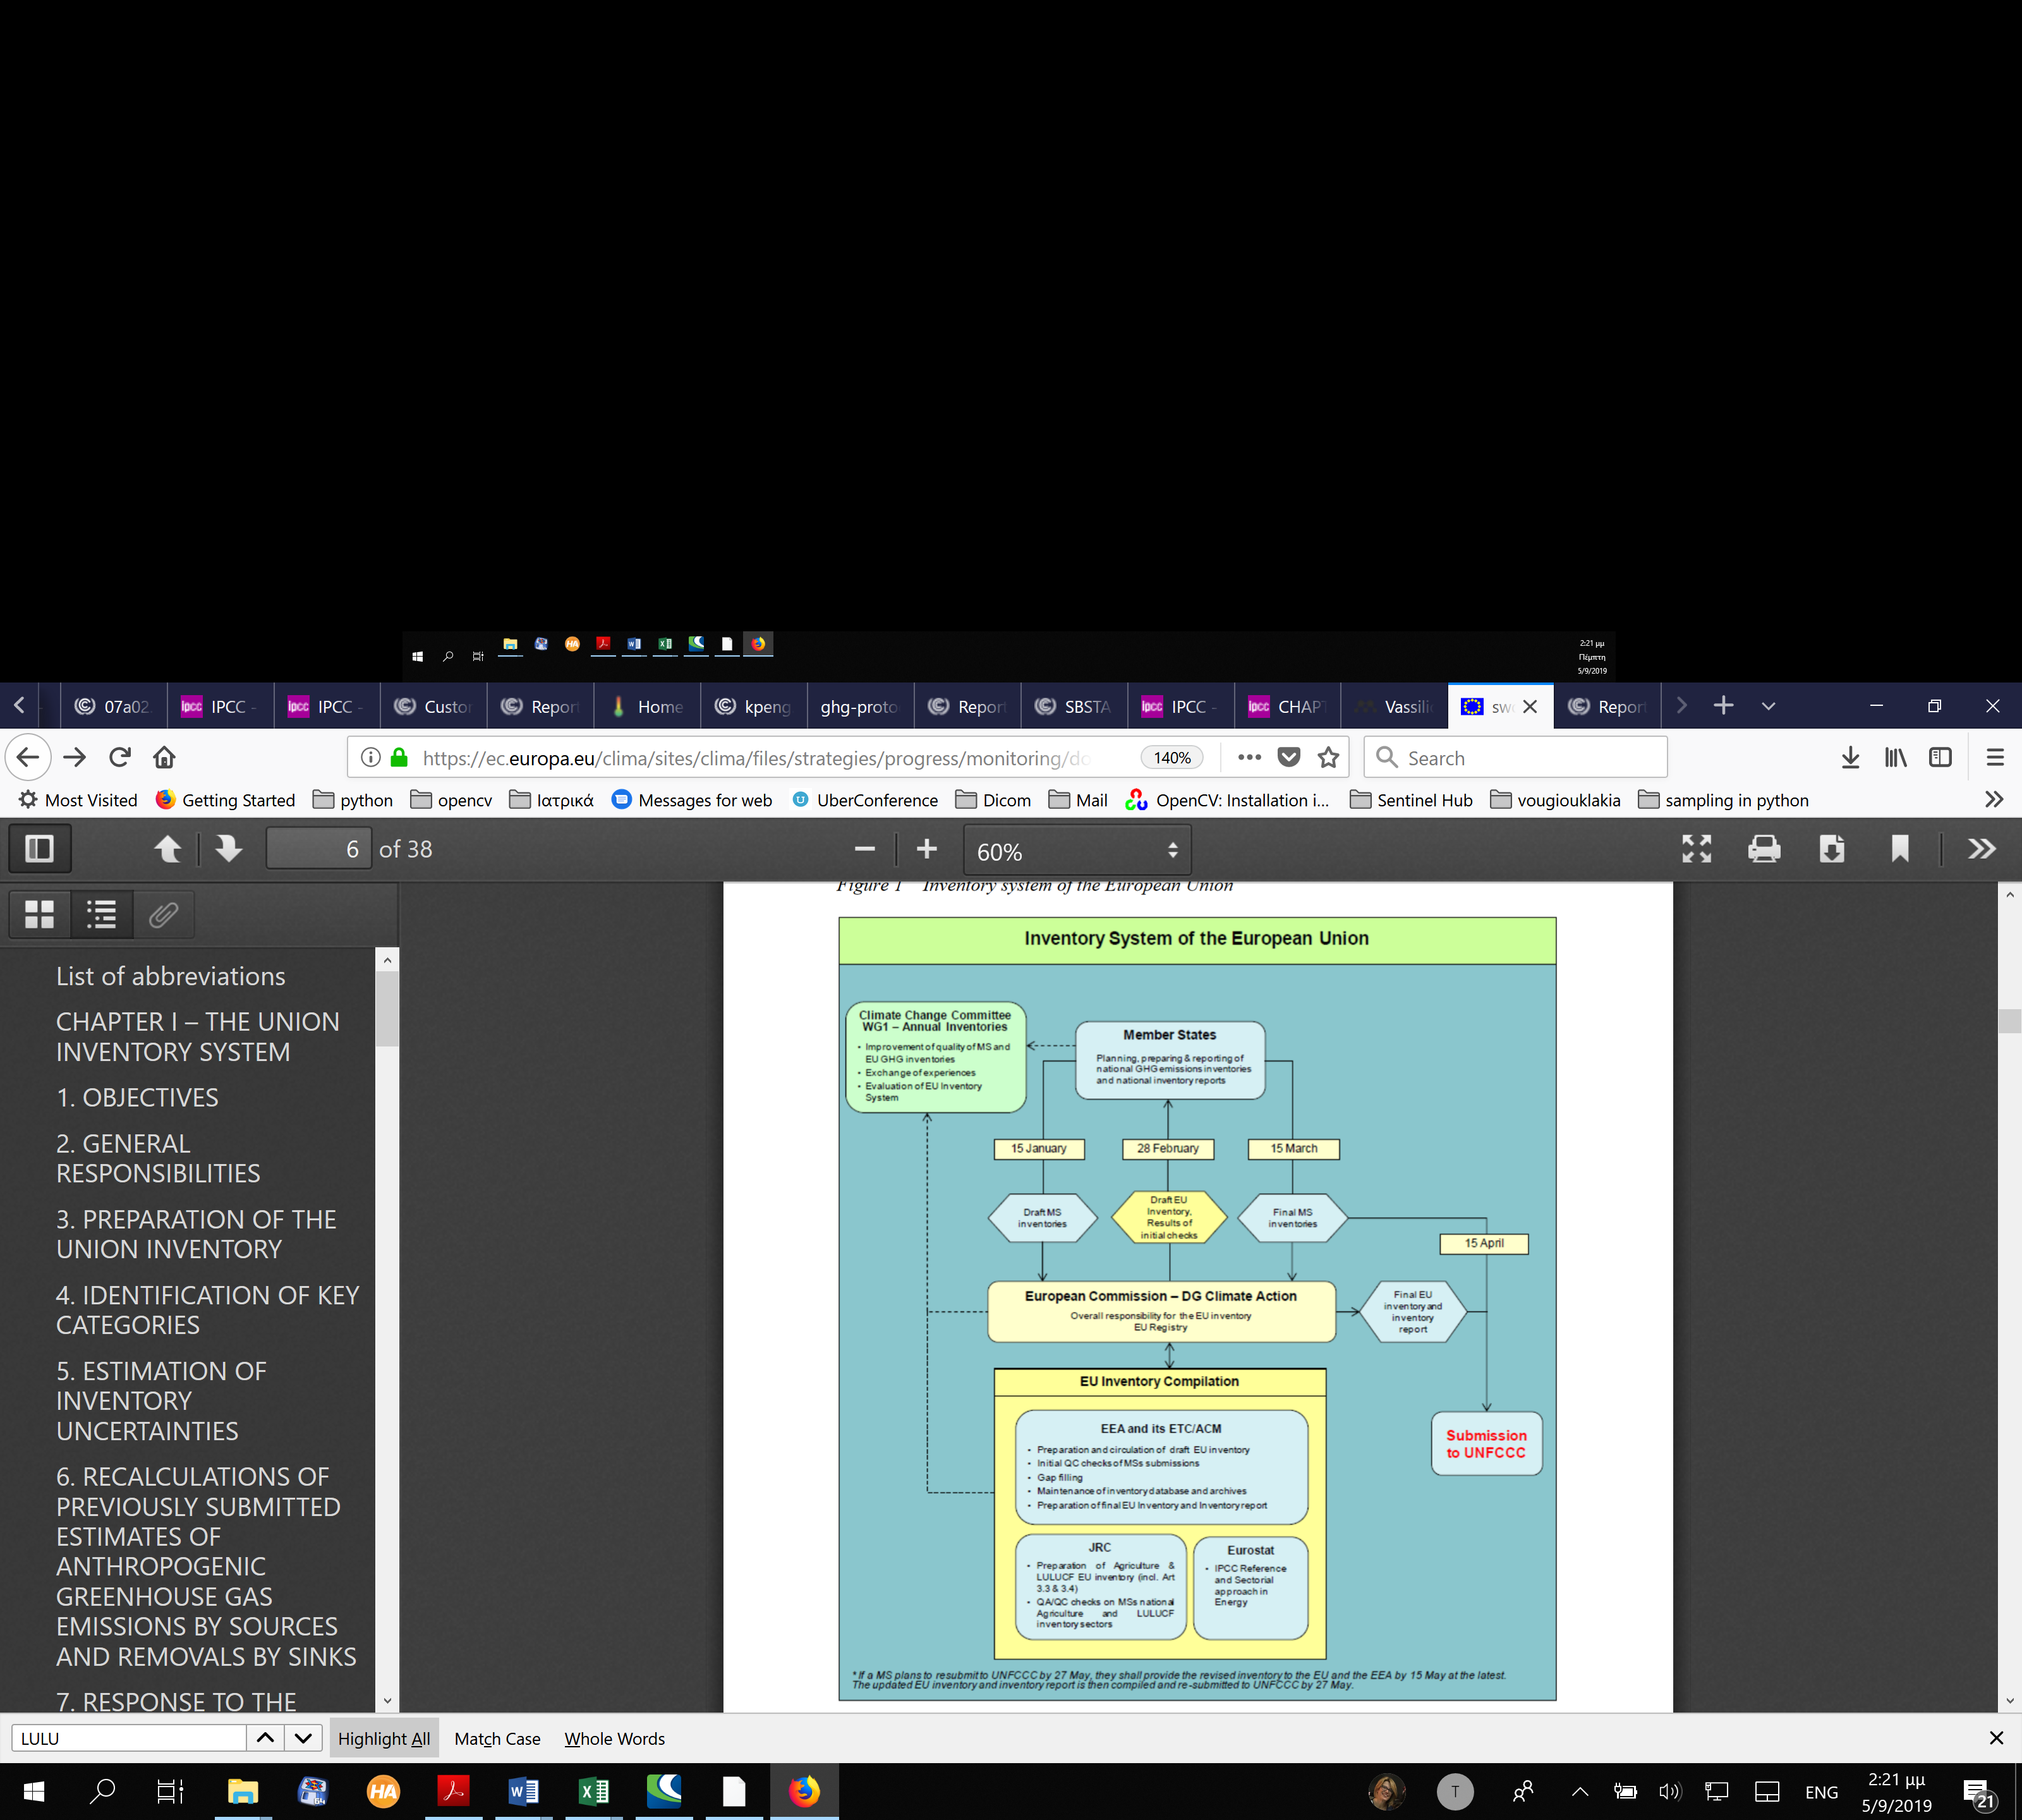
Figure 47 Diagram demonstrating the structure for the preparation of annual reports on GHG emission and their removals. Source: (European Union, 2013)
EU inventory system & quality assurance in the LULUCF sector
European Union is promoting the use of special accounting procedures for annually reporting with Quality Assurance and Quality Control approaches for all carbon emissions and their removals in all state members (European Union, 2013). Within the document (European Union, 2013), that was published in 2013, a clear structure is followed to support QA/QC (Figure 47) and more specifically several articles are referred to LULCF sector:
(Article 8) The Commission’s DG ESTAT and DG JRC are also involved in the process of inventory preparation, with their respective roles related to energy statistics for ESTAT and LULUCF and agriculture for JRC. DG ESTAT assists DG CLIMA and cooperates with the EEA in quality assurance and quality control activities of the Union inventory as described in the QA/QC program, focusing on activity data, in particular energy data. DG ESTAT compiles annual estimates of the Union CO2 emissions from fossil fuels using the IPCC Reference Approach, based on the ESTAT energy balance data. ESTAT collects energy data from EU Member States under Regulation (EC) No 1099/2008 of the European Parliament and of the Council of 22 October 2008 on energy statistics. The specific activities of DG ESTAT are outlined in its annual statistical work program. `
(Article 9) DG JRC assists DG CLIMA and cooperates with the EEA in quality assurance and quality control activities of the Union inventory, focusing on the sectors of land use, land-use change and forestry (LULUCF) and agriculture. JRC performs these activities in close cooperation with the Member States and the research community. The specific activities of DG JRC are outlined in its annual management plan.
(Article 60) DG JRC assists in the improvement of methodologies for the LULUCF and agriculture sectors. It does so by comparing methodologies used among the Member States for estimating emissions and removals from LULUCF and agriculture and by providing EU-wide emissions and removals estimates obtained using various models/methods with a focus on LULUCF. In performing these activities DG JRC interacts closely with the Member States and the research community. The results of these activities are made available to Member States in the period between May and December to assist Member States in the compilation of their national inventories for the subsequent year. In addition, JRC provides the EDGAR estimates as an independent reference for checking the completeness, transparency, correctness, and comparability between the EU Member Statesʼ inventories. JRC annually issues a CO2 report with the full estimate of CO2 emissions for the year before (X-1), using International Energy Agency (IEA) and British Petroleum (BP) statistics and industrial and World Bank data for the most important sectors (e.g., cement).
The EU document (European Union, 2013) is adopting the UNFCCC 2006 guidelines (Intergovernmental Panel on Climate Change, n.d.) for the preparation of GHG emission and removal inventories and probably it will adopt in the near future the revised guidelines (Intergovernmental Panel on Climate Change).
Table 34 EU Legislation on Reporting
EU Legislation on Reporting
Regulation 525/2013 | Greenhouse gas monitoring mechanism
Regulation 749/2014 | Requirements for national reporting under Regulation 525/2013
Regulation 666/2014 | Requirements for the EU inventory system under Regulation 525/2013
- Accounting emissions under the CDM
The basic concept of the Monitoring Reporting and Verification (MRV) was taken from the MRV Manual for CDM Program of Activities that was financed by the KFW-managed “PoA Support Centre” and contributes to the expanded use and implementation of the PoA approach funded by the German Federal Ministry for the Environment, Nature Conservation and Nuclear Safety (Aalders & Lehmann, 2013).
In the climate change negotiations, there is sometimes a different usage for the terminology of MRV, in some of the negotiation text MRV stands for Measuring, Reporting &Verification.
The more common use of MRV is Monitoring, Reporting & Verification. This is because the word “monitoring” represents more a system in which measurements are being made, where the word “measuring” relates generally only to the actual measuring itself. Within this publication MRV will always refer to Monitoring, Reporting &Verification.
The 3 steps (Monitoring, Reporting and Verifications) of a Program of Activities (PoA )are described below in sort:
Monitoring
A CDM project standard requires that project participants shall develop a monitoring plan in the Project Design Document (PDD) for monitoring of all parameters used to calculate baseline, project, and leakage emissions as well as other relevant parameters required by the applied methodology. The monitoring plan shall among others define:
- operational and management structure
- definition of responsibilities and institutional arrangements
- quality assurance and quality control processes
- uncertainty levels, methods, and the associated accuracy level
- specifications of the calibration frequency
Report Monitoring
After the project is implemented project participants shall provide information on how data and parameters have been monitored for all parameters required by the applied methodology and the registered monitoring plan for the monitoring period in question.
The report should:
- Provide the values of the monitored parameter
- Describe the equipment used to
- Describe how the parameters are measured/calculated and the measurements frequency
- Provide and/or identify the source of data
- Provide the calculation method
- Describe the QA/QC procedures
- Provide information about appropriate emission factors, IPCC default values
- and any other reference values
Verification of PoAs
A Designated Operational Entity (DOE) is an independent auditor accredited by the CDM Executive Board (CDM EB) to validate project proposals or verify whether implemented projects have achieved planned greenhouse gas emission reductions.
The requirements for verification of stand-alone CDM project activities apply equally to PoAs. Verification of PoAs will also have to assess the PoA specific requirements.
There are elements in the verification of PoAs that are in addition to the elements typically assessed as part of the verification of a stand-alone CDM project activity.
These additional elements are twofold and further as:
- the DOE needs to assess the management system of the PoA as the CME in a PoA has specific responsibilities and shall develop and implement a management system
- there is a level of complexity that is typically not encountered by a DOE in the verification of a stand-alone CDM project activity
- Voluntary Markets Accounting Standards
Below the reader can find short description of the most commonly used voluntary carbon accounting standards especially those that are closely connected with LULUCF:
    - ACR
The American Carbon Registry®, a nonprofit enterprise of Winrock International, is a leading carbon offset program that operates in both the voluntary and the regulated carbon markets. Founded in 1996 as the first private voluntary GHG registry in the world, ACR has two decades of unparalleled carbon market experience in the development of rigorous, science-based offset standards and methodologies as well as operational experience in the oversight of offset project verification, registration, offset issuance, and retirement reporting.
ACR operates a transparent online registry system for members to register projects and record the issuance, transfer, and retirement of serialized, project-based, and independently verified offsets. ACR’s registry system records transactions directly negotiated between buyers and sellers; it is not an exchange. Offset transactions take place outside of ACR, over the counter or on exchanges, and are tracked on ACR through the unique serial numbers assigned to every offset (AMERICAN CARBON REGISTRY , 2019).
ACR’s objectives are to:
- Encourage action to manage GHG emissions;
- Provide guidance, transparent infrastructure, and science-based standards to foster high-quality reductions in GHG emissions;
- Support best practices in project-level GHG accounting;
- Commercialize innovative new methodologies;
- Encourage broad adoption of practices that mitigate climate change with significant
- community, economic, and environmental benefits
- Enhance public confidence in market-based action for GHG reduction and
- Support convergence of international and U.S. carbon markets.
Among the methodologies that have been approved within the ACS certain are strongly connected with LULUCF and more specifically with degraded lands (Carbon Accounting Standard, 2019)(Table 4)
Table 35 Methodologies of ACR
Methodology title | Version
Afforestation and Reforestation of Degraded Lands | 1.2
Avoided Conversion of Grasslands and Shrublands to Crop Production | 1
Compost Additions to Grazed Grasslands | 1
Improved Forest Management (IFM) for Non-Federal U.S. Forestlands | 1.3
Restoration of California Deltaic and Coastal Wetlands | 1.1
Restoration of Degraded Wetlands of the Mississippi Delta | 2
Restoration of Pocosin Wetlands | 1
ACR registers offset projects from around the globe in a wide range of project types including among others, projects of certain type (American Carbon Registry, 2019):
- Afforestation / Reforestation (A/R)
- Improved Forest Management (IFM)
- Reduced Emissions from Deforestation and Degradation (REDD)
- Wetland Restoration
- Fertilizer Management
- Avoided Conversion of Grasslands & Rangelands
- Rice Production
- Livestock Waste Management
- Improved Cookstoves
- Water Purification
- Destruction of Ozone Depleting Substances (ODS)
- Fugitive Methane Emissions
- Transport / Fleet Efficiency
- Landfill Gas Capture & Combustion
- Renewable Energy and Energy Efficiency
Site: americancarbonregistry.org
    - Plan Vivo
The Plan Vivo Standard requires the use of approved approaches for estimating emissions and removals from the baseline scenario, and project intervention, and for emissions from leakage. If a suitable approved approach is not available, projects can develop or adopt their own approaches for estimating emissions and removals and submit these to the Plan Vivo Foundation for approval, either separately or in the relevant sections of the PDD. Methodologies developed for other standards can be considered, although it should be noted that Plan Vivo projects are encouraged to make use of simple, low-cost approaches where possible. Methodologies from other standards can be complex and costly to implement, with the aim of providing precise estimates of all emission reductions and removals. Many of these methodologies can prove impractical when applied to smaller scale projects, and the use of simpler methods, with conservative assumptions, can often reduce cost and complexity without the risk of over-estimating benefits. A full list of approved approaches and a template that should be used when submitting new approaches can be found in Plan Vivo’s official site. Approved approaches should include clear applicability criteria describing the conditions under which the approach can be used. When adopting an approved approach for estimating emissions and removals, care should be taken to ensure that the project area, baseline scenario and project intervention meet all of the applicability criteria specified for the approach (Berry, 2017), (Plan Vivo, 2013).
Plan Vivo is designing and implementing Projects to contribute to 5 core Sustainable Development Goals (SDGs) due to the ethical principles laid out in the Plan Vivo Standard. By contributing to the core SDGs, Plan Vivo projects are committed into a Pathway to Impact, delivering long-term impacts in terms of poverty alleviation, food security, economic growth, climate action and biodiversity protection. More specifically they contribute with Projects to SDG 13 (Urgent Action to Combat Climate Change) and more specifically to Reforestation, afforestation, agroforestry and the protection and management of forests for the mitigation of climate change threats and impacts. By using scientifically rigorous peer-reviews and third-party validation and verification, it is ensured that Plan Vivo projects’ carbon models are robust and conservative.
Site: www.planvivo.org
    - VERRA (old VCR) Standard
VERRA develops and manages standards and frameworks to vet environmental and sustainable development efforts, build their capacity and enable funding for sustaining and scaling up their benefits. VERRA works closely with civil society, governments, and the private sector to develop novel frameworks and enable results on the ground.
All our programs undergo extensive stakeholder consultation and expert review, and draw from four key components: standard, independent assessment, accounting methodologies, and registry.
According to VERRA an accounting voluntary market standard should set out detailed procedures, methodologies for quantifying the real greenhouse gas (GHG) benefits of a project and provide guidance to help project developers determine project boundaries, set baselines, assess additionality, and ultimately quantify the GHG emissions that were reduced or removed. Methodologies developed under the United Nations Clean Development Mechanism can be used for projects and programs registering with other accounting standards. The most recent and updated valid version of a methodology must always be used. From time to time, a methodology may be revised, withdrawn, or put on hold (Verra, 2019).
Since November 2014 all standards introduced by the Climate, Community and Biodiversity Standards are managed now by the Verra.
Approved Methodologies are divided for different sectors. The separate methodologies per sector are:
- Energy
- Industrial Processing
- Construction
- Transport
- Waste
- Mining
- Agriculture
- Forestry
- Grasslands
- Wetlands
- Livestock & manure
- Non-VCS methodologies
Site: verra.org
    - Gold Standard
Gold Standard was founded by WWF and other NGOs to serve as the benchmark in carbon markets -- ensuring that projects adhered to the highest levels of environmental integrity and delivered sustainable development benefits to local communities. Gold Standard continues to represent the best that can be achieved in carbon markets, featuring:
- The most stringent environmental and social safeguards
- Local stakeholder consultation
- Gender-sensitive project design
- Multiple contributions to sustainable development
- Higher environmental integrity
- Civil society endorsement
Gold Standard climate protection projects delivers up to $465 in additional value toward the SDGs for every ton of CO2 mitigated (Gold Standard, 2019).
Gold standard has published guidelines for the implementation of projects towards the sequestration of CO₂ with LULUCF (Gold Standard, 2017).
All projects implemented by Gold Standard can be found following the link.
Site: www.goldstandard.org
    - Emissions Reduction Fund
The Emissions Reduction Fund is a voluntary scheme that aims to provide incentives for a range of organizations and individuals to adopt new practices and technologies to reduce their emissions. It is enacted through the Carbon Credits (Carbon Farming Initiative) Act 2011, the Carbon Credits (Carbon Farming Initiative) Regulations 2011 and the Carbon Credits (Carbon Farming Initiative) Rule 2015.
Several activities are eligible under the scheme and participants can earn Australian Carbon Credit Units (ACCUs) for emissions reductions. One ACCU is earned for each ton of carbon dioxide equivalent (tCO₂-e) stored or avoided by a project. ACCUs can be sold to generate income, either to the government through a carbon abatement contract, or in the secondary market.
To ensure these emissions reductions are not displaced significantly by a rise in emissions elsewhere in the economy, the Emissions Reduction Fund also includes a safeguard mechanism​, which encourages large businesses to keep their emissions within historical levels.
The types of projects to choose and undertake as part of the Emissions Reduction Fund are called methods. The methods explain how to carry out a project and measure the resulting reductions in emissions.
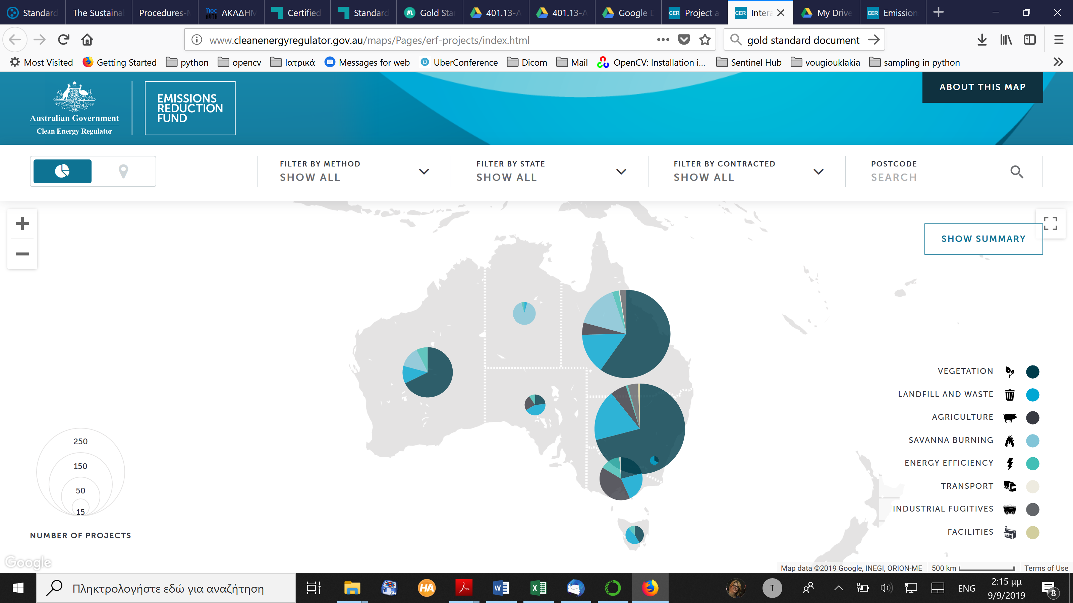
Figure 48 Distribution map of Emissions Reductions Fund projects in Australia. Source: http://www.cleanenergyregulator.gov.au/maps/Pages/erf-projects/index.html
Several different methods are already available and many of them can be applied broadly which means that a wide variety of projects can use each one.
Methods include:
- a generic method for emissions reductions at facilities reporting under the National Greenhouse and Energy Reporting Scheme
- capture and destruction of coal mine fugitive emissions​​
- reductions in emissions-intensity of transport
- commercial, industrial, and aggregated energy efficiency
- capture and combustion of landfill gas and agricultural waste
- alternative treatment of organic waste
- capture and combustion of biogas from wastewater, and
- methods for the land sector, including increasing soil carbon, reducing livestock emissions, expanding opportunities for environmental and carbon sink plantings, and reforestation.
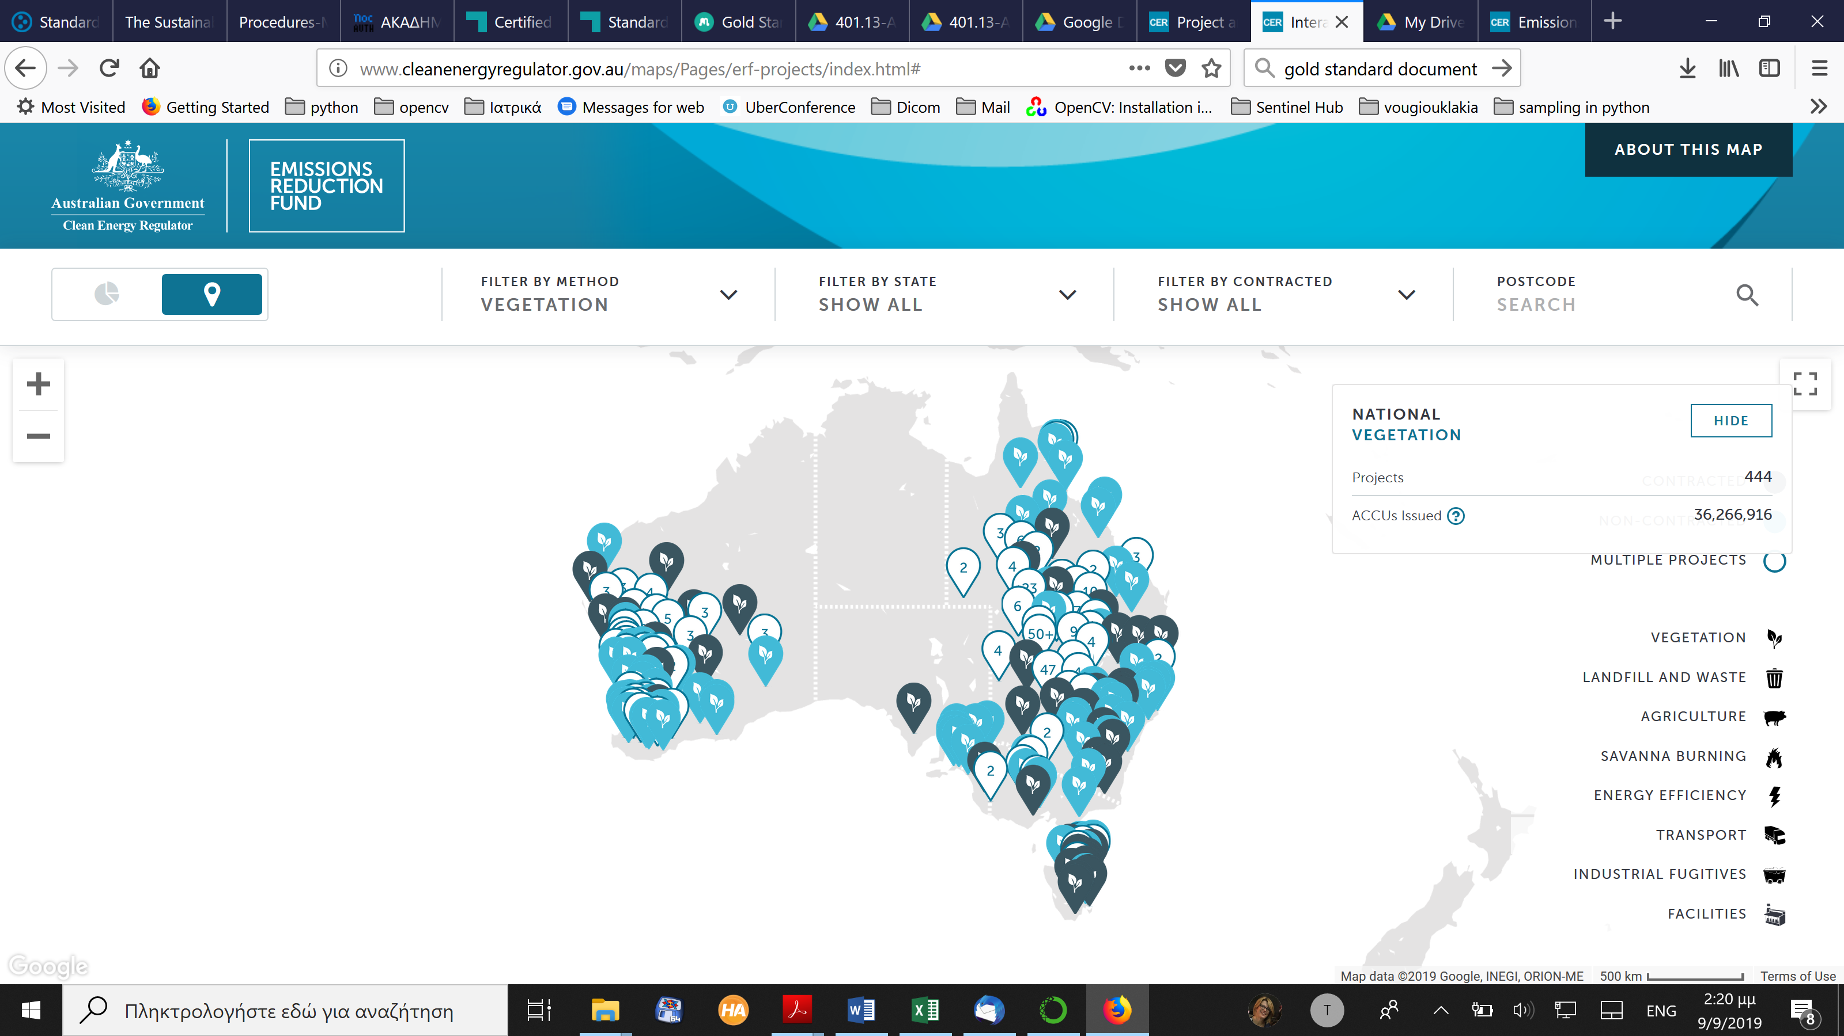
Figure 49 Projects relative to LULUCF. Source: http://www.cleanenergyregulator.gov.au/maps/Pages/erf-projects/index.html
Site: www.cleanenergyregulator.gov.au/ERF
    - Climate Action Reserve (Reserve)
The Reserve develops protocols specifying eligibility criteria and detailing steps to estimate, monitor, and verify GHG reductions achieved by specific types of projects. While each project protocol contains guidance specific to individual project types, Reserve protocols also adhere to general project accounting principles. This section describes the Reserve’s standardized project accounting guidelines that are the foundation for all project protocols.
The Reserve strives to develop protocols that are “standardized” in nature, meaning they apply standardized factors and eligibility rules to the higher possible extent while maintaining sufficient rigor and accuracy. In addition, the form and content of Reserve protocols follow internationally established accounting principles and standards (Climate Action Reserve, 2015).
The Reserve has set several protocols (methodologies) to apply for the implementation of a Carbon Offset program:
Table 36 Reserve’s protocols’ list
Title | Version | Date issued | Development status
Adipic Acid Production | Draft 1.0 | TBD | In development
Canada Grassland | Draft 1.0 | Expected October 2019 | Available for public review and comment
Coal Mine Methane | 1.1 | October 26, 2012 | Approved
Forest | 4 | June 28, 2017 | Under revision to Version 5.0
Grassland | 2 | January 18, 2017 | Approved
Mexico Boiler Efficiency | 1 | November 1, 2016 | Approved
Mexico Forest | 1.5 | September 14, 2017 | Approved
Mexico Landfill | 1.1 | September 13, 2011 | Approved
Mexico Livestock | 2 | September 29, 2010 | Approved
Mexico Ozone Depleting Substances | 1 | April 28, 2015 | Approved
Nitric Acid Production | 2.2 | April 18, 2019 | Approved
Nitrogen Management | 2 | October 17, 2018 | Approved
Organic Waste Composting | 1.1 | July 29, 2013 | Approved
Organic Waste Digestion | 2.1 | January 16, 2014 | Approved
Ozone Depleting Substances | 2 | June 27, 2012 | Approved
Rice Cultivation | 1.1 | June 3, 2013 | Approved
Urban Forest Management | 1.1 | April 18, 2019 | Approved
Urban Tree Planting | 2 | June 25, 2014 | Approved
U.S Landfill | 5 | April 24, 2019 | Approved
U.S. Livestock | 4 | January 23, 2013 | Approved
The Reserve releases policy memos that update or replace guidance in the Program Manual, protocols, and other guidance documents. These memos are considered effective on the date they are posted on the Reserve website. The list of memos is given below:
- Global Warming Potential (GWP) (May 1, 2018)
- Forest Verifier Training Requirements (September 14, 2017)
- Monitoring and Reporting Activities for Forest Projects with Credits at Both ARB and the Reserve (April 6, 2017)
- Registry Offset Credits – Retirement or Conversion to CRTs (September 20, 2016)
- Forest Project Reporting and Verification Requirements (May 19, 2016)
- PIA and PIA Amendment Agreement and Recordation Policy (October 20, 2015)
- Risk Factors for Water Quality Regulatory Violations at Livestock Facilities (September 1, 2015)
- Effect of New Waste Diversion Mandates on Reserve Projects (Seattle, California) (January 14, 2015)
- Manufacturer Recommendations for Meter Maintenance (December 12, 2013)
- Requirements for Project Diagrams (February 13, 2012)
- Use of eGRID Electricity Emission Factors for All Project Protocols (May 3, 2011)
- Immediate Crediting of Future Avoided Emissions (September 7, 2010)
Site: www.climateactionreserve.org
    - Greenhouse gas protocol
GHG Protocol establishes comprehensive global standardized frameworks to measure and manage greenhouse gas (GHG) emissions from private and public sector operations, value chains and mitigation actions.
The standard is built on a 20-year partnership between World Resources Institute (WRI) and the World Business Council for Sustainable Development (WBCSD), GHG Protocol works with governments, industry associations, NGOs, businesses and other organizations.
GHG Protocol supplies the world's most widely used greenhouse gas accounting standards. The Corporate Accounting and Reporting Standard provides the accounting platform for virtually every corporate GHG reporting program in the world.
In 2016, 92% of Fortune 500 companies responding to the CDP used GHG Protocol directly or indirectly through a program based on GHG Protocol.
Through their commitment to the Compact of Mayors, hundreds of cities across the globe have committed to using the GHG Protocol for Cities.
There is also a close cooperation with partners in key countries to develop national GHG emissions programs based on the GHG Protocol.
GHG Protocol arose when WRI and WBCSD recognized the need for an international standard for corporate GHG accounting and reporting in the late 1990s. Together with large corporate partners such as BP and General Motors, in 1998 WRI published a report called, “Safe Climate, Sound Business.” It identified an action agenda to address climate change that included the need for standardized measurement of GHG emissions.
Similar initiatives were being discussed at WBCSD. In late 1997, WRI senior managers met with WBCSD officials, and an agreement was reached to launch an NGO-business partnership to address standardized methods for GHG accounting. WRI and WBCSD convened a core steering group comprised of members from environmental groups (such as WWF, Pew Center on Global Climate Change, The Energy Research Institute) and industry (such as Norsk Hydro, Tokyo Electric, Shell) to guide the multi-stakeholder standard development process.
The first edition of the Corporate Standard, published in 2001, has been updated with additional guidance that clarifies how companies can measure emissions from electricity and other energy purchases, and account for emissions from throughout their value chains. GHG Protocol also developed a suite of calculation tools to assist companies in calculating their greenhouse gas emissions and measure the benefits of climate change mitigation projects.
The Paris Agreement, adopted within the United Nations Framework Convention on Climate Change (UNFCC) in December 2015, commits participating all countries to limit global temperature rise, adapt to changes already occurring, and regularly increase efforts over time. GHG Protocol is developing standards, tools and online training that helps countries and cities track progress towards their climate goals (Greenhouse Gas Protocol, 2019).
The standards are designed to provide a framework for businesses, governments, and other entities to measure and report their greenhouse gas emissions in ways that support their missions and goals.
In 2016, 92% of Fortune 500 companies responding to the CDP used GHG Protocol directly or indirectly through a program based on GHG Protocol. It provides the accounting platform for virtually every corporate GHG reporting program in the world.
The popularity of GHG Protocol standards is due in part to the widespread stakeholder outreach and consultation that is facilitated by WRI and WBCSD during each standard development project.
There are several standards proposed by GHG Protocol. All of them are well described in https://ghgprotocol.org/standards and the user can choose the most appropriate for further implementation.
Site: ghgprotocol.org
    - The Panda standard
The Panda Standard is the first voluntary carbon standard designed specifically for China. The China Beijing Environment Exchange (CBEEX) and BlueNext, and Winrock International founded the Panda Standard. Version 1.0 of the standard was launched at COP 15 in Copenhagen in December 2009:
" The Panda Standard effort will support the commitment of the People's Republic of China Government to reducing the greenhouse gas (GHG) emissions intensity of its economy, help develop national capacity in domestic voluntary carbon markets, and, as a first focus, promote Agriculture, Forestry and Other Land Use (AFOLU) GHG offset projects with significant poverty alleviation benefit." (Carbon Offset Research and Education, 2019)
    - ISO 14064-1:2006 Greenhouse gases -- Part 1: Specification with guidance at the organization level for quantification and reporting of greenhouse gas emissions and removals
ISO (the International Organization for Standardization) is a worldwide federation of national standards bodies (ISO member bodies). The work of preparing International Standards is normally carried out through ISO technical committees. Each member body interested in a subject for which a technical committee has been established has the right to be represented on that committee. International organizations, governmental and non-governmental, in liaison with ISO, also take part in the work. ISO collaborates closely with the International Electrotechnical Commission (IEC) on all matters of electrotechnical standardization.
The first edition of the standard was published in 2006. This second edition cancels and replaces the first edition (ISO 14064-1:2006), which has been technically revised.
The main changes compared to the previous edition are as follows.
- A new approach has been introduced to reporting boundaries, facilitating the inclusion and expansion of indirect emissions. This change is a response to a growing number of organizations that are recognizing the importance and significance of indirect emissions and are developing GHG inventories that include more types of indirect emissions across the value chain.
- The GHG emissions category “other indirect GHG emissions” has been renamed “indirect GHG emissions.” Requirements and guidance have been provided for classification of indirect GHG emissions into five specific categories. “Operational boundaries” has been renamed “reporting boundaries” for clarification and simplicity.
- New requirements and guidance for GHG quantification and reporting of specific items, such as the treatment of biogenic carbon and GHG emissions related to electricity, have been added for clarification.
The complete documentation of the ISO standard is not freely available over the internet. The reader can purchase for an amount of about 160CHF the standard’s description and details.
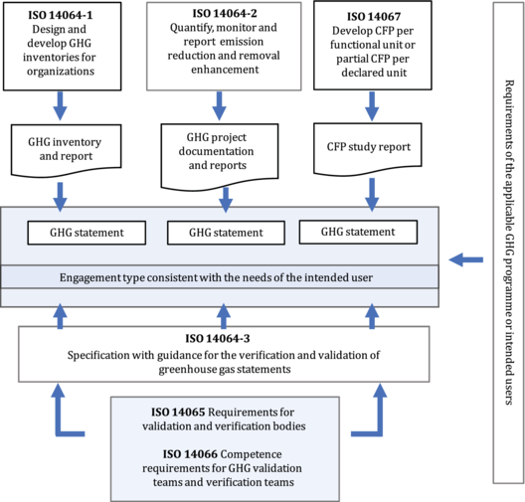
Figure 50: Relationship among ISO 14060 family and the GHG standards. Source: https://www.iso.org/obp/ui/#iso:std:iso:14064:-1:ed-2:v1:en
    - WWF report on forest carbon accounting standards
A thorough report about the current trend of voluntary markets has been given since 2010 by the World Wide Fund (WWF) and is assessing the carbon markets based also on previous published documents and reports from relevant institutions. One of the most important conclusions of the report is about the basic principles that a credible forest carbon standard should have (Figure 51) (WWF, 2010).
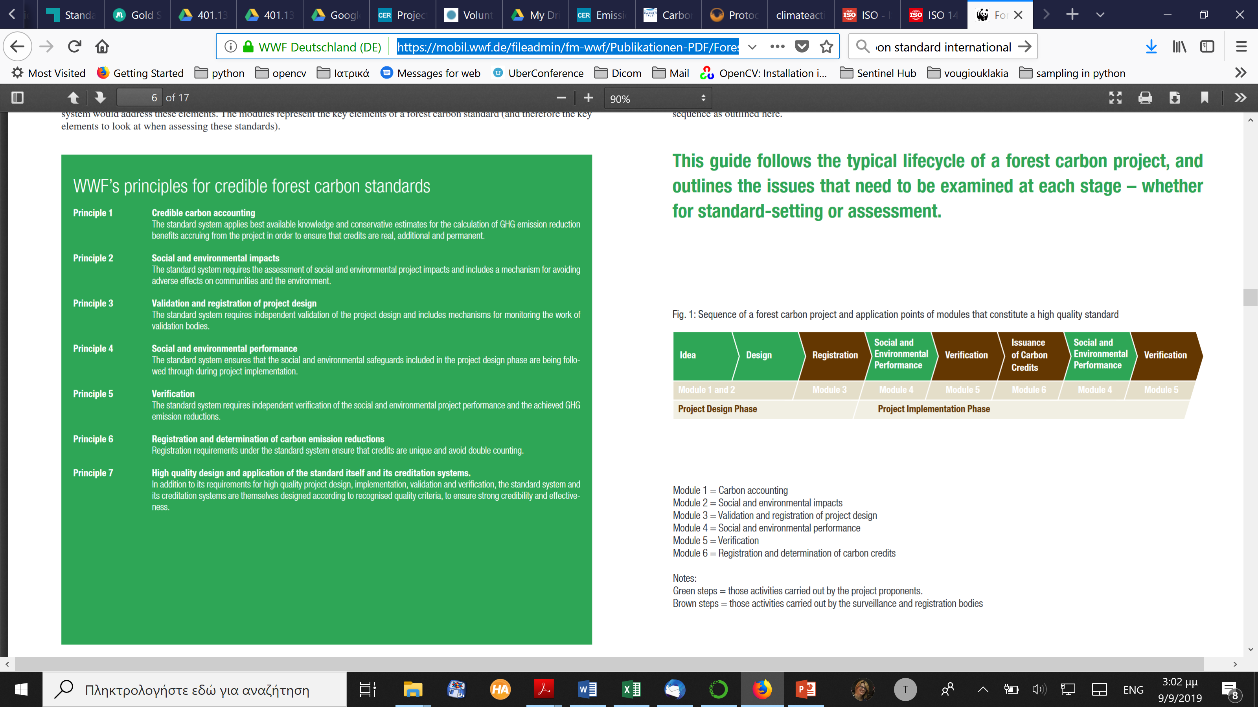
Figure 51 Basic characteristics of a forest carbon standard. Source: https://mobil.wwf.de/fileadmin/fm-wwf/Publikationen-PDF/Forest_Carbon_Standards_Assessment_Guide.pdf
A state of the art of most of the Carbon Voluntary markets reported in a yearly basis since the last years of the past decade can be found at the site of Ecosystem Marketplace (Ecosystem Marketplace, 2019).

- Carbon offset and absorption projects: public and private initiatives
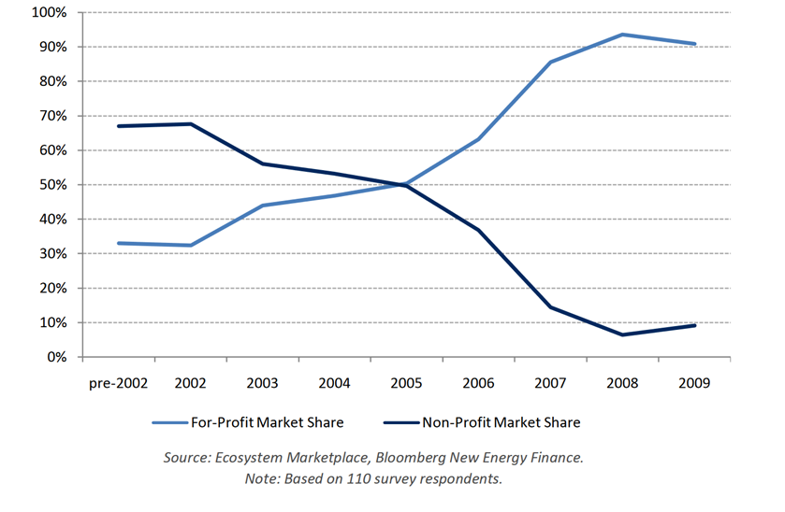
Figure 52 Historical market share of transaction Volume by profit and non-profit suppliers. Source: https://www.forest-trends.org/wp-content/uploads/imported/final_report_2010_9-1-10_no-crop-pdf.pdf
- Public initiatives
Carbon Offset and voluntary markets are synonym concepts and most of the voluntary markets have started from non-profit and Non-Government Organizations (NGOs) (Figure 52). However, this trend started to change in 2005 (Ecosystem Marketplace, 2010). Domestic Offset Projects (DOP) refer to Carbon Offset Projects that are creating allowances within the country that will use them (either by the government to fulfil their INDC or private institutes/polluters). The DOPs can be either of public (governmental) or of private character. However, EU with the early establishment of ETS and of the future Effort Sharing mechanism has not given a lot of space for the development of public DOPs. There exist only a few paradigms in Europe where governments have implemented Carbon Offsets Market and the reason is because of the unlinked operation of several compliance and voluntary mechanisms that might lead to double counting of allowances and the inability of their users to prove the additionality (Nett & Volters, 2017). We remind that the topic of additionality is the most fundamental issue in the carbon offset market. In theory, additionality answers a very simple question: Would the emissions reductions have occurred, holding all else constant, if the activity were not implemented as an offset project? Or more simply: Would the project have happened anyway? If the answer to that is yes, the project is not additional (Core Carbon Offset Research Education, 2019).
The public initiatives examples are coming from Spain (participating in MAIL with 2 partners- CESEFOR and UPV), France and Italy (Nett & Volters, 2017). Since no partners from Italy and France are participating in MAIL, we describe only the Spanish public DOPs.
There are two major crediting schemes in Spain:
- The Spanish “Fondo de Carbono para una Economía Sostenible (FES-CO2)” is a voluntary scheme to promote private actions to reduce emissions in non-EU ETS sectors. The scheme is exclusively domestic and does not allow for credits to be traded outside of Spain.
- The voluntary carbon footprint registry (Registro de huella de carbono, compensación y proyectos de absorción – RHC) that generates credits from voluntary projects in the forestry and land use sector. These credits can be purchased by companies wishing to voluntarily reduce their carbon footprint.
Participation in the FES-CO2 scheme is voluntary for companies, but projects are intended to contribute to the Spanish ESD target. So, at the moment units are not actually traded on the carbon market for compensation but used to reduce emissions within the non-ETS sectors and help the Spanish government achieve its reduction target. The project categories agriculture, housing, waste, industry, transport and fluorinated GHGs are counted towards the ESD target and are part of the commitments under the Kyoto Protocol. This means that double claiming can occur but as its use towards the reduction target is communicated transparently, it is not a challenge for environmental integrity. As long as AAUs are not sold to other Annex B countries, double monetization does not occur.
Regarding RHC, project activities eligible under the voluntary registry, reforestation with land use change and restoration of existing forests, are mandatory reporting categories according to articles 3.3 (type A) and 3.4 (type B) of the Kyoto Protocol and must therefore be listed in Spain’s national inventory and counted towards its Kyoto target. This puts projects theoretically at risk of double counting, at least on the international level. Regarding the European framework there is no problem with double counting until 2021. However, in practice this does not occur as removals exceed the cap of what can be counted towards Kyoto.
In all other countries (Germany, Greece and Poland) which are participating in the MAIL Program, there is no official public initiative to exploit LULUCF and create Carbon Allowances.
- CDM Projects
Under the official site of the Clean Development Mechanism (Clean Development Mechanism Projects Registry, 2019) the reader can locate and derive information of all approved projects since the first year of its operation. More specifically the projects that are connected to LULUCF and those especially with reforestation of degraded lands are more than 60 (Table 37).
Table 37 Lists of CDM Projects connected with LULUCF
Project Title | Host parties
Facilitating Reforestation for Guangxi Watershed Management in Pearl River Basin | China
Moldova Soil Conservation Project | Republic of Moldova
Small Scale Cooperative Afforestation CDM Pilot Project Activity on Private Lands Affected by Shifting Sand Dunes in Sirsa, Haryana | India
Cao Phong Reforestation Project | Viet Nam
Reforestation of severely degraded landmass in Khammam District of Andhra Pradesh, India under ITC Social Forestry Project | India
CARBON SEQUESTRATION THROUGH REFORESTATION IN THE BOLIVIAN TROPICS BY SMALLHOLDERS OF “The Federaciσn de Comunidades Agropecuarias de Rurrenabaque (FECAR)” | Bolivia
Uganda Nile Basin Reforestation Project No.3 | Uganda
Reforestation of croplands and grasslands in low income communities of Paraguarν Department, Paraguay | Paraguay
Afforestation and Reforestation on Degraded Lands in Northwest Sichuan, China | China
“Reforestation, sustainable production and carbon sequestration project in Josι Ignacio Tαvara΄s dry forest, Piura, Peru” | Peru
Humbo Ethiopia Assisted Natural Regeneration Project | Ethiopia
Assisted Natural Regeneration of Degraded Lands in Albania | Albania
The International Small Group and Tree Planting Program (TIST), Tamil Nadu, India | India
Forestry Project for the Basin of the Chinchinα River, an Environmental and Productive Alternative for the City and the Region | Colombia
Nerquihue Small-Scale CDM Afforestation Project using Mycorrhizal Inoculation in Chile | Chile
Reforestation as Renewable Source of Wood Supplies for Industrial Use in Brazil | Brazil
Reforestation on Degraded Lands in Northwest Guangxi | China
'Posco Uruguay' afforestation on degraded extensive grazing land | Uruguay
AES Tietκ Afforestation/Reforestation Project in the State of Sγo Paulo, Brazil | Brazil
Reforestation of grazing Lands in Santo Domingo, Argentina | Argentina
Argos CO2 Offset Project, through reforestation activities for commercial use | Colombia
Ibi Batιkι degraded savannah afforestation project for fuelwood production (Democratic Republic of Congo) | Democratic Republic of the Congo
Improving Rural Livelihoods Through Carbon Sequestration By Adopting Environment Friendly Technology based Agroforestry Practices | India
India: Himachal Pradesh Reforestation Project – Improving Livelihoods and Watersheds | India
Kachung Forest Project: Afforestation on Degraded Lands | Uganda
Southern Nicaragua CDM Reforestation Project | Nicaragua
Forestry Project in Strategic Ecological Areas of the Colombian Caribbean Savannas | Colombia
Bagepalli CDM Reforestation Programme | India
Commercial reforestation on lands dedicated to extensive cattle grazing activities in the region of Magdalena Bajo Seco | Colombia
Aberdare Range/ Mt. Kenya Small Scale Reforestation Initiative Kamae-Kipipiri Small Scale A/R Project | Kenya
Uganda Nile Basin Reforestation Project No.5 | Uganda
Reforestation of degraded land by MTPL in India | India
Uganda Nile Basin Reforestation Project No 1 | Uganda
Uganda Nile Basin Reforestation Project No 2 | Uganda
Uganda Nile Basin Reforestation Project No 4 | Uganda
Aberdare Range / Mt. Kenya Small Scale Reforestation Initiative Kirimara-Kithithina Small Scale A/R Project | Kenya
SECURITIZATION AND CARBON SINKS PROJECT | Chile
Aberdare Range/ Mt. Kenya Small Scale Reforestation Initiative Kibaranyeki Small Scale A/R Project | Kenya
Oceanium mangrove restoration project | Senegal
REFORESTATION OF DEGRADED/DEGRADING LAND IN THE CARIBBEAN SAVANNAH OF COLOMBIA | Colombia
Vale Florestar. Reforestation of degraded tropical land in Brazilian Amazon | Brazil
Carbon Sequestration in Small and Medium Farms in the Brunca Region, Costa Rica (COOPEAGRI Project) | Costa Rica
Moldova Community Forestry Development Project | Republic of Moldova
Agro-forestry Interventions in Koraput district of Orissa | India
Reforestation of Abandoned Dairy Cattle Grazing Grasslands in Korea | Republic of Korea
San Nicolas CDM Reforestation Project | Colombia
Afforestation of Degraded Shengle Ecological Zone in Helinge'er of Inner Mongolia, China | China
Rehabilitation of Degraded Wastelands at Deramandi in Southern District of National Capital Territory of Delhi through Reforestation | India
Namwasa Central Forest Reserve Reforestation Initiative | Uganda
Afforestation/Reforestation on Degraded Lands in Southwest Sichuan, China | China
CDM Project for Forestry Restoration in Productive and Biological Corridors in the Eastern Plains of Colombia | Colombia
Niger Acacia Senegal Plantation Project | Niger
Niassa Reforestation Project | Mozambique
Restoration of Degraded Lands through Reforestation in MAU Forest Complex, Kenya | Kenya
Restoration of Degraded Lands through Reforestation in Aberdare Forest Complex & National Park area, Kenya | Kenya
Mitigation of GHG: Rubber based agro-forestry system for sustainable development and poverty reduction in Pakkading, Bolikhamsay Province, Lao PDR. | Lao People's Democratic Republic
Small scale Allahabad JFM A/R CDM Project on degraded lands in Allahabad Forest Division, Uttar Pradesh, India | India
Small scale Chitrakoot JFM A/R CDM Project on degraded lands in Chitrakoot Forest Division, Uttar Pradesh, India | India
Small scale Mirzapur JFM A/R CDM Project on degraded lands in Mirzapur Forest Division, Uttar Pradesh, India | India
Small scale Kashi JFM A/R CDM Project on degraded lands in Kashi Forest Division, Uttar Pradesh, India | India
Small scale Lalitpur JFM A/R CDM Project on degraded lands in Lalitpur Forest Division, Uttar Pradesh, India | India
Small scale Obra JFM A/R CDM Project on degraded lands in Obra Forest Division, Uttar Pradesh, India | India
Small scale Sonbhadra JFM A/R CDM Project on degraded lands in Sonbhadra Forest Division, Uttar Pradesh, India | India
Small scale Renukoot JFM AR CDM Project on degraded lands in Renukoot Forest Division, Uttar Pradesh, India | India
Small scale Mahoba JFM A/R CDM Project on degraded lands in Mahoba Forest Division, Uttar Pradesh, India | India
Small scale Jhansi JFM A/R CDM Project on degraded lands in Jhansi Forest Division, Uttar Pradesh, India | India
The most important information about all the projects is that the complete description as well as all the other documents concerning the approval/monitoring/reporting/validation and all-important stages of a PoA is available for any registered user of the CDM site.
- Private initiatives - Voluntary Carbon Offset Projects
The report about the State of the art of Voluntary markets of 2016 gathered the suppliers of Carbon Offset Projects using the major accounting standards (ACR, Verra, Gold Standard, etc.) and they are given below in the following list (Table 38):
Table 38 Organizations providing Carbon offset Projects through Voluntary Markets
Continent /Institutions | Website | County
Africa
BioCarbon Partners | https://www.biocarbonpartners.com/ | Zambia
Carbon Manna Africa Ltd /Climate Pal Ltd | www.carbonmannaafrica.com | Kenya
Carbon Tanzania | www.carbontanzania.com | Tanzania
Credible Carbon | www.crediblecarbon.com | South Africa
ECOTRUST | www.ecotrust.org | Uganda
Nedbank | www.nedbank.co.za | South Africa
Nova Institute | www.nova.org.za | South Africa
Uganda Carbon Bureau | www.ugandacarbon.org
Vi Agroforestry Programme | viagroforestry.org
Asia
CAFACA | www.cafaca.com | Cambodia
CARBONyatra | www.carbonyatra.com | India
CLP Wind Farms (India) Private | www.clpindia.in | India
Hydrologic Social Enterprise Ltd. | www.hydrologichealth.com | Cambodia
Infinite Solutions | www.infisolutions.org | India
InfiniteEARTH Ltd | www.infinite-earth.com | Hong Kong
Korea Energy Agency | http://www.energy.or.kr | Korea
MAFF/National Biodigester Programme | www.nbp.org.kh | Cambodia
Microenergy Credits | www.microenergycredits.com | India
Nexus - Carbon for Development Overseas Environmental | www.nexus-c4d.org | Singapore
Cooperation Center - JCREDIT | www.oecc.or.jp | Japan
PEAR Carbon Offset Initiative | www.pear-carbon-offset.org | Japan
Shan Shui Conservation Center | www.shanshui.org | China
Sindicatum Sustainable Resources | www.sindicatum.com | Singapore
SKG SANGHA | www.skgsangha.org | India
Tamiladu Spinning Mills Association (TASMA) | www.tasma.in | India
The Carbon Consulting Company | www.carbonconsultingcompany.com | Sri Lanka
Think Green |  | Pakistan
Value Network Venture Advisory Services LLP | www.vnvadvisory.com | India
Vert Conservation PTE LTD | www.vertconservation.com | Singapore
Europe
2050 Consulting | www.2050.se | Sweden
Aera Group | aera-group.fr | France
ALLCOT Group | www.allcot.com | Switzerland
Althelia Ecosphere | www.althelia.com | United Kingdom
AzzeroCO2 | www.azzeroco2.it | Italy
BaumInvest GmbH & Co KG | www.bauminvest.de | Germany
BioCarbon Group | www.biocarbongroup.com | Germany
Bischoff & Ditze Energy GmbH | www.bd-energy.com | Germany
Bosques Sostenibles | www.bosquessostenibles.com | Spain
Carbon Clear | www.carbon-clear.com | United Kingdom
Carbon Expert | www.carbonexpert.ro | Romania
Carbon Online Ltd | www.carbononline.co | Hungary
carbon-connect AG | www.carbon-connect.ch | Switzerland
CarbonSinkGroup | www.carbonsink.it | Italy
China Carbon | www.chinacarbonfund.com | Netherlands
Clevel | www.clevel.co.uk | United Kingdom
Climate Care | www.climatecare.org | United Kingdom
Climate Neutral Group | www.climateneutralgroup.com | Netherlands
Climate Partner | www.climatepartner.com | Germany
Climex | www.climex.com | Netherlands
CO2 Solidaire | www.co2solidaire.org | France
co2balance | www.co2balance.com | United Kingdom
CO2OL | www.co2ol.de | Germany
Concern Universal | www.concern-universal.org | United Kingdom
Cool Earth | www.coolearth.org | United Kingdom
Die Ofenmacher e.V. | www.ofenmacher.org | Germany
EcoAct | www.eco-act.com | France
EcoWay S.p.a. | www.ecoway.it | Italy
Face the Future | www.facethefuture.com | Netherlands
Fair Recycling Foundation | www.fair-recycling.com | Switzerland
Fair Climate Fund | www.fairclimatefund.nl | Netherlands
First Climate | www.firstclimate-climateneutral.com/gb | Germany
Forest Carbon Ltd | www.forestcarbon.co.uk | United Kingdom
FutureCamp Climate GmbH | future-camp.de | Germany
Green Innovation Srl | www.co2-zero.it | Italy
Green Resources | www.greenresources.no | Norway
GTE Carbon Trading | www.gtecarbon.com | Turkey
Initiative Développement (ID) | www.id-ong.org | France
Lavola 1981, SA | www.clean-co2.com | Spain
Mavi Consultants | www.maviconsultants.com | Turkey
Microsol | www.microsol-int.com | France
myclimate | www.myclimate.org | Switzerland
Natural Capital Partners | www.naturalcapitalpartners.com | United Kingdom
Numerco | www.numerco.com | United Kingdom
OurOffsetLtd | www.ouroffset.com | Hungary
PrimaKlima -weltweit- e.V. | www.primaklima.org | Germany
South Pole Carbon Asset Management Ltd. | www.southpolecarbon.com | Switzerland
Stichting HIVOS | www.hivos.org | Netherlands
UPM Umwelt-Projekt-Management GmbH | www.upm-cdm.eu | Germany
Wind to Market SA | www.w2m.es | Spain
Woodland Trust | www.woodland-trust.org.uk | United Kingdom
World Land Trust | www.worldlandtrust.org | United Kingdom
Yorkshire Dales Millennium Trust | www.ydmt.org | United Kingdom
ZeroMission | www.zeromission.se | Sweden
Latn America
AMBIO S.C. de R.L. | www.ambio.org.mx | Mexico
Biofílica | www.biofilica.com.br | Brazil
Brasil Mata Viva | www.brasilmataviva.com.br | Brazil
CIMA-Cordillera Azul | www.cima.org.pe | Peru
COLBUN S.A. | www.colbun.cl | Chile
Cooperativa Agraria Cacaotera ACOPAGRO | www.acopagro.com.pe | Peru
Green Farm CO2FREE | www.greenfarmco2free.com.br | Brazil
Greenoxx NGO | www.greenoxx.com | Uruguay
Grupo Ecológico Sierra Gorda, I.A.P. | www.sierragorda.net | Mexico
MÉXICO2 | www.mexico2.com.mx | Mexico
Mindo Cloudforest Foundation | www.mindocloudforest.org | Ecuador
Monte Rosa S.A. | www.pantaleon.com | Nicaragua
ONF International - Brazil | www.onfinternational.org | Brazil
Pacific Hydro Chacayes | www.pacifichydro.cl | Chile
Pronatura Mexico | www.pronatura.org.mx | México
Proyecto Mirador | www.proyectomirador.org | Honduras
Secacao Group | www.gruposecacao.com | Guatemala
Sustainable Carbon | www.sustainablecarbon.com | Brazil
North America
3Degrees | www.3degreesinc.com | United States
Blue Source, LLC | www.bluesource.com | United States
Bonneville Environmental Foundation | www.b-e-f.org | United States
Brinkman Climate | www.brinkmanclimate.com | Canada
Carbon Offsets To Alleviate Poverty (COTAP) | COTAP.org | United States
Carbonfund.org Foundation, Inc. | www.carbonfund.org | United States
Clean Air Action Corp | www.cleanairaction.com | United States
ClimeCo Corporation | climeco.com | United States
Clinton Development Initiative | www.clintonfoundation.org | United States
Code REDD | www.coderedd.org | United States
Community Energy, Inc. | www.communityenergyinc.com | United States
Conservation International | conservation.org | United States
Diversified Pure Chem, LLC | www.divpc.com | United States
ECOTIERRA | www.ecotierra.co/en | Canada
Ecotrust Forest Management | www.ecotrustforests.com | United States
Element Markets | www.elementmarkets.com | United States
Envirofit | www.envirofit.org | United States
Environmental Attribute Advisors | www.enviadvi.com | United States
Forest Carbon Offsets LLC | www.forestcarbonoffsets.net | United States
GreenTrees (C2Invest) | www.c2invest.net | United States
Impact Carbon | www.impactcarbon.org | United States
Less Emissions Inc. | www.less.ca | Canada
Mikro-Tek Inc | www.mikro-tek.com | Canada
NativeEnergy Inc. | www.nativeenergy.com | United States
NatureBank | naturebank.com | Canada
Origin Climate | www.originclimate.com | United States
Renewable Choice Energy | www.renewablechoice.com | United States
Sustainable Travel International | www.sustainabletravel.org | United States
Taking Root | www.takingroot.org | Canada
TerraPass | www.terrapass.com | United States
The Climate Trust | www.climatetrust.org | United States
The Conservation Fund | www.conservationfund.org | United States
The Paradigm Project | www.theparadigmproject.org | United States
Verus Carbon Neutral | www.verus-co2.com | United States
Wildlife Conservation Society | www.wcs.org | United States
Wildlife Works LLC | www.wildlifeworks.com | United States
Ocenia
Carbon Neutral Australia | www.carbonneutral.com.au | Australia
Carbon Trade Exchange | www.ctxglobal.com | Australia
Cassinia Environmental | www.cassinia.com | Australia
Climate Friendly Pty Ltd | www.climatefriendly.com | Australia
Cool Planet Energy Pty Ltd | www.coolplanet.com.au | Australia
Ekos | www.ekos.org.nz | New Zealand
Enviro-Mark Solutions (Landcare Research) | www.enviro-mark.com | New Zealand
GreenCollar Climate Solution | www.greencollarclimate.com.au | Australia
Greenfleet | www.greenfleet.com.au | Australia
New Leaf Carbon Project | tasland.org.au | Australia
SIGMA GLOBAL | www.sigmaglobalcompany.com | Australia
WeAct | www.weact.com.au | Australia
Not all the above-mentioned projects refer to LULUCF however for most of them are related to forest and agricultural applications.
Additionally, a similar list giving additionally the type of the enterprise providing Carbon Offsets are given in Annex III.
- New methodologies and research not included in current standards
- Carbon Offsetting and Reduction Scheme for International Aviation – CORSIA
In October 2016, the 39th General Assembly of ICAO Contracting States reconfirmed the 2013 objective of stabilizing CO₂ emissions from international aviation at 2020 levels. In addition, the States adopted Resolution A39-3, aiming to introduce a global market-based measure, namely the ‘Carbon Offsetting and Reduction Scheme for International Aviation’ (CORSIA), to offset international aviation’s CO₂ emissions above 2020 levels through international credits.
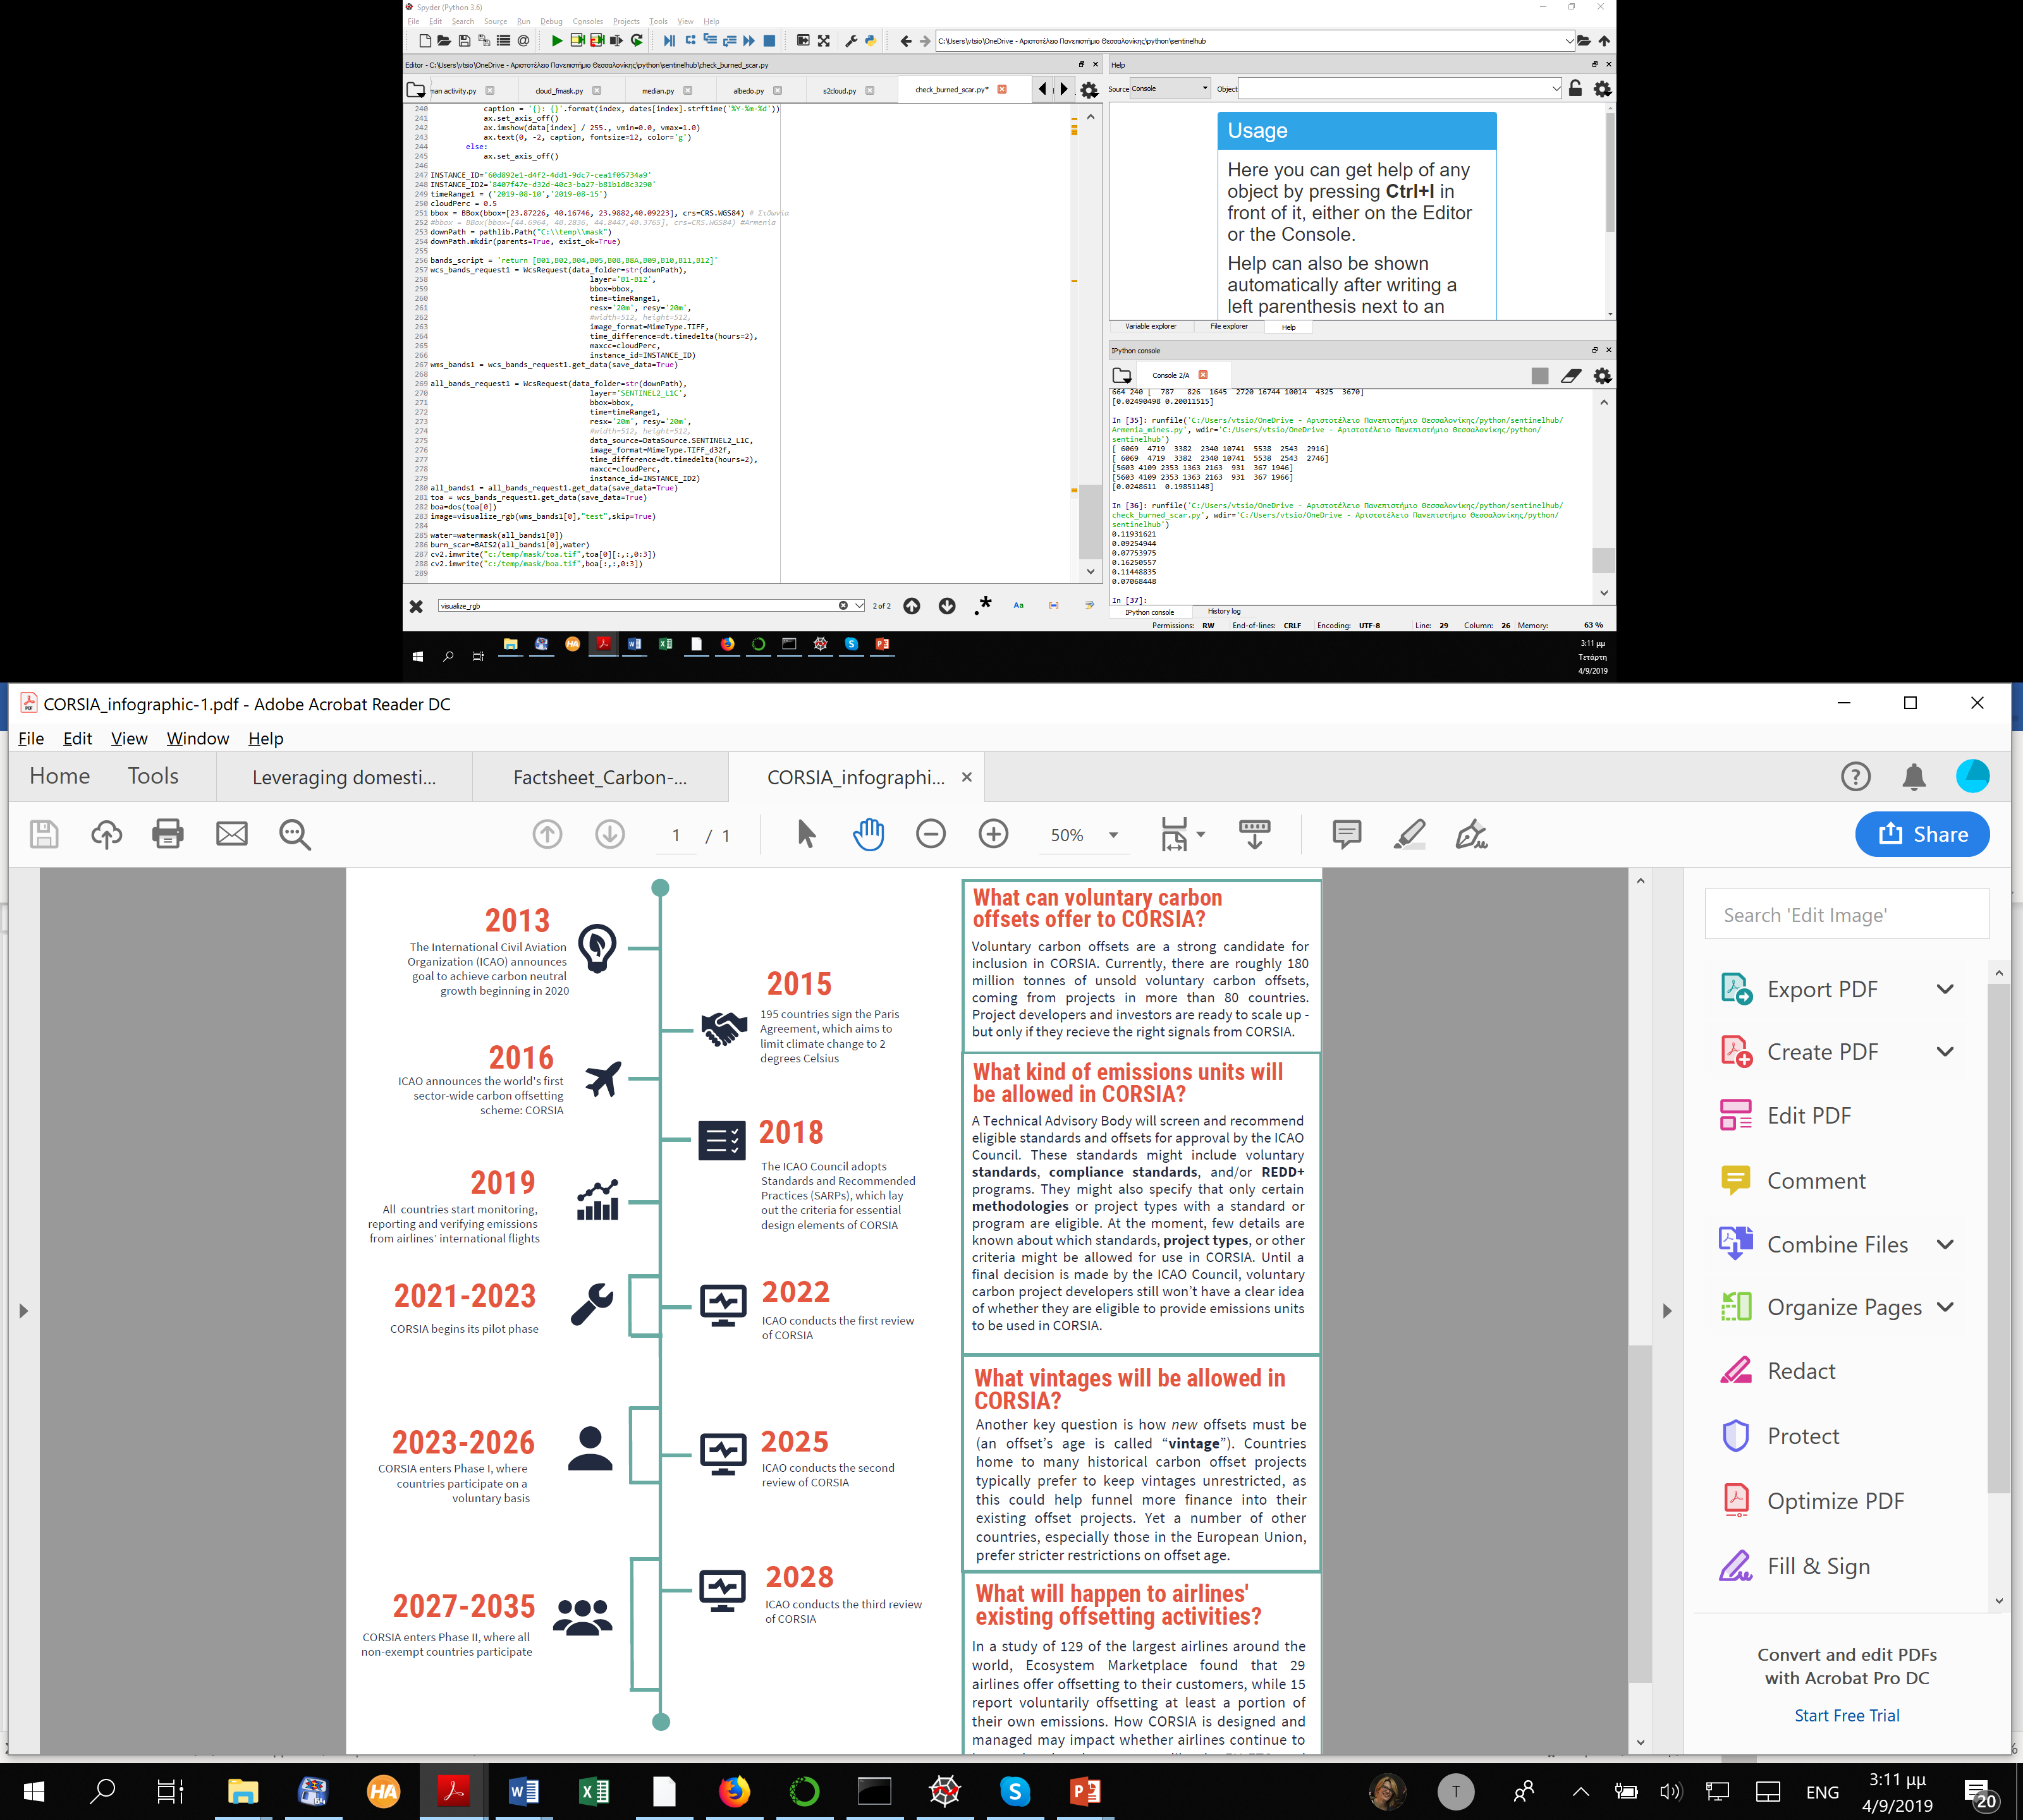
Figure 53 Implementation phases of CORSIA. Source: (Ecosystem Marketplace, 2010)

Additionally, on 3 September 2016, the Directors General of Civil Aviation of EU Member States and the other Member States of the European Civil Aviation Conference (ECAC) signed the ‘Bratislava Declaration’. This signaled their intention to fully implement CORSIA from the start of the pilot phase, provided that certain conditions were met, notably on the environmental integrity of the scheme and global participation. The Bratislava Declaration illustrated the commitment of the EU and ECAC States to address the growth of CO₂ emissions from international air transport and to achieving overall carbon neutral growth from 2020.
The main aim of CORSIA implementation will be to include all airplane operators with international flights producing annual CO₂ emissions greater than 10,000 tons from airplanes with a maximum take-off mass greater than 5,700 kg. Regardless of whether their administering State is participating or not in the offsetting phases, they will be required to monitor, verify, and report their CO₂ emissions during 2019 and 2020. Humanitarian, medical, and firefighting operations will be exempted. The average yearly CO₂ emissions reported during that period will represent the baseline for carbon neutral growth from 2020. Beyond 2020, the aviation sector will be required to offset its international CO2 emissions above this level.
CORSIA comprises of three implementation phases: the pilot phase (2021-2023), a first phase (2024-2026) and a second phase (2027-2035). During the pilot phase and first phase, offsetting requirements will only be applicable to flights between States that have volunteered to participate. As of 5 November 2018, 76 States have officially notified ICAO that they intend to voluntarily participate in the pilot and first phase of CORSIA, representing approximately 76% of international aviation activity. States can notify their intentions for the year 2021 up until 30 June 2020, and thereafter on an annual basis during the voluntary period. The second phase will apply to all ICAO Member States within the agreed applicability scope, with certain exemptions (European Aviation Safety Agency, 2019). A nice visualization about all the discussion to implement CORSIA and its phases are given by EcoSyctem MarketPlace (Ecosystem Marketplace) (Figure 53).
States covered by the exemption criteria above can volunteer to participate. The contribution of CORSIA to stabilize international aviation emissions at 2020 levels is to some extent reliant on the level of participation of States in CORSIA.
Voluntary carbon offsets are a strong candidate for inclusion in CORSIA. Currently, there are roughly 180 million tons of unsold voluntary carbon offsets, coming from projects in more than 80 countries. Project developers and investors are ready to scale up - but only if they receive the right signals from CORSIA.
Certain rules have been placed by ICAO for the operation of the CORSIA Program. These rules include certain procedures and guidelines for Monitoring, Reporting and Verification of CO₂ emissions as well as guidelines for the calculation of offsetting requirements (Internation Civil Aviation Organisation, 2018).
- Result-Based Climate Financing
Results-Based Climate Financing (RBCF) is a financing modality or approach under which a donor or investor disburses funds to a upon the achievement and independent verification of a pre-agreed set of results. Four criteria must be followed:
- Payments are made for climate mitigation or adaptation results;
- Payments are made ex post;
- Payments are made once predefined results have been achieved;
- Reported results have been independently verified.
To understand the role RBCF can play in supporting the Paris Agreement, it is important to recognize RBCF is both an approach that can be combined in a program with other financial instruments—such as upfront grants, loans, or guarantees—and a vehicle for delivering the funding associated with those financial instruments.
In a recent report given by World Bank Group 74 sample programs are analyzed. The 12 largest programs providing international public RBCF to developing countries identified in this report reached their estimated peak capitalization of $2.6 billion in 2015. About 90 percent of these funds are dedicated to the forestry and land use sector. While this number was up from $2 billion in 2010, it is expected to rapidly decline over the next few years, unless additional funds are provided.
The 74 programs of the sample underlying this report are evenly distributed among the Sub-Saharan Africa Region (29 programs), the Latin America and the Caribbean Region (29 programs), and the East Asia and Pacific Region (28 programs) (Image 18). Several programs are implemented in more than one region. The prevalence of RBCF in low-income countries, as well as its application in middle-income countries, indicates the potential for the broad application of the approach, and its ability to overcome several barriers to investment identified in the literature, including limited access to financing and a weak MRV infrastructure (International Bank for Reconstruction and Development / The World Bank, May).
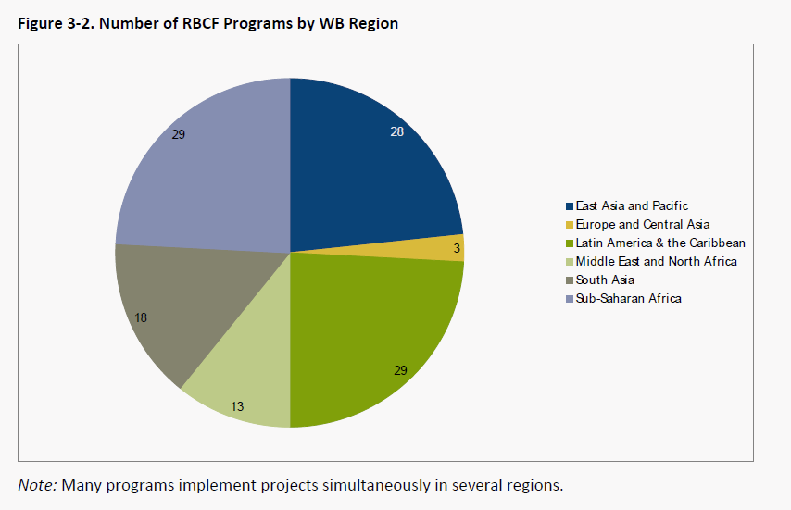
Figure 54 RBCF Programmes in different continents. Source: https://www.mainstreamingclimate.org/publication/new-report-from-the-world-bank-on-results-based-climate-financing/
- UN REDD Program
The UN-REDD Program is the United Nations Collaborative Program on Reducing Emissions from Deforestation and forest Degradation (REDD+) in developing countries. The Program was launched in 2008 and builds on the convening role and technical expertise of the Food and Agriculture Organization of the United Nations (FAO), the United Nations Development Program (UNDP) and the United Nations Environment Program (UNEP). The Program supports nationally led REDD+ processes and promotes the informed and meaningful involvement of all stakeholders, including indigenous peoples and other forest-dependent communities, in national and international REDD+ implementation. Additionally, the program supports national REDD+ readiness efforts in 65 partner countries, spanning Africa, Asia-Pacific and Latin America (Figure 55).
​Support to partner countries is delivered through;
- ​Direct support to the design and implementation of National REDD+ Programs;
- Complementary tailored support to national REDD+ actions;
- Technical capacity building support through sharing of expertise, common approaches, analyses, methodologies, tools, data, best practices and facilitated South-South knowledge sharing.
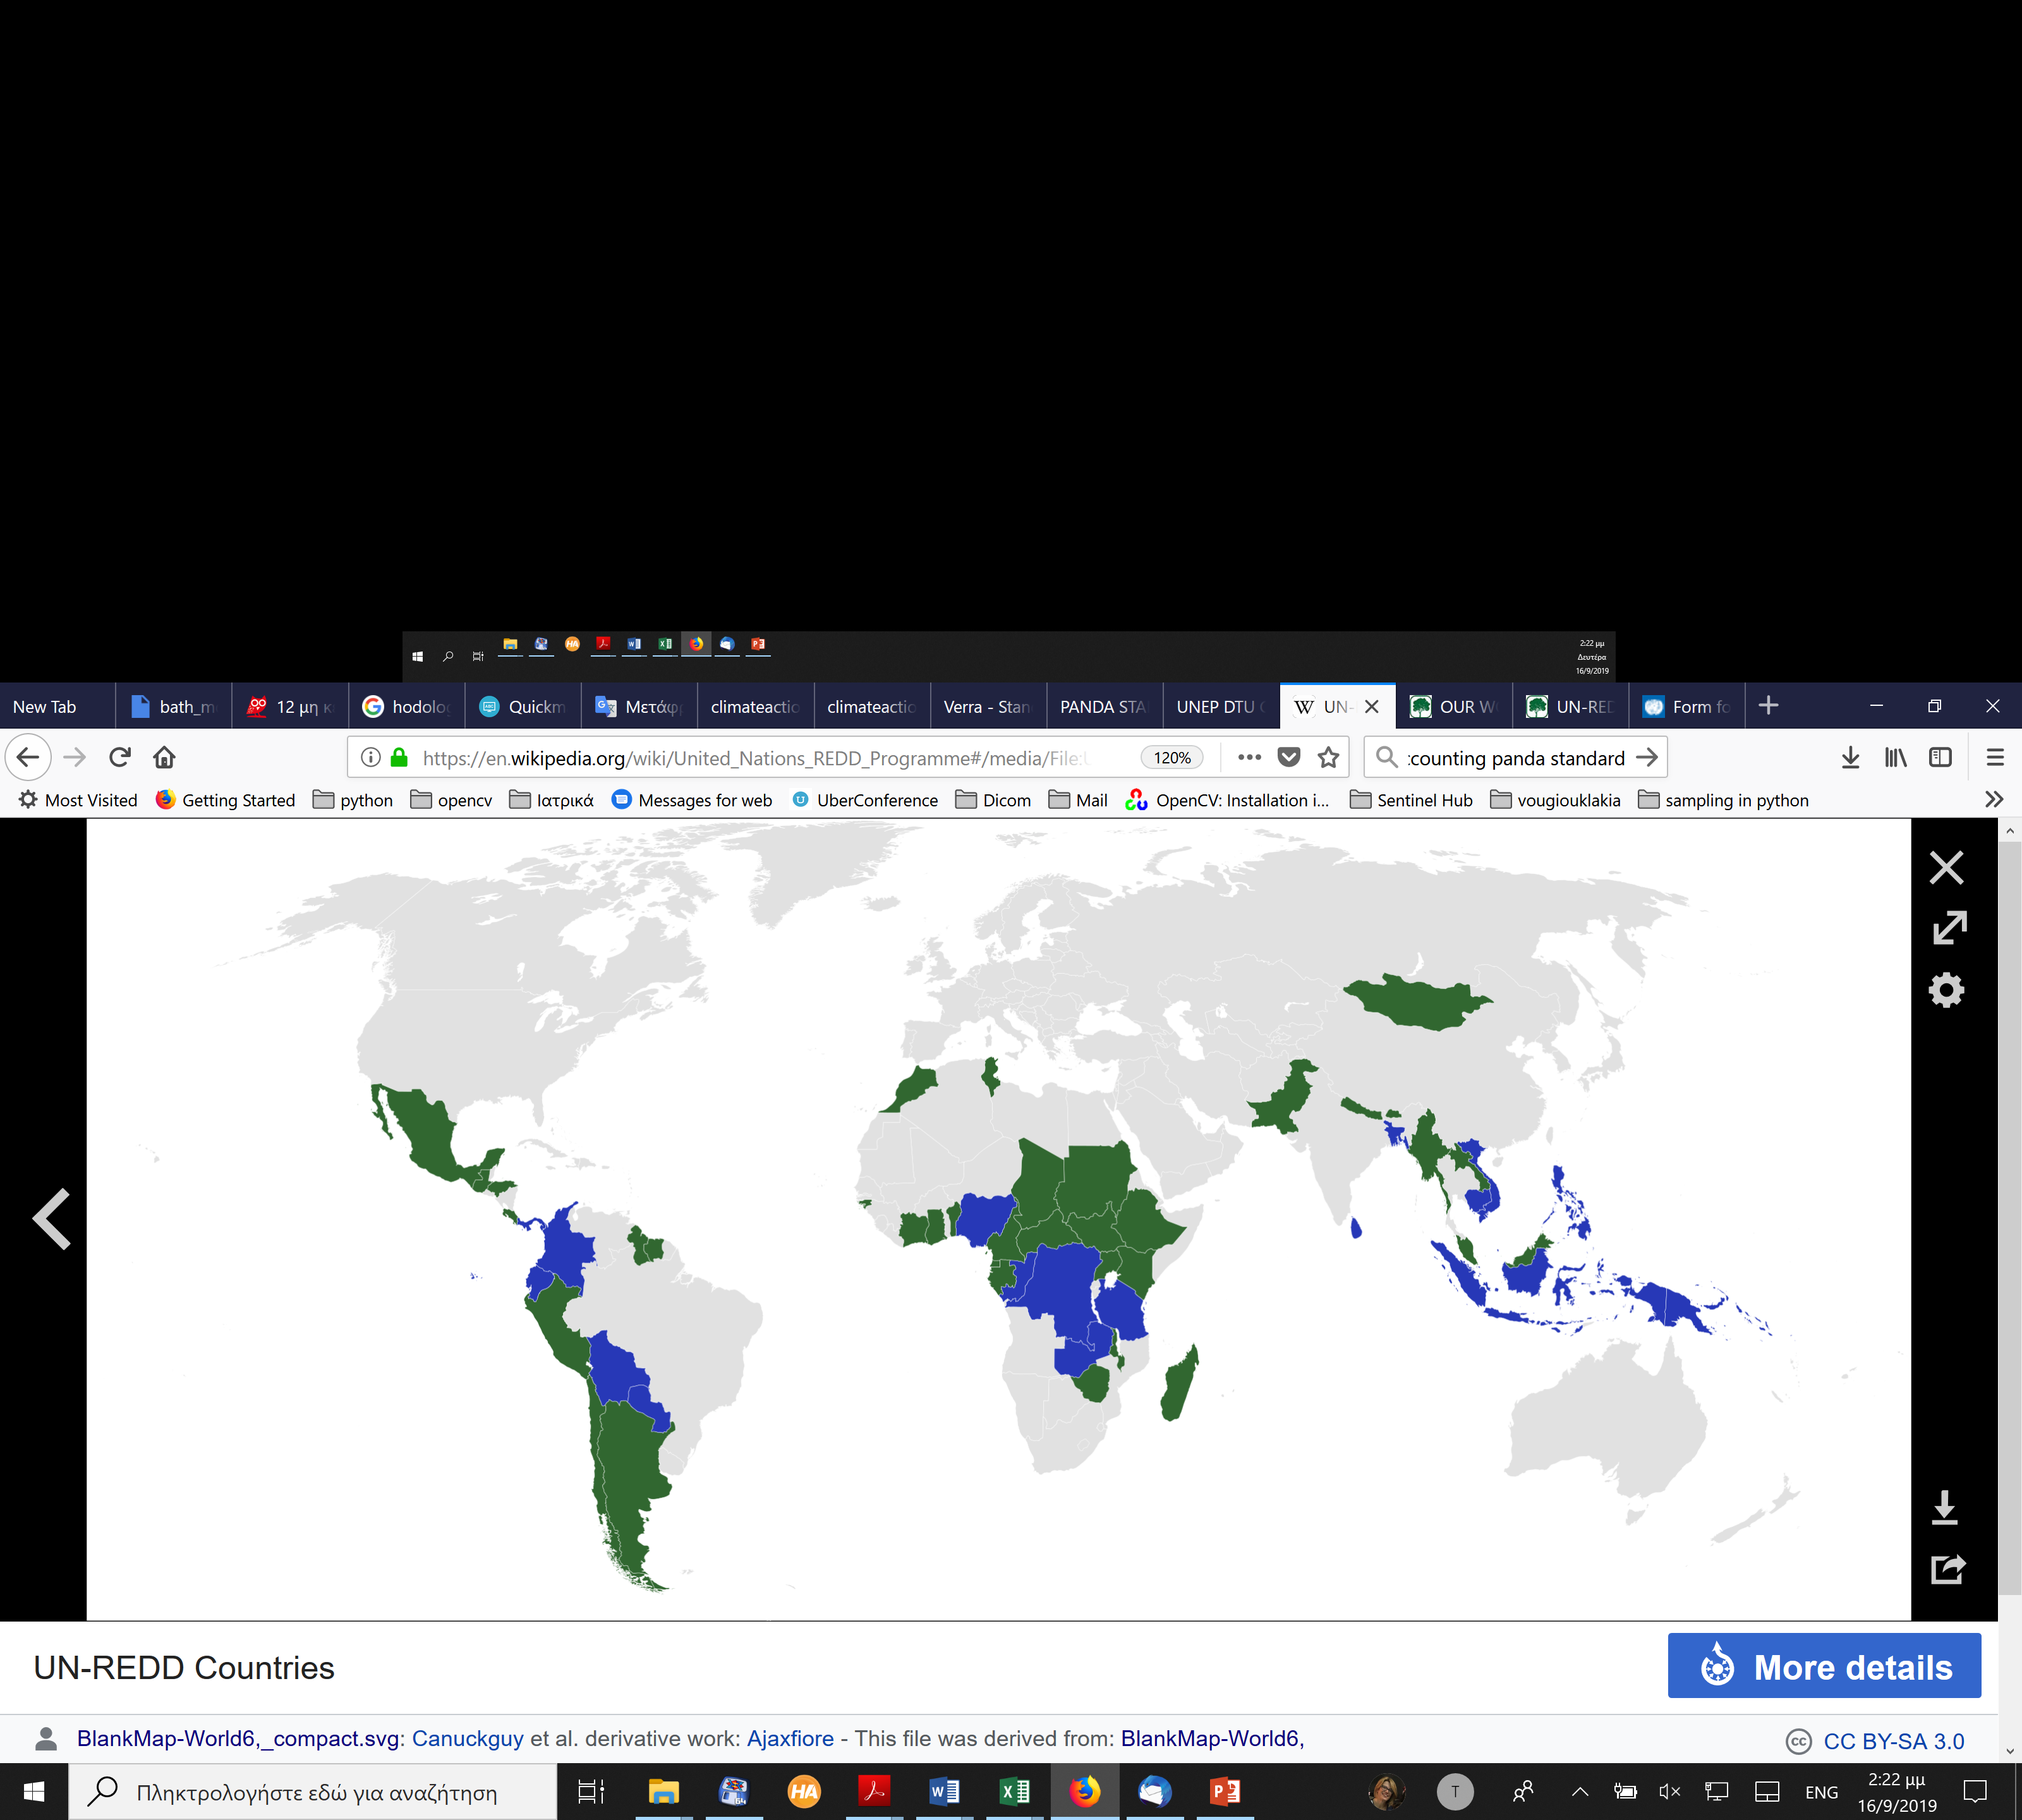
Figure 55 UN-REDD National Programmes (blue) and UN-REDD Partner Countries (green) countries. Source: https://en.wikipedia.org/wiki/United_Nations_REDD_Programme
- Activities out of the box
Climate change mitigation is one of the biggest challenges not only for our generation but also for at least the next generations till 2100. The impact of the use of fossil fuels and the production of CO₂ and other GHGs emissions has been evident worldwide since the weather changing and becoming more extreme across all longitudes and latitudes.
A lot of individuals but also companies are working beyond ETS, CDM and other official mechanisms in their effort to mitigate, but also, and most important, to influence their customers be environmentally friendly and minimize their emissions. During the editing of the current manuscript and in the search of facts, techniques and methodologies concerning climate change mitigation activities a small number of exceptional success stories-paradigms (according to the author’s opinion) against climate change but effects were found and are given bellow.
ECOSIA
Ecosia is an Internet search engine based in Berlin, Germany, that plants trees by donating 80% or more of its profits to nonprofit organizations that focus on Reforestation. Ecosia considers itself a social business, is CO₂-negative, claims to support full financial transparency, protect the privacy of its users; and is certified by B-Lab as a benefit corporation.
The website maintains a running total of the number of trees planted. According to their website, as of 9th September 2019, the search engine had been responsible for the planting of more than 67 million trees.
Site: www.ecosia.org
Timberland
The goal the big apparel company is to inspire a greening movement that makes a difference every day with tangible and small actions. The company emphasizes to make heroes out of its potential customers for the shake of environment, people of open-minded and multi-generational “Changemakers,” who devote their talents to making a difference, committed together to building a better future for the environment and the people who live in it (Timberland, 2019).
According to the newsletter Timberland aims to plant 50billion trees 2025 (Timberland , 2019)
Porsche
Porsche will soon introduce its first zero-emissions vehicle, the battery-powered Taycan sedan, but in the meantime, the company is launching an initiative in the United States that will allow its customers to reach carbon neutrality.
The program, known as Porsche Impact, uses an online tool to estimate an individual’s carbon dioxide emissions based on mileage and average fuel consumption. Once calculated, that individual is given a link and invited to make a financial contribution to an environmental cause that will help offset their specific carbon footprint.
“Porsche drivers want it all, and offering an option for greater sustainability is part of creating a superb Porsche experience,” said Klaus Zellmer, President and CEO of Porsche Cars North America. “Porsche Impact connects our strategies for innovation, mobility and sustainability with the individual customer.”
Porsche owners can select from one of four approved projects to support: forest protection in the U.S., hydropower in Vietnam, solar energy in Mexico, and habitat preservation in Zimbabwe.
The cost of any given trip using Porsche Impact obviously varies based on vehicle and driving habits, but the company estimates the annual cost for a 2019 Cayenne S driven 10,000 miles per year would be between $67 and $152, depending on the project selected.
To show its support for the program, Porsche Cars North America has enrolled all of its Porsche Experience Center cars in Porsche Impact, as well as the vehicles in its Porsche Passport subscription fleet.
The Porsche Impact program is managed by Swiss-based carbon finance consultancy South Pole. Porsche Impact has been available to customers in Germany, the UK, and Poland since 2018.
Porsche isn't the first company to offer customer a carbon offset program. In 2007, both Volkswagen and Land Rover offered similar programs of their own. However, both of those programs have since been suspended (Porsche, 2019).
- Implementation of sustainable management for MLs
In this Chapter, the integration of a given project into the voluntary carbon market is described. The stakeholders’ role in the project, from the development until the implementation is illustrated below, as well as the steps and the stages that the project must follow for entering into the carbon market. Although there are numerous of programs and standards in which the MAIL Project can be assimilated, in this chapter three have been chosen to be reported. The Gold Standard, the Plan Vivo and the Verified Carbon Standard were selected and described due to the global geographical coverage and to their wide hearsay and scope. Additionally, these standards have broadly project type coverage, especially in afforestation and reforestation project methodologies, and they are functional/ operational in the way that several GHG programs have ceased operations, while some standards have not yet seen wide applicability since their founding (Schmidt & Gerber, 2016). The most important principles and requirement that each standard has are listed and explained in detail. It should be noticed that for the sake of simplicity and practicality, other standards currently available in the voluntary market are not covered in this chapter. The stakeholders are encouraged to review such standards to decide which of them are best suited to their project ideas.
- Carbon offset Projects
Carbon offset credits can be generated through a variety of actions that reduce GHG emissions or increase carbon sequestration. In the majority of cases, these actions are carried out as discrete “projects.” For example, a carbon offset project could include renewable energy production, avoided deforestation, and so on. Projects can range in size from small scale / local scale (e.g., decreasing hundreds tonnes of CO₂e per year) to large scale / national or international scale (e.g., reducing millions tonnes of CO₂e per year). Large scale "programs of activities" (e.g. “programs” pioneered under the Kyoto Protocol’s Clean Development Mechanism), that aggregate numerous similar small projects or coordinated efforts across entire jurisdictions, can also create carbon offset credits (such as in the case of avoided deforestation) (Broekhoff et al., 2019; Kollmuss et al., 2008).
A variety of parties, stakeholders, and authorities must be involved in the design, implementation, and operation of carbon offset projects. Although the parties involved vary from project to project, the following indicate the most common market player categories and types.
- The project owner is the person that manages and owns the physical installation where the emission reduction project takes place. An owner might be a private individual, a company, or another organization.
- The Project Developer is a person or organization who is working on a project to reduce emissions. This could be the project owner, a consultant, or a provider of specialized services.
- Banks, private equity firms, private investors, non-profit organizations, and other organizations are examples of project funders who may lend or invest equity to fund a project. Some offset program standards specify what types of funding, other than offset revenue, are permitted for offset projects.
- Individuals and organizations who are directly or indirectly impacted by the emission reduction project are referred to as stakeholders. Parties interested in establishing a project (e.g., owner, developer, financier), parties affected by the project (e.g., local population, host community, environmental and human rights advocates), and national and international authorities are all examples of stakeholders.
- In order to validate and verify a project's baseline, as well as its predicted and achieved emission reductions almost all offset programs require a third-party auditor. Most offset programs have procedures in place for approving third-party auditors before they may conduct validation and verification operations.
- The role of standard organizations is to define a set of rules and criteria for voluntary emission reduction credits in the absence of national or international legislation.
- Emission offset buyers and sellers might use brokers or exchanges to ease transactions in the wholesale market for offset credits. Exchanges are normally chosen for frequent trades or large volumes of standardized contracts or products, whereas brokers are frequently used for non-standardized products, occasional trades, and small volumes.
- Emissions reduction by professional traders take advantage of market pricing distortions and arbitrage opportunities to buy and sell emission reductions.
- Between project developers and buyers, offset providers operate as aggregators and sellers. They make it simple for consumers and businesses to obtain offset credits from a portfolio of projects.
- Carbon offsets are purchased by individuals and organizations to offset GHG emissions. As a result, the final buyer has no interest to resale the offset, but will instead request that the carbon offset credit be retired (Broekhoff et al., 2019).
- Implementation of offset Project
This chapter describes the offset project development process, for projects implemented under voluntary offset standards, from the design of the project to commercialization. All the phases of the project, from design to commercialization, are explained below.
Design stage
The Project Design stage includes the concept development of a project, selecting or developing a baseline and monitoring methodology, as well as stakeholder consultations. All these elements are documented in the project design document (PDD).
For the concept of the project a feasibility study is conducted to evaluate a potential offset project's technical feasibility, investment requirements, development, and operational expenses, expected returns, administrative and legal barriers, and project risks and pitfalls. The project owner will decide whether or not to continue developing the potential offset project based on the feasibility study's results.
The rules that a project developer needs to follow to establish a project baseline and identify project additionality, calculate emission reductions, and monitor the parameters used to estimate actual emission reductions are defined by an offset project methodology. The offset project methodology is a generic formula that can be used for a variety of different projects of a given type and applicability conditions. If no approved methodology exists for a particular project type, a project developer can submit a new methodology to the offset program for approval (e.g., CDM, Gold Standard, VCS).
The Project Design Document (PDD) describes the project activity in detail, it discusses the methods used to determine the baseline scenario, demonstrate additionality, calculate emission reductions, and describes the chosen technology. It also includes information on how to monitor all relevant technical parameters, as well as instructions on setting up monitoring methods, taking measurements, ensuring quality, and storing and accessing records. Finally, it demonstrates the contribution of the initiative to sustainable development. Throughout the implementation phase, the PDD is utilized to ensure that the project follows the parameters indicated in the document.
Most voluntary offset schemes must show that the project's activities will have no negative impact on local populations or other stakeholders. To guarantee that all relevant stakeholders have had an opportunity to comment on a proposed project, the developer must notify them via proper media.
Validation is not usually required by voluntary standards, and validation and verification are occasionally combined. In addition, most voluntary offset programs do not require approval from the host country.
Most projects in the voluntary offset market are directly approved by project auditors and do not require extra registration with an offset program organization. The Gold Standard (GS) is an exception, as project approval is reviewed by the Gold Standard Technical Advisory Committee.
Implementation stage
The implementation of a project can begin at any point during its life cycle. If the project is implemented before it is registered, the project developer must provide documentary evidence that the voluntary credits earnings were considered when the project was planned. The documentary evidence must be provided when applying for registration. If documented evidence is not provided, the project will most likely be rejected considered as non-additional.
During the implementation phase of a project, project developers are expected to keep records quantifying the emission reductions achieved. These records, which must be kept in a monitoring report, must adhere to the parameters and procedures outlined in the validated PDD. The monitoring report is used to issue emission reductions. As a result, a project developer must choose between having a steady stream of offset credit income and lower administrative costs. There are no limitations for the duration of a monitoring period, which might range from a few weeks to several years.
A third-party auditor evaluates and approves the monitoring that the project developer has done. The monitoring report, together with any supporting papers, is submitted to the auditor by the project developer. The auditor conducts a desk review of the report to check that the monitoring was done according to the methods outlined in the original PDD. If necessary, the auditor may also conduct a site visit. The auditor provides a draft verification report after the desk review and site inspection, identifying any concerns. The auditor prepares the final verification and certification report, which also quantifies the actual emission reductions achieved by the project, once the project developer has resolved these difficulties. Verification is carried out in accordance with the stated requirements of the project protocol. This is usually the last step in the voluntary market before offset credits can be issued and sold.
Most emission reductions in the voluntary market are directly approved by project auditors and do not require an additional certification process with the offset program body. The GS is an exception to this, as the GS Technical Advisory Committee approves emission reductions.
Commercialization stage
A project developer sells offset credits from a project to a buyer at the commercialization stage. The credits can be sold either directly to a company that will use them to meet its legally binding or voluntary emission reduction obligations, or through a trading company that will handle the transaction between the seller and the end-user of the credits. A contract to sell a project's carbon credits can be signed at any point throughout the project's development. Payment for the credits is normally made only once they have been provided to the project developer. A project developer may, however, be paid in advance in a few instances. These payments are typically made when a project developer has to bridge a funding gap or meet cash flow requirements during the project's implementation (Broekhoff et al., 2019).
- Carbon offset Programs
Carbon offset credits are not a straightforward product. Standard-setting organizations have been established to provide quality assurance for carbon offsets, as they have done for many other products whose quality is difficult for casual buyers to assess. Carbon offset programs range from international or governmental regulatory authorities – such as the UN's Clean Development Mechanism (CDM) Executive Board, which monitors carbon offsets under the Kyoto Protocol – to non-governmental organizations (NGOs). Offset programs have three basic functions. Firstly, they develop and approve standards that set quality criteria for carbon offset credits; secondly, they review offset projects against these standards (usually with the assistance of third-party verifiers); and last but not least they operate registry systems that issue, transfer, and retire offset credits (Kollmuss et al., 2008).
Table 39 Carbon Offset Programmes
Voluntary Carbon Offset Programs | Geographic Coverage | Label Used for Offset Credits
The Gold Standard | International | Verified Emission Reduction (VER)
Plan Vivo | International | Plan Vivo Certificate (PVC)
The Verified Carbon Standard | International | Verified Carbon Unit (VCU)
Voluntary carbon offset programs started to evolve after 2005, as the CDM gained traction and the corporate social responsibility sector realized there was a need for these instruments beyond the Kyoto Protocol's regulated companies and countries. There are currently several carbon offset programs that cater mostly (or exclusively) to the voluntary market, which is comprised by enterprises seeking to reduce their GHG emissions (Broekhoff et al., 2019).
    - The Gold Standard
The Gold Standard (GS) is a voluntary carbon offset scheme that aims to advance the United Nations' Sustainable Development Goals (SDGs) while also ensuring that projects benefit the communities around them. The GS can be used for voluntary offset projects as well as programs under the Clean Development Mechanism (CDM). It was developed with the World Wildlife Fund (WWF), HELIO International, and SouthSouthNorth as the driving forces, with an emphasis on offset projects that give long-term social, economic, and environmental benefits. The GS is a completely developed carbon offset standard. It demands social and environmental benefits from its carbon offset projects, and it has a well-developed stakeholder process. The GS can be used for both voluntary offset and CDM projects. All initiatives seeking Gold Standard Certification must meet the following General Eligibility Criteria (Broekhoff et al., 2019; Gold Standard, 2020; Kollmuss et al., 2008).
- Project Types: Physical implementation on the ground is required for eligible projects.
- Project Location: Projects can be located anywhere in the world.
- Area, Boundary, and Scale of the Project: The Project Area and Boundary must be defined. Although some rules, requirements, and constraints may apply under specific Activity Requirements, Impact Quantification Methodologies, and Products Requirements, projects can be established at any scale. To avoid double counting, the Project must be certified by Gold Standard before being included in any other voluntary or compliance standards program. In addition, if the Project Area overlaps with that of another Gold Standard or other voluntary or compliance standard program of a similar type, the project must show that no impacts are counted twice at design and performance certification.
- Requirements of the Host Country: Projects must adhere to all applicable legal, environmental, ecological, and social regulations of the Host Country.
- Contact Information: As part of the Project Documentation, the Project Developer must provide the names and contact information of all Project Participants. In case of an organization, the legal registration details and documentation from the governing jurisdiction proving that the entity is in good standing. Where reputational concerns are raised, Gold Standard has the right to refuse usage of the Standard at its discretion.
- Legal Ownership: Any products developed under Gold Standard Certification, such as carbon credits, must be proved to have full and uncontested legal ownership. When project beneficiaries' ownership is transferred, it must be done so in a transparent manner and with a full, prior, and informed consent. It should be referred that full and uncontested legal land title/tenure is required for some Project types. Any land title/tenure disputes that arise must be immediately reported to Gold Standard.
- Other Rights: In addition to legal title and ownership, the Project Developer must show uncontested legal rights and/or permissions to change the usage of other resources required to service the Project (for example, access rights, water rights etc.). The Project Developer must immediately report any known conflicts or contested rights to Gold Standard and have them addressed before moving further with project execution in the impacted areas (Herrmann & Bucksch, 2019).
To receive a Golden Standard certification, all projects must contribute to Gold Standard's vision and mission, as defined by the eligibility principles and requirements listed below.
- The first principle is the Contribution to Climate Security and Sustainable Development. Which means that projects must be of a type that has been pre-identified as eligible, or they must apply to GS for eligibility approval. For income stability, food security, and long-term development, increasing resilience to deal with the effects of climate change is critical. As a result, project participants' adaptive capacity must be preserved and increased as part of every project. Specifically, the Project Developer must determine the existing and expected climate/weather variability for the project region.
- The second principle is the Safeguarding Principles. Safeguarding Principles Assessments and GS Safeguarding Principles and Requirements must be completed by projects. The project completes a Safeguarding Principles Assessment as per Safeguarding Principles and Requirements to determine the relevance of the various requirements to the project by successfully following these requirements and procedures. At least 10% of the overall Project Area must be identified and used to protect or enhance biological diversity. The Project Developer will manage the designated protected area, which will be located inside the Project Area. Waterbodies' buffer zones can be included in the protected area. Existing native tree patches, single isolated stems of native tree species, habitats of rare, threatened, and endangered species, and habitat connectivity regions, must be recognized and handled in order to protect or improve biodiversity. Furthermore, on both sides of any permanent or temporary water bodies such as lakes, streams, rivers, wetlands, and so on, the Project Developer must maintain a 15-meter buffer zone for water bodies (this requirement does not apply to irrigation channels). All existing native trees must be preserved in these buffer zones; no fertilizer or pesticides are permitted; no logging, cropping or heavy machinery is permitted; and, if trees are planted, they must be native tree species.
- The third principle is the Stakeholder Inclusivity which means that projects should identify and engage relevant stakeholders, as well as seek expert stakeholder input when required, during the project's design, planning, and implementation. Stakeholder input and opinions should be reflected in the project design, and continual feedback should be solicited, captured, and acted upon throughout the project's life cycle. if these are successfully followed, the project demonstrates how it has identified, engaged, and consulted with relevant stakeholders. Expert stakeholders are involved in the process when needed. The project displays the consultation records as well as how the consultation has influenced in a positive way the project's design and implementation. Furthermore, the project illustrates that stakeholder concerns have been addressed, as well as any conflicts that have arisen and system is being designed for continuously capturing, recording, and responding to stakeholder concerns.
- The fourth principle is the Demonstration of real outcomes. Projects must create an upfront Project Design Document (PDD) that includes a monitoring and reporting plan, pass design certification, and conduct monitoring in line with the monitoring and reporting plan, as well as produce annual reports and monitoring reports. In case of Afforestation/ Reforestation Projects, as the MAIL Project, the crediting period must be at least 30 years and no more than 50 years. The crediting term will be chosen by the Project Developer based on the project's parameters. The crediting period begins on the Project Start Date or three years before the Project Design Certification Date, whichever comes first. Verification and Issuance Review can happen before or after Project Design Certification, and it has to happen at least once during the 5-year Certification cycle. Until the end of the crediting period, verification must be conducted at least every 5 years.
- Last, the fifth principle is the Financial Additionality and Ongoing Financial Need. As stated in the first principle, all projects must demonstrate increased impacts when compared to their baseline situation. A/R Projects, demonstrate project additionality, the project will use one of the following options. The first option requires to use the most recent version of the A/R CDM “Combined tool to identify the baseline scenario and demonstrate additionality in A/R CDM project activities” (UNFCCC/CCNUCC, 2007). The CDM-specific terminology of the A/R CDM additionality tool (tCERs, A/R CDM project, and so on) must be read in the context of the Gold Standard. The second option requires the following: the project must not have the goal of creating a forest for the commercial use of timber or non-timber forest products, and the project activities must not be mandated by any law or regulation. In addition, the project should be located in an area with a mean annual precipitation of less than 600 mm or a soil pH of less than 4.0 in the planting area. The planting area should be planted with a minimum of 5 different native tree species in mixed stands, with at least 50% of the planting area covered. (Gold Standard, 2020; Herrmann & Bucksch, 2019; The Gold Standard Foundation, 2013)
Site: www.goldstandard.org
    - Plan Vivo
Plan Vivo is an Offset Project Standard for forestry, agriculture, and other land-use projects that aims to promote sustainable development while also enhancing rural livelihoods and ecosystems. A set of standards (the Plan Vivo Standards), administrative processes, tools, and guidance are all part of the Plan Vivo System. The Plan Vivo Foundation governs and oversees it to ensure that producers in developing countries are fairly paid for ecosystem services (PES) they provide through their Plan Vivo. These payments boost producers ability to conserve and improve the natural and productive ecosystems on which they depend, as well as the global public goods they supply such as carbon sinks and biodiversity. Plan Vivo collaborates closely with rural communities and places a strong emphasis on participatory design, ongoing stakeholder consultation, and the use of native species. Post-sequestration offsets are not verified by the Plan Vivo Foundation, which only verifies and awards forward credits known as Plan Vivo Certificates (PVC). (Plan Vivo, 2008)
The Plan Vivo Foundation, a Scottish non-profit organization who focuses on environmental improvement and poverty reduction, is currently in charge of Plan Vivo. The Foundation reviews and registers projects that meet the Plan Vivo Standard, issues Plan Vivo Certificates annually after each project's annual report is submitted and approved and serves as the overall "keeper" of the Plan Vivo Standard, which is reviewed on a regular basis in consultation with the Technical Advisory Committee and Stakeholder Groups. It moreover registers Plan Vivo Certificate resellers and approves third-party validators and verifiers (Broekhoff et al., 2019).
Plan Vivo programs are developed and managed by a range of organizations, the majority of which are international and locally based non-governmental organizations (NGOs) that serve as project developers/coordinators. They organize sales with carbon purchasers, coordinate ongoing monitoring and community consultation, and distribute staged payments for ecosystem services to project participants based on the achievement of "monitoring targets" outlined in land-management plans, the Plan Vivos.
All Plan Vivo projects must be evaluated by third parties, both for project validation before registration and for project verification every five years thereafter. Validation and Verification Bodies (VVBs) shall follow Project Validation Guidance. Find information on validation and verification within the program documents, the list of approved VVBs here, and directions for submitting a brand new VVB entity for approval. Plan Vivo accepts projects that meet other standards, however projects must notify the Plan Vivo Foundation to avoid double-counting or duplication of ecosystem service claims (Broekhoff et al., 2019).
Plan Vivo is the highest standard for conservation and restoration projects involving smallholders and communities. To maintain this high level of quality, all new projects must demonstrate that they meet the eight core principles stated below.
- Eligible project intervention areas and participants. Smallholders and community groups are directly involved in and benefit from projects. Smallholders and/or community groups must be able to commit to project interventions for the period of the Payment for Ecosystem Services (PES) Agreement on land where they have defined, stable land tenure, either through ownership or user rights.
- Eligible project activities. Projects benefit ecosystem services while also preserving or enhancing biodiversity. Projects must generate ecosystem service benefits through one or more of the project intervention types such as ecosystem restoration, ecosystem rehabilitation, prevention of ecosystem conversion or ecosystem degradation, improved land use management. Any threats to biodiversity produced by the project intervention must be identified and mitigated. There must be no negative environmental consequences of project interventions, such as soil erosion or a decline in water quality. Any trees that are planted to generate ecosystem services must be native or naturalized species that are not invasive. Naturalized species must only be planted if they provide livelihood benefits that make them preferable to other native plants; and if they do not have a negative impact on biodiversity or the provision of important ecosystem services in the project area and surrounding areas.
- Project coordination and management. Projects are managed with transparency and accountability, as well as the participation of stakeholders and adherence to the law. A legal entity must be in place to function as project coordinator, taking overall responsibility for the project and ensuring that it complies with the Plan Vivo Standard throughout the period of its existence. The project coordinator must be able to assist participants in developing project interventions, selecting eligible participants for inclusion in the project, and developing effective participatory relationships, including providing continuous assistance as needed to keep the project running. The project coordinator must do a stakeholder analysis to identify key communities, organizations, and local and national authorities who will be impacted by or have a stake in the project. This coordinator must take the necessary steps to notify them about the project, get their feedback, and seek approval where is needed. The project coordinator must identify relevant laws and regulations addressing workers' rights in the hosting country and ensure that the employment arrangements meet or exceed those criteria where participants or other community members are given employment opportunities through the project.
- Participatory design and development of plan vivos. Community ownership is demonstrated through the design and implementation of plan vivos (land management plans) that covers local needs and priorities. A voluntary and participatory planning process is required to identify project interventions that address local needs and priorities, as well as to inform the development of technical specifications, taking into account local livelihood needs and opportunities to improve or diversify existing livelihoods and incomes, local customs, land availability, food security, land tenure, practical and resource consequences for different groups' participation, as well as chances to improve biodiversity.
- Quantifying and monitoring ecosystem services. Real and additional ecosystem service benefits are generated by projects, as evidenced by credible measurement and monitoring. The project must create technical specifications for each of the project interventions, describing the applicability conditions (e.g., under what baseline conditions the technical specification can be used), the activities and required inputs, and the ecosystem service benefits that will be generated and how they will be quantified.
- Risk management. Risks are successfully managed during the design and implementation of projects. The risks to ecosystem services delivery and the long-term sustainability of project interventions must be identified, and relevant mitigation actions must be provided. Every five years, projects must reassess their risk assessments and resubmit them to the Plan Vivo Foundation.
- Livelihood impacts. Positive livelihood and socioeconomic outcomes are demonstrated by the projects. The project must show that it has concrete plans to help the participants' livelihoods. Participants in the local community will identify what constitutes a benefit. A project socioeconomic baseline scenario must be created, which includes information on the socioeconomic context in participating communities at the start of the project, as well as how these conditions are expected to remain or alter if the project is not implemented.
- Benefit sharing and PES Agreements (transacting ecosystem services). Through unambiguous PES Agreements with performance-based incentives, projects share rewards equitably and transact ecosystem service advantages. Participants commit to follow their plan vivo in exchange for phased, performance-related payments or benefits, which must be documented in written PES Agreements between the project coordinator and participants (Plan Vivo Foundation, 2013).
Site: www.planvivo.org
    - The Verified Carbon Standard
The Verified Carbon Standard is a full-fledged carbon offset program created and managed by Verra, a non-profit organization. It simply considers features that reduce GHG emissions and does not require projects to have additional environmental or social benefits. The VCS is global initiative supported by the carbon offset market (project developers, large offset buyers, verifiers, and project advisors). Verra's role is to create and manage the program. It is in charge of overseeing all operational aspects of the VCS Program, as well as revising the VCS standards to assure the quality of VCUs. The VCS Program Advisory Group, a multi-stakeholder body that helps ensuring that the VCS Program continues to serve its users in an effective and efficient manner while also driving realistic and resilient climate change solutions, is supporting the growth of the VCS Program. To be certified, projects developed under the VCS Program must go through a rigorous assessment process. Renewable energy, forestry, and other sectors are all covered by VCS programs. VCUs can be granted for emissions reductions validated by VCS programs, with one VCU representing one metric tonne of greenhouse gas emissions decreased or removed from the atmosphere.
The four major steps in developing an individual project for VCS to create quality assured GHG emission reductions and credits are outlined below. As it is referred before,
- the first step in the project development process is to select a methodology that is suitable for the proposed project. This can be a pre-existing VCS methodology, or one developed as part of a GHG program that has been approved. Project developers are welcome to offer their own methodology if one does not exist.
- The second step is the validation of the project description. Once a project has been added to the Project Pipeline, the proponents need to write a detailed project description using the VCS template and get it validated by an approved validation/verification body (VVB). This procedure determines whether a project complies with all VCS rules and requirements. The project description might be created prior to, during, or after the project is designed and implemented.
- The third step is the verification of emission reduction. Project proponents monitor and measure GHG emission reductions or removals once the project starts. A monitoring report, using the VCS template, includes all information for a given monitoring period, including GHG benefit calculations. An approved VVB must verify the monitoring report.
- The last step is the registration of the project. To be registered on the Verra Registry and request the issuing of VCUs, projects must create an account and submit all needed documentation to a VCS registry operator. Projects can either register immediately after validation or wait until they are ready to issue credits. When projects are registered and VCUs are issued, all project information is available publicly (VERRA, 2017).
VCS quality assurance principles ensure that all VCUs represent real, measurable, additional, permanent, independently verified, conservatively estimated, uniquely numbered, and transparently listed GHG emission reductions or removals. The VCS Standard establishes the rules and regulations that must be followed by all projects in order to be certified.
- Additional: projects must demonstrate that GHG emission reductions or removals would not occur without revenue from the sale of VCUs, which must be greater than the most likely "business-as-usual" scenario.
- Real and measurable: Projects must use an approved methodology to guarantee that net GHG emission reductions or removals have occurred and are measurable.
- Conservative: To ensure that emission reductions are not overestimated, projects must employ conservative assumptions, values, and methods.
- Permanent: Agriculture, Forestry, and Other Land Use (AFOLU) projects must guarantee that GHG reductions are not lost due to unforeseen events like fire or disease.
- Independently verified: Projects must contract a VVB to verify that the project design meets VCS criteria and that all GHG emission reductions or removals are measured in accordance with VCS requirements.
- Uniquely numbered and transparently listed: Projects must register with a VCS registry operator in order for each VCU to be assigned a unique serial number and listed in the VCS Project Database. Furthermore, important safeguards are in place to prevent emissions reductions from being counted twice across different GHG programs (Verra, 2019).
MAIL Project can fulfil the requirements of VCU. It can be added in AFOLU project in the category of afforestation, reforestation, and revegetation (ARR), which focuses in increasing carbon sequestration and/or reducing GHG emissions by establishing, increasing or restoring vegetative cover (forest or non-forest) through the planting, sowing or human-assisted natural regeneration of woody vegetation (Verra, 2019).
Site: www.verra.org
- Future of voluntary carbon markets
Concerning the future of the voluntary markets and since this report is just to give the state of the art of Carbon Markets, we are borrowing the opinion of the experts as it was given in the recent report of Ecosystem Marketplace: In describing the foundations upon which many promising carbon-reducing strategies have been created, the Voluntary Carbon Market covers a remarkable area of innovation in the struggle to reduce global warming pollution. The Voluntary Carbon Market also foreshadows the forces that will drive the next generation of market-based innovation for combating global warming pollution in the absence of a global regulatory system for carbon reduction (Ecosystem Marketplace, 2021).
The voluntary carbon market's importance in the net-zero transition and the worldwide fight against climate change is growing and projected to rise. The patterns are visible, as seen above, but their exact consequences are impossible to anticipate. However, one thing appears certain: demand and prices for high-quality credits, particularly carbon sinks, will rise. If companies want to demonstrate leadership on climate change, they'll need to develop carefully considered carbon credit strategies to guide their voluntary market investment or acquisition strategies in the coming decade if they want guaranteed access to the credit types, amounts, and other attributes (such as corresponding adjustments) they value. Finally, corporations wanting particularly large volumes of credits or credits with associated changes will likely want to restart their engagement with governments now, in order to ensure they have enough time to form the relationships they will need to accomplish their long-term climate goals (Environmental Defense Fund, 2021).
The Paris Agreement infrastructure will regulate the worldwide approach to fighting climate change beginning in 2021. As a result of this new framework, public, institutional, and private actors are considering how they might continue to participate in the voluntary carbon market as part of their efforts to combat climate change. Carbon markets passed a resilience test this year, proving to be rather resilient to the economic effects of COVID-19. Despite initial price drops as a result of the pandemic, by the end of 2020, prices had significantly surpassed their pre-pandemic levels. Market resilience can be linked to two important factors: market stability measures that are now broadly in place across systems, and future expectations of increasingly stringent conditions as governments seek more ambitious goals. Despite the pandemic, ETS coverage continues to spread globally, and it is playing a larger role in climate policy as more governments declare net-zero targets (ICAP, 2021).

References
- Adams, M. A., & Pfautsch, S. (2018). Grand Challenges: Forests and Global Change. Frontiers in Forests and Global Change, 1. https://doi.org/10.3389/ffgc.2018.00001
- Aalders, E., & Lehmann, M. (2013). MRV Manual for CDM Programme of Activities.
- Agostini, A., Giuntoli, J., Boulamanti, A., & Marelli L. (2014). Carbon accounting of forest bioenergy: conclusions and recommendations from a critical literature review. Publications Office of the European Union. http://dx.doi.org/10.2788/29442.
- Amazon rainforest fires: How it affects the world and you (n.d.). [Motion Picture]. Retrieved from https://www.youtube.com/watch?v=DMjEeffbedY
- American Carbon Registry. (2019, July). The American Carbon Registry Standard.
- American Carbon Registry. (2019, July). The American Carbon Registry Standard. Washington DC.
- Alfaro, R. I., Fady, B., Vendramin, G. G., Dawson, I. K., Fleming, R. A., Sáenz-Romero, C., Lindig-Cisneros, R. A., Murdock, T., Vinceti, B., Navarro, C. M., Skrøppa, T., Baldinelli, G., El-Kassaby, Y. A., & Loo, J. (2014). The role of forest genetic resources in responding to biotic and abiotic factors in the context of anthropogenic climate change. Forest Ecology and Management, 333, 76–87. https://doi.org/10.1016/j.foreco.2014.04.006
- Averill, C., & Waring, B. (2018). Nitrogen limitation of decomposition and decay: How can it occur? Global Change Biology, 24(4), 1417–1427. https://doi.org/10.1111/gcb.13980
- Beck, U. & Wilms, J. (2004). Conversations with Ulrich Beck. Cambridge: Polity Press. In Duran, C.D., Gogan, L.M., Artene, A. & Duran, V. (2015). The components of sustainable development - a possible approach. Procedia Economics and Finance, 26, 806-811.
- Berthrong, S. T., Jobbágy, E. G., & Jackson, R. B. (2009). A global meta-analysis of soil exchangeable cations, pH, carbon, and nitrogen with afforestation. Ecological Applications, 19(8), 2228–2241. https://doi.org/10.1890/08-1730.1
- Berry, N. (2017, May 24 ). Plan Vivo Guidance and Resources Climate Benefit Estimation.
- Braun, M., Winner, G., Schwarzbauer, P., & Stern, T. (2016). Apparent Half-Life-Dynamics of Harvested Wood Products (HWPs) in Austria: Development and analysis of weighted time-series for 2002 to 2011. Forest Policy and Economics, 63, 28–34. https://doi.org/10.1016/j.forpol.2015.11.008
- Bremer, L. L., & Farley, K. A. (2010). Does plantation forestry restore biodiversity or create green deserts? A synthesis of the effects of land-use transitions on plant species richness. Biodiversity and Conservation, 19(14), 3893–3915. https://doi.org/10.1007/s10531-010-9936-4
- Broekhoff, D., Gillenwater, M., Colbert-Sangree, T., & Cage, P. (2019). Securing Climate Benefit : A Guide to Using Carbon Offsets. GHG management Institute & Stokholm Environment Institute. Offsetguide.org/pdf-download/
- Carbon Accounting Standard. (2019, September 9). Retrieved from https://americancarbonregistry.org/carbon-accounting/standards-methodologies
- Carbon Offset Research and Education. (2019, September 6). Retrieved from Carbon Offset Research and Education: https://www.co2offsetresearch.org/policy/MandatoryVsVoluntary.html
- Carbon Offset Research and Education. (2019, September 11). Retrieved from Carbon Offset Research and Education: https://www.co2offsetresearch.org/policy/PandaStandard.html
- Castrogiovanni, G. J. (1996). Pre-startup planning and the survival of new small businesses: Theoretical linkages. Journal of Management, 22(6), 801–822. https://doi.org/10.1016/S0149-2063(96)90037-9
- CDM Can Inspire, Inform, Outfit Any New Mechanism under Paris Agreement. (2018, May 3). Retrieved from United Nations Framework Convention on Climate Change: https://unfccc.int/news/cdm-can-inspire-inform-outfit-any-new-mechanism-under-paris-agreement
- César, R. G., Moreno, V. S., Coletta, G. D., Chazdon, R. L., Ferraz, S. F. B., de Almeida, D. R. A., & Brancalion, P. H. S. (2018). Early ecological outcomes of natural regeneration and tree plantations for restoring agricultural landscapes. Ecological Applications, 28(2), 373–384. https://doi.org/10.1002/eap.1653
- Chen, G., Yang, Y., Yang, Z., Xie, J., Guo, J., Gao, R., Yin, Y., & Robinson, D. (2016). Accelerated soil carbon turnover under tree plantations limits soil carbon storage. Scientific Reports, 6(1), 19693. https://doi.org/10.1038/srep19693
- Clean Development Mechanism. (2019, September 6). Clean Development Mechanism Registry. Retrieved from https://cdm.unfccc.int/Projects/projsearch.html
- Clean Development Mechanism Projects Registry. (2019, September 16). Retrieved from Clean Development Mechanism: https://cdm.unfccc.int/Projects/projsearch.html
- Climate Action Reserve. (2015, September 1). Climate Action Reserve Program Manual. Los Angeles, USA. Retrieved from https://www.climateactionreserve.org/wp-content/uploads/2015/08/Climate_Action_Reserve_Program_Manual_090115.pdf
- Copernicus, High Resolution Layers, HRL. (2012, 2015). Retrieved August 08, 2019, from https://land.copernicus.eu/pan-european/high-resolution-layers
- Core Carbon Offset Research Education. (2019, September 9). Core Carbon Offset Research Education. Retrieved from Core Carbon Offset Research Education: https://www.co2offsetresearch.org/consumer/Additionality.html
- Costa, H., de Rigo, D., Libertà, G., Houston Durrant, T., & San-Miguel-Ayanz, J. (2020). European wildfire danger and vulnerability in a changing climate: towards integrating risk dimensions. https://doi.org/10.2760/46951
- Currie, R. R., Seaton, S., & Wesley, F. (2009). Determining stakeholders for feasibility analysis. Annals of Tourism Research, 36(1), 41–63. https://doi.org/10.1016/j.annals.2008.10.002
- Di Fulvio, F., Forsell, N., Lindroos, O., Korosuo, A., & Gusti, M. (2016). Spatially explicit assessment of roundwood and logging residues availability and costs for the EU28. Scandinavian Journal of Forest Research, 31(7), 691–707. https://doi.org/10.1080/02827581.2016.1221128
- Dixon, R. K., Andrasko, K. J., Sussman, F. G., Lavinson, M. A., Trexler, M. C., & Vinson, T. S. (1993). Forest Sector Carbon Offset Projects: Near-Term Opportunities to Mitigate Greenhouse Gas Emissions. Water, Air and Soil Pollution, 70, 561–577.
- Duran, C.D., Gogan, L.M., Artene, A. & Duran, V. (2015). The components of sustainable development - a possible approach. Procedia Economics and Finance, 26, 806-811.
- Ecosystem Marketplace. (2010, June 14). Forest Trends. Retrieved from Forest Trends: https://www.forest-trends.org/wp-content/uploads/imported/final_report_2010_9-1-10_no-crop-pdf.pdf
- Ecosystem Marketplace. (2021, November 26). Forest Trends. Retrieved from Forest Trend, Former U.S. Vice-President Al Gore: https://www.ecosystemmarketplace.com/publications/voluntary-carbon-markets/
- Ecosystem Marketplace. (n.d.). CORSIA and the Voluntary Carbon Markets. Retrieved Sepember 4, 2019, from https://www.forest-trends.org/wp-content/uploads/2018/10/CORSIA_infographic.pdf
- ENDS Carbon Offset. (2019, September 11). Retrieved from The ENDS Carbon Offset Providers Directory
- Environmental Defense Fund (2021). Mobilizing Voluntary Carbon Markets to Drive Climate Action Trends in the Voluntary Carbon Markets: Where We Are and What’s Next.
- European Aviation Safety Agency. (2019, September 4). Retrieved from European Aviation Safety Agency: https://www.easa.europa.eu/eaer/topics/market-based-measures/corsia
- European Parliament and the Council of the European Union. (2013). Decision No 529/2013/EU of the European Parliament and of the Council. Decision No 529/2013/EU of the European Parliament and of the Council of May 21 2013 (p. 18). Brussels: European Union.
- European Union. (2013, 8 12). Elements of the Union greenhouse gas inventory system and the Quality Assurance and Control (QA/QC) programme. Brussels, Belgium.
- European Union. (2015). EU ETS Handbook. European Union.
- European Union. (2019, September 3). Effort Sharing Decision. Retrieved from https://ec.europa.eu/: https://ec.europa.eu/clima/policies/effort_el#tab-0-0
- Eurpean Union. (2018, December 17). Report on the functioning of the European carbon market. Retrieved from https://ec.europa.eu/: https://ec.europa.eu/clima/sites/clima/files/ets/docs/com_2018_842_final_en.pdf
- European Comission. (2019). ANNEX I Actions to be implemented by the European Comission.
- European Commission. (2013a). A new EU Forest Strategy: for forests and the forest-based sector. Communication from the Commission to the Council, the European Parliament, the European Economic and Social Committee and the Committee of the Regions, SWD(2013) 342 final, 17. https://www.eea.europa.eu/policy-documents/the-eu-forest-strategy-com
- European Commission. (2013b). Forest Management Plans or equivalent instruments. Agriculture, Forests and Soil Forest, 1(June).
- European Commission. (2019). Report From The Commission To The European Parliament And The Council on the implementation of the Water Framework Directive (2000/60/EC) and the Floods Directive (2007/60/EC) Second River Basin Management Plans First Flood Risk Management Plans. SWD(2019) 51 Final.
- European Commission. (2020). Communication from the Commission to the European Parliament, the Council, the European Economics and Social Committee and the Committee of the Regions: A new Circular Economy Action Plan For a cleaner and more competitive Europe. European Commission, 98 final, 1–20. https://doi.org/10.7312/columbia/9780231167352.003.0015
- European Commission. (2021a). New EU Forest Strategy for 2030. European Commission, 5–24.
- European Commission. (2021b). New EU Forest Strategy for 2030 (Vol. 572).
- European Commission. (2021c). Proposal for a Regulation of the European Parliament and of the Council amending Regulation 2018/841 on the inclusion of greenhouse gas emissions and removals from land use, land use change and forestry in the 2030 climate and energy framework, and amendi. European Commission, 554.
- European Commission. (2021d). The 3 Billion Tree Planting Pledge For 2030. In Brussels.
- European Economic Interest Grouping. (2018). Evaluation study of the forestry measures under Rural Development (Issue September).
- FOREST EUROPE 7th Ministerial Conference Madrid 20-21 October 2015 Expert Level Meeting 30 June – 2 July 2015, Madrid, Spain. https://foresteurope.org/wp-content/uploads/2016/11/III.-ELM_7MC_2_2015_MinisterialDeclaration_adopted-2.pdf#page=5
- FOREST EUROPE, 2015: State of Europe’s Forests 2015 (https://www.foresteurope.org/docs/fullsoef2015.pdf)
- FOREST EUROPE, Liaison Unit Bratislava, 2019: Human Health and Sustainable Forest Management by, Marušáková Ľ. and Sallmannshoferet M., et al. FOREST EUROPE Study. ISBN 978 - 80 - 8093 - 266 – 4.
- Forest Europe, Resolution H1, 1993. Available at: www.foresteurope.org/docs/MC/MC_helsinki_resolutionH1.pdf (last accessed on 25.11.2019).
- German Emissions Trading Authority (DEHSt) at the German Environment Agency. (2018). Future of the Voluntary Carbon Markets in the Light of the Paris Agreement, Perspectives for Soil Carbon Projects. Berlin.
- Gold Standard. (2017). Gold Standard Afforestation/Reforestation (A/R) GHG Emissions. Retrieved from Gold Standard: https://docs.google.com/viewerng/viewer?url=https://globalgoals.goldstandard.org/wp-content/uploads/2017/07/401.13-AR-Methodology-V1-1.pdf&hl=en
- Gold Standard. (2019, September 9). Gold Standard. Retrieved from www.goldstandard.org
- Gold Standard. (2020). Land Use & Forests Activity Requirements. Gold Standard, 1.2.1(October 2019), 1–44. https://eur03.safelinks.protection.outlook.com/?url=https%3A%2F%2Fglobalgoals.goldstandard.org%2F200-gs4gg-land-use-forests-activity-requirements%2F&data=02%7C01%7Csusan.lecomte%40student.hogent.be%7Ccc6e834ee20440e03fe208d8355547e0%7C5cf7310e091a4bc5acd7
- Greenhouse Gas Protocol. (2019, September 11). Retrieved from Greenhouse Gas Protocol: https://ghgprotocol.org/about-us

- Grassi, G., Cescatti, A., Matthews, R., Duveiller, G., Camia, A., Federici, S., … Vizzarri, M. (2019). On the realistic contribution of European forests to reach climate objectives. Carbon Balance and Management, 14(1), 8. https://doi.org/10.1186/s13021-019-0123-y
- Grassi, G., Fiorese, G., Pilli, R., Jonsson, K., Blujdea, V., Korosuo, A., & Vizzarri, M. (2021). Brief on the role of the forest-based bioeconomy in mitigating climate change through carbon storage and material substitution. 1–16. https://publications.jrc.ec.europa.eu/repository/handle/JRC124374
- Griscom, B. W., Busch, J., Cook-Patton, S. C., Ellis, P. W., Funk, J., Leavitt, S. M., Lomax, G., Turner, W. R., Chapman, M., Engelmann, J., Gurwick, N. P., Landis, E., Lawrence, D., Malhi, Y., Murray, L. S., Navarrete, D., Roe, S., Scull, S., Smith, P., … Worthington, T. (2020). National mitigation potential from natural climate solutions in the tropics. Philosophical Transactions of the Royal Society B: Biological Sciences, 375(1794). https://doi.org/10.1098/rstb.2019.0126
- Grossman, J. J., Vanhellemont, M., Barsoum, N., Bauhus, J., Bruelheide, H., Castagneyrol, B., Cavender-Bares, J., Eisenhauer, N., Ferlian, O., Gravel, D., Hector, A., Jactel, H., Kreft, H., Mereu, S., Messier, C., Muys, B., Nock, C., Paquette, A., Parker, J., … Verheyen, K. (2018). Synthesis and future research directions linking tree diversity to growth, survival, and damage in a global network of tree diversity experiments. Environmental and Experimental Botany, 152, 68–89. https://doi.org/10.1016/j.envexpbot.2017.12.015
- Harwood, R.R. (1990). The history of sustainable agriculture. In C.A. Edwards et al. (Eds.). Sustainable Farming Systems, (pp. 3-19). In Duran, C.D., Gogan, L.M., Artene, A. & Duran, V. (2015). The components of sustainable development - a possible approach. Procedia Economics and Finance, 26, 806-811.
- Hamrick, K., & Gallant, M. (2018). Voluntary Carbon Markets Insights: 2018 Outlook and First-Quarter Trends. Donofrio Stefan, Anne Donofrio.
- Hamrick, K., & Goldstein, A. (2016). Raising Ambition - State of the Voluntary Carbon Markets 2016. Ecosystem Marketplace.
- Herrmann, H., & Bucksch, H. (2019). Gold Standard for thr Global Goals, Principles and Requirements. Gold Standard. https://doi.org/10.1007/978-3-642-41714-6_163857
- Hemingway, J. D., Rothman, D. H., Grant, K. E., Rosengard, S. Z., Eglinton, T. I., Derry, L. A., & Galy, V. V. (2019). Mineral protection regulates long-term global preservation of natural organic carbon. Nature, 570(7760), 228–231. https://doi.org/10.1038/s41586-019-1280-6
- Hua, F., Wang, X., Zheng, X., Fisher, B., Wang, L., Zhu, J., Tang, Y., Yu, D. W., & Wilcove, D. S. (2016). Opportunities for biodiversity gains under the world’s largest reforestation programme. Nature Communications, 7(1), 12717. https://doi.org/10.1038/ncomms12717
- Intergonvermental Panel on Climate Change. (2019, September 4). Task Forse on National Greenhouse Gas Inventories. Retrieved from Task Forse on National Greenhouse Gas Inventories: https://www.ipcc-nggip.iges.or.jp/public/gl/invs1.html
- Intergovernmental Panel on Climate Change. (n.d.). 2006 IPCC Guidelines for National Greenhouse Gas Inventories. Retrieved from https://www.ipcc-nggip.iges.or.jp/public/2006gl/index.html
- Intergovernmental Panel on Climate Change. (n.d.). 2019 Refinement to the 2006 IPCC Guidelines for National GHG Inventories.
- Intergovernmental Panel on Climate Change. (2019, September 5). Task force on National GHG inventories. Retrieved from Task force on National GHG inventories: https://www.ipcc-nggip.iges.or.jp/public/2006gl/index.html
- Intergovernmental Panel on Climate Change. (2019, September 5). Task Force on National GHG Inventories. Retrieved from Intergovernmental Panel on Climate Change: https://www.ipcc-nggip.iges.or.jp/public/gp/english/
- Internation Civil Aviation Organisation. (2018). Environmental Technical Manual - Volume 4 - Procedures for demonstrating compliance with the Carbon Offsetting and Reduction Scheme for International Aviation (CORSIA).
- International Bank for Reconstruction and Development / The World Bank. (May, 2017). Results-Based Climate Finance in Practice: Delivering Climate Finance for Low-Carbon Development. Washington DC.
- International Carbon Action Partnership (2021, November 29). Emissions Trading Worldwide: ICAP Status Report 2021: https://icapcarbonaction.com/en/icap-status-report-2021
- IPCC, 2001: Climate change. (2001). Contribution of Working Group I to the Third Assessment Report of the Intergovernmental Panel on Climate Change [Houghton, J.T. Ding, Y. Griggs, D.J. Noguer, M. Linden, P.J. van der Dai, X. Maskell, K. Johnson, C.A.]. Cambridge University Press, 94.
- ITTO (1992). Criteria for the measurement of sustainable tropical forest management. International Tropical Timber Organization Policy Development. Series No. 3. Yokohama, Japan.
- IUCN, UNDP & WWF, International Union for Conservation of Nature and Natural Resources, United Nations Environmental Programme & World Wildlife Fund (1991). Caring for the Earth. A Strategy for Sustainable Living.
- Jose, S., & Bardhan, S. (2012). Agroforestry for biomass production and carbon sequestration: An overview. Agroforestry Systems, 86(2), 105–111. https://doi.org/10.1007/s10457-012-9573-x
- Kollmuss, A., Zink, H., & Polycarp, C. (2008). Making Sense of the Voluntary Carbon Market: A Comparison of Carbon Offset Standards. In WWF Germany (Vol. 51, Issue 2). http://www.wwf.de/fileadmin/fm-wwf/pdf_neu/A_Comparison_of_Carbon_Offset_Standards_lang.pdf
- Koskela, J., Vinceti, B., Dvorak, W., Bush, D., Dawson, I. K., Loo, J., Kjaer, E. D., Navarro, C., Padolina, C., Bordács, S., Jamnadass, R., Graudal, L., & Ramamonjisoa, L. (2014). Utilization and transfer of forest genetic resources: A global review. Forest Ecology and Management, 333, 22–34. https://doi.org/10.1016/j.foreco.2014.07.017
- Lele, S.M. (1991). Sustainable development: A Critical Review. World Development, 19(6), 607-621. DOI: 10.1016/0305-750X(91)90197-P.
- Leskinen, P., Cardellini, G., González-García, S., Hurmekoski, E., Sathre, R., Seppälä, J., Smyth, C., Stern, T., & Verkerk, P. J. (2018). Substitution effects of wood-based products in climate change mitigation. From Science to Policy 7, European Forest Institute. 27.
- Lewis, S. L., Wheeler, C. E., Mitchard, E. T. A., & Koch, A. (2019). Restoring natural forests is the best way to remove atmospheric carbon. Nature, 568(7750), 25–28. https://doi.org/10.1038/d41586-019-01026-8
- Liang, J., Crowther, T. W., Picard, N., Wiser, S., Zhou, M., Alberti, G., Schulze, E.-D., McGuire, A. D., Bozzato, F., Pretzsch, H., De-Miguel, S., Paquette, A., Hérault, B., Scherer-Lorenzen, M., Barrett, C. B., Glick, H. B., Hengeveld, G. M., Nabuurs, G.-J., Pfautsch, S., … Reich, P. B. (2016). Positive biodiversity-productivity relationship predominant in global forests. Science, 354(6309). https://doi.org/10.1126/science.aaf8957
- Lippke, B., Oneil, E., Harrison, R., Skog, K., Gustavsson, L., & Sathre, R. (2011). Life cycle impacts of forest management and wood utilization on carbon mitigation: Knowns and unknowns. Carbon Management, 2(3), 303–333. https://doi.org/10.4155/cmt.11.24
- Liu, X., Trogisch, S., He, J.-S., Niklaus, P. A., Bruelheide, H., Tang, Z., Erfmeier, A., Scherer-Lorenzen, M., Pietsch, K. A., Yang, B., Kühn, P., Scholten, T., Huang, Y., Wang, C., Staab, M., Leppert, K. N., Wirth, C., Schmid, B., & Ma, K. (2018). Correction to ‘Tree species richness increases ecosystem carbon storage in subtropical forests.’ Proceedings of the Royal Society B: Biological Sciences, 285(1888), 20182090. https://doi.org/10.1098/rspb.2018.2090
- Lovrić, M., Da Re, R., Vidale, E., Prokofieva, I., Wong, J., Pettenella, D., Verkerk, P. J., & Mavsar, R. (2020). Non-wood forest products in Europe – A quantitative overview. Forest Policy and Economics, 116(April). https://doi.org/10.1016/j.forpol.2020.102175
- Marin, C., Dorobanțu, R., Codreanu, D. & Mihaela, R. (2012). The Fruit of Collaboration between Local Government and Private Partners in the Sustainable Development Community Case Study: County Valcea. Economy Transdisciplinarity Cognition, 2, 93–98. In Duran, C.D., Gogan, L.M., Artene, A. & Duran, V. (2015). The components of sustainable development - a possible approach. Procedia Economics and Finance, 26, 806-811.
- Martha J Groom, Elizabeth M Gray, & Townsend, P. A. (2008). Biofuels and Biodiversity: Principles for Creating Better Policies for Biofuel Production. Conservation Biology, 22(3), 602–609. https://doi.org/10.1111/j.1523-1739.2007.00879.x
- Marketing Week. (2019, September 16). Retrieved from Marketting Week: https://www.marketingweek.com/timberland-sustainability-marketing-campaign/
- Matson, J. (2000). Cooperative Feasibility Study Guide. 17.
- Max Hall Public Engagement, & Russo, A. (2020). US Businesses, Governments and Non-Profits Join Global Push for 1 Trillion Trees. World Economic Forum. https://www.weforum.org/press/2020/08/us-businesses-governments-and-non-profits-join-global-push-for-1-trillion-trees/
- Meadows, D.H. (1998). Indicators and Information Systems for Sustainable Development. A report to the Balaton Group 1998. The Sustainability Institute.
- McLennan Magasanik Associates. (2019, September 2). The Climate Institute. Retrieved from The Climate Institute: http://www.climateinstitute.org.au/verve/_resources/cap_and_trade_vs_baseline_briefing_paper_june_25_2009.pdf
- Nave, L. E., Domke, G. M., Hofmeister, K. L., Mishra, U., Perry, C. H., Walters, B. F., & Swanston, C. W. (2018). Reforestation can sequester two petagrams of carbon in US topsoils in a century. Proceedings of the National Academy of Sciences, 115(11), 2776–2781. https://doi.org/10.1073/pnas.1719685115
- Nett, K., & Volters, S. (2017). Leveraging domestic offset projects for a climate-neutral world. Berlin: German Emissions Trading Authority (DEHSt).
- Nichols, J. D., Bristow, M., & Vanclay, J. K. (2006). Mixed-species plantations: Prospects and challenges. Forest Ecology and Management, 233(2–3), 383–390. https://doi.org/10.1016/j.foreco.2006.07.018
- O’Driscoll, D. (2018). Carbon Abatement Potential of Reforestation. K4D Helpdesk, Brighton, UK: Institute of Development Studies.
- OECD. (2019, Sepetember 2). Retrieved from Organisation for Economic Co-operation and Development: https://www.oecd.org/environment/tools-evaluation/emissiontradingsystems.htm
- Oliver, C. D., Nassar, N. T., Lippke, B. R., & McCarter, J. B. (2014). Carbon, Fossil Fuel, and Biodiversity Mitigation With Wood and Forests. Journal of Sustainable Forestry, 33(3), 248–275. https://doi.org/10.1080/10549811.2013.839386
- Osuri, A. M., Gopal, A., Raman, T. R. S., Defries, R., Cook-Patton, S. C., & Naeem, S. (2020). Greater stability of carbon capture in species-rich natural forests compared to species-poor plantations. Environmental Research Letters, 15(3). https://doi.org/10.1088/1748-9326/ab5f75
- Pan European Guidelines for Afforestation and Reforestation with a special focus on the provision of the UNFCCC, 2008. https://www.foresteurope.org/docs/other_meetings/2008/Geneva/Guidelines_Aff_Ref_ADOPTED.pdf
- PAP/RAC, Priority Actions Programme, in framework of Regional Activity Centre Mediterranean Action Plan (1999). Coastal Area Management Programme (CAMP) Fuka-Matrouh – Egypt. Carrying capacity assessment for tourism development. Split: Regional Activity Centre.
- Partnership, I. C. (2019, April 9). ETS Detailed Information. Retrieved from International Carbon Action Partnership: https://icapcarbonaction.com/en/?option=com_etsmap&task=export&format=pdf&layout=list
- Paquette, A., Hector, A., Castagneyrol, B., Vanhellemont, M., Koricheva, J., Scherer-Lorenzen, M., & Verheyen, K. (2018). A million and more trees for science. Nature Ecology & Evolution, 2(5), 763–766. https://doi.org/10.1038/s41559-018-0544-0
- Paustian, K., Six, J., Elliott, E., & Hunt, H. (2000). Management options for reducing CO2 emissions from agricultural soils. Biochemistry, 97(1–4), 131–141. https://doi.org/10.1023/A
- Pearce, D. (1989). Tourism Development. London: Harlow.
- Pechony, O., & Shindell, D. T. (2010). Driving forces of global wildfires over the past millennium and the forthcoming century. Proceedings of the National Academy of Sciences, 107(45), 19167–19170. https://doi.org/10.1073/pnas.1003669107
- Plan Vivo. (2008). The Plan Vivo System and Standards (Issue February).
- Plan Vivo. (2013). Plan Vivo Standard.
- Plan Vivo Foundation. (2013). The Plan Vivo Standard for Community Payments for Ecosystem Services Programmes. Www.Planvivo.Org.
- Pogson, M., Richards, M., Dondini, M., Jones, E. O., Hastings, A., & Smith, P. (2016). ELUM: A spatial modelling tool to predict soil greenhouse gas changes from land conversion to bioenergy in the UK. Environmental Modelling and Software, 84(October), 458–466. https://doi.org/10.1016/j.envsoft.2016.07.011
- Pomponi, F., Hart, J., Arehart, J. H., & D’Amico, B. (2020). Buildings as a Global Carbon Sink? A Reality Check on Feasibility Limits. One Earth, 3(2), 157–161. https://doi.org/10.1016/j.oneear.2020.07.018
- Porsche. (2019, September 11). Retrieved from Porsche: https://www.motorauthority.com/news/1124408_porsche-announces-carbon-offset-program-for-us
- Ramstein , C., Dominioni, G., & Ettehad, S. (2019). State and Trends of Carbon Pricing 2019. Washington DC: World Bank Group.
- Ratcliffe, S., Wirth, C., Jucker, T., van der Plas, F., Scherer-Lorenzen, M., Verheyen, K., Allan, E., Benavides, R., Bruelheide, H., Ohse, B., Paquette, A., Ampoorter, E., Bastias, C. C., Bauhus, J., Bonal, D., Bouriaud, O., Bussotti, F., Carnol, M., Castagneyrol, B., … Baeten, L. (2017). Biodiversity and ecosystem functioning relations in European forests depend on environmental context. Ecology Letters, 20(11), 1414–1426. https://doi.org/10.1111/ele.12849
- Richards, K. R., & Stokes, C. (2004). a Review of Forest Carbon Sequestration Cost Studies. Climatic Change, 63(1993), 1–48.
- Richards, K., & Andersson, K. (2001). The leaky sink: Persistent obstacles to a forest carbon sequestration program based on individual projects. Climate Policy, 1(1), 41–54. https://doi.org/10.3763/cpol.2001.0105
- Saito, T., & Rehmsmeier, M. (2015). The Precision-Recall Plot Is More Informative than the ROC Plot When Evaluating Binary Classifiers on Imbalanced Datasets. PLOS ONE, 10(3), e0118432. https://doi.org/10.1371/journal.pone.0118432
- Santikarn, M., Li, L., La Hoz Theuer, S., & Haug, C. (2018). A Guide to Linking Emissions Trading Systems. Berlin: Dallas Burtraw, Michael Mehling.
- Sathre, R., & O’Connor, J. (2010). Meta-analysis of greenhouse gas displacement factors of wood product substitution. Environmental Science and Policy, 13(2), 104–114. https://doi.org/10.1016/j.envsci.2009.12.005
- Schaltegger, S., Zvezdov, D., Guenther, E., Csutora , M., & Alvarez, I. (2015). Corporate Carbon and Climate Change Accounting: Application, Developments and Issues. Springer.
- Schmidt, L., & Gerber, K. (2016). A comparison of carbon market standards for REDD+ projects. 32. https://germanwatch.org/en/download/17247.pdf
- Schmidt, M. W. I., Torn, M. S., Abiven, S., Dittmar, T., Guggenberger, G., Janssens, I. A., Kleber, M., Kögel-Knabner, I., Lehmann, J., Manning, D. A. C., Nannipieri, P., Rasse, D. P., Weiner, S., & Trumbore, S. E. (2011). Persistence of soil organic matter as an ecosystem property. Nature, 478(7367), 49–56. https://doi.org/10.1038/nature10386
- Seidl, R., Thom, D., Kautz, M., Martin-Benito, D., Peltoniemi, M., Vacchiano, G., Wild, J., Ascoli, D., Petr, M., Honkaniemi, J., Lexer, M. J., Trotsiuk, V., Mairota, P., Svoboda, M., Fabrika, M., Nagel, T. A., & Reyer, C. P. O. (2017). Forest disturbances under climate change. Nature Climate Change, 7(6), 395–402. https://doi.org/10.1038/nclimate3303
- Shive, K. L., Fulé, P. Z., Sieg, C. H., Strom, B. A., & Hunter, M. E. (2014). Managing burned landscapes: evaluating future management strategies for resilient forests under a warming climate. International Journal of Wildland Fire, 23(7), 915. https://doi.org/10.1071/WF13184
- Singhal, P. (2018). Environmental regulations: Lessons from the command-and-control approach (No. 124). . DIW Roundup: Politik im Fokus.
- Siry, J.P, Cubbage, F.W & Newman, D.H. 2009: Global Forest Ownership: Implications for Forest Production, Management and Protection. In: Proceedings of the XIII World Forestry Congress (18-23 Oct. 2009), Buenos Aires, Argentina.
- Skidmore, A. K., Wang, T., de Bie, K., & Pilesjö, P. (2019). Comment on “The global tree restoration potential.” Science, 366(6469), 1–5. https://doi.org/10.1126/science.aaz0111
- Sloan, T. J., Payne, R. J., Anderson, A. R., Bain, C., Chapman, S., Cowie, N., Gilbert, P., Lindsay, R., Mauquoy, D., Newton, A. J., & Andersen, R. (2018). Peatland afforestation in the UK and consequences for carbon storage. Mires and Peat, 23, 1–17. https://doi.org/10.19189/MaP.2017.OMB.315
- Smith, P., Davis, S. J., Creutzig, F., Fuss, S., Minx, J., Gabrielle, B., Kato, E., Jackson, R. B., Cowie, A., Kriegler, E., Van Vuuren, D. P., Rogelj, J., Ciais, P., Milne, J., Canadell, J. G., McCollum, D., Peters, G., Andrew, R., Krey, V., … Yongsung, C. (2016). Biophysical and economic limits to negative CO2 emissions. Nature Climate Change, 6(1), 42–50. https://doi.org/10.1038/nclimate2870
- Stephens, S. L., Agee, J. K., Fulé, P. Z., North, M. P., Romme, W. H., Swetnam, T. W., & Turner, M. G. (2013). Managing Forests and Fire in Changing Climates. Science, 342(6154), 41–42. https://doi.org/10.1126/science.1240294
- Sterling, S. (2010). Learning for resilience, or the resilient learner? Towards a necessary reconciliation in a paradigm of sustainable education. Environmental Education Research, 16, 511-528. DOI: 10.1080/13504622.2010.505427.
- The Amazon Fund. (2019, September 2019). Retrieved from The Amazon Fund: http://www.amazonfund.gov.br/en/home/
- The Gold Standard Foundation. (2013). The Gold Standard Afforestation/Reforestation (A/R) Requirements v.0.9. 9(August 2013). http://www.cdmgoldstandard.org/wp-content/uploads/2014/01/AR-Requirements_v0-9.pdf
- The Guardian. (2019, Seotember 11). Retrieved from The Guardian: https://www.theguardian.com/world/2019/aug/16/norway-halts-amazon-fund-donation-dispute-brazil-deforestation-jair-bolsonaro
- The Intergovernmental Panel on Climate Change. (n.d.). Supplement to the 2006 IPCC Guidelines for National Greenhouse Gas Inventories: Wetlands (Wetlands Supplement). (T. K. Takahiko Hiraishi, Compiler) Switzerland. Retrieved September 5, 2019, from https://www.ipcc-nggip.iges.or.jp/public/wetlands/pdf/Wetlands_Supplement_Entire_Report.pdf
- Tietenberg, T., Grubb, M., Michaelowa, A., Swift, B., & Zhang, Z. (1999). International Rules for Greenhouse Gas Emissions Trading. United Nations Conference On Trade And Development.
- Timberland . (2019, September 16). Timberland Plant the Change. Retrieved from Timberland Plant the Change: https://www.timberland.com/responsibility/stories/plant-the-change.html
- Timberland. (2019, September 16). Timberland. Retrieved from Timberland: https://www.timberland.com/nature-needs-heroes.html
- Torres, A. B., Marchant, R., Lovett, J. C., Smart, J. C. R., & Tipper, R. (2010). Analysis of the carbon sequestration costs of afforestation and reforestation agroforestry practices and the use of cost curves to evaluate their potential for implementation of climate change mitigation. Ecological Economics, 69(3), 469–477. https://doi.org/10.1016/j.ecolecon.2009.09.007
- UNFCCC/CCNUCC. (2007). “Combined tool to identify the baseline scenario and demonstrate additionality in A/R CDM project activities.” In UNFCCC.
- United Nations Framework Convention on Climate Change. (2014). Handbook on Measurement, Reporting and Verification for developing country Parties.
- Van Kooten, G. C., Wang, Y., & Laaksonen-craig, S. (2007). Carbon sequestration in forest ecosystems as a strategy for mitigating climate change. Selected Paper Prepared for Presentation at the American Agricultural Economics Association Annual Meeting. United States.
- Vander-Merwe, I. & Van-der-Merwe, J. (1999). Sustainable development at the local level: An introduction to local agenda 21. Pretoria: Department of environmental affairs and tourism. In Duran, C.D., Gogan, L.M., Artene, A. & Duran, V. (2015). The components of sustainable development - a possible approach. Procedia Economics and Finance, 26, 806-811.
- Vare, P. & Scott, W. (2007). Learning for a change exploring the relationship between educationand sustainable development. Journal of Education for Sustainable Development, 1, 191-198.
- Verra. (2017). VCS Project cycle: How to develop a VCS Project.
- Verra. (2019, September 3). Retrieved from https://verra.org/methodologies/: https://verra.org/methodologies/
- Verra. (2019). Verified Carbon Standard Program Guide v4.0. September, 10
- Waring, B., Neumann, M., Prentice, I. C., Adams, M., Smith, P., & Siegert, M. (2020). Forests and Decarbonization – Roles of Natural and Planted Forests. Frontiers in Forests and Global Change, 3(May), 1–6. https://doi.org/10.3389/ffgc.2020.00058
- WCED, United Nations World Commission on Environment and Development (1987). Our Common Future. Retrieved November 5,2019 https://sustainabledevelopment.un.org/content/documents/5987our-common-future.pdf.
- Winckler, J., Lejeune, Q., Reick, C. H., & Pongratz, J. (2019). Nonlocal Effects Dominate the Global Mean Surface Temperature Response to the Biogeophysical Effects of Deforestation. Geophysical Research Letters, 46(2), 745–755. https://doi.org/10.1029/2018GL080211
- World Bank Group. (2019). State and Trends of Carbon Pricing 2019. Washington DC.
- WWF. (2010, May). Forest Carbon Standards a WWF Assessment Guide. Frankfurt, Germany. Retrieved from https://mobil.wwf.de/fileadmin/fm-wwf/Publikationen-PDF/Forest_Carbon_Standards_Assessment_Guide.pdf
- Xiang, Y., Cheng, M., Huang, Y., An, S., & Darboux, F. (2017). Changes in Soil Microbial Community and Its Effect on Carbon Sequestration Following Afforestation on the Loess Plateau, China. International Journal of Environmental Research and Public Health, 14(8), 948. https://doi.org/10.3390/ijerph14080948

Annex I: List of figures
Figure 1 Potential Marginal lands in Europe, Layer "ML_Hard" for Europe where the orange colors represent the areas defined as marginal excluding land use "impervious", "croplands", "forest", "protected areas" and "changed". (Source: personal compilation of Jesús Torralba Pérez) 37
Figure 2 Sustainable development assessment workflow 38
Figure 3 Sentinel spatial resolution (SENTINEL-2 10 m spatial resolution bands: B2 (490 nm), B3 (560 nm), B4 (665 nm) and B8 (842 nm) top, SENTINEL-2 20 m spatial resolution bands: B5 (705 nm), B6 (740 nm), B7 (783 nm), B8a (865 nm), B11 (1610 nm) and B12 (2190 nm), middle, SENTINEL-2 60 m spatial resolution bands: B1 (443 nm), B9 (940 nm) and B10 (1375 nm) , bottom), source ESA 40
Figure 4 Financial sustainability assessment 42
Figure 5 IHS Markit Global Carbon Index (USD) (Source: https://indices.ihsmarkit.com/Carbonindex) 44
Figure 6 Total value of marketed non-wood goods (Source: Forest Europe, 2015) 45
Figure 7 Classification of European Countries per region according to The Europe Forest, 2015 (Source: Forest Europe, 2015) 47
Figure 8 Total reported value of marketed NWGs accounted for by plant products (in percent) (Source: Forest Europe, 2015) 47
Figure 9 Shares of total value of marketed NWGs accounted for by animal products; absolute values specified in EUR 1,000 (Source: Forest Europe, 2015) 48
Figure 10 Total value of marketed services (Source: Forest Europe, 2015) 50
Figure 11 Proportion of marketed services provided by reporting countries (Source: Forest Europe, 2015) 51
Figure 12 Social aspects of sustainability 54
Figure 13 Forest ownership in Europe (Source: Forest Europe, 2015) 59
Figure 14 Area of privately owned forest as a percentage of total forest (2010) (Source: Forest Europe, 2015) 59
Figure 15 Distribution of forest area in 2010 by ownership classes and region (Forest Europe, 2015) 60
Figure 16 Private Forest area 1990 - 2010 by region (Forest Europe, 2015) 60
Figure 17 Forest employment distribution (Source: Forest Europe, 2015) 60
Figure 18 Development of forest-related employment from 2000-2010 (Forest Europe, 2015) 61
Figure 19 Environmental aspects of sustainability 63
Figure 20 Issues covered by the main policy objectives relating to protective forests and other wooded land for the period 2011-2014 (Source: Forest Europe, 2015) 70
Figure 21 Area of protected forest (1,000 ha) in Europe by MCPFE class (1.1–1.3 and 2) in 2000, 2010 and 2015 (based on available data) (Source: Forest Europe, 2015) 73
Figure 22 Technological aspects for the enhancement of sustainability 75
Figure 23 Methodology’s Workflow of the economical afforestation model of ML 83
Figure 24 Cost of manual soil preparation 86
Figure 25 Cost of mechanical soil preparation 86
Figure 26. European regional groups by EuroVoc. Map by Samotny Wędrowiec based on this design: https://commons.wikimedia.org/wiki/File:Map_of_Europe_(political).png, CC BY-SA 3.0, https://en.wikipedia.org/w/index.php?curid=42792537. 96
Figure 27 Costs. GFCG Building and Equipment over Forest Sector GVA 98
Figure 28 Costs. GFCF planting of trees for regular income in Forest sector GVA 99
Figure 29. Costs. Maintenance of materials in the Forest sector GVA 100
Figure 30. Costs. Economic compensation by employee. 100
Figure 31. income from NWP in gross value added of the forestry sector 101
Figure 32. Employment in the forest sector by activity 104
Figure 33 Surface of terrestrial sites designated under Natura 2000 106
Figure 34. Area protected for biodiversity conversion 106
Figure 35 Erosion by land cover type 107
Figure 36 Share of forest and other wooded land that provides a protective function 108
Figure 37 Emission Trade worldwide. The map. Source: https://icapcarbonaction.com/en/?option=com_attach&task=download&id=637 125
Figure 38 Shares of several ETSs in world carbon markets. Source: World Bank, 2021: State and Trends of Carbon Pricing. Online available at: https://openknowledge.worldbank.org/handle/10986/35620 127
Figure 39 Historical Market-Wide Voluntary Offset Transaction Volumes. Source: (Hamrick & Goldstein, Raising Ambition - State of the Voluntary Carbon Markets 2016, 2016) 129
Figure 40 Types of Carbon Offset traders. Source: (Hamrick & Goldstein, Raising Ambition - State of the Voluntary Carbon Markets 2016, 2016) 130
Figure 41 Carbon price of EU ETS. Source: https://icapcarbonaction.com/en/ets-prices 132
Figure 42 EU ETS trading periods. Source: https://ec.europa.eu/clima/sites/clima/files/docs/ets_handbook_en.pdf 135
Figure 43 Member states GHG emissions in 2020 compared to 2005. Source: https://ec.europa.eu/clima/policies/effort_el#tab-0-0 140
Figure 44 Member state emission reduction targets for 2030 compared to 2005, for sectors outside of EU-ETS including new flexibilities to reaching these targets. Source: https://ec.europa.eu/clima/policies/effort_el#tab-0-0 141
Figure 45 Greenhouse gas emissions in ESD sectors. Source: Eurostat, https://ec.europa.eu/eurostat/tgm/refreshTableAction.do?tab=table&plugin=1&pcode=t2020 143
Figure 46 Gas CO2 Emissions LULUCF 151
Figure 47 Diagram demonstrating the structure for the preparation of annual reports on GHG emission and their removals. Source: (European Union, 2013) 158
Figure 48 Distribution map of Emissions Reductions Fund projects in Australia. Source: http://www.cleanenergyregulator.gov.au/maps/Pages/erf-projects/index.html 167
Figure 49 Projects relative to LULUCF. Source: http://www.cleanenergyregulator.gov.au/maps/Pages/erf-projects/index.html 168
Figure 50: Relationship among ISO 14060 family and the GHG standards. Source: https://www.iso.org/obp/ui/#iso:std:iso:14064:-1:ed-2:v1:en 174
Figure 51 Basic characteristics of a forest carbon standard. Source: https://mobil.wwf.de/fileadmin/fm-wwf/Publikationen-PDF/Forest_Carbon_Standards_Assessment_Guide.pdf 175
Figure 52 Historical market share of transaction Volume by profit and non-profit suppliers. Source: https://www.forest-trends.org/wp-content/uploads/imported/final_report_2010_9-1-10_no-crop-pdf.pdf 176
Figure 53 Implementation phases of CORSIA. Source: (Ecosystem Marketplace, 2010) 190
Figure 54 RBCF Programmes in different continents. Source: https://www.mainstreamingclimate.org/publication/new-report-from-the-world-bank-on-results-based-climate-financing/ 193
Figure 55 UN-REDD National Programmes (blue) and UN-REDD Partner Countries (green) countries. Source: https://en.wikipedia.org/wiki/United_Nations_REDD_Programme 194

Annex II: List of Tables
Table 1 Overview of activities connected to the sustainable development concept (Source: Tomislav K., 2018) 19
Table 2 Overview of the sustainable development meaning in the period 1987-2015 (Source: Tomislav K., 2018) 20
Table 3 Forest Policy and governance Indicators. (Source: Forest Europe 7th Ministerial Conference, 2015) 24
Table 4 SFM Pan European Criteria and Indicators (Source: Forest Europe 7th Ministerial Conference, 2015) 24
Table 5 Pan European Guidelines for Afforestation and reforestation projects. (Source: Pan European Guidelines for Afforestation and Reforestation with a special focus on the provision of the UNFCCC, 2008) 28
Table 6 Legal regulatory instruments of EU and further non legally binding instruments related to forests (Source: Forest Europe, 2015) 31
Table 7 EU financial programs 34
Table 8 Implementation costs for an afforestation project 43
Table 9 Value of marketed NWGs (Source: Forest Europe, 2015) 48
Table 10 Quantity and value of different types of marketed animal products (Source: Forest Europe, 2015) 49
Table 11 Average value of the marketed services per hectare for countries that reported positive values for the various service (Source: Forest Europe, 2015) 49
Table 12 Definition of forest services (Source: Forest Europe, 2015) 50
Table 13 Total values for other marketed forest ecosystem services reported by country groups (Source: Forest Europe, 2015) 52
Table 14 Potential Sources of Income 52
Table 15 Generic Financial Assessment 53
Table 16 Area with public access and area managed for recreational use by region (Forest Europe, 2015) 61
Table 17 Forest land reported for the protection of soil, water and other ecosystem services in 2015 by region (Source: Forest Europe, 2015) 69
Table 18 Share (percentage and million ha) of forest area (uneven-aged and even-aged) by regeneration types in the European regions, 2010 (based on the available data) (Source: Forest Europe, 2015) 70
Table 19 Numbers of threatened forest-occurring tree species, birds, mammals, other vertebrates, other invertebrates, vascular plants and fungi (number of reporting countries: 30) (Source: Forest Europe, 2015) 71
Table 20 Numbers of extinct forest-occurring tree species, birds, mammals, other vertebrates, other invertebrates, vascular plants and fungi by regions, EU 28 and Europe (number of reporting countries: 45) (Source: Forest Europe, 2015) 72
Table 21 Selected objectives of the EU biodiversity strategy to 2020 relevant to forests 73
Table 22 Average prices, in euros, per European country for planting 1,000 trees per ha 87
Table 23 Planting cost estimation by European Commission (Source: European Commission, 2021d) 88
Table 24. Indicators identified for the sustainability aspects. 90
Table 25 Environmental datasets found in the Eurostat database 91
Table 26 Social datasets found in the Eurostat database 92
Table 27 Financial datasets found in the Eurostat database 92
Table 28.Variables found on Eurostat dataset for both indicators and sustainability aspects 94
Table 29. Income provided by forest services by hectare for the regional groups. Forest Area is represented in thousands of hectares. Forest services in Millions of Euros. 102
Table 30 Income provided by other forest services by hectare for the regional groups 103
Table 31 Mean participation rate in recreational activities in the regional groups 105
Table 32 Related decisions of UNFCCC to LULUCF 146
Table 33 EU Legislation and related documents 152
Table 34 EU Legislation on Reporting 160
Table 35 Methodologies of ACR 163
Table 36 Reserve’s protocols’ list 169
Table 37 Lists of CDM Projects connected with LULUCF 178
Table 38 Organizations providing Carbon offset Projects through Voluntary Markets 183
Table 39 Carbon Offset Programmes 201

Annex III The ENDS Carbon Offset Providers Directory
The ENDS Carbon Offset Providers Directory (ENDS Carbon Offset, 2019)
Provider Name | Location | Provider Type
3Degrees | United States | Retailer
4 Offsets | United States | Retailer
A2G | Peru | Project developer
Action Carbone | France | Project developer, Retailer, Consultant
Advanced Global Trading | United Kingdom | Project developer, Wholesaler, Trader and/or broker, Retailer, Consultant
Ag Cert International | Ireland | Project developer
AGL | Australia | Project developer, Retailer, Consultant
Ambiental PV | Brazil | Project developer
American Forests | United States | Project developer, Retailer
Atmosclear | United States | Project developer, Retailer, Consultant
Atmosfair | Germany | Retailer
Australian Carbon Traders | Australia | Trader and/or broker, Retailer, Consultant
Balance Carbon | Australia | Retailer, Consultant
Balanz CO2 | United Kingdom | Retailer
Bendigo Bank | Australia | Retailer, Consultant
Bionersis | France | Project developer, Retailer
Blue Green Carbon Offsetting | United Kingdom | Retailer, Consultant
Blue Source | United States | Project developer, Wholesaler
Blue Source Canada | Canada | Project developer, Wholesaler
Blue Ventures Carbon Offset | United Kingdom
Bonneville Environment Foundation | United States | Project developer, Retailer
Breathe Easy Now | Australia | Retailer, Consultant
Brighter Planet | United States | Retailer
C Level | United Kingdom | Project developer, Retailer, Consultant
Camco | United Kingdom | Project developer, Wholesaler, Trader and/or broker, Retailer, Consultant
Canopy | Australia | Project developer, Retailer
Cantor CO2e | United Kingdom | Project developer, Wholesaler, Trader and/or broker, Retailer
Carbon Angel | United States | Retailer
Carbon Bank USA | United States | Project developer, Retailer
Carbon Brake | United Kingdom | Project developer, Retailer
Carbon Clear | United Kingdom | Retailer, Consultant
Carbon Company | United States | Project developer, Retailer
Carbon Control | United States | Project developer, Retailer
Carbon Credit Capital | United States | Wholesaler, Retailer
Carbon Earth | United Kingdom | Retailer
Carbon Fix | Germany | Project developer
Carbon Footprint 360 | United States | Retailer
Carbon Forestry | United Kingdom | Project developer, Retailer
Carbon Friendly | Canada | Project developer, Retailer
Carbon Impacts | United Kingdom | Retailer, Consultant
Carbon Life | United Kingdom | Project developer, Retailer, Consultant
Carbon Managers | United Kingdom | Retailer, Consultant
Carbon Me | United Kingdom | Project developer, Retailer
Carbon Negative Worldwide | United Kingdom | Retailer
Carbon Neutral | Australia | Project developer, Retailer, Consultant
Carbon Offset Scotland | United Kingdom | Project developer, Retailer
Carbon Offset Solutions | United Kingdom | Retailer
Carbon Offsets Ltd | United Kingdom | Retailer
Carbon Passport | United Kingdom | Retailer
Carbon Planet | Australia | Trader and/or broker, Retailer, Consultant
Carbon Pool | Australia | Project developer, Consultant
Carbon Reduction Institute | Australia | Retailer, Consultant
Carbon Resource Management | United Kingdom | Project developer, Wholesaler, Trader and/or broker, Retailer, Consultant
Carbon Retirement | United Kingdom | Retailer
Carbon Ventures | United States | Project developer
Carbon Zero Canada | Canada | Retailer
CarbonAided | United Kingdom | Retailer
Carbonfootprint.com | United Kingdom | Retailer, Consultant
Carbonfund.org | United States | Retailer
Carbonica | United Kingdom | Retailer
Carbonless Promise | United States | Project developer, Retailer
Carbonza | Australia | Retailer, Consultant
CarboNZero | New Zealand | Retailer, Consultant
CERPD Inc | United States | Project developer, Trader and/or broker, Consultant
City Project Group | United Kingdom | Project developer, Wholesaler, Trader and/or broker, Retailer, Consultant
Cleaner Climate | Australia | Project developer, Retailer, Consultant
Clear | United Kingdom | Retailer, Consultant
ClearSky Climate Solutions | United States | Project developer, Retailer, Consultant
Climact | Belgium | Retailer
Climat Mundi | France | Retailer
Climate Action | China | Retailer, Consultant
Climate Bridge | United Kingdom | Project developer, Wholesaler, Consultant
Climate Care | United Kingdom | Project developer, Retailer, Consultant
ClimateCare is an independent ‘profit for purpose’ organisation committed...
Climate Change Capital | United Kingdom | Project developer, Wholesaler
Climate Clean | United States | Wholesaler, Consultant
Climate Company | Germany | Wholesaler, Trader and/or broker, Retailer, Consultant
Climate Corporation | Austria | Trader and/or broker, Consultant
Climate Friendly | Australia | Retailer, Consultant
Climate Neutral Group | Netherlands | Project developer, Retailer, Consultant
Climate Postive | Australia | Retailer, Consultant
Climate Save | United States | Retailer
Climate Stewards | United Kingdom | Project developer, Retailer
Climate Warehouse | United Kingdom | Wholesaler, Trader and/or broker, Retailer
Climate Wedge | Finland | Project developer, Trader and/or broker, Consultant
CO2 Australia | Australia | Project developer, Retailer
CO2 Balance | United Kingdom | Project developer, Retailer, Consultant
CO2 Impact | Canada | Wholesaler, Trader and/or broker, Retailer
CO2 Logic | Belgium | Retailer
CO2 Neutraal | Netherlands
CO2 Solidaire | France | Project developer, Retailer
CO2NTRA | Hungary | Retailer, Consultant
Community Energy | United States | Project developer, Retailer
CompenCO2 | Belgium
Conservation Fund | United States | Project developer, Retailer
Conservation International | United States | Project developer, Retailer
Cool Earth | United Kingdom | Project developer, Retailer
Coolaction | Canada | Project developer, Retailer
Corporate Carbon Offset | United Kingdom | Retailer
Cred | United Kingdom | Trader and/or broker, Consultant
Delta-Institute | United States | Project developer
Drive Greener | United States
Ducks Unlimited | United States | Project developer, Retailer
E+Co | United States | Project developer
E-BlueHorizons | United States | Retailer
Easy Carbon | China | Project developer, Trader and/or broker
Eco-Libris | United States | Retailer
EcoAct | France | Project developer, Retailer, Consultant
EcoNeutral | Canada | Project developer, Retailer
EcoSecurities | United Kingdom | Project developer, Wholesaler, Retailer, Consultant
About EcoSecurities: EcoSecurities has spent the last 11 years focusing on...
EcoVoom | United States | Project developer, Retailer
Emergent Ventures India | India | Project developer, Wholesaler, Consultant
Enviro Friendly | Australia | Project developer, Retailer
Environmental Credit Corporation | United States | Project developer, Wholesaler, Retailer
Environmental Synergy | United States | Project developer
Envirotrade | United Kingdom | Project developer
Equiclimate | United Kingdom | Trader and/or broker, Retailer
Essent Trading | Switzerland | Trader and/or broker, Consultant
Evolution Markets | United States | Project developer, Trader and/or broker
First Climate | Germany | Project developer, Trader and/or broker, Retailer
Flying Forests | United Kingdom | Retailer
Future Camp | Germany | Trader and/or broker, Retailer, Consultant
Future Forests | United Kingdom | Project developer, Retailer
Futuro Forestal | Panama | Project developer
General-Carbon | Singapore | Project developer, Trader and/or broker, Retailer, Consultant
Go Carbon Free | United Kingdom | Retailer
Go Neutral | United States | Project developer, Retailer
Good Energy Initiative | Israel | Project developer, Retailer
Green Mountain Energy Company | United States | Wholesaler, Trader and/or broker, Retailer, Consultant
Green Pass | Australia | Retailer, Consultant
Greenfleet | Australia | Project developer, Retailer
Greenhouse Balanced | Australia | Retailer
Greenhouse Gas Services | United States | Project developer, Wholesaler, Retailer
Greenstone Carbon Management | United Kingdom | Project developer, Retailer, Consultant
GroPower | United Kingdom | Project developer, Retailer
Growaforest | United Kingdom | Project developer, Retailer
Impatto Zero | Italy | Retailer, Consultant
Iniciativa Verde | Brazil | Project developer, Retailer, Consultant
Klima ohne Grenzen | Germany | Project developer, Retailer, Consultant
KlimaFa | Hungary | Project developer
LandcareCarbonSMART | Australia | Project developer, Retailer
Less | Canada | Retailer
LivClean | Canada | Retailer
Live Climate | United States | Retailer
LiveCooler | United States | Project developer, Retailer
LiveNeutral | United States | Retailer
LMS Generation | Australia | Project developer, Trader and/or broker
London Social Carbon Offset | United Kingdom | Project developer, Retailer
Love Trees | Canada | Project developer, Retailer
Mercy Corps - Cool Climate | United Kingdom | Project developer, Retailer
MGM International | United States | Project developer, Trader and/or broker, Retailer, Consultant
MMA Renewable Ventures | United States | Project developer, Retailer
Moor Trees | United Kingdom | Project developer, Retailer
My Clean Sky | Australia | Project developer, Retailer
MyClimate | Switzerland | Project developer, Retailer
Native Energy | United States | Project developer, Retailer
Natsource | United States | Project developer, Trader and/or broker
Neco | Australia | Retailer
Neutral Gator | United States | Project developer, Retailer
New Forests | Australia | Project developer, Trader and/or broker, Consultant
Offset Carbon Company | United Kingdom | Retailer, Consultant
Offset My Carbon Footprint | United Kingdom | Project developer, Retailer
Offset the Rest | New Zealand | Retailer
Offsetters (CA) | Canada | Project developer, Retailer, Consultant
One Dollar Carbon Credits | Australia | Retailer
One Penny Per Mile | United States | Project developer, Retailer
Origin Energy | Australia | Retailer
PACE | South Africa | Project developer, Retailer, Consultant
Pacific Forest Trust | United States | Project developer
Palmetto Climate | United States | Project developer, Wholesaler, Consultant
PEAR | Japan | Retailer
Plan Vivo | United Kingdom | Project developer
Planetair | Canada | Retailer
Planktos | United States | Project developer
Plant Jatropha | United States | Project developer
Power Tree Carbon | United States | Project developer, Retailer
Prima Klima | Germany | Project developer, Retailer
Pure | United Kingdom | Trader and/or broker, Retailer
RBS | United Kingdom | Retailer, Consultant
Reduce My Footprint | United Kingdom | Retailer
REEEP | Austria | Project developer, Retailer
Reforest The Tropics | United States | Project developer, Retailer
Renewable Choice Energy | United States | Project developer, Retailer, Consultant
Ripple Africa | United Kingdom | Project developer, Retailer
Sandbag | United Kingdom | Retailer
Seacology | United States | Project developer, Retailer
SELF | United States | Project developer, Retailer
SILVACONSULT AG | Switzerland | Project developer, Consultant
Sindicatum Carbon Capital | United Kingdom | Project developer, Consultant
SKG Sangha | India | Project developer
South Pole Carbon | Switzerland | Project developer, Wholesaler, Retailer, Consultant
South South North | South Africa | Project developer
Spectron Group | United Kingdom | Project developer, Trader and/or broker, Consultant
Standard Carbon | United States | Retailer
Sterling Planet | United States | Retailer, Consultant
TargetNeutral | United Kingdom | Project developer, Retailer
Terracarbon | United States | Project developer, Wholesaler
Terrapass | United States | Project developer, Wholesaler, Retailer, Consultant
The C-Change Trust | United Kingdom | Retailer, Consultant
The Carbon Neutral Company | United Kingdom | Project developer, Retailer, Consultant
The Climate Trust | United States | Project developer, Retailer
The Converging World | United Kingdom | Project developer, Retailer
The Nature Conservancy | United States | Project developer, Retailer
The Original Carbon Company | United Kingdom | Project developer, Wholesaler, Trader and/or broker, Retailer, Consultant
TICOS | United Kingdom | Project developer
TIST | United States | Project developer
Tolerance International | United Kingdom | Retailer
Trading Emissions | United Kingdom | Project developer, Trader and/or broker
Tradition Financial Services | United Kingdom | Project developer, Wholesaler, Trader and/or broker
Tree Canada | Canada | Project developer, Retailer
Tree Smart | Australia | Project developer, Retailer
Treeflights | United Kingdom | Project developer, Retailer
Trees for Cities | United Kingdom | Project developer, Retailer
Trees for Life | United Kingdom | Project developer, Retailer
Trees for the Future | United States | Project developer, Retailer
Trees, Water & People | United States | Project developer, Retailer
Treeshirt | United States | Retailer
Trexler Climate and Energy Services | United States | Project developer, Consultant
Tricorona | Sweden | Project developer, Retailer
Tru Green Globe | United States | Retailer
TZ1 | United States | Trader and/or broker
Uncook the Planet | Australia | Retailer
Vanrenewable | Canada | Project developer, Retailer
Vert Conservation Pte Ltd | Singapore | Project developer, Wholesaler, Trader and/or broker, Retailer, Consultant
Vertis Environmental Finance | Hungary | Project developer, Trader and/or broker, Retailer
Verus Carbon Neutral | United States | Retailer
Vita | Ireland | Project developer, Retailer
Woodland Trust | United Kingdom | Project developer, Retailer
World Land Trust CarbonBalanced | United Kingdom | Project developer, Retailer
Xelector | United Kingdom | Trader and/or broker, Retailer
Zero | United States | Retailer
Zerofootprint | Canada | Project developer, Retailer
Zeroghg | Canada | Retailer, Consultant

R = Report, P = Prototype, D = Demonstrator, O = Other
PU = Public, PP = Restricted to other programme participants (including the Commission Services), RE = Restricted to a group specified by the consortium (including the Commission Services), CO = Confidential, only for members of the consortium (including the Commission Services).
http://www.fao.org/forestry/sfm/85084/en/
Requires to be further developed and checked under which Criterion (2 or 5) better fits
Requires to be further developed and tested.
Requires further development and testing for consideration.
https://sentinel.esa.int/web/sentinel/user-guides/sentinel-2-msi/overview
https://sentinel.esa.int/web/sentinel/user-guides/sentinel-2-msi/resolutions/spatial
https://sentinel.esa.int/web/sentinel/user-guides/sentinel-2-msi/product-types/level-1c
Excluding the Russian Federation
The information is not summarized for South-West Europe as the reported data cover less than 5% of the region’s total Forest and Other Wooded Land (FOWL).
Threatened forest-occurring species include the IUCN Red List categories “vulnerable”, “endangered” and “critically endangered”.

