

|  |  |
| --- | --- |
| D4.1 | Report of pilot case study 1 |
|  | |
| **MAIL**: Identifying Marginal Lands in Europe and strengthening their contribution potentialities in a CO2 sequestration strategy | |

MAIL project has received funding from the European Union’s Horizon 2020 research and innovation programme under the Marie Skłodowska-Curie grant agreement No 823805; [H2020 MSCA RISE 2018]

|  |  |
| --- | --- |
| Project title | Identifying Marginal Lands in Europe and strengthening their contribution potentialities in a CO2 sequestration strategy |
| Call identifier | H2020 MSCA RISE 2018 |
| Project acronym | MAIL |
| Starting date | 01.01.2019 |
| End date | 31.12.2021 |
| Funding scheme | Marie Skłodowska-Curie |
| Contract no. | 823805 |
|  | |
| Deliverable no. | D4.1 |
| Document name | MAIL_D4.1.pdf |
| Deliverable name | Report of pilot case study 1 |
| Work Package | WP4 |
| Nature[1] | R |
| Dissemination[2] | CO |
| Editors | Lampros Papalampros (HOMEOTECH), Charalampos Georgiadis (AUTH) |
| Authors | Alfonso Abad (Cesefor), Elisa Bender (IABG),  Laura Martín Collado (Cesefor), Michał Krupiński (CBK PAN), Ewa Gromny (CBK PAN), Marta Milczarek (CBK PAN) |
| Contributors | Dzhaner Emin (IABG), Franscisco Gallego Ciprés (Cesefor) |
| Date | 29.12.2021 |

# MAIL Consortium

|  |  |
| --- | --- |
| Aristotle University of Thessaloniki (AUTH) Greece | Industrieanlagen Betriebsgesellschaft MBH (IABG) Germany |
| Gounaris N. – Kontos K. OE (HOMEOTECH) Greece | Centrum Badan Kosmicznych Polskiej Akademii Nauk (CBK PAN) Poland |
| Universitat Politecnica de Valencia (UPV) Spain | Fundacion Centro De Servicios Y Promocion FOrestral Y de su Industria De Castilla y Leon (CESEFOR) Spain |

# Abbreviations

|  |  |
| --- | --- |
| **Term** | **Explanation** |
| AHP | Analytical Hierarchy Process |
| AWC | Available Water Capacity |
| CLC | Corine Land Cover |
| CLC_CH | Corine Land Cover Change |
| CR | Consistency Ratio |
| EAFRD | European Agricultural Fund for Rural Development |
| FCC | fraction of tree cover |
| FEADER | European Agricultural Fund for Rural Development |
| GEE | Google Earth Engine |
| INIA | National Institute for Agrarian Innovation |
| ITACyL | Agrarian Technology Institute of Castile and León |
| MFE | Forest Map of Spain |
| ML | Marginal Land |
| MSDA | Multi Criteria Decision Analysis |
| OLC | Other Land Cover |
| PCM | Pairwise Comparison Matrix |
| REN | Protected Natural Areas |
| S2GLC | Sentinel2 Global Land Cover |
| SAGA | System for Automated Geoscientific Analyses |
| SIOSE | Spanish Land Cover and Land Use Information System |
| SQR | Soil Quality Rating |
| TCCM | Tree Cover Density Changes |
| TDM-FNF | TanDEM – Forest – Non-Forest |
| VEG YPEKA | Vegetation (Greek Ministry of Environment and Energy) |

Contents

MAIL Consortium 3

Abbreviations 4

Executive Summary 9

1. Introduction 11

2. MAIL’s detection system scheme 11

2.1 Detection of potential MLs (hard constrains) 12

2.2 Classification of MLs (soft constrains) 12

3. Comparison of products 14

4. Germany 15

4.1 Site’s location 15

4.2 System development 16

4.2.1 Dataset selection 16

4.2.2 Implementation 18

4.2.2.1 Detection of potential MLs (hard constraints) 18

4.2.2.1.1 Other Land Cover 18

4.2.2.1.2 Croplands 19

4.2.2.1.3 Impervious areas 19

4.2.2.1.4 Changed areas 20

4.2.2.1.5 Forest areas 21

4.2.2.1.6 Protected areas 22

4.2.2.2 Classification of MLs (soft constraints) 25

4.3 Results and comparison 30

5. Greece 35

5.1 Site’s location 35

5.2 System development 36

5.2.1 Dataset selection 36

5.2.2 Implementation 37

5.2.2.1 Detection of potential MLs (hard constrains) 37

5.2.2.1.1 Land cover type 38

5.2.2.1.2 Protected areas 39

5.2.2.1.3 Digital Elevation Model 39

5.2.2.2 Classification of MLs (soft constrains) 39

5.3 Results and comparison 44

6. Poland 49

6.1 Site’s location 49

6.2 System development 49

6.2.1 Dataset selection 50

6.2.2 Implementation 50

6.2.2.1 Detection of potential MLs (hard constraints) 50

6.2.2.2 Classification of MLs (soft constrains) 52

6.3 Results and comparison 54

7. Spain 58

7.1 Sites’ location 58

7.2 System development 59

7.2.1 Dataset selection 60

7.2.2 Implementation 64

7.2.3 National indicators dataset 64

7.2.3.1 Detection of potential MLs (hard constraints) 64

7.2.3.1.1 Spanish Land Cover / Land Use 65

7.2.3.1.2 Digital Elevation Model 67

7.2.3.2 Classification of MLs (soft constraints) 67

7.2.3.3 Results National Level. Pilot Sites 70

7.2.3.3.1 Tierras Altas (Soria) 71

7.2.3.3.2 “Nogueruelas” (Teruel) 72

7.2.3.3.3 “Espadán” (Castellón) 73

7.2.4 Regional/local Level. Castile and León 74

7.2.4.1 Detection of potential MLs (hard constraints) 75

7.2.4.1.1 Protected Areas 76

7.2.4.2 Classification of MLs (soft constraints) 77

7.2.4.2.1 Tierras Altas (Soria) Pilot Site. 77

7.3 Results and comparison 78

8. Conclusions 82

8.1 Germany 82

8.2 Greece 82

8.3 Poland 83

8.4 Spain 83

References 85

Annex I: Datasets 87

Annex II: Table of figures 89

Annex III: List of Tables 93

# Executive Summary

This task aims at the development of a marginality detection system for the four Member States that participate in the ***MAIL*** project (Germany, Greece, Poland and Spain), based on open-source data. As a marginality detection system, we consider a GIS analysis based on national/ regional datasets that a priori will have better accuracy or better understanding of local aspects. The results of each system were further compared with the results of D2.3 in order to better understand marginality and its local aspects. Although the results of Task 4.1 are focused on pilot case sites, marginality detection systems were developed on a wider extent depending on the availability of regional or national datasets.

Regarding **Germany**, it was decided to keep the overall concept of combining hard thresholds and soft constraints but it was adapted to available data and regulations of the country. Protected areas play a big role in any form of planning and there are certain regulations to follow, which is why these areas are an important part of the hard thresholds and the used datasets were more detailed compared to the ones used in D2.3. Another focus of this methodology is using regional data for the soft constraints. In the case of Germany there are two options: data on a national level for the whole country, or data on a state level. Depending on the availability of suitable datasets, an individual combination of national and state data was used for each state. If no suitable data was available for important indicators the European data from D2.3 was used. Germany’s system has **national extend** and focuses on the pilot sites of Nochten and Welzow.

Regarding **Greece**, the same basic methodology was implemented which combines hard and soft thresholds based on national data. In the first step the hard layer of ML was defined. This was done with two different ways by selecting specific classes from two different datasets as proper basemaps for further process, one dataset was the CLC18 and the other the Vegetation Map of Greece coming from the Ministry of Environment and Energy. To that direction another three different masks were realized: the cores of absolute protection of Greek protected areas, the elevation zone >1200m and the steep slopes >45%. In the second step the soft layers were selected (slope, aspect, soil depth, erosion, rain, and productivity capacity regarding Forestry). Then values were allocated per soft layer categories in order to perform an Analytic Hierarchy Process (AHP). The results led to the production of two different datasets that were further compared with the deliverable D2.3. According to that the localized systems managed to perform better, as they describe sounder the local aspects/particularities. Furthermore, the product that was based on the Vegetation Map that is coming from the Greek Ministry of Environment and Energy performs better than the one that comes from CLC18. Greece’s system has **national extend** and focuses on the pilot sites of Thessaloniki and Rhodope.

In the case of **Poland,** the area of Swietokrzyskie Vooivodship (province) was selected. The methodology was adjusted to regional conditions on both stage: hard and soft constrains. Areas for exclusion were identified using only the national topographic dataset, which provides a more detailed range of land cover / land use classes, comparing to databases used in Task 2.3. In the case of soft layers, only productivity parameters were modified by the usage of the national soil quality map, while weights of specific layer groups were preserved, according to Task 2.3. The reasons for that were: lack of open access products in case of most layers, or lack of information (empty records) in the available ones. Poland’s system has **regional extend**.

In the case of **Spain**, two models have been developed for the detection of marginal areas: the first at national level and the second at regional level with Castile and León as a reference. These scalable models are based on the national definition of forest land that considers a minimum tree cover of 10% and on the use of the national land use mapping (SIOSE). The SIOSE mapping is based on the multi-labelling of landscape functions and incorporates updated cadastral and national forest inventory information in a useful input to improve accuracy in the detection and analysis of MLs. The Marginal lands proposed for Spain consist of several potential sites that could be defined as Marginal Lands including semi-urban degraded lands and low productivity lands adjacent to natural parks and forest areas. Spain’s systems have generic **national** and a more detailed **regional extend,** focusing on the pilot sites of “Tierras Altas” that is located in Soria province of Castile and León, the area of the Municipality of Nogueruelas (Teruel) in the Central Eastern part of the Iberian Peninsula, and “Sierra de Espadán” in the province of Castellón (region of Valencia).

In all cases the adaptions of the original methodology resulted in more precise results compared to D2.3. The previously used classification methods to rate the suitability of Marginal Lands have been applied as well and show similar results to each other, so certain areas can be interpreted as suitable or unsuitable with a strong reliability.

# Introduction

This document presents the work done during the task T4.1 “Pilot case study 1: Use of open-source platform and free satellite data to map and monitor MLs” concerning:

* Development of a national or regional marginality detection system
* Comparison with the results derived from the pilot cases implemented on each consortium member.
* Comparison and analysis of the regional marginality detection with the final results of Task 2.3.
* Feedback in order to improve the algorithm used for marginality detection.
* Improvement of the classification of marginal lands in terms of suitability.

As a marginality detection system per country, we consider a GIS analysis based on national/ regional datasets that a priory will have better accuracy or better understanding of local aspects. A marginality detection system was developed on each consortium member (Spain, Greece, Poland, and Germany). Although the results of Task 4.1 are focused on pilot case sites, marginality detection systems were developed on a wider extent depending on the availability of regional or national datasets.

# MAIL’s detection system scheme

The methodology proposed in T2.3 is based on the division of marginality constrains that drives into “hard” and “soft”. “Hard” constraints are binary exclusion factors such as protected areas, “soft” constraints being factors with variable thresholds (e.g., elevation) including biophysical variables such as slope, elevation, soil quality/fertility and erodibility. Current land use and land cover policies can be classified as “hard” constraints. Land that is currently in active use for agriculture cannot be seen as marginal, even if it has all the characteristics of ML. This includes lands temporarily fallow as part of crop rotation. Thus, within the ***MAIL*** project, the proposed methodology for MLs detection is divided into two main steps: The implementation of the “hard” thresholds and constrains methodology which relies on the exclusion of areas that do not meet the requirements of the definition of Marginal Lands (i.e. agricultural lands, forest and impervious areas, permanent water and snow areas, peatbogs, marshes, and more) and the “additional indicators/thresholds” phase based on the development of specific sets of additional indicators (i.e. “soft” constrains) that will be applied according to the physical characteristics of each selected test site.

Therefore, in T4.1 a similar approach was implemented by each consortium member state, using local, regional or national parameters.

## Detection of potential MLs (hard constrains)

In the first phase, a top-down stepwise approach is followed, in which areas that are not MLs are incrementally removed resulting on potential MLs. Applying regional and local datasets, areas are excluded, based on land cover type (i.e., urban areas, protected areas, water and forest areas, areas covered with snow, and more). This phase is the “hard” thresholds and constraints methodological approach.

## Classification of MLs (soft constrains)

In phase two, the resulting potential MLs are further downsized using additional indicators, related to Terrain, Soil, Sustainability, Climate and Productivity thresholds. The ***MAIL*** project aims to map MLs which can potentially become carbon sinks, thus MLs must be classified in Carbon sequestration capacity groups based on the indicators. Therefore, MLs are reclassified into 3 classes, depicting marginality: 1) Marginal lands with high plantation suitability, 2) Marginal lands with low plantation suitability and 3) Potentially unsuitable lands.

Below, classified on terrain and soil, sustainability and productivity (Table 1, Table 2 and Table 3) categories, the indicators used for MLs classification together with the threshold and weights for each of them as per T2.3 are summarized.

Table 1: Terrain and Soil indicator classes, scores, and weights. Source: Deliverable 2.3

| **Indicator** | **Classes** | **Score** | **Weight** |
| --- | --- | --- | --- |
| slope | [15% - 40%]  [40% - 65%]  [65% - 90%] | 10  5  1 | 0.17 |
| depth available to roots | [100cm – 66.7cm]  [66.7cm – 33.3cm]  [33.3cm – 0cm] | 10  5  1 | 0.17 |
| texture | [30% - 53.3%]  [53.3% - 76.7%]  [76.7% - 100%] | 10  5  1 | 0.09 |
| stoniness | [10% - 15%]  [15% - 20%] | 10  5 | 0.06 |
| water capacity | [100mm – 50mm]  [50mm – 0mm] | 10  5 | 0.04 |
| clay | [50% - 58.7%]  [58.7% - 67.3%]  [67.3% - 76%] | 10  5  1 | 0.03 |
| sand | [60% - 70%]  [70% - 80%]  [80% - 90%] | 10  5  1 | 0.03 |

Table 2: Sustainability indicator classes, scores, and weights. Source: Deliverable 2.3

| **Indicator** | **Classes** | **Score** | **Weight** |
| --- | --- | --- | --- |
| acidity (pH) | [pH>8, pH<6]  [pH>8.5, pH<5.25]  [pH>9, pH<4.5] | 10  5  1 | 0.09 |
| erosion | [200 – 241.7]  [241.7 – 283.4]  [283.4- 325] | 10  5  1 | 0.06 |
| flood | [50% - 66.7%]  [66.7% - 83.3%]  [83.3% - 100%] | 10  5  1 | 0.04 |
| sodicity | [6% - 36.7%]  [36.7% - 67.4%]  [67.4% - 98%] | 10  5  1 | 0.03 |
| contamination | [1cg/kg – 3cg/kg]  [3cg/kg – 10cg/kg]  [10cg/kg – 23.5cg/kg] | 10  5  1 | 0.03 |
| dryness | [0.5 – 0.34]  [0.34 – 0.18]  [0.18 – 0] | 10  5  1 | 0.02 |
| natural toxicity | [150g/Kg - 328g/Kg]  [328g/Kg - 506g/Kg]  [506g/Kg – 684g/Kg] | 10  5  1 | 0.02 |

Table 3: Productivity indicator classes, scores, and weights. Source: Deliverable 2.3

| **Indicator** | **Classes** | **Score** | **Weight** |
| --- | --- | --- | --- |
| soil organic matter | [OM < 1%, OM ≥ 20%]  [OM < 0.75%, OM ≥ 30%] | 10  5 | 0.06 |
| cation exchange capacity | [8 – 5.3]  [5.3 – 2.7]  [2.7 – 0] | 10  5  1 | 0.03 |
| productivity | Grasslands:  [6-4]  [4-2]  [2-0]  Forests:  [3-2]  [2-1]  [1-0] | 10  5  1  10  5  1 | 0.02 |

To elaborate the division between "Marginal lands with high plantation suitability", "Marginal lands with low plantation suitability" and "Unsuitable MLs" once all the soft layers have been processed and overlapped, the maximum and minimum values will be analyzed and the division into the three categories of marginality will be elaborated[3].

# Comparison of products

As stated by Visser and De Nijs (2006), the general objectives of comparing different products of spatial data are:

* to detect temporal/spatial changes or hot-spots
* to compare and adjust different models, methodologies or scenarios
* to calibrate, validate land use models
* to analyse model uncertainty and sensitivity
* to assess map accuracy

During this task the products (ML’s detection and classification outputs) obtained both at Pan-European scale (output from T2.3) and at national scale (output from T4.1) were compared. For the comparison the area results obtained at the two scales mentioned above on the pilot sites previously selected under the scope of ***MAIL*** project where computed. The comparison performed on T4.1 was focused on adjusting the general methodology developed on T2.3, detecting the significant differences that arise at regional or national level and will contribute to improve the methodology used for marginality detection.

# Germany

## Site’s location

Two test sites were chosen for Germany, they include lowland areas of productivity as well as post-mining areas. One is “Nochten”, located in the northern part of Saxony and the other one “Welzow”, located in the south of Brandenburg and next to (Figure 1). They have been selected as representative pilot sites because they include large post-mining areas that could be defined as Marginal Lands.

Ein Bild, das Karte enthält.

Figure 1. Germany (left) and the pilot sites of “Welzow” (outlined with blue) and “Nochten” (outlined with purple). Source: personal compilation of Jesús Torralba Pérez

## System development

### Dataset selection

Within this pilot case study for Germany the original methodology of task 2.3 of the ***MAIL*** project was slightly modified to suit the national data. The overall concept of using hard thresholds to exclude non-marginal lands and applying soft constraints afterwards for classifying potential marginal lands were maintained, however the weighting process of the latter was divided into two weighting steps, which will be explained in more detail in chapter 4.2.2.2.

The data used for the German case study is mainly based on regional data, both on federal and state level. Data on a state level would be preferred but not for all soft constraints and states these datasets were available. In those cases, the data from the national level was used. For a few constraints suitable data was not available on that level either, so the European layers from task 2.3 were used instead. In general, both on a federal and state level, the data was mainly retrieved from the Geological Office of each federal state or the Federal Institute for Geosciences and Natural Resources (BGR), which all provide open-source data suitable for the detection of marginal lands.

Table 4: Data sources used for the identification of potential MLs (hard thresholds) in Germany. Source: personal compilation.

| **Layer** | **Coverage** | **Source** | **Scale** |
| --- | --- | --- | --- |
| Corine Land Cover for Germany, 2018 (clc18_de) | Germany | Federal Environment Agency (Umweltbundesamt) | 25ha |
| Land Cover Map of Europe, 2017 (S2GLC) | Pan-European | Project Website S2GLC | 10m |
| Copernicus High-Resolution Layer – Imperviousness Density, 2018 (imd_2018) | Pan-European | Copernicus – Land Monitoring Service | 10m |
| Corine Land Cover Change (CLC_CH) | Pan-European | Federal Environment Agency (Umweltbundesamt) | 25ha |
| High Resolution Layer – Impervious Change, 2015 - 2018 (imcc) | Pan-European | Copernicus – Land Monitoring Service | 20m |
| Tree Cover Density Changes, 2015 - 2018 (TCCM) | Pan-European | Copernicus – Land Monitoring Service | 20m |
| High Resolution-Layer – Tree Cover Density, 2018 (HRL_forest) | Pan-European | Copernicus – Land Monitoring Service | 10m |
| TanDem – Forest – Non-Forest, 2015 (TDM_FNF) | Global | German Aerospace Center (DLR) | 50m |
| Protected Areas | Baden-Württemberg | Daten- & Kartendienst der LUBW (Landesanstalt für Umwelt Baden-Württemberg) | undefined |
| Bavaria | Umweltatlas Bayern – Natur, Suchbegriff „Schutzgebiete“ |
| Berlin | FIS-Broker |
| Brandenburg | Landwirtschafts- und Umweltinformationssystem Brandenburg (LUIS-BB) - VertiGIS WebOffice OSIRIS |
| Bremen | Die Senatorin für Klimaschutz, Umwelt, Mobilität, Stadtentwicklung und Wohnungsbau |
| Hamburg | Transparenzportal Hamburg |
| Hesse | HLNUG (Hessisches Landesamt für Naturschutz, Umwelt und Geologie) |
| Mecklenburg-Western Pomerania | Geoportal.MV |
| Lower Saxony | Niedersächsischer Landesbetrieb für Wasserwirtschaft, Küsten- & Naturschutz |
| North Rhine-Westphalia | Information und Technik Nordrhein-Westfalen – OpenGeodata.NRW |
| Rhineland-Palatinate | OGC-Geodatendienste LANIS Rlp |
| Saarland | Geoportal Saarland |
| Saxony | Sachsen.de |
| Saxony-Anhalt | lvermgeo.sachsen-anhalt - MetaVer (MetadatenVerbund) |
| Schleswig-Holstein | Open-Data Schleswig-Holstein |
| Thuringia | Geoportal-Th.de |

### Implementation

#### Detection of potential MLs (hard constraints)

##### Other Land Cover

Both the “Corine Land Cover for Germany” (CLC) and the “Sentinel2 Global Land Cover (S2GLC)” layers were used to detect land cover classes which are unsuitable for marginal lands. It was decided to use the combined classes of the datasets because they complement each other and therefore it was possible to extract the maximum number of pixels covering relevant areas. Especially the accuracy of water bodies and water courses has benefited significantly from this.

In the first step both datasets were reclassified, in which the relevant classes were assigned to 1 and every other class to 0. These relevant classes are for the CLC dataset: 335 (Glaciers & perpetual snow), 411 (inland marshes), 412 (peatbogs), 511 (water courses), 512 (water bodies) and 521 (coastal lagoons); and for S2GLC: 105 (marshes), 106 (peatbogs), 123 (permanent snow) and 162 (water bodies). In the second step both layers were combined through the Fuzzy Overlay function with the overlay type OR.

Ein Bild, das Text enthält.

Figure 2: Workflow for the classification of other land cover. Source: personal compilation of Elisa Bender

Where:  
clc18_de: Corine Land Cover for Germany 2018  
S2GLC: Land Cover Map of Europe 2017

The intermediate layers “OLC_CLC18” and “OLC_S2GLC” contain the reclassification of relevant and irrelevant land cover classes, both layers combined result in the final layer OLC (other land cover).

##### Croplands

Another type of land classification that should be included in the hard thresholds are croplands. For this workflow the combination of the “Corine Land Cover for Germany” (CLC) and the “Sentinel2 Global Land Cover (S2GLC)” layers was used again. In this case the relevant classes to be reclassified with value 1 as unsuitable areas for marginal lands, are the classes 2xx, except 231 (for agricultural areas) of CLC and classes 73 (cultivated areas) and 76 (vineyards) of S2GLC. Both datasets were combined by a Fuzzy Overlay with overlay type OR.

Ein Bild, das Text enthält.

Figure 3: Workflow for the classification of croplands. Source: personal compilation of Elisa Bender

Where:  
clc18_de: Corine Land Cover for Germany   
S2GCL: Land Cover Map of Europe 2017

The intermediate layers “CLC18_crop” and “S2GLC_crop” contain the reclassification of relevant and unrelevant land cover classes in regards of croplands, both layers combined result in the final layer croplands.

##### Impervious areas

For the workflow to reclassify impervious areas the same datasets “Corine Land Cover” and “Copernicus High Resolution Layer (imd_2018)” of the original methodology were used. For the reclassification of CLC the classes 1xx, except 131 (mineral extraction sites) and 132 (dump sites) were assigned with value 1, where in imd_2018 all values above 30% of imperviousness density where chosen to be unsuitable for marginal lands. Again both layers were combined with a Fuzzy Overlay with overlay type OR to create the final impervious areas layer.

Ein Bild, das Text enthält.

Figure 4: Workflow for the classification of impervious areas. Source: personal compilation of Elisa Bender

Where:  
clc18_de: Corine Land Cover for Germany  
imd_2018: Copernicus High - Resolution Layer – Imperviousness Density

The intermediate layers “Clc_reclassified” and “IMD_reclassified” contain the reclassification of relevant and unrelevant classes in regards of impervious areas, both layers combined result in the final layer impervious areas.

##### Changed areas

The workflow for changed areas is focusing on the changes in impervious surfaces and changes of forest areas. For this the classes 1xx (except 131 and 132) of “Corine Land Cover Change (CLC_CH)”, “increadedIMD” and “new cover” of “High Resolution Layer Impervious Changes (IMCC)” and “new tree cover”, “loss of tree cover” of “Tree Cover Density Changes (TCCM)” were reclassified to value 1. All three datasets were again combined with fuzzy overlay using OR as overlay type, to create the layer of changed areas.

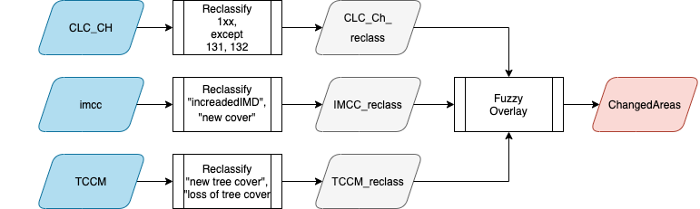

Figure 5: Workflow for the classification of changed areas. Source: personal compilation of Elisa Bender

Where:   
CLC_CH: Corine Land Cover Change   
imcc: High Resolution Layer Impervious Changes  
TCCM: Tree Cover Density Changes

The intermediate layers “CLC_Ch_reclass”, “IMCC_reclass” and “TCCM_reclass” contain the reclassification of relevant and unrelevant classes in regards of changed areas, both layers combined result in the final layer changed areas.

##### Forest areas

Considering hard thresholds are also forest areas, this layer is again a combination of multiple datasets. The “Global Forest Change Tree Cover” layer from in the origanal workflow could not be used in this one since it did not meet the forest definition parameters of Germany, which are 10% tree crown cover instead of the previously used 30%. Instead the “High Resolution Layer – Tree Cover Density (HRL_forest)” was used for that threshold. In the CLC dataset the classes 311 (broad-leaved forest), 312 (coniferous forest) and 313 (mixed forest) were reclassified with the value 1 and in the “TanDEM – Forest – Non-Forest (TDM-FNF)” dataset the class 1 already contained all forest areas, so the other class was reclassified to 0. Again all thre datasets were combined through Fuzzy Overlay with the overlay type OR to create the layer of forest areas.

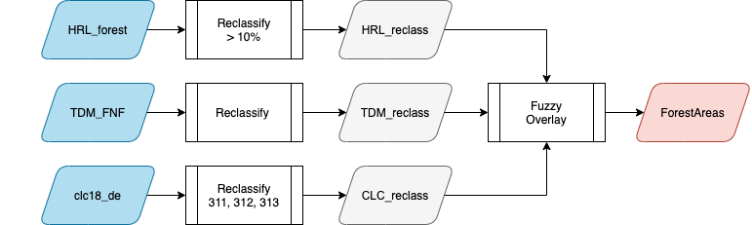

Figure 6: Workflow for the classification of forest areas. Source: personal compilation of Elisa Bender

Where:  
HRL_forest: High Resolution Layer – Tree Cover Density   
TDM_FNF: TanDem – Forest – Non-Forest  
clc18_de: Corine Land Cover for Germany

The intermediate layers “HRL_reclass”, “TDM_reclass” and “CLC_reclass” contain the reclassification of relevant and unrelevant classes in regards of forests, all layers combined result in the final layer forest areas.

##### Protected areas

The workflow for the layer of protected areas is different from the others since data from each state was used and united to create a layer covering the whole country of Germany.

There are different kinds of protected areas in Germany, the protection of each type of these reserves is regulated by international laws or the laws of the Federal Nature Conservation Act (BNatSchG) and the State Nature Conservation Acts (NatSchG, BayNatSchG, NatSchGBIn, BbgNatSchAG, BremNatG, HmbBNatSchAG, HAGBNatSchG, NatSchAG M-V, NAGBNatSchG, LNatSchG NRW, LNatSchG, SNG, SächsNatSchG, NatSchG LSA, LNatSchG, ThürNatG). The areas can be distinguished in two groups: Strictly protected areas include nature reserves, parts of national parks, FFH areas, European bird sanctuaries and the core zones of biosphere reserves. Less protected areas comprise nature parks and landscape conservation areas. Due to the inconsistent availabiltiy of datasets regarding the three zones of biosphere reserves and the fact that every potential interference with nature has to be checked with an Environmental Impact Assessment (Umweltverträglichkeitsprüfung), no matter which group of protected areas it would affect, it was decided to treat all types of protected areas as hard thresholds. The most important types of protected areas, that are available for the majority of federal states and therefore being used in this methodology, are: Biosphere reserves, FFH areas, Protected landscape areas, national parks, nature parks, nature reserves, European bird sanctuaries (an overview of available datasets for each state can be found in Table 5).

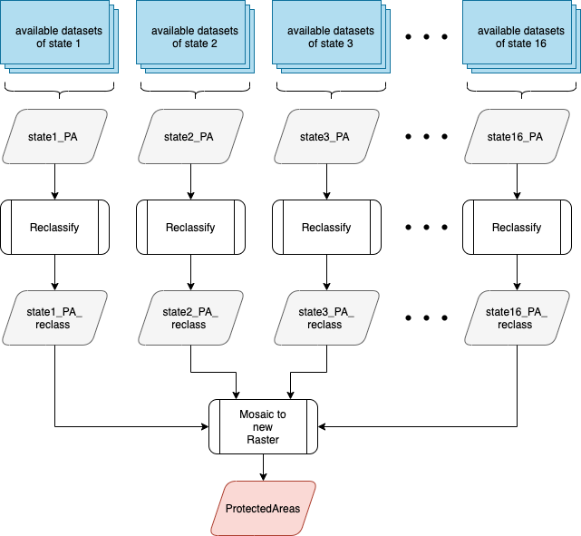

Figure 7: Workflow for the classification of protected areas. Source: personal compilation of Elisa Bender

In a first step the available feature layers of each state were united and converted into a raster, so 16 raster datasets were created. Afterwards the classes containing the protected areas were assigned to 1. In the second step these individual rasters were combined using the function Mosaic to New Raster to create a layer that contains all protected areas in Germany.

Where:  
X: stands for a certain state  
available datasets of state X: all available feature layers regarding protected areas for that state  
stateX_PA: Raster that contains all protected areas for that state

The intermediate layer “stateX_PA _reclass” contains the reclassification of relevant and unrelevant classes in regards of forests, all layers combined result in the final layer protected areas.

Table 5: Overview of data availability of protected areas per federal state.  
Source: personal compilation of Elisa Bender

| **Federal state / available datasets** | **Biosphere reserves** | **FFH areas** | **Proected landscape areas** | **National parks** | **Nature parks** | **Nature reserves** | **European bird sanctuaries** |
| --- | --- | --- | --- | --- | --- | --- | --- |
| Baden-Württemberg | X | X | X | X | X | X | X |
| Bavaria | X | X | X |  | X | X | X |
| Berlin |  | X | X |  |  | X | X |
| Brandenburg | X |  | X | X | X | X |  |
| Bremen |  | X | X |  |  | X | X |
| Hamburg | X | X | X | X |  | X | X |
| Hesse | X |  |  | X |  | X | X |
| Mecklenburg-Western Pomerania | X |  | X | X | X | X | X |
| Lower Saxony | X | X | X | X | X | X | X |
| North Rhine-Westphalia |  | X |  | X | X | X | X |
| Rhineland-Palatinate | X | X | X | X | X | X | X |
| Saarland | X | X | X | X | X | X | X |
| Saxony | X | X | X | X | X | X | X |
| Saxony-Anhalt | X | X | X | X | X | X | X |
| Schleswig-Holstein | X | X | X |  | X | X |  |
| Thuringia | X | X | X | X | X | X | X |

#### Classification of MLs (soft constraints)

The original methodology regarding the soft constraints for the classification of MLs was modified for this case study, in a way that the constraints go through a process of two weighting steps. In the first step the soft constraints for each indicator class (soil, terrain, sustainability and productivity) are weighted to create the indicator layer. The weights of this step are following literature research for regulations and marginal land definitions in Germany, as well as definitions of suitable soil parameters for forests. The second step consists of the weighting of the newly created four indicator layers “soil”, “terrain”, “sustainability” and “productivity”. These weights are based on the literature research from task 2.3 where the according weights within each indicator class were summed up to create a weight for the corresponding layer. An overview of the methodology can be found in Figure 8.

The indicators themselves are the same as in the original methodology of 2.3, with the exception that no distinction is made between topsoil and subsoil, as no suitable data is available that could be used for the whole of Germany. In total 16 indicators have been taken into consideration for this pilot study. Originally the idea was to also include the layer of natural toxicity but the available dataset from 2.3 did not contain relevant MLs classes in Germany, so it would not influence the result. Ultimately the indicator was left out because there was also no other dataset available on a federal level or other relevant thresholds found for Germany. The soil and terrain indicators were split into the two classes to create four layers and to have the opportunity to define more precise weights in the second step.

Ein Bild, das Text, Fern, Elektronik, Fernbedienung enthält.

Figure 8: Methodology for the classification of MLs (soft constraints) with the first (yellow) and second (violet) weighting steps. Source: personal compilation of Elisa Bender

This methodology was chosen because of the availability of federal and state data and because this means the classification of MLs within each federal state will consists of individual combinations of these datasets. It was decided to create the four indicator layers as intermediate results with weights that indicate the importance of each indicator for the detection for MLs in Germany. The weights were calculated with the Analytical Hierarchy Process (AHP) and can be found in **Error! Reference source not found.**. AHP is a complex method of the Multi Criteria Decision Analysis (MCDA) which “is used to deal with the difficulties that decision makers encounter in handling large amounts of complex information” (Basak, 2006). The idea behind this method is to split decision problems into smaller parts, analyze and solve them individually and then bring them back together logically (Malczewski 1997, cited in Basak, 2006). Combining GIS and MCDA with each other creates a tool which is very convenient for site selection processes and therefore, useful for the purpose of ***MAIL*** and the detection of Marginal Lands. The final step of the AHP process is the calculation of ${}_{max}$, the consistency index and the consistency ratio (Table 7) to verify the accuracy of the calculated weights. For this the consistency ratio must be smaller than 0.1, which is the case for all four indicator classes and therefore the calculated weights can be used for the methodology.

Table 6: Indicators and their weights used for the first weighting step. Source: Personal compilation of Elisa Bender

|  |  |  |
| --- | --- | --- |
| **Indicator class** | **Indicator** | **Weight** |
| Terrain | Slope | 0.6571 |
| Depth available to roots | 0.2746 |
| Stoniness | 0.0683 |
| Soil | Texture | 0.1637 |
| Water storage capacity | 0.5798 |
| Clay | 0.0929 |
| Sand | 0.1637 |
| Sustainability | Erosion | 0.1321 |
| Flooding | 0.2386 |
| Dryness | 0.0761 |
| Acidity (pH) | 0.0761 |
| Sodicity | 0.2386 |
| Contamination | 0.2386 |
| Productivity | Soil organic matters | 0,2500 |
| Cation exchange capacity | 0,2500 |
| Soil fertility (Productivity) | 0,5000 |

Table 7: Verification of the accuracy of the calculated weights. Source: Personal compilation of Elisa Bender

| **Indicator class** | $${}_{max}$$ | **Consistency index** | **Consistency ratio** |
| --- | --- | --- | --- |
| Terrain | 3.0444 | 0.0222 | 0.0383 |
| Soil | 4.0278 | 0.0093 | 0.0103 |
| Sustainability | 6.0138 | 0.0028 | 0.0022 |
| Productivity | 3.0000 | 0.0000 | 0.0000 |

The overall significance of the indicator classes in a general context of MLs should be considered as well, that is why the second weighting step was created to include the weights defined in task 2.3. Therefore, the weights of each indicator of the same class were summed up to create a weight for the corresponding intermediate layer (Table 8). The weights of all indicators used in task 2.3 add up to 0.99 instead of 1.0, which is why the value of 0.0025 was added to each of the four indicator layers. That way the additional weight is not interfering with the importance of each indicator class.

Table 8: Indicator layers and their weights used for the second weighting step. Source: Personal compilation of Elisa Bender

|  |  |
| --- | --- |
| **Indicator layers** | **Weights** |
| Soil layer | 0.1925 |
| Terrain layer | 0.4025 |
| Sustainability layer | 0.2925 |
| Productivity layer | 0.1125 |

A lot of available data for Germany in the context of soil is already classified into (five) classes. This is because the Geological Offices providing this data are following the handbooks of “soil mapping manual” (Bodenkundliche Kartieranleitung) and “The Muencheberg Soil Quality Rating” (SQR), in which thresholds for the classification of soil parameters are provided. Therefore, the indicator classes being used in the context of this pilot study are adapted to fit the manual thresholds and pre-classified datasets, they can be found in Table 9.

.

Table 9: Indicators proposed for Germany. Classes and score. Source: Personal compilation of Elisa Bender

| **Indicator class** | **Indicator** | **Classes** | **Score** |
| --- | --- | --- | --- |
| Terrain | Slope | < 10  > 10 & < 20  > 20 | 10  5  1 |
| Depth available to roots | < 3  > 3 & < 7  > 7 | 1  5  10 |
| Stoniness | 10 – 15%  (15-20%) | 10  5 |
| Soil | Texture | ll, lu, tl, tu,  sl  us | 1  5  10 |
| Clay | > 50 & < 58,7  > 58,7 & < 67,3  > 67,3 | 10  5  1 |
| Sand | Ss  Ls  us | 1  5  10 |
| Water storage capacity | < 50  > 50 & < 90  > 90 | 1  5  10 |
| Sustainability | Erosion | < 30  > 30 & < 60  > 60 | 10  5  1 |
| Acidity (pH) | < 5,0 & > 8  > 5,0 & < 7,5  > 5,5 & < 8 | 1  5  10 |
| Sodicity | 0 – 36,7  36,7 – 67,4  67,4 – 131 | 10  5  1 |
| Contamination | < 3  > 3 & < 10  > 10 | 10  5  1 |
| Flooding | 50% - 66.7%  66.7% - 83.3%  83.3% - 100% | 10  5  1 |
| Dryness | 0.5 – 0.34  0.34 – 0.18  0.18 – 0 | 10  5  1 |
| Productivity | Soil organic matters | > 15  > 30  >45 | 10  5  1 |
| Cation exchange capacity | < 4  > 4 & < 8  > 8 | 1  5  10 |
| Soil fertility (Productivity) | < 20  > 20 & < 30  > 30 | 1  5  10 |

The combination of hard thresholds and soft constraints to detect Marginal Lands in Germany was executed in Google Earth Engine (GEE). The soft constraints were merged with their associated weights, from which the areas of hard thresholds were excluded. The result contains the Marginal Lands and was reclassified into three classes, “MLs with high plantation suitability”, “MLs with low plantation suitability” and “Potentially unsuitable lands”. For this the three classification methods from 2.3 were followed:

* computing the maximum and minimum and dividing the range of values by 3
* computing the 25th and 75th percentile and setting these values as threshold limits
* computing the 33rd and 66th percentile to keep the same number of pixels in each category.

An overview of the methods and their thresholds can be found in Table 10.

Table 10: Methods and thresholds for the classification of the detected Marginal Lands. Source: Personal compilation of Elisa Bender

|  |  |  |  |  |  |  |  |
| --- | --- | --- | --- | --- | --- | --- | --- |
| **Method** | | **A)** | | **B)** | | **C)** | |
| **Min. - Max.** | | **p25 - p75** | | **p33 - p66** | |
| **Value** | | 0.0 | 86.2463 | 27.702 | 46.278 | 30.932 | 42.67 |
|  | | **Thresholds** | | | | | |
| ***1*** | ***Marginal lands with high plantation suitability*** | 57.4975 | 86.2463 | 46.278 | 86.2463 | 42.67 | 86.2463 |
| ***2*** | ***Marginal lands with low plantation suitability*** | 28.7488 | 57.4975 | 27.702 | 46.278 | 30.932 | 42.67 |
| ***3*** | ***Potentially unsuitable lands*** | 0.0 | 28.7488 | 0.0 | 27.702 | 0.0 | 30.932 |

## Results and comparison

The following tables contain the calculated areas of MLs in the selected test sites “Nochten” and “Welzow” in hectares and percent. While Table 11 shows the results of task 2.3, Table 12 shows the results retrieved from the adapted methodology of task 4.1.

Table 11: MLs areas for test sites in hectares and percent for each classification method following the 2.3 methodology. Source: Personal compilation of Elisa Bender

|  |  |  |  |  |  |
| --- | --- | --- | --- | --- | --- |
| **Pilot site** | **Total of ML** | **Classification Method** | **ML high** | **ML low** | **ML unsuitable** |
| **Nochten (Germany)** | 21120.5  (16.9%) | min - max | 6.6  (0.01%) | 2,023.3 (1.62%) | 19,090.6  (15.31%) |
| p25 - p75 | 1,255.5  (1.01%) | 17,891.5  (14.35%) | 1,973.5  (1.58%) |
| p33 – p66 | 1,933.4  (1.55%) | 14,043.5  (11.26%) | 5,143.6  (4.13%) |
| **Welzow (Germany)** | 6533.0  (26.3 %) | min - max | 27.1 (0.11%) | 1,554.8  (6.26%) | 4,951.2  (19.95%) |
| p25 - p75 | 1,095.4  (4.41%) | 5,437.6  (21.91%) | 0.0  (0.0%) |
| p33 – p66 | 1,581.1  (6.37%) | 4,952.0  (19.95%) | 0.0  (0.0%) |

Table 12: MLs areas for test sites in hectares and percent for each classification method following the 4.1 methodology. Source: Personal compilation of Elisa Bender

| **Pilot site** | **Total of ML** | **Classification Method** | **ML high** | **ML low** | **ML unsuitable** |
| --- | --- | --- | --- | --- | --- |
| **Nochten (Germany)** | 18924.0  (15.14%) | min - max | 2,479.0  (1.98%) | 10,767.5  (8.62%) | 5,677.5  (4.54%) |
| p25 - p75 | 5,883.25  (4.71%) | 7,373.5  (5.9%) | 5,667.25  (4.53%) |
| p33 – p66 | 7,216.25  (5.77%) | 5,960.25  (4.77%) | 5,747.5  (4.6%) |
| **Welzow (Germany)** | 5960.75  (24.0%) | min - max | 999.0  (4.02%) | 3,322.0  (13.37%) | 1,639.75  (6.6%) |
| p25 - p75 | 2,137.75  (8.61%) | 2,194  (8.83%) | 1,629  (6.56%) |
| p33 – p66 | 2,411.5  (9.71%) | 1,863  (7.5%) | 1,686.25  (6.79%) |

Comparing the results of 2.3 and 4.1 it can be found that there is a slight decrease of MLs, 1.76% for the test site Nochten and 2.3% for Welzow. Overall, about 4% less Marginal Land was found for Germany as a whole (Table 13).

Table 13: Total area of Marginal Lands detected in Germany, for methodology 2.3 and 4.1. Source: Personal compilation of Elisa Bender

|  |  |  |  |
| --- | --- | --- | --- |
| **Methodology** | **Total country area (${km}^{2})$** | **ML area (${km}^{2})$** | **ML area (%)** |
| 2.3 | 357,340 | 41,606 | 11.64 |
| 4.1 | 27,113 | 7.59 |

In general comparison to 2.3, the classification methods of 4.1 categorize Marginal Lands quite evenly into the three classes. Just for the method A the majority is classified as “Marginal lands with low plantation suitability”. Altogether the results of method A, B and C are very similar to each other, and it is apparent which areas are suitable or unsuitable Marginal Lands, this can be seen in Figure 10.

Comparing the visual results of 2.3 (Figure 9) and 4.1 with each other, it can be seen that areas, classified in 2.3 as “Marginal Lands with high plantation suitability”, have been classified as “potentially unsuitable lands” in 4.1. This is very visible for the methods B and C.

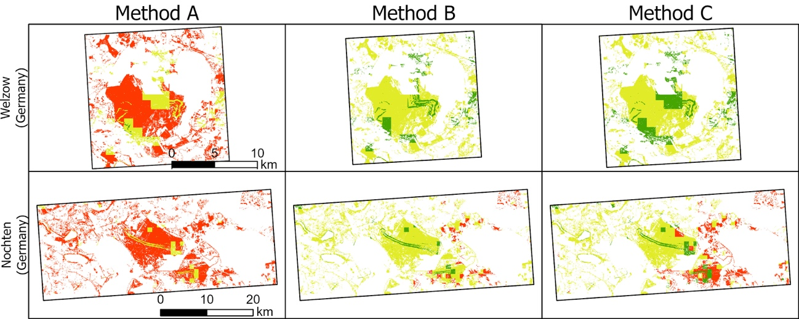

Figure 9: Final Layer of MLs (task 2.3) classified with 3 methods into the 3 categories: “Marginal lands with high plantation suitability” (green), “Marginal lands with low plantation suitability” (yellow) and “Potentially unsuitable lands” (red). Source: Personal compilation of Elisa Bender

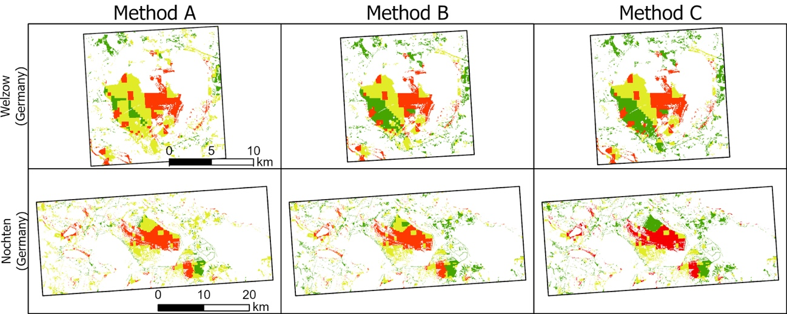

Figure 10: Final Layer of MLs (task 4.1) classified with 3 methods into the 3 categories: “Marginal lands with high plantation suitability” (green), “Marginal lands with low plantation suitability” (yellow) and “Potentially unsuitable lands” (red). Source: Personal compilation of Elisa Bender

|  |  |
| --- | --- |
|  |  |
|  | |

Figure 11. Percentage of area classified as ML by typology (ML high, ML low & ML unsuitable) on the pilot sites of Germany. Source: personal compilation of Elisa Bender

As expected, the methodology executed in task 4.1 detects generally less Marginal Lands then task 2.3 (Figure 11). This is because local datasets and more suitable thresholds for Germany were being used, resulting in a more precise layer of hard thresholds.

Especially the detailed layer of protected areas cut out areas that were classified as marginal in task 2.3. Furthermore, the adaptions made to the soft constraints result in very different classifications of Marginal Lands.

In conclusion it can be said that the adapted methodology of 4.1 leads to more meaningful results for Germany and seems reasonable, since all three classification methods of 4.1 show similar results.

# Greece

## Site’s location

The pilot sites selected in Greece are low productivity lands adjacent to natural parks and forest areas. The test sites are presented in Figure 12. The test sites are two and located in the region of Macedonia and Thrace. One in Thessoloniki prefecture at the mountainous areas above “Thermi” and “Vassilika” and one in Rhodope prefecture and more specifically at the mountainous areas of of “Proskynites” and “Xylagani” southern of Komotini. Part of Thessaloniki’s pilot case is “Isenli” forest, where HOMEOTECH had implemented the managerial plan for the period 2007 – 2016. Results and field data from that project were taken into account for better understanding the local marginal lands.

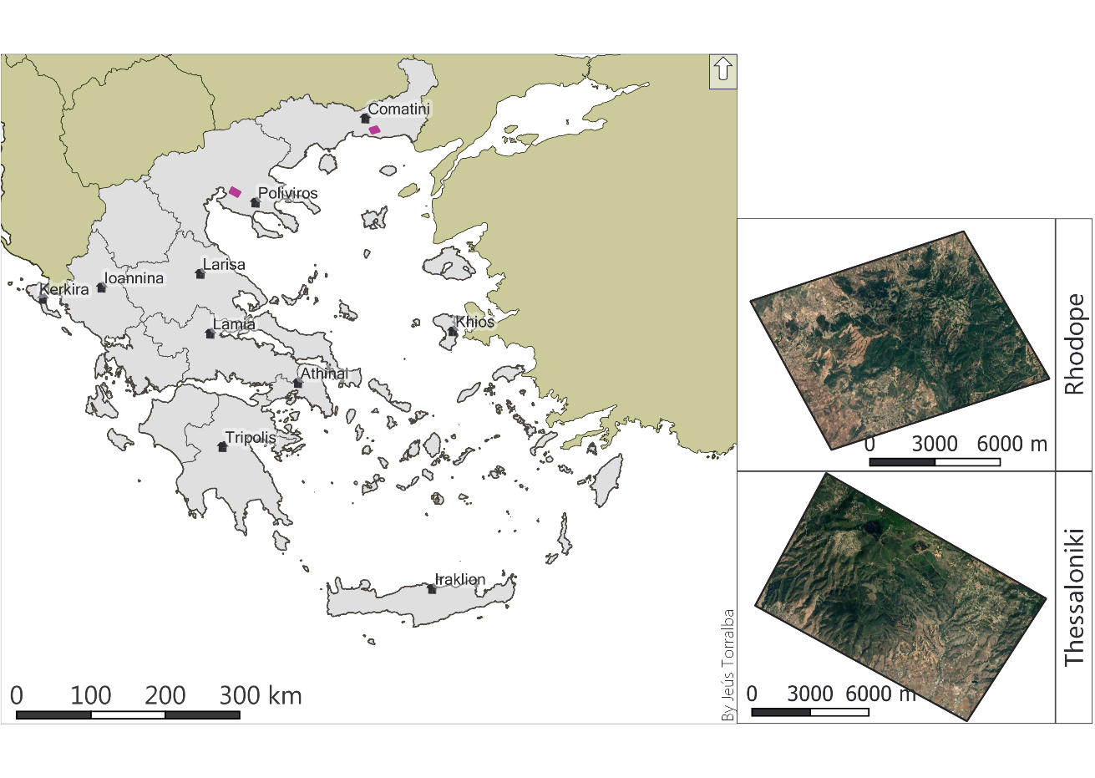

Figure 12. Greece and the pilot site of the afforestation forest of “Rhodope” and “Thessaloniki”. Source: personal compilation of Jesús Torralba Pérez.

## System development

### Dataset selection

The data used for this methodology can be divided in two groups: Data used for potential MLs detection (hard constrains, Table 14) and datasets available for ML´s classification (soft constrains,Table 15).

Table 14. Data sources used for the identification potential MLs (hard constrains) in pilot sites of Greece. Source: personal compilation of Alfonso Abad

|  |  |  |  |  |
| --- | --- | --- | --- | --- |
| **Layer** | **Description** | **Usage** | **Source** | **Scale** |
| Corine Land Cover 2018 | Land Cover Land Use map (2018) | Removal of areas that are not MLs candidates. | Copernicus | undefined |
| Vegetation of Greece | Vegetation and land use of Greece (XXXX) | Removal of areas that are not MLs candidates | Department of forests - ΥΠΕΚΑ | undefined |
| Greek pilot sites vegetation | Improvement of the Vegetation of Greece with photointerpretation | Identification of vegetation on pilot sites (Greece) | Internal | undefined |
| Digital elevation model (DEM-65) | Model used for elevation and slope zonification | Identification of areas above 1200 meters and slope above 45% | ΥΠΕΚΑ, OKXE | 65x65 (grid) |
| Ethnikoi Drymoi | This dataset contains the boundaries of National Parks of Greece | Definition of the environmental protected areas | Geodata.gov.gr  ΥΠΕΚΑ | undefined |
| Ethnika Parka | Geodata.gov.gr  ΥΠΕΚΑ | undefined |

Table 15. Data sources used for the classification of MLs (soft constrains). Source: personal compilation of Alfonso Abad

| **Layer** | **Description** | **Usage** | **Source** | **Scale** |
| --- | --- | --- | --- | --- |
| Soil - Geological | Classification of lands based on soil attributes and fertility | Calculation of soil depth, erosion categories and forest capacity | Ministry of Agriculture (Υπ. Γεωργίας, ΕΘ.Ι.ΑΓ.Ε.) | undefined |
| Rainfall | Annual rainfall data (1975 – 2004) | Model used rainfall zonification | www.geoclima.eu | undefined |
| Digital elevation model (DEM-65) | Digital elevation model of Greece | Model used for elevation and slope zonification | Greek cadastral service, Ministry of Environmen and climate change ΥΠΕΚΑ, OKXE | 65x65 (grid) |

### Implementation

#### Detection of potential MLs (hard constrains)

The methodology applied for marginal land detection under the framework of MAIL project is summarized in the workflow below:

Figure 13. Methodology for identifying marginal lands (hard layers). Source: personal compilation of Alfonso Abad

##### Land cover type

To define the first set of candidates the layers corresponding to Corine Land Cover of Greece for 2018 (CLC18) and Vegetation of Greece (VEG YPEKA) were selected. The detection methodology was implemented separately in these two layers.

CLC18 is one of the Corine Land Cover datasets produced within the frame the Copernicus Land Monitoring Service referring to land cover / land use status of year 2018. This dataset is based on the classification of satellite images produced by the national teams of the participating countries with 44 classes in the hierarchical 3-level Corine Land Cover nomenclature. The classes selected in this step of the workflow are as follows:

Table 16. Land cover classes (CLC18) used to detect marginal land candidates. Source: personal compilation of Alfonso Abad

|  |  |  |  |
| --- | --- | --- | --- |
| **Level 1** | **Level 2** | **Level 3** | **COD** |
| Artificial surfaces | Mine, dump and construction sites | Mineral extraction sites | 131 |
| Dump sites | 132 |
| Agricultural areas | Pastures | Pastures | 231 |
| Heterogeneous agricultural areas | Agro-forestry areas | 244 |
| Scrub and/or herbaceous vegetation  associations | Natural grasslands | 321 |
| Moors and heathland | 322 |
| Open spaces with little or no vegetation | Sparsely vegetated areas | 333 |
| Burnt areas | 334 |

VEG YPEKA is the map of Vegetation and land use of Greece corresponding to the year 1998 and produced by the Department of forests – (ΥΠΕΚΑ). The original dataset is composed of 29 classes. The classes selected in this step of the workflow are as follows:

Table 17. Classes from the Vegetation and land use of Greece (VEG YPEKA) used to detect marginal land candidates. Source: personal compilation of Alfonso Abad

| **Description** | **COD** |
| --- | --- |
| Moors and heathland (Juniperus sp.) | ΑΡΚ |
| Shrubs | ΘΑΜ |
| Deciduous shrubs | ΦΘΑ |
| Natural grasslands | ΛΙΒ |
| Abandoned agricultural areas | ΓΚΕ |

After establishing the candidates for marginal land, exclusion criteria were selected to fine tune the identification. For each criterion a mask was generated to be applied in order to subtract on the candidate’s layer.

##### Protected areas

The first criterion was to exclude environmental protected areas with total protection status (cores of absolute protection). In this regard, the methodology takes into account, the zoning established for National Parks and Natural Protected Areas in Greece by the Ministry of Environment and Energy. The protection areas mask was compiled with a reclassification of the total protected areas with value 0 and 1 for the rest.

##### Digital Elevation Model

In order to include in the workflow, the feasibility of further activities in marginal land candidates, as areas suitable for reforestation plans, environmental factors were excluded through the Digital Elevation Model: areas above 1200 meters and terrains presenting slope values above 45% (computed on DEM-65). Two masks were created for both topographic limitations.

#### Classification of MLs (soft constrains)

A new set of indicators used for the classification of MLs at local scale was developed based on the ones applied at Pan-European developed on deliverable 2.3 mainly due to the following reasons:

* Lack of some of the indicators proposed on deliverable 2.3 at Pan-European.
* Addition of new indicators that were considered as relevant at local scale.

From the original set of 21 indicators, a selection of 6 as presented below was used (Table 18).

Table 18. Indicators proposed at local scale. Classes and score. Source: Personal compilation of Alfonso Abad

| **Type of indicator** | **Indicator** | **Classes** | **Score** |
| --- | --- | --- | --- |
| Terrain and soil | slope | [0% - 10%]  [10% - 45%]  [>45%] | 10  5  1 |
| depth | [1, 2, 3]  [4, 5, 6]  [7, 8, 9] | 10  5  1 |
| aspect | [S, SE, SW]  [E, W, flat]  [N, NE, NW] | 10  5  1 |
| rain | [700mm – 1500mm]  [300mm – 700mm]  [250mm -300 mm] | 10  5  1 |
| Sustainability | erosion | [1, 2, 3]  [4, 5, 6]  [7, 8, 9] | 10  5  1 |
| Productivity | Forestry capacity | [1]  [2, 3, 4]  [5] | 10  5  1 |

For the calculation of new weights, the Analytical Hierarchy Process (AHP) was followed. The AHP tool is widely accepted for multi criteria decision-making, based on Eigen values approach to the pair-wise comparisons (Vaidya & Kumar, 2006). When measuring something with respect to a property, it is usually applied some known scale for that purpose.

The AHP tool allows to derive relative scales using judgment from a standard scale, and to perform arithmetic operations on such scales. The judgments on this tool are given in the form of paired comparisons (Saaty, 1990).

Below (Table 19) is presented the pairwise comparison matrix (PCM) used for the comparison between indicators according to its importance at local scale along with the normalized PCM by column’s total (Table 20).

Table 19. PCM of marginality indicators at local scale, based on its importance (1=equal, 3=slightly higher, 2=intermediate scales). Source: Personal compilation of Alfonso Abad

|  | **Slope** | **Aspect** | **Depth** | **Erosion** | **Rain** | **Forestry capacity** |
| --- | --- | --- | --- | --- | --- | --- |
| **Slope** | 1 | 3 | 3 | 3 | 2 | 3 |
| **Aspect** | 1/3 | 1 | 3 | 2 | 2 | 3 |
| **Depth** | 1/3 | 1/3 | 1 | 1/3 | 1 | 2 |
| **Erosion** | 1/3 | 1/2 | 3 | 1 | 1 | 2 |
| **Rain** | 1/2 | 1/2 | 1 | 1 | 1 | 2 |
| **Forestry capacity** | 1/3 | 1/3 | 1/2 | 1/2 | 1/2 | 1 |

Table 20. Normalized PCM of marginality indicators at local scale. Source: Personal compilation of Alfonso Abad

|  |  |  |  |  |  |  |
| --- | --- | --- | --- | --- | --- | --- |
|  | **Slope** | **Aspect** | **Depth** | **Erosion** | **Rain** | **Forestry capacity** |
| **Slope** | 0.3529 | 0.5294 | 0.2609 | 0.3830 | 0.2667 | 0.2308 |
| **Aspect** | 0.1176 | 0.1765 | 0.2609 | 0.2553 | 0.2667 | 0.2308 |
| **Depth** | 0.1176 | 0.0588 | 0.0870 | 0.0426 | 0.1333 | 0.1538 |
| **Erosion** | 0.1176 | 0.0882 | 0.2609 | 0.1277 | 0.1333 | 0.1538 |
| **Rain** | 0.1765 | 0.0882 | 0.0870 | 0.1277 | 0.1333 | 0.1538 |
| **Forestry capacity** | 0.1176 | 0.0588 | 0.0435 | 0.0638 | 0.0667 | 0.0769 |

The final weights for each indicator are calculated based on the normalized PCM, computing for each indicator row’s median. In Table 21 the final weights for each factor together with the label used to measure the consistently of the comparison preformed are summarized.

Table 21. Weights and labels of marginality indicators. Source: Personal compilation of Alfonso Abad

| **marginality indicators** | **Label** | **Weight** |
| --- | --- | --- |
| **Slope** | A | 0.3373 |
| **Aspect** | B | 0.2180 |
| **Depth** | C | 0.0989 |
| **Erosion** | D | 0.1469 |
| **Rain** | E | 0.1278 |
| **Forestry capacity** | F | 0.0712 |

The final stage is to calculate a Consistency Ratio (CR) as defined by (Saaty and Vargas, 2001) for measuring how consistent the obtained weights are relative to purely random judgments. This evaluation is performed through the Consistency Index (CI) of the PCM and the Random Consistency Index (RI). Table 22 summarizes those values.

Table 22. Consistency Index for PCM (CI) and Random Consistency Index (RI). Source: Personal compilation of Alfonso Abad

|  |  |
| --- | --- |
| **CI** | 0.06 |
| **RI** | 1.24 |
| **CR** | 0.05 |

A PCM is considered acceptable when the value of its CR - the most widely-used measure for consistency - remains below 0,1 (Goepel, 2019; Siraj, 2011). Therefore, the weights depicted from the PCM can be considered acceptable.

Figure 14 below present both the weights distribution and the accumulative of variance explained using various indicators.

Figure 14. Weights distribution and variance explained for each indicator of the new dataset. Source: Personal compilation of Alfonso Abad

A weighted overlay in a GIS, based on the scores and weights calculated for each new indicator was created. The final step in the mapping of marginal lands at regional scale, is the reclassification of the resulting product of the weighted overlay into the 3 ML classes (as explained in section 10.3 of deliverable D2.3): “MLs with high plantation suitability”, “MLs with low plantation suitability” and “Potentially unsuitable lands”. Three methods were used to divide up marginal lands according to their marginality:

* Computing the maximum and minimum and dividing the range of values by 3 (min -max method).
* Computing the 25th and 75th percentile and setting these values as threshold limits (p25 – p75 method).
* C. computing the 33rd and 66th percentile to keep the same number of pixels in each category (p33 – p66 method).

Table 23. Methods to subdivide by type of marginality used on Greek pilot site (CLC18). Source: Personal compilation of Alfonso Abad

| **Method** | | **1)** | | **2)** | | **3)** | |
| --- | --- | --- | --- | --- | --- | --- | --- |
| **Max. - Min.** | | **p25 - p75** | | **p33 - p66** | |
| **Value** | | 10.618 | 1.903 | 6.253 | 8.534 | 6.718 | 7.939 |
|  | | **Thresholds** | | | | | |
| ***1*** | ***Marginal lands with high plantation suitability*** | 10.618 | 7.713 | 10.618 | 8.534 | 10.618 | 7.939 |
| ***2*** | ***Marginal lands with low plantation suitability*** | 7.713 | 4.808 | 8.534 | 6.253 | 7.939 | 6.718 |
| ***3*** | ***Potentially unsuitable lands*** | 4.808 | 1.903 | 6.253 | 1.903 | 6.718 | 1.903 |

Table 23 shows the ranges of values obtained when using the three segmentation methods using CLC18 as hard layer and on **Error! Not a valid bookmark self-reference.** are represented the thresholds using VEG YPEKA as hard layer.

Table 24. Methods to subdivide by type of marginality used on Greek pilot site (VEG YPEKA). Source: Personal compilation of Alfonso Abad

| **Method** | | **1)** | | **2)** | | **3)** | |
| --- | --- | --- | --- | --- | --- | --- | --- |
| **Max. - Min.** | | **p25 - p75** | | **p33 - p66** | |
| **Value** | | 10.618 | 2.031 | 5.630 | 7.662 | 6.079 | 7.253 |
|  | | **Thresholds** | | | | | |
| ***1*** | ***Marginal lands with high plantation suitability*** | 10.618 | 7.755 | 10.618 | 7.662 | 10.618 | 7.253 |
| ***2*** | ***Marginal lands with low plantation suitability*** | 7.755 | 4.893 | 7.662 | 5.630 | 7.253 | 6.079 |
| ***3*** | ***Potentially unsuitable lands*** | 4.893 | 2.031 | 5.630 | 2.031 | 6.079 | 2.031 |

## Results and comparison

The corresponding areas calculated in hectares of each class for the selected test sites are outlined in Table 25 (area results of D2.3) and Table 26 (area results of D4.1).

Table 25. Areas in hectares of each type of MLs for the selected test sites as per derivable 2.3. Source: Personal compilation of Alfonso Abad

| **Pilot site** | **Hard layer** | **Total of ML** | **Classification Method** | **ML high** | **ML low** | **ML unsuitable** |
| --- | --- | --- | --- | --- | --- | --- |
| **Rhodope (Greece)** | Corine Land Cover 2018 | 2813.42 (35.2%) | min - max | 568.90  (7.1%) | 1,809.54 (22.6%) | 434.98  (5.4%) |
| p33 – p66 | 2,241.45 (28.0%) | 571.97  (7.2%) | 0  (0.0%) |
| p25 - p75 | 2,024.72 (25.3%) | 788.7  (9.9%) | 0  (0.0%) |
| **Thessaloniki (Greece)** | 4631.44 (47.9%) | min - max | 2,596.92 (26.9%) | 1,887.25 (19.5%) | 147.27  (1.5%) |
| p33 – p66 | 4,391.86 (45.5%) | 161.48  (1.7%) | 78.10  (0.8%) |
| p25 - p75 | 4,377.33 (45.3%) | 243.57  (2.5%) | 10.54  (0.1%) |
| **Total (Greece)** | 7444.86 (42.2%) | min - max | 3,165.82 (17.9%) | 3,696.79 (20.9%) | 582.25 (3.3%) |
| p33 – p66 | 6,633.31 (37.6%) | 733.45  (4.2%) | 78.1  (0.4%) |
| p25 - p75 | 6,402.05 (36.3%) | 1,032.27 (5.8%) | 10.54  (0.1%) |

Table 26. Areas in hectares of each type of MLs for the selected test sites as per derivable 4.1. Source: Personal compilation of Alfonso Abad

| **Pilot site** | **Hard layer** | **Total of ML** | **Classification Method** | **ML high** | **ML low** | **ML unsuitable** |
| --- | --- | --- | --- | --- | --- | --- |
| **Rhodope**  **(Greece)** | Corine Land Cover 2018 | 561.99 (7.1%) | min - max | 453.59  (5.7%) | 108.40  (1.4%) | 0  (0.0%) |
| p33 – p66 | 453.59  (5.7%) | 108.34  (1.4%) | 0.05  (0.0%) |
| p25 - p75 | 436.54  (5.5%) | 125.39  (1.6%) | 0.05  (0.0%) |
| VEG YPEKA | 1523.50 (19.0%) | min - max | 1,108.96 (13.9%) | 227.77  (2.8%) | 186.78  (2.3%) |
| p33 – p66 | 1,108.96 (13.9%) | 227.37  (2.8%) | 187.17  (2.3%) |
| p25 - p75 | 1,016.70 (12.7%) | 320.02  (4.0%) | 186.78  (2.3%) |
| **Thessaloniki (Greece)** | Corine Land Cover 2018 | 1.122.78 (11.6%) | min - max | 73.97  (0.8%) | 1,045.89 (10.8%) | 2.92  (0.0%) |
| p33 – p66 | 73.97  (0.8%) | 255.30  (2.6%) | 793.51  (8.2%) |
| p25 - p75 | 72.68  (0.8%) | 296.19  (3.1%) | 753.91  (7.8%) |
| VEG YPEKA | 2.409.37 (24.9%) | min - max | 328.81  (3.4%) | 1,210.20 (12.5%) | 870.36  (9.0%) |
| p33 – p66 | 328.81  (3.4%) | 1,098.11 (11.4%) | 982.44  (10.2%) |
| p25 - p75 | 327.74  (3.4%) | 1,237.77 (12.8%) | 843.86  (8.7%) |
| **Total (Greece)** | Corine Land Cover 2018 | 1.684.76 (9.5%) | min - max | 527.55 (3.0%) | 1,154.28 (6.5%) | 2.92 (0.0%) |
| p33 – p66 | 527.55 (3.0%) | 363.64 (2.1%) | 793.56  (4.5%) |
| p25 - p75 | 509.21 (2.9%) | 421.58 (2.4%) | 753.96  (4.3%) |
| VEG YPEKA | 3.932.87 (22.3%) | min - max | 1,437.77 (8.1%) | 1,437.97 (8.1%) | 1,057.13 (6.0%) |
| p33 – p66 | 1,437.77 (8.1%) | 1,325.48 (7.5%) | 1,169.62 (6.6%) |
| p25 - p75 | 1,344.44 (7.6%) | 1,557.79 (8.8%) | 1,030.64  (5.8%) |

Figure 15 shows the marginal lands for the pilot sites of Greece both as per D2.3 and D4.1. On the graph of Figure 16, the percentage of area classified as ML for each pilot site of Greece is summarized. For each product and taking into consideration the layer used as hard layer, the methodologies for classification of ML´s that maximize the area classified as marginal on each site are compared. The amount of ML was maximized on the product D2.3 and applying the classification methodology p25 – p75 (42% of the pilot site was set as marginal).

Figure 15. Comparison of ML’s detected as per D2.3 and as per D4.1 (CLC18 and VEG YPEKA as hard layers) for Greece’s pilot sites (Rhodope and Thessaloniki). Source: Personal compilation of Alfonso Abad

The minimum amount of ML was detected on the D4.1 product and using as hard layer CLC18, and classification methodology the min – max option (9.5% of the pilot site was set as marginal).

|  |  |
| --- | --- |
|  |  |
|  | |

Figure 16. Percentage of area classified as ML by typology (ML high, ML low & ML unsuitable) on the pilot sites of Greece. Source: Personal compilation of Alfonso Abad

The D4.1 product obtained using as hard layer YPEKA classify the 22% of the pilot site as marginal. Regarding the distribution of ML typologies this methodology has found the most equilibrated between ML typologies (ML high, low and unsuitable).

Indisputably both methods detect marginal lands with a very good accuracy. As it was expected a localized system manages to perform better, as it describes sounder the local aspects/particularities. Regarding the Greek pilot sites the results obtained on the product D2.3 (42% of the pilot site as marginal) were found excessive considering the local characteristics of the area, as shrubbed areas are considered also marginal.

Regarding the methodology developed in T4.1 for Greece the method using YPEKA as hard layer was found more appropriate to ***MAIL***´s scope in comparison with CLC18 as it seems to describe better the marginality and detect potential lands for future afforestation projects.

# Poland

## Site’s location

In Poland, the area of one of 16 Voivodeships/Provinces was selected to perform the analysis of marginal lands on regional level, using freely available data with higher level of details, comparing to the analysis performed in Task 2.3. Świętokrzyskie Voivodeship covers an area ff 11.672 km2 and is characterizedd by high number of marginal lands and semi-mountains terrain.

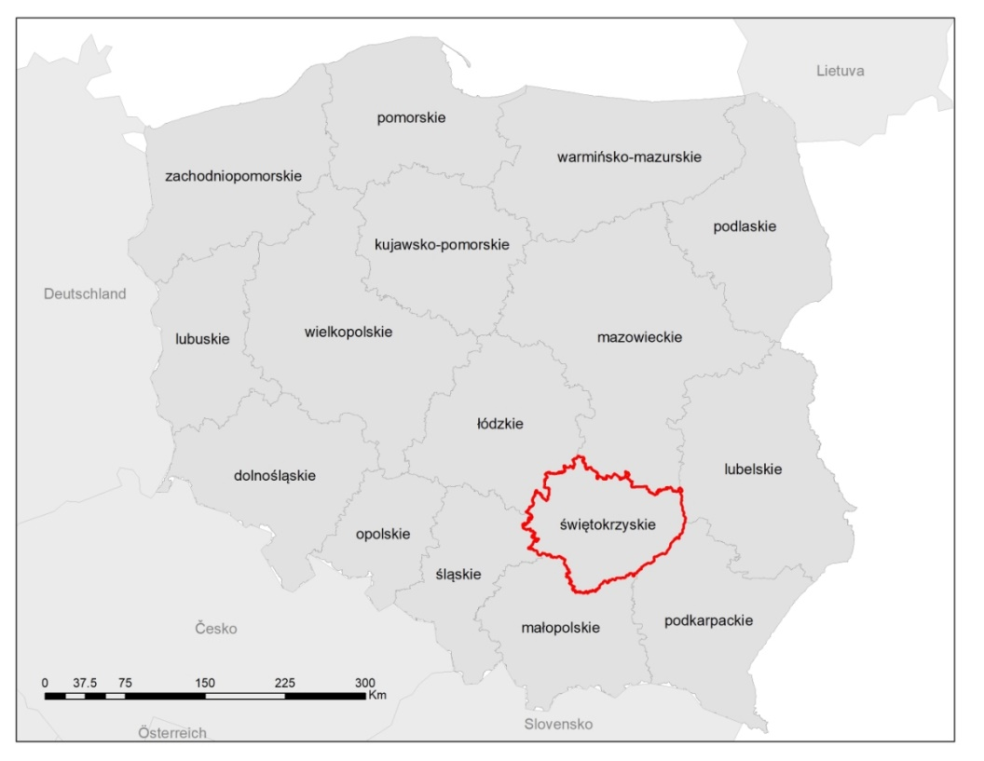

Figure 17. The area of Świętokrzyskie (red line). Source: personal compilation of Ewa Gromny and Michał Krupiński.

## System development

In the Polish case study, ***MAIL*** methodology from Task 2.3 (Deliverable 2.3) has been modified by inclusion of specific data sources on both stages of the algorithm – for hard and soft layer preparation.

### Dataset selection

Databases available for the area of Poland have been analysed to identify their usefulness for marginal lands identification and classification. Finally, for the application, two sources have been selected. Their characteristics are summarized in the Table 27

Table 27: Summary of auxiliary data source used for identification and classification of marginal lands within Polish pilot case. Source: personal compilation of Ewa Gromny and Michał Krupiński.

|  |  |  |
| --- | --- | --- |
| **Layer** | **Usage** | **Scale** |
| National Database of Topographic Objects BDOT 10k | Source of areas for exclusion | 1:10 000 |
| Soil Map of Poland | Source of information about soil productivity | 1:1 000 000 |

### Implementation

#### Detection of potential MLs (hard constraints)

Selection of areas which are not marginal lands was performed using the National Database of Topographic Objects 10k (BDOT 10k). It contains information about land cover, land use and protected areas. The level of detail corresponds to topographical maps of scale 1:10000. Table 28 presents various classes available in BDDOT10k database. They have been grouped into two categories: potential marginal lands and no marginal lands, ML and NoML in the last column. For the next steps, only areas which were not excluded as no marginal lands have been used.

Table 28. Land cover / land use classes (BDOT 10k) used to detect marginal land candidates. Source: personal compilation of Ewa Gromny and Michał Krupiński.

| **Level 1** | **Level 2** | **Level 3 (PL)** | **Code** | **ML/NoML** |
| --- | --- | --- | --- | --- |
| Land cover | Surface waters | woda morska | PTWP01 | NoML |
| woda płynąca | PTWP02 | NoML |
| woda stojąca | PTWP03 | NoML |
| Built up | Zabudowa wielorodzinna | PTZB01 | NoML |
| zabudowa jednorodzinna | PTZB02 | NoML |
| zabudowa przemysłowo‐składowa | PTZB03 | NoML |
| Zabudowa handlowo‐usługowa | PTZB04 | NoML |
| Pozostała zabudowa | PTZB05 | NoML |
| Forests | las | PTLZ01 | NoML |
| zagajnik | PTLZ02 | NoML |
| zadrzewienie | PTLZ03 | NoML |
| Shrubs | kosodrzewina | PTRK01 | ML |
| krzewy | PTRK02 | ML |
| Permanent cultivated areas | ogród działkowy | PTUT01 | NoML |
| plantacja | PTUT02 | NoML |
| sad | PTUT03 | NoML |
| szkółka leśna | PTUT04 | NoML |
| szkółka roślin ozdobnych | PTUT05 | NoML |
| Grasslands and cultivated areas | roślinność trawiasta | PTTR01 | ML |
| uprawa na gruntach ornych | PTTR02 | NoML |
| Roads, railways and airports | teren pod drogą kołową | PTKM01 | NoML |
| teren pod torowiskiem | PTKM02 | NoML |
| teren pod drogą kołową i torowiskiem | PTKM03 | NoML |
| teren pod drogą lotniskową | PTKM04 | NoML |
| Not used areas | piarg, usypisko lub rumowisko skalne | PTGN01 | ML |
| teren kamienisty | PTGN02 | ML |
| teren piaszczysty lub żwirowy | PTGN03 | ML |
| pozostały grunt nieużytkowany | PTGN04 | ML |
| Square | plac | PTPL01 | NoML |
| Landfill | teren składowania odpadów komunalnych | PTSO01 | ML |
| teren składowania odpadów przemysłowych | PTSO02 | ML |
| Excavation and dump | wyrobisko | PTWZ01 | ML |
| zwałowisko | PTWZ02 | ML |
| Other no built up areas | teren pod urządzeniami technicznymi lub budowlami | PTNZ01 | ML |
| teren przemysłowo‐składowy | PTNZ02 | ML |
| Protected areas | Natura 2000 | obszar Natura 2000 | TCON01 | NoML |
| Landscaped park | park krajobrazowy | TCPK01 | NoML |
| National park | park narodowy | TCPN01 | NoML |
| Reserve | rezerwat | TCRZ01 | NoML |
| Land use | Sacral complex | Cmentarz, zespół sakralny lub klasztorny | KUSC01,  KUSC02 | NoML |
| Other types | poligon wojskowy | KUIK01 | NoML |
| Hotels | hotel lub motel, kemping, ośrodek wypoczynkowy, schronisko turystyczne | KUHO01, KUHO02, KUHO03, KUHO04 | NoML |
| Sports and recreation complex | Ogród botaniczny, ogród zoologiczny, ośrodek sportowo-rekreacyjny, park, zespół domów letniskowych | KUSK01, KUSK02, KUSK03, KUSK04,  KUSK05 | NoML |

#### Classification of MLs (soft constrains)

Access to information about soil properties was very limited and data obtained from responsible authorities was not complete. The only complete and available materials were geological maps with types of soils. One of them has been vectorised and classified into 3 classes. Table 29 contains how specific types of soils have been grouped and ranked to match other soft layers. Class 1 – the best soil suitability, class 3 – the worst.

Table 29. List of soil types categorized into productivity classes. personal compilation of Marta Milczarek and Michał Krupiński

| **Type** | **Class** | **Rank** |
| --- | --- | --- |
| initial and weakly developed soils | 3 | 1 |
| carbonate rendzinas derived from cretaceous formation | 2 | 5 |
| carbonate rendzinas derived from sediments of other geological formations | 2 | 5 |
| sulfate (gypsum) rendzinas | 2 | 5 |
| soil complex: rendzinas, brown and leached brown soils | 1 | 10 |
| alluvial soils | 2 | 5 |
| silty and silty-gleyey soils | 2 | 5 |
| pesty and perst-muck soils | 3 | 1 |
| black and grey earths | 1 | 10 |
| degraded chernozem and gray forest soils | 1 | 10 |
| brown and leached brown soils derived from boulder loam and clays of different origin | 1 | 10 |
| brown and leached brown soils derived from loess and loess-like sediments | 1 | 10 |
| complex soils: pseudo-podzolic soils, leached brown and pseudo-gleyey soils; derived from sands of different origin | 1 | 10 |
| complex soils: pseudo-podzolic soils, leached brown and pseudo-gleyey soils; derived from loamy sands and boulder loam | 1 | 10 |
| complex soils: pseudo-podzolic soils, leached brown and pseudo-gleyey soils; derived from loess and loess-like sediments | 1 | 10 |
| complex soils: pseudo-podzolic soils, leached brown and pseudo-gleyey soils; derived from silt of different origin | 1 | 10 |
| rusty soild and podzolized rusty soils derived from loose sands and of sandy gravel of different origin | 1 | 10 |
| rusty soild and podzolized rusty soils derived from weakly loamy and loamy sands of different origin | 1 | 10 |

To adjust the weights of soft layers to local conditions of marginal lands in Poland, literature review was performed. Research papers related to this area take usage of satellite data directly, not like in pan European studies. For this reason, the weights of the soft layers have been preserved from D2.3 with one exception – instead of productivity layers from European layer, Polish soil data was used.

Table 30: Indicators and their weights used for the first weighting step. Source: Personal compilation of Michał Krupiński

| **Indicator group** | **Indicator** | **Weight** |
| --- | --- | --- |
| Terrain and Soil | Slope | 0.17 |
| Depth available roots | 0.18 |
| Stoniness (subsoil) | 0.03 |
| Stoniness (topsoil) | 0.03 |
| Texture (subsoil) | 0.045 |
| Texture (topsoil) | 0.045 |
| Clay (subsoil) | 0.015 |
| Clay (topsoil) | 0.015 |
| Sand (subsoil) | 0.015 |
| Sand (topsoil) | 0.015 |
| Total available water (subsoil) | 0.02 |
| Total available water (topsoil) | 0.02 |
| Sustainability | Soil acidity | 0.09 |
| Soil erosion | 0.06 |
| Flooding | 0.04 |
| Sodicity | 0.03 |
| Toxicity contamination | 0.03 |
| Natural toxicity | 0.02 |
| Dryness | 0.02 |
| Productivity | Soil type | 0.11 |

The final step of potential marginal lands classification is a division of the weighted sum into three classes (as explained in section 10.3 of deliverable D2.3).

The following three different ways of division were used:

* Divide values into 3 equal classes
* Divide values into groups following the rules: class1: <min; 25th percentile>, class 2: <25th percentile; 75th percentile>, class 3: <75th percentile; max>
* Divide values into groups following the rules: class1: <min; 33th percentile>, class 2: <33th percentile; 66th percentile>, class 3: <66th percentile; max>

## Results and comparison

Division of potential marginal land areas into 3 classes was performed in 3 different ways. The area of specific classes, and their percentage within the whole pilot case area are presented in Table 32. For comparison, the results from pan-European layers were extracted and summarized in Table 31.

Table 31: MLs areas for test sites in hectares and percent for each classification method following the 2.3 methodology. Source: Personal compilation of Michał Krupiński

|  |  |  |  |  |
| --- | --- | --- | --- | --- |
| **Total of ML** | **Classification Method** | **ML high** | **ML low** | **ML unsuitable** |
| 46345.7  (4.0%) | A: min - max | 2807.2  (0.24%) | 28392.9  (2.42%) | 15145.6 (1.29%) |
| B: p25 - p75 | 11605.6 (0.99%) | 22823.3  (1.95%) | 11916.8  (1.02%) |
| C: p33 – p66 | 14830.0 (1.27%) | 16169.4 (1.38%) | 15346.3 (1.31%) |

Table 32: MLs areas for test sites in hectares and percent for each classification method following the 4.1 methodology. Source: Personal compilation of Michał Krupiński

|  |  |  |  |  |
| --- | --- | --- | --- | --- |
| **Total of ML** | **Classification Method** | **ML high** | **ML low** | **ML unsuitable** |
| 181067.3  (15.5%) | A: min - max | 6696.6 (0.57%) | 161896.8 (13.82%) | 12473.8 (1.07%) |
| B: p25 - p75 | 46013.9 (3.93%) | 90599.0 (7.74%) | 44454.4 (3.80%) |
| C: p33 – p66 | 62830.4 (5.37%) | 64483.2 (5.51%) | 53753.7  (4.59%) |

To visually compare both methodologies (Task 2.3 and Task 4.1), maps with 3 classes estimated with 3 different methods were prepared and compared (Figure 18).

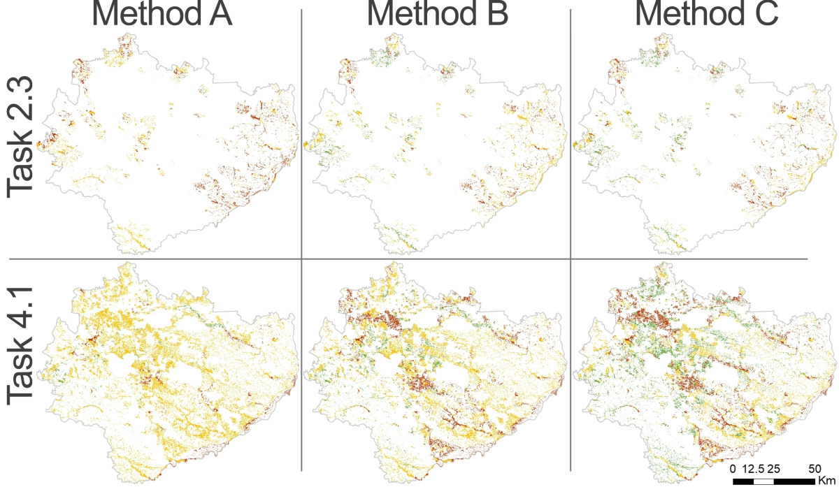

Figure 18. Final Layer of MLs classified with 3 methods into the 3 categories: “Marginal lands with high plantation suitability” (green), “Marginal lands with low plantation suitability” (yellow) and “Potentially unsuitable lands” (red). First row contains result of Task 2.3, second row – Task 4.1. Source: Personal compilation of Michał Krupiński.

The map of marginal lands detected within this task resulted in 3 times more area then in task 2.3 in Polish pilot case, 15.5% of province area, comparing to 4.0%.

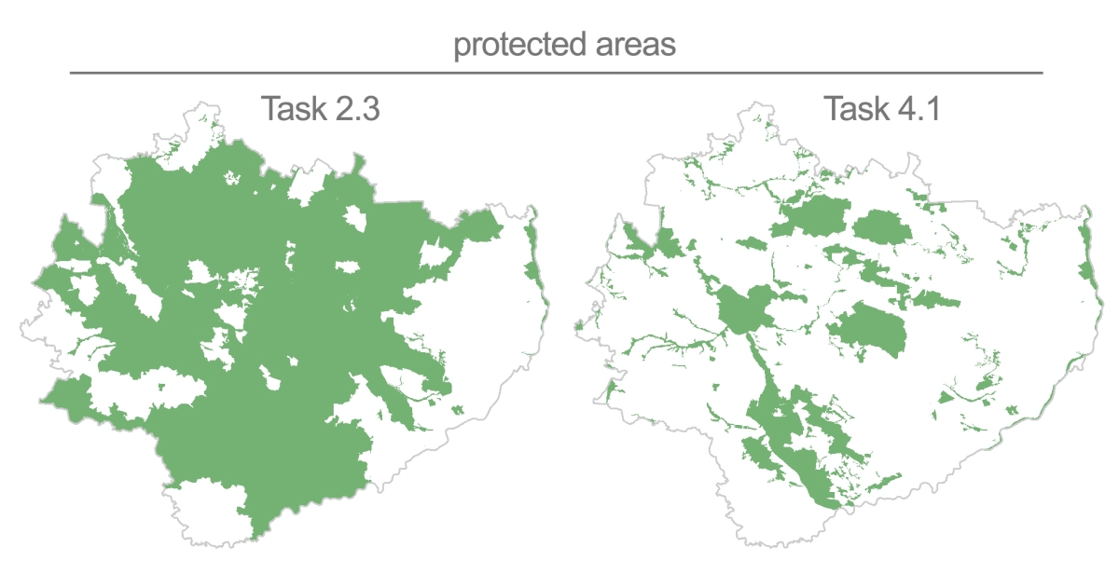

Figure 19. Comparison of Protected areas mask developed within task 2.3 and task 4.1

A detailed comparison of both methodologies revealed that in Task 2.3 much more protected areas are excluded from analyses (Figure 19). Protected areas in task 2.3 result from combination (sum of areas) of two bases: Natura 2000 and Common Database on Designated Areas (CDDA). CDDA provides more areas than Natura 2000 and in case of Poland it includes regions of protected landscape. This type of protection is defined on province level and does not imply very strict rules about human interventions within. For this reason, this type of protected areas was not applied as hard constrain in Task 4.1.

In the areas outside protected areas defined in Task 2.3, both approaches indicate highly similar results. Comparison of percentage of 3 classes and 2 approaches is presented in Figure 20.

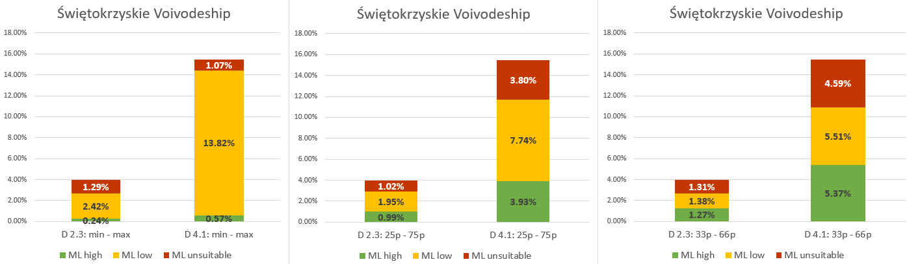

Figure 20. Percentage of area classified as ML by typology (ML high, ML low & ML unsuitable) within pilot case in Poland. Source: Personal compilation of Michał Krupiński.

Besides the method A, two other approaches result in comparable percentage of various marginal land classes. In method A the class of marginal lands with moderate suitability for afforestation dominates.

# Spain

The definition of Marginal Lands in the ***MAIL*** project are lands with significant, either environmental (biophysical variables) or socioeconomic, constraints and with potential to impact national accounting for C stock, excluding agricultural lands and other valuable areas (protected areas, uses with local importance, etc.).

In Mediterranean environments, MLs will be defined as degraded areas and linked to forest fires as vector shaping landscape dynamics.

The selection of indicators for Spain focuses on the detection of land use change dynamics, using the most detailed and up-to-date land cover and land use maps available, capable of identifying changes in the landscape and vegetation formations. However, the model also incorporates socio-economic data restrictions associated to land management at regional/local level. For this reason, the model proposed for Spain develops two levels: the first one integrates a model of indicators for the identification and characterisation of the MLs in the national territory and the second level develops a model for Castile and León, incorporating detailed soft and hard indicators for MLs bounded to that geographic and administrative region.

## Sites’ location

The methodology based on the definition of two data sets of national and regional indicators is tested in the pilot sites proposed by ***MAIL*** in the national territory: "Tierras Altas" is located in the province of Soria in Castile and León, the area of the Municipality of Nogueruelas (Teruel) in the Central East of the Iberian Peninsula, and the “Sierra de Espadán” in the province of Castellón (region of Valencia), in order to compare the results with the main ***MAIL*** methodology develop at the European level (tasks 2.3, ***MAIL*** Project). These pilot sites were defined as potentially marginal areas and include semi-urban degraded lands and low productivity lands adjacent to natural parks and forest areas.

In the three pilot areas the MLs are analysed and categorised on the basis of the national methodology and compared with the main ***MAIL*** methodology. In addition, the Tierras Altas pilot site allows to compare the three methodologies developed at European, national and regional/local level developing a model for the detection of MLs for Castile and León region and analysing the fit of the models with downscaling.

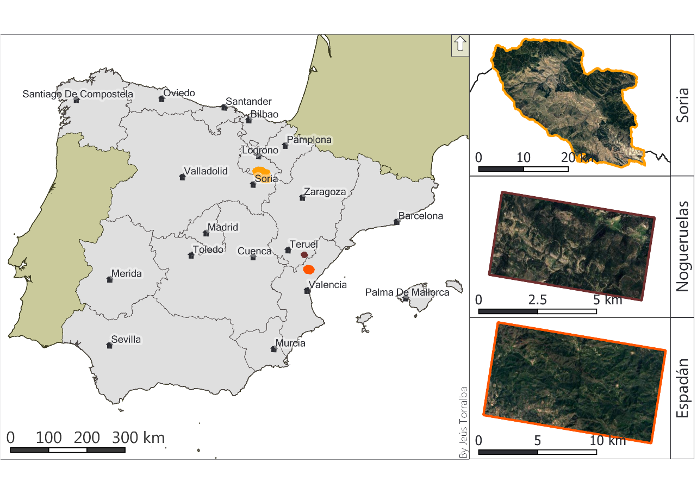

Figure 21:Spain (left) and the pilot site of “Soria” (outlined with light orange), “Nogueruelas” (outlined with dark red), and “Espadán” (right image outlined with dark orange). Source: personal compilation of Jesús Torralba Pérez

## System development

The methodology proposed in the ***MAIL*** project is divided into two main steps: the identification of possible marginal areas from binary input (with yes or no values) called Hard layers. The second step is the classification and overlap process based on the development of specific sets of indicators, named soft layers, that are applied according to the physical characteristics of each selected test site.

According to this methodology defined in the framework of the ***MAIL*** project, the national model for identification and classification of marginal lands has been developed by selecting and analysing the most relevant set of indicators in Mediterranean environments, both “hard” and “soft” layers, and adding the socio-economic component through the development of a new model at regional scale, using Castile and León and the pilot area of Tierras Altas (Soria) as test site. The reginal/local model inherits the national hard and soft layers and integrates local datasets of terrain, soil, sustainability and productivity constraints adjusting a final and detailed classification of the MLs at local scale.

Thus, as a result of this development, two models are available for Spain: one applicable to the entire national territory, and the other applicable to the autonomous community of Castile and León, based on a scalable methodology and repeatable for other autonomous communities or regions.

### Dataset selection

The analysis and selection of indicators to build soft and hard layers is done on the basis of the list of indicators defined in the Pan-European scale developed in output 2.3.

The methodology developed considers two types of variables and process: first, the hard constraints, which are Boolean variables (0,1) and the value 0 exclude from the classification areas that are not available for future reforestation due to certain ecological or socio-economic restrictions, and the value 1 identify the areas that can be suitable for the restoration. Second it is defining the categorical variables named soft constraints that allow the evaluation of the level of marginality of an area according to its viability for reforestation with endemic or accepted forest species in the study region: Spain and Castile and León.

The selection of indicators to create the Soft constraints dataset in the case of Spain considers two scales of territorial management: national and regional. The regional scale incorporates the variables defined at the national level but adjusts and improves the model to regional conditions by adding regional information through detailed indicators.

The search for information was carried out mainly on the Spatial Data Infrastructure of Spain and Castile and León, in datasets from reference research centres such as the National Institute for Agrarian Innovation (INIA) and the Agrarian Technology Institute of Castile and León (ITACyL), which comply in all cases with the standards of accessibility and interoperability of the data. Other data sources elaborated by the regional departments and processed by Cesefor have been added to the dataset, such as the map of potential forestry production areas.

Table 33: Data sources used for the identification potential MLs (hard constraints) in national and Castile and León models. Source: personal compilation of Laura Martín Collado

|  |  |  |  |  |  |
| --- | --- | --- | --- | --- | --- |
| **Territorial scope** | **Layer** | **Description** | **Usage** | **Source** | **Min. mapping unit/width** |
| **Spain** | SIOSE | Land Cover Land Use map (2014) | Removal of areas that are not MLs candidates. | Organismo Autónomo Centro Nacional de Información Geográfica (CNIG) | 0.5–2 ha |
| Forest Map of Spain (MFE25-MFE50) | Distribution of Spanish forest ecosystems. | Removal of areas that are not MLs candidates | MITECO | 0.5 – 2 ha |
| Digital Elevation Model | Digital terrain model made from the LIDAR point clouds of the second Cover with a mesh pitch of 2 meters. | Mask of areas with a slope of more than 45% and exclude areas above 1800m altitude. | Infraestructura de Datos Espaciales de España (IDEE) | Cover with a mesh pitch of 5 meters. |
| **Castile and León** | Protected areas | Protected areas excluded in Order FYM/648/2016 of 6 July on Plantations of species with high value forestry production due to conservation goals. | Removal of areas that are not MLs candidates | EU database on Natura 2000 | 0.5 ha |

Table 34: Data sources used for the classification of MLs (soft constraints) in national and Castile and León model. Source: personal compilation of Laura Martín Collado

| **Territorial scope** | **Layer** | **Description** | **Usage** | **Source** | **Min. mapping unit/width** |
| --- | --- | --- | --- | --- | --- |
| **Level 1. National level** | Digital Elevation Model | Digital Terrain Models at different resolutions | Categorisation of the feasibility of carrying out forestry work due to the altitude, slope, aspect of the terrain. | Infraestructura de Datos Espaciales de España (IDEE), Centro Nacional de Información Geográfica (CNIG) | Cover with a mesh pitch of 5 meters. |
| Topsoil physical properties | Soil property maps that have been derived using soil point data from the LUCAS 2009 soil survey. | Analytical soil properties: clay, silt and sand content; coarse fragments; bulk density; USDA soil textural class; available water capacity. | European Soil Data Centre (ESDAC) (based on LUCAS topsoil data) | 500 m |
| Agro-climatic data | Thematic maps on agro-climatic variables for the whole country. | Analyse the climatic conditions regarding forest sustainability. | Geographical Information System for agricultural data, Ministry of Agriculture, Fisheries and Food | undefined |
| Climatological statistics | Basic climatological statistics for the period 1981-2010 for a set of observatories. | Analyses the normal climatological values corresponding to the reference period 1981-2010 for Spain for different climatic variables, in particular the mean annual and summer precipitation. | State Meteorological Agency-AEMET | undefined |
| National Soil Erosion Inventory | The National Soil Erosion Inventory provides information on the state and process of soil erosion in Spain. | Analyses the soil condition and erosion processes. | Ministry of Agriculture, Fisheries and Food | 1:50.000 |
| Map of soil erosion state | Map of soil erosion state at sub-watershed level in Spain | Definition of erosion classes according to soil losses in Tm/ha/year | Ministry of Agriculture, Fisheries and Food | 1:1.000.000 |
| **Level 2. Regional level. Case of Castille and León** | Topsoil physical properties | Thematic maps of soil propiertes | To analyse the productive capacity of soils through data on water retention capacity, organic matter content, among other soil properties. | ITACYL | 1 : 400.000 |
| Soil Database of Castile and León | Database of the Soils of Castile and León that compiles data obtained from the horizons of the calicatas of surface samples (from the first 25 or 30 cm of soil) and from the horizons of calicatas up to 2 m deep for the creation of soil maps, or to have edaphological information for the realisation of different projects or scientific studies. The dimension of the dataset is 18 564 records(rows)and 48 attributes (columns). | It has been used for the analysis of soil properties on a regional scale | ITACYL | undefined |
| Maps of Thermopluviometric Potential | Thematic maps of Thermo Pluviometric Potential based on the main productive forest plantations in Castile and León and collected in the area notebooks. | Incorporate regional regulations on productive reforestation and forest production feasibility analysis. | The Regional Government of Castile and León (Junta de Castilla y León) | undefined |

### Implementation

The model for Spain uses restrictions and categorisation of marginal lands, respectively Hard Layers and Soft Layers, based on a scalar methodology and the construction of two indicators models: national and autonomous level, thus incorporating the information defined at autonomous scale and for the case of Castile and León.

The process of calculation and analysis of both the intermediate layers (hard and soft layers) and the result (coverage of marginal areas classified according to degree of marginality) has been carried out in the QGIS environment, a free and open-source cross-platform desktop geographic information system (GIS) application, and through the use of SAGA (System for Automated Geoscientific Analyses) modelling tools especially for raster calculations.

### National indicators dataset

#### Detection of potential MLs (hard constraints)

The methodology for the detection of potential MLS (hard constraints) is based on two steps. During the first step, the candidate land uses are filtered by selecting land use covers corresponding to degraded or low forest value areas and the not-forested areas that can be suitable for the reforestation. The second step consists of excluding areas with low viability for the reforestation due to ecophysiological constraints: areas with altitude above 1800m.

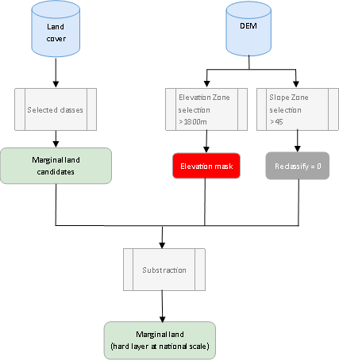

Figure 22: Workflow design for the production of hard layers at national scale. Source: personal compilation of Laura Martín Collado

##### Spanish Land Cover / Land Use

The land uses likely to be subject to reforestation in the short and medium term correspond to non-productive uses and with low tree cover or no arboreal structure. The national definition of non-forested forest area includes sparse forests and non-forested forests, and in any case assumes an FCC <10% of tree forest species. To identify these forest areas and include them in the model as possible marginal areas, the Spanish Land Cover and Land Use Information System (SIOSE) has been used with a spatial detail of 0.5 to 2ha) a multiple labelling character of the cover in use and function classes.

SIOSE is a database on land cover for the whole of national territory, integrating different data of regional and national administrations, and design at a scale of 1: 25 000 which was first produced in 2005, with updates in 2009, 2011 and 2014. The main advantage of this layer is the implementation of multi-criteria fields that are described by coverages or combinations of them with their different percentages of occupancy and attributes, i.e. it is multi-labelled.

The production of SIOSE is carried out at a regional level, with the possibility of production differences according to the team in charge of the production, this is why this land cover map offers the best result at both national and regional level.

SIOSE takes as its starting unit of information from the Cadastre (in turn the reference line of SIGPAC) and integrates several official sources as an exogenous source, highlighting the integration of data from the MFE, which improves the identification and characterization of the forest areas.

SIOSE consists of simple and composite cover types. SIOSE classes have been selected from the simple cover (100%) with grassland, scrub and bare land use as potential MLs. Within the grassland cover areas, areas with firebreak functions and logged areas with incipient herbaceous encroachment are excluded by querying the SIOSE attribute table (cf: firebreak; ct: cut).

The following two groups and criteria have been selected as composite hedges (code 600) which comply with the national definition of marginal land:

1. Associations with the presence of forest trees with a value of fraction of tree cover (FCC) in the range 0-20%, excluding pastures, olive groves, vineyards and plantations with fruit harvesting. In addition, recent forest plantations with low cover have been eliminated through the attribute plantation (pl: plantación *|forest* plantation), riparian formations (fr: formación de ribera |*riparian formation*), areas with firebreak function and areas with timber exploitation (ct: cortas *|wood felling*).
2. Grassland, scrub and bare ground associations without attributes of firebreak function (fc: cortafuego |*firebreak*) or timber harvesting (ct: cortas *|wood felling*).

Table 35: SIOSE Land cover layers selected as intermediate layers for identification of MLs. Source: personal compilation of Laura Martín Collado

| **SIOSE** | **CODIIGE** | **Cover** |
| --- | --- | --- |
| 300 | 320 | Grassland |
| 320 | 330 | Scrubs |
| 333 | 333 | Bare soils |
| 334 | 334 | Burnt areas |
| 600 | - | SIOSE Composite Covers |

##### Digital Elevation Model

Areas with altitude above 1800m have been excluded as possible marginal land from the point of view of the feasibility of afforestation and the cost associated with steep slopes.

In the case of the slope layer, values above 45% are reclassified with value 0 but are not excluded as marginal area considering that afforestation is possible on steep slopes and its role in soil erosion prevention.

#### Classification of MLs (soft constraints)

A set of indicators has been defined at national scale on those proposed at Pan-European scale (developed in task 2.3) adjusting the model to the main indicators and conditioning factors for the viability and sustainability of reforestations in Mediterranean climate environments and where climate change scenarios predict a generalized reduction in precipitation and an increase in temperature and, therefore, in evaporation of vegetation. For this reason, it is considered necessary to include in the national dataset the mean annual precipitation and the mean summer precipitation for the period 1981-2010 contained in the publication Climate maps of Span (1981-2010) and ETo (1996-2016) published by the State Meteorological Agency (2018) to classify the dataset according to the optimal conditions described for the main native forest species.

In addition, and with the aim of generating a comparable model in the Mediterranean basin, the indicators for Greece have been selected by common agreement, these being: Slope, Aspect, Available Water Capacity (AWC), Depth roots and Erosion, although the weighting of the variables has been carried out according to criteria based on consultation of bibliography and studies of the Iberian Peninsula.

The Horn method (Horn, 1981): nearest points weighted more than diagonal neighbours, has been used as the algorithm for generating the slope and aspect raster.

The indicator values are categorized in a range of [1, 5, 10] as categories from lower to higher functional status and potentiality from the point of view of the feasibility of afforestation.

Table 36: Indicators classes and scores selected for the national model. Source: personal compilation of Laura Martín Collado

|  |  |  |  |
| --- | --- | --- | --- |
| **Type of indicator** | **Indicator** | **Classes** | **Score** |
| Terrain and soil | Slope | [0% - 10%]  [10% - 35%]  [35%-45%] | 10  5  1 |
| Aspect | [N, NE, NW]  [E, W, flat]  [S, SE, SW] | 10  5  1 |
| Available Water Capacity (AWC) | [>0,12]  [0,1 – 0,12]  [<0,1] | 10  5  1 |
| Depth roots | [>50 cm]  [30 cm – 50 cm]  [<30 cm] | 10  5  1 |
| Sustanibility | Erosion | [<25 T/ha/año ]  [25-100 T/ha/año]  [>100 T/ha/año] | 10  5  1 |
| Forestry productivity | Forestry productivity | [>700mm, (10-15C)]  [500-700, (7-15C)]  [<500, (<7C)] | 10  5  1 |

The weighting of indicators is done in a pairwise comparison matrix (Process Correlation Matrix, PCM) and assigning three levels of comparison ac The PCM matrix is normalised for the calculation of the relative weight of each indicator within the model (PCM Normalized and Weights Matrix) and according to the following domain: 1=equal, 3=slightly higher, 2=intermediate scales.

Table 37: The pairwise comparison matrix of the marginality indicators based on the ranks (1=equal, 3=slightly higher, 2=intermediate scales). Source: personal compilation of Laura Martín Collado

|  |  |  |  |  |  |  |
| --- | --- | --- | --- | --- | --- | --- |
|  | **Slope** | **Aspect** | **Available Water Capacity (AWC)** | **Depth roots** | **Erosion** | **Forestry productivity** |
| **Slope** | 1 | 3 | 1/3 | 1/3 | 1 | 1/2 |
| **Aspect** | 1/3 | 1 | 1/3 | 1/3 | 1/3 | 1/3 |
| **Available Water Capacity (AWC)** | 3 | 3 | 1 | 1 | 3 | 1/2 |
| **Depth roots** | 3 | 3 | 1 | 1 | 3 | 1/2 |
| **Erosion** | 1/3 | 3 | 1/3 | 1/3 | 1 | 1/3 |
| **Forestry productivity** | 2 | 3 | 2 | 2 | 3 | 1 |

Table 38: The normalized comparison matrix and calculated weights. Source: personal compilation of Laura Martín Collado

|  |  |  |  |  |  |  |
| --- | --- | --- | --- | --- | --- | --- |
|  | **Slope** | **Aspect** | **Available Water Capacity (AWC)** | **Depth roots** | **Erosion** | **Forestry productivity** |
| **Slope** | 0.103448 | 0.187500 | 0.066667 | 0.066667 | 0.088235 | 0.157895 |
| **Aspect** | 0.034483 | 0.062500 | 0.066667 | 0.066667 | 0.029412 | 0.105263 |
| **Available Water Capacity (AWC)** | 0.310345 | 0.187500 | 0.200000 | 0.200000 | 0.264706 | 0.157895 |
| **Depth roots** | 0.310345 | 0.187500 | 0.200000 | 0.200000 | 0.264706 | 0.157895 |
| **Erosion** | 0.034483 | 0.187500 | 0.066667 | 0.066667 | 0.088235 | 0.105263 |
| **Forestry productivity** | 0.206897 | 0.187500 | 0.400000 | 0.400000 | 0.264706 | 0.315789 |

Table 39: Calculated weight for each indicator Source: personal compilation of Laura Martín Collado

|  | **Label** | **Weight** |
| --- | --- | --- |
| **Slope** | A | 0.1118 |
| **Aspect** | B | 0.0609 |
| **Available Water Capacity (AWC)** | C | 0.2201 |
| **Depth roots** | D | 0.2201 |
| **Erosion** | E | 0.0915 |
| **Forestry productivity** | F | 0.2959 |

The Consistency Ratio (CR) test is used to assess the consistency of the decisions taken in the pairwise comparison of indicators. The result, with a value of 0.028, complies with the null hypothesis (<0.1) and suggests that the set of judgments are consistent and reliable.

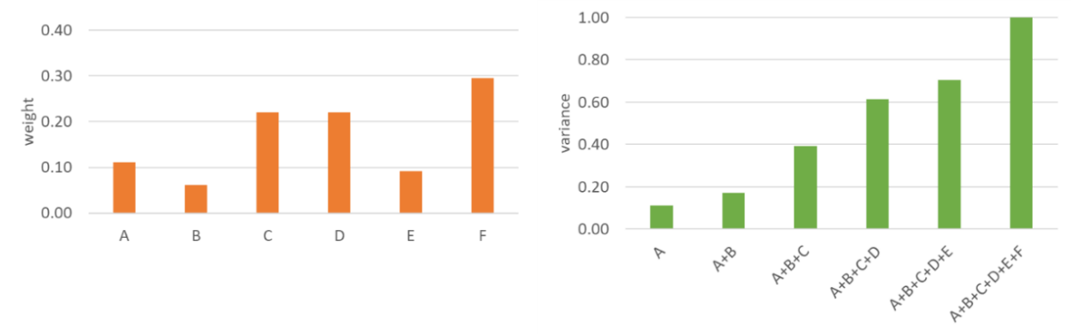

Figure 23: Weights distribution and variance explained for each indicator of the new dataset. Source: personal compilation of Laura Martín Collado

#### Results National Level. Pilot Sites

The pilot sites proposed by ***MAIL*** in the national territory are "Tierras Altas", located in the province of Soria in Castile and León, the area of the Municipality of Nogueruelas (Teruel) in the Central East of the Iberian Peninsula and the “Sierra de Espadán” in the province of Castellón (region of Valencia). All sites consist of several potential sites that could be defined as Marginal Lands including semi-urban degraded lands and low productivity lands adjacent to natural parks and forest areas.

The marginal area of the pilot site is categorised into three classes according to the viability and potential for reforestation after the detection of marginal areas and their weighting through the intersection of the soft layer information, these are: “MLs with high plantation suitability”, “MLs with low plantation suitability” and “Potentially unsuitable lands” estimated by three methods: a) computing the maximum and minimum and dividing the range of values by 3, b) computing the 25th and 75th percentile and setting these values as threshold limits, c) computing the 33rd and 66th percentile to keep the same number of pixels in each category, to calibrate and validate the uncertainty and sensitivity of each model.

##### Tierras Altas (Soria)

The pilot area of “Tierras Altas” has an area of 57,672.36 ha, with an altitudinal difference of 628.82m to 1785.35m asl (MDE Cyl), with forest formations mainly of coniferous stands native to the Mediterranean biogeographical region, pine forests of Scots pine (*Pinus syvestrys*), maritime pine (*Pinus pinaster*) and black pine (*Pinus nigra*), juniper and juniper (*Juniperus Phoenicia*) and herbaceous vegetation and moors and heathland.

The detection of marginal areas based on the use of the national land use mapping (SIOSE), and excluding areas of agricultural production, impervious areas, permanent water and snow, peatbogs and marshes and forest areas with a fraction of tree cover of less than 10%, areas of recent planting, riparian forest formations and firebreaks, results in a marginal area estimated as % of the pilot area, 23,023 ha, i.e. 39.92%.

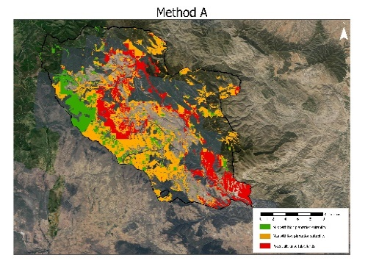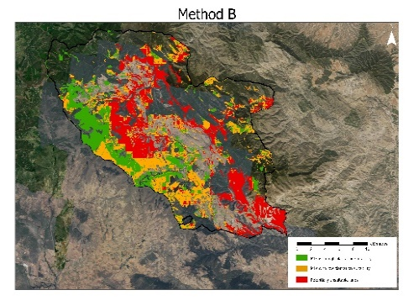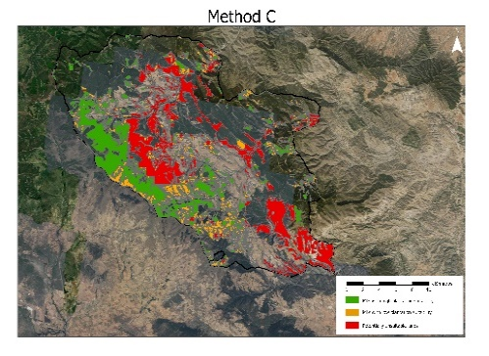

Figure 24: Final layer of MLs on Tierras Altas pilot site classified into three categories “Marginal lands with high plantation suitability” (green areas), “Marginal lands with low plantation suitability” (orange areas) and “Potentially unsuitable lands” (red areas) three classification methods. Source: personal compilation of Laura Martín Collado

The marginality map with method A shows patterns of spatial distribution that are more distinct (Figure 24: Final layer of MLs on Tierras Altas pilot site classified into three categories “Marginal lands with high plantation suitability” (green areas), “Marginal lands with low plantation suitability” (orange areas) and “Potentially unsuitable lands” (red areas) three classification methods.). The class "Marginal land with low suitability for planting" has the highest percentage in all methods, as the data values are most frequent and concentrated very close to the mean. The spatial distribution of marginal land areas with high plantation suitability is concentrated towards the south-west of the pilot area. The "Potentially unsuitable lands" class is distributed in an East-West band in the central part of the pilot area. The class “Marginal lands with low plantation suitability” does not show a spatial pattern and is distributed in patches over the whole marginal area.

Figure 25Figure 25 shows the results obtained by applying the three classification methods at the “Tierras Altas” pilot site. It can be seen that there are large differences in the results if method A) is applied or if methods B) and C) are applied due to the distribution of the data values which are more concentrated near the average.

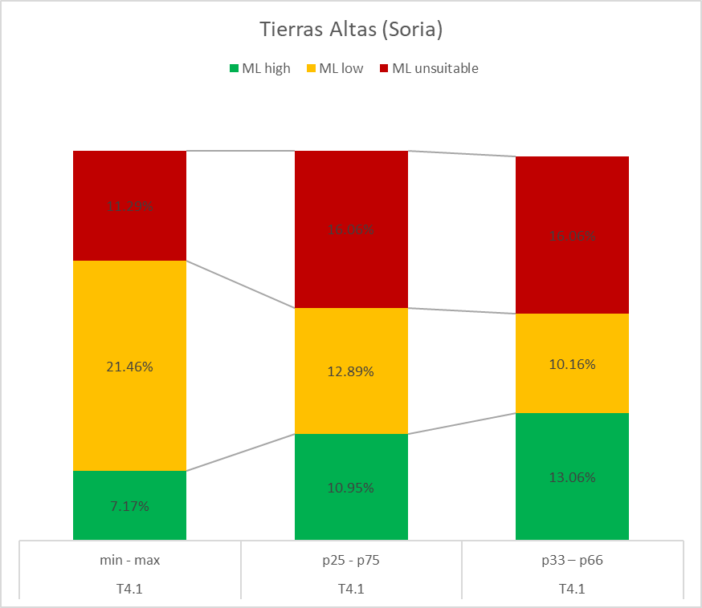

Figure 25: Percentage of area classified as ML by typology (ML high, ML low and ML unsuitable) on Tierras Altas pilot site. Source: personal compilation of Laura Martín Collado

##### “Nogueruelas” (Teruel)

The pilot area of Nogueruelas is a conifer forest zone and the estimated area of MLs is 292 ha, which represents 12.46% of the total area of the pilot site.

There are differences between method B and method A and C which obtains a higher percentage for the class "Marginal lands with low plantation suitability". Classification method A (min – max), obtains from highest to lowest proportions for the ML unsuitable, ML low and ML high classes, with percentages of 5.96%, 4.92% and 1.33% respectively (Figure 25).

The spatial distribution of the marginality classes and for the three methods is shown in Figure 26 below:

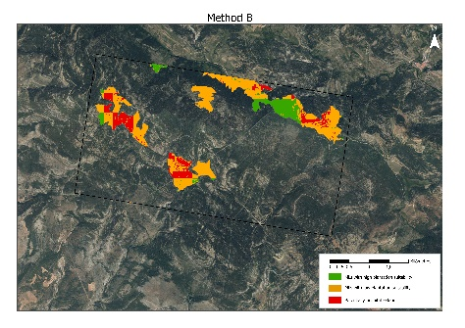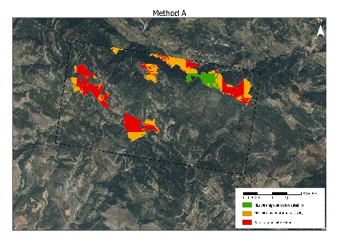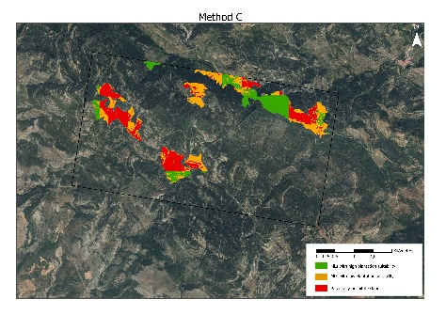

Figure 26: Final layer of MLs on Nogueruelas classified into three categories “Marginal lands with high plantation suitability”(green areas), “Marginal lands with low plantation suitability” (orange areas) and “Potentially unsuitable lands”(red areas) three classification methods. Source: personal compilation of Laura Martín Collado

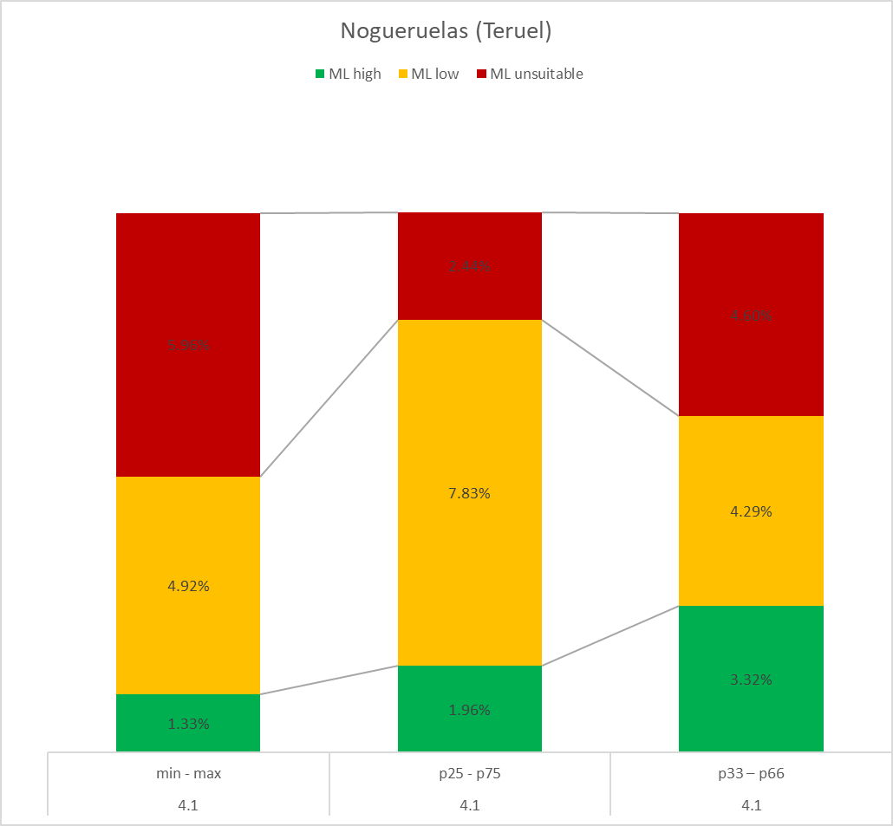

Figure 27: Percentage of area classified as ML by typology (ML high, ML low and ML unsuitable) on Nogueruelas pilot site. Source: personal compilation of Laura Martín Collado

##### “Espadán” (Castellón)

The morphometry of the Espadán pilot site presents a gradient of 340m to 1090m asl and the hardlayer layer does not exclude surface above 1800m asl.

The mapping of the application of hard constraints according to the national methodology against the main ***MAIL*** methodology results in a ML with a wider spatial distribution pattern and a higher value of the estimated area compared to the main ***MAIL*** methodology (Figure 28).

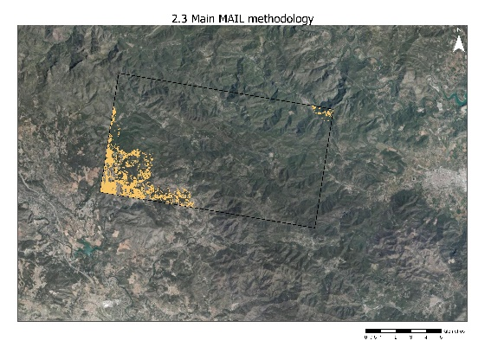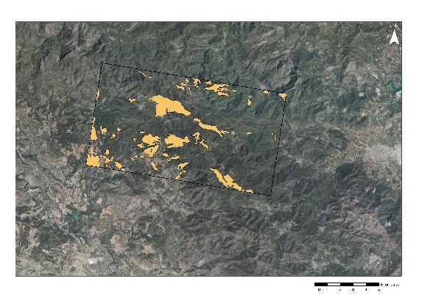

Figure 28: MLs detection of Espadán pilot site (hard layer constraints) according main *MAIL* methodology (left) and national methodology (right). Source: personal compilation of Laura Martín Collado

The mapping of the ML categories (ML high, ML low and ML unsuitable) on Nogueruelas pilot site shows a dispersed and non-uniform spatial pattern (Figure 29).

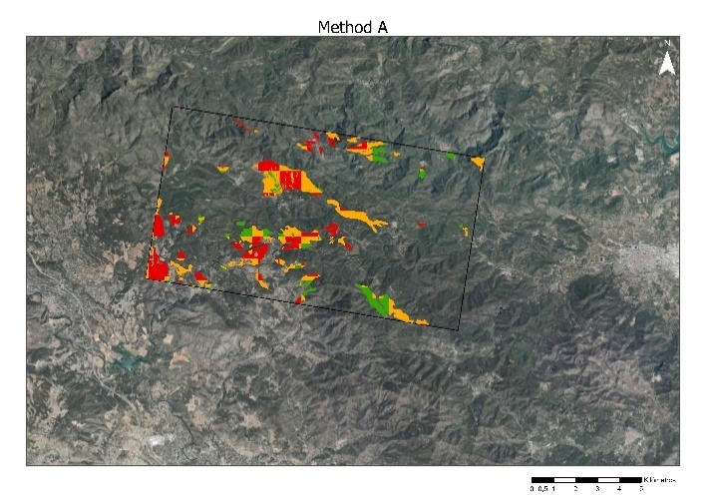

Figure 29: Final layer of MLs classified into three categories (ML high, ML low and ML unsuitable) on Espadan pilot site with the method A (min-max). Source: personal compilation of Laura Martín Collado

### Regional/local Level. Castile and León

The regional/local model developed aims to adjust the national model by incorporating datasets of socio-economic contextualisation of the Castile and León region.

The construction of the model for the characterisation of the marginal areas of Castile and León is in accordance with the defined man ***MAIL*** methodology: a first phase of definition of hard and second phase of selection of soft constraints, but the regional/local model inherits the soft and hard layers of the national workflow and datasets.

#### Detection of potential MLs (hard constraints)

The regional model inherits the masks for detecting possible marginal areas but incorporates its own legislation, specifically that which refers to Order FYM/648/2016, of 6 July, which establishes the regulatory bases for granting aid for the promotion of plantations of species with high value forestry production, co-financed by the European Agricultural Fund for Rural Development (EAFRD), within the framework of the Castile and León Rural Development Programme 2014-2020, and which is in line with the objectives set out by the ***MAIL*** Project: sustainability of reforestations, increased carbon retention and ecological improvement.

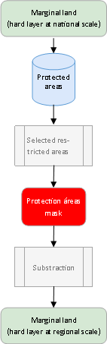



Figure 30: Workflow design for the production of hard layer for the Castile and León autonomous community. Source: personal compilation of Laura Martín Collado

##### Protected Areas

The Network of Protected Natural Areas (REN), integrated in the Law 4/2015, of the Natural Heritage of Castile and León, make up a network of landscapes of high ecological and social value, and are areas that, in the legislation of land use planning and management, are considered singularly. In this regard, the methodology takes into account, in the context of restoration plans, specifically in the promotion of plantations of forest species of high economic value, co-financed by the European Agricultural Fund for Rural Development (FEADER), of the Programme for Rural Development of Castile and León 2014-2020, Order FYM/648/2016 of 6 July, indicates that the following SPAs are for their own value for conservation out of object as areas to be reforested, these are:

* ZEPA Oteros-Campos (ES0000194).
* ZEPA Oteros-Cea (ES0000215).
* ZEPA Páramo Leónés (ES0000365).
* ZEPA Valdería-Jamuz (ES0000366).
* ZEPA Campo de Aliste (ES0000358).
* ZEPA Llanuras del Guareña (ES0000208).
* ZEPA Tierra del Pan (ES0000209).
* ZEPA Campos de Alba (ES0000359).
* ZEPA Tierra de Campiñas (ES0000204).
* ZEPA La Nava-Rueda (ES0000362).
* ZEPA La Nava-Campos Norte (ES4140036).
* ZEPA La Nava-Campos Sur (ES0000216).
* ZEPA Penillanuras-Campos Norte (ES0000217).
* ZEPA Penillanuras-Campos Sur (ES0000207).
* ZEPA Camino de Santiago (ES0000201).
* ZEPA Lagunas del Canal de Castilla (ES0000205).
* ZEPA Altos de Barahona (ES0000203).
* ZEPA Páramo de Layna (ES0000255).
* ZEPA Altos Campos de Gómara (ES0000357).
* ZEPA Cihuela-Deza (ES0000360).
* ZEPA Monteagudo de las Vicarías (ES0000363)

#### Classification of MLs (soft constraints)

It is proposed to implement in the national model the regional forest potential layer instead of the national forest productivity layer. This layer represents the forest productivity indicator at regional level and is derived from the maps of thermo-pluviometric potential linked to the application for grants to promote plantations of species with high value forestry production in Castile and León elaborated by the Regional Government of Castile and León (Junta de Castile and León).

##### Tierras Altas (Soria) Pilot Site.

The methodology takes into account, in the context of restoration plans, specifically in the promotion of plantations of forest species of high economic value. This Order FYM/648/2016, of 6 July, lists certain protected areas, belonging to the Natura 2000 Network, which are for their own conservation value out of object as areas to be reforested. The Urbión Protected Area is within the pilot area but is not subject to this restriction and therefore MLs for the pilot remains at 323,023 ha, i.e. 39.92% (Figure 31).

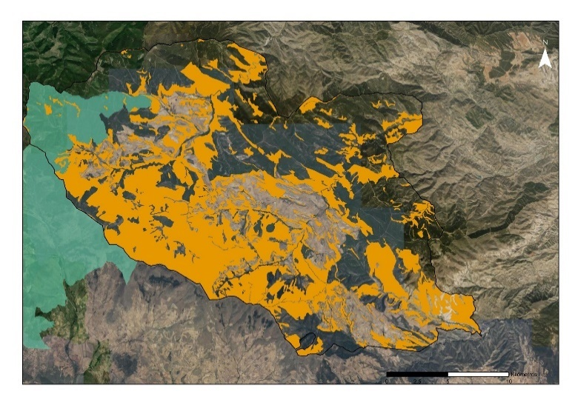

Figure 31: Layer "ML_Hard" for Tierras Altas pilot site according regional methodology where the orange colors represent the areas defined as marginal and green SPAs eligible for reforestation. Source: personal compilation of Laura Martín Collado

## Results and comparison

The objective of this section is to compare the results of the MLS of the different scale models: European, national and regional/local (castile and León), and according to their marginality: “MLs with high plantation suitability”, “MLs with low plantation suitability” and “Potentially unsuitable lands” estimated by three methods: a) computing the maximum and minimum and dividing the range of values by 3, b) computing the 25th and 75th percentile and setting these values as threshold limits, c) computing the 33rd and 66th percentile to keep the same number of pixels in each category, to calibrate and validate the uncertainty and sensitivity of each model.

The main ***MAIL*** methodology derived from task 2.3 (Table 40) obtains a lower ML land than the methodology developed for Spain and Castile and León. This is mainly due to the definition of the exclusion (Hard layers) in the main ***MAIL*** methodology, and especially the exclusion of the protected areas of the Natura 2000 network.

Table 40: MLs areas for test sites in hectares and percent for each classification method following the 2.3 methodology. Source: personal compilation of Laura Martín Collado

|  |  |  |  |  |  |
| --- | --- | --- | --- | --- | --- |
| **Pilot site** | **Total of ML** | **Classification Method** | **ML high** | **ML low** | **ML unsuitable** |
| **Tierras Altas** | 25719  (26.10) | min - max | 3,611 (3.66%) | **19,194**  **(19.45%)** | 2,913  (2.95%) |
| p25 - p75 | **20,367**  **(20.64%)** | 5,082  (5.15%) | 269  (0.27%) |
| p33 – p66 | **22,587.9 (22.89 %)** | 2,751.0 (2.79%) | 380.5 (0.39%) |
| **Nogueruelas (Teruel)** | 27.3  (0.8%) | min - max | 0  (0%) | 12.7  (0.39 %) | **14.6**  **(0.45 %)** |
| p25 - p75 | 0.3  (0.01 %) | **21.0**  **(0.65 %)** | 6.0  (0.18 %) |
| p33 – p66 | **12.7**  **(0.39%)** | 8.3  (0.25%) | 6.4  (0.20%) |
| **Espadán** | 623.9  (3.9%) | min - max | 0  (0.00%) | **341.8**  **(2.14%)** | 282.0  (1.77%) |
| p25 - p75 | 103.0  (0.64%) | **272.1**  **(1.70%)** | 248.7  (1.56%) |
| p33 – p66 | 341.2  (1.56%) | 341.2  (0.21%) | **249.0**  **(2.14%)** |

* The class with the highest value is marked in bold type.

Table 41: MLs areas for test sites in hectares and percent for each classification method following the 4.1 methodology and national level.* Source: personal compilation of Laura Martín Collado

| **Pilot site** | **Total of ML** | **Classification Method** | **ML high** | **ML low** | **ML unsuitable** |
| --- | --- | --- | --- | --- | --- |
| **Tierras Altas** | 23023 ha  (39.92) | min - max | 4,136  (7.17%) | **12,376**  **(21.45%)** | 6,512  (11.29%) |
| p33 – p66 | 7,899 (13.06%) | 5,860  (10.16%) | **9,264**  **(16.06%)** |
| p25 - p75 | 63,20  (10.95%) | 7,438  (12.89%) | **9,264**  **(16.06%)** |
| **Nogueruelas (Teruel)** | 292 ha  (12.46%) | min - max | 31  (1.33%) | 116  (4.92%) | **140**  **(5.96%)** |
| p25 - p75 | 46  (1.96%) | **183**  **(7.82%)** | 57  ( 2.44%) |
| p33 – p66 | 78  (3.32%) | 100  (4.29%) | **108**  **(4.60%)** |
| **Espadán** | 1376 ha  (11.9%) | min - max | 207  (1.79%) | **628**  **(5.43%)** | 541  4.67%) |
| p25 - p75 | 203  (1.76%) | 462  (4.00%) | **709**  **(6.1%)** |
| p33 – p66 | 181  (1.56%) | 327  (2.83%) | **867**  **(7.50%)** |

* The class with the highest value is marked in bold type.

The improved exclusion of riparian formations and firebreaks from the national model through multi-labelling of the SIOSE mapping as well as the improved classification of forest areas, especially recent forest plantations due to the improved spatial detail and updated information inherent in the national mapping and compared to the Corine Land Cover (CLC) database used in Task 2.3, are noteworthy as shown in Figure 32.

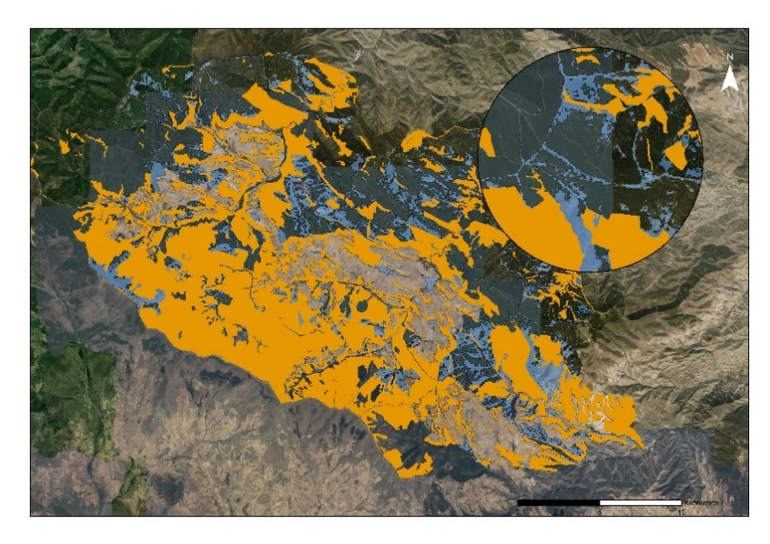 

Figure 32: Map of the pilot area "Tierras Altas" (Soria) according to *MAIL* Europe methodology (Blue) and *MAIL* National methology (Orange) zooming in on a forest firebreak area. Source: personal compilation of Laura Martín Collado

The three regional European, national and regional/local models of Castile and León applied in the Tierras Altas pilot site show that marginal areas are a very dynamic phenomenon and depend on the update from the different sources of information available at regional/ local level.

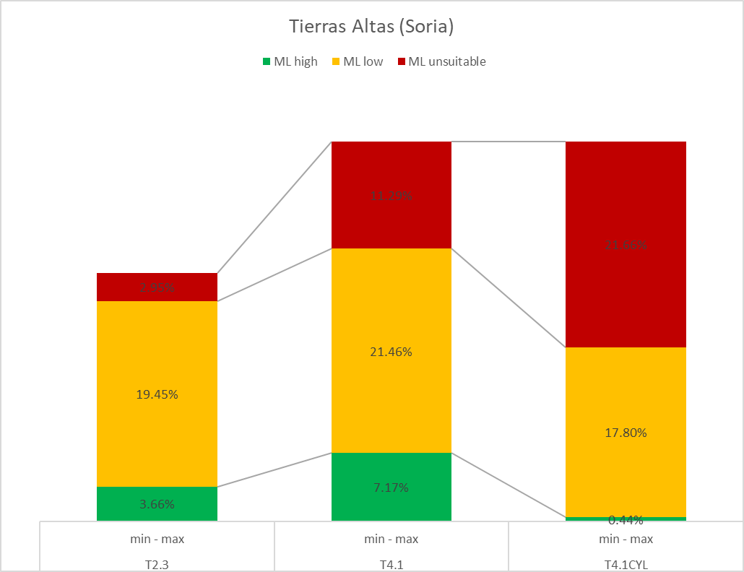

Figure 33: Percentage of area classified by min-max method across the different scale models (Main *MAIL* methodology, 4.1 National Methodology, 4.1 Regional/local methodology) Source: personal compilation of Laura Martín Collado

Regarding the distribution of ML typologies, the national model results the most equilibrated between ML typologies (ML high, low and unsuitable).

The final estimation of the marginal area from the reforestation feasibility point of view is close to the estimates according method A (min-max) of the Castile and León model at 18.4% (ML High + ML Low classes), a smaller area compared to 28.63% in the national methodology and 23.11% in the main ***MAIL*** methodology.

The discrepancy in the estimation of the surface area of the “Potentially unsuitable lands” class between the three scales is remarkable. The regional model of Castile and León estimates a greater area for the unsuitable ML class with a value of 21.66% over compared to the main ***MAIL*** methodology and the national methodology, which obtain values for ML unsuitable of 2.95% and 11.29% respectively (Figure 33).

# Conclusions

## Germany

The comparison of the results regarding marginal lands from task 2.3 and 4.1 can be summarized as follows: The general methodology from task 2.3 of combining hard thresholds and soft constraints is a reasonable technique for the detection of Marginal Lands. The usage of local data along with thresholds adapted to state laws and regulations is benefitting the site selection process and produces more accurate results. Especially the use of national data for the hard thresholds has a big impact on the outcome, as seen in the case study for Germany.

The methodology used in task 2.3 gives a good overview of potential marginal lands on a Pan-European level. Compared to the adapted methodology of task 4.1 it predicts more marginality because it uses general Pan-European data and thresholds. The methodology used in this case study therefore is more accurate and the results are more precise. Therefore, for further studies on afforestation or reforestation of marginal lands, it is useful to proceed with regional data and adapted methods in order to obtain maximum and realistic results for each individual country.

## Greece

After comparing the MLs detected applying the general methodology (Pan-European level, output of Task 2.3) and the regional modification (Greek level, output of task 4.1), it should be considered as follows:

* The algorithm developed for marginality detection on Task 2.3 can be considered as adequate.
* Applying more detailed dataset as input of the general algorithm improves the detection performance.
* Detail of layers related to vegetation / forest / land coverage description can be considered as a key factor for accuracy improvement.
* Both methods detect marginal lands in a very good accuracy. A localized system manages to perform better, as it describes sounder the local aspects/particularities.
* Methodology developed in T2.3 overestimates marginality for Greece in comparison with the methodology developed in T4.1. This probably happens due to better description of local aspects by the second methodology and by the fact that considers shrubbed areas as transitional forested areas and not as potentially marginal.
* Regarding the methodology developed in T4.1 for Greece the method using YPEKA as hard layer was found more appropriate to ***MAIL***´s scope in comparison with CLC18, as it seems to describe better the marginality and detect potential lands for future afforestation projects.

## Poland

Adjustment of pan European methodology to local conditions within Polish pilot was performed on province level and can be up scaled to the national level. Availability of land cover / land use data with high level of details, available in open access allows for precise detection of potential marginal lands (hard layer). National Database of Topographic Objects BDOT 10k was used to provide exclusion mask.

Access to open access, digital, georeferenced data about soil properties revealed issues like: lack of soil properties which are available on European level (e.g., about texture, erosion, socidity, contamination, etc.), lack of full data coverage.

Comparing to European approach (Task 2.3), regional methodology identified 3 times more potential marginal lands. It can result from detailed class definitions within national database, comparing to classes used in Task 2.3.

## Spain

The comparison of the three models for the detection and classification of marginal areas with the main ***MAIL*** methodology, the model for Spain and the model for Castile and León shows that dynamics and variability are key concepts for the identification of marginal lands. In this respect it is significant the application of the appropriate threshold of tree cover values according to the national forest definition, instead of the common value of 30%.

By way of summary, the following points should be considered for downscaling the main ***MAIL*** methodology at national and regional/local level to improve the accuracy of the detection of MLs:

On national level:

* The methodology used in task 2.3 gives a good overview of potential marginal lands on a Pan-European level and by keeping the methodology scheme, it is possible to adapt the model according to the availability of information and to implement local datasets.
* Especially the use of national data for the hard thresholds improves the detection of MLs. In this aspect, the national model proposes not to create a mask with protected areas and to analyse these areas on a regional level.
* The national model incorporates updated and detailed land use and land cover information through SIOSE mapping that improves the description of forest and shrubland area useful for the detection of marginal areas and their characterisation.
* The use of SIOSE labelling achieves model fit in areas of scrub or sparse woodland excluding riparian protection functions and forest firebreaks.

On regional/local level:

* The usage of local data along with thresholds adapted to state laws and regulations is benefitting the site selection process and produces more accurate results.
* The application of regional information related to regional regulations adjusts the detection of MLs and improves the weighting of the level of marginality with the biophysical characteristics of the region.
* Improving understanding of complex socio-ecological systems and developing eco-social indicators is key for the detection of MLs at local level.

# References

1. Basak, S. (2006). Landfill site selection by using geographic information systems. Environmental Geology, *49*, 376-388.
2. Eckelmann, W., Sponagel, H., Grottenthaler, W., Hartmann, K. J., Hartwich, R., Janetzko, P., ... & Traidl, R. (2006). Bodenkundliche Kartieranleitung. KA5.
3. Goepel, K. D. (2019). Comparison of Judgment Scales of the Analytical Hierarchy Process - A New Approach. International Journal of Information Technology and Decision Making, 18(2), 445–463. <https://doi.org/10.1142/S0219622019500044>
4. Mueller, L., Schindler, U., Behrendt, A., Eulenstein, F., & Dannowski, R. (2007). The Muencheberg soil quality rating (SQR).
5. Saaty, T. L. (1990). How to make a decision: The analytic hierarchy process. European Journal of Operational Research, 48(1), 9–26. https://doi.org/10.1016/0377-2217(90)90057-I
6. Saaty, T. L., & Vargas, L. G. (2001). Models, methods, concepts & applications of the Analytic Hierarchy Process. Springer Science+Business Media, LLC. https://doi.org/10.1057/jors.1962.41
7. Siraj, S. (2011). Preference Elicitation from Pairwise Comparisons for Traceable Multi-Criteria Decision Making.
8. Vaidya, O. S., & Kumar, S. (2006). Analytic hierarchy process: An overview of applications. European Journal of Operational Research, 169(1), 1–29. https://doi.org/10.1016/j.ejor.2004.04.028
9. Visser, H., & De Nijs, T. (2006). The map comparison kit. Environmental Modelling and Software, 21(3), {Bibliography}346–358. <https://doi.org/10.1016/j.envsoft.2004.11.013>
10. Area notebooks for the implementation of afforestation works on agricultural land (2014-2020). Junta de Castilla y León. Retrieved November 15, 2021, from <https://medioambiente.jcyl.es/>
11. Ciria, Carlos & Sanz, Marina & Carrasco, Juan & Ciria, Pilar. (2019). Identification of Arable Marginal Lands under Rainfed Conditions for Bioenergy Purposes in Spain. Sustainability. 11. 1833. 10.3390/su11071833.
12. Cortina, Jordi & Amat, Beatriz & Castillo, V. & Fuentes, David & Maestre, Fernando & Padilla, Francisco & Rojo, L. (2011). The restoration of vegetation cover in the semi-arid Iberian southeast. Journal of Arid Environments. 75. 1377-1384. 10.1016/j.jaridenv.2011.08.003.
13. Meier, E.S.; Indermaur, A.; Ginzler, C.; Psomas, A. An Effective Way to Map Land-Use Intensity with a High Spatial Resolution Based on Habitat Type and Environmental Data. Remote Sens. 2020, 12, 969. <https://doi.org/10.3390/rs12060969>
14. Spanish Land Cover / Land Use. Information System. - SIOSE2005 -. National Geographic Institute of Spain. Gobierno de España. Ministerio De Fomento. Retrieved November 10, 2021, from [https://www.ine.es](https://www.ine.es/)
15. Vilagrosa, Alberto & Caturla, RN & Hernández, N & Cortina, Jordi & Bellot, Juan & Vallejo, Ramon. (2001). Reforestación en ambiente semiárido del sureste peninsular. Resultados de las investigaciones desarrolladas para optimizar la supervivencia y el crecimiento de especies autóctonas. Montes para la sociedad del nuevo milenio. III Congreso Forestal Español. Junta de Andalucia-Consejeria de Medio Ambiente. 4. 5.

# Annex I: Datasets

For all layers the horizontal coordinate system shall be European Terrestrial Reference System 1989 (ETRS89) using Lambert Azimuthal Equal-Area projection (LAEA) and is delivered in image, *\*.shp* or *\*.gdb* format. These datasets are considered as inseparable part of the Deliverable D4.1 and are listed bellow

1. **Germany**

HardThresholds.tif

MLs_Ger_MinMax.tif

MLs_Ger_p25p75.tif

MLs_Ger_p33p66.tif

MLs_Nochten_MinMax_clip.tif

MLs_Nochten_p25p75_Clip.tif

MLs_Nochten_p33p66_Clip.tif

MLs_Welzow_MinMax_Clip.tif

MLs_Welzow_p25p75_Clip.tif

MLs_Welzow_p33p66_Clip.tif

1. **Greece**

MLs_GR_T41.gdb

MLs_GR_T41

MLs_GR_CLC18

MLs_GR_CLC18_Rhodope

MLs_GR_CLC18_Thessaloniki

MLs_GR_VEG_YPEKA

MLs_GR_VEG_YPEKA_Rhodope

MLs_GR_VEG_YPEKA_Thessaloniki

1. **Poland**

MLs_PL_Swietokrzyskie_Hard.tif

MLs_PL_Swietokrzyskie_MinMax.tif

MLs_PL_Swietokrzyskie_p25p75.tif

MLs_PL_Swietokrzyskie_p33p66.tif

1. **Spain**

ESPADAN

Espadan_studyarea.shp

MLs_Espadan_div3_MinMax_clip.shp

MLs_Espadan_div3_p25p75_Clip.shp

MLs_Espadan_div3_p33p66_Clip.shp

MLs_Espadan_hardlayer_.shp

NOGUERUELAS

MLs_Nogueruelas_div3_MinMax_clip.shp

MLs_Nogueruelas_div3_p25p75_Clip.shp

MLs_Nogueruelas_div3_p33p66_Clip.shp

MLs_Nogueruelas_hardlayer_.shp

SORIA

CYL

MLs_Soria_CYL_div3_MinMax_clip.shp

MLs_Soria_CYL_div3_p25p75_Clip.shp

MLs_Soria_CYL_div3_p33p66_Clip.shp

soria_studyarea.shp

MLs_Soria_div3_MinMax_clip.shp

MLs_Soria_div3_p25p75_Clip.shp

MLs_Soria_div3_p33p66_Clip.shp

# Annex II: Table of figures

Figure 1. Germany (left) and the pilot sites of “Welzow” (outlined with blue) and “Nochten” (outlined with purple). Source: personal compilation of Jesús Torralba Pérez 15

Figure 2: Workflow for the classification of other land cover. Source: personal compilation of Elisa Bender 18

Figure 3: Workflow for the classification of croplands. Source: personal compilation of Elisa Bender 19

Figure 4: Workflow for the classification of impervious areas. Source: personal compilation of Elisa Bender 20

Figure 5: Workflow for the classification of changed areas. Source: personal compilation of Elisa Bender 20

Figure 6: Workflow for the classification of forest areas. Source: personal compilation of Elisa Bender 21

Figure 7: Workflow for the classification of protected areas. Source: personal compilation of Elisa Bender 23

Figure 8: Methodology for the classification of MLs (soft constraints) with the first (yellow) and second (violet) weighting steps. Source: personal compilation of Elisa Bender 26

Figure 9: Final Layer of MLs (task 2.3) classified with 3 methods into the 3 categories: “Marginal lands with high plantation suitability” (green), “Marginal lands with low plantation suitability” (yellow) and “Potentially unsuitable lands” (red). Source: Personal compilation of Elisa Bender 32

Figure 10: Final Layer of MLs (task 4.1) classified with 3 methods into the 3 categories: “Marginal lands with high plantation suitability” (green), “Marginal lands with low plantation suitability” (yellow) and “Potentially unsuitable lands” (red). Source: Personal compilation of Elisa Bender 33

Figure 11. Percentage of area classified as ML by typology (ML high, ML low & ML unsuitable) on the pilot sites of Germany. Source: personal compilation of Elisa Bender 33

Figure 12. Greece and the pilot site of the afforestation forest of “Rhodope” and “Thessaloniki”. Source: personal compilation of Jesús Torralba Pérez. 35

Figure 13. Methodology for identifying marginal lands (hard layers). Source: personal compilation of Alfonso Abad 37

Figure 14. Weights distribution and variance explained for each indicator of the new dataset. Source: Personal compilation of Alfonso Abad 43

Figure 15. Comparison of ML’s detected as per D2.3 and as per D4.1 (CLC18 and VEG YPEKA as hard layers) for Greece’s pilot sites (Rhodope and Thessaloniki). Source: Personal compilation of Alfonso Abad 47

Figure 16. Percentage of area classified as ML by typology (ML high, ML low & ML unsuitable) on the pilot sites of Greece. Source: Personal compilation of Alfonso Abad 47

Figure 17. The area of Świętokrzyskie (red line). Source: personal compilation of Ewa Gromny and Michał Krupiński. 49

Figure 18. Final Layer of MLs classified with 3 methods into the 3 categories: “Marginal lands with high plantation suitability” (green), “Marginal lands with low plantation suitability” (yellow) and “Potentially unsuitable lands” (red). First row contains result of Task 2.3, second row – Task 4.1. Source: Personal compilation of Michał Krupiński. 56

Figure 19. Comparison of Protected areas mask developed within task 2.3 and task 4.1 56

Figure 20. Percentage of area classified as ML by typology (ML high, ML low & ML unsuitable) within pilot case in Poland. Source: Personal compilation of Michał Krupiński. 57

Figure 21:Spain (left) and the pilot site of “Soria” (outlined with light orange), “Nogueruelas” (outlined with dark red), and “Espadán” (right image outlined with dark orange). Source: personal compilation of Jesús Torralba Pérez 59

Figure 22: Workflow design for the production of hard layers at national scale. Source: personal compilation of Laura Martín Collado 65

Figure 23: Weights distribution and variance explained for each indicator of the new dataset. Source: personal compilation of Laura Martín Collado 70

Figure 24: Final layer of MLs on Tierras Altas pilot site classified into three categories “Marginal lands with high plantation suitability” (green areas), “Marginal lands with low plantation suitability” (orange areas) and “Potentially unsuitable lands” (red areas) three classification methods. Source: personal compilation of Laura Martín Collado 71

Figure 25: Percentage of area classified as ML by typology (ML high, ML low and ML unsuitable) on Tierras Altas pilot site. Source: personal compilation of Laura Martín Collado 72

Figure 26: Final layer of MLs on Nogueruelas classified into three categories “Marginal lands with high plantation suitability”(green areas), “Marginal lands with low plantation suitability” (orange areas) and “Potentially unsuitable lands”(red areas) three classification methods. Source: personal compilation of Laura Martín Collado 73

Figure 27: Percentage of area classified as ML by typology (ML high, ML low and ML unsuitable) on Nogueruelas pilot site. Source: personal compilation of Laura Martín Collado 73

Figure 28: MLs detection of Espadán pilot site (hard layer constraints) according main *MAIL* methodology (left) and national methodology (right). Source: personal compilation of Laura Martín Collado 74

Figure 29: Final layer of MLs classified into three categories (ML high, ML low and ML unsuitable) on Espadan pilot site with the method A (min-max). Source: personal compilation of Laura Martín Collado 74

Figure 30: Workflow design for the production of hard layer for the Castile and León autonomous community. Source: personal compilation of Laura Martín Collado 75

Figure 31: Layer "ML_Hard" for Tierras Altas pilot site according regional methodology where the orange colors represent the areas defined as marginal and green SPAs eligible for reforestation. Source: personal compilation of Laura Martín Collado 77

Figure 32: Map of the pilot area "Tierras Altas" (Soria) according to *MAIL* Europe methodology (Blue) and *MAIL* National methology (Orange) zooming in on a forest firebreak area. Source: personal compilation of Laura Martín Collado 80

Figure 33: Percentage of area classified by min-max method across the different scale models (Main *MAIL* methodology, 4.1 National Methodology, 4.1 Regional/local methodology) Source: personal compilation of Laura Martín Collado 80

# Annex III: List of Tables

Table 1: Terrain and Soil indicator classes, scores, and weights. Source: Deliverable 2.3 12

Table 2: Sustainability indicator classes, scores, and weights. Source: Deliverable 2.3 13

Table 3: Productivity indicator classes, scores, and weights. Source: Deliverable 2.3 13

Table 4: Data sources used for the identification of potential MLs (hard thresholds) in Germany. Source: personal compilation. 16

Table 5: Overview of data availability of protected areas per federal state. Source: personal compilation of Elisa Bender 24

Table 6: Indicators and their weights used for the first weighting step. Source: Personal compilation of Elisa Bender 27

Table 7: Verification of the accuracy of the calculated weights. Source: Personal compilation of Elisa Bender 27

Table 8: Indicator layers and their weights used for the second weighting step. Source: Personal compilation of Elisa Bender 28

Table 9: Indicators proposed for Germany. Classes and score. Source: Personal compilation of Elisa Bender 29

Table 10: Methods and thresholds for the classification of the detected Marginal Lands. Source: Personal compilation of Elisa Bender 30

Table 11: MLs areas for test sites in hectares and percent for each classification method following the 2.3 methodology. Source: Personal compilation of Elisa Bender 30

Table 12: MLs areas for test sites in hectares and percent for each classification method following the 4.1 methodology. Source: Personal compilation of Elisa Bender 31

Table 13: Total area of Marginal Lands detected in Germany, for methodology 2.3 and 4.1. Source: Personal compilation of Elisa Bender 32

Table 14. Data sources used for the identification potential MLs (hard constrains) in pilot sites of Greece. Source: personal compilation of Alfonso Abad 36

Table 15. Data sources used for the classification of MLs (soft constrains). Source: personal compilation of Alfonso Abad 37

Table 16. Land cover classes (CLC18) used to detect marginal land candidates. Source: personal compilation of Alfonso Abad 38

Table 17. Classes from the Vegetation and land use of Greece (VEG YPEKA) used to detect marginal land candidates. Source: personal compilation of Alfonso Abad 39

Table 18. Indicators proposed at local scale. Classes and score. Source: Personal compilation of Alfonso Abad 40

Table 19. PCM of marginality indicators at local scale, based on its importance (1=equal, 3=slightly higher, 2=intermediate scales). Source: Personal compilation of Alfonso Abad 41

Table 20. Normalized PCM of marginality indicators at local scale. Source: Personal compilation of Alfonso Abad 41

Table 21. Weights and labels of marginality indicators. Source: Personal compilation of Alfonso Abad 42

Table 22. Consistency Index for PCM (CI) and Random Consistency Index (RI). Source: Personal compilation of Alfonso Abad 42

Table 23. Methods to subdivide by type of marginality used on Greek pilot site (CLC18). Source: Personal compilation of Alfonso Abad 43

Table 24. Methods to subdivide by type of marginality used on Greek pilot site (VEG YPEKA). Source: Personal compilation of Alfonso Abad 44

Table 25. Areas in hectares of each type of MLs for the selected test sites as per derivable 2.3. Source: Personal compilation of Alfonso Abad 45

Table 26. Areas in hectares of each type of MLs for the selected test sites as per derivable 4.1. Source: Personal compilation of Alfonso Abad 45

Table 27: Summary of auxiliary data source used for identification and classification of marginal lands within Polish pilot case. Source: personal compilation of Ewa Gromny and Michał Krupiński. 50

Table 28. Land cover / land use classes (BDOT 10k) used to detect marginal land candidates. Source: personal compilation of Ewa Gromny and Michał Krupiński. 50

Table 29. List of soil types categorized into productivity classes. personal compilation of Marta Milczarek and Michał Krupiński 52

Table 30: Indicators and their weights used for the first weighting step. Source: Personal compilation of Michał Krupiński 53

Table 31: MLs areas for test sites in hectares and percent for each classification method following the 2.3 methodology. Source: Personal compilation of Michał Krupiński 55

Table 32: MLs areas for test sites in hectares and percent for each classification method following the 4.1 methodology. Source: Personal compilation of Michał Krupiński 55

Table 33: Data sources used for the identification potential MLs (hard constraints) in national and Castile and León models. Source: personal compilation of Laura Martín Collado 61

Table 34: Data sources used for the classification of MLs (soft constraints) in national and Castile and León model. Source: personal compilation of Laura Martín Collado 62

Table 35: SIOSE Land cover layers selected as intermediate layers for identification of MLs. Source: personal compilation of Laura Martín Collado 66

Table 36: Indicators classes and scores selected for the national model. Source: personal compilation of Laura Martín Collado 68

Table 37: The pairwise comparison matrix of the marginality indicators based on the ranks (1=equal, 3=slightly higher, 2=intermediate scales). Source: personal compilation of Laura Martín Collado 69

Table 38: The normalized comparison matrix and calculated weights. Source: personal compilation of Laura Martín Collado 69

Table 39: Calculated weight for each indicator Source: personal compilation of Laura Martín Collado 70

Table 40: MLs areas for test sites in hectares and percent for each classification method following the 2.3 methodology. Source: personal compilation of Laura Martín Collado 78

Table 41: MLs areas for test sites in hectares and percent for each classification method following the 4.1 methodology and national level.* Source: personal compilation of Laura Martín Collado 79

1. **R** = Report, **P** = Prototype, **D** = Demonstrator, **O** = Other
2. **PU** = Public, **PP** = Restricted to other programme participants (including the Commission Services), **RE** = Restricted to a group specified by the consortium (including the Commission Services), **CO** = Confidential, only for members of the consortium (including the Commission Services).
3. *As per T2.3, to carry out the subdivision in the three types of marginal lands (“Marginal lands with high plantation suitability”, “Marginal lands with low plantation suitability”, “Potentially unsuitable lands”) three methodological approaches were developed:*

   *a) The first is to calculate the maximum and minimum value obtained in the MLs layer and divide the difference by three. This will obtain three ranges of equal magnitude.*

   *b) The second methodological approach is to calculate the 25th and 75th percentiles of the values obtained in the MLs layer. This approach would penalize the “Marginal lands with high plantation suitability” and the "Potentially unsuitable lands" and increasing the number of pixels belonging to the middle layer "Marginal lands with low plantation suitability".*

   *c) The third one is to calculate the 33rd and 66th percentile of the values obtained in the layer MLs. In this case, the total number of pixels is divided equally into the three categories. But with the difference with respect to the a) method that in this case the thresholds are established with the maximum number of pixels and not with the maximum and minimum values.*