

D4.2 | Report on pilot case study 2
MAIL: Identifying Marginal Lands in Europe and strengthening their contribution potentialities in a CO2 sequestration strategy

MAIL project has received funding from the European Union’s Horizon 2020 research and innovation programme under the Marie Skłodowska-Curie grant agreement No 823805; [H2020 MSCA RISE 2018]

Project title | Identifying Marginal Lands in Europe and strengthening their contribution potentialities in a CO2 sequestration strategy
Call identifier | H2020 MSCA RISE 2018
Project acronym | MAIL
Starting date | 01.09.2020
End date | 31.12.2021
Funding scheme | Marie Skłodowska-Curie
Contract no. | 823805
Deliverable no. | D4.2
Document name | MAIL_D4.2.pdf
Deliverable name | Report on pilot case study 2
Work Package | WP4
Nature | R
Dissemination | CO
Editor | Charalampos Georgiadis (AUTH)
Authors | Fernando Bezares Sanfelip (CESEFOR)  Michał Krupiński (CBK PAN)  Jesús Torralba Pérez (UPV)
Contributors | All project partners
Date | 29.12.2021

MAIL Consortium
  Aristotle University of Thessaloniki (AUTH) Greece |   Industrieanlagen Betriebsgesellschaft MBH (IABG) Germany
  Gounaris N. – Kontos K. OE (HOMEOTECH) Greece |   Centrum Badan Kosmicznych Polskiej Akademii Nauk (CBK PAN) Poland
  Universitat Politecnica de Valencia (UPV) Spain |   Fundacion Centro De Servicios Y Promocion FOrestral Y de su Industria De Castilla y Leon (CESEFOR) Spain

Abbreviations
Term | Explanation
AGB | Above-Ground Biomass
BCEF | Biomass Conversion and Expansion Factor
BGB | Below-Ground Biomass
C | Carbon
DBH | Diameter at breast height
Dg | Mean square diameter
DG | Stand mean diameter
ESA | European Space Agency
G | Basal area
GIS | Geographic Information System
H | Height of the forest stand
H0 | Dominant stand height
Hm | Stand mean height
HO | Stand top height (height of the base center trunk of the 100 strongest trunks/ha)
IPCC | Intergovernmental Panel on Climate Change
MFE50 | Mapa Forestal Español Escala 1:50.000
MLs | Marginal Lands
N | Forest stand density
NASA | National Aeronautics and Space Administration
SI | Site Index
UNFCCC | United Nations Framework Convention on Climate Change
V | stand tree wood volume
VB | Stand tree wood volume per hectare in m³
VD | Stand solid wood volume per hectare in m³
VS | Stand timber volume per hectare in m³

Contents
MAIL Consortium 3
Abbreviations 4
Contents 6
Executive Summary 8
1 Introduction 9
2 Data acquisition 10
2.1 Forest inventories for species selection 10
2.2 Yield tables 11
2.2.1 Germany 12
2.2.2 Poland 19
2.2.3 Spain 21
2.2.4 Greece 23
2.3 Biomass and Carbon estimation 25
2.3.1 Germany 26
2.3.2 Poland 28
2.3.3 Spain 28
2.3.4 Greece 29
2.4 Wood density values 30
3 Marginal Land Area for study sites 31
4 Methodology and Carbon sequestration capacity analysis 34
4.1 Current biomass stock information integration 34
4.2 Methodology 34
5. Results 38
5.1 Germany 38
5.1.1 Species selection 39
5.1.2 Biomass and carbon estimation by species 39
5.1.3 Carbon sequestration capacity simulations 45
5.2 Poland 48
5.2.1 Species selection 48
5.2.2 Biomass and carbon estimation by species 50
5.2.3 Carbon sequestration capacity simulations 54
5.3 Spain 56
5.3.1 Species selection 56
5.3.2 Biomass and carbon estimation by species 59
5.3.3 Carbon sequestration capacity simulations 63
5.4 Greece 68
5.4.1 Species selection 69
5.4.2 Biomass and carbon estimation by species 70
5.4.3 Carbon sequestration capacity simulations 75
6 References 77
Annex I: Tables of figures 79
Annex II: List of tables 81
Annex III: Carbon estimation for the pilot site: Results 85

Executive Summary
The assessment of carbon sequestration capacity is necessary to evaluate how proposed afforestation strategies may be beneficial as carbon sinks. Eight test sites from four countries (Germany, Poland, Spain and Greece) were analysed and used as show cases to present to potential of marginal lands in details. In the first step, data about dominant species and their characteristics were gathered. Next, for each test site, the dominant species were identified, and for them the optimal biomass and carbon estimation method was selected. Simulations of potential forest properties were realized using yield tables as prediction for future (from 20 to 140 years).
Carbon sequestration capacity estimates for test sites using mixtures of dominant species were prepared for ~50 years into the future.

1 Introduction
The main objective of the MAIL project is to increase the utilization of the MLs as carbon sinks by the agricultural and forestry related sectors. To achieve this, the MAIL project focuses on the development of innovative methods and tools (Web GIS/ web platform) for the identification of MLs based on open source and free satellite data, as well as fully consistent carbon sequestration calculation methodologies with the guidelines published by the IPCC and aligned with the UNFCCC carbon emission reporting requirements. This document is scoped under the work package 4 (WP4) of the MAIL project, which focuses on pilot cases studies and aims:
- To define the best methods to map and monitor the MLs based on open-source data and open-source applications
- To estimate carbon stock in forest products
- And to validate the methodologies and procedures defined in work package 2
Aligned with the aforementioned goals, in this task we will assess the quantification of carbon sequestration capacity in MLs based on the following objectives:
- To determine the land cover and land use of the area of interest
- To integrate the environmental limitations in the analysis of the MLs
- To evaluate the status of the existing biomass stock at the area of interest
- To quantify the carbon sequestration capacity in the MLS
As a starting point, the methods and calculations proposed in this document are based in the outputs of the previous deliverables of this project concerning (1) the definition of the MLs in deliverable 2.1. D2.1 presents a coherent theoretical description of MLs under MAIL scope considering the three major drivers for marginality: environmental factors, socioeconomic factors, and cultural factors. (2) The available data at European level described in deliverable 2.2, (3) the proposed methodology for MLs identification (deliverable 2.3), and the carbon sequestration models reviewed in deliverable 2.5. The outputs of this task will help develop the MLs classification in carbon sequestration capacity groups.

Data acquisition
Several data sources are required to analyze the carbon sequestration capacity. The main information needed is a description of the forest in an area that can relate to the marginal land. This information can be obtained from traditional yield tables for low-quality sites.

2.1 Forest inventories for species selection
Forest inventory or biodiversity databases were consulted to evaluate the main species present in the pilot sites. The most present species in the ML surrounding forest areas will be proposed as the suitable ones for the reforestation of the marginal lands and the estimation of future carbon sequestration. Therefore, the most updated or accurate sources of information were assessed to propose a detailed species selection. The sources consulted were:
- Spanish national forest map 1:50,000 (MFE50): This layer identifies the location of the forests in Spain and attaches a hierarchical classification of land uses, focusing on the forest classes, especially in the wooded ones. The map includes information of the three main species present in the stand/forest coded following the National forest inventory nomenclature, forest structure, area occupied by species in the stand, canopy cover fraction, and the state of development of the stands. The map was created during 1998 and 2007. The layer can be found in the Ministery for Ecological Transition.
- Greece. The species selection in the Greek pilot sites was performed using the information provided by two forest inventories carried out in 2007 in the Isenli forest. The forest inventory consists of 45 plots, where 25 are rectangular plots with an area of 0.1 ha and 20 plots correspond to an older inventory (Kossenakis, 1939) which does not provide species composition but forest type. From the inventory, we learn the species composition by hectare for the 25 rectangular plots (the older plots do not contain this information).
- In Poland, databases available in Forest Data Bank have been used. It contains inter alia information about species, density, mixture, site type, site class, volume, and data state year.
- Third German forest inventory: The German forest inventory is a legal mandate registered in the German Forest Law in Article 41a. German forests are inventoried every ten years being the first inventory executed in the period 1986-1988, the second one 2001/2002, and the third one in 2011/2012. The data is extracted from more than 60,000 sampling points scattered all around the country where more than 420,000 trees are measured. The inventory offers information about forest area and changes over time, the growing wood stock and variation, the timber harvest, deadwood stock and variation, the species composition and forest diversity, carbon stock. Al the information and data of the German forest inventory is available at Dritte Bundeswaldinventur.
Table 1. Summary of the main species selected for each country with test areas.
Country | Species | Source
Germany | Pinus sylvestris L. Orlova  Picea abies Link | National Forest Inventory
Poland | Pinus sylvestris L. Orlova  Quercus species | Polish National Forest Inventory / Forest Data Bank
Spain | Pinus pinaster Aiton  Pinus nigra J.F.Arnold  Pinus sylvestris L. Orlova  Pinus halepensis Mill. | Spanish Forest Map 1:50 000
Greece | Pinus halepensis Mill.  Quercus species | Inventory of the test sites

2.2 Yield tables
The traditional forestry tools to describe different stages of a monospecific forest stand are the yield tables. These tables provide both variables that explain the structure of the forest stand and yield in terms of stem volume over time and for a given forest management plan that includes silvicultural treatments for a selected species. Every row entry in the yield table represents either an age (or a diametric class) for which the following information is typically provided:
- N: stand density or number of trees present in the stand.
- H: height of the stand, can either be represented by the dominant height (height of the 100 trees holding the biggest diameter) or mean height. Unit: meters
- G: Basal area. Cross-section area for all the trees at 1.3 meters’ height. Unit: m²
- V: Stem volume with bark. Unit: dm³
Yield tables are statistical models based on empirical data that relate the yield production with a volume equation that is dependent on one (single entry table) or two variables (double-entry table), frequently the diameter at breast height and dominant height. The output of these models is a table showing the yield in terms of stem volume for the different ages of a stand, hence the name (Bravo et al., 2012). Besides, yield tables are linked to silvicultural interventions (such as thinning) where the volume of extracted wood is quantified, and the final status of the stand is presented.
A more modern approach to project and estimate growth in a forest stand is applying growth and yield models. Models differ essentially from yield tables in the number of variables used for explaining the target variables and the more complex statistical analysis involved. For example, to perform simulations closer to reality, models can include predictions on mortality rate, ingrowth, competence using as input data forest inventory. The more variables and equations to explain the behavior of the forest, the more complex the model results (Bravo et al., 2012).
For the development of the task both options were considered as a valid source to predict the structure of the modules. Although old-fashioned, the yield tables stand out for their easy readability and being ready to use. On the other hand, models offer higher accuracies, however, they are not often available or already implemented in software or user-friendly interface. Most of the growth models are fitted local or regional scopes or are harder to implement. Therefore, models were not implemented as their implementation was constrained by inventory data availability. This limitation arises from the definition of ML created in task 2.1. which states that MLs do not present arboreal vegetation, where there is no forest inventory data. At this point, the methodology assumes that the forest inventory data used for the MLs will correspond with low site index areas, except those areas where marginality is not originated by environmental constraints, but social.

2.2.1 Germany
In Germany, the latest available yield tables were obtained for the species selected: Pinus sylvestris and Picea abies. For Pinus sylvestris we used the yield tables from (Lembcke et al., 1975). The yield tables are based on very large dynamic data and long-term observed test areas. The data was biometrically well represented and allowed for the creation of yield tables classified in several levels of yield and for different silvicultural treatments. An analysis performed on the yield parameters at all levels of nutrient components, hydric balance, macroclimatic levels from northwestern Germany showed that the Pinus sylvestris yield tables were representative of the states of Brandenburg, Mecklenburg-Western Pomerania, and Saxony-Anhalt (Lembcke et al., 1975). For the marginal lands, the yield tables corresponding to the lowest levels of yield and with moderate thinning were selected as, typically lower intensities in silvicultural treatment are aimed for conservation goals whereas high intensities typically target and increase on the yield at the final cut (del Río et al., 2006), (Montero et al., 2001), (Lembcke et al., 1975), (García Abejón J.L., 1981).Additionally, yield tables with average production levels were selected for the less marginal lands (type 1). The yield tables selected were presented in Table 2,
Table 3,
Table 4, and Table 5, where A is the stand age in years, HG is the stand mean height (base area mean height) in meters, HO is the stand top height (height of the base center trunk of the 100 strongest trunks/ha) in meters), G is the basal area in m², DG is the stand mean diameter (diameter of the base area mean stem) in cm, N is the number of trees per hectare, VS in the stand timber volume per hectare in m³, VD in the stand solid wood volume per hectare in m³, and VB stand tree wood volume per hectare in m³.
Table 2. Scots pine (Pinus sylvestris) yield table. Lower yield level Medium high creditworthiness 18 tillering degree 0.95 (U 18 (III, 5) - 0.95 Unteres Ertragsniveau Mittelhöhenbonität 18 Bestockungsgrad 0,95).
Remaining inventory
Age | HG | HO | G | DG | N | VS | VD | VB
years | m | m | m² | cm | trees/ha | m³ | m³ | m³
30 | 6.6 | 7.8 | 19.4 | 5.8 | 7,317 | 70 | 20 | 123
35 | 7.7 | 9 | 21.2 | 7.3 | 5,129 | 88 | 43 | 129
40 | 8.8 | 10.1 | 22.8 | 8.8 | 3,754 | 106 | 72 | 141
45 | 9.9 | 11.2 | 24.1 | 10.4 | 2,850 | 123 | 99 | 155
50 | 10.9 | 12.2 | 25.3 | 12 | 2,233 | 140 | 122 | 171
55 | 11.8 | 13.1 | 26.2 | 13.6 | 1,795 | 155 | 142 | 186
60 | 12.7 | 14 | 27 | 15.3 | 1,476 | 170 | 160 | 202
65 | 13.6 | 14.8 | 27.7 | 16.9 | 1,236 | 183 | 177 | 217
70 | 14.3 | 15.5 | 28.2 | 18.5 | 1,052 | 196 | 191 | 230
75 | 15.1 | 16.2 | 28.6 | 20 | 908 | 207 | 204 | 243
80 | 15.8 | 16.9 | 28.9 | 21.6 | 793 | 217 | 216 | 255
85 | 16.4 | 17.5 | 29.2 | 23 | 700 | 226 | 226 | 265
90 | 17 | 18 | 29.3 | 24.5 | 623 | 234 | 235 | 274
95 | 17.5 | 18.5 | 29.4 | 25.9 | 560 | 241 | 242 | 282
100 | 18 | 18.9 | 29.5 | 27.2 | 507 | 247 | 249 | 289
105 | 18.4 | 19.3 | 29.5 | 28.5 | 462 | 252 | 256 | 295
110 | 18.8 | 19.6 | 29.4 | 29.7 | 424 | 256 | 261 | 299
115 | 19.1 | 19.9 | 29.3 | 30.9 | 391 | 259 | 264 | 303
120 | 19.4 | 20.2 | 29.2 | 32 | 362 | 261 | 267 | 306
125 | 19.7 | 20.4 | 29.1 | 33.1 | 338 | 262 | 269 | 307
130 | 19.9 | 20.6 | 28.9 | 34.1 | 316 | 262 | 270 | 308
135 | 20 | 20.7 | 28.7 | 35.1 | 297 | 262 | 271 | 308
140 | 20.1 | 20.8 | 28.5 | 36 | 280 | 261 | 270 | 307

Table 3. Scots pine (Pinus sylvestris) yield table. Lower yield level Medium high creditworthiness 20 tillering degree 0.95. (U 20 (III, 0) - 0.95 Unteres Ertragsniveau Mittelhöhenbonität 20 Bestockungsgrad 0,95).
Remaining inventory
A | HG | HO | G | DG | N | VS | VD | VB
years | m | m | m² | cm | trees/ha | m³ | m³ | m³
30 | 7.7 | 9 | 20.8 | 6.9 | 5,629 | 86 | 39 | 129
35 | 8.9 | 10.3 | 22.7 | 8.5 | 4,036 | 107 | 70 | 143
40 | 10.2 | 11.5 | 24.3 | 10.1 | 3,011 | 127 | 101 | 160
45 | 11.3 | 12.7 | 25.7 | 11.9 | 2,322 | 147 | 128 | 178
50 | 12.4 | 13.7 | 26.9 | 13.6 | 1,843 | 166 | 152 | 197
55 | 13.4 | 14.7 | 27.8 | 15.4 | 1,498 | 183 | 173 | 215
60 | 14.4 | 15.7 | 28.6 | 17.1 | 1,243 | 200 | 192 | 233
65 | 15.3 | 16.5 | 29.3 | 18.8 | 1,050 | 215 | 210 | 249
70 | 16.1 | 17.3 | 29.8 | 20.5 | 900 | 229 | 225 | 265
75 | 16.9 | 18 | 30.2 | 22.2 | 782 | 241 | 239 | 279
80 | 17.6 | 18.7 | 30.5 | 23.8 | 686 | 252 | 252 | 292
85 | 18.3 | 19.3 | 30.7 | 25.4 | 609 | 262 | 262 | 303
90 | 18.9 | 19.9 | 30.9 | 26.9 | 545 | 271 | 272 | 313
95 | 19.5 | 20.4 | 31 | 28.3 | 492 | 278 | 282 | 322
100 | 20 | 20.9 | 31 | 29.7 | 447 | 285 | 289 | 329
105 | 20.5 | 21.3 | 31 | 31.1 | 409 | 290 | 295 | 335
110 | 20.9 | 21.7 | 31 | 32.4 | 377 | 294 | 300 | 340
115 | 21.2 | 22 | 30.9 | 33.6 | 349 | 297 | 304 | 344
120 | 21.5 | 22.3 | 30.7 | 34.7 | 324 | 300 | 307 | 347
125 | 21.8 | 22.5 | 30.6 | 35.8 | 303 | 301 | 309 | 348
130 | 22 | 22.7 | 30.4 | 36.9 | 285 | 301 | 310 | 349
135 | 22.2 | 22.8 | 30.2 | 37.8 | 269 | 301 | 311 | 349
140 | 22.3 | 22.9 | 30 | 38.8 | 254 | 300 | 310 | 348

Table 4. Scots pine (Pinus sylvestris) yield table. Average yield medium-high creditworthiness 18 tillering degree 1.0. (U 18 (III, 5) - 1.0 Mittleres Ertragsniveau Mittelhöhenbonität 18 Bestockungsgrad 1.0).
Remaining inventory
Age | HG | HO | G | DG | N | VS | VD | VB
years | m | m | m² | cm | Trees/ha | m³ | m³ | m³
30 | 6.6 | 7.9 | 20.4 | 5.5 | 8,613 | 74 | 18 | 135
35 | 7.7 | 9.1 | 22.3 | 6.9 | 6,009 | 93 | 42 | 139
40 | 8.8 | 10.2 | 24 | 8.3 | 4,384 | 111 | 71 | 150
45 | 9.9 | 11.3 | 25.4 | 9.9 | 3,320 | 130 | 101 | 165
50 | 11 | 12.3 | 26.6 | 11.4 | 2,596 | 147 | 126 | 180
55 | 12 | 13.2 | 27.6 | 13 | 2,084 | 164 | 148 | 196
60 | 13 | 14 | 28.4 | 14.5 | 1,711 | 179 | 167 | 212
65 | 14 | 14.9 | 29.1 | 16.1 | 1,432 | 193 | 185 | 227
70 | 14 | 15.6 | 29.7 | 17.6 | 1,218 | 207 | 200 | 242
75 | 15 | 16.3 | 30.1 | 19.1 | 1,050 | 218 | 214 | 255
80 | 16 | 16.9 | 30.4 | 20.6 | 917 | 229 | 226 | 267
85 | 16 | 17.5 | 30.7 | 22 | 809 | 239 | 237 | 278
90 | 17 | 18.1 | 30.9 | 23.4 | 721 | 247 | 246 | 287
95 | 18 | 18.5 | 31 | 24.7 | 647 | 254 | 255 | 296
100 | 18 | 19 | 31 | 26 | 586 | 260 | 261 | 303
105 | 18 | 19.4 | 31 | 27.2 | 534 | 265 | 267 | 309
110 | 19 | 19.7 | 31 | 28.4 | 490 | 270 | 274 | 314
115 | 19 | 20 | 30.9 | 29.5 | 451 | 273 | 277 | 318
120 | 19 | 20.3 | 30.8 | 30.6 | 419 | 275 | 280 | 321
125 | 20 | 20.5 | 30.6 | 31.6 | 390 | 276 | 282 | 322
130 | 20 | 20.6 | 30.4 | 32.6 | 365 | 276 | 283 | 323
135 | 20 | 20.8 | 30.2 | 33.5 | 343 | 276 | 284 | 323
140 | 20 | 20.8 | 30 | 34.3 | 324 | 275 | 283 | 322
Table 5. Scots pine (Pinus sylvestris) yield table. Average yield medium-height creditworthiness 20 tillering degree 1.0. (U 20 (III, 0) - 1.0 Mittleres Ertragsniveau Mittelhöhenbonität 20 Bestockungsgrad 1.0).
Remaining inventory
Age | HG | HO | G | DG | N | VS | VD | VB
years | m | m | m² | cm | trees/ha | m³ | m³ | m³
30 | 7.7 | 9 | 21.9 | 6.6 | 6,460 | 90 | 38 | 139
35 | 8.9 | 10.4 | 23.9 | 8.1 | 4,616 | 112 | 70 | 152
40 | 10 | 11.6 | 25.6 | 9.7 | 3,435 | 134 | 103 | 169
45 | 11 | 12.7 | 27.1 | 11.4 | 2,645 | 155 | 133 | 188
50 | 12 | 13.8 | 28.3 | 13.1 | 2,096 | 175 | 158 | 207
55 | 13 | 14.8 | 29.3 | 14.8 | 1,702 | 193 | 181 | 226
60 | 14 | 15.7 | 30.1 | 16.5 | 1,411 | 210 | 202 | 244
65 | 15 | 16.6 | 30.8 | 18.2 | 1,191 | 226 | 220 | 262
70 | 16 | 17.4 | 31.4 | 19.8 | 1,020 | 241 | 236 | 278
75 | 17 | 18.1 | 31.8 | 21.4 | 885 | 254 | 251 | 293
80 | 18 | 18.8 | 32.1 | 22.9 | 777 | 266 | 264 | 306
85 | 18 | 19.4 | 32.4 | 24.4 | 690 | 276 | 276 | 318
90 | 19 | 20 | 32.5 | 25.9 | 617 | 286 | 286 | 328
95 | 20 | 20.5 | 32.6 | 27.3 | 557 | 293 | 295 | 338
100 | 20 | 20.9 | 32.7 | 28.7 | 506 | 300 | 304 | 345
105 | 21 | 21.4 | 32.6 | 30 | 463 | 306 | 310 | 352
110 | 21 | 21.7 | 32.6 | 31.2 | 426 | 310 | 315 | 357
115 | 21 | 22 | 32.5 | 32.4 | 394 | 313 | 319 | 361
120 | 22 | 22.3 | 32.4 | 33.5 | 367 | 316 | 322 | 364
125 | 22 | 22.6 | 32.2 | 34.6 | 343 | 317 | 324 | 366
130 | 22 | 22.7 | 32 | 35.6 | 322 | 318 | 326 | 367
135 | 22 | 22.9 | 31.8 | 36.5 | 304 | 317 | 326 | 367
140 | 22 | 23 | 31.6 | 37.4 | 288 | 316 | 326 | 366
The Picea abies yield tables were extracted from (Schober, 1975). In this publication, yield tables for 17 German forest species are compiled from different authors. The forest species considered in the document are Quercus robur, Quercus rubra, Fagus sylvatica, Dalbergia melanoxylon, Fraxinus excelsior, Betula sp., Robinia sp., Populus sp., Picea Abies, Picea sitchensis, Pseudotsuga menziesii, Crataegus sp., Pinus sylvestris, Pinus strobus, Larix decidua, Larix kaempferi. Wiedemann defined 2 regimes of management for Picea abies: one of medium intensity or intermediate profit (mässige Starke) and another one with staggered intervention scheme (gestaffelte duchforstung). Both yield tables were developed in 1936 with an update of the moderate regime in 1942. Despite their antiquity, these yield tables were chosen as no more recent yield tables/growth models could be found for this species in Germany. The yield tables selected were presented in Table 6,

Table 7, Table 8, and Table 9, where A is the stand age in years, HG is the stand mean height (base area mean height) in meters, HO is the stand top height (height of the base center trunk of the 100 strongest trunks/ha) in meters, DG is the stand mean diameter (diameter of the base area mean stem) in cm, N is the number of trees per hectare, and V is the stand tree wood volume per hectare in m³.
Table 6. Norway spruce (Picea abies) yield table. Moderate thinning class 5 (lowest production) (Fichte Mässige V.Ertrags).
Remaining inventory
A | HG | HO | DG | N | V
years | m | m | cm | trees/ha | fm
40 | 4.5 | 5.2 | 6.8 | 4,880 | 17
45 | 5.6 | 6.7 | 7.7 | 4,345 | 39
50 | 6.8 | 8.3 | 8.5 | 3,795 | 64
55 | 8 | 9.8 | 9.4 | 3,350 | 90
60 | 9.3 | 11.3 | 10.3 | 2,965 | 117
65 | 10.5 | 12.7 | 11.2 | 2,630 | 145
70 | 11.7 | 14 | 12.1 | 2,335 | 170
75 | 12.8 | 15.2 | 12.9 | 2,100 | 191
80 | 13.8 | 16.2 | 13.7 | 1,900 | 208
85 | 14.8 | 17.3 | 14.4 | 1,738 | 221
90 | 15.7 | 18.2 | 15 | 1,578 | 231
95 | 16.5 | 19 | 15.7 | 1,442 | 239
100 | 17.2 | 19.7 | 16.3 | 1,325 | 245

Table 7. Norway spruce (Picea abies) yield table. Moderate thinning class 4 (low production). (Fichte Mässige IV.Ertrags).
Remaining inventory

A | HG | HO | DG | N | V
years | m | m | cm | trees/ha | fm
30 | 4.2 | 4.7 | 6.3 | 5,917 | -
35 | 5.5 | 6.6 | 7.2 | 4,718 | 22
40 | 6.9 | 8.4 | 8.3 | 3,870 | 54
45 | 8.3 | 10.1 | 9.4 | 3,370 | 91
50 | 9.8 | 11.9 | 10.6 | 2,977 | 129
55 | 11.3 | 13.6 | 11.7 | 2,635 | 167
60 | 12.7 | 15.1 | 12.8 | 2,355 | 203
65 | 14 | 16.5 | 13.8 | 2,097 | 234
70 | 15.2 | 17.7 | 14.9 | 1,862 | 261
75 | 16.3 | 18.9 | 15.9 | 1,670 | 284
80 | 17.3 | 19.9 | 16.8 | 1,509 | 304
85 | 18.3 | 20.9 | 17.8 | 1,365 | 321
90 | 19.2 | 21.7 | 18.7 | 1,232 | 335
95 | 20.1 | 22.6 | 19.5 | 1,120 | 348
100 | 21 | 23.5 | 20.4 | 1,023 | 360
105 | 21.8 | 24.2 | 21.2 | 942 | 368
110 | 22.6 | 25 | 21.9 | 867 | 376
115 | 23.3 | 25.6 | 22.6 | 800 | 375
120 | 24 | 26.3 | 23.2 | 735 | 373
Table 8. Norway spruce (Picea abies) yield table. Staggered thinning class 3 (lowest production) (Fichte Gestaffelte Durchforstung III.Ertrags).
Remaining inventory
A | HG | HO | DG | N | V
years | m | m | cm | trees/ha | fm
20 | 3.7 | 3.8 | 4.1 | 5,917 | -
25 | 5.5 | 6.5 | 6.1 | 4,617 | 1
30 | 7 | 8.4 | 7.8 | 3,667 | 35
35 | 8.6 | 10.3 | 9.5 | 2,887 | 72
40 | 10 | 11.9 | 11 | 2,392 | 111
45 | 12.1 | 14.2 | 12.6 | 2,002 | 152
50 | 13.9 | 16.1 | 14.3 | 1,692 | 194
55 | 15.5 | 17.7 | 15.9 | 1,454 | 233
60 | 17 | 19.3 | 17.5 | 1,266 | 269
65 | 18.4 | 20.6 | 19.1 | 1,110 | 302
70 | 19.6 | 21.8 | 20.6 | 984 | 331
75 | 20.7 | 22.9 | 22.1 | 879 | 356
80 | 21.8 | 23.9 | 23.5 | 791 | 378
85 | 22.8 | 24.9 | 24.9 | 715 | 397
90 | 23.7 | 25.7 | 26.2 | 649 | 415
95 | 24.5 | 26.4 | 27.6 | 590 | 431
100 | 25.4 | 27.3 | 29 | 539 | 446
105 | 26.3 | 28.1 | 30.4 | 494 | 460
110 | 27.1 | 28.8 | 31.8 | 453 | 472
115 | 27.7 | 29.4 | 33.2 | 417 | 480
120 | 28.3 | 29.9 | 34.6 | 384 | 488
Table 9. Norway spruce (Picea abies) yield table. Staggered thinning class 2 (low production) (Fichte Gestaffelte Durchforstung II).
Remaining inventory
A | HG | HO | DG | N | V
years | m | m | cm | trees/ha | fm
20 | 4.9 | 5.6 | 5.2 | 5,917 | -
25 | 7.2 | 8.6 | 7.8 | 3,594 | 33
30 | 9.2 | 11 | 10 | 2,794 | 86
35 | 11.4 | 13.4 | 11.9 | 2,204 | 133
40 | 13.7 | 15.8 | 13.7 | 1,795 | 183
45 | 15.8 | 18 | 15.5 | 1,517 | 235
50 | 17.9 | 20.2 | 17.3 | 1,303 | 287
55 | 19.8 | 22.1 | 19.1 | 1,127 | 334
60 | 21.5 | 23.7 | 20.9 | 987 | 377
65 | 23 | 25.2 | 22.7 | 867 | 414
70 | 24.2 | 26.3 | 24.6 | 760 | 443
75 | 25.3 | 27.3 | 26.3 | 678 | 469
80 | 26.3 | 28.3 | 28.1 | 610 | 491
85 | 27.3 | 29.2 | 29.7 | 553 | 511
90 | 28.4 | 30.2 | 31.4 | 501 | 529
95 | 29.2 | 30.9 | 33.1 | 456 | 545
100 | 30.1 | 31.8 | 34.8 | 416 | 559
105 | 30.9 | 32.5 | 36.5 | 379 | 572
110 | 31.6 | 33.1 | 38.1 | 350 | 584
115 | 32.1 | 33.5 | 39.7 | 325 | 595
120 | 32.6 | 33.9 | 41.3 | 302 | 605

2.2.2 Poland
Yield tables used in the case of the Polish test site were published in 2001 (Szymkiewicz, 2001) and contain information about 10 species (merging information from various sources). The species selected for this test site are the Pinus sylvestris and Quercus species. For each of them several classes are available and two types of treatment (weak and strong). For biomass and carbon estimations, weak treatment and 2 worst classes have been selected. Class IV and V for Pinus sylvestris and class III and IV for Quercus species. Higher class number corresponds to lower quality of the stand. The values extracted from the reforestation guide are shown in Table 10 and

Table 11, where Age represents the stand age, N is the number of trees per hectare and V (stem+branch) is the tree stem wood and branch wood volume in m³ per hectare.
Table 10. Pinus sylvestris yield table (low class (IV) and lowest class (V) quality production).
Class IV - for ML1 |  |  | Class V - for ML2
Age | N | V (stem+ branch) | Age | N | V (stem+ branch)
years | trees/ha | m³/ha | years | trees/ha | m³/ha
20 | 7,600 | 50 | 20 | - | -
25 | 5,813 | 67 | 25 | 7,188 | 51
30 | 4,508 | 88 | 30 | 5,590 | 66
35 | 3,598 | 112 | 35 | 4,428 | 83
40 | 2,983 | 137 | 40 | 3,648 | 103
45 | 2,473 | 162 | 45 | 3,058 | 124
50 | 2,079 | 186 | 50 | 2,598 | 144
55 | 1,769 | 208 | 55 | 2,228 | 165
60 | 1,524 | 228 | 60 | 1,928 | 183
65 | 1,329 | 246 | 65 | 1,678 | 199
70 | 1,171 | 262 | 70 | 1,476 | 212
75 | 1,041 | 276 | 75 | 1,309 | 222
80 | 931 | 288 | 80 | 1,164 | 231
85 | 841 | 299 | 85 | 1,040 | 238
90 | 765 | 308 | 90 | 936 | 244
95 | 700 | 316 | 95 | 852 | 249
100 | 645 | 323 | 100 | 782 | 253
105 | 599 | 328 | 105 | 726 | 257
110 | 561 | 333 | 110 | 684 | 259
115 | 528 | 337 | 115 | 646 | 260
120 | 499 | 340 | 120 | 613 | 261

Table 11. Quercus spp. yield table (low class (III) and lowest class (IV) quality production).
Class III - for ML1 |  |  | Class IV - for ML2
Age | N | V (stem+ branch) | Age | N | V (stem+ branch)
 | trees/ha | m³/ha |  | trees/ha | m³/ha
20 | 11,000 | 55 | 20 | 16,950 | 44
25 | 6,600 | 72 | 25 | 12,000 | 62
30 | 4,540 | 92 | 30 | 8,180 | 74
35 | 3,290 | 113 | 35 | 5,550 | 88
40 | 2,480 | 135 | 40 | 4,060 | 101
45 | 1,930 | 159 | 45 | 3,170 | 116
50 | 1,500 | 184 | 50 | 2,490 | 132
55 | 1,240 | 208 | 55 | 2,000 | 149
60 | 1,060 | 232 | 60 | 1,660 | 167
65 | 923 | 255 | 65 | 1,390 | 186
70 | 812 | 278 | 70 | 1,190 | 204
75 | 721 | 300 | 75 | 1,050 | 222
80 | 645 | 321 | 80 | 936 | 240
85 | 579 | 341 | 85 | 832 | 258
90 | 529 | 361 | 90 | 754 | 275
95 | 485 | 381 | 95 | 688 | 292
100 | 448 | 400 | 100 | 628 | 309
105 | 413 | 419 | 105 | 580 | 326
110 | 383 | 436 | 110 | 538 | 342
115 | 356 | 453 | 115 | 500 | 357
120 | 333 | 469 | 120 | 468 | 371
125 | 292 | 500 | 125 | 409 | 409
130 | 259 | 530 | 130 | 360 | 437
135 | 233 | 558 | 135 | 320 | 463
140 | 212 | 585 | 140 | 285 | 489

Spain
The yield tables for the Spanish test sites were extracted from two sources:
The reforestation guide for Castilla y Leon (del Río et al., 2006) proposes reforestation and management plans for 3 coniferous species in Castilla y León (Pinus pinaster, P. nigra and P. sylvestris). The management plans consist of applying thinning to maintain the stand density within a defined threshold of observed density. Two site index values were selected for each species. Specifically, the most restrictive site index values were chosen (SI = 15 and SI = 12). Then, for each quality site, the yield was estimated for a management plan that considered silvicultural treatments (thinning). The tables extracted from the reforestation guide are shown in Table 12, Table 13, and Table 14, where quality is the stand quality, Age represents the stand age, H_{o} is the dominant stand height in meters, N is the number of trees per hectare, Hm is the stand mean height, Dg is the mean square diameter in cm, G is the basal area in m² per hectare and V is the tree wood volume in m³ per hectare.
Table 12. Pinus pinaster yield table (lowest class (12) and second-lowest class quality production).
Species | Quality | Age | Before thinning |  |  |  |  | Thinning |  |  | After thinning
 |  |  | Ho | N | Dg | G | V | N | Dg | V | N | Dg | G | V
 |  | years | m | trees/ ha | cm | m²/ ha | m³/ ha | trees/ ha | cm | m³/ ha | trees/ ha | cm | m²/ ha | m³/ ha
P. pinaster | 12 | 40 | 10.4 | 1,500 | 13 | 21.1 | 92.8 | 575 | 12 | 29.4 | 925 | 14 | 14.6 | 63.4
P. pinaster | 12 | 50 | 12 | 925 | 19 | 26.9 | 136 | 375 | 16.7 | 42.4 | 550 | 20.8 | 18.6 | 93.2
P. pinaster | 12 | 65 | 13.6 | 550 | 27 | 31.2 | 178 | 150 | 24.2 | 40.1 | 400 | 27.8 | 24.3 | 138
P. pinaster | 12 | 80 | 14.6 | 400 | 33 | 33.1 | 202 | - | - | - | - | - | - | -
P. pinaster | 15 | 35 | 11.7 | 1500 | 14 | 24.2 | 119 | 575 | 12.9 | 37.8 | 925 | 15.2 | 16.7 | 81.6
P. pinaster | 15 | 45 | 14.1 | 925 | 21 | 31.2 | 183 | 375 | 18.0 | 57.2 | 550 | 22.4 | 21.6 | 126
P. pinaster | 15 | 60 | 16.5 | 550 | 29 | 36.1 | 246 | 200 | 26.0 | 73.8 | 350 | 30.4 | 25.5 | 172
P. pinaster | 15 | 75 | 17.9 | 350 | 37 | 37.9 | 280 | - | - | - | - | - | - | -
Table 13. Pinus nigra yield table (lowest class (12) and second-lowest class quality production).
Species | Quality | Age | Before thining |  |  |  |  | Thining |  |  | After thining
 |  |  | Ho | N | Dg | G | V | N | Dg | V | N | Dg | G | V
 |  | years | m | trees/ ha | cm | m²/ ha | m³/ ha | trees/ ha | cm | m³/ ha | trees/ ha | cm | m²/ ha | m³/ ha
P. nigra | 12 | 45 | 10.8 | 1,500 | 17 | 33.3 | 161 | 500 | 15 | 42.8 | 1,000 | 18 | 24.5 | 118
P. nigra | 12 | 60 | 14.3 | 1,000 | 22 | 37.9 | 234 | 350 | 19.1 | 62.3 | 650 | 23.3 | 27.8 | 171
P. nigra | 12 | 75 | 17.2 | 650 | 27 | 36.2 | 263 | 225 | 22.6 | 66.3 | 425 | 28.5 | 27.2 | 197
P. nigra | 12 | 85 | 18.9 | 425 | 30 | 29.8 | 234 | - | - | - | - | - | - | -
P. nigra | 15 | 40 | 12.2 | 1500 | 19 | 40.8 | 220 | 550 | 16.6 | 64.3 | 950 | 19.7 | 29 | 156
P. nigra | 15 | 55 | 16.3 | 950 | 25 | 45.3 | 313 | 350 | 21.4 | 88 | 600 | 26.3 | 32.6 | 225
P. nigra | 15 | 70 | 19.5 | 600 | 30 | 41.8 | 339 | 200 | 25.3 | 82.1 | 400 | 31.8 | 31.7 | 257
P. nigra | 15 | 80 | 21.3 | 400 | 33 | 34.4 | 300 | - | - | - | - | - | - | -
Table 14. Pinus sylvestris yield table (lowest class (12) and second-lowest class quality production).
Species | Quality | Age | Before thinning |  |  |  |  | Thinning |  |  | After thinning
 |  |  | Ho | N | Dg | G | V | N | Dg | V | N | Dg | G | V
 |  | years | m | trees/ ha | cm | m²/ ha | m³ /ha | trees/ ha | cm | m³/ ha | trees/ ha | cm | m²/ ha | m³/ ha
P. sylvestris | 12 | 40 | 9.4 | 1,500 | 15 | 26.8 | 115 | 500 | 13.4 | 30.9 | 1,000 | 15.9 | 19.7 | 83.7
P. sylvestris | 12 | 55 | 13.2 | 1,000 | 20 | 30.1 | 176 | 375 | 16.6 | 48.6 | 625 | 21.1 | 21.9 | 127
P. sylvestris | 12 | 70 | 13.9 | 625 | 25 | 29.9 | 183 | 175 | 22.2 | 42.3 | 450 | 25.6 | 23.2 | 141
P. sylvestris | 12 | 110 | 15.9 | 450 | 31 | 34.8 | 241 | - | - | - | - | - | - | -
P. sylvestris | 15 | 35 | 10.4 | 1,500 | 16 | 29.1 | 137 | 550 | 14.0 | 40.4 | 950 | 16.6 | 20.6 | 96.1
P. sylvestris | 15 | 50 | 15 | 950 | 21 | 32.8 | 215 | 375 | 17.8 | 62.4 | 575 | 22.8 | 23.4 | 152
P. sylvestris | 15 | 65 | 16.9 | 575 | 27 | 32.2 | 235 | 175 | 24.0 | 59.1 | 400 | 27.8 | 24.3 | 176
P. sylvestris | 15 | 110 | 19.9 | 400 | 34 | 37.2 | 315 | - | - | - | - | - | - | -
Montero’s yield table for Pinus halepensis (Montero et al., 2001). The yield table is built using information from 72 forest plots distributed within the natural distribution of Pinus halepensis and representing a wide range of site qualities. The plots were distributed throughout eastern and central easter Span, in the provinces of Albacete, Castellón, Jaén, Murcia, Teruel, Valencia, and Zaragoza. The document also provides a classification of the yield using as quality indicator Richard’s site index (Richards, 1959). In addition, several silvicultural regimes are proposed which determine the final yield output. The SI indexes selected for Pinus halepensis were 11 and 14. Table 15 shows the yield table of Pinus halepensis.
Table 15. Pinus halepensis yield table (lowest class (12) and second-lowest class quality production).
Species | Quality | Age | Before thining |  |  |  |  | thining |  |  |  | After thining
 |  |  | Ho | N | Dg | G | V | N | Dg | G | V | N | Dg | G | V
 |  | years | m | trees/ ha | cm | m²/ ha | m³/ ha | trees/ ha | cm | m²/ ha | m³/ ha | trees/ ha | cm | m²/ ha | m³/ ha
P. halepensis | 11 | 20 | 4.5 | 2,103 | 5.9 | 5.7 | 12.9 | 65 | 2.5 | 0 | 0.1 | 2,038 | 6 | 5.7 | 13
P. halepensis | 11 | 30 | 6.2 | 2,038 | 8 | 10.1 | 30.2 | 86 | 3 | 0 | 0.3 | 1,952 | 8.1 | 10.1 | 30.1
P. halepensis | 11 | 40 | 7.5 | 1,952 | 9.8 | 14.6 | 51.2 | 647 | 4 | 0.8 | 3.6 | 1,305 | 11.6 | 13.8 | 47.1
P. halepensis | 11 | 50 | 8.7 | 1,305 | 13 | 17.1 | 65.8 | 72 | 6.1 | 0.2 | 4.5 | 1,233 | 13.2 | 16.9 | 64.8
P. halepensis | 11 | 60 | 9.6 | 1,233 | 14 | 19.9 | 82.7 | 227 | 7.7 | 1.1 | 9.3 | 1,005 | 15.4 | 18.8 | 77.5
P. halepensis | 11 | 70 | 10.4 | 1,005 | 16 | 21.1 | 92.5 | 143 | 9 | 0.9 | 13.7 | 862 | 17.3 | 20.2 | 87.8
P. halepensis | 11 | 80 | 11 | 862 | 18 | 21.9 | 100 | 96 | 10.2 | 0.8 | 17.6 | 766 | 18.8 | 21.2 | 96.1
P. halepensis | 11 | 90 | 11.5 | 766 | 19 | 22.6 | 107 | 67 | 11.1 | 0.6 | 21 | 699 | 20 | 21.9 | 102.9
P. halepensis | 11 | 100 | 11.9 | 699 | 21 | 23 | 112 | 49 | 11.8 | 0.5 | 23.8 | 650 | 21 | 22.5 | 108.5
P. halepensis | 11 | 110 | 12.3 | 650 | 21 | 23.4 | 116 | 37 | 12.4 | 0.4 | 26.2 | 613 | 21.8 | 23 | 113
P. halepensis | 11 | 120 | 12.6 | 613 | 22 | 23.7 | 119 | – | – | – | – | – | – | – | –
P. halepensis | 14 | 20 | 5.7 | 1,586 | 8.5 | 9 | 24.7 | 105 | 3 | 0.1 | 0.2 | 1,481 | 8.8 | 9.1 | 24.7
P. halepensis | 14 | 30 | 7.8 | 1,481 | 11 | 15 | 53.3 | 139 | 4.7 | 0.2 | 1.2 | 1,342 | 11.8 | 14.7 | 52.1
P. halepensis | 14 | 40 | 9.6 | 1,342 | 14 | 20.3 | 85 | 336 | 7.6 | 1.5 | 8.2 | 1,006 | 15.4 | 18.8 | 77.4
P. halepensis | 14 | 50 | 11 | 1,006 | 17 | 23.2 | 107 | 29 | 9.9 | 0.2 | 9.3 | 977 | 17.3 | 23 | 105.9
P. halepensis | 14 | 60 | 12.2 | 977 | 19 | 26.8 | 135 | 180 | 11.7 | 1.9 | 19.7 | 797 | 19.9 | 24.9 | 123.6
P. halepensis | 14 | 70 | 13.2 | 797 | 21 | 27.9 | 147 | 113 | 13.3 | 1.6 | 28.7 | 684 | 22.1 | 26.3 | 137.9
P. halepensis | 14 | 80 | 14 | 684 | 23 | 28.6 | 157 | 76 | 14.7 | 1.3 | 36.3 | 608 | 23.9 | 27.3 | 149.5
P. halepensis | 14 | 90 | 14.7 | 608 | 25 | 29.1 | 166 | 53 | 15.8 | 1 | 42.6 | 554 | 25.4 | 28.1 | 158.9
P. halepensis | 14 | 100 | 15.2 | 554 | 26 | 29.5 | 172 | 39 | 16.7 | 0.9 | 47.9 | 515 | 26.6 | 28.6 | 166.5
P. halepensis | 14 | 110 | 15.7 | 515 | 27 | 29.8 | 177 | 29 | 17.4 | 0.7 | 52.4 | 486 | 27.6 | 29.1 | 172.8
P. halepensis | 14 | 120 | 16 | 486 | 28 | 30 | 182 | – | – | – | – | – | – | – | 234

2.2.4 Greece
The growth simulation was calculated for the two selected species for the Greek marginal lands: Pinus halepensis and Quercus sp. Given the lack of information on Pinus halepensis yield estimations for Greece, Spanish yield tables were used (G. Montero et al., 2000). Despite being from a different geographical area, both ecological distributions preserve similar environmental characteristics. Therefore, the yield values proposed by Montero were considered suitable for the Greek pilot sites. For the Quercus sp. Kossenakis yield tables for coppice stands of Quercus frainetto Ten., were used (Kossenakis, 1939). Site indexes selected for Pinus halepensis were equivalent to 14 for marginal lands of type 1, and production class Vb was selected for Quercus sp. On the other hand, the yield values for the site index equal to 11 were used for the marginal lands type 2 for Pinus halepensis, while the yield class Va was chosen for the lowest productivity type of the marginal lands for Quercus sp. The yield tables selected were presented in Table 16 and Table 17, where SI is the stand quality, year represent the stand age, N is the number of trees per hectare, Hm is the stand mean height in meters, G basal area m² per hectare, DBH is the diameter at breast height in cm, Vol+bark is the stand tree wood and bark volume in m³ per hectare, Vol is the stand tree wood volume in m³ per hectare and Dry weight is the dry biomass of the trunk volume.
Table 16. Quercus species yield table. Class quality Va (second lowest production).
SI | Age | N | Hm | G | DBH | Vol+ bark | Vol | Dry  weight
 | year | trees/ ha | m | m²/ ha | cm | m³/ ha | m³/ ha | m³/ ha
Va | 10 | 9,100 | 3.2 | 6.4 | 3 | 16 | 10.46 | 11,840
Va | 12 | 8,820 | 3.7 | 6.88 | 3.1 | 19.6 | 12.84 | 14,504
Va | 14 | 8,540 | 4.2 | 7.35 | 3.3 | 23.4 | 15.42 | 17,316
Va | 15 | 8,400 | 4.4 | 7.72 | 3.4 | 25.6 | 16.92 | 18,944
Va | 16 | 8,262 | 4.6 | 8.1 | 3.5 | 27.8 | 18.42 | 20,572
Va | 18 | 7,980 | 5 | 8.78 | 3.7 | 32.4 | 21.59 | 23,976
Va | 20 | 7,700 | 5.4 | 9.38 | 3.9 | 36.6 | 24.53 | 27,084
Va | 22 | 7,380 | 5.7 | 9.9 | 4.1 | 40.6 | 27.39 | 30,044
Va | 24 | 7,060 | 6 | 10.3 | 4.3 | 44.2 | 30.04 | 32,708
Va | 25 | 6,900 | 6.2 | 10.4 | 4.4 | 45.8 | 31.3 | 33,892
Va | 26 | 6,700 | 6.3 | 10.6 | 4.5 | 47.35 | 32.48 | 35,039
Va | 28 | 6,300 | 6.6 | 10.8 | 4.7 | 50.4 | 34.78 | 37,296
Va | 30 | 5,900 | 6.9 | 11 | 4.9 | 53.2 | 36.96 | 39,368
Va | 32 | 5,420 | 7.1 | 11.2 | 5.1 | 55.8 | 39 | 41,292
Va | 34 | 4,940 | 7.4 | 11.3 | 5.4 | 58 | 40.87 | 42,920
Va | 35 | 4,700 | 7.5 | 11.4 | 5.5 | 59.1 | 41.76 | 43,734
Va | 36 | 4,620 | 7.6 | 11.5 | 5.6 | 60.1 | 42.58 | 44,474
Va | 38 | 4,460 | 7.8 | 11.5 | 5.7 | 62.1 | 44.11 | 45,954
Va | 40 | 4,300 | 8 | 11.6 | 5.8 | 63.9 | 45.51 | 47,286
Va | 42 | 4,300 | 8.2 | 16.2 | 5.9 | 65.7 | 46.82 | 48,618
Va | 44 | 4,300 | 8.4 | 16.3 | 5.9 | 67 | 47.85 | 49,580
Va | 45 | 4,300 | 8.5 | 16.4 | 5.9 | 67.7 | 48.35 | 50,098
Table 17. Quercus species yield table. Class quality Vb (lowest production).
SI | Age | N | Hm | G | DBH | Vol+ bark | Vol | Dry  weight
 | year | trees/ ha | m | m²/ ha | cm | m³/ ha | m³/ ha | m³/ ha
Vb | 10 | 9,300 | 2.8 | 5.3 | 2.7 | 12.1 | 7.69 | 8,954
Vb | 12 | 9,020 | 3.3 | 5.55 | 2.8 | 15 | 9.56 | 11,100
Vb | 14 | 8,740 | 3.7 | 6.27 | 3 | 18.3 | 11.75 | 13,542
Vb | 15 | 8,600 | 3.9 | 6.54 | 3.1 | 20 | 12.87 | 14,800
Vb | 16 | 8,460 | 4.1 | 6.79 | 3.2 | 21.7 | 14 | 16,058
Vb | 18 | 8,180 | 4.5 | 7.42 | 3.4 | 25.4 | 16.46 | 18,796
Vb | 20 | 7,900 | 4.8 | 7.9 | 3.6 | 18.8 | 18.75 | 13,912
Vb | 22 | 7,580 | 5.1 | 8.31 | 3.7 | 32 | 20.88 | 23,680
Vb | 24 | 7,260 | 5.4 | 8.7 | 3.9 | 35 | 22.95 | 25,900
Vb | 25 | 7,100 | 5.6 | 8.8 | 4 | 36.4 | 23.92 | 26,936
Vb | 26 | 6,900 | 5.7 | 8.92 | 4.1 | 37.6 | 24.83 | 27,824
Vb | 28 | 6,500 | 6 | 9.1 | 4.2 | 39.9 | 26.57 | 29,526
Vb | 30 | 6,100 | 6.2 | 9.3 | 4.4 | 42.1 | 28.2 | 31,154
Vb | 32 | 5,620 | 6.5 | 9.36 | 4.6 | 44 | 29.76 | 32,560
Vb | 34 | 5,140 | 6.7 | 9.4 | 4.9 | 45.6 | 31.28 | 33,744
Vb | 35 | 4,900 | 6.8 | 9.43 | 5 | 46.4 | 31.97 | 34,336
Vb | 36 | 4,820 | 6.9 | 9.47 | 5.1 | 47.3 | 32.6 | 35,002
Vb | 38 | 4,620 | 7.2 | 9.54 | 5.2 | 48.8 | 33.82 | 36,112
Vb | 40 | 4,500 | 7.4 | 9.6 | 5.2 | 50.5 | 35 | 37,370
Vb | 42 | 4,500 | 7.5 | 9.66 | 5.3 | 52 | 36.14 | 38,480
Vb | 44 | 4,500 | 7.7 | 9.72 | 5.3 | 53.5 | 37.19 | 39,590
Vb | 45 | 4,500 | 7.8 | 9.75 | 5.3 | 54.2 | 37.67 | 40,108

Biomass and Carbon estimation
For biomass estimation two sources for estimating biomass were consulted depending on data availability:
- Biomass functions are based on allometric equations which provide a relationship between the stem volume and different tree parts (leaves, branches, etc.). To establish those relationships biomass functions are built on variables extracted from forest inventory data. Biomass functions can also estimate directly the total biomass of the tree, i.e. generalized biomass equations. However, for our purpose it was more interesting to consider additive components biomass functions where the total biomass of the tree can be obtained by the aggregation of the individual parts of the component (Neumann et al., 2016).
- Biomass Conversion and Expansion Factor (BCEF). BECF are ratios that relate the volume between the above-ground biomass (ABG) with the belowground biomass (BGB) and the stem and are based on generalized allometric relationships for each species or group of species. Not only BCEF can refer to relationships between ABG and BGB, but also between stem and other parts of the tree such as leaves, branches, roots, etc. BCEF could be found for the main forestry species in (Montero et al., 2005). Alternatively, general values were obtained from the IPCC 2019 Guidelines Chapter 4 (Aalde et al., 2006).

Germany
For the German pilot sites, the biomass was estimated using several biomass equations. For above-ground biomass, (Vonderach et al., 2018) additive biomass functions for German forest species were used. The AGB equations were parametrized 8 species, for all of them regressions coefficients were adjusted for the different components of the aerial part and several equations were set. The components were described in
Table 18.

Table 18. Components of the German forest species biomass equations.
Component | Description
stw | Stump wood
stb | Bark of stump wood
stwb | Stump wood incl. bark
cww | Coarse wood (≥ 7 cm in diameter)
cwb | Bark of coarse wood (≥ 7 cm in diameter)
cwwb | Coarse wood (≥ 7 cm in diameter) incl. bark
sw | Small wood (< 7 cm in diameter) incl. bark
nd | Needles
agb | Total above-ground biomass
Next, the ABG component equations for the Pinus sylvestris and Picea abies are shown in Table 19.
Table 19. AGB Components biomass equations for the Pinus sylvestris and Pices abies.
Species | Type | Comp. | Equation
Pinus sylvestris | Simple | stw | 0.0624⋅dbh^{1.9322}⋅sth^{1.0414}
 |  | stb | 0.0077⋅dbh^{1.8127}⋅sth^{0.8732}
 |  | stwb | stw + stb
 |  | cww | 0.0173⋅dbh^{2.0072}⋅h^{0.914}
 |  | cwb | 0.0055⋅dbh^{2.0108}⋅h^{0.5374}
 |  | cwwb | cww + cwb
 |  | sw | 0.1316⋅dbh^{2.444}⋅h^{−0.949}
 |  | nd | 0.1484⋅dbh^{2.332}⋅h^{−1.2026}
 |  | agb | Sum of all components
Picea abies | Simple | stw | 0.022⋅dbh^{2.1212}⋅sth^{0.6056}
 |  | stb | − 0.0128+0.0067⋅dbh^{1.7268}⋅sth^{0.5947}
 |  | stwb | stw + stb
 |  | cww | 0.0142⋅dbh^{1.7414}⋅h^{1.2401}
 |  | cwb | 0.0038⋅dbh^{1.6076}⋅h^{1.0528}
 |  | cwwb | cww + cwb
 |  | sw | 1.8472 + 0.0243⋅dbh^{2.9671}⋅h^{−0.8183}
 |  | nd | − 1.6847 + 0.285⋅dbh^{2.1173}⋅h^{−0.8334}
 |  | agb | Sum of all components

Out of all the equations for the different above-ground biomass components proposed in the document, only the equations which had as parameters the mean height and the mean diameter at breast height were selected. Therefore, the stump wood, the stump wood including bark, and the bark of stamp wood equations were excluded because the stump height was required as an input parameter. The rest of the equations were used for the estimation of the above-ground biomass. Although the exclusion of the stump biomass diminishes the estimations on the total above-ground biomass, we consider that this fraction can be neglected for the total above-ground biomass estimation without creating a strong bias in the final output.
For the estimation of the below-ground biomass, generalized biomass equations were used.
Equation 1. $BGB= b_{0}* {DBH}^{b_{1}}$
The equations proposed by (Bolte A et al., 2004) used in the German National Greenhouse Inventory (Röhling et al., 2016) were chosen to estimate the below-ground biomass for the Picea abies for the region of Solling, whereas for the Pinus sylvestris we used the equation in (Röhling et al., 2019) because more trees were accounted for the parameterization than in the equation used in the National greenhouse inventory of Germany 2012. Next,
Table 20 containing the BGB equations and coefficients adjusted for each species is presented:
Table 20. BGB equations and coefficients adjusted for each species for the Pinus sylvestris and Pices abies.
BGB
Tree species | b0 | Parameter | b1 | RMSE (%) | Region | Source
Picea abies | 0.00372 | DBH (cm) | 2.792465 | 3.6 | Solling | (Bolte A et al., 2004)
Pinus sylvestris | 0.010617 | DBH (cm) | 2.593122 | 13.7 | - | (Röhling et al., 2016)

Poland
Total biomass of potential forest in Polish test site was calculated using BECF and values of Basic Specific Density (Table 25). Additionally, ABG and BGB were calculated using information about tree components percentage (stem, branch, foliage) in total biomass, available in scientific papers (Table 21). In case of the Pinus Sylvestris values were obtained from research performed in Poland (Chmura et al., 2013). For the Quercus species no research from Poland was available, and values from Czechia for Quercus robur were used (Krejza et al., 2017). Carbon content was estimated as 50% of dry tree biomass.

Table 21. Proportions between the above-ground and below-ground biomass used for Polish test site.
 | AG Biomass |  |  | Tree
Species | Stem  (%) | Branch (%) | Foliage (%) | AG Biomass (%) | BG Biomass (%)
Pinus pinaster | 57.0 | 17.2 | 9.6 | 83.7 | 16.3
Quercus spp. | 63.0 | 18.0 | 1.0 | 82.0 | 18.0

Spain
Biomass was estimated in Spain using Montero’s 2005 (Gregorio Montero et al., 2005) allometric relationships for the Spanish forest's species. First, biomass for the stem volume was estimated using specific wood density for each species (Rodríguez et al., 2006) presented in Table 25, then Montero’s allometric relationships or BECF were applied to the stem biomass to obtain the biomass for other parts of the tree.
The proportions or BCEF between the above-ground and below-ground biomass for the Spanish forest species are presented in Table 22. It is important to note that these proportions are generalized for the species and can differ for different growth stages of the tree.
Table 22. Proportions between the above-ground and below-ground biomass for Pinus pinaster, P.nigra, P.sylvestris, and P. halepensis (Montero et al., 2005).
 | AG Biomass |  |  |  | Tree
Species | branch >7cm (%) | branch 2-7cm  (%) | branch < 2cm  (%) | Stem  (%) | AG Biomass  (%) | BG Biomass  (%)
Pinus pinaster | 1.2 | 5.3 | 14.0 | 79.5 | 77.9 | 22.1
P. nigra | 6.7 | 9.9 | 19.8 | 63.6 | 80.4 | 19.6
P. sylvestris | 3.2 | 9.0 | 9.4 | 71.3 | 78.6 | 21.4
P. halepensis | 12.8 | 11.0 | 27.8 | 48.4 | 76.4 | 23.6
With the biomass, the values from the different parts of the tree, the carbon content of the biomass is calculated applying the species carbon fraction ratio for dry biomass. This ratio was extracted from Montero 2005 (Table 23).
Table 23. Species carbon fraction ratio for dry biomass for Pinus pinaster, P.nigra, P.sylvestris, and P. halepensis (Montero et al., 2005).
Species | C% in dry wood
Pinus pinaster | 51.1
P. nigra | 50.9
P. sylvestris | 50.9
P. halepensis | 49.9

Greece
The biomass estimation on Greece was calculated using Biomass expansion factors that were applied to the biomass calculated in the Yield tables of Kossenakis. Kossenakis obtained the stem biomass values by multiplying the volume by a wood density parameter previously calculated to produce the yield table. Here, the estimation of wood density for the Quercus frainetto Ten., in Greece is 740 kg/dm³. Next, the biomass for the above-ground biomass pool was estimated using a generalized relationship for above-ground parameters for oak (Quercus frainetto, Quercus cerris L., and Quercus petraea Matt.) coppice forests for Northern Turkey (Thrace)(Ozdemir et al., 2019). The selection of these biomass relationships is based on several factors:
- the date of the study. Other biomass coppice studies are conducted in less relatable areas and are not as recent (Albert et al., 2014). Other extensive review studies compiling existing biomass equation equations were checked, however, no information was offered for Quercus frainetton (Zianis et al., 2005)
- the application of oak coppice forest biomass equations to oak coppice forest Kossenaki’s yield table (Kossenakis, 1939).In this case, we deem that the forest structure is significant and therefore biomass equation should reflect that structure, despite differing the study area.
The above-ground biomass relationships for Quercus frainetto forest are reflected in Table 24.
The ratio between the above-ground proportion between the above-ground biomass and below-ground biomass in Quercus frainetto forest could not be found for this study area or any relatable one. Therefore, as the above-ground/below-ground biomass ratio, it was used the one proposed in the IPCC guidelines chapter 4 (Aalde et al., 2006), for the subtropical dry forest with above-ground biomass values superior to 20 tones by a hectare (28%).
Table 24. ABG relationships for Quercus frainetto forest in Northern Turkey.
Species | Foliage (%) | Branch (%) | Bark (%) | Stem (%) | Stem+bark (%)
Quercus frainetto | 11.87 | 18 | 13.85 | 56.28 | 70.13

2.4 Wood density values
Wood density values were obtained for each species where the biomass estimation methodology involved the conversion from a stem volume to stem biomass. For this conversion, it is necessary to know the normal density of the dry wood for a given species (Equation 3).The pilot sites where volume to biomass conversion was applied were in Staszów (Poland), Thessaloniki (Greece), Komotini (Greece), Nogueruelas (Spain), Espadán (Spain), Soria (Spain). For Germany, the biomass was estimated using accumulative biomass equations, therefore German forest species were excluded (Picea abies and Pinus sylvestris).
Table 25. Wood density values for the forest species selected for Poland, Spain, and Greece.
Country | Species | Normal density/ Basic Specific Gravity (kg/dm³) | Source
Spain | Pinus pinaster | 0.52 | (Rodríguez et al., 2006)
Spain | P. nigra | 0.62 | (Rodríguez et al., 2006)
Spain | P. sylvestris | 0.56 | (Rodríguez et al., 2006)
Poland | P. sylvestris | 0.42 | Spike
Spain & Greece | P. halepensis | 0.61 | (Rodríguez et al., 2006)
Greece | Quercus frainetto | 0.74 | (Kossenakis, 1939b)
Poland | Quercus spp. | 0.56 | Spike

Marginal Land Area for study sites
To estimate the area to be reforested, it is necessary to know the marginal areas present in each of the eight pilot sites: Staszów (Poland), Thessaloniki (Greece), Komotini (Greece), Welzow (Germany), Nochten (Germany), Nogueruelas (Spain), Espadan (Spain) and Soria (Spain). For this purpose, we worked with the surfaces calculated in task 2.3 "Methodology development" and the results described in deliverable 2.3 "Report on Methodology development". In task 2.3 the methodology for the identification of marginal lands and their corresponding degree of marginality ("Marginal lands with high plantation suitability", "Marginal lands with low plantation suitability", "Potentially unsuitable lands") was elaborated for Europe. As a result of this task, a European layer of marginal lands was obtained and the degree of marginality was calculated following three methodological approaches (Table 26):
a) The first is to calculate the maximum and minimum value obtained in the MLs layer and divide the difference by three. This will obtain three ranges of equal magnitude.
b) The second methodological approach is to calculate the 25th and 75th percentiles of the values obtained in the MLs layer. This approach would penalize the “Marginal lands with high plantation suitability” and the "Potentially unsuitable lands" and increasing the number of pixels belonging to the middle layer "Marginal lands with low plantation suitability".
c) The third one is to calculate the 33rd and 66th percentile of the values obtained in the layer MLs. In this case, the total number of pixels is divided equally into three categories. But with the difference concerning the a) method that in this case the thresholds are established with the maximum number of pixels and not with the maximum and minimum values.
Table 26. Methods to subdivide by type of marginality (“Marginal lands with high plantation suitability”, “Marginal lands with low plantation suitability”, and “Potentially unsuitable lands”). Source: Deliverable 2.3 MAIL project.
Method |  | a) |  | b) |  | c)
 |  | Max. - Min. |  | P25 - P75 |  | P33 - p66
Value |  | 6.862 | 0.120 | 1.390 | 2.890 | 1.579 | 2.516
 |  | Thresholds
1 | Marginal lands with high plantation suitability | 6.862 | 4.615 | 6.862 | 2.890 | 6.862 | 2.516
2 | Marginal lands with low plantation suitability | 4.615 | 2.367 | 2.890 | 1.390 | 2.516 | 1.579
3 | Potentially unsuitable lands | 2.367 | 0.120 | 1.390 | 0.120 | 1.579 | 0.120
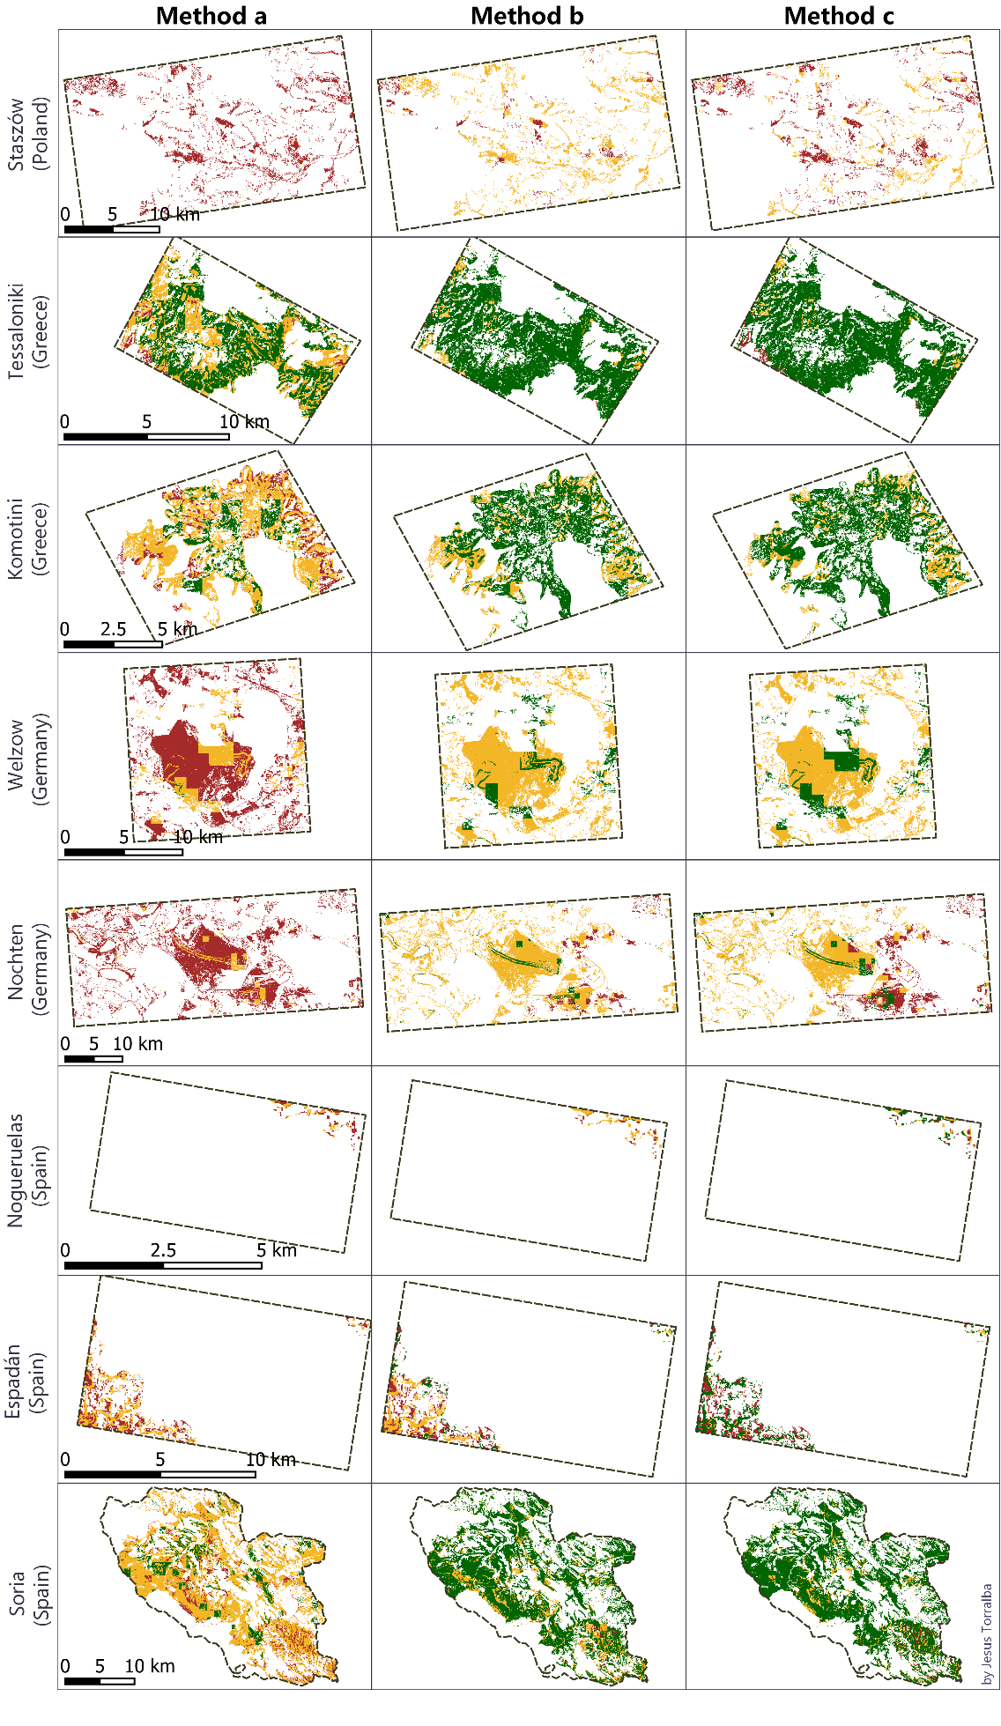
Besides, in chapter 12 of deliverable 2.3, the areas under marginal lands classification were analyzed for each method implemented on the pilot sites as shown in Figure 1.

Figure 1. The final layer of MLs classified with 3 methods into 3 categories “Marginal lands with high plantation suitability” (green), “Marginal lands with low plantation suitability” (gold), and “Potentially unsuitable lands” (dark red) in the pilot sites. Source: Deliverable 2.3 MAIL project.

Table 27 shows the area occupied by each marginality category "Marginal lands with high plantation suitability", "Marginal lands with low plantation suitability", "Potentially unsuitable lands" for each method on each pilot site. Also, the percentage that marginal lands represent over the total area of each pilot site.
Table 27. Hectares and percentage of total area for each of the ML categories according to marginality (“Marginal Lands with high plantation suitability”, “Marginal Lands with low plantation suitability”, and “Potentially unsuitable lands”) for each pilot site and method. Source: Deliverable 2.3 MAIL project.
 |  | Poland (Staszów) |  | Greece (Tessaloniki) |  | Greece (Komotini) |  | Germany (Welzow) |  | Germany (Nochten) |  | Spain (Nogueruelas) |  | Spain (Espadán) |  | Spain (Soria)
Method | Type | ha | % | ha | % | ha | % | ha | % | ha | % | ha | % | ha | % | ha | %
A | MLs with high plantation suitability | 0.0 | 0.0 | 2,596.9 | 26.9 | 568.9 | 7.1 | 27.1 | 0.1 | 6.6 | 0.0 | 0.0 | 0.0 | 0.0 | 0.0 | 3,611.5 | 6.3
 | MLs with low plantation suitability | 19.6 | 0.0 | 1,887.3 | 19.5 | 1,809.6 | 22.6 | 1,554.8 | 7.0 | 2,023.3 | 1.9 | 12.7 | 0.5 | 341.8 | 3.0 | 19,194.2 | 33.3
 | Potentially unsuitable lands | 4,076.4 | 8.5 | 147.3 | 1.5 | 435.0 | 5.4 | 4,951.2 | 22.3 | 19,090.6 | 18.3 | 14.6 | 0.6 | 282.0 | 2.4 | 2,913.7 | 5.0
 | Total MLs | 4,096.0 | 8.5 | 4,631.5 | 47.9 | 2,813.5 | 35.2 | 6,533.0 | 29.4 | 21,120.5 | 20.3 | 27.3 | 1.2 | 623.9 | 5.4 | 25,719.3 | 44.6
B | MLs with high plantation suitability | 17.8 | 0.0 | 4,377.4 | 45.3 | 2,024.8 | 25.3 | 1,095.4 | 4.9 | 1,255.5 | 1.2 | 0.3 | 0.0 | 103.0 | 0.9 | 20,367.3 | 35.3
 | MLs with low plantation suitability | 3,487.6 | 7.3 | 243.6 | 2.5 | 788.7 | 9.9 | 5,437.6 | 24.5 | 17,891.5 | 17.2 | 21.0 | 0.9 | 272.1 | 2.4 | 5,082.2 | 8.8
 | Potentially unsuitable lands | 590.6 | 1.2 | 10.5 | 0.1 | 0.0 | 0.0 | 0.0 | 0.0 | 1,973.5 | 1.9 | 6.0 | 0.3 | 248.7 | 2.2 | 269.9 | 0.5
 | Total MLs | 4,096.0 | 8.5 | 4,631.5 | 47.9 | 2,813.5 | 35.2 | 6,533.0 | 29.4 | 21,120.5 | 20.3 | 27.3 | 1.2 | 623.9 | 5.4 | 25,719.3 | 44.6
C | MLs with high plantation suitability | 18.9 | 0.0 | 4,391.9 | 45.4 | 2,241.5 | 28.0 | 1,581.1 | 7.1 | 1,933.4 | 1.9 | 12.7 | 0.5 | 341.2 | 3.0 | 22,587.9 | 39.1
 | MLs with low plantation suitability | 1,682.5 | 3.5 | 161.5 | 1.7 | 572.0 | 7.2 | 4,952.0 | 22.3 | 14,043.5 | 13.5 | 8.3 | 0.4 | 33.7 | 0.3 | 2,751.0 | 4.8
 | Potentially unsuitable lands | 2,394.6 | 5.0 | 78.1 | 0.8 | 0.0 | 0.0 | 0.0 | 0.0 | 5,143.6 | 4.9 | 6.4 | 0.3 | 249.0 | 2.2 | 380.5 | 0.7
 | Total MLs | 4,096.0 | 8.5 | 4,631.5 | 47.9 | 2,813.5 | 35.2 | 6,533.0 | 29.4 | 21,120.5 | 20.3 | 27.3 | 1.2 | 623.9 | 5.4 | 25,719.3 | 44.6

Methodology and Carbon sequestration capacity analysis

4.1 Current biomass stock information integration
At this point, the evaluation of the current biomass stock on the pilot site’s MLs is assessed. The goal is to study how current biomass stock is distributed within the marginality classes using open-source ABG biomass products (like ESA or NASA). According to the definition of MLs for the MAIL project and the proposed methodology for their identification, it is expected that the areas defined as MLs are devoid of vegetation and this assumption about the current state of marginal lands is the condition that has been taken as a reference to develop this methodology. In the case of pre-existing vegetation in the areas defined as marginal, it would be necessary to consider other reforestation methodologies that take into account the existing vegetation. The woody biomass in MLs was assumed as 0.

4.2 Methodology
To carry out the carbon sequestration capacity analysis in marginal lands a methodology is presented according to the different information available described in chapter 2 for every test site. The methodology follows the steps of an afforestation plan. However, it is not the goal of defining an afforestation plan for the pilot sites as many ancillary variables should be added that are currently out of the scope, such as pre-preparation of the terrain, available machinery, access to the areas, definition, and creation of forest roads, etc. Therefore, the main goal of the methodology is to forecast how certain planted species would evolve in the marginal lands.
Figure 2 presents an overview of the methodology which firstly addresses a description of the pilot site vegetation. An identification of all the main vegetation formations and species is required to decide what species are most suitable for the marginal lands. The species selected will be the most represented ones in the area. However, species with high nutrient or hydric requirements will be discarded as marginal lands are characterized for their poor soil conditions. Additionally, the plantations will be composed of two species to enhance the diversity of the marginal lands and make the future forest more resilient to disturbances such as pests, droughts, extreme climatic events.
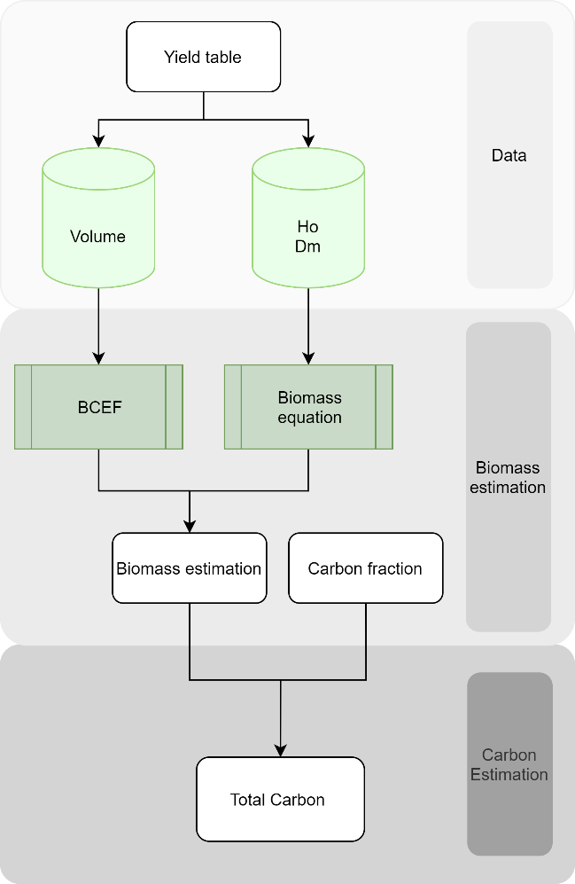
Figure 2. Methodology workflow.
After the definition of the species that will be planted in each test sit, the growth of the newly implanted forest must be forecasted for every species. This prediction is based on yield tables or growth models. Unfortunately, the option of using growth model inventory is constrained by inventory data unavailability. This limitation arises from the definition of ML created in task 2.1. which states that MLs do not present arboreal vegetation, where there is no forest inventory data. At this point, the methodology assumes that the forest inventory data used for the MLs will correspond with low site index areas, except those areas where marginality is not originated by environmental constraints, but social. Therefore, forest growth in marginal lands will be forecasted with yield tables and it is represented as the commercial wood volume for a given class age. To better reflect the environmental condition of the marginal lands, the two lowest site indexes of the yield tables for each species will be selected, corresponding to the lowest site index to the marginal lands classified as type 2 and the second the lowest site index to the ML type 1. Once the growth is forecasted the biomass is estimated in two components of the tree: the aerial part (branches, stem, and leaves) corresponding to the above-ground biomass (AGB) and the radicular tree components corresponding to the below-ground biomass (BGB). From here on, the methodology splits into two branches according to the data availability for the pilot sites and species:
On one hand, biomass equations specific for the selected species of the module were evaluated. The dasometric stand variables from the yield tables were used as input for the biomass equations. Therefore, dbh and height-dependent allometric biomass equations were selected for the methodology, as more specific metrics such as crown diameter or branch diameter were not provided by the growth models.
On the other hand, if no biomass equations were found for the target species or, the input parameters were not included in the inventory or yield table data, the biomass equations were replaced by a Biomass Conversion and Expansion Factor (BCEF). Here we use the BCEF to relate stem dry biomass and the other parts of the tree (branches, leaves, ABG, and BGB) (equation 3, 4, Table 28) or to the whole tree biomass (equation 5, Table 28). To calculate the stem dry biomass, it is necessary to convert the stem volume (yield table’s output) and multiply it by the specific gravity of the wood or normal density of the wood (equation 2, Table 28).
As a result of both aforementioned methods, a biomass estimation for the individual tree will be obtained for above ground and below-ground biomass. Next, the carbon is calculated by applying a carbon fraction for a given species and test site to biomass estimation for the different tree components (equation 8, Table 28). If no carbon fraction is specified, then the general carbon content in dry biomass suggested by the IPCC guidelines (50%) was used (Aalde et al., 2006). Finally, the carbon per tree values was extrapolated to the hectare using the density parameter from the yield tables. The whole methodology for carbon estimation using BCEF is simplified in equation 11 of the table of equations, where the calculation is optimized to avoid unnecessary steps. All the equations of the methodology can be consulted in Table 28.
For every pilot site, the carbon estimation for each type of ML (type 1: ML1 and type 2: ML2) was calculated by hectare and for the total area. A value of carbon was reported considering the mixture between the two species selected. The degree of mixture ranges in steps of 10% from 0% (purity of species 1) to 100% (purity of species 2) where 50% is the equal combination of both species.
Table 28. Equations for carbon estimation based on yield table data and BECF.
Nº | Equation | Units
Equation 2 | $V_{tree}=\frac{V_{plot}}{N}*1000$ | - V_{tree} (dm³/ha)  - N (trees/ha)  - V_{plot} (m³/ha)
Equation 3 | $${ABG}_{Stem}=V_{tree}*D$$ | - Density (D) (kg/dm³)  - AGB_{Strem} (kg/tree)
Equation 4 | $${ABG}_{branches}={ABG}_{stem}*{BECF}_{branches}$$ | - AGB_{Branches} (kg/tree)  - BECF_{branches} (%)
Equation 5 | $${ABG}_{tree}=\frac{{ABG}_{stem}}{{BECF}_{stem}}$$ | - AGB_{tree} (kg/tree)  - BECF_{stem} (%) Proportion of the stem over the ABG
Equation 6 | $${Total Biomass}_{tree}=\frac{{ABG}_{tree}}{{BECF}_{ABG }}$$ | - Total Biomass_{tree (}kg/tree)  - BECF_{ABG} (%): Proportion of the ABG over the whole tree
Equation 7 | $${BGB}_{tree}={Total Biomass}_{tree}-{ABG}_{tree}$$ | - BGB_{tree} (kg/tree)
Equation 8 | $${Total Biomass}_{ha}={Total Biomass}_{tree}*N$$ | - Total Biomass_{ha} (kg/tree)
Equation 9 | $$Carbon=Biomass*CF$$ | - Biomass (kg)  - Carbon Fraction (CF) (%)
Equation 10 | $${Total Biomass}_{ha}=\frac{\left(\frac{V_{plot}}{N}*1000\right)*D}{{BECF}_{stem}}*{BECF}_{ABG }*N$$
Equation 11 | $${Total Carbon}_{ha}=\frac{\left(\frac{V_{plot}}{N}*1000\right)*D}{{BECF}_{stem}}*{BECF}_{ABG }*N*CF$$
Equation 12 | $${Total Carbon}_{ha}=1000*V_{plot}*D*{BECF}_{ratio }*CF$$
Equation 13 | $${BECF}_{ratio }=\frac{{BECF}_{ABG }}{{BECF}_{stem}}$$

Results
Biomass and carbon sequestration capacity were estimated for 8 test sites in 4 countries. The obtained values describe carbon which may be stored within one hectare of marginal lands. To provide biodiversity, we proposed various scenarios of how to mix 2 species in different proportions. It can be used as a reference table for future afforestation plans. Thanks to these tables we can see how much carbon can be stored if a specific species mixture is applied. Additionally, as the way of estimating the ML area differs depending on the methodology selected (Chapter 3 “Marginal Land Area for study sites”), values for each method were calculated. For the results, we showed the carbon estimations corresponding to methodology C. Results for methodology A and B are in “Annex III: Carbon estimation for the pilot site: Results”.

Germany
The area within the federal state of Saxony was selected as a test site in Germany. The aforementioned state includes lowland areas of low productivity while post-mining areas are also a distinctive land use in the region. More specifically, Nochten and Welzow sites located in the northern part of the federal state of Saxony (Figure 3), have been selected as representative pilot sites which include large post-mining areas that could be defined as Marginal Lands.
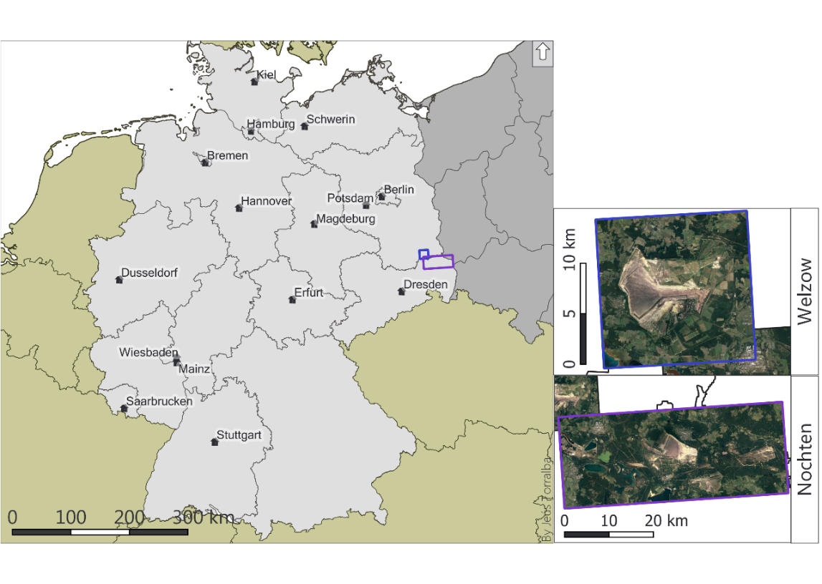
Figure 3. Germany (left) and the pilot sites of “Welzow” (outlined with blue) and “Welzow” (outlined with purple).

5.1.1 Species selection
In Germany, the pilot site is in the landers of Sachsen and Brandenburg. The National Forest Inventory was consulted to select the main forest species distributed in the study area.
Table 29. Area distribution for the main species in the German landers of Brandenburg + Berlin and Sachsen.
Land | Brandenburg + Berlin | Sachsen | Germany (all Länder)
Measure | % | % | %
Oak | 6.59 | 8.59 | 10.38
Beech | 3.30 | 4.23 | 15.43
Other deciduous trees with a long life expectancy | 3.35 | 4.09 | 7.07
Other deciduous trees with a short life expectancy | 11.28 | 14.59 | 10.54
All deciduous trees | 24.52 | 31.50 | 43.42
Spruce | 1.80 | 34.38 | 25.38
Fir | 0.00 | 0.15 | 1.68
Douglas fir | 0.97 | 0.20 | 2.00
Pine | 70.14 | 28.20 | 22.31
Larch | 1.17 | 3.42 | 2.82
All coniferous trees | 74.07 | 66.35 | 54.19
Gap | 1.18 | 1.67 | 2.02
Temporarily unstocked area | 0.22 | 0.48 | 0.38
All tree species | 100 | 100 | 100

As shown in Table 29, the most represented species are the pine (Pinus sylvestris) dominant in the Brandenburg region, and the spruce (Picea abies) in Sachsen. Given that the pilot site is allocated in both regions, it is proposed to select both species for the reforestation modules. Unfortunately, no disaggregated data in smaller administrative units have been found for the German forest inventory.

Biomass and carbon estimation by species
The results for the biomass estimations for the selected German forest species (Pinus sylvestris and Picea abies) applying biomass equations in section 2.3.1 are presented in Table 30, Table 31, Table 32, Table 33, Table 34, Table 35, Table 36 and Table 37.

Table 30. Biomass and Carbon estimates for Pinus sylvestris Remaining inventory Unteres Ertragsniveau Mittelhöhenbonität 18.
A | HG | HO | G | DG | N | ABG | BGB | ABG C | BGB C | Total Carbon
years | m | m | m² | cm | trees/ ha | kg/tree | kg/tree | kg/tree | kg/tree | kg/tree | tn/ha
30 | 6.6 | 7.8 | 19.4 | 5.8 | 7,317 | 12.8 | 1.0 | 6.4 | 0.5 | 6.9 | 50.6
35 | 7.7 | 9.0 | 21.2 | 7.3 | 5,129 | 22.2 | 1.8 | 11.1 | 0.9 | 12.0 | 61.7
40 | 8.8 | 10.1 | 22.8 | 8.8 | 3,754 | 34.8 | 3.0 | 17.4 | 1.5 | 18.9 | 71.0
45 | 9.9 | 11.2 | 24.1 | 10.4 | 2,850 | 52.2 | 4.6 | 26.1 | 2.3 | 28.4 | 80.9
50 | 10.9 | 12.2 | 25.3 | 12.0 | 2,233 | 73.7 | 6.7 | 36.9 | 3.3 | 40.2 | 89.8
55 | 11.8 | 13.1 | 26.2 | 13.6 | 1,795 | 99.8 | 9.2 | 49.9 | 4.6 | 54.5 | 97.8
60 | 12.7 | 14.0 | 27.0 | 15.3 | 1,476 | 132.7 | 12.5 | 66.3 | 6.3 | 72.6 | 107.1
65 | 13.6 | 14.8 | 27.7 | 16.9 | 1,236 | 169.0 | 16.2 | 84.5 | 8.1 | 92.6 | 114.5
70 | 14.3 | 15.5 | 28.2 | 18.5 | 1,052 | 210.2 | 20.5 | 105.1 | 10.3 | 115.3 | 121.3
75 | 15.1 | 16.2 | 28.6 | 20.0 | 908 | 254.3 | 25.1 | 127.1 | 12.6 | 139.7 | 126.8
80 | 15.8 | 16.9 | 28.9 | 21.6 | 793 | 306.4 | 30.6 | 153.2 | 15.3 | 168.5 | 133.6
85 | 16.4 | 17.5 | 29.2 | 23.0 | 700 | 356.7 | 36.1 | 178.4 | 18.0 | 196.4 | 137.5
90 | 17.0 | 18.0 | 29.3 | 24.5 | 623 | 415.6 | 42.5 | 207.8 | 21.2 | 229.0 | 142.7
95 | 17.5 | 18.5 | 29.4 | 25.9 | 560 | 475.1 | 49.1 | 237.5 | 24.5 | 262.1 | 146.8
100 | 18.0 | 18.9 | 29.5 | 27.2 | 507 | 534.9 | 55.7 | 267.4 | 27.9 | 295.3 | 149.7
105 | 18.4 | 19.3 | 29.5 | 28.5 | 462 | 598.2 | 62.9 | 299.1 | 31.4 | 330.5 | 152.7
110 | 18.8 | 19.6 | 29.4 | 29.7 | 424 | 660.7 | 70.0 | 330.3 | 35.0 | 365.3 | 154.9
115 | 19.1 | 19.9 | 29.3 | 30.9 | 391 | 725.9 | 77.6 | 363.0 | 38.8 | 401.7 | 157.1
120 | 19.4 | 20.2 | 29.2 | 32.0 | 362 | 789.2 | 84.9 | 394.6 | 42.5 | 437.1 | 158.2
125 | 19.7 | 20.4 | 29.1 | 33.1 | 338 | 855.7 | 92.7 | 427.8 | 46.4 | 474.2 | 160.3
130 | 19.9 | 20.6 | 28.9 | 34.1 | 316 | 918.1 | 100.1 | 459.0 | 50.1 | 509.1 | 160.9
135 | 20.0 | 20.7 | 28.7 | 35.1 | 297 | 981.7 | 107.9 | 490.9 | 54.0 | 544.8 | 161.8
140 | 20.1 | 20.8 | 28.5 | 36.0 | 280 | 1041.3 | 115.3 | 520.7 | 57.6 | 578.3 | 161.9
Table 31. Biomass and Carbon estimates for Pinus sylvestris. Remaining inventory Unteres Ertragsniveau Mittelhöhenbonität 20.
A | HG | HO | G | DG | N | ABG | BGB | ABG C | BGB C | Total Carbon
years | m | m | m² | cm | trees/ ha | kg/tree | kg/tree | kg/tree | kg/tree | kg/tree | tn/ha
30 | 7.7 | 9.0 | 20.8 | 6.9 | 5,629 | 19.5 | 1.6 | 9.8 | 0.8 | 10.6 | 59.4
35 | 8.9 | 10.3 | 22.7 | 8.5 | 4,036 | 32.2 | 2.7 | 16.1 | 1.4 | 17.5 | 70.6
40 | 10.2 | 11.5 | 24.3 | 10.1 | 3,011 | 49.1 | 4.3 | 24.5 | 2.1 | 26.7 | 80.3
45 | 11.3 | 12.7 | 25.7 | 11.9 | 2,322 | 72.9 | 6.5 | 36.4 | 3.3 | 39.7 | 92.2
50 | 12.4 | 13.7 | 26.9 | 13.6 | 1,843 | 100.8 | 9.2 | 50.4 | 4.6 | 55.0 | 101.4
55 | 13.4 | 14.7 | 27.8 | 15.4 | 1,498 | 136.3 | 12.7 | 68.1 | 6.4 | 74.5 | 111.6
60 | 14.4 | 15.7 | 28.6 | 17.1 | 1,243 | 176.0 | 16.7 | 88.0 | 8.4 | 96.3 | 119.7
65 | 15.3 | 16.5 | 29.3 | 18.8 | 1,050 | 221.6 | 21.4 | 110.8 | 10.7 | 121.5 | 127.6
70 | 16.1 | 17.3 | 29.8 | 20.5 | 900 | 273.3 | 26.8 | 136.6 | 13.4 | 150.0 | 135.0
75 | 16.9 | 18.0 | 30.2 | 22.2 | 782 | 331.6 | 32.9 | 165.8 | 16.5 | 182.3 | 142.5
80 | 17.6 | 18.7 | 30.5 | 23.8 | 686 | 392.5 | 39.4 | 196.3 | 19.7 | 216.0 | 148.2
85 | 18.3 | 19.3 | 30.7 | 25.4 | 609 | 459.8 | 46.7 | 229.9 | 23.3 | 253.2 | 154.2
90 | 18.9 | 19.9 | 30.9 | 26.9 | 545 | 528.3 | 54.1 | 264.1 | 27.1 | 291.2 | 158.7
95 | 19.5 | 20.4 | 31.0 | 28.3 | 492 | 597.8 | 61.8 | 298.9 | 30.9 | 329.8 | 162.2
100 | 20.0 | 20.9 | 31.0 | 29.7 | 447 | 671.6 | 70.0 | 335.8 | 35.0 | 370.8 | 165.8
105 | 20.5 | 21.3 | 31.0 | 31.1 | 409 | 750.7 | 78.9 | 375.3 | 39.4 | 414.8 | 169.6
110 | 20.9 | 21.7 | 31.0 | 32.4 | 377 | 828.1 | 87.7 | 414.1 | 43.9 | 457.9 | 172.6
115 | 21.2 | 22.0 | 30.9 | 33.6 | 349 | 902.9 | 96.4 | 451.5 | 48.2 | 499.6 | 174.4
120 | 21.5 | 22.3 | 30.7 | 34.7 | 324 | 975.1 | 104.8 | 487.6 | 52.4 | 540.0 | 174.9
125 | 21.8 | 22.5 | 30.6 | 35.8 | 303 | 1050.7 | 113.6 | 525.4 | 56.8 | 582.2 | 176.4
130 | 22.0 | 22.7 | 30.4 | 36.9 | 285 | 1128.2 | 122.9 | 564.1 | 61.4 | 625.6 | 178.3
135 | 22.2 | 22.8 | 30.2 | 37.8 | 269 | 1194.6 | 130.8 | 597.3 | 65.4 | 662.7 | 178.3
140 | 22.3 | 22.9 | 30.0 | 38.8 | 254 | 1269.1 | 140.0 | 634.6 | 70.0 | 704.5 | 179.0
Table 32. Biomass and Carbon estimates for Pinus sylvestris. Remaining inventory Mittleres Ertragsniveau Mittelhöhenbonität 18.
A | HG | HO | G | DG | N | ABG | BGB | ABG C | BGB C | Total Carbon
years | m | m | m² | cm | trees/ ha | kg/tree | kg/tree | kg/tree | kg/tree | kg/tree | tn/ha
30 | 6.6 | 7.9 | 20.4 | 5.5 | 8,613 | 11.4 | 0.9 | 5.7 | 0.4 | 6.1 | 52.7
35 | 7.7 | 9.1 | 22.3 | 6.9 | 6,009 | 19.5 | 1.6 | 9.8 | 0.8 | 10.6 | 63.4
40 | 8.8 | 10.2 | 24.0 | 8.3 | 4,384 | 30.5 | 2.6 | 15.2 | 1.3 | 16.5 | 72.4
45 | 9.9 | 11.3 | 25.4 | 9.9 | 3,320 | 46.6 | 4.1 | 23.3 | 2.0 | 25.3 | 84.1
50 | 10.9 | 12.3 | 26.6 | 11.4 | 2,596 | 65.6 | 5.8 | 32.8 | 2.9 | 35.7 | 92.7
55 | 11.8 | 13.2 | 27.6 | 13.0 | 2,084 | 90.0 | 8.2 | 45.0 | 4.1 | 49.1 | 102.3
60 | 12.7 | 14.0 | 28.4 | 14.5 | 1,711 | 117.3 | 10.9 | 58.7 | 5.5 | 64.1 | 109.7
65 | 13.6 | 14.9 | 29.1 | 16.1 | 1,432 | 151.3 | 14.3 | 75.7 | 7.2 | 82.8 | 118.6
70 | 14.3 | 15.6 | 29.7 | 17.6 | 1,218 | 187.6 | 18.0 | 93.8 | 9.0 | 102.8 | 125.2
75 | 15.1 | 16.3 | 30.1 | 19.1 | 1,050 | 229.0 | 22.3 | 114.5 | 11.1 | 125.6 | 131.9
80 | 15.8 | 16.9 | 30.4 | 20.6 | 917 | 275.0 | 27.1 | 137.5 | 13.6 | 151.1 | 138.5
85 | 16.4 | 17.5 | 30.7 | 22.0 | 809 | 322.4 | 32.1 | 161.2 | 16.1 | 177.3 | 143.4
90 | 17.0 | 18.1 | 30.9 | 23.4 | 721 | 374.3 | 37.7 | 187.2 | 18.9 | 206.0 | 148.5
95 | 17.5 | 18.5 | 31.0 | 24.7 | 647 | 426.5 | 43.4 | 213.2 | 21.7 | 234.9 | 152.0
100 | 18.0 | 19.0 | 31.0 | 26.0 | 586 | 482.7 | 49.6 | 241.4 | 24.8 | 266.1 | 156.0
105 | 18.4 | 19.4 | 31.0 | 27.2 | 534 | 537.9 | 55.7 | 269.0 | 27.9 | 296.8 | 158.5
110 | 18.8 | 19.7 | 31.0 | 28.4 | 490 | 596.7 | 62.3 | 298.4 | 31.2 | 329.5 | 161.5
115 | 19.1 | 20.0 | 30.9 | 29.5 | 451 | 653.3 | 68.8 | 326.6 | 34.4 | 361.0 | 162.8
120 | 19.4 | 20.3 | 30.8 | 30.6 | 419 | 712.9 | 75.6 | 356.4 | 37.8 | 394.3 | 165.2
125 | 19.7 | 20.5 | 30.6 | 31.6 | 390 | 770.0 | 82.2 | 385.0 | 41.1 | 426.1 | 166.2
130 | 19.9 | 20.6 | 30.4 | 32.6 | 365 | 828.8 | 89.1 | 414.4 | 44.6 | 458.9 | 167.5
135 | 20.0 | 20.8 | 30.2 | 33.5 | 343 | 882.9 | 95.6 | 441.4 | 47.8 | 489.3 | 167.8
140 | 20.1 | 20.8 | 30.0 | 34.3 | 324 | 932.8 | 101.7 | 466.4 | 50.8 | 517.2 | 167.6
Table 33. Biomass and Carbon estimates for Pinus sylvestris. Remaining inventory Mittleres Ertragsniveau Mittelhöhenbonität 20.
A | HG | HO | G | DG | N | ABG | BGB | ABG C | BGB C | Total Carbon
years | m | m | m² | cm | trees/ ha | kg/tree | kg/tree | kg/tree | kg/tree | kg/tree | tn/ha
30 | 7.7 | 9 | 21.9 | 6.6 | 6,460 | 17.6 | 1.4 | 8.8 | 0.7 | 9.5 | 61.5
35 | 8.9 | 10.4 | 23.9 | 8.1 | 4,616 | 28.9 | 2.4 | 14.4 | 1.2 | 15.6 | 72.2
40 | 10.2 | 11.6 | 25.6 | 9.7 | 3,435 | 44.7 | 3.8 | 22.4 | 1.9 | 24.3 | 83.4
45 | 11.3 | 12.7 | 27.1 | 11.4 | 2,645 | 66.1 | 5.8 | 33.0 | 2.9 | 36.0 | 95.1
50 | 12.4 | 13.8 | 28.3 | 13.1 | 2,096 | 92.6 | 8.4 | 46.3 | 4.2 | 50.5 | 105.8
55 | 13.4 | 14.8 | 29.3 | 14.8 | 1,702 | 124.5 | 11.5 | 62.2 | 5.7 | 68.0 | 115.7
60 | 14.4 | 15.7 | 30.1 | 16.5 | 1,411 | 162.2 | 15.2 | 81.1 | 7.6 | 88.7 | 125.2
65 | 15.3 | 16.6 | 30.8 | 18.2 | 1,191 | 205.8 | 19.7 | 102.9 | 9.8 | 112.7 | 134.3
70 | 16.1 | 17.4 | 31.4 | 19.8 | 1,020 | 252.5 | 24.5 | 126.3 | 12.2 | 138.5 | 141.3
75 | 16.9 | 18.1 | 31.8 | 21.4 | 885 | 305.1 | 29.9 | 152.5 | 15.0 | 167.5 | 148.2
80 | 17.6 | 18.8 | 32.1 | 22.9 | 777 | 359.6 | 35.7 | 179.8 | 17.8 | 197.7 | 153.6
85 | 18.3 | 19.4 | 32.4 | 24.4 | 690 | 419.7 | 42.0 | 209.9 | 21.0 | 230.9 | 159.3
90 | 18.9 | 20 | 32.5 | 25.9 | 617 | 484.8 | 49.1 | 242.4 | 24.5 | 266.9 | 164.7
95 | 19.5 | 20.5 | 32.6 | 27.3 | 557 | 550.9 | 56.3 | 275.5 | 28.1 | 303.6 | 169.1
100 | 20 | 20.9 | 32.7 | 28.7 | 506 | 621.4 | 64.0 | 310.7 | 32.0 | 342.7 | 173.4
105 | 20.5 | 21.4 | 32.6 | 30 | 463 | 691.8 | 71.8 | 345.9 | 35.9 | 381.8 | 176.8
110 | 20.9 | 21.7 | 32.6 | 31.2 | 426 | 760.2 | 79.5 | 380.1 | 39.8 | 419.9 | 178.9
115 | 21.2 | 22 | 32.5 | 32.4 | 394 | 831.4 | 87.7 | 415.7 | 43.9 | 459.6 | 181.1
120 | 21.5 | 22.3 | 32.4 | 33.5 | 367 | 900.3 | 95.6 | 450.2 | 47.8 | 498.0 | 182.8
125 | 21.8 | 22.6 | 32.2 | 34.6 | 343 | 972.5 | 104.0 | 486.3 | 52.0 | 538.3 | 184.6
130 | 22 | 22.7 | 32 | 35.6 | 322 | 1040.1 | 112.0 | 520.0 | 56.0 | 576.0 | 185.5
135 | 22.2 | 22.9 | 31.8 | 36.5 | 304 | 1103.5 | 119.5 | 551.7 | 59.7 | 611.5 | 185.9
140 | 22.3 | 23 | 31.6 | 37.4 | 288 | 1167.6 | 127.2 | 583.8 | 63.6 | 647.4 | 186.5
Table 34. Biomass and Carbon estimates for Picea abies. Remaining inventory Fichte Mässige V.Ertrags.
A | HG | HO | DG | N | ABG | BGB | ABG C | BGB C | Total Carbon
years | m | m | cm | trees/ ha | kg/tree | kg/tree | kg/tree | kg/tree | kg/tree | tn/ha
40 | 4.5 | 5.2 | 6.8 | 4,880 | 32.5 | 0.8 | 16.2 | 0.4 | 16.6 | 81.1
45 | 5.6 | 6.7 | 7.7 | 4,345 | 52.6 | 1.1 | 26.3 | 0.6 | 26.9 | 116.7
50 | 6.8 | 8.3 | 8.5 | 3,795 | 79.6 | 1.5 | 39.8 | 0.7 | 40.5 | 153.8
55 | 8 | 9.8 | 9.4 | 3,350 | 119.3 | 1.9 | 59.6 | 1.0 | 60.6 | 203.1
60 | 9.3 | 11.3 | 10.3 | 2,965 | 173.7 | 2.5 | 86.8 | 1.3 | 88.1 | 261.2
65 | 10.5 | 12.7 | 11.2 | 2,630 | 242.7 | 3.2 | 121.3 | 1.6 | 122.9 | 323.3
70 | 11.7 | 14 | 12.1 | 2,335 | 330.0 | 3.9 | 165.0 | 2.0 | 167.0 | 389.9
75 | 12.8 | 15.2 | 12.9 | 2,100 | 426.3 | 4.7 | 213.1 | 2.3 | 215.5 | 452.5
80 | 13.8 | 16.2 | 13.7 | 1,900 | 538.6 | 5.6 | 269.3 | 2.8 | 272.1 | 516.9
85 | 14.8 | 17.3 | 14.4 | 1,738 | 658.1 | 6.4 | 329.0 | 3.2 | 332.2 | 577.4
90 | 15.7 | 18.2 | 15 | 1,578 | 776.8 | 7.2 | 388.4 | 3.6 | 392.0 | 618.6
95 | 16.5 | 19 | 15.7 | 1,442 | 922.8 | 8.1 | 461.4 | 4.1 | 465.5 | 671.2
100 | 17.2 | 19.7 | 16.3 | 1,325 | 1063.9 | 9.0 | 532.0 | 4.5 | 536.5 | 710.8
Table 35. Biomass and Carbon estimates for Picea abies. Remaining inventory Fichte Mässige IV.Ertrags.
A | HG | HO | DG | N | ABG | BGB | ABG C | BGB C | Total Carbon
years | m | m | cm | trees/ ha | kg/tree | kg/tree | kg/tree | kg/tree | kg/tree | tn/ha
30 | 4.2 | 4.7 | 6.3 | 5,917 | 25.4 | 0.6 | 12.7 | 0.3 | 13.0 | 76.9
35 | 5.5 | 6.6 | 7.2 | 4,718 | 43.2 | 0.9 | 21.6 | 0.5 | 22.1 | 104.1
40 | 4.2 | 4.7 | 6.3 | 5,917 | 25.4 | 0.6 | 12.7 | 0.3 | 13.0 | 76.9
45 | 5.5 | 6.6 | 7.2 | 4,718 | 43.2 | 0.9 | 21.6 | 0.5 | 22.1 | 104.1
50 | 6.9 | 8.4 | 8.3 | 3,870 | 75.3 | 1.4 | 37.6 | 0.7 | 38.3 | 148.3
55 | 8.3 | 10.1 | 9.4 | 3,370 | 122.7 | 1.9 | 61.4 | 1.0 | 62.3 | 210.1
60 | 9.8 | 11.9 | 10.6 | 2,977 | 196.4 | 2.7 | 98.2 | 1.4 | 99.6 | 296.4
65 | 11.3 | 13.6 | 11.7 | 2,635 | 291.5 | 3.6 | 145.8 | 1.8 | 147.6 | 388.8
70 | 12.7 | 15.1 | 12.8 | 2,355 | 414.2 | 4.6 | 207.1 | 2.3 | 209.4 | 493.2
75 | 14 | 16.5 | 13.8 | 2,097 | 556.4 | 5.7 | 278.2 | 2.8 | 281.1 | 589.4
80 | 15.2 | 17.7 | 14.9 | 1,862 | 741.9 | 7.0 | 371.0 | 3.5 | 374.5 | 697.3
85 | 16.3 | 18.9 | 15.9 | 1,670 | 947.4 | 8.4 | 473.7 | 4.2 | 477.9 | 798.1
90 | 17.3 | 19.9 | 16.8 | 1,509 | 1166.2 | 9.8 | 583.1 | 4.9 | 588.0 | 887.3
95 | 18.3 | 20.9 | 17.8 | 1,365 | 1443.5 | 11.5 | 721.8 | 5.8 | 727.5 | 993.1
100 | 19.2 | 21.7 | 18.7 | 1,232 | 1732.1 | 13.2 | 866.1 | 6.6 | 872.7 | 1,075.2
105 | 20.1 | 22.6 | 19.5 | 1,120 | 2030.9 | 14.9 | 1015.5 | 7.4 | 1,022.9 | 1,145.6
110 | 21 | 23.5 | 20.4 | 1,023 | 2399.9 | 16.9 | 1200.0 | 8.4 | 1,208.4 | 1,236.2
115 | 21.8 | 24.2 | 21.2 | 942 | 2767.4 | 18.8 | 1383.7 | 9.4 | 1,393.1 | 1,312.3
120 | 22.6 | 25 | 21.9 | 867 | 3133.1 | 20.6 | 1566.6 | 10.3 | 1,576.8 | 1,367.1
125 | 23.3 | 25.6 | 22.6 | 800 | 3520.6 | 22.5 | 1760.3 | 11.2 | 1,771.6 | 1,417.2
130 | 24 | 26.3 | 23.2 | 735 | 3893.4 | 24.2 | 1946.7 | 12.1 | 1,958.8 | 1,439.7

Table 36. Biomass and Carbon estimates for Picea abies. Fichte Gestaffelte Durchforstung III.Ertrags.
A | HG | HO | DG | N | ABG | BGB | ABG C | BGB C | Total Carbon
years | m | m | cm | trees/ ha | kg/tree | kg/tree | kg/tree | kg/tree | kg/tree | tn/ha
20 | 3.7 | 3.8 | 4.1 | 5,917 | 7.7 | 0.2 | 3.9 | 0.1 | 4.0 | 23.5
25 | 5.5 | 6.5 | 6.1 | 4,617 | 27.5 | 0.6 | 13.7 | 0.3 | 14.0 | 64.8
30 | 7 | 8.4 | 7.8 | 3,667 | 64.0 | 1.2 | 32.0 | 0.6 | 32.6 | 119.5
35 | 8.6 | 10.3 | 9.5 | 2,887 | 130.0 | 2.0 | 65.0 | 1.0 | 66.0 | 190.5
40 | 10 | 11.9 | 11 | 2,392 | 221.7 | 3.0 | 110.9 | 1.5 | 112.4 | 268.8
45 | 12.1 | 14.2 | 13 | 2,002 | 380.7 | 4.4 | 190.3 | 2.2 | 192.5 | 385.5
50 | 13.9 | 16.1 | 14 | 1,692 | 612.6 | 6.3 | 306.3 | 3.1 | 309.4 | 523.5
55 | 15.5 | 17.7 | 16 | 1,454 | 908.8 | 8.4 | 454.4 | 4.2 | 458.6 | 666.8
60 | 17 | 19.3 | 18 | 1,266 | 1293.0 | 11.0 | 646.5 | 5.5 | 652.0 | 825.5
65 | 18.4 | 20.6 | 19 | 1,110 | 1777.5 | 14.1 | 888.8 | 7.0 | 895.8 | 994.3
70 | 19.6 | 21.8 | 21 | 984 | 2331.3 | 17.4 | 1165.6 | 8.7 | 1,174.3 | 1,155.5
75 | 20.7 | 22.9 | 22 | 879 | 2990.6 | 21.1 | 1495.3 | 10.6 | 1,505.9 | 1,323.7
80 | 21.8 | 23.9 | 24 | 791 | 3731.3 | 25.1 | 1865.6 | 12.5 | 1,878.2 | 1,485.6
85 | 22.8 | 24.9 | 25 | 715 | 4582.2 | 29.5 | 2291.1 | 14.7 | 2,305.8 | 1,648.7
90 | 23.7 | 25.7 | 26 | 649 | 5486.9 | 34.0 | 2743.5 | 17.0 | 2,760.5 | 1,791.5
95 | 24.5 | 26.4 | 28 | 590 | 6563.5 | 39.3 | 3281.8 | 19.6 | 3,301.4 | 1,947.8
100 | 25.4 | 27.3 | 29 | 539 | 7812.2 | 45.1 | 3906.1 | 22.6 | 3,928.7 | 2,117.5
105 | 26.3 | 28.1 | 30 | 494 | 9226.8 | 51.5 | 4613.4 | 25.7 | 4,639.1 | 2,291.7
110 | 27.1 | 28.8 | 32 | 453 | 10787.6 | 58.3 | 5393.8 | 29.2 | 5,423.0 | 2,456.6
115 | 27.7 | 29.4 | 33 | 417 | 12458.8 | 65.8 | 6229.4 | 32.9 | 6,262.3 | 2,611.4
120 | 28.3 | 29.9 | 35 | 384 | 14309.7 | 73.9 | 7154.9 | 36.9 | 7,191.8 | 2,761.6
Table 37. Biomass and Carbon estimates for Picea abies. Remaining inventory Fichte Gestaffelte Durchforstung II.Ertrags
A | HG | HO | DG | N | ABG | BGB | ABG C | BGB C | Total Carbon
years | m | m | cm | trees/ ha | kg/tree | kg/tree | kg/tree | kg/tree | kg/tree | tn/ha
20 | 4.9 | 5.6 | 5.2 | 5,917 | 16.7 | 0.4 | 8.3 | 0.2 | 8.5 | 50.4
25 | 7.2 | 8.6 | 7.8 | 3,594 | 65.4 | 1.2 | 32.7 | 0.6 | 33.3 | 119.5
30 | 9.2 | 11 | 10 | 2,794 | 158.4 | 2.3 | 79.2 | 1.2 | 80.4 | 224.5
35 | 11.4 | 13.4 | 12 | 2,204 | 308.1 | 3.7 | 154.1 | 1.9 | 155.9 | 343.7
40 | 13.7 | 15.8 | 14 | 1,795 | 535.4 | 5.6 | 267.7 | 2.8 | 270.5 | 485.5
45 | 15.8 | 18 | 16 | 1,517 | 858.1 | 7.8 | 429.0 | 3.9 | 433.0 | 656.8
50 | 17.9 | 20.2 | 17 | 1,303 | 1305.5 | 10.7 | 652.7 | 5.3 | 658.1 | 857.5
55 | 19.8 | 22.1 | 19 | 1,127 | 1889.0 | 14.1 | 944.5 | 7.0 | 951.5 | 1,072.4
60 | 21.5 | 23.7 | 21 | 987 | 2625.1 | 18.1 | 1312.5 | 9.0 | 1,321.6 | 1,304.4
65 | 23 | 25.2 | 23 | 867 | 3527.8 | 22.8 | 1763.9 | 11.4 | 1,775.3 | 1,539.2
70 | 24.2 | 26.3 | 25 | 760 | 4647.8 | 28.5 | 2323.9 | 14.2 | 2,338.1 | 1,777.0
75 | 25.3 | 27.3 | 26 | 678 | 5,857.2 | 34.3 | 2,928.6 | 17.2 | 2,945.8 | 1,997.2
80 | 26.3 | 28.3 | 28 | 610 | 7,335.0 | 41.3 | 3,667.5 | 20.7 | 3,688.1 | 2,249.8
85 | 27.3 | 29.2 | 30 | 553 | 8,891.3 | 48.2 | 4,445.7 | 24.1 | 4,469.8 | 2,471.8
90 | 28.4 | 30.2 | 31 | 501 | 10,807.9 | 56.3 | 5,403.9 | 28.2 | 5,432.1 | 2,721.5
95 | 29.2 | 30.9 | 33 | 456 | 12,901.0 | 65.3 | 6,450.5 | 32.6 | 6,483.1 | 2,956.3
100 | 30.1 | 31.8 | 35 | 416 | 15,315.5 | 75.0 | 7,657.7 | 37.5 | 7,695.3 | 3,201.2
105 | 30.9 | 32.5 | 37 | 379 | 17,995.3 | 85.7 | 8,997.7 | 42.9 | 9,040.5 | 3,426.4
110 | 31.6 | 33.1 | 38 | 350 | 20,785.2 | 96.7 | 10,392.6 | 48.3 | 10,440.9 | 3,654.3
115 | 32.1 | 33.5 | 40 | 325 | 23,753.2 | 108.4 | 11,876.6 | 54.2 | 11,930.8 | 3,877.5
120 | 32.6 | 33.9 | 41 | 302 | 27,012.3 | 121.1 | 13,506.1 | 60.5 | 13,566.7 | 4,097.1

Carbon sequestration capacity simulations
Using simulated forest growth and values of future biomass and carbon sequestration capacity of selected species (Figure 6, Figure 5) one-time point was selected (~50 years). The tables presented in Figure 6 and Figure 7 show the carbon sequestration for the test sites in Germany. For these areas, two species were proposed as indicated in chapter 5.1.1 The Carbon values are given by ML type and by species combination in tones by ha [t/ha] and for all the surface of the ML in kilotonnes by ha [kt/ha]. Here, we observe that the main carbon fixing species is Picea abies sequestering 148.3 C t/ha whereas Pinus sylvestris captures 109.7 C t /ha in the case of ML1 class. If we observe the amount of carbon fixed for the whole ML area, planting only Picea abies would fix 996.1 Kilotonnes of Carbon in Wezlow and 2,313.7 kilotonnes of Carbon in the Nochte test site. On the other hand planting the whole surface of the ML with Pinus sylvestris, 655.7 kilotonnes of Carbon in Wezlow, and 1,579.9 kilotonnes of Carbon in Nochte would be fixed. Although maximizing the carbon intake of the ML would be better than the plantation of one species, it is encouraged to apply a mixture of Picea abies in and Pinus sylvestris to enhance biodiversity, resilience against disturbances such as forest fires, extreme weather events, and pest. The percentage of specific species should depend on forestry recommendations within the country.

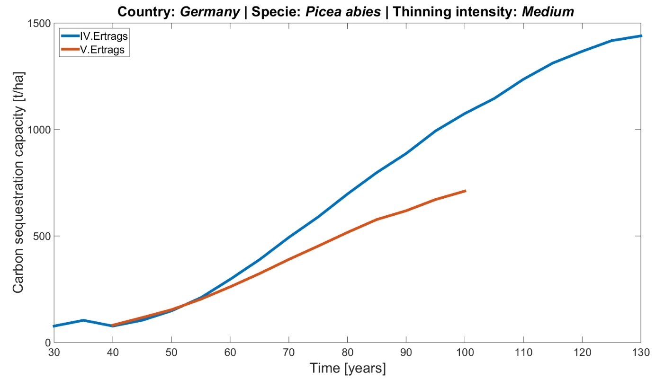
Figure 4. Simulation of carbon sequestration capacity of Picea abies in Germany.
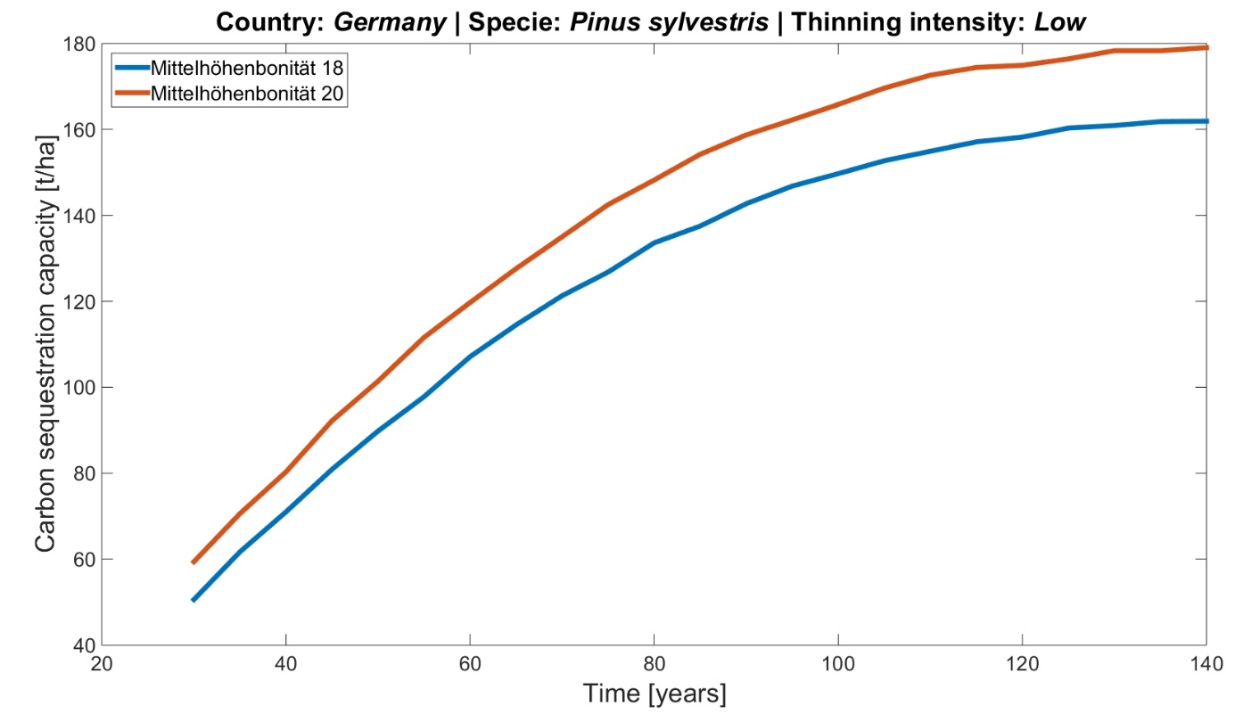
Figure 5. Simulation of carbon sequestration capacity of Pinus sylvestris in Germany.

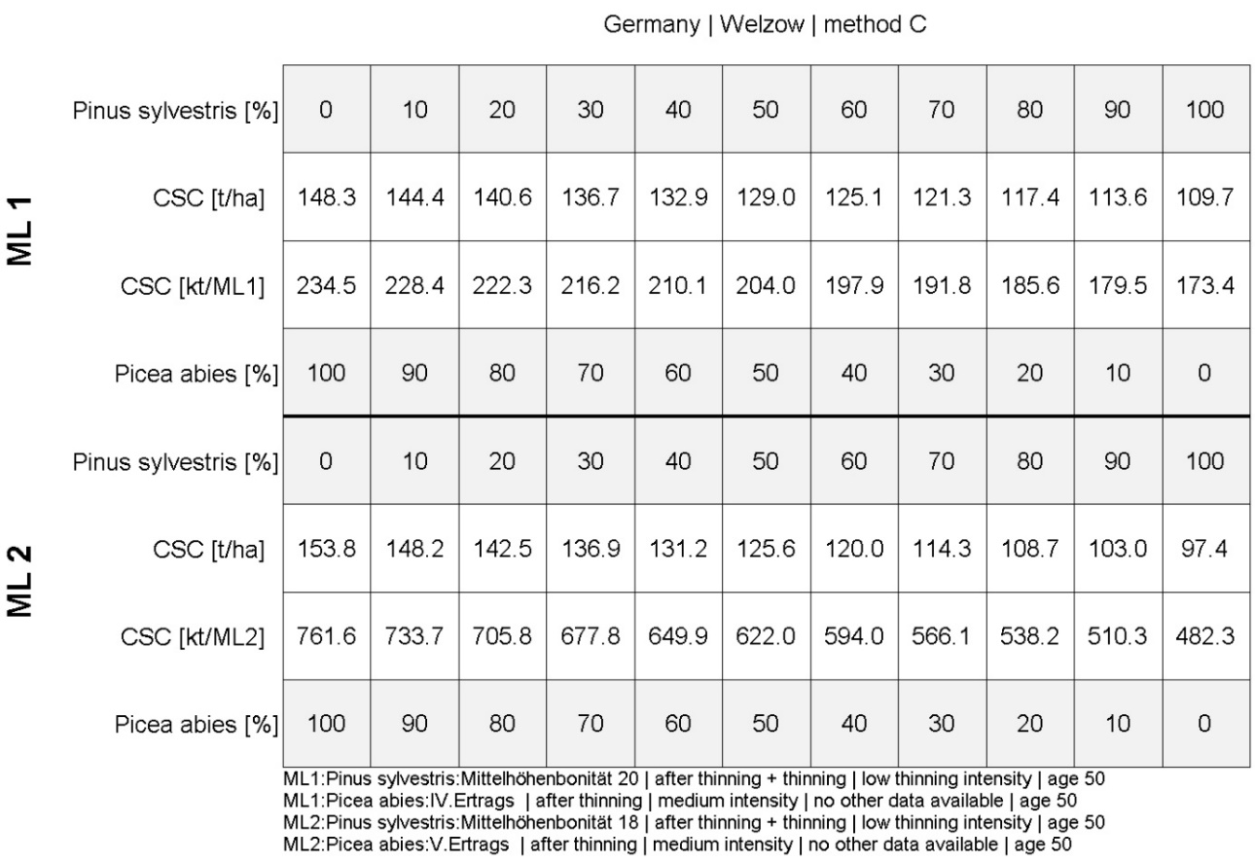
Figure 6. Carbon sequestration capacity of mixed species in “Welzow” test site.
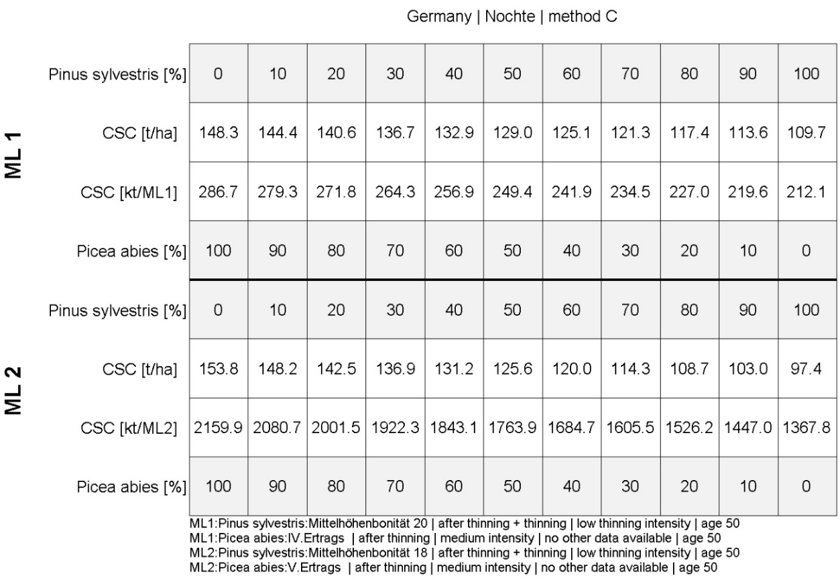
Figure 7. Carbon sequestration capacity of mixed species in “Nochte” test site.

Poland
The test site selected for Poland was “Staszów” - the region within Staszów County part of Świętokrzyskie Voivodeship (Figure 8). The size and the whole region are divided into industrial (north) and rural (south) parts. Local deposits of gypsum stone are one of the largest in Europe. 50% of national lime production and 25% of national cement production come from this Voivodeship. According to the official data, the area of devastated land was increasing between 2004 and 2012. This region includes upland and lowland areas, strongly fragmented croplands, and low productivity lands that could be defined as potential Marginal Lands.
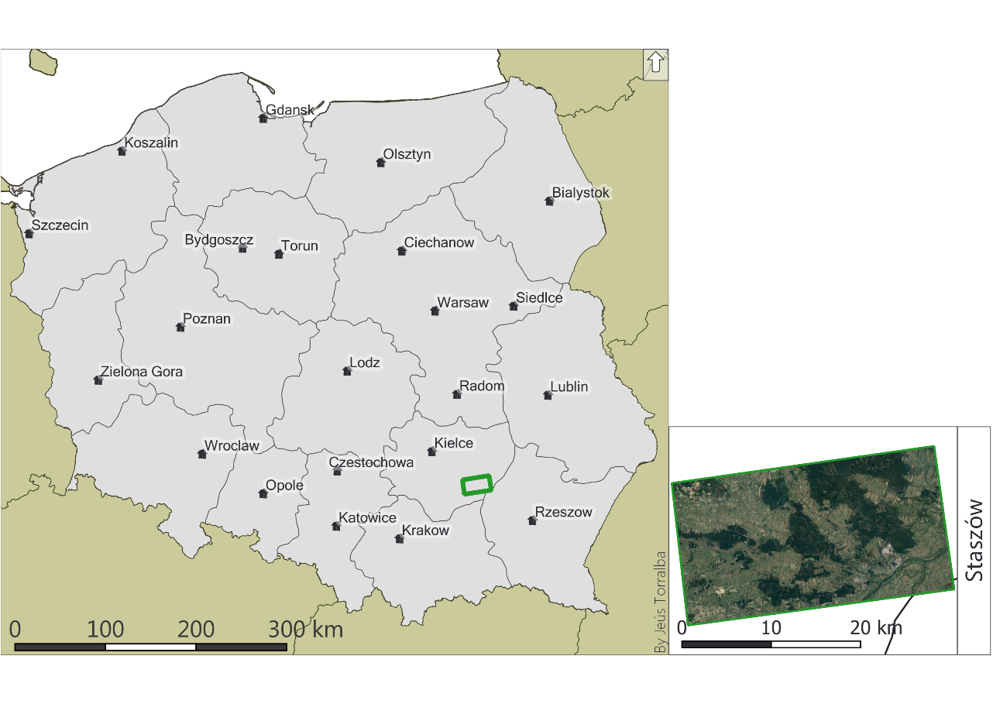
Figure 8. Poland (left) and the corresponding selected pilot site (outlined with green).

5.2.1 Species selection
The species composition for the Polish modules was based on the information extracted from the Polish National Inventory. The inventory provides spatially referenced data for all the forest plots. In our study site, the species composition of each plot was analyzed and plotted. Table 38 represents the area representation of every species in the marginal lands:

Table 38. Area distribution for the main species in the Polish test site according to the Polish Forest Data Bank.
Species CD | Scientific name | Area [ha] | % | Frequency
SO | Pinus sylvestris | 7,101.43 | 76.67 | 2271
DB | Quercus species | 1031.29 | 11.13 | 301
OL | Alnus glutinosa | 538.84 | 5.82 | 260
BRZ | Betula pendula | 253.70 | 2.74 | 124
JD | Abies alba | 90.16 | 0.97 | 28
BK | Fagus sylvatica | 63.10 | 0.68 | 17
MD | Larix decidua | 49.66 | 0.54 | 16
DB.S | Quercus robur | 23.78 | 0.26 | 7
OS | Populus tremula | 22.83 | 0.25 | 18
ŚW | Picea abies | 22.07 | 0.24 | 23
DB.C | Quercus rubra | 15.67 | 0.17 | 7
GB | Pyrus communis | 11.62 | 0.13 | 9
WB | Salix alba | 8.43 | 0.09 | 6
DB.B | Quercus petraea | 7.56 | 0.08 | 4
KRU | Rhamnus frangula | 7.01 | 0.08 | 8
AK | Robinia pseudoacacia | 4.00 | 0.04 | 6
ŚL.T | Prunus spinosa | 3.60 | 0.04 | 5
JS | Fraxinus excelsior | 3.39 | 0.04 | 3
JW | Acer pseudoplatanus | 1.47 | 0.02 | 2
LP | Tilia cordata | 1.41 | 0.02 | 3
KL | Acer platanoides | 0.73 | 0.01 | 1
CZM | Prunus padus | 0.27 | 0.003 | 1
DG | Pseudotsuga menziesii | 0.26 | 0.003 | 1
TP | Populus alba | 0.13 | 0.001 | 1
 | Total | 9,262.40 | 100 | 3,122
The inventory (Figure 9) reflects that there is a high diversity for the species composition in the forest plots of the polish Pilot site, accounting for 24 species. However, only three species describe almost the totality of the study area (93.32%). As previously done in the other test sites, the more represented species were selected. Pinus sylvestris was the dominant species by occupying 76.67% of the forested area. Forest stands that presented a mixture of Quercus species in their composition (presumably Quercus petraea, Quercus robur, and Quercus rubra) meant 11.13% of the surface. Finally, the 5.82% is occupied by Alnus glutinosa.
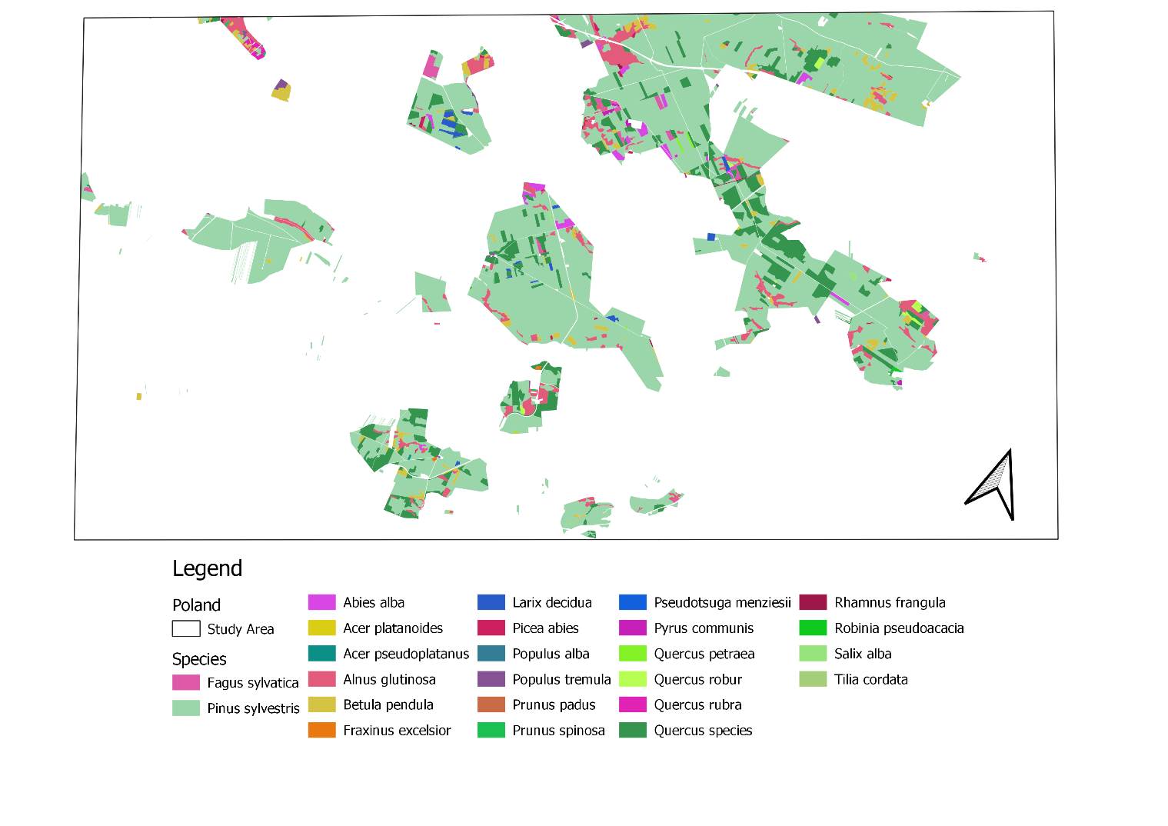
Figure 9. Species distribution in the Polish test site according to the Polish Forest Data Bank.

Biomass and carbon estimation by species
Biomass and carbon estimations were calculated for two species (Pinus sylvestris, Quercus spp.) and two ML classes (ML1 and ML2). Biomass and carbon values are presented (with division into ABG and BGB) in Table 39, Table 40, Table 41, and Table 42.Table 39. Biomass and Carbon estimates for Pinus sylvestris Class IV for ML1.
Table 39. Biomass and Carbon estimates for Pinus sylvestris Class IV for ML1.
Class IV - for ML1
Age | N | V (stem+ branch) | V (stem+ branch) | V (stem+ branch+ foliage) | AGB (weight) | BGB | Total Biomass | Total Biomass | C AGB | C BGB | Total C | Total C
 | trees/ ha | m³/ ha | dm³/ tree | dm³/ tree | kg/ tree | kg/ tree | kg/ tree | kg/ ha | kg/ tree | kg/ tree | kg/tree | kg/ha
20 | 7600 | 50 | 6.58 | 7.43 | 3.13 | 0.61 | 3.74 | 28444.58 | 1.57 | 0.30 | 1.87 | 14222.29
25 | 5813 | 67 | 11.53 | 13.01 | 5.49 | 1.07 | 6.56 | 38115.74 | 2.75 | 0.53 | 3.28 | 19057.87
30 | 4508 | 88 | 19.52 | 22.04 | 9.30 | 1.81 | 11.11 | 50062.46 | 4.65 | 0.90 | 5.55 | 25031.23
35 | 3598 | 112 | 31.13 | 35.15 | 14.83 | 2.88 | 17.71 | 63715.86 | 7.41 | 1.44 | 8.85 | 31857.93
40 | 2983 | 137 | 45.93 | 51.85 | 21.88 | 4.25 | 26.13 | 77938.15 | 10.94 | 2.13 | 13.06 | 38969.07
45 | 2473 | 162 | 65.51 | 73.96 | 31.20 | 6.06 | 37.27 | 92160.44 | 15.60 | 3.03 | 18.63 | 46080.22
50 | 2079 | 186 | 89.47 | 101.01 | 42.62 | 8.28 | 50.90 | 105813.83 | 21.31 | 4.14 | 25.45 | 52906.92
55 | 1769 | 208 | 117.58 | 132.75 | 56.01 | 10.88 | 66.89 | 118329.45 | 28.00 | 5.44 | 33.45 | 59164.72
60 | 1524 | 228 | 149.61 | 168.91 | 71.26 | 13.85 | 85.11 | 129707.28 | 35.63 | 6.92 | 42.55 | 64853.64
65 | 1329 | 246 | 185.10 | 208.99 | 88.17 | 17.13 | 105.30 | 139947.33 | 44.08 | 8.57 | 52.65 | 69973.67
70 | 1171 | 262 | 223.74 | 252.61 | 106.57 | 20.71 | 127.28 | 149049.60 | 53.29 | 10.35 | 63.64 | 74524.80
75 | 1041 | 276 | 265.13 | 299.34 | 126.29 | 24.54 | 150.83 | 157014.08 | 63.14 | 12.27 | 75.42 | 78507.04
80 | 931 | 288 | 309.34 | 349.26 | 147.35 | 28.63 | 175.98 | 163840.78 | 73.68 | 14.32 | 87.99 | 81920.39
85 | 841 | 299 | 355.53 | 401.41 | 169.35 | 32.91 | 202.26 | 170098.58 | 84.68 | 16.45 | 101.13 | 85049.29
90 | 765 | 308 | 402.61 | 454.57 | 191.78 | 37.27 | 229.04 | 175218.61 | 95.89 | 18.63 | 114.52 | 87609.30
95 | 700 | 316 | 451.43 | 509.68 | 215.03 | 41.78 | 256.81 | 179769.74 | 107.52 | 20.89 | 128.41 | 89884.87
100 | 645 | 323 | 500.78 | 565.40 | 238.54 | 46.35 | 284.89 | 183751.98 | 119.27 | 23.18 | 142.44 | 91875.99
105 | 599 | 328 | 547.58 | 618.24 | 260.83 | 50.68 | 311.51 | 186596.44 | 130.42 | 25.34 | 155.76 | 93298.22
110 | 561 | 333 | 593.58 | 670.18 | 282.74 | 54.94 | 337.68 | 189440.90 | 141.37 | 27.47 | 168.84 | 94720.45
115 | 528 | 337 | 638.26 | 720.62 | 304.02 | 59.08 | 363.10 | 191716.46 | 152.01 | 29.54 | 181.55 | 95858.23
120 | 499 | 340 | 681.36 | 769.29 | 324.56 | 63.07 | 387.62 | 193423.14 | 162.28 | 31.53 | 193.81 | 96711.57
Table 40. Biomass and Carbon estimates for Pinus sylvestris Class V (worst bonitation) - for ML2.
Class V - for ML2
Age | N | V (stem+ branch) | V (stem+ branch) | V (stem+ branch+ foliage) | AGB (weight) | BGB | Total Biomass | Total Biomass | C AGB | C BGB | Total C | Total C
 | trees/ ha | m³/ ha | dm³/ tree | dm³/ tree | kg/ tree | kg/ tree | kg/ tree | kg/ ha | kg/ tree | kg/ tree | kg/ tree | kg/ ha
20
25 | 7188 | 51 | 7.10 | 8.01 | 3.38 | 0.66 | 4.04 | 29013.47 | 1.69 | 0.33 | 2.02 | 14506.74
30 | 5590 | 66 | 11.81 | 13.33 | 5.62 | 1.09 | 6.72 | 37546.84 | 2.81 | 0.55 | 3.36 | 18773.42
35 | 4428 | 83 | 18.74 | 21.16 | 8.93 | 1.73 | 10.66 | 47218.00 | 4.46 | 0.87 | 5.33 | 23609.00
40 | 3648 | 103 | 28.23 | 31.88 | 13.45 | 2.61 | 16.06 | 58595.83 | 6.72 | 1.31 | 8.03 | 29297.92
45 | 3058 | 124 | 40.55 | 45.78 | 19.32 | 3.75 | 23.07 | 70542.56 | 9.66 | 1.88 | 11.53 | 35271.28
50 | 2598 | 144 | 55.43 | 62.58 | 26.40 | 5.13 | 31.53 | 81920.39 | 13.20 | 2.57 | 15.77 | 40960.19
55 | 2228 | 165 | 74.06 | 83.61 | 35.28 | 6.85 | 42.13 | 93867.11 | 17.64 | 3.43 | 21.07 | 46933.56
60 | 1928 | 183 | 94.92 | 107.17 | 45.21 | 8.79 | 54.00 | 104107.16 | 22.61 | 4.39 | 27.00 | 52053.58
65 | 1678 | 199 | 118.59 | 133.90 | 56.49 | 10.98 | 67.47 | 113209.43 | 28.25 | 5.49 | 33.73 | 56604.71
70 | 1476 | 212 | 143.63 | 162.17 | 68.42 | 13.29 | 81.71 | 120605.02 | 34.21 | 6.65 | 40.86 | 60302.51
75 | 1309 | 222 | 169.60 | 191.48 | 80.78 | 15.70 | 96.48 | 126293.93 | 40.39 | 7.85 | 48.24 | 63146.97
80 | 1164 | 231 | 198.45 | 224.06 | 94.53 | 18.37 | 112.90 | 131413.96 | 47.26 | 9.18 | 56.45 | 65706.98
85 | 1040 | 238 | 228.85 | 258.38 | 109.01 | 21.18 | 130.19 | 135396.20 | 54.50 | 10.59 | 65.09 | 67698.10
90 | 936 | 244 | 260.68 | 294.32 | 124.17 | 24.13 | 148.30 | 138809.55 | 62.09 | 12.06 | 74.15 | 69404.77
95 | 852 | 249 | 292.25 | 329.97 | 139.21 | 27.05 | 166.26 | 141654.00 | 69.60 | 13.53 | 83.13 | 70827.00
100 | 782 | 253 | 323.53 | 365.28 | 154.11 | 29.95 | 184.05 | 143929.57 | 77.05 | 14.97 | 92.03 | 71964.79
105 | 726 | 257 | 353.99 | 399.68 | 168.62 | 32.77 | 201.38 | 146205.14 | 84.31 | 16.38 | 100.69 | 73102.57
110 | 684 | 259 | 378.65 | 427.52 | 180.37 | 35.05 | 215.41 | 147342.92 | 90.18 | 17.52 | 107.71 | 73671.46
115 | 646 | 260 | 402.48 | 454.41 | 191.71 | 37.25 | 228.97 | 147911.81 | 95.86 | 18.63 | 114.48 | 73955.91
120 | 613 | 261 | 425.77 | 480.72 | 202.81 | 39.41 | 242.22 | 148480.70 | 101.41 | 19.70 | 121.11 | 74240.35
Table 41. Biomass and Carbon estimates for Quercus species Class III for ML1.
Class III - for ML1
Age | N | V (stem+ branch) | V (stem+ branch) | V (stem+ branch+ foliage) | AGB (weight) | BGB | Total Biomass | Total Biomass | C AGB | C BGB | Total C | Total C
 | trees/ ha | m³/ ha | dm³/ tree | dm³/ tree | kg/ tree | kg/ tree | kg/ tree | kg/ ha | kg/ tree | kg/ tree | kg/tree | kg/ha
20 | 11000 | 55 | 5.00 | 5.06 | 2.83 | 0.62 | 3.46 | 38024.69 | 1.42 | 0.31 | 1.73 | 19012.35
25 | 6600 | 72 | 10.91 | 11.04 | 6.18 | 1.36 | 7.54 | 49777.78 | 3.09 | 0.68 | 3.77 | 24888.89
30 | 4540 | 92 | 20.26 | 20.51 | 11.49 | 2.52 | 14.01 | 63604.94 | 5.74 | 1.26 | 7.00 | 31802.47
35 | 3290 | 113 | 34.35 | 34.77 | 19.47 | 4.27 | 23.75 | 78123.46 | 9.74 | 2.14 | 11.87 | 39061.73
40 | 2480 | 135 | 54.44 | 55.11 | 30.86 | 6.77 | 37.63 | 93333.33 | 15.43 | 3.39 | 18.82 | 46666.67
45 | 1930 | 159 | 82.38 | 83.40 | 46.70 | 10.25 | 56.96 | 109925.93 | 23.35 | 5.13 | 28.48 | 54962.96
50 | 1500 | 184 | 122.67 | 124.18 | 69.54 | 15.27 | 84.81 | 127209.88 | 34.77 | 7.63 | 42.40 | 63604.94
55 | 1240 | 208 | 167.74 | 169.81 | 95.10 | 20.87 | 115.97 | 143802.47 | 47.55 | 10.44 | 57.98 | 71901.23
60 | 1060 | 232 | 218.87 | 221.57 | 124.08 | 27.24 | 151.32 | 160395.06 | 62.04 | 13.62 | 75.66 | 80197.53
65 | 923 | 255 | 276.27 | 279.68 | 156.62 | 34.38 | 191.00 | 176296.30 | 78.31 | 17.19 | 95.50 | 88148.15
70 | 812 | 278 | 342.36 | 346.59 | 194.09 | 42.61 | 236.70 | 192197.53 | 97.05 | 21.30 | 118.35 | 96098.77
75 | 721 | 300 | 416.09 | 421.23 | 235.89 | 51.78 | 287.67 | 207407.41 | 117.94 | 25.89 | 143.83 | 103703.70
80 | 645 | 321 | 497.67 | 503.82 | 282.14 | 61.93 | 344.07 | 221925.93 | 141.07 | 30.97 | 172.04 | 110962.96
85 | 579 | 341 | 588.95 | 596.22 | 333.88 | 73.29 | 407.17 | 235753.09 | 166.94 | 36.65 | 203.59 | 117876.54
90 | 529 | 361 | 682.42 | 690.84 | 386.87 | 84.92 | 471.80 | 249580.25 | 193.44 | 42.46 | 235.90 | 124790.12
95 | 485 | 381 | 785.57 | 795.27 | 445.35 | 97.76 | 543.11 | 263407.41 | 222.67 | 48.88 | 271.55 | 131703.70
100 | 448 | 400 | 892.86 | 903.88 | 506.17 | 111.11 | 617.28 | 276543.21 | 253.09 | 55.56 | 308.64 | 138271.60
105 | 413 | 419 | 1014.53 | 1027.05 | 575.15 | 126.25 | 701.40 | 289679.01 | 287.57 | 63.13 | 350.70 | 144839.51
110 | 383 | 436 | 1138.38 | 1152.44 | 645.36 | 141.67 | 787.03 | 301432.10 | 322.68 | 70.83 | 393.51 | 150716.05
115 | 356 | 453 | 1272.47 | 1288.18 | 721.38 | 158.35 | 879.73 | 313185.19 | 360.69 | 79.18 | 439.87 | 156592.59
120 | 333 | 469 | 1408.41 | 1425.80 | 798.45 | 175.27 | 973.71 | 324246.91 | 399.22 | 87.63 | 486.86 | 162123.46
125 | 292 | 500 | 1712.33 | 1733.47 | 970.74 | 213.09 | 1183.83 | 345679.01 | 485.37 | 106.54 | 591.92 | 172839.51
130 | 259 | 530 | 2046.33 | 2071.60 | 1160.09 | 254.65 | 1414.75 | 366419.75 | 580.05 | 127.33 | 707.37 | 183209.88
135 | 233 | 558 | 2394.85 | 2424.42 | 1357.67 | 298.03 | 1655.70 | 385777.78 | 678.84 | 149.01 | 827.85 | 192888.89
140 | 212 | 585 | 2759.43 | 2793.50 | 1564.36 | 343.40 | 1907.76 | 404444.44 | 782.18 | 171.70 | 953.88 | 202222.22
Table 42. Biomass and Carbon estimates for Quercus species Class IV for ML2
Class IV - for ML2
Age | N | V (stem+ branch) | V (stem+ branch) | V (stem+ branch+ foliage) | AGB (weight) | BGB | Total Biomass | Total Biomass | C AGB | C BGB | Total C | Total C
 | trees/ ha | m³/ ha | dm³/ tree | dm³/ tree | kg/ tree | kg/ tree | kg/ tree | kg/ ha | kg/ tree | kg/ tree | kg/ tree | kg/ ha
20 | 16950 | 44 | 2.60 | 2.63 | 1.47 | 0.32 | 1.79 | 30419.75 | 0.74 | 0.16 | 0.90 | 15209.88
25 | 12000 | 62 | 5.17 | 5.23 | 2.93 | 0.64 | 3.57 | 42864.20 | 1.46 | 0.32 | 1.79 | 21432.10
30 | 8180 | 74 | 9.05 | 9.16 | 5.13 | 1.13 | 6.25 | 51160.49 | 2.56 | 0.56 | 3.13 | 25580.25
35 | 5550 | 88 | 15.86 | 16.05 | 8.99 | 1.97 | 10.96 | 60839.51 | 4.49 | 0.99 | 5.48 | 30419.75
40 | 4060 | 101 | 24.88 | 25.18 | 14.10 | 3.10 | 17.20 | 69827.16 | 7.05 | 1.55 | 8.60 | 34913.58
45 | 3170 | 116 | 36.59 | 37.04 | 20.75 | 4.55 | 25.30 | 80197.53 | 10.37 | 2.28 | 12.65 | 40098.77
50 | 2490 | 132 | 53.01 | 53.67 | 30.05 | 6.60 | 36.65 | 91259.26 | 15.03 | 3.30 | 18.33 | 45629.63
55 | 2000 | 149 | 74.50 | 75.42 | 42.24 | 9.27 | 51.51 | 103012.35 | 21.12 | 4.64 | 25.75 | 51506.17
60 | 1660 | 167 | 100.60 | 101.84 | 57.03 | 12.52 | 69.55 | 115456.79 | 28.52 | 6.26 | 34.78 | 57728.40
65 | 1390 | 186 | 133.81 | 135.46 | 75.86 | 16.65 | 92.51 | 128592.59 | 37.93 | 8.33 | 46.26 | 64296.30
70 | 1190 | 204 | 171.43 | 173.54 | 97.19 | 21.33 | 118.52 | 141037.04 | 48.59 | 10.67 | 59.26 | 70518.52
75 | 1050 | 222 | 211.43 | 214.04 | 119.86 | 26.31 | 146.17 | 153481.48 | 59.93 | 13.16 | 73.09 | 76740.74
80 | 936 | 240 | 256.41 | 259.58 | 145.36 | 31.91 | 177.27 | 165925.93 | 72.68 | 15.95 | 88.64 | 82962.96
85 | 832 | 258 | 310.10 | 313.92 | 175.80 | 38.59 | 214.39 | 178370.37 | 87.90 | 19.29 | 107.19 | 89185.19
90 | 754 | 275 | 364.72 | 369.22 | 206.77 | 45.39 | 252.15 | 190123.46 | 103.38 | 22.69 | 126.08 | 95061.73
95 | 688 | 292 | 424.42 | 429.66 | 240.61 | 52.82 | 293.43 | 201876.54 | 120.30 | 26.41 | 146.71 | 100938.27
100 | 628 | 309 | 492.04 | 498.11 | 278.94 | 61.23 | 340.17 | 213629.63 | 139.47 | 30.62 | 170.09 | 106814.81
105 | 580 | 326 | 562.07 | 569.01 | 318.64 | 69.95 | 388.59 | 225382.72 | 159.32 | 34.97 | 194.30 | 112691.36
110 | 538 | 342 | 635.69 | 643.54 | 360.38 | 79.11 | 439.49 | 236444.44 | 180.19 | 39.55 | 219.74 | 118222.22
115 | 500 | 357 | 714.00 | 722.81 | 404.78 | 88.85 | 493.63 | 246814.81 | 202.39 | 44.43 | 246.81 | 123407.41
120 | 468 | 371 | 792.74 | 802.52 | 449.41 | 98.65 | 548.06 | 256493.83 | 224.71 | 49.33 | 274.03 | 128246.91
125 | 409 | 409 | 1000.00 | 1012.35 | 566.91 | 124.44 | 691.36 | 282765.43 | 283.46 | 62.22 | 345.68 | 141382.72
130 | 360 | 437 | 1213.89 | 1228.88 | 688.17 | 151.06 | 839.23 | 302123.46 | 344.09 | 75.53 | 419.62 | 151061.73
135 | 320 | 463 | 1446.88 | 1464.74 | 820.25 | 180.06 | 1000.31 | 320098.77 | 410.13 | 90.03 | 500.15 | 160049.38
140 | 285 | 489 | 1715.79 | 1736.97 | 972.70 | 213.52 | 1186.22 | 338074.07 | 486.35 | 106.76 | 593.11 | 169037.04

Carbon sequestration capacity simulations
Using simulated forest growth and values of future biomass and carbon sequestration capacity of selected species (Figure 10, Figure 11) one-time point was selected (~50 years). The table presented in Figure 12 shows the carbon sequestration for the test site in Poland. For this area, two species were proposed as indicated in chapter 5.2.1 The Carbon values are given by ML type and by species combination in tones by ha [t/ha] and for all the surface of the ML in kilotonnes by ha [kt/ha]. Here, we observe that the main carbon fixing species is Quercus spp. sequestering 63.6 C t/ha whereas Pinus sylvestris captures 52.9 C t/ha in the case of ML1 class. If we observe the amount of carbon fixed for the whole ML area, planting only Quercus spp. would fix 77.9 kilotonnes of Carbon in Staszów test site. On the other hand, planting the whole surface of the ML with Pinus sylvestris, 69.9 kilotonnes of Carbon would be fixed. Although maximizing the carbon intake of the ML would be better for the plantation of one species, it is encouraged to apply a mixture of Quercus spp. in 70 % and Pinus sylvestris in 30% to enhance biodiversity, resilience against disturbances such as forest fires, extreme weather events, and pest.
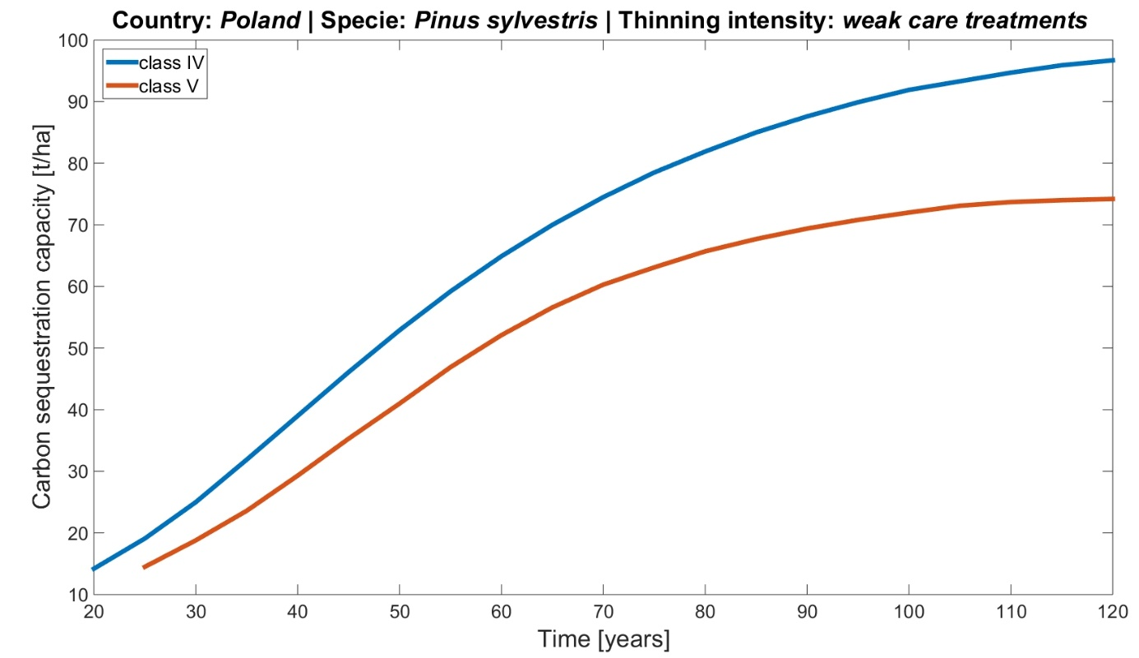
Figure 10. Simulation of carbon sequestration capacity of Pinus sylvestris in Poland.
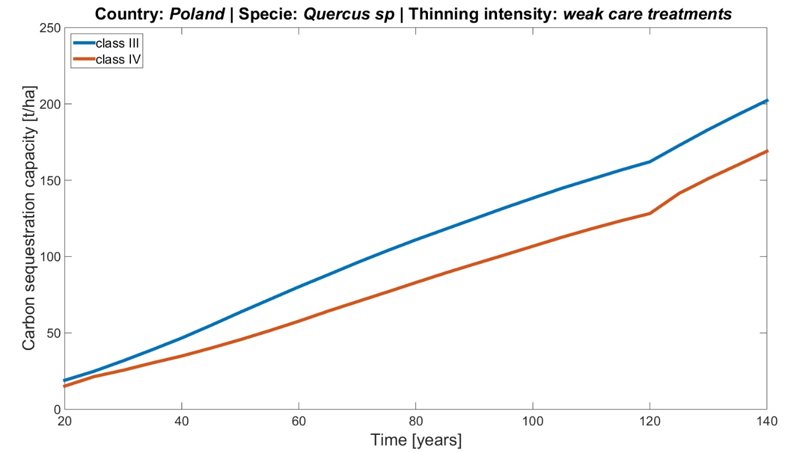
Figure 11. Simulation of carbon sequestration capacity of Quercus spp. in Poland.
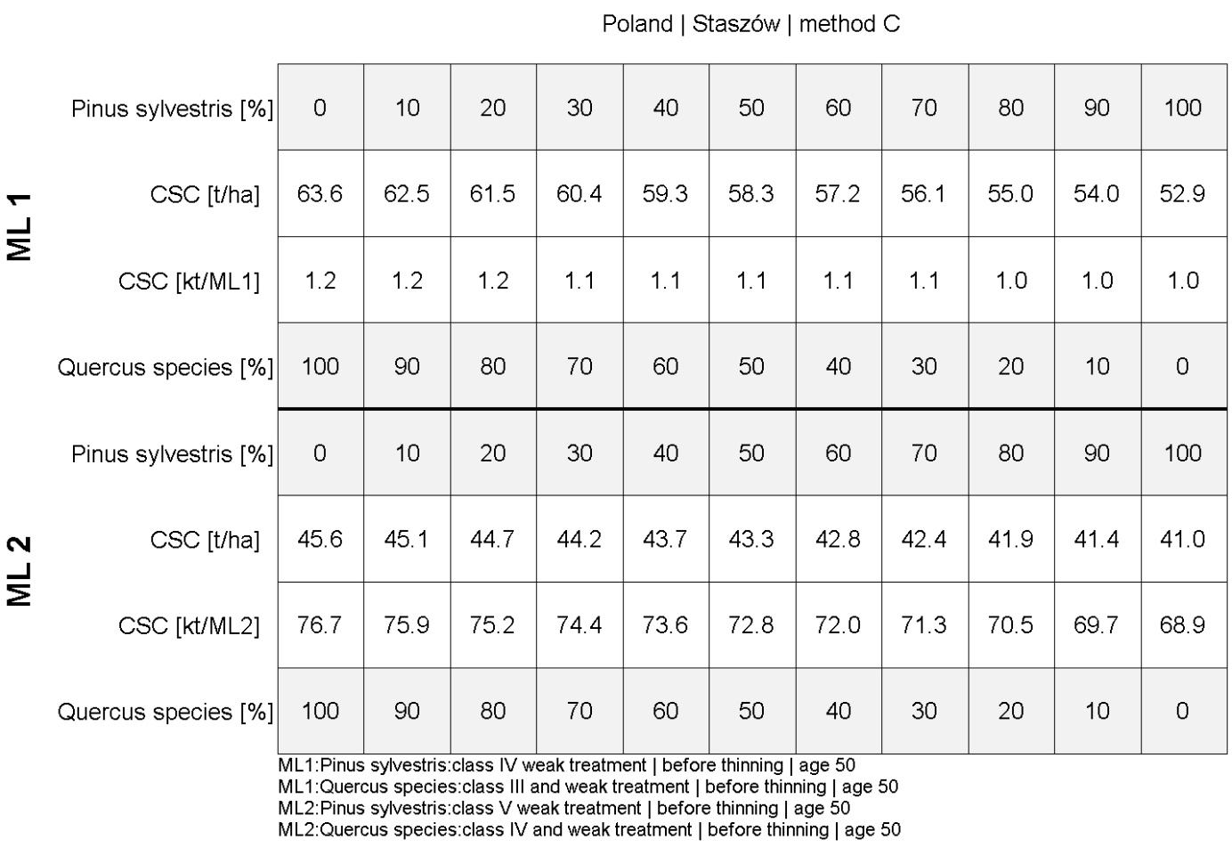
Figure 12. Carbon sequestration capacity of mixed species in “Staszów” test site.

Spain
The Marginal lands proposed for Spain consist of several potential sites that could be defined as Marginal Lands including semi-urban degraded lands and low productivity lands adjacent to natural parks and forest areas. The test sites are “Tierras Altas” is located in Soria province of Castilla y León, the area of the Municipality of Nogueruelas (Teruel) in the Central Eastern part of the Iberian Peninsula, and “Sierra de Espadán” in the province of Castellón ( region of Valencia) see Figure 13.
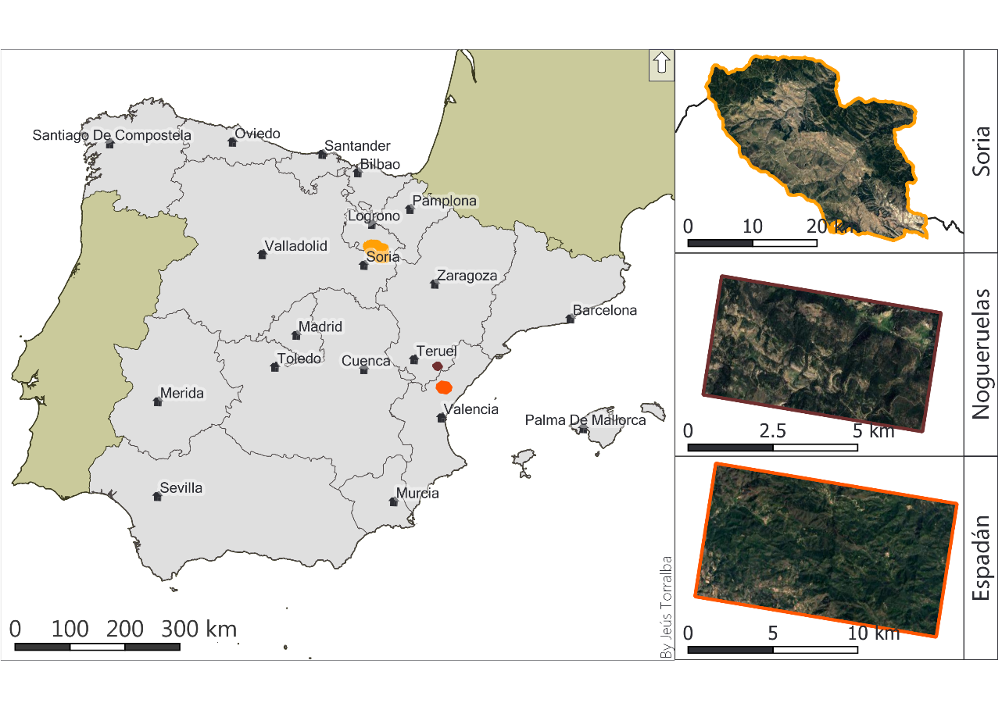
Figure 13. Spain (left) and the pilot site of “Soria” (outlined with light orange), “Nogueruelas” (outlined with dark red), and “Espadán” (right image outlined with dark orange).

Species selection
For the Spanish pilot sites, the national forest map was used (Figure 14, Figure 15, and Figure 16). This layer offers information about the structure and species composition for all the forest areas in Spain represented in tiles. For each pilot site, the current species composition was analyzed, and the most frequent species were selected for the reforestation module.

Soria: Tierras Altas
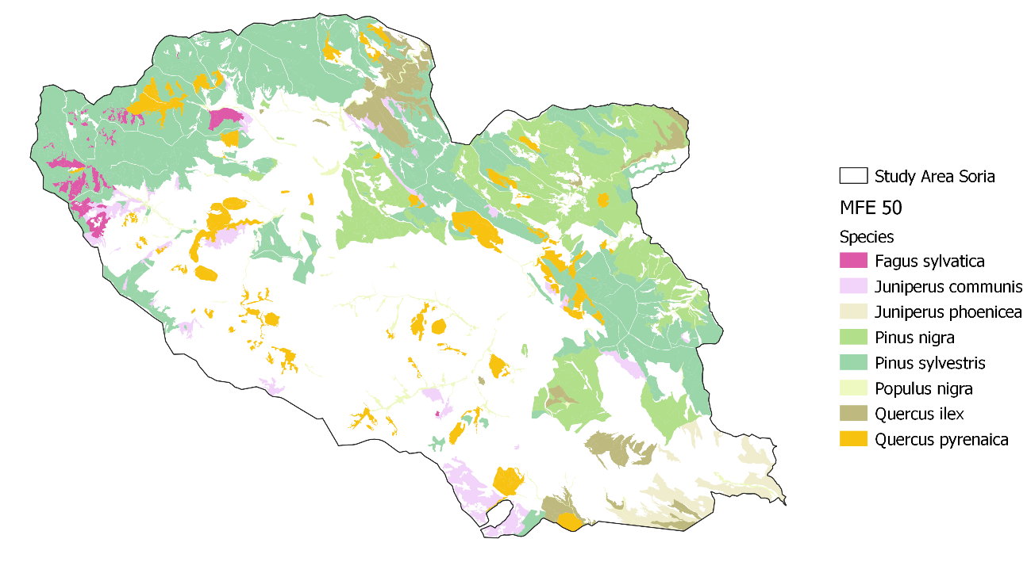
Figure 14. Species distribution for Tierras Altas, Soria. Source MFE50.
The species recurrence is summarized in Table 43:
Table 43. Area distribution for the main species in Tierras Altas, Soria according to the MFE50.
Species | Area [ha] | Area [%] | Frequency
Crataegus monogyna | 29.91 | 0.11 | 1
Fagus sylvatica | 552.46 | 1.95 | 35
Ilex aquifolium | 304.50 | 1.08 | 12
Juniperus communis | 1,307.99 | 4.62 | 47
Juniperus oxycedrus | 39.25 | 0.14 | 2
Juniperus phoenicea | 962.30 | 3.40 | 23
Juniperus thurifera | 47.82 | 0.17 | 1
Pinus nigra | 6,431.56 | 22.71 | 151
Pinus pinaster | 14.66 | 0.05 | 2
Pinus sylvestris | 13,410.31 | 47.36 | 313
Populus nigra | 668.71 | 2.36 | 47
Populus x canadensis | 65.31 | 0.23 | 3
Prunus avium | 2.79 | 0.01 | 1
Quercus faginea | 117.68 | 0.42 | 5
Quercus ilex | 1,853.43 | 6.54 | 64
Quercus pyrenaica | 2,484.21 | 8.77 | 117
Salix fragilis | 9.33 | 0.03 | 1
Salix spp. | 16.36 | 0.06 | 2
Total | 28,318.59 | 100.00 | 827

The table reflects that the most represented species in the Sorian test site area are: Pinus sylvestris, Pinus nigra, and Quercus pyrenaica. Although Quercus pyrenaica is representative of the study area, the fact that it is more resource-demanding than the conifer species present in the test site deems this species as a less suitable candidate for entering the restauration module.
Castellón: Sierra de Espadán
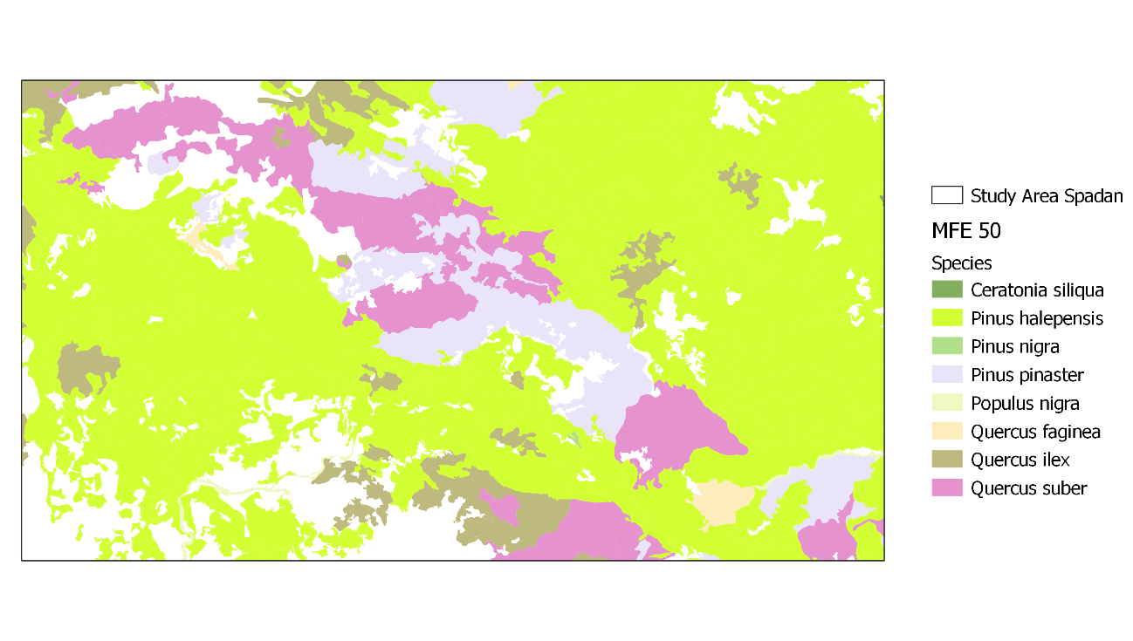
Figure 15. Species distribution in Sierra de Espadán, Castellón. Source MFE50.
The test site in la Sierra de Espadán is characterized by the presence of coniferous species (Table 44), mainly represented by Pinus halepensis (70%) and Pinus pinaster (10%), while broadleaves species are constituted by Quercus suber (12,30%) and Quercus ilex (6,41%). As previously argued before in the Soria test site (Tierras Altas), the marginal lands located in the Spanish Mediterranean sites are originated by environmental limitations rather than economic or social. Therefore, the species selection must prioritize the most resistant species to adverse ecological factors over more resource-demanding species. For this reason, coniferous species have been chosen for the reforestation module in Espadán. On a further note, Quercus ilex, despite its low representation in the area (6%), could be considered as potential species for reforestation in marginal lands, due to its endurance to both high and low temperatures and arid conditions during summer.
Table 44. Area distribution for the main species in Sierra de Espadán, Castellón according to the MFE50.
Species | Area [ha] | Area [%] | Frequency
Ceratonia siliqua | 0.70 | 0.01 | 1
Pinus halepensis | 6,786.63 | 70.04 | 156
Pinus nigra | 2.45 | 0.03 | 1
Pinus pinaster | 974.26 | 10.05 | 34
Populus nigra | 36.55 | 0.38 | 4
Quercus faginea | 75.75 | 0.78 | 4
Quercus ilex | 621.57 | 6.41 | 24
Quercus suber | 1,192.37 | 12.30 | 27
Total | 9,690.28 | 100.00 | 251
Teruel: Nogueruelas
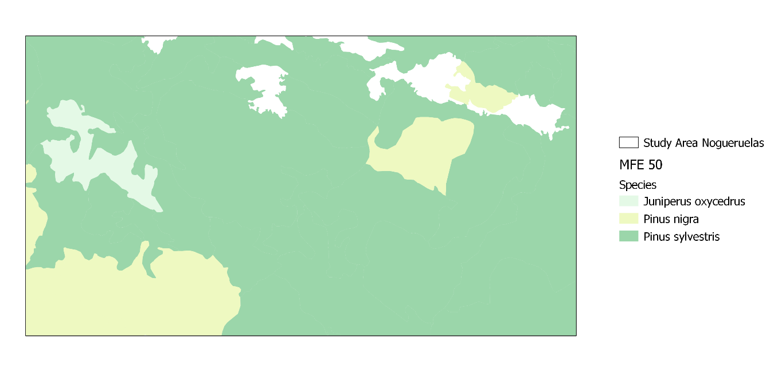
Figure 16. Species distribution in Nogueruelas, Teruel. Source MFE50.
As in other test sites in Spain, Nogueruela’s test site is mainly populated by coniferous species. In this area, the species composition is led by Pinus sylvestris and followed by Pinus nigra. Additionally, scarce formations of Juniperus oxycedrus appear in the study area. Next, the species abundance and area distribution are summarized:
Table 45. Area distribution for the main species in Nogueruelas, Teruel according to the MFE50.
Species | Area [ha] | Area [%] | Frequency
Juniperus oxycedrus | 71.91 | 3.21 | 1
Pinus nigra | 331.97 | 14.83 | 10
Pinus sylvestris | 1835.29 | 81.96 | 28
Total | 2239.17 | 100 | 39
The species selected for the reforestation modules were Pinus sylvestris and Pinus nigra as they were the most abundant.

Biomass and carbon estimation by species
Next, all the carbon estimations by species are presented for the Spanish test sites. The carbon values are given in 3 pools, above-ground carbon, below-ground carbon, and total carbon per tree and hectare (Table 46, Table 47, Table 48, and Table 49). Additionally, the above-ground carbon is divided into values branches, foliage, and stem.
Table 46. Biomass and Carbon estimation for Pinus pinaster for the aboveground and belowground components and total tree.
Species | Quality | State | Age | N | V | V | ABG C (kg)/tree |  |  |  | C AGB | C BGB | Total C | Total C
 |  |  | years | tree/ ha | m³/ ha | dm³/ tree | branch >7cm | branch 2-7cm | branch < 2cm | Stem | kg/ tree | kg/ tree | kg/ tree | kg/ ha
Pinus pinaster | 12 | Before thining | 40 | 1500 | 92.8 | 61.9 | 0.2 | 1.1 | 2.9 | 16.4 | 20.7 | 5.9 | 26.5 | 39816.9
P. pinaster | 12 | Before thining | 50 | 925 | 135.7 | 146.7 | 0.6 | 2.6 | 6.9 | 39.0 | 49.0 | 13.9 | 62.9 | 58223.7
P. pinaster | 12 | Before thining | 65 | 550 | 178.0 | 323.6 | 1.3 | 5.7 | 15.1 | 86.0 | 108.2 | 30.7 | 138.9 | 76373.0
P. pinaster | 12 | Before thining | 80 | 400 | 201.8 | 504.5 | 2.0 | 8.9 | 23.6 | 134.1 | 168.6 | 47.8 | 216.5 | 86584.6
P. pinaster | 12 | Thining | 40 | 575 | 29.4 | 51.1 | 0.2 | 0.9 | 2.4 | 13.6 | 17.1 | 4.8 | 21.9 | 12614.4
P. pinaster | 12 | Thining | 50 | 375 | 42.4 | 113.1 | 0.5 | 2.0 | 5.3 | 30.0 | 37.8 | 10.7 | 48.5 | 18192.2
P. pinaster | 12 | Thining | 65 | 150 | 40.1 | 267.3 | 1.1 | 4.7 | 12.5 | 71.0 | 89.4 | 25.3 | 114.7 | 17205.4
P. pinaster | 12 | After thining | 40 | 925 | 63.4 | 68.5 | 0.3 | 1.2 | 3.2 | 18.2 | 22.9 | 6.5 | 29.4 | 27202.5
P. pinaster | 12 | After thining | 50 | 550 | 93.2 | 169.5 | 0.7 | 3.0 | 7.9 | 45.0 | 56.6 | 16.1 | 72.7 | 39988.5
P. pinaster | 12 | After thining | 65 | 400 | 137.9 | 344.8 | 1.4 | 6.1 | 16.1 | 91.6 | 115.2 | 32.7 | 147.9 | 59167.6
P. pinaster | 15 | Before thinning | 35 | 1500 | 119.4 | 79.6 | 0.7 | 2.0 | 2.1 | 22.5 | 31.5 | 8.6 | 40.1 | 60187.0
P. pinaster | 15 | Before thinning | 45 | 925 | 182.8 | 197.6 | 1.8 | 5.0 | 5.2 | 55.8 | 78.3 | 21.3 | 99.6 | 92145.7
P. pinaster | 15 | Before thinning | 60 | 550 | 245.9 | 447.1 | 4.0 | 11.4 | 11.9 | 126.3 | 177.1 | 48.2 | 225.4 | 123953.1
P. pinaster | 15 | Before thinning | 75 | 350 | 279.6 | 798.9 | 7.2 | 20.3 | 21.2 | 225.7 | 316.5 | 86.2 | 402.7 | 140940.5
P. pinaster | 15 | Thinning | 35 | 575 | 37.8 | 65.7 | 0.6 | 1.7 | 1.7 | 18.6 | 26.0 | 7.1 | 33.1 | 19054.2
P. pinaster | 15 | Thinning | 45 | 375 | 57.2 | 152.5 | 1.4 | 3.9 | 4.1 | 43.1 | 60.4 | 16.5 | 76.9 | 28833.3
P. pinaster | 15 | Thinning | 60 | 200 | 73.8 | 369.0 | 3.3 | 9.4 | 9.8 | 104.2 | 146.2 | 39.8 | 186.0 | 37201.0
P. pinaster | 15 | Stand after thinning | 35 | 925 | 81.6 | 88.2 | 0.8 | 2.2 | 2.3 | 24.9 | 35.0 | 9.5 | 44.5 | 41132.9
P. pinaster | 15 | Stand after thinning | 45 | 550 | 125.6 | 228.4 | 2.1 | 5.8 | 6.1 | 64.5 | 90.5 | 24.6 | 115.1 | 63312.3
P. pinaster | 15 | Stand after thinning | 60 | 350 | 172.1 | 491.7 | 4.4 | 12.5 | 13.1 | 138.9 | 194.8 | 53.0 | 247.9 | 86752.0
Table 47. Biomass and Carbon estimation for Pinus nigra for the aboveground and belowground components and total tree.
Species | Quality | State | Age | N | V | V | ABG C (kg)/tree |  |  |  | C AGB | C BGB | Total C | Total C
 |  |  | years | tree/ ha | m³/ ha | dm³/ tree | branch >7cm | branch 2-7cm | branch < 2cm | Stem | kg/ tree | kg/ tree | kg/ tree | kg/ ha
Pinus nigra | 12 | Before thining | 40 | 1500 | 161.1 | 107.4 | 3.6 | 5.3 | 10.6 | 33.9 | 53.3 | 13.0 | 66.3 | 99424.1
P. nigra | 12 | Before thining | 50 | 1000 | 233.7 | 233.7 | 7.8 | 11.5 | 23.0 | 73.8 | 116.0 | 28.3 | 144.2 | 144229.8
P. nigra | 12 | Before thining | 65 | 650 | 263.1 | 404.8 | 13.5 | 19.9 | 39.8 | 127.7 | 200.8 | 49.0 | 249.8 | 162374.2
P. nigra | 12 | Before thining | 80 | 425 | 234.2 | 551.1 | 18.3 | 27.1 | 54.1 | 173.9 | 273.4 | 66.7 | 340.1 | 144538.4
P. nigra | 12 | Thining | 40 | 500 | 42.8 | 85.6 | 2.8 | 4.2 | 8.4 | 27.0 | 42.5 | 10.4 | 52.8 | 26414.4
P. nigra | 12 | Thining | 50 | 350 | 62.3 | 178.0 | 5.9 | 8.7 | 17.5 | 56.2 | 88.3 | 21.5 | 109.9 | 38448.9
P. nigra | 12 | Thining | 65 | 225 | 66.3 | 294.7 | 9.8 | 14.5 | 28.9 | 93.0 | 146.2 | 35.6 | 181.9 | 40917.6
P. nigra | 12 | After thining | 40 | 1000 | 118.3 | 118.3 | 3.9 | 5.8 | 11.6 | 37.3 | 58.7 | 14.3 | 73.0 | 73009.8
P. nigra | 12 | After thining | 50 | 650 | 171.3 | 263.5 | 8.8 | 12.9 | 25.9 | 83.2 | 130.8 | 31.9 | 162.6 | 105719.2
P. nigra | 12 | After thining | 65 | 425 | 196.9 | 463.3 | 15.4 | 22.8 | 45.5 | 146.2 | 229.9 | 56.0 | 285.9 | 121518.4
P. nigra | 15 | Before thinning | 40 | 1500 | 220.0 | 146.7 | 1.3 | 3.7 | 3.9 | 41.4 | 58.1 | 15.8 | 73.9 | 110897.4
P. nigra | 15 | Before thinning | 55 | 950 | 313.3 | 329.8 | 3.0 | 8.4 | 8.8 | 93.2 | 130.7 | 35.6 | 166.2 | 157928.0
P. nigra | 15 | Before thinning | 70 | 600 | 338.6 | 564.3 | 5.1 | 14.3 | 15.0 | 159.4 | 223.6 | 60.9 | 284.5 | 170681.2
P. nigra | 15 | Before thinning | 80 | 400 | 299.8 | 749.5 | 6.8 | 19.1 | 19.9 | 211.7 | 297.0 | 80.9 | 377.8 | 151122.9
P. nigra | 15 | Thinning | 40 | 550 | 64.3 | 116.9 | 1.1 | 3.0 | 3.1 | 33.0 | 46.3 | 12.6 | 58.9 | 32412.3
P. nigra | 15 | Thinning | 55 | 350 | 88.0 | 251.4 | 2.3 | 6.4 | 6.7 | 71.0 | 99.6 | 27.1 | 126.7 | 44359.0
P. nigra | 15 | Thinning | 70 | 200 | 82.1 | 410.5 | 3.7 | 10.4 | 10.9 | 116.0 | 162.6 | 44.3 | 206.9 | 41384.9
P. nigra | 15 | Stand after thinning | 40 | 950 | 155.6 | 163.8 | 1.5 | 4.2 | 4.3 | 46.3 | 64.9 | 17.7 | 82.6 | 78434.7
P. nigra | 15 | Stand after thinning | 55 | 600 | 225.4 | 375.7 | 3.4 | 9.6 | 10.0 | 106.1 | 148.8 | 40.5 | 189.4 | 113619.4
P. nigra | 15 | Stand after thinning | 70 | 400 | 256.5 | 641.3 | 5.8 | 16.3 | 17.0 | 181.1 | 254.1 | 69.2 | 323.2 | 129296.3
Table 48. Biomass and Carbon estimation for Pinus sylvestris for the aboveground and belowground components and total tree.
Species | Quality | State | Age | N | V | V | ABG C (kg)/tree |  |  |  | C AGB | C BGB | Total C | Total C
 |  |  | years | tree/ ha | m³/ ha | dm³/ tree | branch >7cm | branch 2-7cm | branch < 2cm | Stem | kg/ tree | kg/ tree | kg/ tree | kg/ ha
Pinus sylvestris | 12 | Before thinning | 40 | 1500 | 114.6 | 76.4 | 0.7 | 1.9 | 2.0 | 21.6 | 30.3 | 8.2 | 38.5 | 57767.5
P. sylvestris | 12 | Before thinning | 55 | 1000 | 175.8 | 175.8 | 1.6 | 4.5 | 4.7 | 49.7 | 69.7 | 19.0 | 88.6 | 88617.1
P. sylvestris | 12 | Before thinning | 70 | 625 | 182.8 | 292.5 | 2.6 | 7.4 | 7.8 | 82.6 | 115.9 | 31.6 | 147.4 | 92145.7
P. sylvestris | 12 | Before thinning | 110 | 450 | 241 | 535.6 | 4.8 | 13.6 | 14.2 | 151.3 | 212.2 | 57.8 | 270.0 | 121483.1
P. sylvestris | 12 | Thinning | 40 | 500 | 30.9 | 61.8 | 0.6 | 1.6 | 1.6 | 17.5 | 24.5 | 6.7 | 31.2 | 15576.0
P. sylvestris | 12 | Thinning | 55 | 375 | 48.6 | 129.6 | 1.2 | 3.3 | 3.4 | 36.6 | 51.3 | 14.0 | 65.3 | 24498.2
P. sylvestris | 12 | Thinning | 70 | 175 | 42.3 | 241.7 | 2.2 | 6.1 | 6.4 | 68.3 | 95.8 | 26.1 | 121.8 | 21322.5
P. sylvestris | 12 | Stand after thinning | 40 | 1000 | 83.7 | 83.7 | 0.8 | 2.1 | 2.2 | 23.6 | 33.2 | 9.0 | 42.2 | 42191.4
P. sylvestris | 12 | Stand after thinning | 55 | 625 | 127.2 | 203.5 | 1.8 | 5.2 | 5.4 | 57.5 | 80.6 | 22.0 | 102.6 | 64118.9
P. sylvestris | 12 | Stand after thinning | 70 | 450 | 140.5 | 312.2 | 2.8 | 7.9 | 8.3 | 88.2 | 123.7 | 33.7 | 157.4 | 70823.1
P. sylvestris | 15 | Before thinning | 35 | 1500 | 136.5 | 91.0 | 0.8 | 2.3 | 2.4 | 25.7 | 36.1 | 9.8 | 45.9 | 68806.8
P. sylvestris | 15 | Before thinning | 50 | 950 | 214.7 | 226.0 | 2.0 | 5.7 | 6.0 | 63.8 | 89.5 | 24.4 | 113.9 | 108225.8
P. sylvestris | 15 | Before thinning | 65 | 575 | 234.8 | 408.3 | 3.7 | 10.4 | 10.8 | 115.4 | 161.8 | 44.0 | 205.8 | 118357.8
P. sylvestris | 15 | Before thinning | 110 | 400 | 315.2 | 788.0 | 7.1 | 20.0 | 20.9 | 222.6 | 312.2 | 85.0 | 397.2 | 158885.7
P. sylvestris | 15 | Thinning | 35 | 550 | 40.4 | 73.5 | 0.7 | 1.9 | 2.0 | 20.8 | 29.1 | 7.9 | 37.0 | 20364.8
P. sylvestris | 15 | Thinning | 50 | 375 | 62.4 | 166.4 | 1.5 | 4.2 | 4.4 | 47.0 | 65.9 | 18.0 | 83.9 | 31454.5
P. sylvestris | 15 | Thinning | 65 | 175 | 59.1 | 337.7 | 3.1 | 8.6 | 9.0 | 95.4 | 133.8 | 36.4 | 170.2 | 29791.1
P. sylvestris | 15 | Stand after thinning | 35 | 950 | 96.1 | 101.2 | 0.9 | 2.6 | 2.7 | 28.6 | 40.1 | 10.9 | 51.0 | 48442.0
P. sylvestris | 15 | Stand after thinning | 50 | 575 | 152.3 | 264.9 | 2.4 | 6.7 | 7.0 | 74.8 | 104.9 | 28.6 | 133.5 | 76771.2
P. sylvestris | 15 | Stand after thinning | 65 | 400 | 175.7 | 439.3 | 4.0 | 11.2 | 11.7 | 124.1 | 174.0 | 47.4 | 221.4 | 88566.7
Table 49. Biomass and Carbon estimation for Pinus halepensis for the aboveground and belowground components and total tree.
Species | Quality | State | Age | N | V | V | ABG C (kg)/tree |  |  |  | C AGB | C BGB | Total C | Total C
 |  |  | years | tree/  ha | m³/  ha | dm³/  tree | branch >7cm | branch 2-7cm | branch < 2cm | Stem | kg/  tree | kg/  tree | kg/  tree | kg/  ha
Pinus halepensis | 11 | Before thining | 20 | 2103 | 12.9 | 6.1 | 0.5 | 0.4 | 1.1 | 1.9 | 3.9 | 1.2 | 5 | 10618.9
P. halepensis | 11 | Before thining | 30 | 2038 | 30.2 | 14.8 | 1.2 | 1 | 2.6 | 4.5 | 9.3 | 2.9 | 12.2 | 24859.9
P. halepensis | 11 | Before thining | 40 | 1952 | 51.2 | 26.2 | 2.1 | 1.8 | 4.6 | 8 | 16.5 | 5.1 | 21.6 | 42146.5
P. halepensis | 11 | Before thining | 50 | 1305 | 65.8 | 50.4 | 4.1 | 3.5 | 8.8 | 15.3 | 31.7 | 9.8 | 41.5 | 54164.9
P. halepensis | 11 | Before thining | 60 | 1233 | 82.7 | 67.1 | 5.4 | 4.6 | 11.7 | 20.4 | 42.2 | 13 | 55.2 | 68076.5
P. halepensis | 11 | Before thining | 70 | 1005 | 92.5 | 92 | 7.4 | 6.4 | 16.1 | 28 | 57.9 | 17.9 | 75.8 | 76143.6
P. halepensis | 11 | Before thining | 80 | 862 | 100.3 | 116.4 | 9.4 | 8 | 20.3 | 35.4 | 73.2 | 22.6 | 95.8 | 82564.4
P. halepensis | 11 | Before thining | 90 | 766 | 106.5 | 139 | 11.2 | 9.6 | 24.3 | 42.3 | 87.4 | 27 | 114.4 | 87668
P. halepensis | 11 | Before thining | 100 | 699 | 111.5 | 159.5 | 12.8 | 11 | 27.9 | 48.6 | 100.3 | 31 | 131.3 | 91783.9
P. halepensis | 11 | Before thining | 110 | 650 | 115.6 | 177.8 | 14.3 | 12.3 | 31.1 | 54.1 | 111.8 | 34.6 | 146.4 | 95158.9
P. halepensis | 11 | Before thining | 120 | 613 | 118.9 | 194 | 15.6 | 13.4 | 33.9 | 59 | 122 | 37.7 | 159.7 | 97875.4
P. halepensis | 11 | Thining | 20 | 65 | 0.1 | 1.5 | 0.1 | 0.1 | 0.3 | 0.5 | 1 | 0.3 | 1.3 | 82.3
P. halepensis | 11 | Thining | 30 | 86 | 0.3 | 3.5 | 0.3 | 0.2 | 0.6 | 1.1 | 2.2 | 0.7 | 2.9 | 247
P. halepensis | 11 | Thining | 40 | 647 | 3.6 | 5.6 | 0.4 | 0.4 | 1 | 1.7 | 3.5 | 1.1 | 4.6 | 2963.4
P. halepensis | 11 | Thining | 50 | 72 | 4.5 | 62.5 | 5 | 4.3 | 10.9 | 19 | 39.3 | 12.1 | 51.4 | 3704.3
P. halepensis | 11 | Thining | 60 | 227 | 9.3 | 41 | 3.3 | 2.8 | 7.2 | 12.5 | 25.8 | 8 | 33.7 | 7655.5
P. halepensis | 11 | Thining | 70 | 143 | 13.7 | 95.8 | 7.7 | 6.6 | 16.7 | 29.2 | 60.3 | 18.6 | 78.9 | 11277.5
P. halepensis | 11 | Thining | 80 | 96 | 17.6 | 183.3 | 14.8 | 12.7 | 32.1 | 55.8 | 115.3 | 35.6 | 150.9 | 14487.9
P. halepensis | 11 | Thining | 90 | 67 | 21 | 313.4 | 25.2 | 21.7 | 54.8 | 95.4 | 197.1 | 60.9 | 258 | 17286.7
P. halepensis | 11 | Thining | 100 | 49 | 23.8 | 485.7 | 39.1 | 33.6 | 84.9 | 147.8 | 305.5 | 94.4 | 399.8 | 19591.5
P. halepensis | 11 | Thining | 110 | 37 | 26.2 | 708.1 | 57 | 49 | 123.8 | 215.5 | 445.3 | 137.6 | 582.9 | 21567.2
P. halepensis | 11 | Thining | 120 | – | – | – | – | – | – | – | – | – | – | –
P. halepensis | 11 | After thining | 20 | 2038 | 13 | 6.4 | 0.5 | 0.4 | 1.1 | 1.9 | 4 | 1.2 | 5.3 | 10701.3
P. halepensis | 11 | After thining | 30 | 1952 | 30.1 | 15.4 | 1.2 | 1.1 | 2.7 | 4.7 | 9.7 | 3 | 12.7 | 24777.5
P. halepensis | 11 | After thining | 40 | 1305 | 47.1 | 36.1 | 2.9 | 2.5 | 6.3 | 11 | 22.7 | 7 | 29.7 | 38771.5
P. halepensis | 11 | After thining | 50 | 1233 | 64.8 | 52.6 | 4.2 | 3.6 | 9.2 | 16 | 33.1 | 10.2 | 43.3 | 53341.7
P. halepensis | 11 | After thining | 60 | 1005 | 77.5 | 77.1 | 6.2 | 5.3 | 13.5 | 23.5 | 48.5 | 15 | 63.5 | 63796
P. halepensis | 11 | After thining | 70 | 862 | 87.8 | 101.9 | 8.2 | 7 | 17.8 | 31 | 64.1 | 19.8 | 83.8 | 72274.7
P. halepensis | 11 | After thining | 80 | 766 | 96.1 | 125.5 | 10.1 | 8.7 | 21.9 | 38.2 | 78.9 | 24.4 | 103.3 | 79107
P. halepensis | 11 | After thining | 90 | 699 | 102.9 | 147.2 | 11.9 | 10.2 | 25.7 | 44.8 | 92.6 | 28.6 | 121.2 | 84704.6
P. halepensis | 11 | After thining | 100 | 650 | 108.5 | 166.9 | 13.4 | 11.5 | 29.2 | 50.8 | 105 | 32.4 | 137.4 | 89314.4
P. halepensis | 11 | After thining | 110 | 613 | 113 | 184.3 | 14.8 | 12.8 | 32.2 | 56.1 | 115.9 | 35.8 | 151.7 | 93018.7
P. halepensis | 11 | After thining | 120 | – | – | – | – | – | – | – | – | – | – | –
P. halepensis | 14 | Before thining | 20 | 1586 | 24.7 | 15.6 | 1.3 | 1.1 | 2.7 | 4.7 | 9.8 | 3 | 12.8 | 20332.4
P. halepensis | 14 | Before thining | 30 | 1481 | 53.3 | 36 | 2.9 | 2.5 | 6.3 | 11 | 22.6 | 7 | 29.6 | 43875.2
P. halepensis | 14 | Before thining | 40 | 1342 | 85 | 63.3 | 5.1 | 4.4 | 11.1 | 19.3 | 39.8 | 12.3 | 52.1 | 69969.8
P. halepensis | 14 | Before thining | 50 | 1006 | 107.1 | 106.5 | 8.6 | 7.4 | 18.6 | 32.4 | 67 | 20.7 | 87.6 | 88161.9
P. halepensis | 14 | Before thining | 60 | 977 | 134.5 | 137.7 | 11.1 | 9.5 | 24.1 | 41.9 | 86.6 | 26.7 | 113.3 | 110716.9
P. halepensis | 14 | Before thining | 70 | 797 | 147.2 | 184.7 | 14.9 | 12.8 | 32.3 | 56.2 | 116.2 | 35.9 | 152 | 121171.2
P. halepensis | 14 | Before thining | 80 | 684 | 157.4 | 230.1 | 18.5 | 15.9 | 40.2 | 70 | 144.7 | 44.7 | 189.4 | 129567.6
P. halepensis | 14 | Before thining | 90 | 608 | 165.5 | 272.2 | 21.9 | 18.8 | 47.6 | 82.9 | 171.2 | 52.9 | 224.1 | 136235.3
P. halepensis | 14 | Before thining | 100 | 554 | 172 | 310.5 | 25 | 21.5 | 54.3 | 94.5 | 195.3 | 60.3 | 255.6 | 141585.9
P. halepensis | 14 | Before thining | 110 | 515 | 177.3 | 344.3 | 27.7 | 23.8 | 60.2 | 104.8 | 216.5 | 66.9 | 283.4 | 145948.8
P. halepensis | 14 | Before thining | 120 | 486 | 181.6 | 373.7 | 30.1 | 25.8 | 65.3 | 113.7 | 235 | 72.6 | 307.6 | 149488.4
P. halepensis | 14 | Thining | 20 | 65 | 0.1 | 1.5 | 0.2 | 0.1 | 0.3 | 0.6 | 1.2 | 0.4 | 1.6 | 164.6
P. halepensis | 14 | Thining | 30 | 86 | 0.3 | 3.5 | 0.7 | 0.6 | 1.5 | 2.6 | 5.4 | 1.7 | 7.1 | 987.8
P. halepensis | 14 | Thining | 40 | 647 | 3.6 | 5.6 | 2 | 1.7 | 4.3 | 7.4 | 15.3 | 4.7 | 20.1 | 6750
P. halepensis | 14 | Thining | 50 | 72 | 4.5 | 62.5 | 25.8 | 22.2 | 56.1 | 97.6 | 201.7 | 62.3 | 264 | 7655.5
P. halepensis | 14 | Thining | 60 | 227 | 9.3 | 41 | 8.8 | 7.6 | 19.1 | 33.3 | 68.8 | 21.3 | 90.1 | 16216.5
P. halepensis | 14 | Thining | 70 | 143 | 13.7 | 95.8 | 20.4 | 17.6 | 44.4 | 77.3 | 159.7 | 49.3 | 209.1 | 23625.1
P. halepensis | 14 | Thining | 80 | 96 | 17.6 | 183.3 | 38.4 | 33 | 83.5 | 145.4 | 300.4 | 92.8 | 393.2 | 29881.2
P. halepensis | 14 | Thining | 90 | 67 | 21 | 313.4 | 64.7 | 55.6 | 140.5 | 244.7 | 505.5 | 156.1 | 661.6 | 35067.2
P. halepensis | 14 | Thining | 100 | 49 | 23.8 | 485.7 | 98.9 | 85 | 214.7 | 373.9 | 772.4 | 238.6 | 1011 | 39430
P. halepensis | 14 | Thining | 110 | 37 | 26.2 | 708.1 | 145.5 | 125 | 315.9 | 550 | 1136.4 | 351 | 1487.4 | 43134.3
P. halepensis | 14 | Thining | 120 | – | – | – | – | – | – | – | – | – | – | –
P. halepensis | 14 | After thining | 20 | 2038 | 13 | 6.4 | 1.3 | 1.2 | 2.9 | 5.1 | 10.5 | 3.2 | 13.7 | 20332.4
P. halepensis | 14 | After thining | 30 | 1952 | 30.1 | 15.4 | 3.1 | 2.7 | 6.8 | 11.8 | 24.4 | 7.5 | 32 | 42887.4
P. halepensis | 14 | After thining | 40 | 1305 | 47.1 | 36.1 | 6.2 | 5.3 | 13.5 | 23.4 | 48.4 | 14.9 | 63.3 | 63713.7
P. halepensis | 14 | After thining | 50 | 1233 | 64.8 | 52.6 | 8.7 | 7.5 | 19 | 33 | 68.2 | 21.1 | 89.2 | 87174.1
P. halepensis | 14 | After thining | 60 | 1005 | 77.5 | 77.1 | 12.5 | 10.7 | 27.1 | 47.2 | 97.5 | 30.1 | 127.7 | 101744.3
P. halepensis | 14 | After thining | 70 | 862 | 87.8 | 101.9 | 16.2 | 13.9 | 35.2 | 61.4 | 126.8 | 39.2 | 166 | 113515.7
P. halepensis | 14 | After thining | 80 | 766 | 96.1 | 125.5 | 19.8 | 17 | 43 | 74.8 | 154.6 | 47.8 | 202.4 | 123064.5
P. halepensis | 14 | After thining | 90 | 699 | 102.9 | 147.2 | 23.1 | 19.8 | 50.1 | 87.3 | 180.4 | 55.7 | 236.1 | 130802.4
P. halepensis | 14 | After thining | 100 | 650 | 108.5 | 166.9 | 26 | 22.4 | 56.5 | 98.4 | 203.3 | 62.8 | 266.1 | 137058.5
P. halepensis | 14 | After thining | 110 | 613 | 113 | 184.3 | 28.6 | 24.6 | 62.2 | 108.2 | 223.6 | 69.1 | 292.7 | 142244.5
P. halepensis | 14 | After thining | 120 | – | – | – | – | – | – | – | – | – | – | –

5.3.3 Carbon sequestration capacity simulations
Using simulated forest growth and values of future biomass and carbon sequestration capacity of selected species (Figure 19, Figure 18, Figure 20, Figure 17) one-time point was selected (~50 years). Tables presented in Figure 21, Figure 22, and Figure 23 show the carbon sequestration for the test sites in Spain. For these areas, two species were proposed for each test site, as indicated in chapter 5.3.1 The Carbon values are given by ML type and by species combination in tones by ha [t/ha] and for all the surface of the ML in kilotonnes by ha [kt/ha]. Here, we observe that the main carbon fixing species in the case of ML1 class is Pinus nigra sequestering 157.9 C t/ha whereas Pinus sylvestris captures 108.2 C t /ha, Pinus pinaster captures 108.1 C t /ha and Pinus halepensis captures 88.2 C t /ha. If we observe the amount of carbon fixed for the whole ML area within the Soria test site, planting only Pinus nigra would fix 3,963.3 kilotonnes of Carbon. On the other hand planting the whole surface of the ML with Pinus sylvestris, 2687.7 kilotonnes of would be fixed.
In Nogueruelas, if we observe the amount of carbon fixed for the whole ML area, planting only Pinus nigra would fix 3.2 kilotonnes of Carbon. On the other hand planting the whole surface of the ML with Pinus sylvestris, 2.1 kilotonnes of would be fixed.
In Espadan, if we observe the amount of carbon fixed for the whole ML area, planting only Pinus pinaster would fix 31.9 kilotonnes of Carbon. On the other hand, planting the whole surface of the ML with Pinus halepensis, 38.9 kilotonnes of would be fixed.
Although maximizing the carbon intake of the ML would be better for the plantation of one species, it is encouraged to apply:
- in Soria, a mixture of Pinus nigra in 70-80 % and Pinus sylvestris in 30-20%,
- in Nogueruelas, a mixture of Pinus nigra in 70-80 % and Pinus sylvestris in 30-20%,
- in Espadan, a mixture of Pinus pinaster in 70-80 % and Pinus halepensis in 30-20%,
to enhance biodiversity, resilience against disturbances such as forest fires, extreme weather events, and pests.

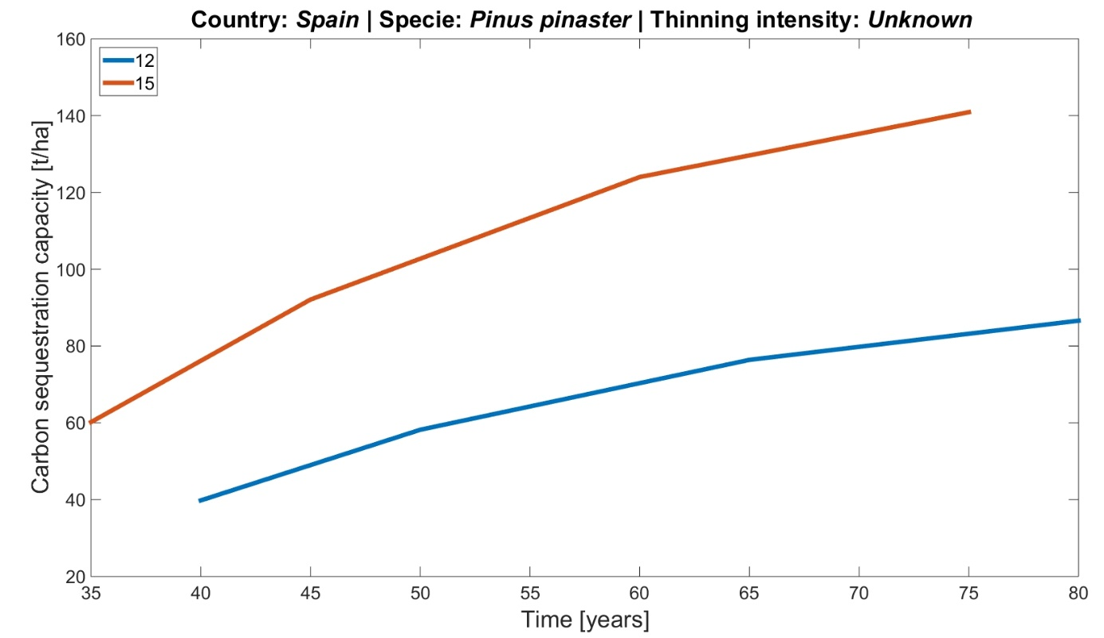
Figure 17. Simulation of carbon sequestration capacity of Pinus pinaster in Spain.

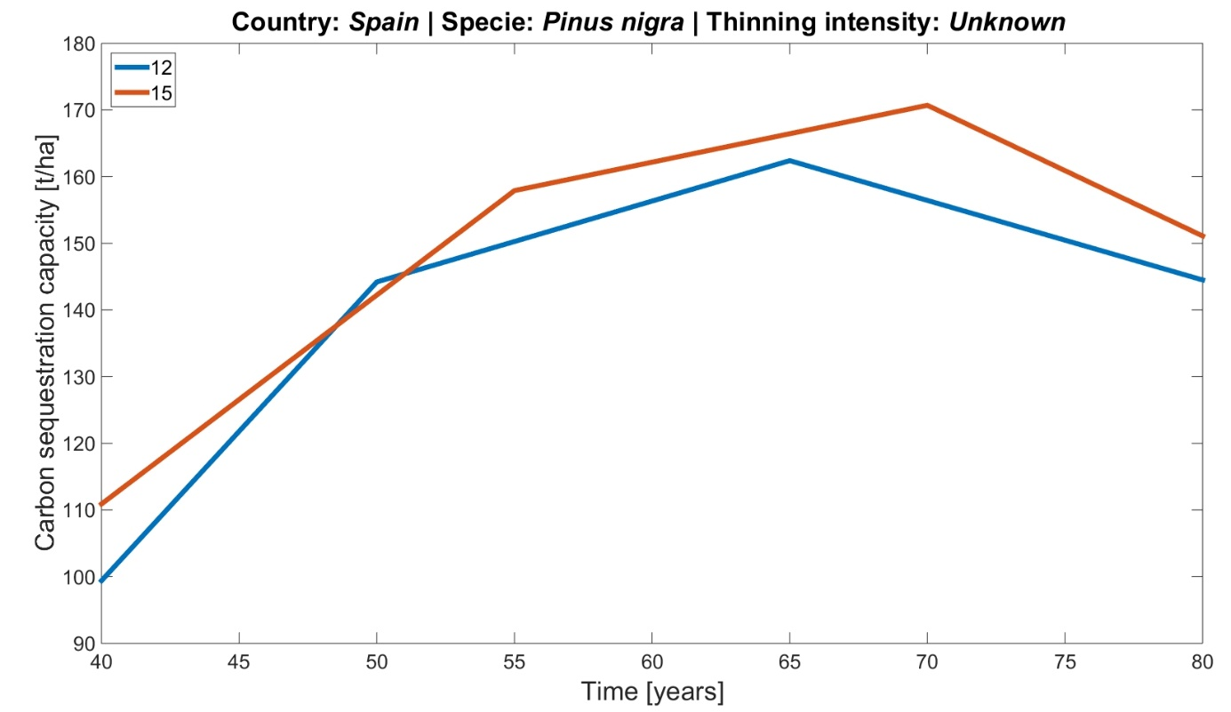
Figure 18. Simulation of carbon sequestration capacity of Pinus nigra in Spain.

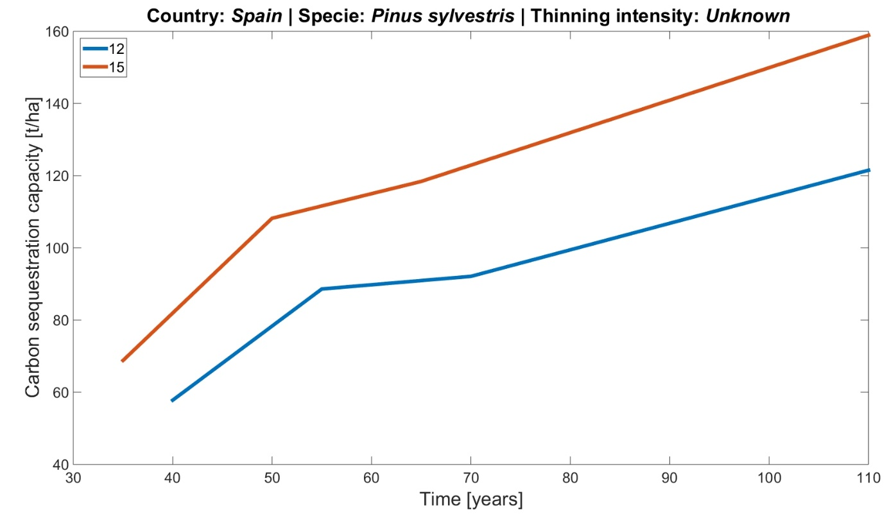
Figure 19. Simulation of carbon sequestration capacity of Pinus sylvestris in Spain.
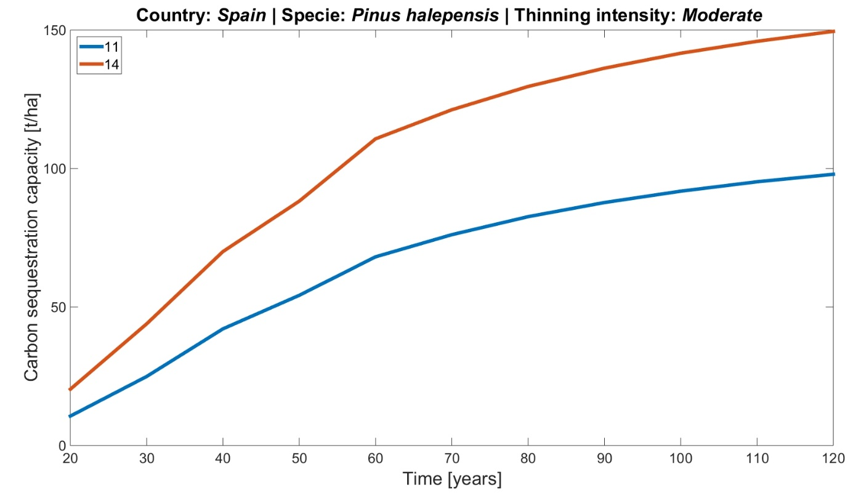
Figure 20. Simulation of carbon sequestration capacity of Pinus halepensis in Spain.

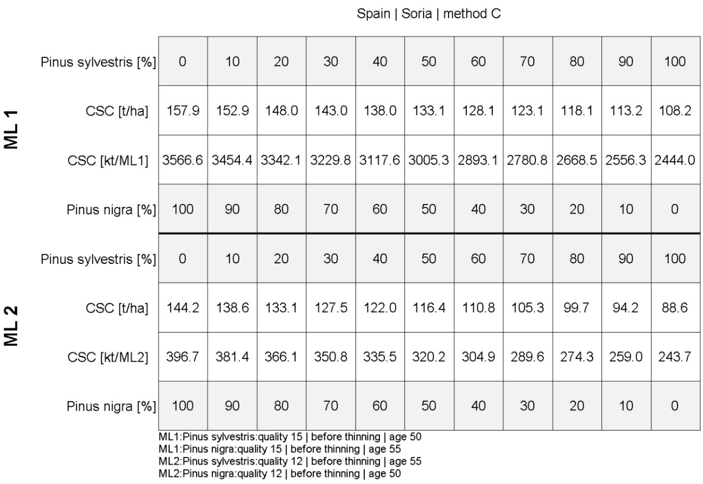
Figure 21. Carbon sequestration capacity of mixed species in “Soria” test site.
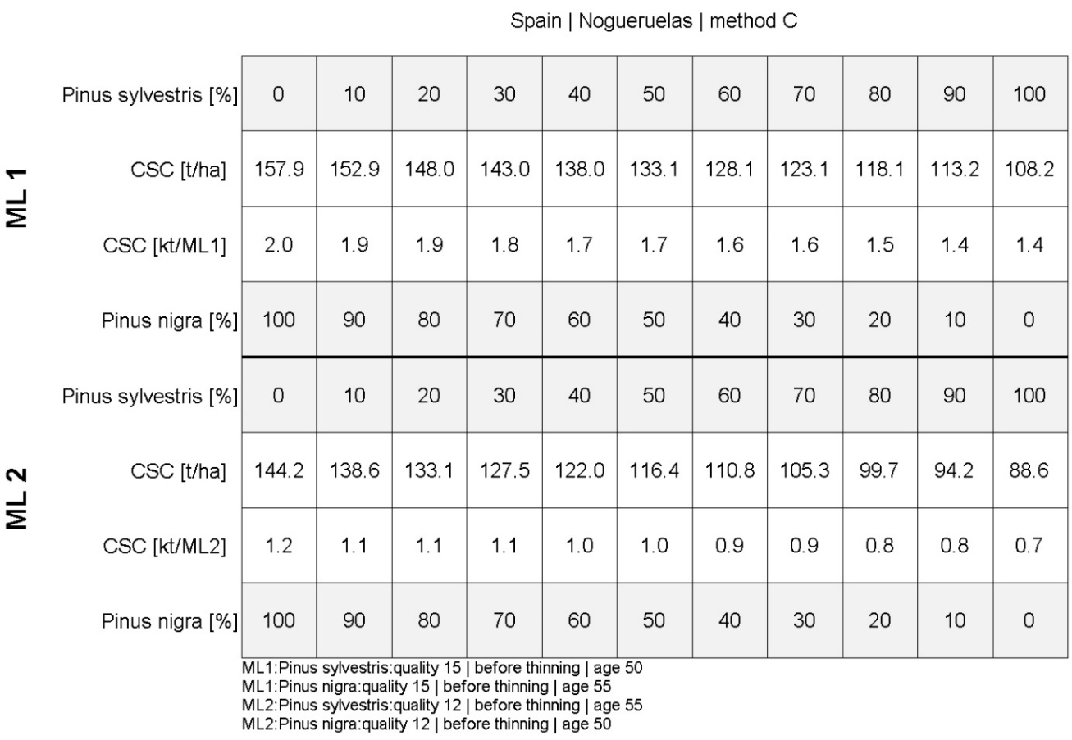
Figure 22. Carbon sequestration capacity of mixed species in “Nogueruelas” test site.
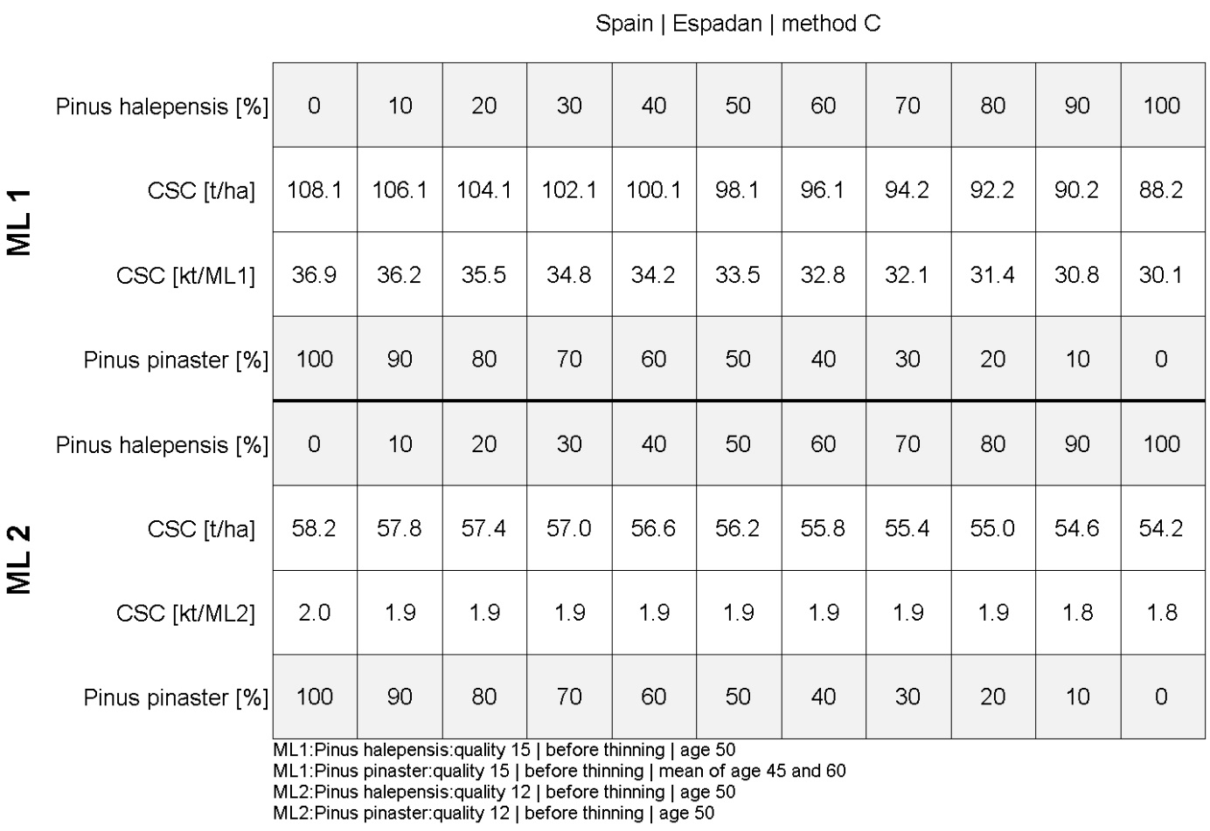
Figure 23. Carbon sequestration capacity of mixed species in “Espadan” test site.

Greece
The pilot site selected Greece to share the same marginality conditions that the Spanish ones, they are low productivity lands adjacent to natural parks and forest areas. The test sites are located in the Region of Eastern Macedonia and Thrace, and more specifically, the agricultural areas of “Proskynites” and “Xylagani” adjacent to the city of Komotini, Namely, the suburban forest of “Kedrinos Lofos” located in the north and the northeast side of the city of Thessaloniki. The test sites are represented in figure Figure 24.
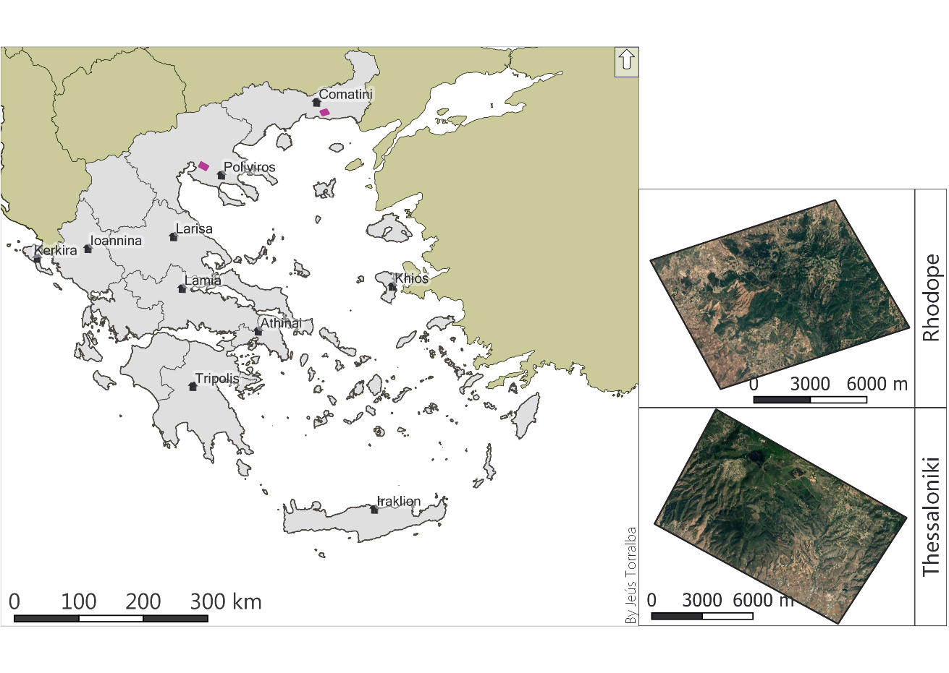
Figure 24. Greece (left) and the pilot site of the afforestation forest of “Rhodope” and “Thessaloniki”.

5.4.1 Species selection
The forest inventory shows that coniferous and deciduous trees are equally distributed in the test site (Table 50). The coniferous species are composed of Pinus brutia and Pinus halepensis, both Mediterranean coniferous species adapted to scarce rainfall regimes, optimal for their implantation in MLs. Although no species composition for broadleaf is retrieved in the forest inventory, after expert consultation with MAIL’s project partner, HOMEOTECH, it was confirmed that the evergreen species present in the Isenli forest was Quercus frainetto. Due to the remarkable presence of Quercus frainetto in the pilot site area, it was selected as well as a suitable species for the reforestation module.
Table 50. Area distribution for the main species in the Greek test sites.
Species | Plot Count | Presence in plot [%] | Trees / ha | trees [%]
Deciduous broadleaf's | 1 | 2.38 | - | -
Evergreen broadleaf's | 16 | 38.10 | - | -
Pinus brutia | 14 | 33.33 | 16,330 | 53.33
Pinus halepensis | 10 | 23.81 | 13,940 | 45.53
Pinus pinaster | 1 | 2.38 | 350 | 1.14%
Total | 42 | 100 | 30,620 | 100

Biomass and carbon estimation by species
The biomass estimations for the species selected for the Greek pilot sites are presented. The carbon values are given for 3 pools the aboveground biomass, below-ground biomass, and the totality of the tree. The biomass estimations for Pinus halepensis in Greece were calculated following the values in the yield table for Pinus halepensis in Spain. Therefore, the carbon estimations for Pinus halepensis in Greece correspond to the values presented in Table 51.
Table 51. Biomass and Carbon estimation for Quercus frainetto for the aboveground and belowground components and total tree.
SI | Age | N | Vol with bark | Vol | Dry weight | Above Ground Biomass (kg/ha) |  |  |  |  |  | Below Ground Biomass | Above Ground Carbon (Kg/Ha) |  |  |  |  |  | Below  Ground  Carbon
 | year | trees/  ha | m³/  ha | m³/  ha | kg/  ha | Foliage | Branch | Bark | Stem | Stem+ bark | Total ABG | kg/ Ha | Foliage | Branch | Bark | Stem | Stem+bark | Total ABG | Kg/  ha
IVa | 10 | 8500 | 24.1 | 16.6 | 17834 | 2116.9 | 3210.1 | 2470.0 | 10037.0 | 12507.0 | 17834 | 4993.5 | 1058.4 | 1605.1 | 1235.0 | 5018.5 | 6253.5 | 8917 | 2496.8
IVa | 12 | 8260 | 28.9 | 20.0 | 21386 | 2538.5 | 3849.5 | 2962.0 | 12036.0 | 14998.0 | 21386 | 5988.1 | 1269.3 | 1924.7 | 1481.0 | 6018.0 | 7499.0 | 10693 | 2994.0
IVa | 14 | 8020 | 34.0 | 23.7 | 25160 | 2986.5 | 4528.8 | 3484.7 | 14160.0 | 17644.7 | 25160 | 7044.8 | 1493.2 | 2264.4 | 1742.3 | 7080.0 | 8822.4 | 12580 | 3522.4
IVa | 15 | 7900 | 36.8 | 25.7 | 27232 | 3232.4 | 4901.8 | 3771.6 | 15326.2 | 19097.8 | 27232 | 7625.0 | 1616.2 | 2450.9 | 1885.8 | 7663.1 | 9548.9 | 13616 | 3812.5
IVa | 16 | 7760 | 39.6 | 27.8 | 29304 | 3478.4 | 5274.7 | 4058.6 | 16492.3 | 20550.9 | 29304 | 8205.1 | 1739.2 | 2637.4 | 2029.3 | 8246.1 | 10275.4 | 14652 | 4102.6
IVa | 18 | 7480 | 45.7 | 32.3 | 33818 | 4014.2 | 6087.2 | 4683.8 | 19032.8 | 23716.6 | 33818 | 9469.0 | 2007.1 | 3043.6 | 2341.9 | 9516.4 | 11858.3 | 16909 | 4734.5
IVa | 20 | 7200 | 51.7 | 36.7 | 38258 | 4541.2 | 6886.4 | 5298.7 | 21531.6 | 26830.3 | 38258 | 10712.2 | 2270.6 | 3443.2 | 2649.4 | 10765.8 | 13415.2 | 19129 | 5356.1
IVa | 22 | 6840 | 57.0 | 40.8 | 42180 | 5006.8 | 7592.4 | 5841.9 | 23738.9 | 29580.8 | 42180 | 11810.4 | 2503.4 | 3796.2 | 2921.0 | 11869.5 | 14790.4 | 21090 | 5905.2
IVa | 24 | 6480 | 62.0 | 44.6 | 45880 | 5446.0 | 8258.4 | 6354.4 | 25821.3 | 32175.6 | 45880 | 12846.4 | 2723.0 | 4129.2 | 3177.2 | 12910.6 | 16087.8 | 22940 | 6423.2
IVa | 25 | 6300 | 64.3 | 46.3 | 47582 | 5648.0 | 8564.8 | 6590.1 | 26779.1 | 33369.3 | 47582 | 13323.0 | 2824.0 | 4282.4 | 3295.1 | 13389.6 | 16684.6 | 23791 | 6661.5
IVa | 26 | 6020 | 66.4 | 48.0 | 49136 | 5832.4 | 8844.5 | 6805.3 | 27653.7 | 34459.1 | 49136 | 13758.1 | 2916.2 | 4422.2 | 3402.7 | 13826.9 | 17229.5 | 24568 | 6879.0
IVa | 28 | 5460 | 70.5 | 51.2 | 52170 | 6192.6 | 9390.6 | 7225.5 | 29361.3 | 36586.8 | 52170 | 14607.6 | 3096.3 | 4695.3 | 3612.8 | 14680.6 | 18293.4 | 26085 | 7303.8
IVa | 30 | 4900 | 74.2 | 54.4 | 54908 | 6517.6 | 9883.4 | 7604.8 | 30902.2 | 38507.0 | 54908 | 15374.2 | 3258.8 | 4941.7 | 3802.4 | 15451.1 | 19253.5 | 27454 | 7687.1
IVa | 32 | 4420 | 77.8 | 57.4 | 57572 | 6833.8 | 10363.0 | 7973.7 | 32401.5 | 40375.2 | 57572 | 16120.2 | 3416.9 | 5181.5 | 3986.9 | 16200.8 | 20187.6 | 28786 | 8060.1
IVa | 34 | 3940 | 80.9 | 60.3 | 59866 | 7106.1 | 10775.9 | 8291.4 | 33692.6 | 41984.0 | 59866 | 16762.5 | 3553.0 | 5387.9 | 4145.7 | 16846.3 | 20992.0 | 29933 | 8381.2
IVa | 35 | 3700 | 82.4 | 61.7 | 60976 | 7237.9 | 10975.7 | 8445.2 | 34317.3 | 42762.5 | 60976 | 17073.3 | 3618.9 | 5487.8 | 4222.6 | 17158.6 | 21381.2 | 30488 | 8536.6
IVa | 36 | 3640 | 83.8 | 62.9 | 62012 | 7360.8 | 11162.2 | 8588.7 | 34900.4 | 43489.0 | 62012 | 17363.4 | 3680.4 | 5581.1 | 4294.3 | 17450.2 | 21744.5 | 31006 | 8681.7
IVa | 38 | 3520 | 86.4 | 65.1 | 63936 | 7589.2 | 11508.5 | 8855.1 | 35983.2 | 44838.3 | 63936 | 17902.1 | 3794.6 | 5754.2 | 4427.6 | 17991.6 | 22419.2 | 31968 | 8951.0
IVa | 40 | 3400 | 88.9 | 67.2 | 65786 | 7808.8 | 11841.5 | 9111.4 | 37024.4 | 46135.7 | 65786 | 18420.1 | 3904.4 | 5920.7 | 4555.7 | 18512.2 | 23067.9 | 32893 | 9210.0
IVa | 42 | 3400 | 91.1 | 68.8 | 67414 | 8002.0 | 12134.5 | 9336.8 | 37940.6 | 47277.4 | 67414 | 18875.9 | 4001.0 | 6067.3 | 4668.4 | 18970.3 | 23638.7 | 33707 | 9438.0
IVa | 44 | 3400 | 93.2 | 70.4 | 68968 | 8186.5 | 12414.2 | 9552.1 | 38815.2 | 48367.3 | 68968 | 19311.0 | 4093.3 | 6207.1 | 4776.0 | 19407.6 | 24183.6 | 34484 | 9655.5
IVa | 45 | 3400 | 94.0 | 71.2 | 69560 | 8256.8 | 12520.8 | 9634.1 | 39148.4 | 48782.4 | 69560 | 19476.8 | 4128.4 | 6260.4 | 4817.0 | 19574.2 | 24391.2 | 34780 | 9738.4
IVb | 10 | 8700 | 19.5 | 13.2 | 14430 | 1712.8 | 2597.4 | 1998.6 | 8121.2 | 10119.8 | 14430 | 4040.4 | 856.4 | 1298.7 | 999.3 | 4060.6 | 5059.9 | 7215 | 2020.2
IVb | 12 | 8460 | 23.7 | 16.0 | 17538 | 2081.8 | 3156.8 | 2429.0 | 9870.4 | 12299.4 | 17538 | 4910.6 | 1040.9 | 1578.4 | 1214.5 | 4935.2 | 6149.7 | 8769 | 2455.3
IVb | 14 | 8220 | 28.4 | 19.2 | 21016 | 2494.6 | 3782.9 | 2910.7 | 11827.8 | 14738.5 | 21016 | 5884.5 | 1247.3 | 1891.4 | 1455.4 | 5913.9 | 7369.3 | 10508 | 2942.2
IVb | 15 | 8100 | 30.7 | 20.9 | 22718 | 2696.6 | 4089.2 | 3146.4 | 12785.7 | 15932.1 | 22718 | 6361.0 | 1348.3 | 2044.6 | 1573.2 | 6392.8 | 7966.1 | 11359 | 3180.5
IVb | 16 | 7960 | 33.2 | 22.7 | 24568 | 2916.2 | 4422.2 | 3402.7 | 13826.9 | 17229.5 | 24568 | 6879.0 | 1458.1 | 2211.1 | 1701.3 | 6913.4 | 8614.8 | 12284 | 3439.5
IVb | 18 | 7680 | 38.4 | 26.4 | 28416 | 3373.0 | 5114.9 | 3935.6 | 15992.5 | 19928.1 | 28416 | 7956.5 | 1686.5 | 2557.4 | 1967.8 | 7996.3 | 9964.1 | 14208 | 3978.2
IVb | 20 | 7400 | 43.5 | 30.1 | 32190 | 3821.0 | 5794.2 | 4458.3 | 18116.5 | 22574.8 | 32190 | 9013.2 | 1910.5 | 2897.1 | 2229.2 | 9058.3 | 11287.4 | 16095 | 4506.6
IVb | 22 | 7040 | 48.1 | 33.5 | 35594 | 4225.0 | 6406.9 | 4929.8 | 20032.3 | 24962.1 | 35594 | 9966.3 | 2112.5 | 3203.5 | 2464.9 | 10016.2 | 12481.0 | 17797 | 4983.2
IVb | 24 | 66800 | 52.6 | 36.8 | 38924 | 4620.3 | 7006.3 | 5391.0 | 21906.4 | 27297.4 | 38924 | 10898.7 | 2310.1 | 3503.2 | 2695.5 | 10953.2 | 13648.7 | 19462 | 5449.4
IVb | 25 | 6500 | 54.7 | 38.4 | 40478 | 4804.7 | 7286.0 | 5606.2 | 22781.0 | 28387.2 | 40478 | 11333.8 | 2402.4 | 3643.0 | 2803.1 | 11390.5 | 14193.6 | 20239 | 5666.9
IVb | 26 | 5940 | 56.5 | 39.9 | 41810 | 4962.8 | 7525.8 | 5790.7 | 23530.7 | 29321.4 | 41810 | 11706.8 | 2481.4 | 3762.9 | 2895.3 | 11765.3 | 14660.7 | 20905 | 5853.4
IVb | 28 | 5380 | 60.2 | 42.9 | 44548 | 5287.8 | 8018.6 | 6169.9 | 25071.6 | 31241.5 | 44548 | 12473.4 | 2643.9 | 4009.3 | 3084.9 | 12535.8 | 15620.8 | 22274 | 6236.7
IVb | 30 | 5100 | 63.8 | 45.6 | 47212 | 5604.1 | 8498.2 | 6538.9 | 26570.9 | 33109.8 | 47212 | 13219.4 | 2802.0 | 4249.1 | 3269.4 | 13285.5 | 16554.9 | 23606 | 6609.7
IVb | 32 | 4620 | 67.0 | 48.3 | 49580 | 5885.1 | 8924.4 | 6866.8 | 27903.6 | 34770.5 | 49580 | 13882.4 | 2942.6 | 4462.2 | 3433.4 | 13951.8 | 17385.2 | 24790 | 6941.2
IVb | 34 | 4140 | 69.8 | 50.8 | 51652 | 6131.1 | 9297.4 | 7153.8 | 29069.7 | 36223.5 | 51652 | 14462.6 | 3065.5 | 4648.7 | 3576.9 | 14534.9 | 18111.8 | 25826 | 7231.3
IVb | 35 | 3900 | 71.0 | 51.9 | 52540 | 6236.5 | 9457.2 | 7276.8 | 29569.5 | 36846.3 | 52540 | 14711.2 | 3118.2 | 4728.6 | 3638.4 | 14784.8 | 18423.2 | 26270 | 7355.6
IVb | 36 | 3840 | 72.3 | 53.0 | 53502 | 6350.7 | 9630.4 | 7410.0 | 30110.9 | 37521.0 | 53502 | 14980.6 | 3175.3 | 4815.2 | 3705.0 | 15055.5 | 18760.5 | 26751 | 7490.3
IVb | 38 | 3720 | 74.9 | 55.0 | 55426 | 6579.1 | 9976.7 | 7676.5 | 31193.8 | 38870.3 | 55426 | 15519.3 | 3289.5 | 4988.3 | 3838.3 | 15596.9 | 19435.1 | 27713 | 7759.6
IVb | 40 | 3600 | 77.3 | 56.9 | 57202 | 6789.9 | 10296.4 | 7922.5 | 32193.3 | 40115.8 | 57202 | 16016.6 | 3394.9 | 5148.2 | 3961.2 | 16096.6 | 20057.9 | 28601 | 8008.3
IVb | 42 | 3600 | 79.3 | 58.5 | 58682 | 6965.6 | 10562.8 | 8127.5 | 33026.2 | 41153.7 | 58682 | 16431.0 | 3482.8 | 5281.4 | 4063.7 | 16513.1 | 20576.8 | 29341 | 8215.5
IVb | 44 | 3600 | 81.0 | 59.8 | 59940 | 7114.9 | 10789.2 | 8301.7 | 33734.2 | 42035.9 | 59940 | 16783.2 | 3557.4 | 5394.6 | 4150.8 | 16867.1 | 21018.0 | 29970 | 8391.6
IVb | 45 | 3600 | 81.7 | 60.3 | 60458 | 7176.4 | 10882.4 | 8373.4 | 34025.8 | 42399.2 | 60458 | 16928.2 | 3588.2 | 5441.2 | 4186.7 | 17012.9 | 21199.6 | 30229 | 8464.1
Va | 10 | 9100 | 16.0 | 10.5 | 11840 | 1405.4 | 2131.2 | 1639.8 | 6663.6 | 8303.4 | 11840 | 3315.2 | 702.7 | 1065.6 | 819.9 | 3331.8 | 4151.7 | 5920 | 1657.6
Va | 12 | 8820 | 19.6 | 12.8 | 14504 | 1721.6 | 2610.7 | 2008.8 | 8162.9 | 10171.7 | 14504 | 4061.1 | 860.8 | 1305.4 | 1004.4 | 4081.4 | 5085.8 | 7252 | 2030.6
Va | 14 | 8540 | 23.4 | 15.4 | 17316 | 2055.4 | 3116.9 | 2398.3 | 9745.4 | 12143.7 | 17316 | 4848.5 | 1027.7 | 1558.4 | 1199.1 | 4872.7 | 6071.9 | 8658 | 2424.2
Va | 15 | 8400 | 25.6 | 16.9 | 18944 | 2248.7 | 3409.9 | 2623.7 | 10661.7 | 13285.4 | 18944 | 5304.3 | 1124.3 | 1705.0 | 1311.9 | 5330.8 | 6642.7 | 9472 | 2652.2
Va | 16 | 8262 | 27.8 | 18.4 | 20572 | 2441.9 | 3703.0 | 2849.2 | 11577.9 | 14427.1 | 20572 | 5760.2 | 1220.9 | 1851.5 | 1424.6 | 5789.0 | 7213.6 | 10286 | 2880.1
Va | 18 | 7980 | 32.4 | 21.6 | 23976 | 2846.0 | 4315.7 | 3320.7 | 13493.7 | 16814.4 | 23976 | 6713.3 | 1423.0 | 2157.8 | 1660.3 | 6746.8 | 8407.2 | 11988 | 3356.6
Va | 20 | 7700 | 36.6 | 24.5 | 27084 | 3214.9 | 4875.1 | 3751.1 | 15242.9 | 18994.0 | 27084 | 7583.5 | 1607.4 | 2437.6 | 1875.6 | 7621.4 | 9497.0 | 13542 | 3791.8
Va | 22 | 7380 | 40.6 | 27.4 | 30044 | 3566.2 | 5407.9 | 4161.1 | 16908.8 | 21069.9 | 30044 | 8412.3 | 1783.1 | 2704.0 | 2080.5 | 8454.4 | 10534.9 | 15022 | 4206.2
Va | 24 | 7060 | 44.2 | 30.0 | 32708 | 3882.4 | 5887.4 | 4530.1 | 18408.1 | 22938.1 | 32708 | 9158.2 | 1941.2 | 2943.7 | 2265.0 | 9204.0 | 11469.1 | 16354 | 4579.1
Va | 25 | 6900 | 45.8 | 31.3 | 33892 | 4023.0 | 6100.6 | 4694.0 | 19074.4 | 23768.5 | 33892 | 9489.8 | 2011.5 | 3050.3 | 2347.0 | 9537.2 | 11884.2 | 16946 | 4744.9
Va | 26 | 6700 | 47.4 | 32.5 | 35039 | 4159.1 | 6307.0 | 4852.9 | 19719.9 | 24572.9 | 35039 | 9810.9 | 2079.6 | 3153.5 | 2426.5 | 9860.0 | 12286.4 | 17520 | 4905.5
Va | 28 | 6300 | 50.4 | 34.8 | 37296 | 4427.0 | 6713.3 | 5165.5 | 20990.2 | 26155.7 | 37296 | 10442.9 | 2213.5 | 3356.6 | 2582.7 | 10495.1 | 13077.8 | 18648 | 5221.4
Va | 30 | 5900 | 53.2 | 37.0 | 39368 | 4673.0 | 7086.2 | 5452.5 | 22156.3 | 27608.8 | 39368 | 11023.0 | 2336.5 | 3543.1 | 2726.2 | 11078.2 | 13804.4 | 19684 | 5511.5
Va | 32 | 5420 | 55.8 | 39.0 | 41292 | 4901.4 | 7432.6 | 5718.9 | 23239.1 | 28958.1 | 41292 | 11561.8 | 2450.7 | 3716.3 | 2859.5 | 11619.6 | 14479.0 | 20646 | 5780.9
Va | 34 | 4940 | 58.0 | 40.9 | 42920 | 5094.6 | 7725.6 | 5944.4 | 24155.4 | 30099.8 | 42920 | 12017.6 | 2547.3 | 3862.8 | 2972.2 | 12077.7 | 15049.9 | 21460 | 6008.8
Va | 35 | 4700 | 59.1 | 41.8 | 43734 | 5191.2 | 7872.1 | 6057.2 | 24613.5 | 30670.7 | 43734 | 12245.5 | 2595.6 | 3936.1 | 3028.6 | 12306.7 | 15335.3 | 21867 | 6122.8
Va | 36 | 4620 | 60.1 | 42.6 | 44474 | 5279.1 | 8005.3 | 6159.6 | 25030.0 | 31189.6 | 44474 | 12452.7 | 2639.5 | 4002.7 | 3079.8 | 12515.0 | 15594.8 | 22237 | 6226.4
Va | 38 | 4460 | 62.1 | 44.1 | 45954 | 5454.7 | 8271.7 | 6364.6 | 25862.9 | 32227.5 | 45954 | 12867.1 | 2727.4 | 4135.9 | 3182.3 | 12931.5 | 16113.8 | 22977 | 6433.6
Va | 40 | 4300 | 63.9 | 45.5 | 47286 | 5612.8 | 8511.5 | 6549.1 | 26612.6 | 33161.7 | 47286 | 13240.1 | 2806.4 | 4255.7 | 3274.6 | 13306.3 | 16580.8 | 23643 | 6620.0
Va | 42 | 4300 | 65.7 | 46.8 | 48618 | 5771.0 | 8751.2 | 6733.6 | 27362.2 | 34095.8 | 48618 | 13613.0 | 2885.5 | 4375.6 | 3366.8 | 13681.1 | 17047.9 | 24309 | 6806.5
Va | 44 | 4300 | 67.0 | 47.9 | 49580 | 5885.1 | 8924.4 | 6866.8 | 27903.6 | 34770.5 | 49580 | 13882.4 | 2942.6 | 4462.2 | 3433.4 | 13951.8 | 17385.2 | 24790 | 6941.2
Va | 45 | 4300 | 67.7 | 48.4 | 50098 | 5946.6 | 9017.6 | 6938.6 | 28195.2 | 35133.7 | 50098 | 14027.4 | 2973.3 | 4508.8 | 3469.3 | 14097.6 | 17566.9 | 25049 | 7013.7
Vb | 10 | 9300 | 12.1 | 7.7 | 8954 | 1062.8 | 1611.7 | 1240.1 | 5039.3 | 6279.4 | 8954 | 2507.1 | 531.4 | 805.9 | 620.1 | 2519.7 | 3139.7 | 4477 | 1253.6
Vb | 12 | 9020 | 15.0 | 9.6 | 11100 | 1317.6 | 1998.0 | 1537.4 | 6247.1 | 7784.4 | 11100 | 3108.0 | 658.8 | 999.0 | 768.7 | 3123.5 | 3892.2 | 5550 | 1554.0
Vb | 14 | 8740 | 18.3 | 11.8 | 13542 | 1607.4 | 2437.6 | 1875.6 | 7621.4 | 9497.0 | 13542 | 3791.8 | 803.7 | 1218.8 | 937.8 | 3810.7 | 4748.5 | 6771 | 1895.9
Vb | 15 | 8600 | 20.0 | 12.9 | 14800 | 1756.8 | 2664.0 | 2049.8 | 8329.4 | 10379.2 | 14800 | 4144.0 | 878.4 | 1332.0 | 1024.9 | 4164.7 | 5189.6 | 7400 | 2072.0
Vb | 16 | 8460 | 21.7 | 14.0 | 16058 | 1906.1 | 2890.4 | 2224.0 | 9037.4 | 11261.5 | 16058 | 4496.2 | 953.0 | 1445.2 | 1112.0 | 4518.7 | 5630.7 | 8029 | 2248.1
Vb | 18 | 8180 | 25.4 | 16.5 | 18796 | 2231.1 | 3383.3 | 2603.2 | 10578.4 | 13181.6 | 18796 | 5262.9 | 1115.5 | 1691.6 | 1301.6 | 5289.2 | 6590.8 | 9398 | 2631.4
Vb | 20 | 7900 | 18.8 | 18.8 | 13912 | 1651.4 | 2504.2 | 1926.8 | 7829.7 | 9756.5 | 13912 | 3895.4 | 825.7 | 1252.1 | 963.4 | 3914.8 | 4878.2 | 6956 | 1947.7
Vb | 22 | 7580 | 32.0 | 20.9 | 23680 | 2810.8 | 4262.4 | 3279.7 | 13327.1 | 16606.8 | 23680 | 6630.4 | 1405.4 | 2131.2 | 1639.8 | 6663.6 | 8303.4 | 11840 | 3315.2
Vb | 24 | 7260 | 35.0 | 23.0 | 25900 | 3074.3 | 4662.0 | 3587.2 | 14576.5 | 18163.7 | 25900 | 7252.0 | 1537.2 | 2331.0 | 1793.6 | 7288.3 | 9081.8 | 12950 | 3626.0
Vb | 25 | 7100 | 36.4 | 23.9 | 26936 | 3197.3 | 4848.5 | 3730.6 | 15159.6 | 18890.2 | 26936 | 7542.1 | 1598.7 | 2424.2 | 1865.3 | 7579.8 | 9445.1 | 13468 | 3771.0
Vb | 26 | 6900 | 37.6 | 24.8 | 27824 | 3302.7 | 5008.3 | 3853.6 | 15659.3 | 19513.0 | 27824 | 7790.7 | 1651.4 | 2504.2 | 1926.8 | 7829.7 | 9756.5 | 13912 | 3895.4
Vb | 28 | 6500 | 39.9 | 26.6 | 29526 | 3504.7 | 5314.7 | 4089.4 | 16617.2 | 20706.6 | 29526 | 8267.3 | 1752.4 | 2657.3 | 2044.7 | 8308.6 | 10353.3 | 14763 | 4133.6
Vb | 30 | 6100 | 42.1 | 28.2 | 31154 | 3698.0 | 5607.7 | 4314.8 | 17533.5 | 21848.3 | 31154 | 8723.1 | 1849.0 | 2803.9 | 2157.4 | 8766.7 | 10924.2 | 15577 | 4361.6
Vb | 32 | 5620 | 44.0 | 29.8 | 32560 | 3864.9 | 5860.8 | 4509.6 | 18324.8 | 22834.3 | 32560 | 9116.8 | 1932.4 | 2930.4 | 2254.8 | 9162.4 | 11417.2 | 16280 | 4558.4
Vb | 34 | 5140 | 45.6 | 31.3 | 33744 | 4005.4 | 6073.9 | 4673.5 | 18991.1 | 23664.7 | 33744 | 9448.3 | 2002.7 | 3037.0 | 2336.8 | 9495.6 | 11832.3 | 16872 | 4724.2
Vb | 35 | 4900 | 46.4 | 32.0 | 34336 | 4075.7 | 6180.5 | 4755.5 | 19324.3 | 24079.8 | 34336 | 9614.1 | 2037.8 | 3090.2 | 2377.8 | 9662.2 | 12039.9 | 17168 | 4807.0
Vb | 36 | 4820 | 47.3 | 32.6 | 35002 | 4154.7 | 6300.4 | 4847.8 | 19699.1 | 24546.9 | 35002 | 9800.6 | 2077.4 | 3150.2 | 2423.9 | 9849.6 | 12273.5 | 17501 | 4900.3
Vb | 38 | 4620 | 48.8 | 33.8 | 36112 | 4286.5 | 6500.2 | 5001.5 | 20323.8 | 25325.3 | 36112 | 10111.4 | 2143.2 | 3250.1 | 2500.8 | 10161.9 | 12662.7 | 18056 | 5055.7
Vb | 40 | 4500 | 50.5 | 35.0 | 37370 | 4435.8 | 6726.6 | 5175.7 | 21031.8 | 26207.6 | 37370 | 10463.6 | 2217.9 | 3363.3 | 2587.9 | 10515.9 | 13103.8 | 18685 | 5231.8
Vb | 42 | 4500 | 52.0 | 36.1 | 38480 | 4567.6 | 6926.4 | 5329.5 | 21656.5 | 26986.0 | 38480 | 10774.4 | 2283.8 | 3463.2 | 2664.7 | 10828.3 | 13493.0 | 19240 | 5387.2
Vb | 44 | 4500 | 53.5 | 37.2 | 39590 | 4699.3 | 7126.2 | 5483.2 | 22281.3 | 27764.5 | 39590 | 11085.2 | 2349.7 | 3563.1 | 2741.6 | 11140.6 | 13882.2 | 19795 | 5542.6
Vb | 45 | 4500 | 54.2 | 37.7 | 40108 | 4760.8 | 7219.4 | 5555.0 | 22572.8 | 28127.7 | 40108 | 11230.2 | 2380.4 | 3609.7 | 2777.5 | 11286.4 | 14063.9 | 20054 | 5615.1

5.4.3 Carbon sequestration capacity simulations
Using simulated forest growth and values of future biomass and carbon sequestration capacity of selected species (Figure 20, Figure 25) one-time point was selected (45 years). Tables presented in Figure 26 and Figure 27 show the carbon sequestration for the test sites in Greece. For these areas, two species were proposed as indicated in chapter 5.4.1 The Carbon values are given by ML type and by species combination in tones by ha [t/ha] and for all the surface of the ML in kilotonnes by ha [kt/ha]. Here, we observe that the main carbon fixing species is Pinus halepensis sequestering 88.2 C t/ha whereas Quercus frainetto captures 72.0 C t /ha in the case of ML1 class. If we observe the amount of carbon fixed for the whole ML area, planting only Pinus halepensis would fix 228.7 kilotonnes of Carbon in Rhodope and 396.2 kilotonnes of Carbon in the Thessaloniki test site. On the other hand planting the whole surface of the ML with Quercus frainetto, 86.7 kilotonnes of Carbon in Rhodope, and 145.1 kilotonnes of Carbon in Thessaloniki would be fixed.
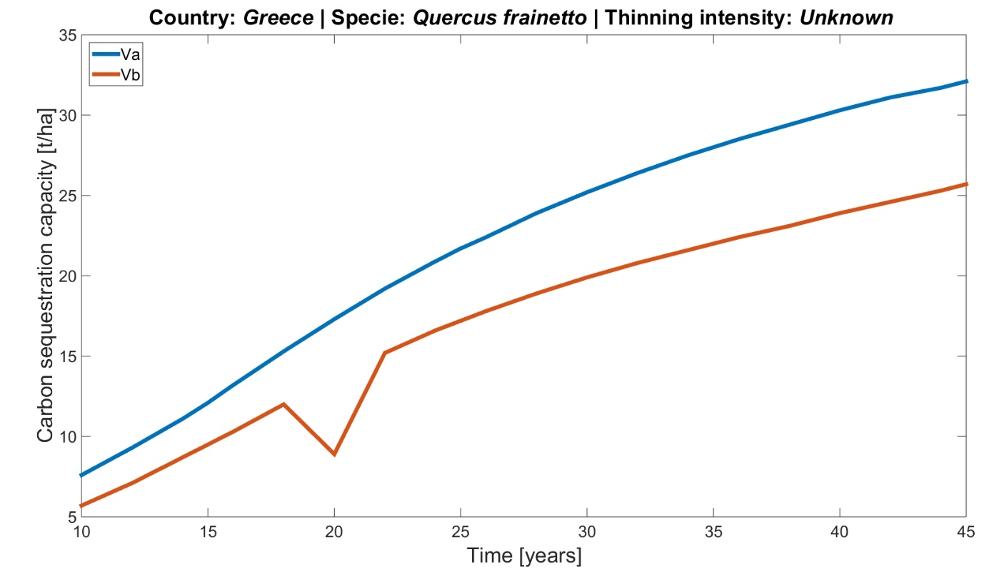
Figure 25. Simulation of carbon sequestration capacity of Quercus frainetto in Greece.
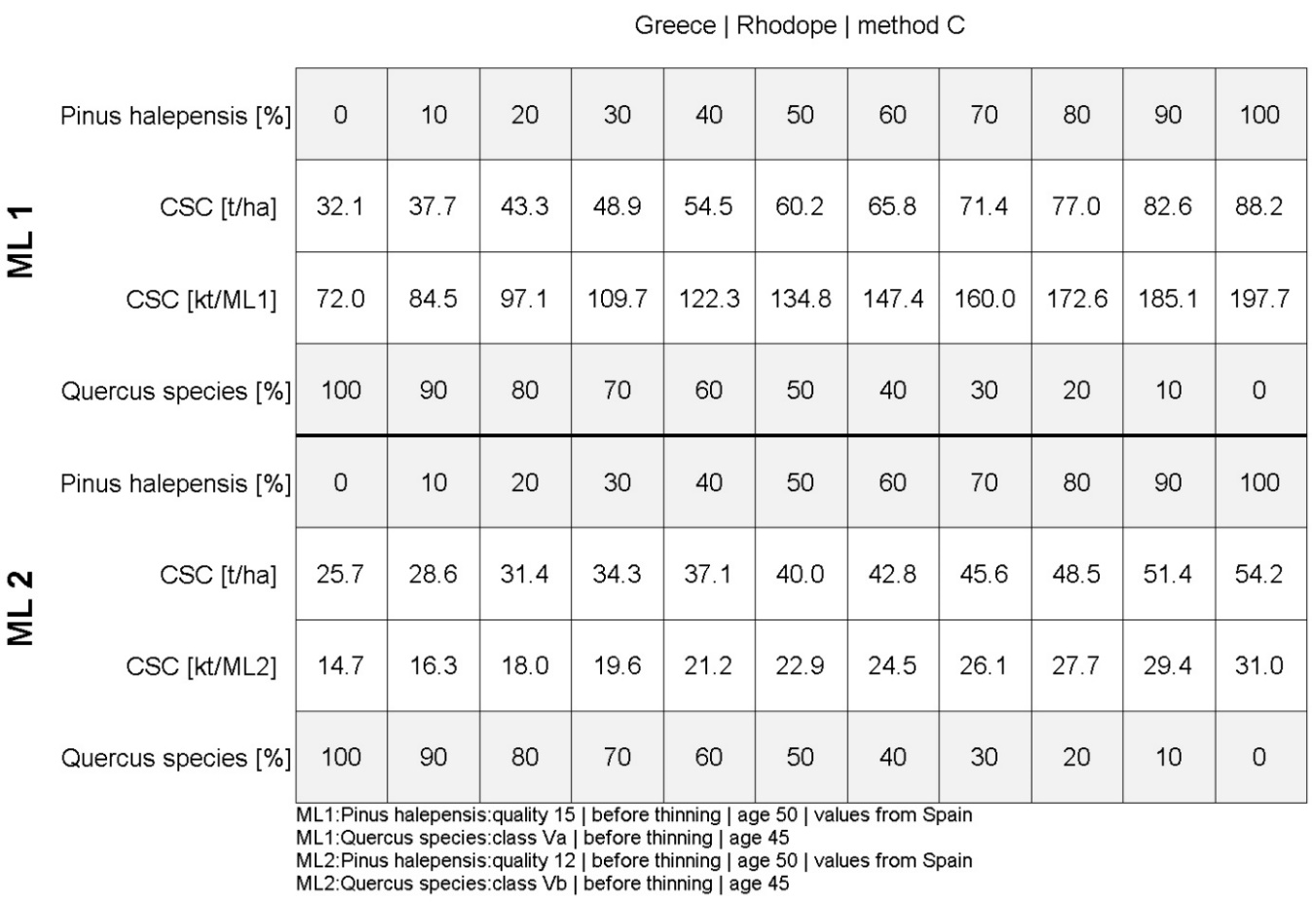
Figure 26. Carbon sequestration capacity of mixed species in “Rhodope” test site.
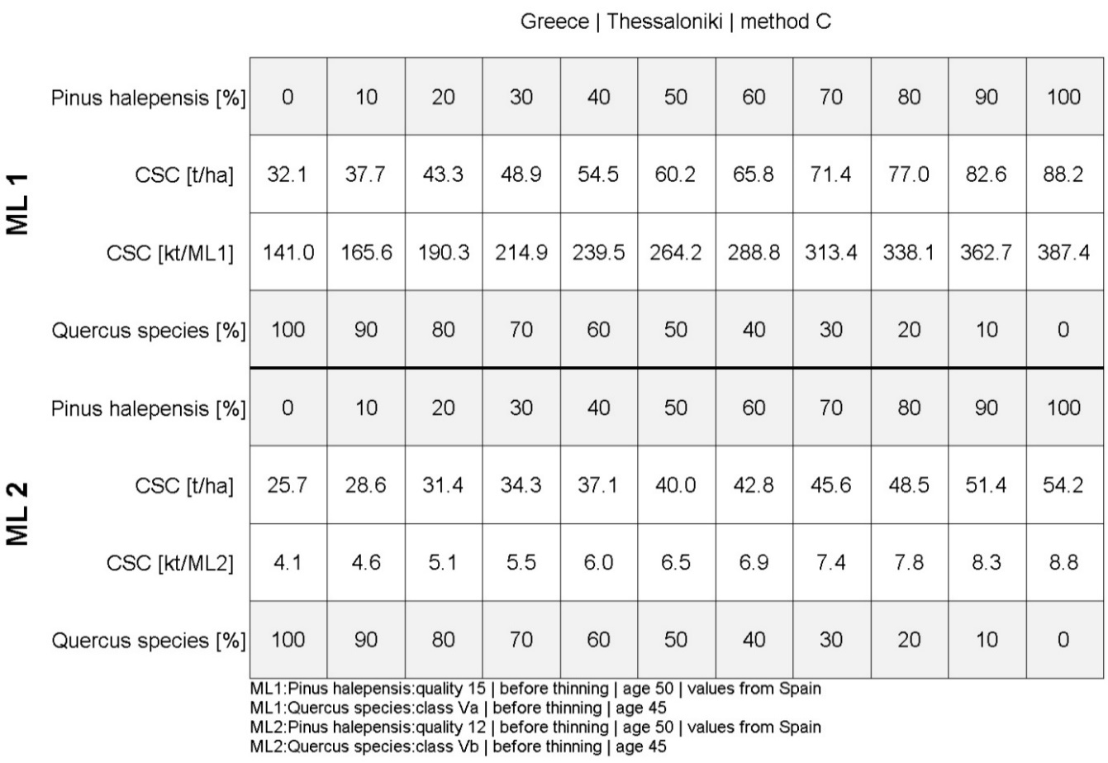
Figure 27. Carbon sequestration capacity of mixed species in “Thessaloniki” test site.

References
Aalde, H., Gonzalez, P., Gytarsky, M., Krug, T., Kurz, W. A., Ogle, S., Raison, J., Schoene, D., Ravindranath, N. H., Elhassan, N. G., Heath, L. S., Higuchi, N., Kainja, S., Matsumoto, M., Sánchez, M. J. S., & Somogyi, Z. (2006). Chapter 4 : Forest land. In S. Eggleston, L. Buendía, K. Miwa, T. Ngara, & K. Tanabe (Eds.), IPCC Guidelines for National Greenhouse Gas Inventories (Vol. 4). Institute for Global Environmental Strategies (IGES).
Bolte A, R., Kuhr, T., Pogoda, M., Murach, P., & Gadow KV, D. (2004). Relationships between tree dimension and coarse root biomass in mixed stands of European beech (Fagus sylvatica L.) and Norway spruce (Picea abies[L.] Karst). Plant Soil. https://doi.org/10.1023/B:PLSO.0000047777.23344.a3
Chmura, D. J., Guzicka, M., Rozkowski, R., & Chałupka, W. (2013). Variation in aboveground and belowground biomass in progeny of selected stands of Pinus sylvestris. Scandinavian Journal of Forest Research, 28(8), 724–734. https://doi.org/10.1080/02827581.2013.844269
del Río, M., Lopez, E., & Montero, G. (2006). Manual de gestión para masa procedentes de repoblación de Pinus pinaster Ait., Pinus sylvestris L. y Pinus nigra Arn. Castilla y León. INIA.
García Abejón J.L. (1981). Tablas de produccion de densidad variable para Pinus sylvestrus L. en el Sistema Iberico. http://www.ucm.es/BUCM/revistas/far/02109778/articulos/LAZA9191110147A.PDF%0Ahttp://dx.doi.org/10.1016/j.foreco.2013.07.034%0Ahttp://dx.doi.org/10.1016/j.tree.2015.09.011%0Ahttp://www.springerlink.com/openurl.asp?id=doi:10.1051/forest/2009121%0Ahttp://dx.
Kossenakis, G. (1939). Yield tables of coppice stands of Quercus frainetto, FAgus sylvatica and Castanea sativa (in Greek).
Krejza, J., Světlík, J., & Bednář, P. (2017). Allometric relationship and biomass expansion factors (BEFs) for above- and below-ground biomass prediction and stem volume estimation for ash (Fraxinus excelsior L.) and oak (Quercus robur L.). Trees - Structure and Function, 31(4), 1303–1316. https://doi.org/10.1007/s00468-017-1549-z
Lembcke, Knapp, & Dittmar. (1975). Ertragstafel für die Kiefer (Pinus sylvestris L.) im nordostdeutschen Tiefland. https://forst.brandenburg.de/sixcms/media.php/9/kieferetk.pdf
Montero, G., Ruiz-Peinado, R., & Cañellas Rey de Viñas, I. (2001). Growth and Yield Models for Pinus halepensis Mill. Forest Systems, 10(1), 179–201. https://doi.org/10.5424/720
Montero, G., Ruiz-peinado, R., & Muñoz, M. (2005). Producción de Biomasa y Fijación de CO2 Por Los Bosques Españoles (Issue June 2014). INIA. Instituto Nacional de Investigaciones Agrarias.
Neumann, M., Moreno, A., Mues, V., Härkönen, S., Mura, M., Bouriaud, O., Lang, M., Achten, W. M. J., Thivolle-Cazat, A., Bronisz, K., Merganič, J., Decuyper, M., Alberdi, I., Astrup, R., Mohren, F., & Hasenauer, H. (2016). Comparison of carbon estimation methods for European forests. Forest Ecology and Management, 361, 397–420. https://doi.org/10.1016/j.foreco.2015.11.016
Ozdemir, E., Makineci, E., Yilmaz, E., Kumbasli, M., Caliskan, S., Beskardes, V., Keten, A., Zengin, H., & Yilmaz, H. (2019). Biomass estimation of individual trees for coppice-originated oak forests. European Journal of Forest Research, 138(4), 623–637. https://doi.org/10.1007/s10342-019-01194-2
Richards, F. J. (1959). A Flexible Growth Function for Empirical Use. Journal of Experimental Botany, 10(2), 290–301. https://doi.org/10.1093/jxb/10.2.290
Rodríguez, F., Broto, M., & Lizarralde, I. (2006). Densidad normal de la madera de las principales especies forestales de Castilla y León.
Röhling, S., Demant, B., Dunger, K., Neubauer, M., Oehmichen, K., Riedel, T., & Stümer, W. (2019). Equations for estimating belowground biomass of silver birch, Oak and Scots pine in Germany. IForest, 12(2), 166–172. https://doi.org/10.3832/ifor2862-012
Röhling, S., Dunger, K., Kändler, G., Klatt, S., Riedel, T., Stümer, W., & Brötz, J. (2016). Comparison of calculation methods for estimating annual carbon stock change in German forests under forest management in the German greenhouse gas inventory. Carbon Balance and Management, 11(1), 1–11. https://doi.org/10.1186/s13021-016-0053-x
Szymkiewicz, B. (2001). Tablice zasobnosci i przyrostu drzewostanów (p. 179).
Vonderach, C., Kändler, G., & Dormann, C. F. (2018). Consistent set of additive biomass functions for eight tree species in Germany fit by nonlinear seemingly unrelated regression. Annals of Forest Science, 75(2). https://doi.org/10.1007/s13595-018-0728-4
Zianis, D., Muukkonen, P., Mäkipää, R., & Mencuccini, M. (2005). Biomass and stem volume equations for tree species in Europe. In Silva Fennica Monographs (Vol. 4).

Annex I: Tables of figures
Figure 1. The final layer of MLs classified with 3 methods into 3 categories “Marginal lands with high plantation suitability” (green), “Marginal lands with low plantation suitability” (gold), and “Potentially unsuitable lands” (dark red) in the pilot sites. Source: Deliverable 2.3 MAIL project. 32
Figure 2. Methodology workflow. 35
Figure 3. Germany (left) and the pilot sites of “Welzow” (outlined with blue) and “Welzow” (outlined with purple). 38
Figure 4. Simulation of carbon sequestration capacity of Picea abies in Germany. 46
Figure 5. Simulation of carbon sequestration capacity of Pinus sylvestris in Germany. 46
Figure 6. Carbon sequestration capacity of mixed species in “Welzow” test site. 47
Figure 7. Carbon sequestration capacity of mixed species in “Nochte” test site. 47
Figure 8. Poland (left) and the corresponding selected pilot site (outlined with green). 48
Figure 9. Species distribution in the Polish test site according to the Polish Forest Data Bank. 50
Figure 10. Simulation of carbon sequestration capacity of Pinus sylvestris in Poland. 54
Figure 11. Simulation of carbon sequestration capacity of Quercus spp. in Poland. 55
Figure 12. Carbon sequestration capacity of mixed species in “Staszów” test site. 55
Figure 13. Spain (left) and the pilot site of “Soria” (outlined with light orange), “Nogueruelas” (outlined with dark red), and “Espadán” (right image outlined with dark orange). 56
Figure 14. Species distribution for Tierras Altas, Soria. Source MFE50. 57
Figure 15. Species distribution in Sierra de Espadán, Castellón. Source MFE50. 58
Figure 16. Species distribution in Nogueruelas, Teruel. Source MFE50. 59
Figure 17. Simulation of carbon sequestration capacity of Pinus pinaster in Spain. 65
Figure 18. Simulation of carbon sequestration capacity of Pinus nigra in Spain. 65
Figure 19. Simulation of carbon sequestration capacity of Pinus sylvestris in Spain. 66
Figure 20. Simulation of carbon sequestration capacity of Pinus halepensis in Spain. 66
Figure 21. Carbon sequestration capacity of mixed species in “Soria” test site. 67
Figure 22. Carbon sequestration capacity of mixed species in “Nogueruelas” test site. 67
Figure 23. Carbon sequestration capacity of mixed species in “Espadan” test site. 68
Figure 24. Greece (left) and the pilot site of the afforestation forest of “Rhodope” and “Thessaloniki”. 69
Figure 25. Simulation of carbon sequestration capacity of Quercus frainetto in Greece. 75
Figure 26. Carbon sequestration capacity of mixed species in “Rhodope” test site. 76
Figure 27. Carbon sequestration capacity of mixed species in “Thessaloniki” test site. 76

Annex II: List of tables
Table 1. Summary of the main species selected for each country with test areas. 11
Table 2. Scots pine (Pinus sylvestris) yield table. Lower yield level Medium high creditworthiness 18 tillering degree 0.95 (U 18 (III, 5) - 0.95 Unteres Ertragsniveau Mittelhöhenbonität 18 Bestockungsgrad 0,95). 13
Table 3. Scots pine (Pinus sylvestris) yield table. Lower yield level Medium high creditworthiness 20 tillering degree 0.95. (U 20 (III, 0) - 0.95 Unteres Ertragsniveau Mittelhöhenbonität 20 Bestockungsgrad 0,95). 14
Table 4. Scots pine (Pinus sylvestris) yield table. Average yield medium-high creditworthiness 18 tillering degree 1.0. (U 18 (III, 5) - 1.0 Mittleres Ertragsniveau Mittelhöhenbonität 18 Bestockungsgrad 1.0). 14
Table 5. Scots pine (Pinus sylvestris) yield table. Average yield medium-height creditworthiness 20 tillering degree 1.0. (U 20 (III, 0) - 1.0 Mittleres Ertragsniveau Mittelhöhenbonität 20 Bestockungsgrad 1.0). 15
Table 6. Norway spruce (Picea abies) yield table. Moderate thinning class 5 (lowest production) (Fichte Mässige V.Ertrags). 16
Table 7. Norway spruce (Picea abies) yield table. Moderate thinning class 4 (low production). (Fichte Mässige IV.Ertrags). 17
Table 8. Norway spruce (Picea abies) yield table. Staggered thinning class 3 (lowest production) (Fichte Gestaffelte Durchforstung III.Ertrags). 17
Table 9. Norway spruce (Picea abies) yield table. Staggered thinning class 2 (low production) (Fichte Gestaffelte Durchforstung II). 18
Table 10. Pinus sylvestris yield table (low class (IV) and lowest class (V) quality production). 19
Table 11. Quercus spp. yield table (low class (III) and lowest class (IV) quality production). 20
Table 12. Pinus pinaster yield table (lowest class (12) and second-lowest class quality production). 21
Table 13. Pinus nigra yield table (lowest class (12) and second-lowest class quality production). 22
Table 14. Pinus sylvestris yield table (lowest class (12) and second-lowest class quality production). 22
Table 15. Pinus halepensis yield table (lowest class (12) and second-lowest class quality production). 23
Table 16. Quercus species yield table. Class quality Va (second lowest production). 24
Table 17. Quercus species yield table. Class quality Vb (lowest production). 24
Table 18. Components of the German forest species biomass equations. 26
Table 19. AGB Components biomass equations for the Pinus sylvestris and Pices abies. 26
Table 20. BGB equations and coefficients adjusted for each species for the Pinus sylvestris and Pices abies. 28
Table 21. Proportions between the above-ground and below-ground biomass used for Polish test site. 28
Table 22. Proportions between the above-ground and below-ground biomass for Pinus pinaster, P.nigra, P.sylvestris, and P. halepensis (Montero et al., 2005). 29
Table 23. Species carbon fraction ratio for dry biomass for Pinus pinaster, P.nigra, P.sylvestris, and P. halepensis (Montero et al., 2005). 29
Table 24. ABG relationships for Quercus frainetto forest in Northern Turkey. 30
Table 25. Wood density values for the forest species selected for Poland, Spain, and Greece. 30
Table 26. Methods to subdivide by type of marginality (“Marginal lands with high plantation suitability”, “Marginal lands with low plantation suitability”, and “Potentially unsuitable lands”). Source: Deliverable 2.3 MAIL project. 31
Table 27. Hectares and percentage of total area for each of the ML categories according to marginality (“Marginal Lands with high plantation suitability”, “Marginal Lands with low plantation suitability”, and “Potentially unsuitable lands”) for each pilot site and method. Source: Deliverable 2.3 MAIL project. 33
Table 28. Equations for carbon estimation based on yield table data and BECF. 37
Table 29. Area distribution for the main species in the German landers of Brandenburg + Berlin and Sachsen. 39
Table 30. Biomass and Carbon estimates for Pinus sylvestris Remaining inventory Unteres Ertragsniveau Mittelhöhenbonität 18. 40
Table 31. Biomass and Carbon estimates for Pinus sylvestris. Remaining inventory Unteres Ertragsniveau Mittelhöhenbonität 20. 40
Table 32. Biomass and Carbon estimates for Pinus sylvestris. Remaining inventory Mittleres Ertragsniveau Mittelhöhenbonität 18. 41
Table 33. Biomass and Carbon estimates for Pinus sylvestris. Remaining inventory Mittleres Ertragsniveau Mittelhöhenbonität 20. 42
Table 34. Biomass and Carbon estimates for Picea abies. Remaining inventory Fichte Mässige V.Ertrags. 42
Table 35. Biomass and Carbon estimates for Picea abies. Remaining inventory Fichte Mässige IV.Ertrags. 43
Table 36. Biomass and Carbon estimates for Picea abies. Fichte Gestaffelte Durchforstung III.Ertrags. 44
Table 37. Biomass and Carbon estimates for Picea abies. Remaining inventory Fichte Gestaffelte Durchforstung II.Ertrags 44
Table 38. Area distribution for the main species in the Polish test site according to the Polish Forest Data Bank. 49
Table 39. Biomass and Carbon estimates for Pinus sylvestris Class IV for ML1. 50
Table 40. Biomass and Carbon estimates for Pinus sylvestris Class V (worst bonitation) - for ML2. 51
Table 41. Biomass and Carbon estimates for Quercus species Class III for ML1. 52
Table 42. Biomass and Carbon estimates for Quercus species Class IV for ML2 53
Table 43. Area distribution for the main species in Tierras Altas, Soria according to the MFE50. 57
Table 44. Area distribution for the main species in Sierra de Espadán, Castellón according to the MFE50. 58
Table 45. Area distribution for the main species in Nogueruelas, Teruel according to the MFE50. 59
Table 46. Biomass and Carbon estimation for Pinus pinaster for the aboveground and belowground components and total tree. 60
Table 47. Biomass and Carbon estimation for Pinus nigra for the aboveground and belowground components and total tree. 60
Table 48. Biomass and Carbon estimation for Pinus sylvestris for the aboveground and belowground components and total tree. 61
Table 49. Biomass and Carbon estimation for Pinus halepensis for the aboveground and belowground components and total tree. 62
Table 50. Area distribution for the main species in the Greek test sites. 69
Table 51. Biomass and Carbon estimation for Quercus frainetto for the aboveground and belowground components and total tree. 70

Annex III: Carbon estimation for the pilot site: Results
Carbon sequestration capacity for test sites estimated using method A.
Germany
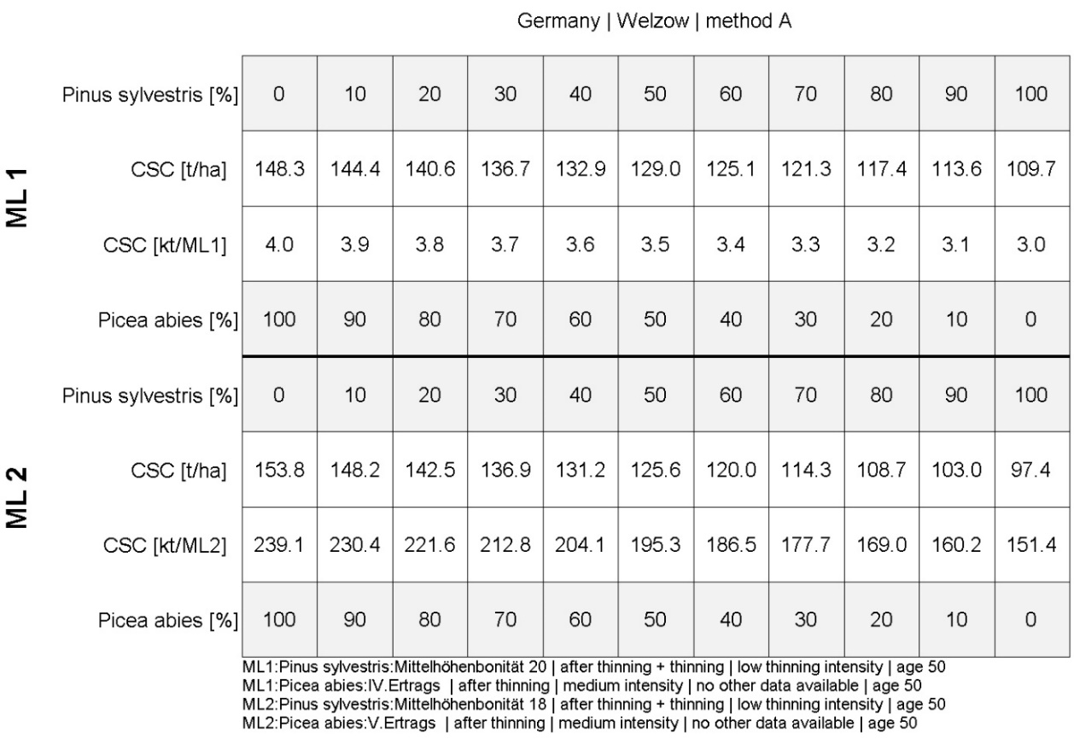
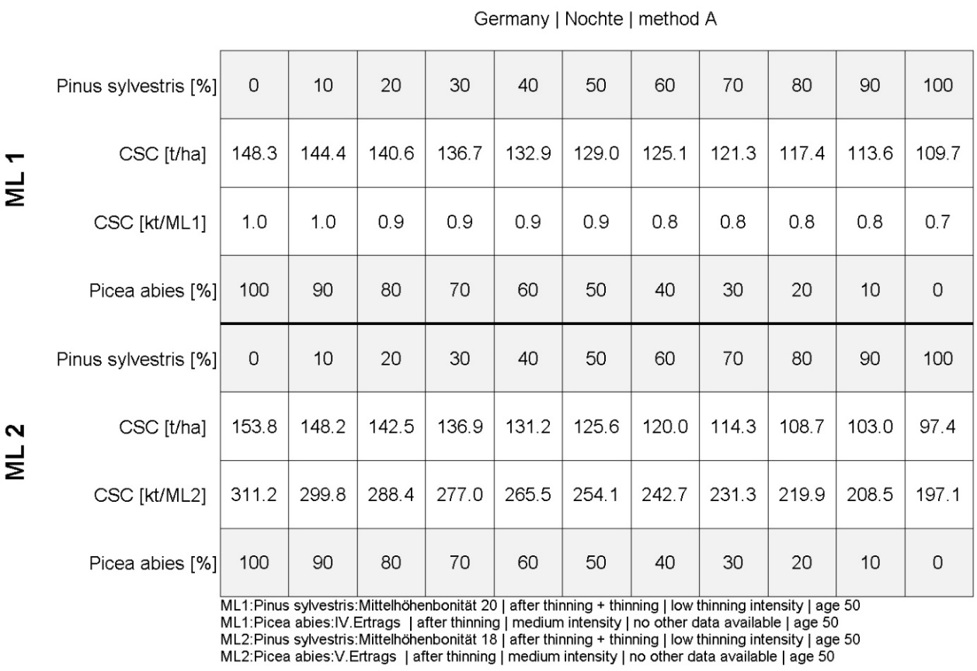
Poland
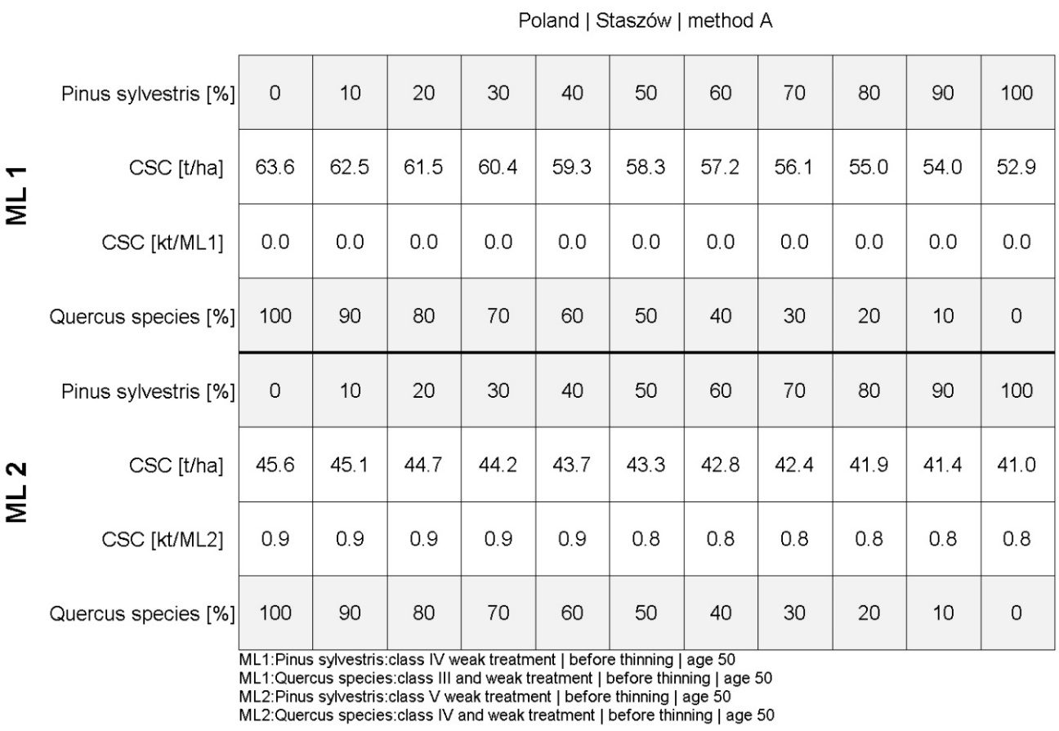
Spain
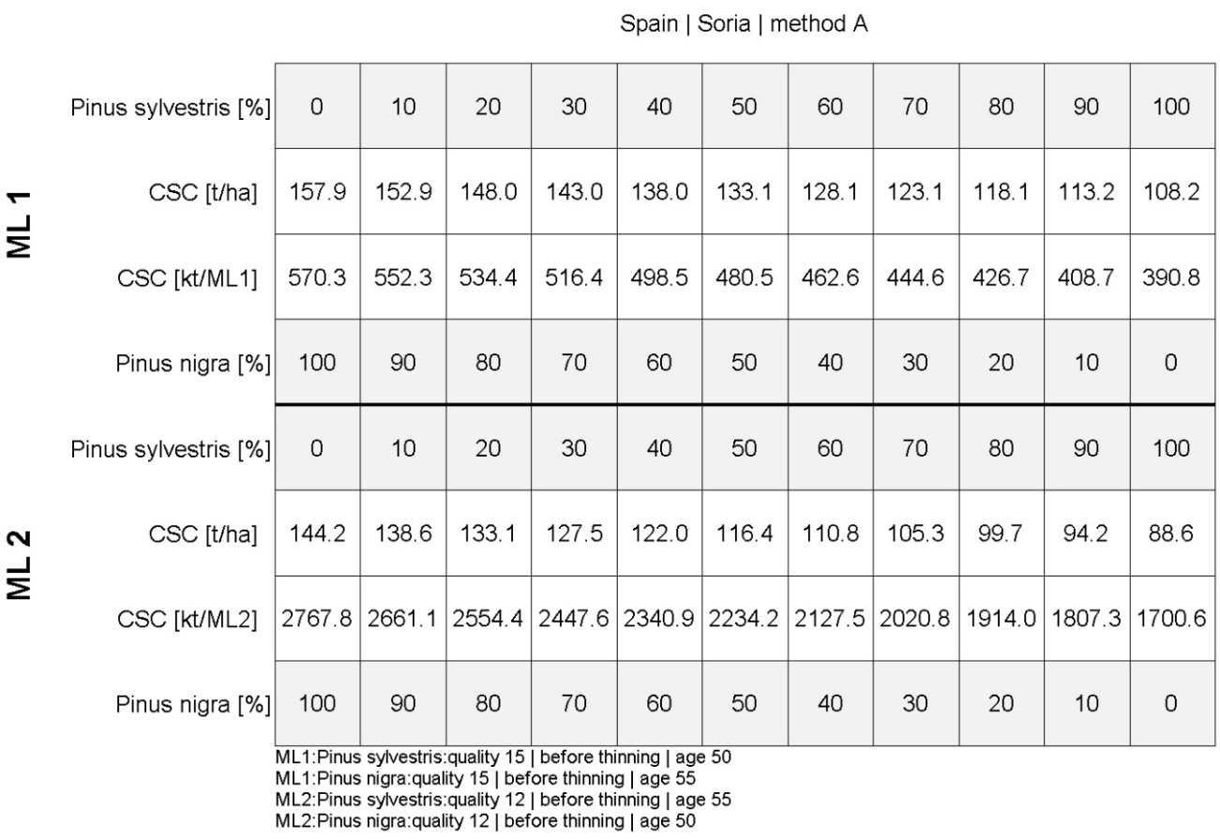
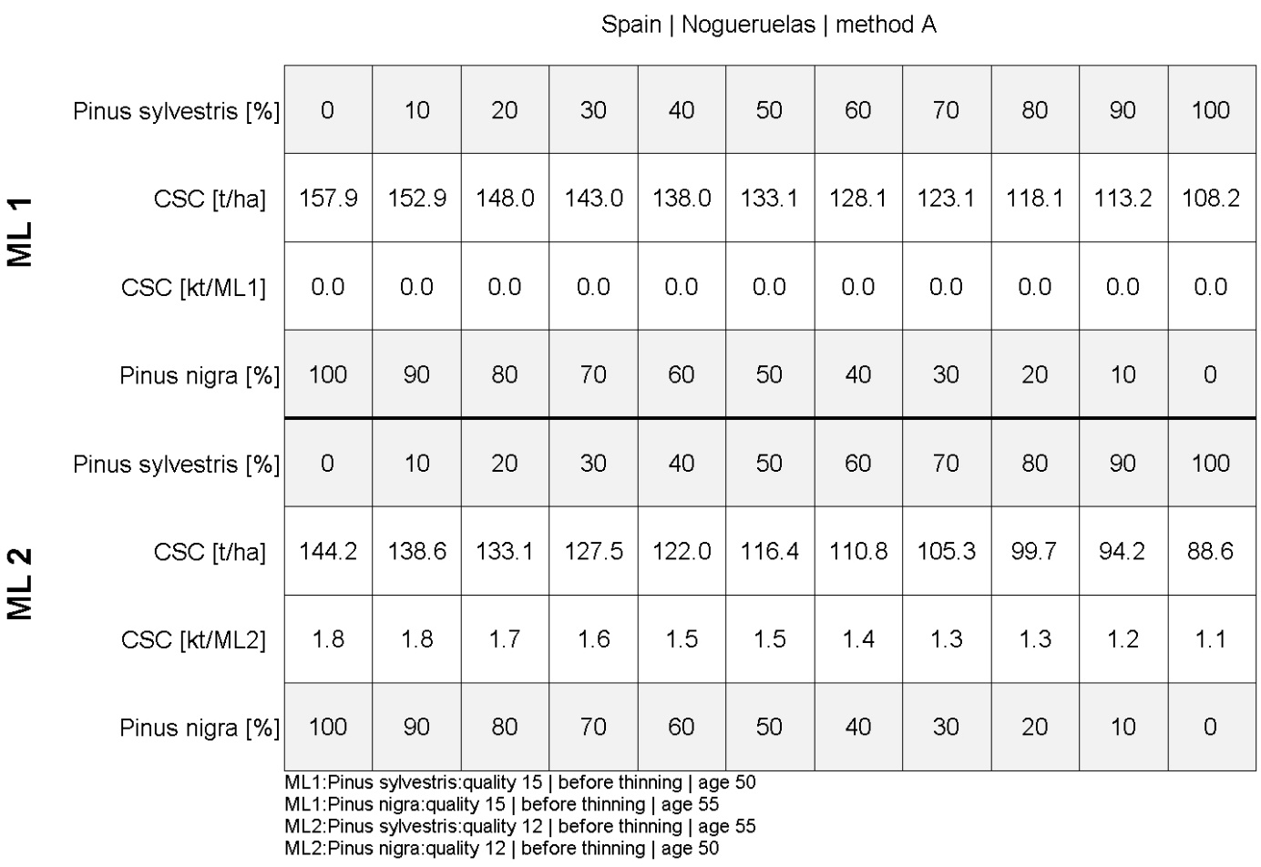
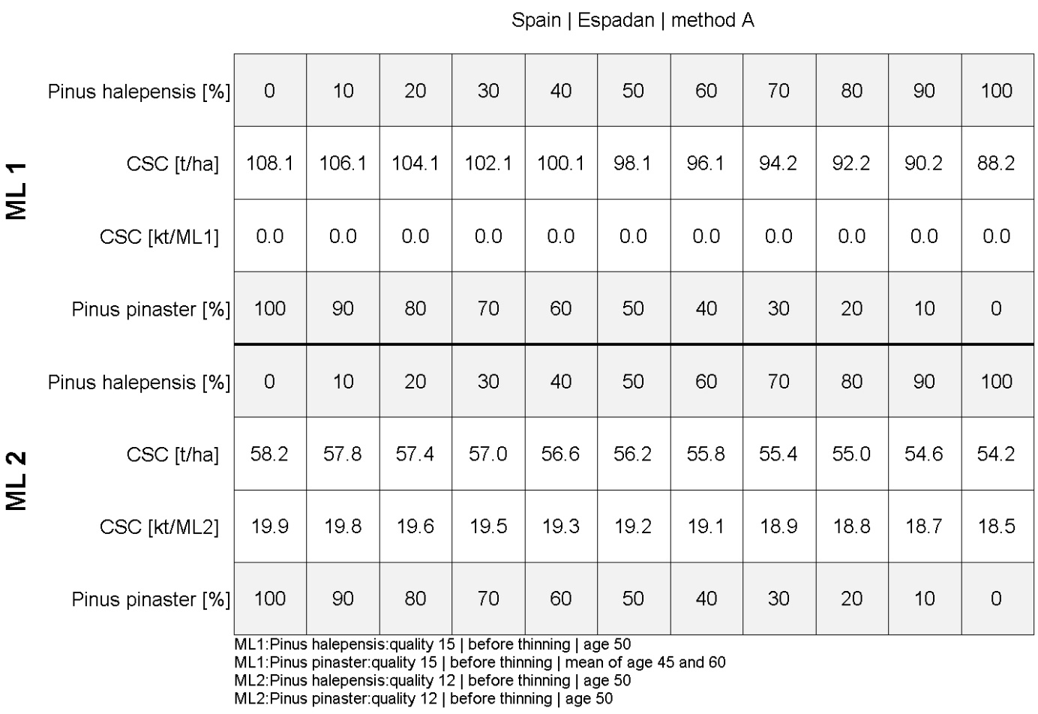

Greece
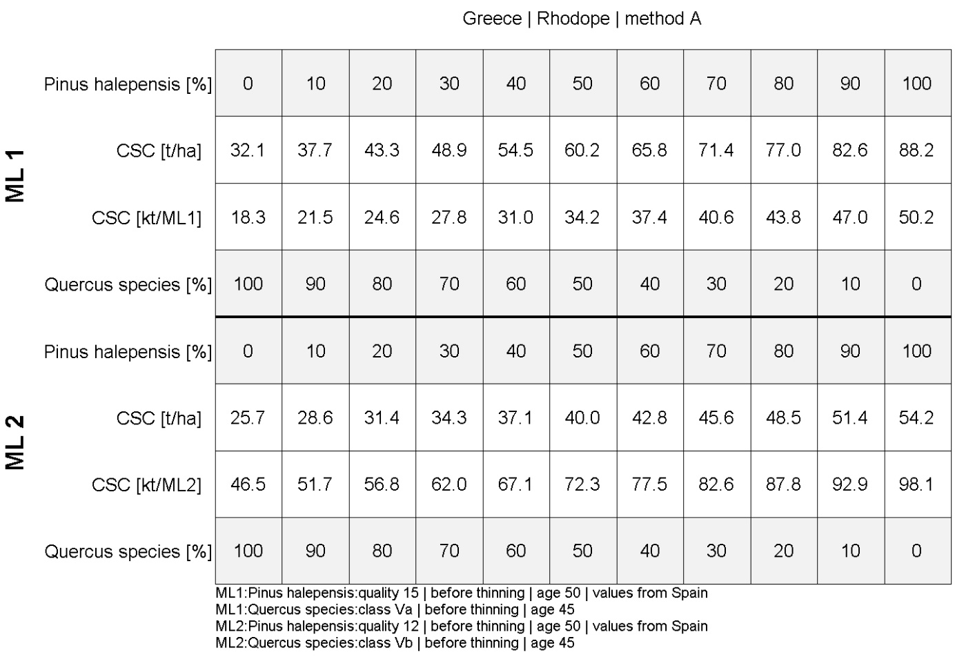
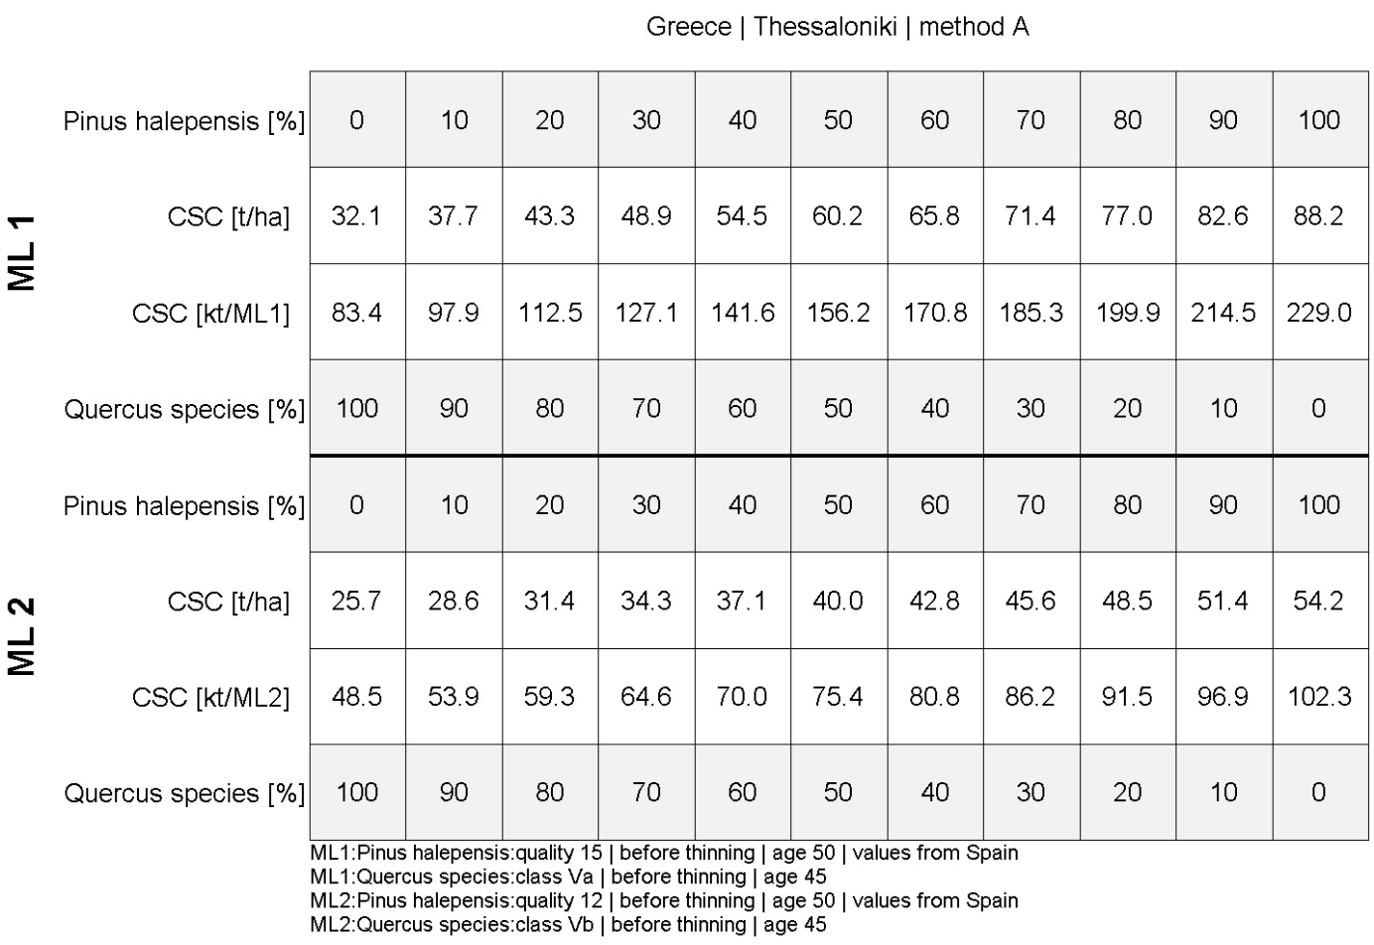
Carbon sequestration capacity for test sites estimated using method B.
Germany
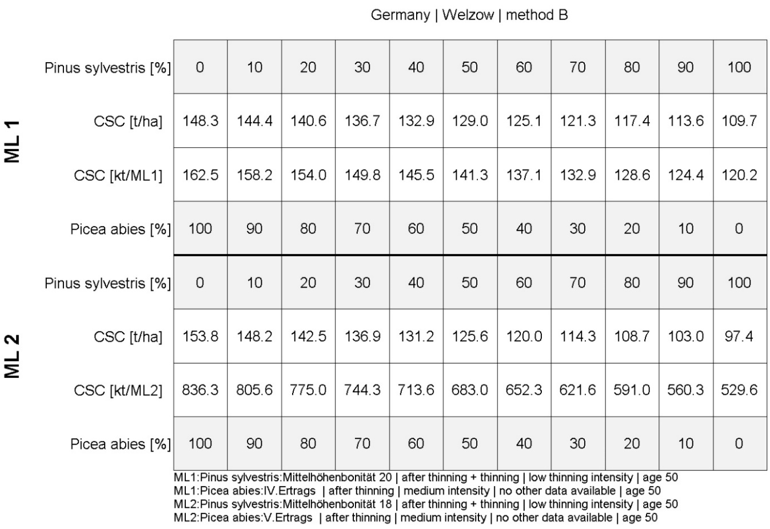
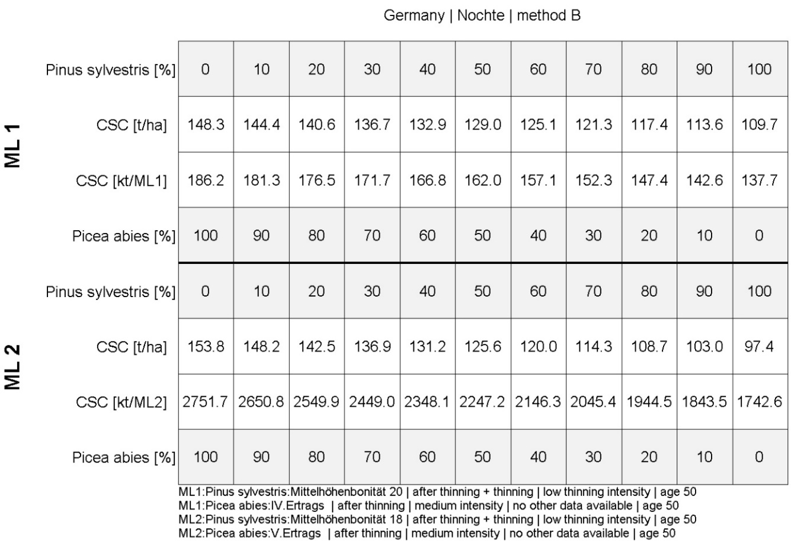
Poland
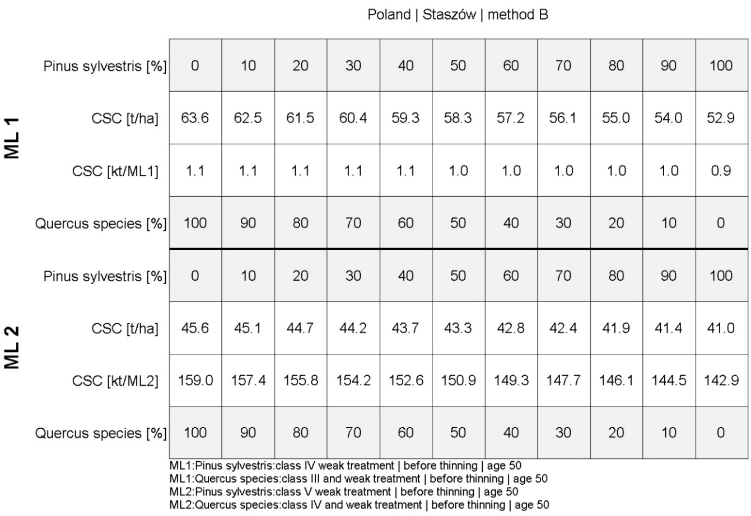
Spain
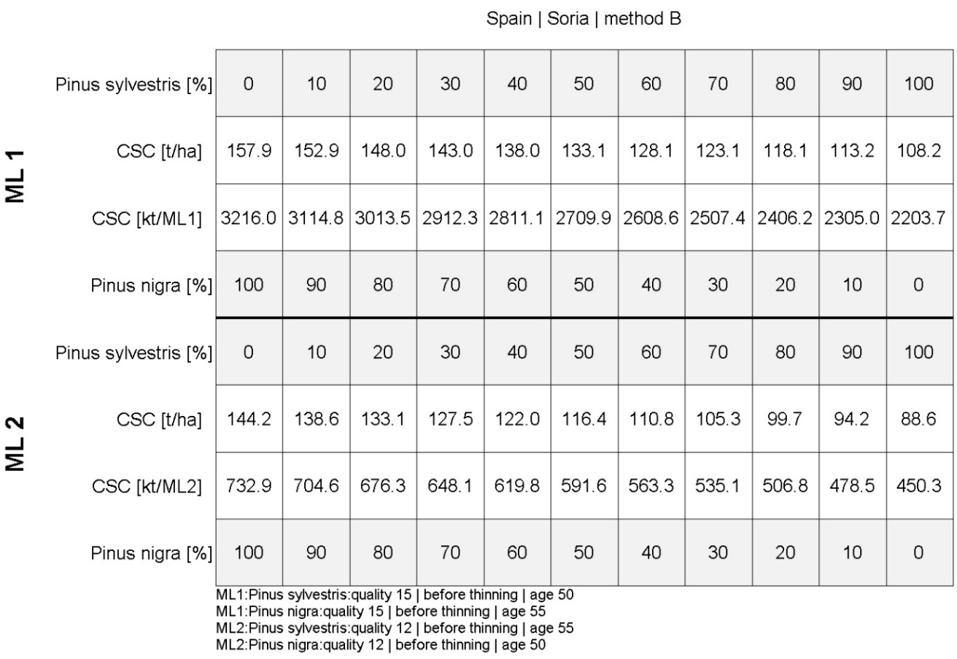
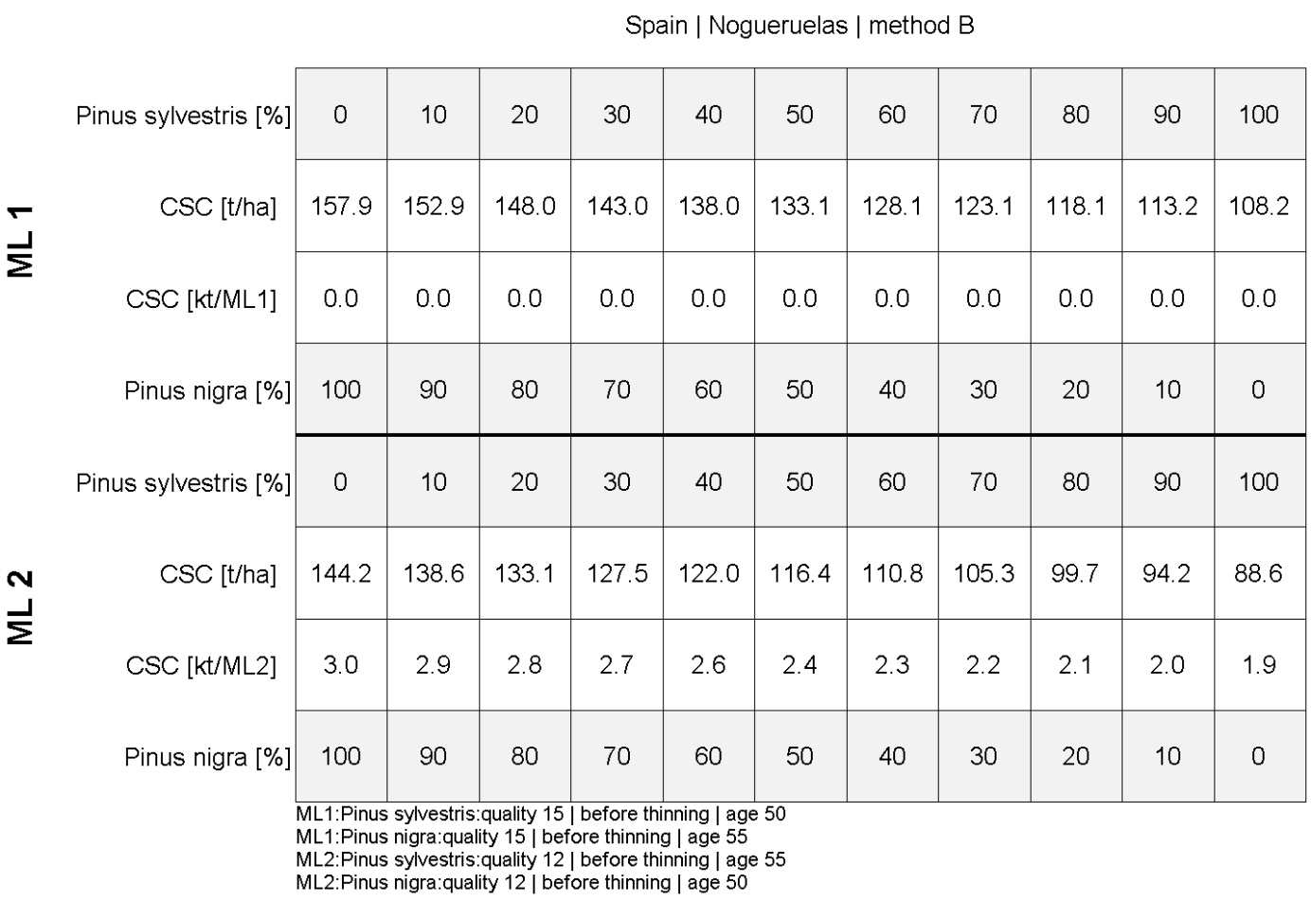
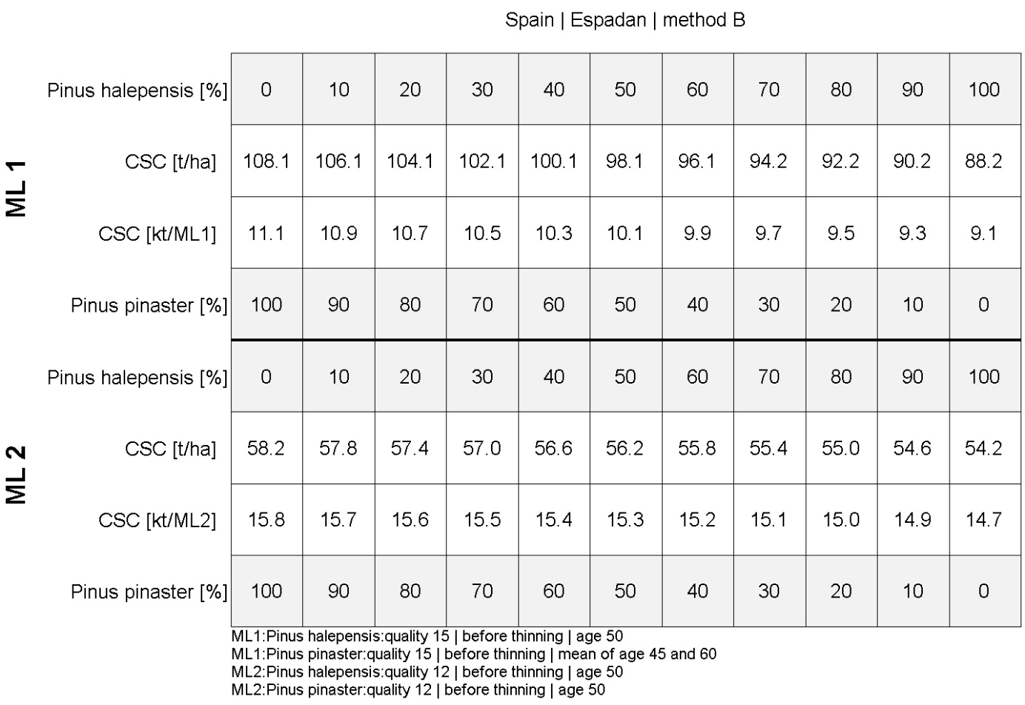

Greece
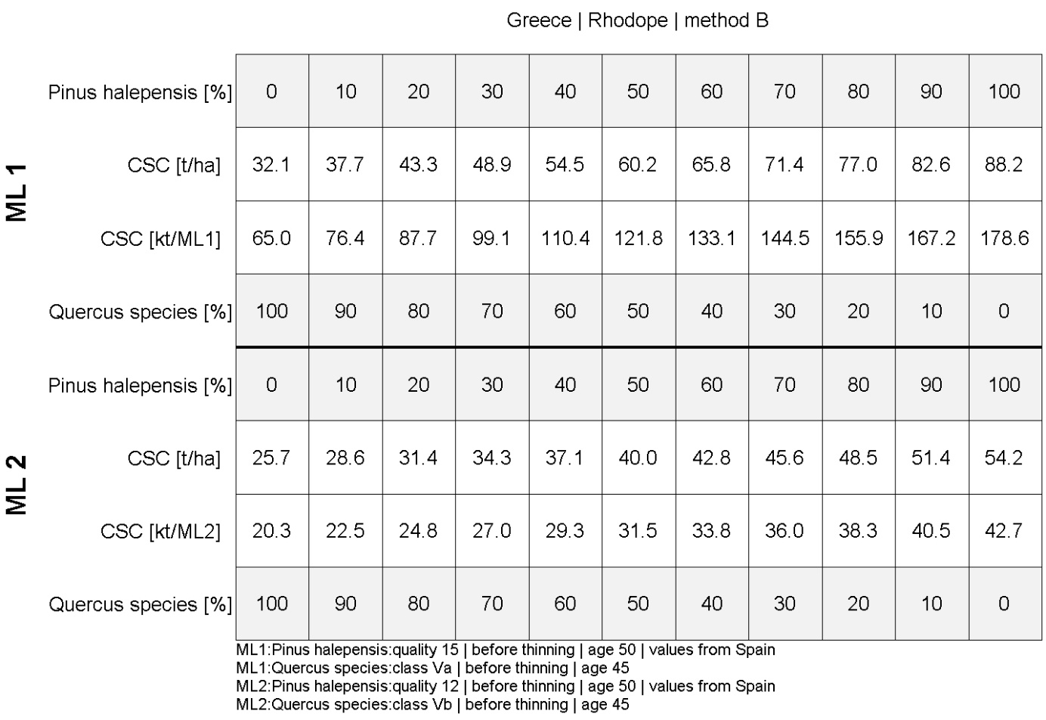
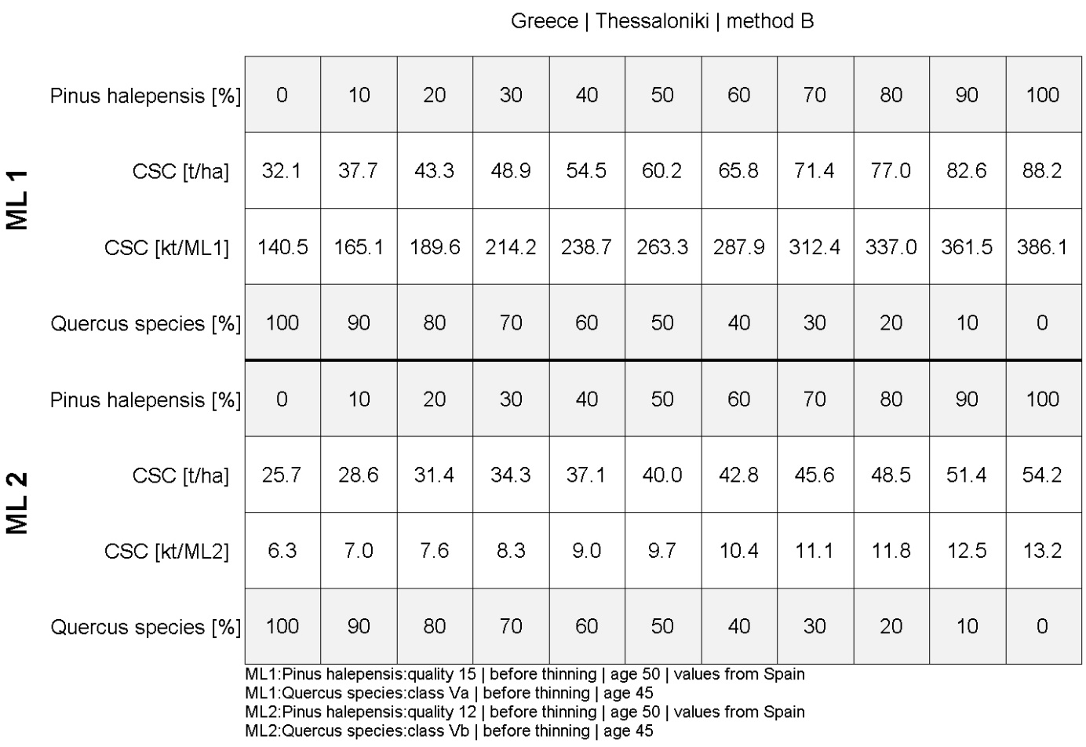

R = Report, P = Prototype, D = Demonstrator, O = Other
PU = Public, PP = Restricted to other programme participants (including the Commission Services), RE = Restricted to a group specified by the consortium (including the Commission Services), CO = Confidential, only for members of the consortium (including the Commission Services).
Relative to the forest

