

D3.2 | Seminar/workshop implementation proceedings and report on scientific publication / participations
  - MAIL: Identifying Marginal Lands in Europe and strengthening their contribution potentialities in a CO2 sequestration strategy

MAIL project has received funding from the European Union’s Horizon 2020 research and innovation programme under the Marie Skłodowska-Curie grant agreement No 823805; [H2020 MSCA RISE 2018]

Project title | Identifying Marginal Lands in Europe and strengthening their contribution potentialities in a CO2 sequestration strategy
Call identifier | H2020 MSCA RISE 2018
Project acronym | MAIL
Starting date | 01.01.2019
End date | 31.12.2021
Funding scheme | Marie Skłodowska-Curie
Contract no. | 823805
Deliverable no. | D3.2
Document name | MAIL_D3.2.pdf
Deliverable name | Seminar/workshop implementation proceedings and report on scientific publication / participations
Work Package | WP3
Nature | R
Dissemination | PU
Editor | Juan Pedro Carbonell-Rivera (UPV) Charalampos Georgiadis (AUTH)
Authors | Marta Milczarek (CBK PAN)
Contributors | Edyta Woźniak (CBK PAN)  Michał Krupiński (CBK PAN)  Jesús Torralba Pérez (UPV)
Date | 29.12.2021

MAIL Consortium
  Aristotle University of Thessaloniki (AUTH) Greece |   Industrieanlagen Betriebsgesellschaft MBH (IABG) Germany
  Gounaris N. – Kontos K. OE (HOMEOTECH) Greece |   Centrum Badan Kosmicznych Polskiej Akademii Nauk (CBK PAN) Poland
  Universitat Politecnica de Valencia (UPV) Spain |   Fundacion Centro De Servicios Y Promocion FOrestral Y de su Industria De Castilla y Leon (CESEFOR) Spain

Abbreviations
Term | Explanation
AOI | Area of Interest
CEO | Chief Executive Officer
CO₂ | Carbon dioxide
DSS | Decision Support System
EU | European Union
FAO |  | Food and Agriculture Organisation
GEE |  | Google Earth Engine
GHG | Green House Gases
GIS | Geographic Information System
IPCC | Intergovenmental Panel on Climate Change
LULUCF | Land Use, Land-Use Change and Forestry
ML | Marginal Land
MLs | Marginal Lands
MOOC | Massive Open Online Course
SAR | Synthetic Aperture Radar
TLS | Terrestrial Laser Scanning
UN | United Nations

Contents

MAIL Consortium 3
Abbreviations 4
Executive Summary 7
1. Introduction 7
2. Workshop “The potential of Marginal Lands as carbon sink in Europe” 8
2.1 Objective 8
2.2 Participants 9
2.3 Agenda 11
2.4 Speakers and presentations 12
2.4.1 Welcome and Introduction to the Workshop Objectives and Participants 12
2.4.2 Introduction to MaiL project (H2020 MSCA RISE) 12
2.4.3 The concept of marginal lands 12
2.4.4 Marginal Lands in EU. Forest regulation and context 13
2.4.5 An approach to detect suitable marginal lands for bioenergy crops in Europe (SeemLa project) 14
2.4.6 Potentialities of emerging stock exchange markets for carbon transaction and proposed policies 15
2.4.7 Growing selected industrial crops on marginal lands (MAGIC project) 16
2.4.8 An approach to detect suitable marginal lands for industrial crops in Europe 16
2.4.9 Identification and classification of marginal lands in Europe 17
2.4.10 MaiL Map Portal; Online tools for marginal lands management and monitoring – General description 19
2.4.11 Mail Map Portal; Decision Support System for marginal lands management – General description 19
2.4.12 Round Table 20
2.4.13 MaiL Massive Open Online Course (MOOC) 22
2.4.14 Mail Map Portal; Online tools for marginal lands management 22
2.4.15 MaiL Map Portal; Decision Support System for marginal lands 22
2.4.16 Closing remarks 23
3. Final conference “Carbon sequestration potential of Marginal Lands in Europe” 24
3.1 Objective 24
3.2 Participants 24
3.3 Agenda 25
3.4 Speakers and topics 26
3.4.1 Welcome / Introduction to MaiL project 26
3.4.2 Promotion Staff Exchanges action 26
3.4.3 Marginal land definition and existing datasets 27
3.4.4 Detection of marginal lands and accuracy assessment 27
3.4.5 Augmenting precision for marginal land definition 28
3.4.6 Existing models considering local aspects 29
3.4.7 Estimation of biomass volume at low productivity m/sm MLs 29
3.4.8 MLs classification in carbon sequestration capacity groups 30
3.4.9 Web application for ML’s management 30
3.4.10 MAIL MOOC and virtual classroom 31
3.4.11 Use of open source platforms and free satellite data to map and monitor MLs 33
3.4.12 Quantification of carbon sequestration capacity in m/sm MLs 33
3.4.13 Estimation of carbon stock in forest products 34
3.4.14 Change detection mapping in forest MLs 35
3.4.15 Financial, social and technical aspects of sustainable development of MLs 35
3.4.16 Potentialities of emerging stock exchange markets for carbon transactions and proposed policies 35
3.4.17 Success stories and guidelines of ML management 36
3.4.18 Round Table / Wrap up / Closing Remarks 37
4. Scientific papers 38
5. Participation in seminars 43
5.1 Symposium “20 Years of Remote Sensing” 43
5.2 XXIV ISPRS Congress 43
5.3 National Copernicus Forum 44
5.4 Copernicus Info Day in Poland 44
5.5 Copernicus User Uptake International Workshop 45
5.6 Third Congress in Geomatic Engineering 46
References 48
Annex I: Poster 49
Annex II: Table of Figures 50

Executive Summary

Introduction
The document contains the description of events and proceedings regarding seminar/workshop organisation and implementation as well as summary of scientific publications and participations during MAIL project. This is joint report from the realisation of tasks: T3.2 “Seminar-workshop organisation through MOOC” (chapters 2 and 3) and T3.3 “Participate in international scientific events” (chapters 4 and 5).

Workshop “The potential of Marginal Lands as carbon sink in Europe”
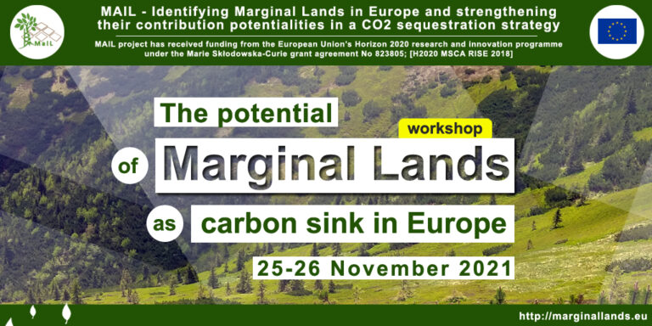
The workshop “The potential of Marginal Lands as carbon sink in Europe” was held online and was jointly organised by the Universitat Politècnica de València (UPV, Spain), Aristotle University of Thessaloniki (AUTH, Greece), Centrum Badan Kosmicznych Polskiej Akademii Nauk (CBK PAN, Poland), Gounaris N. – Kontos K. OE (HOMEOTECH, Greece), Industrieanlagen Betriebsgesellschaft MBH (IABG, Germany) and Fundación Centro de Servicios y Promoción FORestral y de su Industria de Castilla y León (CESEFOR, Spain). The event took place on 25 and 26 November 2021.
The first day consisted of 10 presentations and a round table discussion. The second day was focused on the demonstration of MOOC and MAIL Map Portal, both developed by consortium partners.
Recordings of speeches are available on: www.marginallands.eu/dissemination/media.
All presentations are available here: http://marginallands.eu/mail-workshop.

Objective
The main aim of the workshop was to present some of the results obtained in the MAIL project over the last 3 years. The event gathered several keynote speakers, experts on marginal lands (ML), their management and optimal use.
The main objective of the first day was to provide an opportunity for discussion about the current situation in marginal lands in the European Union, current policies, regulations, potentials and applications. Another topic was the contribution of the MAIL project itself – developing of tools for indication, mapping, management and monitoring of marginal lands, that in particular incorporate remote sensing and GIS techniques. The marginal lands nowadays are becoming more relevant from the environmental and socioeconomic point of view. In order to address this, organisers invited experts from the EU and international level from the academies, universities, administration and industry.

Participants
The workshop was attended by 108 people.
The certificates of attendance (Figure 1) and certificates of presentation (Figure 2) were distributed by e-mail among all the participants and speakers after the workshop.
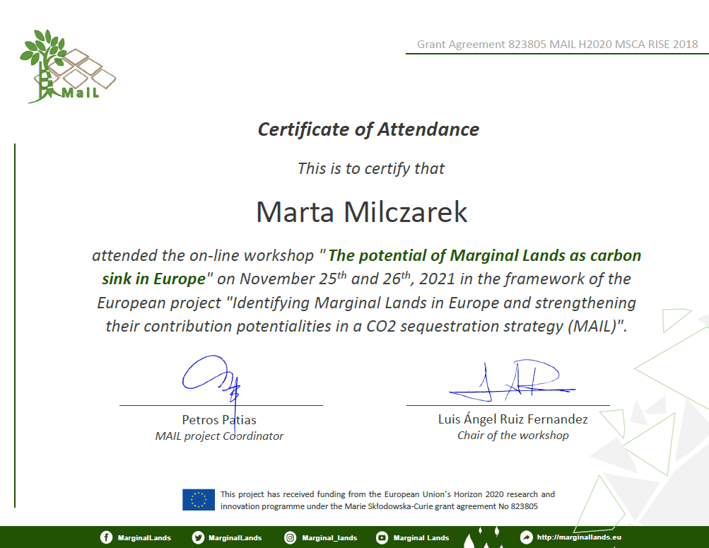
Figure 1: Exemplary Certificate of Attendance in the workshop

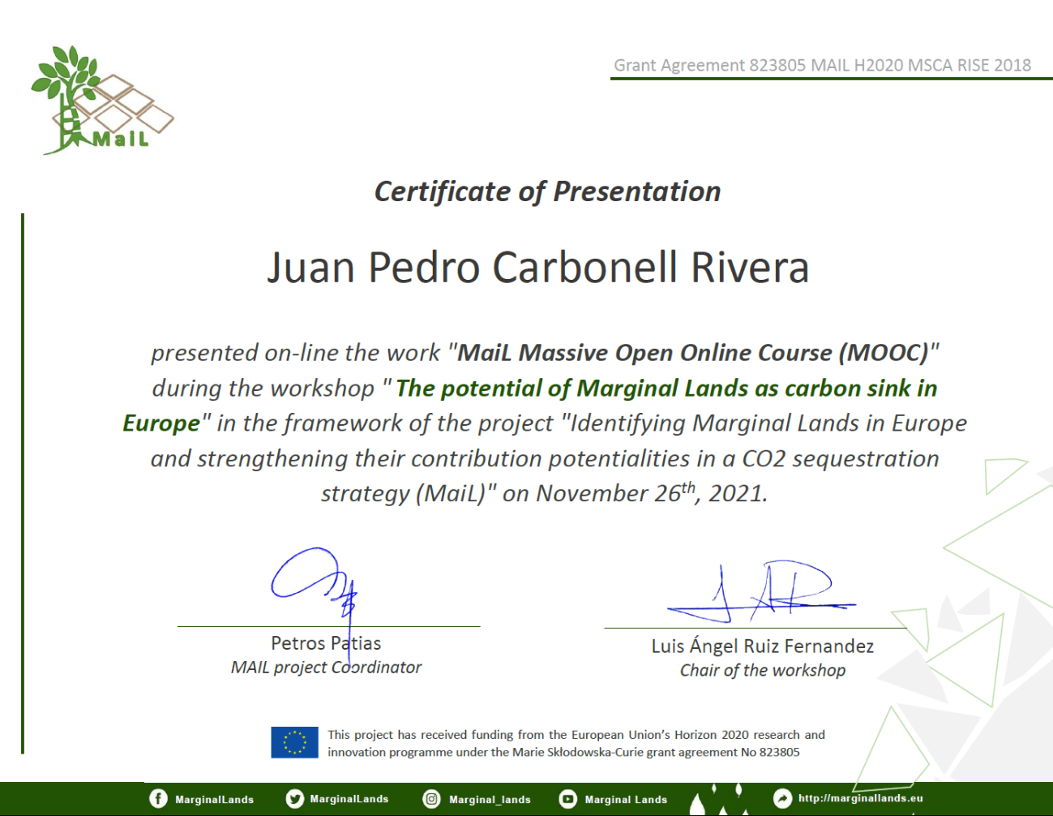
Figure 2: Exemplary Certificate of Presentation during the workshop

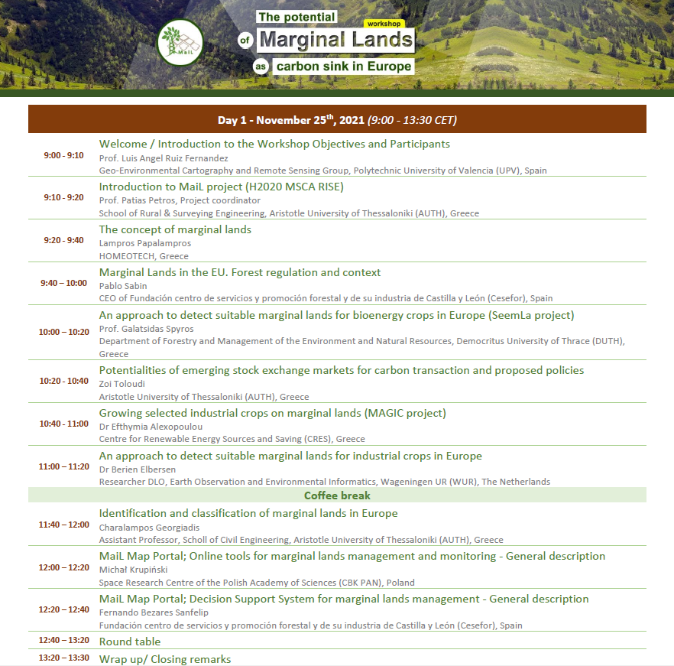
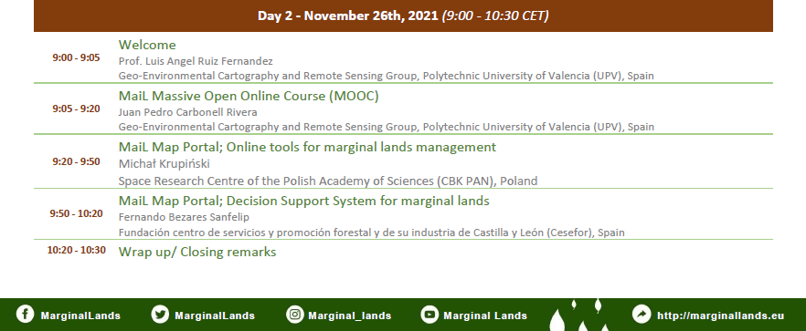
Agenda
Figure 3: Agenda of workshop.

Speakers and presentations

Welcome and Introduction to the Workshop Objectives and Participants
Participants were welcomed by Prof. Luis Ángel Ruiz Fernández. He described the main objectives behind workshop organisation and moderated all sessions.
Prof. Ruiz works at the Engineering in the Geo-Environmental Cartography and Remote Sensing Group of the Polytechnic University of Valencia (UPV), Spain, in the Department of Cartographic Engineering, Geodesy and Photogrammetry. His research focuses on land use/land cover classification and change detection using object-oriented image analysis, LiDAR methods and applications in forest structure, as well as multitemporal urban land use fragmentation metrics.

Introduction to MaiL project (H2020 MSCA RISE)
The presentation was given by Prof. Petros Patias, MAIL Project Coordinator from the Aristotle University of Thessaloniki, Greece, where he is the Director of Laboratory of Photogrammetry and Remote Sensing and ex-Chairman of the School of Rural and Surveying Engineering. Previously, Professor was the vice-Director of the University of Western Macedonia in Greece.
Prof. Patias presented an overview of the project: its topic, objectives, workplan, workload, how the secondments were realized and what dissemination means were engaged to promote the project.

The concept of marginal lands
The first thematic presentation was prepared by Mr. Lampros Papalampros, GIS and Remote Sensing Expert and Senior Officer in HOMEOTECH, Greece. He graduated from the Department of Forestry and Natural Environment in the Aristotle University of Thessaloniki. He was seconded to work in a few tasks of the MAIL project: T2.2, where he did literature review in order to find and evaluate available European and Global scale datasets that help to assess land cover and the characteristics regarding marginality; T2.5 in which he evaluated and validated models of carbon stock estimation.
Mr. Papalampros introduced the general concept of marginal lands as defined in the MAIL project regarding marginality point of view. The project objective was to trigger utilization of marginal lands as carbon sinks by activities related to forestry in the LULUCF sector (Land Use, Land Use Change and Forestry). MAIL focused on Marginal Lands (MLs) that have: afforestation/reforestation capacity and no effect in agri-food production sector. It aimed to encourage a holistic rethinking of marginal lands in order to optimize their use in the framework of climate change mitigation.
A literature review conducted at the beginning of the project resulted in a list of variables of marginality. There are many definitions of marginal land derived from various points of view: economic, physical and production. The presenter quoted terms similar to “marginal land” and listed the defining factors of marginality. The final parameters, that were taken into account in defining the marginal lands, were described. Several examples of land that can be considered as marginal in the scope of MAIL were presented as well as the final definition. Marginality is relative, goal oriented and is affected by multiple constraints: environmental, socioeconomic, cultural.
Then, the speaker started to describe an approach to assess marginality characteristics basing on the European and Global scale datasets. Basic criteria for MLs detection can be grouped into following categories: topography, land use/cover, climate, soil, infrastructure, biodiversity – nature protection, socio-economic. The available datasets were separated into similar categories. Next, there was conducted constraints classification into hard (binary exclusion factors) and soft ones (factors with variable thresholds). The topic was continued in the speech of Prof. Georgiadis.

Marginal Lands in EU. Forest regulation and context
The next speech belonged to Mr. Francisco Gallego from Cesefor, a Foundation for services and promotion of forest industry in Castilla y León in Spain, where he has been working in different projects related to forestry sector since 2007. He is a Forestry Engineer from the University of Valladolid, specialised in GIS. Currently he coordinates projects that imply the use of AI techniques for the afforestation analysis system for agricultural lands.
Mr. Gallego presented various European Union’s environmental policies that affect the restoration of marginal lands and in general the basic framework meaning programs, strategies, conventions, and other documents, especially covering the topics of biodiversity, land use and forestry. Main milestones, objectives, and achievements of the EU in seeking solutions to biodiversity loss, deforestation and climate change were listed. There is no common forest policy in the EU and the speaker showed what does it mean and what are the related concerns. Then he briefly described the priorities and actions connected to the European Green Deal in the topic of environment and oceans.
Finally, a topic of marginal land restoration as a contribution to various EU initiatives was raised, as well as several benefits resulting from such a restoration were highlighted. The presenter showed an example of identification of marginal lands (suitable lands for reforestation/afforestation) in case of Castilla y León region and simplified quantification of CO₂ absorption potential.
In response to the question about the overlap of concepts on marginal lands itself and if that makes it more difficult to make regulations for MLs and how does it affects the regulations, Mr. Gallego said that the definition adopted in MAIL is not the only definition of MLs, because it was created for global scale and in the end when speaking of finding suitable lands for restoration, the works are conducted at the local scale, but this is not a problem. The main issue is that at the European level there is no common forestry policy, so each member state has different views on what is marginal land and instruments to finance it.

An approach to detect suitable marginal lands for bioenergy crops in Europe (SeemLa project)
A different view of marginal lands and their use presented Prof. Spyros Galatsidas, an Associate Professor in the Department of Forestry and Management of the Environment and Natural Resources in the Democritus University of Thrace, Greece. His scientific interests are among others: sustainable management of forest ecosystems, planning forest resources production, exploitation of forest biomass in energy production, assessment, and valuation of ecosystem services. He participated in the Horizon 2020 project SeemLa “Sustainable exploitation of biomass for bioenergy from marginal lands in Europe”, which was the approach to the MLs concept and biomass production in the frame of the H2020 programme.
Prof. Galatsidas presented an approach to detection of marginal lands developed in project SeemLa that ended in 2018. The project gathered 8 institutions from 4 countries. He explained why marginal lands can and should be used for bioenergy production. This is because of the EU policies on renewable energy resources where biomass is the most important renewable energy source to achieve the targets by the respected policies. Therefore, in SeemLa they tried to use any available land to produce biomass for energy purposes and marginal lands seemed a good candidate.
However, the marginal lands definition is not clear. In SeemLa the following definition was used: land with poor site conditions due to low soil fertility and clear economic inefficiencies with regard to agricultural usability. Sites with potentially high productivity set aside or temporarily abandoned due to certain socio-economic reasons are excluded from marginal lands in order to avoid any conflict with food production of this land. Badlands with naturally extreme low soil fertility as well as most parts of brownfields or anthropogenic wastelands are also not considered as marginal lands.
Then the speaker described how they quantified land marginality with the use of soil quality rating system. The algorithm was implemented into the SEEMLA GIS tool for identifying MLs available for biomass production. His results were MLs suitable for the cultivation of bioenergy crops. They are split into four biogeographical regions to get to know biological and physical characteristic of these lands and match them with ecological demands of plants that are planned to be cultivated.
As a result of application of this GIS tool, a series of maps was prepared based on the extent of marginal lands and public databases. According to SeemLa project calculations, less than 25% of MLs in Europe are considered suitable for the production of bioenergy resources, covering the area of 54 Mha with 40 Mha located within the EU (EU26). More information about the results of the project can be found on the website www.seemla.eu.
In response to the question about the economic and cultural factors with regard to different countries which could be taken into account when speaking about the abandonment of lands and their marginality, the speaker said that the presentation considered only land marginality identification on the basis of the soil rating but later on in the project, different scenarios of the development of plantations in each pilot area were considered. Although, the pilot areas were located only in the participating countries so the results cannot be transferred directly to other regions and cannot be taken for granted.

Potentialities of emerging stock exchange markets for carbon transaction and proposed policies
The carbon trade markets were the main topic of Ms. Zoi Touloudi’s presentation. She has studied Agricultural Economics in the Aristotle University of Thessaloniki, Greece and currently is doing her master in Geoinformation in Environmental Management. As a secondee she was engaged in several tasks of the MAIL project.
Ms. Touloudi explained how and why stock exchange markets for carbon transaction were established and discussed two kinds of markets: compliance and voluntary carbon market. Next, she introduced the term: carbon offsets, talked about the EU Emissions Trading System and the rapidly increasing allowance price of carbon dioxide in last years. Effort Sharing Regulation in the EU creates binding annual Green House Gases (GHG) emission targets for Member States. Then, term “sink” was introduced, the ways of GHG removal from the atmosphere and the role of Land Use, Land-Use Change and Forestry (LULUCF) was presented. Finally, the steps in implementation of carbon offsets projects and the project evaluation criteria were described.

Growing selected industrial crops on marginal lands (MAGIC project)
A third, different view on MLs was presented by Dr. Efthymia Alexopoulou, the coordinator of the Horizon 2020 project MAGIC: “Marginal lands for Growing Industrial Crops: Turning a burden into an opportunity”. She is an Agriculture Engineer and currently works as a researcher in the Centre for Renewable Energy Sources and Saving in Greece.
The MAGIC project is realised by 25 partners from research institutes, universities, SMEs and industry. It is focused on sustainable cultivation of industrial crops that can be grown on marginal lands facing natural constraints such as heavy metals contamination. Dr. Alexopoulou explained what stands behind the concept to grow industrial crops on marginal lands. The idea is to let the farmers diversify and increase their income as well as to supply a renewable raw materials. It was estimated that in EU28 a total of 29% of agricultural area is marginal. The project selected promising industrial crops, which were cultivated on field plots as a long-term trials in various climatic zones in Europe. MAGIC developed four tools which can be found on the website: www.magic-h2020.eu: i.e. maps, selected industrial crops database and decision support system providing information for the stakeholders.

An approach to detect suitable marginal lands for industrial crops in Europe
The second representative of MAGIC project was Dr. Berien Elbersen, a Senior Research Scientist in the Earth Observation and Environmental Informatics Team at the Wageningen University and Research, The Netherlands. She is an experienced project coordinator in the field of sustainable biomass use for non-food purposes.
Dr. Elbersen presented an approach to detect suitable marginal lands for industrial crops in Europe which was part of project MAGIC introduced in the previous presentation by Dr. E. Alexopoulou. The speaker described how the marginal lands were mapped with the use of the biophysical factors that have been identified for classification of severe limitations: adverse climate, excessive wetness, low soil fertility, adverse chemical conditions, poor rooting conditions, adverse terrain conditions. Next, she talked about classification of industrial crops according to suitability to different marginal environmental zones. Then, the portal with various maps and their attributes was shown.
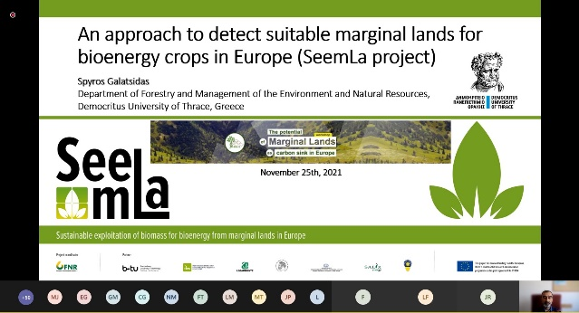
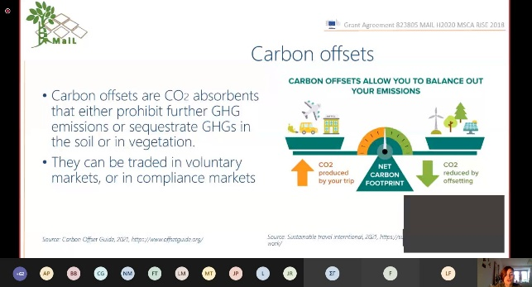
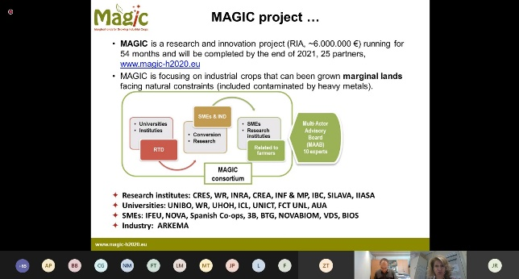
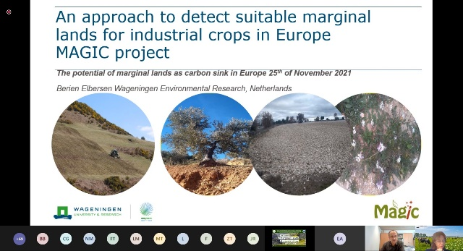
The presenter answered few questions that were asked by the participants, i.e. about the environmental impact of bio-fuels plantations and masking out urban areas from the mapping, because the analysis was done only for agriculture lands (cultivated and abandoned). She talked about difficulties in finding the right mask and about an approach to detect presence or absence of agricultural land management with the use of satellite SAR imagery.
Figure 4: Presentations at the workshop

Identification and classification of marginal lands in Europe
The next speech was given by Dr. Charalampos Georgiadis, an Assistant Professor in the School of Civil Engineering at the Aristotle University of Thessaloniki, Greece. He received his PhD from the Department of Spatial Information Science and Engineering in the University of Maine, USA.
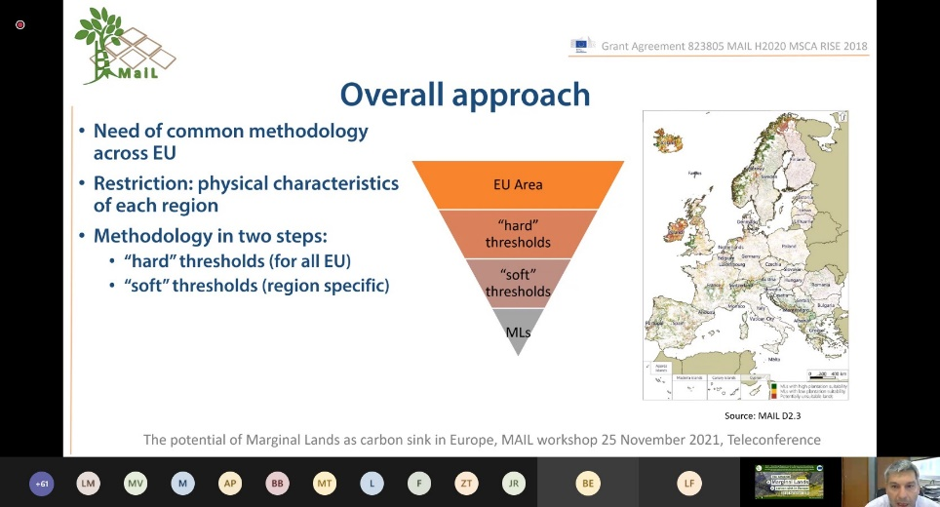
Dr. Georgiadis belongs to coordinating team in the MAIL and was seconded to work on the task related to financial, social and technical aspects of the sustainable development of marginal lands. He performed literature review for definition of variables and indicators that help to assess the sustainability of marginal lands used as carbon sinks. He also developed workflows that were used for sustainability assessment of MLs used as carbon sinks considering financial, social, environmental, and technical aspects of an afforestation project implemented in marginal lands.
Figure 5: Presentation of MaiL methodology for ML detection
His presentation was about the methodology of identifying and classifying marginal lands in Europe that was adopted in the MAIL. The overall approach resulted from the need of having a common methodology for the entire EU. A two-step methodology was used: applying hard and soft thresholds for MLs identification and then classification of MLs into three classes (ML with high or low plantation suitability and potentially unsuitable lands). The presenter described which variables constituted the hard thresholds and which sets of indicators were included in the soft constraints together with the list of used databases. The MLs map was assessed in terms of accuracy with the use of two methods: point- and area-based and the results were shown and explained.
The speaker clarified that general goal of the ML classification was to use it in the assessment of carbon sinks which are usually forests, unlike the agricultural approach of the MAGIC project.

MaiL Map Portal; Online tools for marginal lands management and monitoring – General description
The next presenter was Mr. Michał Krupiński, who works as a Geospatial Analyst and is MAIL project coordinator in the Space Research Centre of the Polish Academy of Sciences. He received M.S. degree in Geodesy and Cartography from Military University of Technology in Warsaw. His research interests include novel methods for satellite imagery classification and imaging spectroscopy. He participated in several tasks in the MAIL.
On the first day of the workshop, Mr. Krupiński made a theoretical introduction to the MAIL Map Portal, the part that contains online tools for marginal lands management and monitoring. The portal is a collection of algorithms and tools developed by project participants as part of various work packages. Its aim is to provide user friendly interface presenting selected outcomes of the project in spatial domain: maps and results of ML analysis, as well as to enable users the analysis of CO₂ sequestration potential of MLs. All of this is based on the Google Earth Engine (GEE). It was decided that the portal will be interactive and enable users to play with some parameters. The speaker described the flexibility given to the user in this tool. He concluded that there will be a section within MAIL Massive Open Online Course (MOOC) dedicated to the Portal and he will give more information during the demonstration on the next day.
Replying to the question about the purpose and main advantages for the users resulting from possibility to modify the parameters, the presenter said that the tool is adjusted to work for any area in Europe so it may give a generalised outcome, but if the user has additional knowledge about some specific region, the tool enables to adjust factors importance and in this way it can provide a better analysis, that is more suited to local conditions.

Mail Map Portal; Decision Support System for marginal lands management – General description
The second presentation about MAIL Map Portal was made by Mr. Fernando Bezares Sanfelip, an Environmental Engineer in Cesefor, Spain, specialised in GIS applied to the forestry sector. Previously he worked in the United Nations FAO defining remote sensing based methodologies for the indicators associated with the UN Sustainability Goals. He was involved in several tasks in the MAIL project.
Mr. Bezares introduced another toolbox of the MAIL Map Portal, which is the Decision Support System (DSS) for marginal lands management. The entire structure of DSS as well as the applied algorithms behind it were described in detail. The tool contains the following functions: AOI selection, identification of MLs, reforestation type selection (protective or productive) and analysis tools. The last panel consists of three different tools: Carbon Calculator, Carbon Predictor and Afforestation Cost Calculator. Similarly to the previous presentation, the speaker announced that more information will be provided at the demonstration the next day.

Round Table
Around the virtual table sat previously introduced: Dr. Berien Elbersen, Prof. Charalampos Georgiadis and Mr. Francisco Gallego, as well as Mr. Dzhaner Emin and Mr. Nikolaos Gounaris. This session was also moderated by Prof. Luis Ángel Ruiz Fernández.
Mr. Dzhaner Emin is a Remote Sensing Specialist at IAGB Geodata Factory Dresden, Germany. He holds an undergraduate degree in Ecology and Natural Conservation from the Forestry University of Bulgaria and a master’s degree in Remote Sensing and Environmental Modelling from ITC Twente, the Netherlands and Lund University, Sweden. During the MAIL project he participated in several tasks and was seconded to work on task related to the development and implementation of a machine learning prediction model for biomass inside MLs and classification of MLs into carbon sequestration groups based on their biomass volumes.
Mr. Nikolaos Gounaris is a Forest Engineer and the CEO and founder of HOMEOTECH company from Thessaloniki, Greece, which provides environmental consultancy and services and specialises in forestry sector.
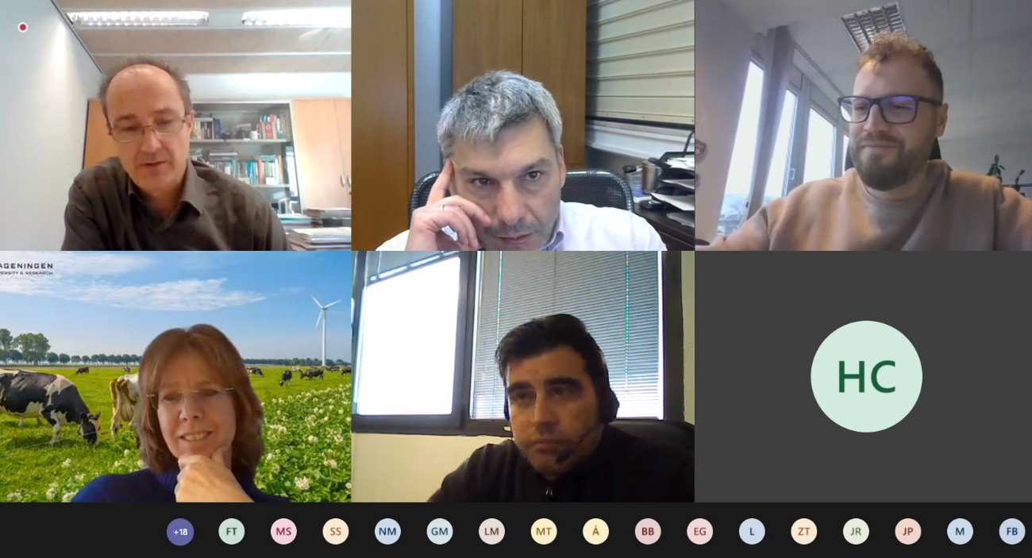
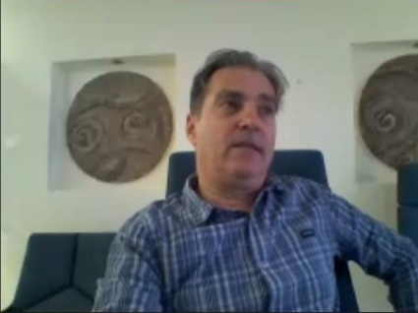
The following topics were discussed:
Figure 6: Participants of the round table discussion
- Concepts of MLs and how the definition of ML evolved and can be adapted to different land uses and goals.
- Development perspective on the example of marginal land in the region of Castilla y León in Spain.
- Challenge of understanding what is the current real use of a land, its management and biodiversity value.
- MLs from the perspective of central Europe (former opencast mines).
- Whether the European policies for the management of MLs (e.g., the Green Deal) are sufficient to preserve the areas and combine biodiversity with the production of these lands.
- A problem of proper rewarding (financial instruments) of ecosystem services, biodiversity conservation and carbon capture in contrast to agriculture and forest production.
- How remote sensing and GIS techniques can help.
- Problem of access to in-situ data.
- The influence of migrations on MLs.
- What will be the future and the use of ML.

MaiL Massive Open Online Course (MOOC)
The second day of workshop was opened with the presentation about MAIL MOOC made by Mr. Juan Pedro Carbonell Rivera, who is a PhD student in Geomatics Engineering in the Geo-Environmental Cartography and Remote Sensing Group of the Polytechnic University of Valencia, Spain. In MAIL project he worked on task related to the use and analysis of geomatics techniques applied for the generation of carbon estimation models. He was also working on preparation of MOOC and coordination.
The MOOC “Management of Marginal Lands and Carbon Sequestration Estimation through Remote Sensing and GIS” is based on the platform UPV[x] hosted in the Polytechnic University of Valencia. It will be an open-access online course containing 5 thematic subsections and prepared by several trainers from all institutions included in the consortium. The launch of the MOOC is planned in the beginning of 2022.

Mail Map Portal; Online tools for marginal lands management
Mr. Michał Krupiński continued the presentation of MAIL Map Portal in a part containing online tools for marginal lands management. In previous presentation he described theoretically how the portal is built and look like, and in this one he showed how the specific tools work in practice and how can be used. He also presented the differences between standard and enhanced layer of marginal lands extent map.
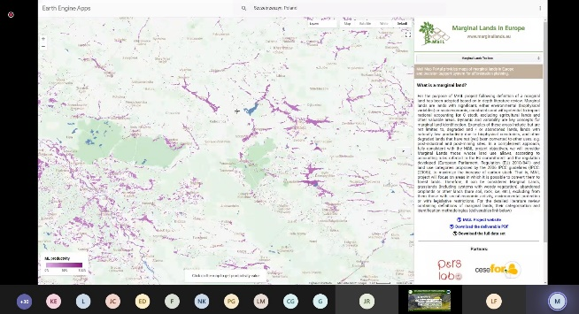
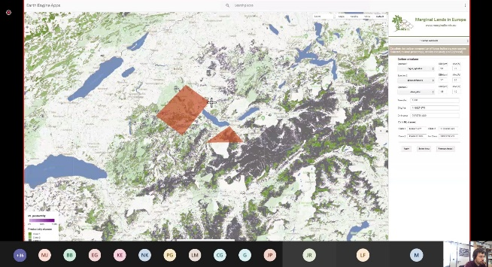
Figure 7: Presentation of MaiL Map Portal

MaiL Map Portal; Decision Support System for marginal lands
Mr. Fernando Bezares Sanfelip spoke about the Decision Support System (DSS) for marginal lands management. He has already made an introduction to theoretical background of MAIL Map Portal in previous show. In this speech, he described what the DSS is able to provide in practice. Mr. Bezares showed live and in detail how DSS’s tools work, how to make the analysis and what kind of information layers or graphs appear as a result. MLs enhanced classification was also presented in practice.
In response to the question about biodiversity, the speaker said that there always has to be a trade-off and balance between the afforestation and the biodiversity. That’s why the tool contains at least 3 species. In such a big scale tool cannot have precise definition of the trade-off between biodiversity and afforestation because there are too many scenarios and too many agroecological zones. A way to tackle it was to introduce three species of trees. The details connected to the impact of selected tree species to the entire environment of a specific area have to be assessed by a specialist like forester or a person who is carrying out the reforestation or ecological restoration process.

Closing remarks
Prof. Ruiz summarized both days of the workshop and listed main highlights. Then, Prof. Patias congratulated organisers and thanked presenters. He stressed that the project’s results were achieved in major part by a young generation of scientists, and that is a great outcome of staff exchanges action.

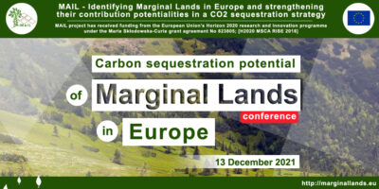
Final conference “Carbon sequestration potential of Marginal Lands in Europe”

The conference “Carbon sequestration potential of Marginal Lands in Europe” was held online and was jointly organised by the Aristotle University of Thessaloniki (AUTH, Greece), Gounaris N. – Kontos K. OE (HOMEOTECH, Greece), Universitat Politecnica de Valencia (UPV, Spain), Industrieanlagen Betriebsgesellschaft MBH (IABG, Germany), Centrum Badan Kosmicznych Polskiej Akademii Nauk (CBK PAN, Poland) and Fundacion Centro De Servicios Y Promocion FOrestral Y de su Industria De Castilla y Leon (CESEFOR, Spain). The event took place on 13 December 2021.
A one day meeting consisted of 17 presentations and a concluding discussion.
Recordings of speeches are available on: www.marginallands.eu/dissemination/media.
All presentations are also available on the MAIL project website.

Objective
The conference aimed to present the results achieved in the MAIL project during its implementation. Speeches about almost every work package and their tasks were made by secondees who worked in those tasks.

Participants
The conference was attended by 51 participants.

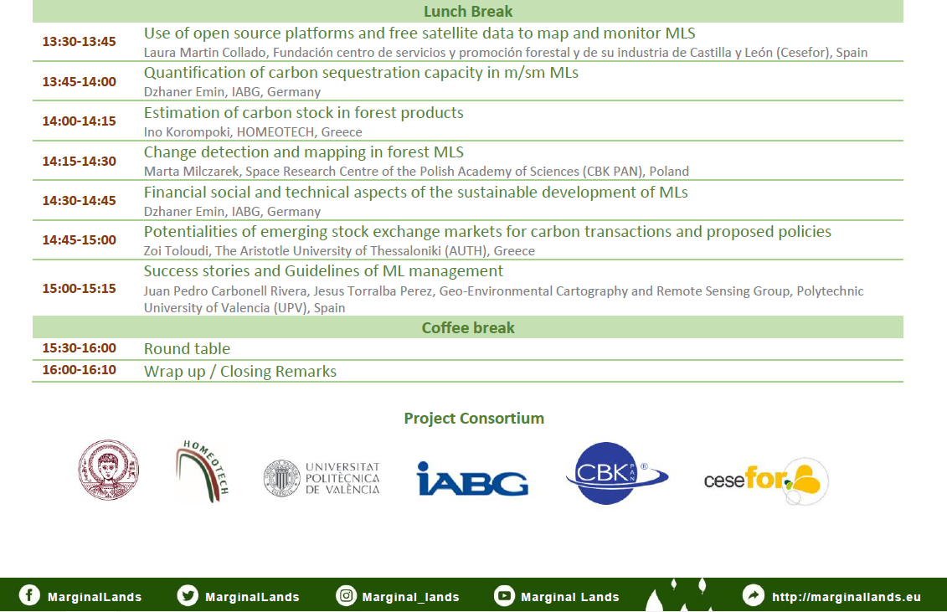
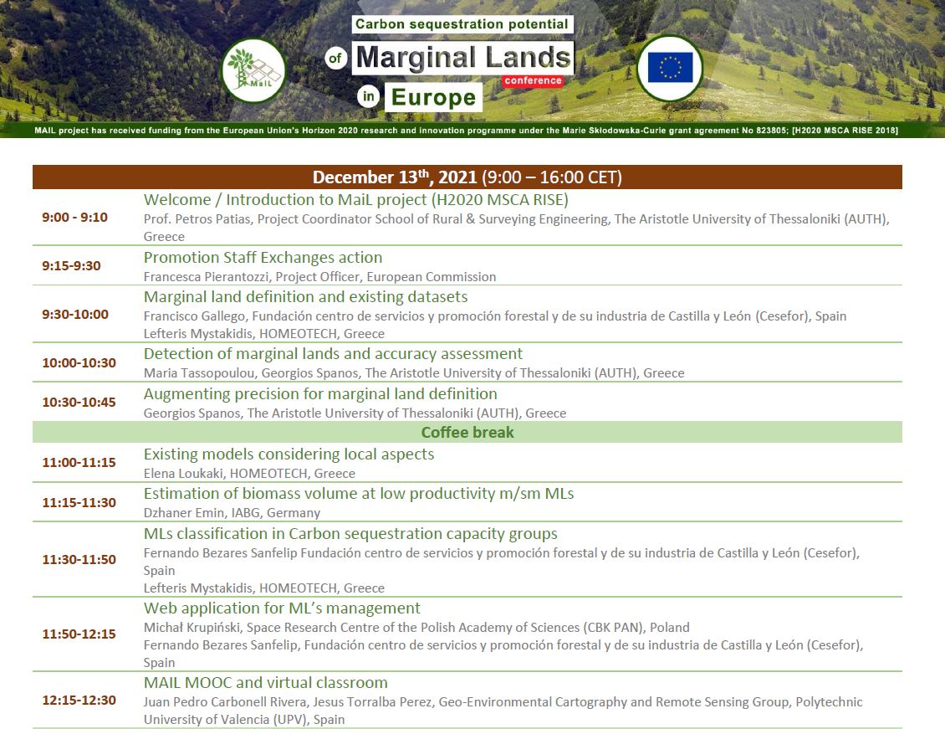
Agenda
Figure 8: Agenda of the Conference

Speakers and topics
All sessions were moderated by Dr. Charalampos Georgiadis (see short introduction in chapter 2.4.9).

Welcome / Introduction to MaiL project
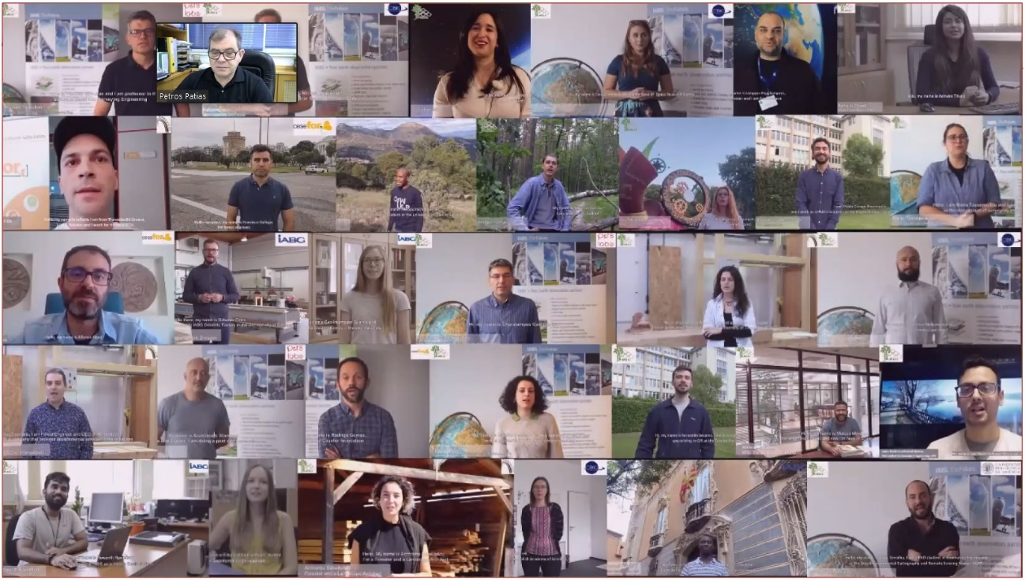
Prof. Petros Patias as MAIL Project Coordinator (see chapter 2.4.2) made an introductory speech, in which he presented an overview of the project: its topic, objectives, partners, workplan, workload, how the secondments were realized and what dissemination means were engaged to promote the project. He summarized the problems and challenges faced by the consortium and project managers during the COVID-19 pandemic. Finally, Prof. Patias briefly summarized the main achievements.

Promotion Staff Exchanges action
Figure 9: Excerpt from the introductory presentation
Then Ms. Francesca Pierantozzi, the Project Officer from the European Research Executive Agency took the floor. She supervised MAIL from June 2021.
Ms. Pierantozzi presented Staff Exchanges in general and what changes were introduced in the new Framework Programme Horizon Europe.
After the presentation, Prof. Patias said that the consortium tries to capitalise on the research performed during the project’s lifetime.

Marginal land definition and existing datasets
The presentation was split between two speakers.
In the first part, Mr. Francisco Gallego from CESEFOR (see chapter 2.4.4) presented the outcomes of the Task 2.1: Literature review and existing models, which comprised 5 person months and was done by two secondees. He listed objectives of the task and then briefly described historical approaches to the definition of marginal land. The concept still develops, is multi-casual, dynamic and goal-oriented. ML are not well-defined at the European level policies.
Then the speaker showed examples of MLs and said that the methodologies to identify MLs are also diverse. In order to identify ML one has to deal with many variables. Finally he described what definition was adopted in the MAIL.
The second part about existing datasets was presented by Mr. Lefteris Mystakidis who graduated from the Department of Forestry and Natural Environment of the Aristotle University of Thessaloniki, Greece. Since 2013, he works at HOMEOTECH providing technical support on project involving GIS applications, databases and field surveying. In MAIL he was seconded to several tasks.
Mr. Mystakidis showed the findings from the Task 2.2: Global datasets collection, on which two secondees worked. They compiled all the datasets in different categories available for Europe. A detailed review can be found at MAIL’s website in the Deliverable D2.2.

Detection of marginal lands and accuracy assessment
The presentation was split between two speakers.
Ms. Maria Tassopolou is a MSc. Surveyor Engineer and a PhD student and an early stage researcher in the laboratory of Photogrammetry and Remote Sensing of the School of Surveying Engineering of the Aristotle University of Thessaloniki, Greece. Her area of expertise include photogrammetry, remote sensing, GIS, 3D modelling and cartography. In the MAIL she participated in works on Task 2.3.
Mr. Georgios Spanos is a Geologist, currently on his last year of master studies on Geoinformation in Environmental Managements at the Aristotle University of Thessaloniki, Greece. In the MAIL project he was involved in 3 different tasks.
Ms. Tassopolou talked about the development of the common methodology for detection of marginal lands in Europe. Fifteen researchers were involved in tasks 2.3 (detection of MLs) and 2.4 (accuracy assessment). The proposed methodology was divided into two phases: implementation of “hard” thresholds for all EU and “soft” thresholds which where region specific. The speaker presented the overall top-down stepwise approach to assess marginality characteristics basing on the collected datasets, which were filtered in order to find those that are the closest to the marginality indicators. She described the finally selected datasets and showed what was their role in detection of MLs. Then, the computation workflows for implementation of hard thresholds regarding each land use category as well as classification results were shown. Also the workflow for defining soft constraints was presented. Due to different physical characteristics found across Europe, three different ranges were proposed to visualise the final layers resulted from the MLs classification.
Mr. Spanos described the aim and objectives of Task 2.4, what was the initial approach and how the methodology was developed, what assessment techniques and evaluation metrics were used and in the end he showed the final results of accuracy assessment. The research was conducted on four test sites located in Germany, Greece, Poland and Spain. Then, he indicated few discussion points regarding the results and showed the findings of land cover analysis.

Augmenting precision for marginal land definition
The presentation of results of Task 2.8 was also delivered by Mr. Georgios Spanos, who worked on it for few months under the supervision of Mr. Michał Krupiński. Mr. Spanos introduced the topic and its objectives, listed the data used, described how the workflow was developed and showed the results. The resulting tool enable to map marginal lands in any place in Europe and at any point in time.
Next, he presented a case study, which was performed on test sites in Greece and Spain in order to evaluate the developed algorithm using input data of higher quality. Finally he concluded his work saying that identifying MLs with Earth Observation data is challenging but possible task. The tool developed in this task is capable of providing accurate results and precision of ML detection can be augmented.

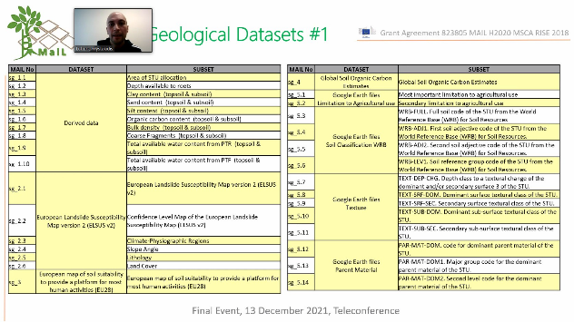
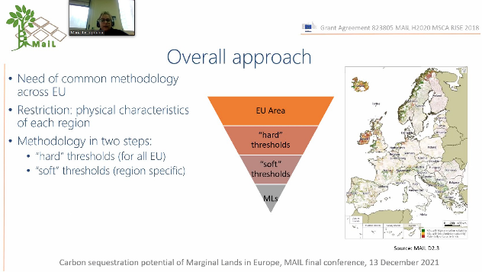
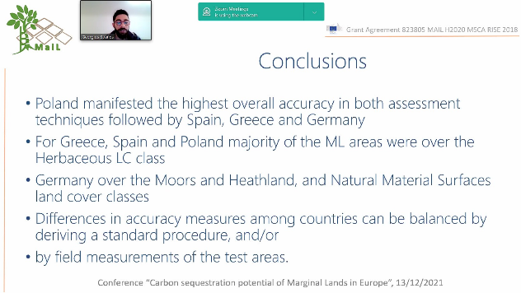
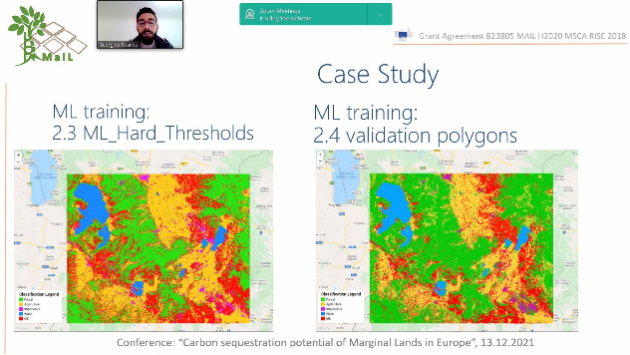
Figure 10: Presentations at the conference

Existing models considering local aspects
Next presentation was delivered by Ms. Elena Loukaki, who is a Forester and has been working in HOMEOTECH since 2013. She graduated from the Aristotle University of Thessaloniki in 2013 and holds two master’s degrees: in Management of Water Resources and in Wildlife Management. In the MAIL project she participated in several tasks.
Ms. Loukaki talked about various methodologies for quantifying carbon sequestration which were reviewed in Task 2.5 – direct: destructive, non-destructive, UK method, resources monitoring based on the EISA method and measurements of direct carbon flux. Next, she described indirect methods: allometric equations and predictive models as well as the use of remote sensing and GIS. Then, the IPCC Guidelines for carbon stock estimation were discussed and indicated as a method (Tier 1) which was selected for MAIL estimation.

Estimation of biomass volume at low productivity m/sm MLs
The next speaker, Mr. Dzhaner Emin from IABG (see speaker’s short introduction in chapter 2.4.12) presented summary of several different studies that were conducted on the topic of estimation of above-ground biomass volume in MLs, that is: 1) exploratory machine learning approach with the use of optical data Sentinel-2, 2) inversion of SAR-based volume estimates with the use of Sentinel-1, 3) SAR-optical data fusion and machine learning.
He described the workflows of each approach, what were the objectives and assumptions, how the input data were pre-processed and biomass estimated and the final results. The third approached occurred to bring better results.

MLs classification in carbon sequestration capacity groups
The presentation was split between two speakers: Mr. Fernando Bezares Sanfelip from CESEFOR (see chapter 2.4.15) and Mr. Lefteris Mystakidis from HOMEOTECH (see chapter 3.4.3). Five secondees worked on the Task 2.7
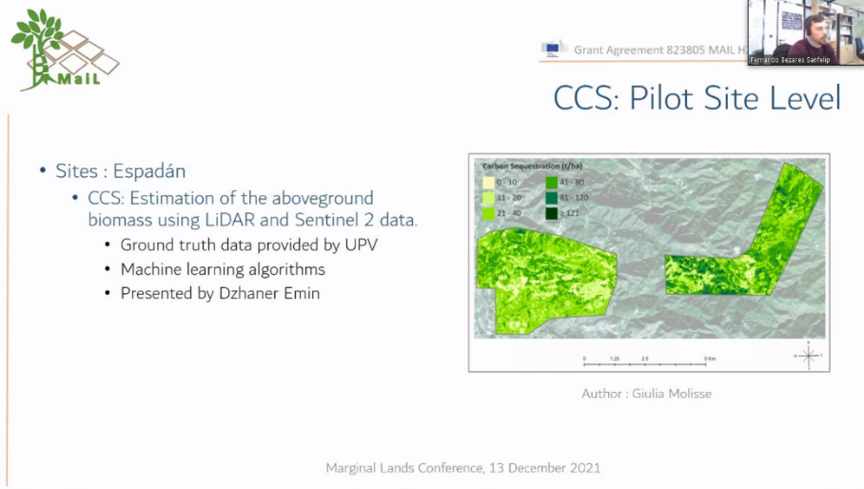
Mr. Bezares, who coordinated this research, introduced the audience to the objectives and goals of the task as well as some basic definitions of: carbon sequestration, current carbon sequestration (CCS), carbon carrying capacity (CCC) and carbon sequestration capacity (CSC). The classification was done at two scales: on a pilot site in Spain, which was presented by Mr. Bezares, and at the European scale which Mr. Mystakidis presented. The resulting maps were shown.
Figure 11: Presentation about carbon sequestration capacity estimation
Due to the scale of Europe, a different approach had to be applied than in case of pilot case site level and Mr. Mystakidis described it, talking about datasets selection, methodology workflow and the development of a tool in Google Earth Engine (GEE).

Web application for ML’s management
The presentation was split between two speakers.
At the beginning, Mr. Michał Krupiński from CBK PAN (see chapter 2.4.10) introduced the whole development team that created the MAIL Map Portal. Then he presented the objectives and requirements of a web application development. The Portal is based on the GEE and the reasons behind using this platform were explained. Mr. Krupiński showed the first part of the Portal related to the marginal lands mapping, which contains products such as: ML productivity map layer (base map and enhanced map), ML productivity classes, multi-temporal MLs monitoring. The differences between base map and enhanced map of ML productivity were explained and the entire tool and its parameters were described in detail.
Then, Mr. Fernando Bezares Sanfelip from CESEFOR (see chapter 2.4.15) spoke about the Decision Support System (DSS), the second part of the MAIL Map Portal, dedicated for carbon analysis, predictions and calculations. He described in details the workflow applied in the ML Toolbox and explained how the different tools in DSS work. The analysis tools contain: carbon calculator, carbon predictor and afforestation cost calculator. The dedicated section on how the MAIL Map Portal works will be available within MAIL MOOC which will open soon.

MAIL MOOC and virtual classroom
Mr. Juan Pedro Carbonell Rivera (see chapter 2.4.13) and Mr. Jesús Torralba Pérez, both from UPV, presented the Massive Open Online Course (MOOC) created by the team of secondees.
Mr. Jesús Torralba Pérez is a Forestry and Natural Environmental Engineer from the University of Castilla-La Mancha, Spain. He has a master’s degree in Remote Sensing from the Universidad Mayor, Chile. Since the end of 2017 he is a PhD student in Geomatics Engineering at the Geo-Environmental Cartography and Remote Sensing Group at the Polytechnic University of Valencia (UPV) and his studies are focused on the characterization of forest structure and forest fuel by integrating analysis of methods based on TLS, airborne LiDAR and imaging. In the MAIL he worked on several tasks.
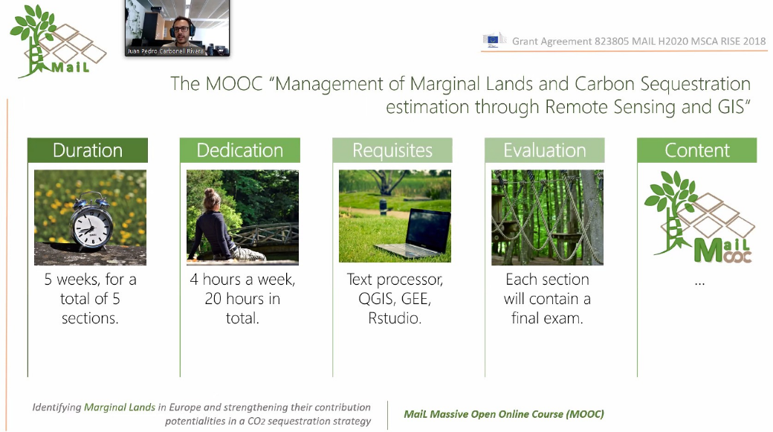
Firstly, Mr. Carbonell Rivera explained what are MOOCs, xMOOCs and cMOOCs. The MOOC “Management of Marginal Lands and Carbon Sequestration Estimation through Remote Sensing and GIS” is based on the platform UPV[x] hosted in the Polytechnic University of Valencia. The speaker presented the objectives behind the course creation and described the MOOC (Figure 12). He introduced the whole team of trainers from all institutions of the consortium that developed the training materials and created the MOOC.
Figure 12: The MaiL MOOC
Then, Mr. Torralba Perez described the content and structure of the course (Figure 13) in details. This open access online course contains 5 thematic subsections. The launch of the MOOC is planned in the beginning of 2022.
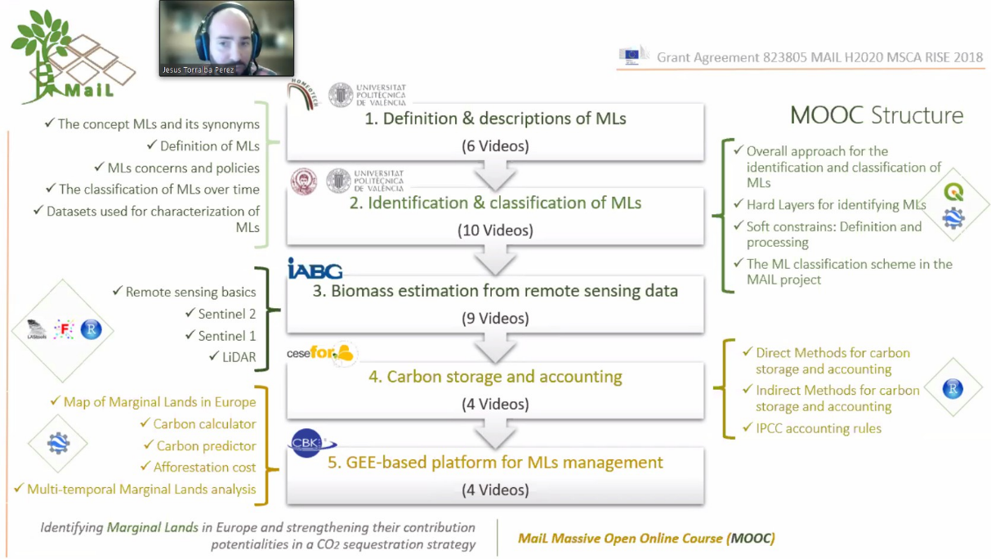
Figure 13: Presentation about MaiL MOOC

Use of open source platforms and free satellite data to map and monitor MLs
The first pilot case study was presented by Ms. Laura Martin Collado, a Forest Engineer specialised in GIS, remote sensing and GPS applied to Land Management. She holds a master’s degree in Protection of Natural Spaces. Currently she is finishing the master’s degree in Data Science-Based Forest Management at the University of Valladolid. She works in CESEFOR, Spain.
The task 4.1 was conducted by four secondees. The case study was conducted differently in test sites located in four countries. Ms. Martin Collado described the objectives, workflow schemes and regional datasets used for each country and showed the results. Then she discussed the differences and compared the results of this pilot case study with the related outputs of the main MAIL methodology developed in task 2.3.
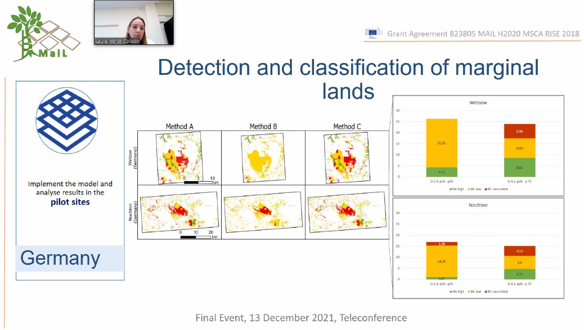
Figure 14: Presentation at the conference

Quantification of carbon sequestration capacity in m/sm MLs
Mr. Dzhaner Emin (see chapter 2.4.12) presented the second pilot case study (Task 4.2) in which four secondees participated. The goal was to model carbon sequestration capacity into the future and forecast how certain planted species would evolve in the MLs. The study was conducted on the same test sites which were selected within MAIL. The speaker explained which species were chosen, how the forest growth simulation and biomass estimation was conducted and showed what species combinations were applied for each marginality class.

Estimation of carbon stock in forest products
The third pilot case study was presented by Ms. Ino Korompoki, who is a Forester – Environmentalist. She has graduated from the Aristotle University of Thessaloniki and she holds the integrated master diploma of Forestry and Environmental Sciences and a master of Sustainable Management of Forest and Natural Ecosystems. Over the last year she has been working in HOMEOTECH. In the MAIL project she participated in several tasks.
The task 4.3 was focused on the identification of the future forest species in MLs pilot areas under projected afforestation modules, calculation of the carbon stored in wood products as well as checking and adjustment of all the quantification of carbon products.
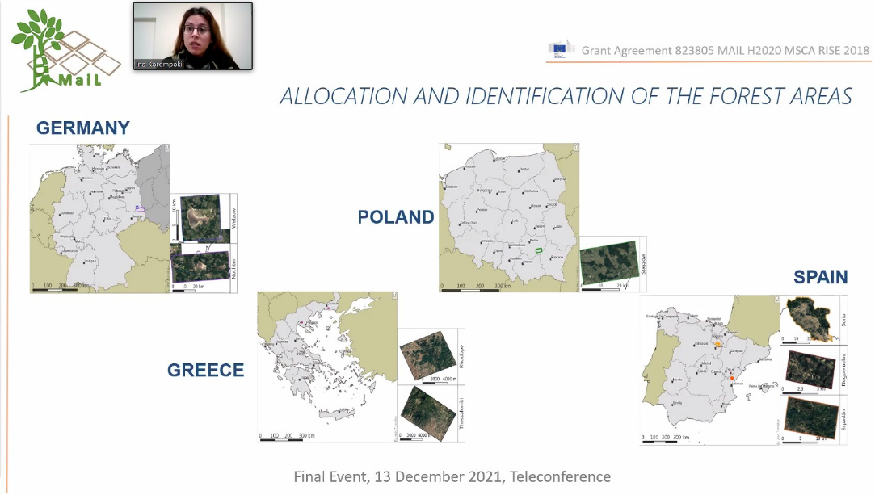
Ms. Korompoki showed the selected tree species, their share and the age of final cut in different countries. She described the scenarios of species planting on the example of Greece and discussed the market demand and use of wood products from harvested trees from MLs plantings. Next, the presenter showed the tables with biomass and carbon estimation for different species. Then, the estimation of total carbon stock in wood products was explained and the results presented for different scenarios. Finally the idea of lifespan of wood products was introduced and the figures showing the estimated values presented.
Figure 15: The allocation of test sites

Change detection mapping in forest MLs
The fourth case study was discussed by Ms. Marta Milczarek, who is a Geographer and has been working as a GIS and Remote Sensing Specialist at the Space Research Centre of the Polish Academy of Sciences in Warsaw since 2014. She graduated from the University of Warsaw, specialising in two fields: Geoinformatics Remote Sensing and Geomorphology. She has worked in several projects dealing with satellite imagery processing and geospatial analysis for crisis management, public security and development assistance. In MAIL project she was seconded to work in two tasks.
The presentation contained the description of objectives and workflow of task 4.4 which was realised by four secondees. The speaker explained what approach was applied to detect land cover change in forest MLs and described the algorithm selected in a result of literature review. LandTrendr Change Mapper Application based on GEE has been shown and its possibilities presented. The selected functionalities will be implemented in the MAIL Map Portal.
Then, three scenarios of application usage were presented, in case of deforestation detection, forest areas monitoring and afforestation / reforestation projects monitoring. The speaker showed several examples of map layers for each scenario.

Financial, social and technical aspects of sustainable development of MLs
The Task 5.2 was presented by Mr. Dzhaner Emin (see chapter 2.4.12). The goal of this feasibility study was to provide sustainability assessment guideline, develop dedicated workflows for sustainable MLs management, perform feasibility analysis for the use of MLs as carbon sinks and focus on transforming MLs to forests.
The presenter introduced the definition of a sustainable development, explained what is a sustainable forest management and what are its indicators. Then, he described the workflow for sustainability assessment, in particular financial, environmental and social aspects. Next, the maps of afforestation cost were shown. Finally, the speaker discussed the possibility of increasing carbon sequestration strategies.

Potentialities of emerging stock exchange markets for carbon transactions and proposed policies
Ms. Zoi Touloudi from AUTH (see chapter 2.4.6) presented the task, which tree seconded worked on. She explained how and why stock exchange markets for carbon transaction were established and discussed two kinds of markets: compliance and voluntary carbon market. Next, she introduced the term: carbon offsets, talked about the EU Emissions Trading System and the rapidly increasing allowance price of carbon dioxide in last years. Effort Sharing Regulation in the EU creates binding annual Green House Gases (GHG) emission targets for Member States.
Then, term “sink” was introduced, the ways of GHG removal from the atmosphere and the role of Land Use, Land-Use Change and Forestry (LULUCF) was presented. Finally, the steps in implementation of carbon offsets projects and the project evaluation criteria were described.

Success stories and guidelines of ML management
The final presentation was delivered by Mr. Jesús Torralba Pérez and Mr. Juan Pedro Carbonell Rivera, both from UPV.
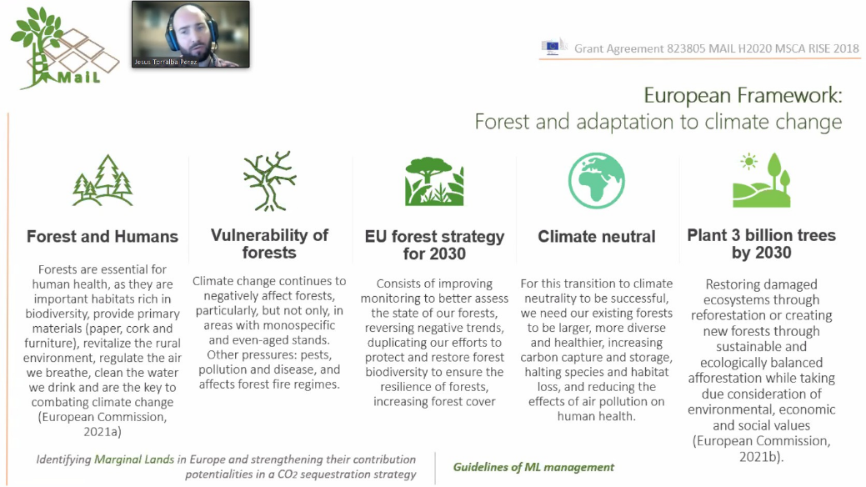
Mr. Torralba elaborated on new European policies about forest and adaptation to climate change (Figure 16). Then, he discussed the proposal for the use of marginal lands for afforestation and reforestation. 58 guidelines of ML management at pan-European level were developed. They contain a set of recommendations for voluntary use in reforestation / afforestation programs on ML. The presenter showed selected examples of guidelines.
Figure 16: Presentation about guidelines of ML management
Mr Carbonell Rivera spoke about success stories of ML monitoring using remote sensing techniques. He discussed the previous studies and projects which were focused on using remote sensing for MLs identification, classification and monitoring as well as the assessment of carbon sequestration potential of ML.

Round Table / Wrap up / Closing Remarks
Mr. Georgiadis indicated that MAIL project achieved all of its objectives. Most of the research was transformed into tools and applications that can be used in web GIS or GEE which is an added value. ML have the potential as a resource to be used for carbon sequestration, not only in Europe but world-wide. All the knowledge gained during project was transformed into MOOC, which everybody can attend. He thanked all secondees for hard work, effort and dedication to produce all this results.
Mr. Krupiński added that despite the pandemic, all tasks were performed, new ways were found how to proceed and explore the potential of MLs for CO2 sequestration. The consortium has already tried to acquire new funding to continue the research on larger scale.
Mr. Emin summarized that although the conditions were not ideal, the results are very promising. A valuable insights into the web application and web platform were done. Firstly, this is a good tool for dissemination and secondly, it can be used, reused and extended in the future. The back-end of the platform is very flexible and new modules additional products can be added in the future.
Mr. Papalampros indicated that very interesting tools were developed by the consortium.
Mr. Gallego acknowledged the effort that everyone has put into the project. In his opinion, technically the consortium has come a long way, has more knowledge about identification of MLs at a big scale.
Mr. Georgiadis summarized that researched on MLs should be pursued in the future because they are a resource that can be used to mitigate the climate change effects and help the European Union to reach the zero carbon and GHG emissions.

Scientific papers
Five papers resulting from the activities of MAIL project were published.
1
Authors | Carbonell-Rivera, Juan Pedro, Estornell, Javier, Ruiz, Luis. Á., Torralba Pérez, Jesús & Crespo-Peremarch, Pablo
Year | 2020
Title | Classification of UAV-based photogrammetric point clouds of riverine species using machine learning algorithms: a case study in the Palancia river, Spain
Paper | Int. Arch. Photogramm. Remote Sens. Spatial Inf. Sci., XLIII-B2-2020, XXIV ISPRS Congresse. 659–666
DOI / link | https://doi.org/10.5194/isprs-archives-XLIII-B2-2020-659-2020
Abstract | “The management of riverine areas is fundamental due to their great environmental importance. The fast changes that occur in these areas due to river mechanics and human pressure makes it necessary to obtain data with high temporal and spatial resolution. This study proposes a workflow to map riverine species using Unmanned Aerial Vehicle (UAV) imagery. Based on RGB point clouds, our work derived simple geometric and spectral metrics to classify an area of the public hydraulic domain of the river Palancia (Spain) in five different classes: Tamarix gallica L. (French tamarisk), Pinus halepensis Miller (Aleppo pine), Arundo donax L. (giant reed), other riverine species and ground. A total of six Machine Learning (ML) methods were evaluated: Decision Trees, Extra Trees, Multilayer Perceptron, K-Nearest Neighbours, Random Forest and Ridge. The method chosen to carry out the classification was Random Forest, which obtained a mean score cross-validation close to 0.8. Subsequently, an object-based reclassification was done to improve this result, obtaining an overall accuracy of 83.6%, and individually a producer’s accuracy of 73.8% for giant reed, 87.7% for Aleppo pine, 82.8% for French tamarisk, 93.5% for ground and 80.1% for other riverine species. Results were promising, proving the feasibility of using this cost-effective method for periodic monitoring of riverine species. In addition, the proposed workflow is easily transferable to other tasks beyond riverine species classification (e.g., green areas detection, land cover classification) opening new opportunities in the use of UAVs equipped with consumer cameras for environmental applications.” (Carbonell-Rivera et al., 2020)
2
Authors | Carbonell-Rivera, Juan Pedro, Estornell, Javier, Ruiz, Luis. Á., Torralba Pérez, Jesús & Crespo-Peremarch, Pablo
Year | 2021
Title | Machine learning applied to the classification of riverine species using UAV-based photogrammetric point clouds
Paper | First International Conference on Smart Geoinformatics Applications (ICSGA), 33-36.
DOI / link | http://cgat.webs.upv.es/wp-content/uploads/2021/06/ICSGA-2021-Proceedings.pdf
Abstract | “Riverine areas are of great importance for their high nature conservation and biodiversity value. These zones are also areas of high human activity, negatively affecting the ecosystem with the modification of riverbeds, construction of dams, or introduction of invasive species. In this sense, to achieve balance in the riverbed, it is essential to have periodic information on the area to be able to implement management plans. From photogrammetric RGB point clouds, our study conducted a classification of species using geometric and spectral features to classify the predominant species of a stretch of the river Palancia (Spain). These species were Arundo donax L., Tamarix gallica L., Pinus halepensis Mill., other riverine species, and ground. The classification was done applying the Random Forest algorithm, obtaining a mean cross-validation score of 82%, and individually by species a score of 88% for giant reed, 70% for French tamarisk, 82% for Aleppo pine, 92% for ground and 62% for other riverine species. The good results obtained show the feasibility of using digital aerial photogrammetry in unmanned aerial vehicle (UAV-DAP) for periodic monitoring of river species, improving the information provided to river administrators to implement management plans.” (Carbonell-Rivera et al., 2021)
3
Authors | Torralba Pérez, Jesús, Ruiz, Luis Á., Georgiadis, Charalampos, Patias, Petros, Conejo, Rodrigo, Verde, Natalia, Tassopoulou, Maria, Bezares, Fernando, Gromny, Ewa, Aleksandrowicz, Sebastian, Krätzschmar, Elke, Krupiński, Michał & Carbonell-Rivera, Juan Pedro.
Year | 2021
Title | Methodological proposal for the identification of marginal lands with remote sensing-derived products and ancillary data
Paper | 3rd Congress on Geomatics Engineering, Valencia, Spain.
DOI / link | 10.4995/CiGeo2021.2021.12729
Abstract | “The concept of marginal land (ML) is dynamic and depends on various factors related to the environment, climate, scale, culture, and economic sector. The current methods for identifying ML are diverse, they employ multiple parameters and variables derived from land use and land cover, and mostly reflect specific management purposes. A methodological approach for the identification of marginal lands using remote sensing and ancillary data products and validated on samples from four European countries (i.e., Germany, Spain, Greece, and Poland) is presented in this paper. The methodology proposed combines land use and land cover data sets as excluding indicators (forest, croplands, protected areas, impervious areas, land-use change, water bodies, and permanent snow areas) and environmental constraints information as marginality indicators: (i) physical soil properties, in terms of slope gradient, erosion, soil depth, soil texture, percentage of coarse soil texture fragments, etc.; (ii) climatic factors e.g. aridity index; (iii) chemical soil properties, including soil pH, cation exchange capacity, contaminants, and toxicity, among others. This provides a common vision of marginality that integrates a multidisciplinary approach. To determine the ML, we first analyzed the excluding indicators used to delimit the areas with defined land use. Then, thresholds were determined for each marginality indicator through which the land productivity progressively decreases. Finally, the marginality indicator layers were combined in Google Earth Engine. The result was categorized into 3 levels of productivity of ML: high productivity, low productivity, and potentially unsuitable land. The results obtained indicate that the percentage of marginal land per country is 11.64% in Germany, 19.96% in Spain, 18.76% in Greece, and 7.18% in Poland. The overall accuracies obtained per country were 60.61% for Germany, 88.87% for Spain, 71.52% for Greece, and 90.97% for Poland.” (Torralba Pérez et al., 2021)
4
Authors | Carbonell-Rivera, Juan Pedro, Estornell, Javier, Ruiz, Luis Á., Abad, Alfonso, Felten, Bettina & Torralba Pérez, Jesús
Year | 2021
Title | A review of the use of remote sensing for monitoring and quantifying carbon sequestration in marginal lands
Paper | 3rd Congress on Geomatics Engineering, Valencia, Spain.
DOI / link | https://dx.doi.org/10.4995/CiGeo2021.2021.12694
Abstract | “In recent years, Remote Sensing (RS) and its derived products have been used as a key tool for the detection, monitoring, management and future use of Marginal Lands (ML). Currently, there is no single, universally accepted definition of the term and there is a wide variety of synonyms. In this paper, we conduct a compilation of synonyms and meanings that encompass the term, as well as propose a definition. To reach this objective, an overview of the state of the art of ML is done, visualising trends by science maps, based on bibliographic data of established research journals, found in Google Scholar, Web of Science (WoS) and Scopus search engines. The bibliographic review carried out shows that the study of ML has traditionally been carried out with an ad hoc basis focused on the objective to be achieved, this aspect and other knowledge gaps are discussed to analyse the global study of ML. Due to the broad spectrum of uses in which ML have been studied, the work has been focused on RS for monitoring and characterizing ML, focusing on two different aspects: (i) satellite monitoring of marginal lands; and (ii) determining carbon sequestration potential of marginal lands using remote sensing.” (Carbonell-Rivera et al., 2021)
5
Authors | Theofanous, Nikos, Chrysafis, Irene, Mallinis, Giorgos, Domakinis, Christos, Verde, Natalia & Siahalou, Sofia
Year | 2021
Title | Aboveground Biomass Estimation in Short Rotation Forest Plantations in Northern Greece Using ESA’s Sentinel Medium-High Resolution Multispectral and Radar Imaging Missions
Paper | Forests 12, no. 7: 902.
DOI / link | https://doi.org/10.3390/f12070902
Abstract | “Plantations of fast-growing forest species such as black locust (Robinia Pseudoacacia) can contribute to energy transformation, mitigate industrial pollution, and restore degraded, marginal land. In this study, the synergistic use of Sentinel-2 and Sentinel-1 time series data is explored for modeling aboveground biomass (AGB) in black locust short-rotation plantations in north-eastern Greece. Optimal modeling dates and EO sensor data are also identified through the analysis. Random forest (RF) models were originally developed using monthly Sentinel-2 spectral indices, while, progressively, monthly Sentinel-1 bands were incorporated in the statistical analysis. The highest accuracy was observed for the models generated using Sentinel-2 August composites (R2 = 0.52). The inclusion of Sentinel-1 bands in the spectral indices’ models had a negligible effect on modeling accuracy during the leaf-on period. The correlation and comparative performance of the spectral indices in terms of pairwise correlation with AGB varied among the phenophases of the forest plantations. Overall, the field-measured AGB in the forest plantations plots presented a higher correlation with the optical Sentinel-2 images. The synergy of Sentinel-1 and Sentinel-2 data proved to be a non-efficient approach for improving forest biomass RF models throughout the year within the geographical and environmental context of our study.” (Theofanous et al. 2021)

Participation in seminars
The representatives of MAIL project participated in six events, where they presented the overall assumptions as well as preliminary results. All the seminars are described below.
Due to COVID-19 pandemic conditions since March 2020, many events which the consortium representatives planned to attend were postponed or cancelled. The list is as follows:
- CBK PAN organised a dedicated session about marginal lands during ForestSAT 2020 conference, but it was postponed until 2022.
- Polish remote sensing conference planned for September 2020 was cancelled.
- Spanish Forest Congress 2020 was postponed until 2021.

Symposium “20 Years of Remote Sensing”
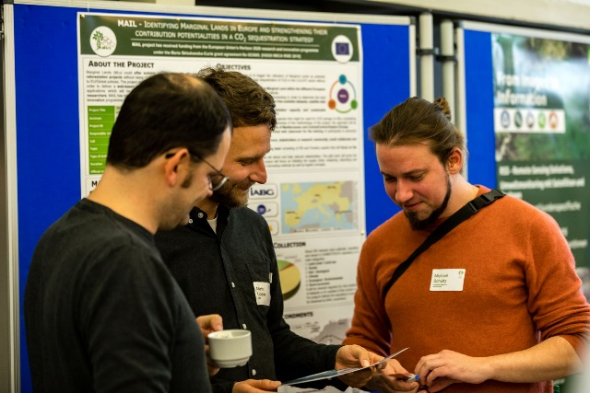
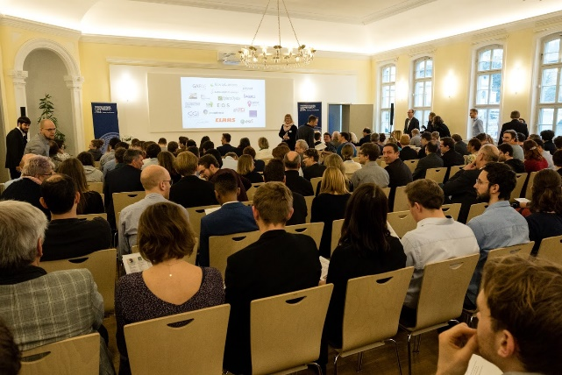
The event took place at the Friedrich-Schiller-University in Jena, Germany, on 7 February 2020. A poster (see Annex I) about MAIL project was prepared and presented by Martin Lindner and Elke Krätzschmar from IABG.
Figure 17: Symposium in Jena

XXIV ISPRS Congress
Representatives of MAIL project participated in the XXIV ISPRC Congress, which was organised online between 4 and 10 July 2020. Juan Pedro Carbonell-Rivera made a speech on “Classification of UAV-based photogrammetric point clouds of riverine species using machine learning algorithms: a case study in the Palancia river, Spain”. The participation resulted in a publication in proceedings (see chapter 4 p. 1).
The short movie presenting research is available under this link.

National Copernicus Forum
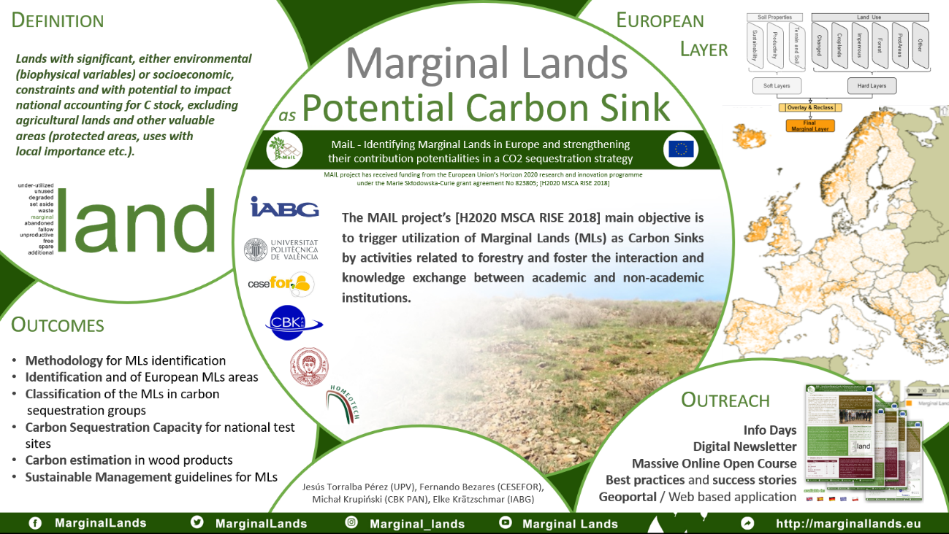
The National Copernicus Forum took place in Germany, 23-24 March 2021. A poster “Marginal Lands as potential carbon sinks“ (Figure 18) was presented. It was prepared by Jesús Torralba Pérez (UPV), Fernando Bezares (CESEFOR), Michał Krupiński (CBK PAN) and Elke Krätzschmar (IABG).
Figure 18: Poster presented on the National Copernicus Forum in Germany

Copernicus Info Day in Poland
An online conference “The Use of Satellite Data and Copernicus Programme in Administration and Private Sector” was held on 31 March – 1 April 2021 in Poland. The event was aimed at Polish users from public and private sector who could watch several presentations about achievements, data and satellite-based products which Polish space industry and research institutions can provide.
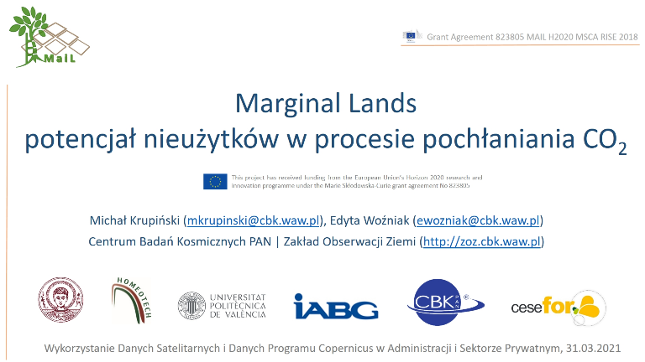
Project MAIL was presented by Michał Krupiński (CBK PAN) who delivered the talk on “Marginal Lands and their potential in the process of CO2 absorption” (Figure 19).
Figure 19: Title slide of the presentation about marginal lands

Copernicus User Uptake International Workshop
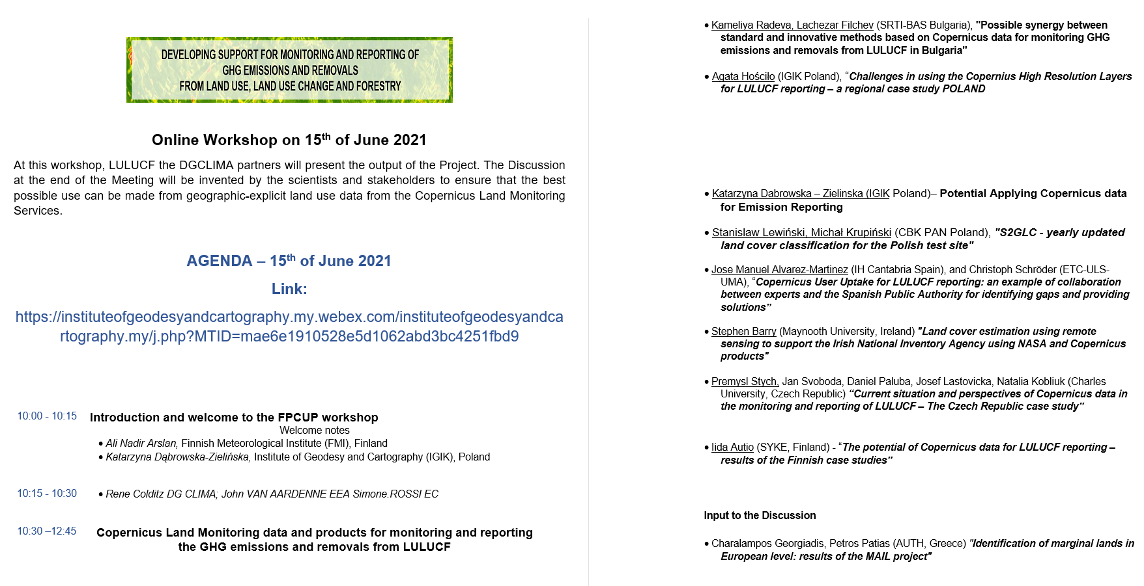
The preliminary results of the MAIL were presented during an online workshop “Developing Support for Monitoring and Reporting of GHG Emissions and Removals from Land Use, Land Use Change and Forestry” on 15 June 2021. The overall aim of this event was to present the output of FPCUP project GD CLIMA. However, it was also an occasion to discuss about possible interactions between the MAIL and GD CLIMA projects.
Figure 20: Agenda of the FPCUP workshop
The presentation (Figure 21) was prepared by Petros Patias and Charalampos Georgiadis (AUTH) and titled “Identification of marginal lands in European level: results of the MAIL project”.
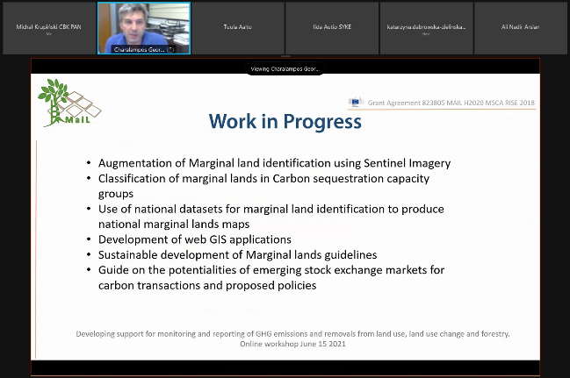
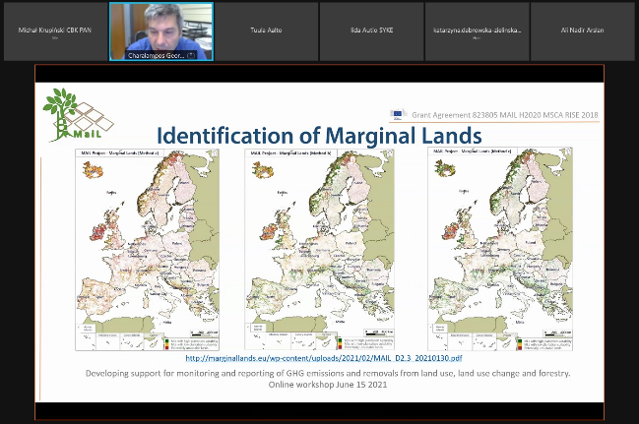
Figure 21: Presentation about MaiL during the FPCUP workshop

Third Congress in Geomatic Engineering
This scientific conference took place in Valencia, Spain on 7 and 8 July 2021. Project was present in two speeches: by Juan Pedro Carbonell-Rivera (UPV) about “A review of the use of remote sensing for monitoring and quantifying carbon sequestration in marginal lands” and by Jesús Torralba Peréz (UPV) on “Methodological proposal for the identification of marginal lands with remote sensing-derived products and ancillary data”. The participation resulted in publication of two scientific papers (see chapter 4, p. 3 & 4).
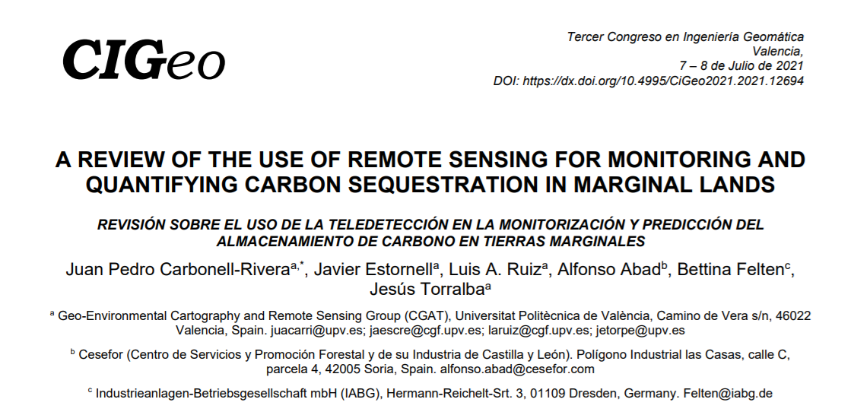
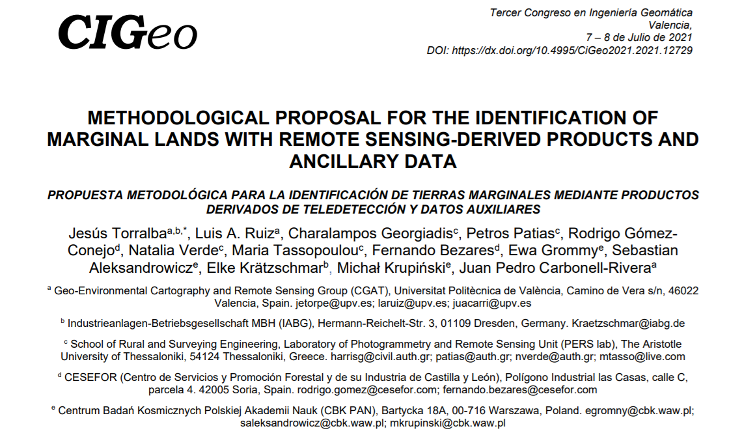
Figure 22: Title pages of two MaiL papers

References
- Carbonell-Rivera, J. P., Estornell, J., Ruiz, L.. Á., Torralba Pérez, J. & Crespo-Peremarch, P. (2020). Classification of UAV-based photogrammetric point clouds of riverine species using machine learning algorithms: a case study in the Palancia river, Spain. Int. Arch. Photogramm. Remote Sens. Spatial Inf. Sci., XLIII-B2-2020, XXIV ISPRS Congresse. 659–666. https://doi.org/10.5194/isprs-archives-XLIII-B2-2020-659-2020
- Carbonell-Rivera, J. P. Estornell, J., Ruiz, L.. Á., Torralba Pérez, J. & Crespo-Peremarch, P. (2021). Machine learning applied to the classification of riverine species using UAV-based photogrammetric point clouds. First International Conference on Smart Geoinformatics Applications (ICSGA), 33-36. http://cgat.webs.upv.es/wp-content/uploads/2021/06/ICSGA-2021-Proceedings.pdf
- Torralba Pérez, J., Ruiz, L. Á., Georgiadis, C., Patias, P., Conejo, R., Verde, N., Tassopoulou, M., Bezares, F., Gromny, E., Aleksandrowicz, S., Krätzschmar, E., Krupiński, M. & Carbonell-Rivera, J. P. (2021). Methodological proposal for the identification of marginal lands with remote sensing-derived products and ancillary data. 3rd Congress on Geomatics Engineering, Valencia, Spain.
10.4995/CiGeo2021.2021.12729
- Carbonell-Rivera, J. P., Estornell, J., Ruiz, L. Á., Abad, A., Felten, B. & Torralba Pérez, J.. (2021). A review of the use of remote sensing for monitoring and quantifying carbon sequestration in marginal lands. 3rd Congress on Geomatics Engineering, Valencia, Spain. https://dx.doi.org/10.4995/CiGeo2021.2021.12694
- Theofanous, N., Chrysafis, I., Mallinis, G., Domakinis, C., Verde, N. & Siahalou, S.. (2021). Aboveground Biomass Estimation in Short Rotation Forest Plantations in Northern Greece Using ESA’s Sentinel Medium-High Resolution Multispectral and Radar Imaging Missions. Forests 12, no. 7: 902. https://doi.org/10.3390/f12070902.

Annex I: Poster
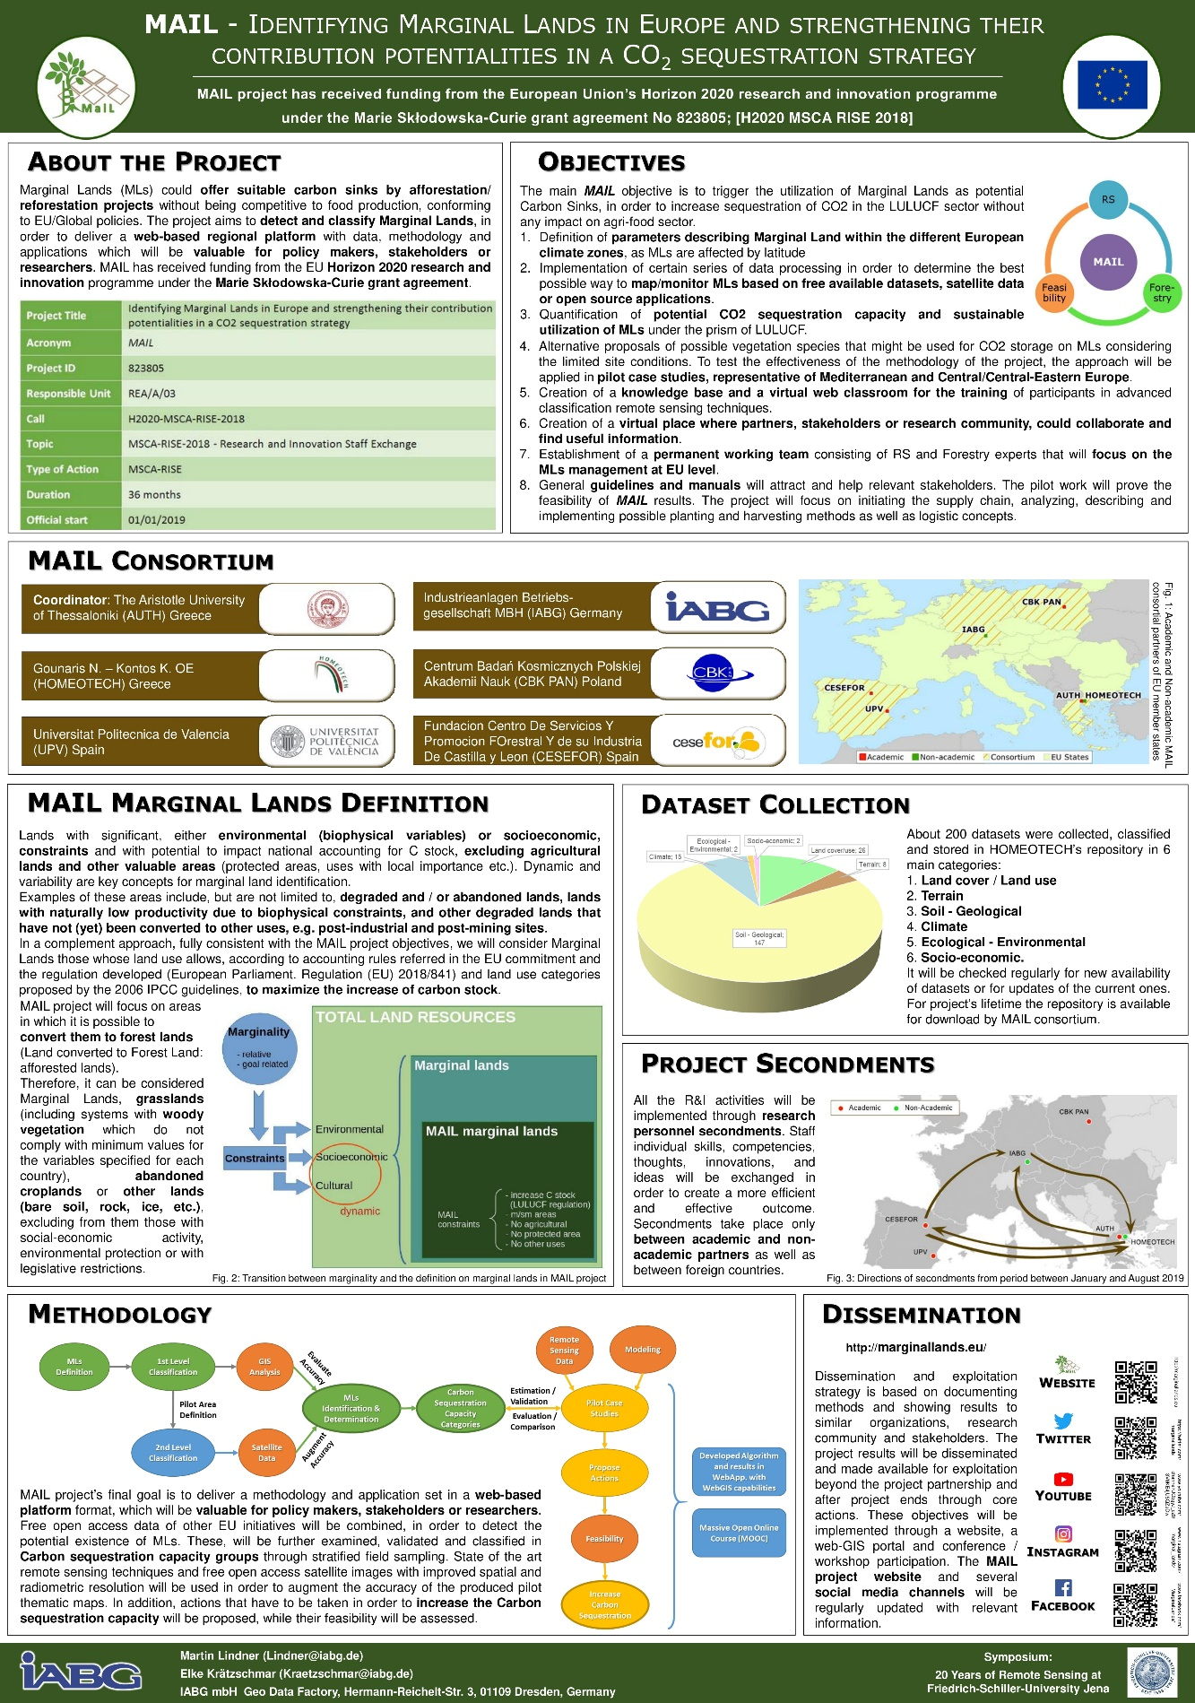
Figure 23: Symposium “20 Years of Remote Sensing”

Annex II: Table of Figures
Figure 1: Exemplary Certificate of Attendance in the workshop 9
Figure 2: Exemplary Certificate of Presentation during the workshop 10
Figure 3: Agenda of workshop. 11
Figure 4: Presentations at the workshop 17
Figure 5: Presentation of MaiL methodology for ML detection 18
Figure 6: Participants of the round table discussion 21
Figure 7: Presentation of MaiL Map Portal 22
Figure 8: Agenda of the Conference 25
Figure 9: Excerpt from the introductory presentation 26
Figure 10: Presentations at the conference 29
Figure 11: Presentation about carbon sequestration capacity estimation 30
Figure 12: The MaiL MOOC 32
Figure 13: Presentation about MaiL MOOC 32
Figure 14: Presentation at the conference 33
Figure 15: The allocation of test sites 34
Figure 16: Presentation about guidelines of ML management 36
Figure 17: Symposium in Jena 43
Figure 18: Poster presented on the National Copernicus Forum in Germany 44
Figure 19: Title slide of the presentation about marginal lands 45
Figure 20: Agenda of the FPCUP workshop 45
Figure 21: Presentation about MaiL during the FPCUP workshop 46
Figure 22: Title pages of two MaiL papers 47
Figure 23: Symposium “20 Years of Remote Sensing” 49

R = Report, P = Prototype, D = Demonstrator, O = Other
PU = Public, PP = Restricted to other programme participants (including the Commission Services), RE = Restricted to a group specified by the consortium (including the Commission Services), CO = Confidential, only for members of the consortium (including the Commission Services).

