

D2.8 | Report on Web application for ML’s management
  - MAIL: Identifying Marginal Lands in Europe and strengthening their contribution potentialities in a CO2 sequestration strategy

MAIL project has received funding from the European Union’s Horizon 2020 research and innovation programme under the Marie Skłodowska-Curie grant agreement No 823805; [H2020 MSCA RISE 2018]

Project title | Identifying Marginal Lands in Europe and strengthening their contribution potentialities in a CO2 sequestration strategy
Call identifier | H2020 MSCA RISE 2018
Project acronym | MAIL
Starting date | 01.01.2019
End date | 31.12.2021
Funding scheme | Marie Skłodowska-Curie
Contract no. | 823805
Deliverable no. | D2.8
Document name | MAIL_D2.8.pdf
Deliverable name | Report on Web application for ML’s management
Work Package | WP2
Nature | R
Dissemination | CO
Editors | Lampros Papalampros (HOMEOTECH), Charalampos Georgiadis (AUTH)
Authors | Juan Pedro Carbonell-Rivera (UPV)  Alfonso Abad (Cesefor)  Michał Krupiński (CBK PAN)  Fernando Bezares Sanfelip (Cesefor)
Developers | Marek Ruciński (CBK PAN)  Fernando Bezares Sanfelip (Cesefor)  Lefteris Mystakidis (HOMEOTECH)  Pablo Crespo Peremarch (UPV)  Zoi Touloudi (AUTH)  Giorgos Spanos (AUTH)  Sebastian Aleksandrowicz (CBK PAN)
Contributors | Charalampos Georgiadis (AUTH)  Dzaner Emin (IABG)  Franscisco Gallego Ciprés (Cesefor)  Jesús Torralba Pérez (UPV)  Marta Milczarek (CBK PAN)
Date | 28.12.2021

MAIL Consortium
  Aristotle University of Thessaloniki (AUTH) Greece |   Industrieanlagen Betriebsgesellschaft MBH (IABG) Germany
  Gounaris N. – Kontos K. OE (HOMEOTECH) Greece |   Centrum Badan Kosmicznych Polskiej Akademii Nauk (CBK PAN) Poland
  Universitat Politecnica de Valencia (UPV) Spain |   Fundacion Centro De Servicios Y Promocion FOrestral Y de su Industria De Castilla y Leon (CESEFOR) Spain

Abbreviations
Term | Explanation
API | Application Program Interface
CEN | European Committee for Standardization
CSS | Cascading Style Sheets
DNS | Domain Name System
DSS | Decision Support System
FTP | File Transfer Protocol
GML | Geography Markup Language
GEE | Google Earth Engine
GUI | Graphical User Interface
HTML | HyperText Markup Language
HTTP | Hypertext Transfer Protocol
IP | Internet Protocol
ISO | International Organization for Standardization
ML | Marginal Land
OGC | Open Geospatial Consortium
P2P | Peer to Peer
PHP | Hypertext Preprocessor
SaaS | Software-as-a-Service
SDI | Spatial Data Infrastructure
SGML | Standard Generalized Markup Language
TCP | Transmission Control Protocol
W3C | World Wide Web Consortium
WCS | Web Coverage Service
WFS | Web Feature Service
WMS | Web Map Service
WPS | Web Processing Service
XML | eXtensible Markup Language

Contents

MAIL Consortium 4
Abbreviations 5
Executive Summary 9
1. Introduction 10
2. Theoretical Background 10
2.1 Spatial Data Infrastructure 11
2.1.1 Components 11
2.1.2 Interoperability, standardisation bodies and main standards 12
2.2 Geoservices architectures 13
2.2.1 Client 14
2.2.2 Server 14
2.2.3 Advantages of the client-server architecture 15
2.2.4 Disadvantages of the client-server architecture 16
2.2.5 Three-tier architecture 16
2.2.6 INSPIRE model 22
2.2.7 N-tier architecture 22
2.3 OGC Standards 23
2.3.1 WMS 23
2.3.2 WCS 24
2.3.3 WFS 25
2.3.4 WPS 26
2.4 Web architecture 26
2.4.1 Web server 27
2.4.2 Web browser 27
2.4.3 Logical tiers of a web architecture 28
2.4.4 Internet protocols 28
2.4.5 Website loading cycle 29
2.5 Languages for geoservices 29
2.5.1 XML 29
2.5.2 HTML 30
2.5.3 CSS 31
2.5.4 JavaScript 32
2.6 Platform architecture 33
2.6.1 Data layer 34
2.6.2 Service layer 34
2.6.3 Application layer 35
2.6.4 Web GIS Client scope 36
3. Web mapping 37
3.1 Commercial solutions 39
3.1.1 ArcGIS Online 39
3.1.2 ArcGIS Enterprise 41
3.1.3 CARTO 42
3.1.4 Google Earth Engine 43
4. MAIL Map Portal 50
4.1 Basic functionality 50
4.1.1 Panel with Map 51
4.1.2 Panel with Tools 53
4.1.3 Searching window 54
4.2 Identification of Marginal Lands 55
4.2.1 Exclude regions by land cover 55
4.2.2 Exclude regions by value 55
4.2.3 Factor importance selector 56
4.2.4 Productivity classification 58
4.3 Decision Support System 60
4.3.1 Carbon Calculator 61
4.3.2 Carbon Prediction 62
4.3.3 Afforestation Cost Calculator 63
4.3.4 Potential Suitable Species 64
4.4 Identification of MLs using satellite images 65
4.5 Multi-temporal Analysis 65
5. Bibliography 67
Annex I: Table of figures 70
Annex II: List of Tables 73

Executive Summary
This document summarises the work done on task 2.9 “Web application for MLs’ management”. The main objective of this task was the development of a web-GIS portal, which resides together with MAIL’s website. The portal was created using specific sets of previously developed computational algorithms in the WP2 to:
- Generate several semiautomatic classifications of Marginal Lands (ML).
- Produce thematic maps.
- Assist in Decision making for MLs management
The portal is open for public use and allows users (even no experts in remote sensing techniques) to perform a variety of studies on MLs. For this purpose, a Decision Support System (DSS) was designed in task 3.4, which was embedded in the web-GIS portal to allow end-users to determine the best possible way to visualize, monitor and sustainably utilize MLs, and also to draw conclusions and decision-making, in the field of forest management, planting etc.
Moreover, in the MAIL Map Portal, tools designed and developed within multiple project tasks were also incorporated into the Portal, such as:
- Carbon Sequestration Capacity (CGC) Groups – Task 2.7
- Enhanced marginal land map – Task 2.9
- Carbon prediction – Task 4.2
- Carbon calculations – Task 4.2
- Cost calculator – Task 4.2
- Multi-temporal Analysis – Task 4.4

Introduction
The development of humans has been linked to the development of cartography since the beginning of our existence. Maps have been one of the most important human creations for millennia, permitting humans to represent the territory that surrounds them. In that sense, one of the earliest archaeological maps is the representation of routes, a mountain, a river and valleys around Pavlov in the Czech Republic, carved on a mammoth tusk, which has been dated to 25,000 BC (Wolodtschenko and Forner, 2007). Most of the earliest known maps focus on the stars, such as the map found on the walls of the Lascaux caves, which dates from 21,000 BC (Sparavigna, 2008). This map shows part of the night sky, including the Pleiades star cluster and the three bright stars Altair, Deneb, and Vega (Summer Triangle asterism).
From the beginning of the history of cartography, until very recent times, the collection and distribution of geographical information used to be controlled by government agencies. Maps were not a consumer product, but were considered part of national value, being used mainly by the government for defence, finance, planning and development.
In recent decades, GIS technology has changed all that. Today geographic information has become a mass product, with anyone being able to create their own maps, thanks to the use of computerized cartography, GIS, GPS surveying, satellite images, scanners, and intelligent programs.

Theoretical Background
With the development of the Internet, the creation of Spatial Data Infrastructure (SDI) has been standardised. SDI is defined as “a coordinated series of agreements on technology standards, institutional arrangements, and policies that enable the discovery and use of geospatial information by users and for purposes other than those it was created for” (Kuhn, 2005). SDIs are a computer system composed of a set of data and services (described through their metadata) that are managed via internet. SDIs are developed according to standards that regulate and guarantee the interoperability of their data, allowing users to access, search, visualize and manipulate geographic information according to their needs.

Spatial Data Infrastructure
SDIs are composed of a set of computer resources such as programs, data catalogues, service catalogues, maps, coverage servers, web pages, etc. The geographic information to be accessed must be in accordance with certain standards and norms. Similarly, computer resources must comply with specifications, protocols and interfaces that guarantee interoperability.
The implementation of an SDI project takes place through a geoportal offering at least the following three requirements (Coll and Martínez-Llario, 2008):
- Visualization, allowing the view of data through web services.
- Location, making possible the search of services and datasets through the content of their metadata.
- Gazetteer, which allows the location on a map through a geographical name.
The standardisation of digital geographic information for SDI in Europe is carried out through two international standardisation bodies, the International Organization for Standardization (ISO) and the European Committee for Standardization (CEN). The technical committees that generate the families of standards that affect digital geographic information are the international committee IS/TC211, Geographic Information, whose standardisation work results in the ISO 19100 family of standards, and the European standardisation committee EN CEN/TC 287, which adopts the ISO 19100 series as a European standard and develops new standards and profiles in cooperation with ISO TC/211.
The European legal framework governing SDI is the Directive 2007/2/EC (INSPIRE) of 14 March 2007, “establishing an infrastructure for spatial information in Europe to support Community environmental policies, and policies or activities which may have an impact on the environment” (Bartha and Kocsis, 2011). Legislation affecting SDIs will be explained in more detail in the following chapters.

Components
The components of a SDI are (Nogueras-Iso et al., 2005):
- Technology. SDIs are developed based on technological components created from experience gained in working with generic information technology.
- Policies and Standards. Standards are the link between the different components of an SDI, establishing common languages and concepts that make communication and coordination possible. All actors in an SDI follow general guidelines that should include several aspects such as architectures, methods, processes, or standards.
- Human resources. The development of an SDI must be implemented by teams of researchers and developers who meet the requirements of e-users, both end-users and data providers (sources).
- Institutional Arrangements. The creation of an institutional framework is necessary to establish national or supranational SDIs, which coordinate with regional or local SDIs, with the main objective of avoid duplicate information.
- Spatial Databases and Metadata. SDIs are created from the geographical data, stored in the spatial databases, and should contain metadata.
- Data Networks. SDIs must be open systems deployed over data networks that provide the channel to access the services of the remote systems.
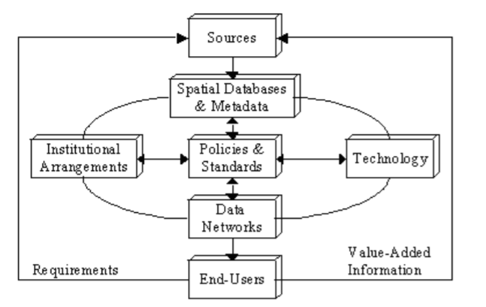
Figure 1. System view of the spatial data infrastructure components. Source: (Coleman and Nebert, 1998)

Interoperability, standardisation bodies and main standards
The INSPIRE directive defines the interoperability as “the possibility for spatial data sets to be combined, and for services to interact, without repetitive manual intervention, in such a way that the result is coherent and the added value of the data sets and services is enhanced”. One of the main objectives of SDIs is to share geographic information to visualize or use it. This implies the need of shared communications protocols, where data is shared in a common format and language. In this sense, the standardization in the sharing of geographic information has been divided into three main aspects (Martínez Llario, 2018a):
- Open Geospatial Consortium (OGC). The Open Geospatial Consortium brings together more than 340 companies, government agencies and universities with the aim of developing specifications or standards for geographic information.
- The Geography Markup Language (GML) communication language. GML is the eXtensible Markup Language (XML) language for geospatial information. This language is an OGC-supported specification for the encoding, storage, and transport of geographic information on the Internet.
- Metadata. The metadata allow users to know the characteristics of the data, facilitating its search and selection. Some examples of geographic information metadata are reference systems, date of capture, extension, date of capture, security and legal restrictions, frequency of updating, accuracy, etc.

Geoservices architectures
The architecture of SDIs is usually based on client-server architecture. This architecture is a distributed system composed of clients, which request services, and servers that respond to the requests. This architecture allows the development of information systems, where operations are split into independent processes that cooperate with each other to exchange information, resources, or services (Martínez Llario, 2012).
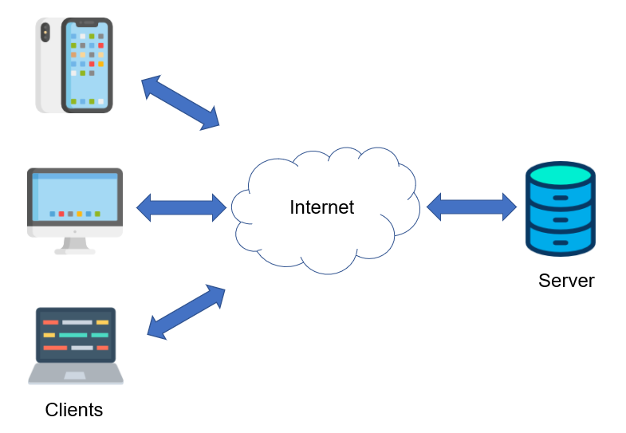
Figure 2. Client/Server architecture. Source: personal compilation of Juan Pedro Carbonell Rivera
In this architecture, the client is the one who initiates service requests, waiting and receiving the answers from the server. It can be connected to several servers at the same time. This layer interacts directly with the end users through a Graphical User Interface (GUI). On the other hand, the server processes the request and sends the result back to the client. The server processes and responds to the requests.

Client
Within the client-server architecture, the client is the one that initiates the requests or applications, having an active role in the communication, being also called master. The client initiates the communication by sending a request to the server and waits until it receives the response from the server. The client can usually make connections to different servers at the same time. Usually, it is the component that interacts with the end user via a GUI.
Clients are divided into thin and thick ones. The difference between them is whether an express installation is required. Thin clients require a minimum activation, which is negligible in most cases. An example of a thin client is Google Maps. Thick clients require an installation, which usually needs administrator privileges on the computer. Examples of thick clients are ArcGIS Desktop or Google Earth.

Server
In client-server communication, the server is the element that waits for client requests to be received, playing a passive role. The server is also called a slave device. Upon receipt of a request, the server processes it and sends a response to the client. Usually, the server accepts connections from multiple clients. The separation between client and server is logical, therefore the server does not necessarily operate on a single machine nor is it necessarily a single program.
The following types of servers are among the most widely used:
- Web server. This server mainly stores the HyperText Markup Language (HTML) files of a web page (texts, images, videos, etc.). Communication over the Internet between the server and the browser follows the "Hypertext Transfer Protocol (HTTP) protocol". Within the web servers some of the most used are Apache, Microsoft IIS, Sun Java System Web Server, Ngnix or Lighttp.
- Mail server. This server is in charge of sending, receiving, storing and performing all operations related to e-mails.
- Domain Name System (DNS) server. These servers oversee managing the web domain names. The DNS servers associate the Internet Protocol (IP) address of the computer where the website is hosted with the domain name of the web pages.
- File Transfer Protocol (FTP) server. This type of server is used for transferring files between computers.
- Database server. Computers that offer storage, hosting and database management services. These servers are in charge of data analysis, processing and storage, among others.
- Cloud server. These servers are characterized by storing user information on the Internet. Some examples are platforms such as Google Drive or Dropbox.

Figure 3. Wikimedia Foundation servers. Source: Victor Grigas, distributed under a CC BY-SA 3.0 license.

Advantages of the client-server architecture
- Access, resources, and data integrity are controlled by the server, so that a faulty or unauthorised client cannot damage the system. This centralisation allows to easily update data or resources.
- This architecture has a high scalability, as the capacity of clients and servers can be increased separately. Any element can be increased or improved at any time, or new nodes can be added to the network (clients and/or servers).
- As the client and the server are separated, any modification, update or repair can be carried out without affecting the nodes.
- The clients are independent from each other, so they do not have information about other clients that may be connected to the server.

Disadvantages of the client-server architecture
- A high number of simultaneous requests on the server can cause congestion problems. On the contrary, other architectures as Peer to Peer (P2P) networks solve this problem by making each node of the network operating as a server, getting more bandwidth.
- Robustness is not very high in this type of configuration, when a server is down, client requests cannot be satisfied. P2P networks are distributed in several nodes, allowing that the fall of one of them will not affect the whole network.
- The software and hardware on the server side must be very demanding to be able to respond to all requests.
- Different clients connected to a server cannot share information between them without first going through the server.

Three-tier architecture
In the three-tier architecture, also called three layers architecture, the server is decomposed into different programs. The primary objective of this tier arrangement is the separation of logically distinguishable elements.
N-tier architecture is characterised by the respect of the following principles:
- Each layer resides in a physically independent system (also called level). In this way, the architecture is completely scalable from an operational point of view.
- A layer should only share information with the tiers immediately above and below it.
- The content of each layer can be interchangeable if the definition of the communication interface (API) with the adjacent layers is respected, and if no information is demanded from the other layers.
Currently the three-tier architecture is the one most used, as an evolution of the two-tier architecture, characteristic of the client-server architecture. In a three-tier design, a separation is established between the presentation tier, the business tier, and the data tier (Figure 4).
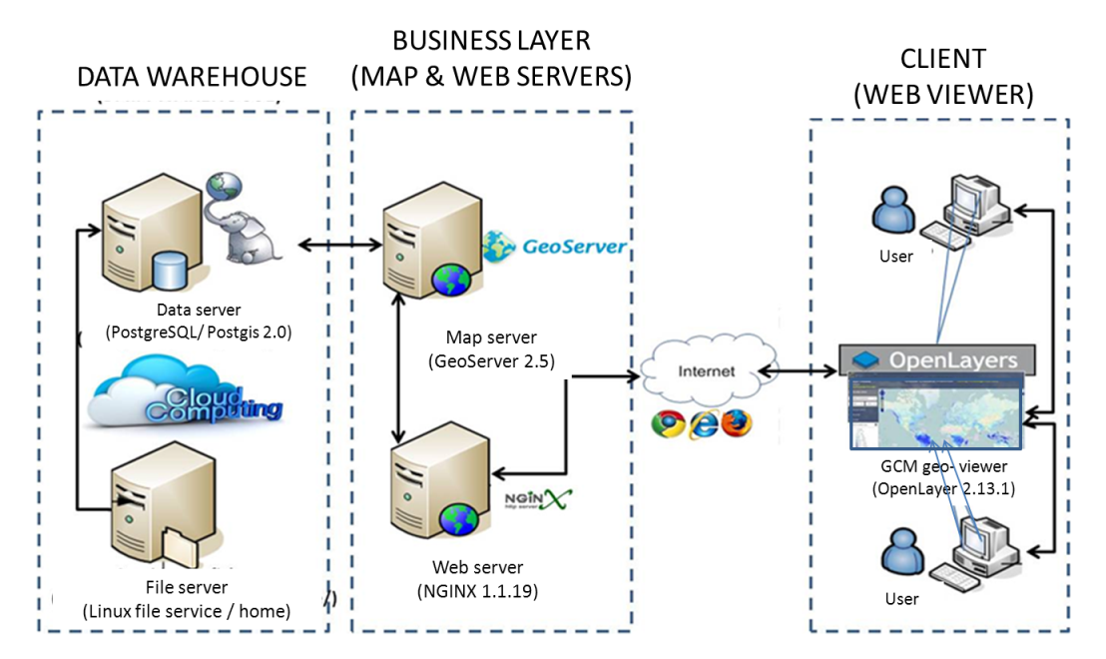
Figure 4. Example of three-tier web GIS architecture. Source: (Morales, 2015).
This separation by tiers can also be understood as a separation by software since each layer of the spatial data infrastructure is usually associated with a specific software. Some examples are shown in Figure 5.
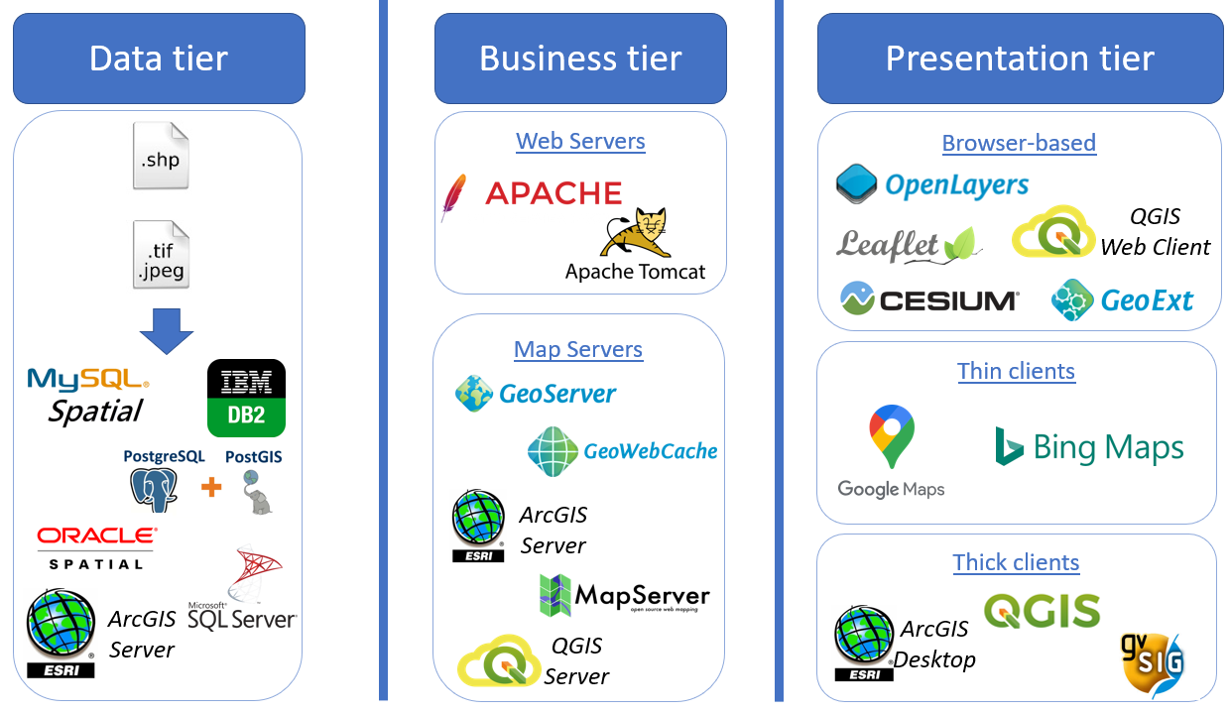
Figure 5. Three-tier architecture software. Source: personal compilation of Juan Pedro Carbonell Rivera

Data tier
In the data tier resides the data, and it oversees access to the data. This layer is composed of one or more database managers that are in charge of the data storage, receive requests for storage or recovery information. It communicates only with the business tier.
This tier contains the files with geographical information, either vector (commonly .shp format) or raster (commonly .tif or .jpeg format).
In this tier users can find open-source options to manage the information such as PostgreSQL with its spatial extension PostGIS, or MySQL Spatial. It is also possible to find commercial options as ArcGIS Server, Oracle Spatial, Microsoft SQL Server or IBM BD2. Currently the most widely used database in all areas is PostgreSQL and PostGIS.

Business tier
In the business tier reside the algorithms that solve the problems underlying the functionality presented by the system. This layer communicates with the presentation tier to receive applications and present results. It also communicates with the data tier to request the database manager to store or retrieve information.
The business tier is primarily responsible for providing WMS (Web Map Service), Web Feature Service (WFS), Web Coverage Service (WCS), or Web Processing Service (WPS), services from the data stored on the data tier. This tier is divided into web servers and map servers (Figure 5). Web servers will be discussed later, but focusing on map servers, the open-source options are GeoServer, GeoWebCache, MapServer and QGIS Server. On the other hand, as far as commercial products are concerned, the most widely used software is ArcGIS Server. Currently the most widely used software for providing services is GeoServer.

Presentation tier
The presentation tier is the system's interface with the user, also called the user tier. This tier communicates information to the system through requests, also capturing the user information.
It is also known as graphic interface and should be easily understood and used by the user. This layer is used by the system to present the information resulting from a request, communicating exclusively with the business layer.
The distribution of the tiers in levels depends on the needs of the system. It is important to note that the term tier refers to a logical segmentation. The term level corresponds to the way in which the logical layers are physically distributed. For example, a three-tier solution residing in a single computer has one level, while a three-tier solution residing in two computers would have two levels.
Therefore, all tiers can reside on the same computer, but most often the presentation tier is installed on a set of computers from which users access the system, while the business and data tiers can reside on a single level. Business and data tiers, if demand requires it, can be physically separated. Going deeper into this aspect, the following considerations should be considered:
- The data tier can be separated on several computers in case the size or complexity of the database increases.
- If complexity were to be applied to the business tier, it could also reside on one or more computers that would make requests to a single database.
The presentation tier is the mean to provide the user with different visualisation, analysis, or management solutions. For this reason, it is the tier where most solutions can be found, both open source and commercial. This tier has been divided in Figure 5 into three parts, depending on whether thin, thick, or browser-based clients are used.
Regarding thin clients, which are the most commonly used by users when using geographic information on the Internet, the most used are Google Maps or Bing Maps. Thick clients that are well known in the geographical area includeArcMap, QGIS or gvSIG.
In relation with browser-based client, different solutions will be analysed individually in the following sections.

OpenLayers
OpenLayers is an open-source JavaScript library under a derivation of the BSD license for displaying interactive maps in web browsers. OpenLayers offers an API to access different sources of cartographic information on the web: WMS, WFS, Commercial Base Maps (such as Google Maps, Bing, Yahoo), different vector formats, OpenStreetMap maps, etc. (Figure 6).
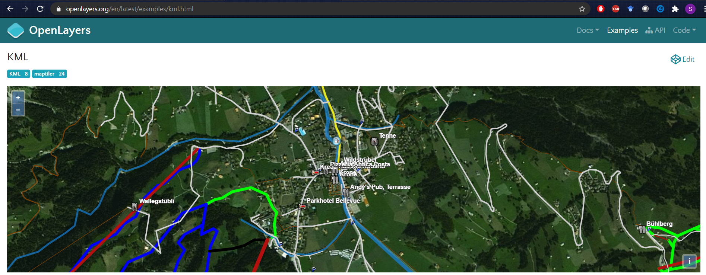
Figure 6. OpenLayers example. Source: openlayers.org

Leaflet
Leaflet is an open-source JavaScript library under the BSD-2 license used to develop web mapping applications. Leaflet was released in 2011 supporting most mobile and desktop platforms thanks to be based on HTML5 and CSS3.
Leaflet allows users with no GIS knowledge to easily create maps, and load information from WMS or GeoJSON files. In addition, it allows users to style and create interactive layers, markers, etc. (Figure 7)
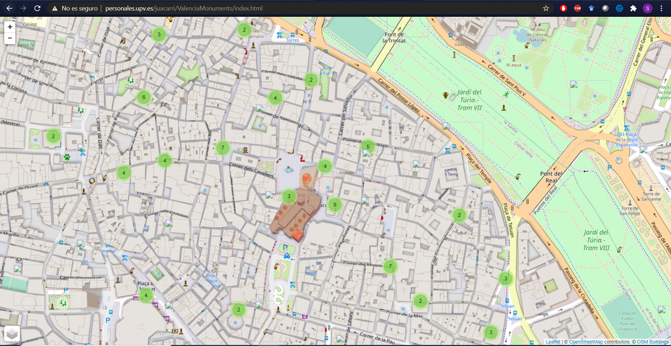
Figure 7. “Monuments of Valencia” developed using Leaflet. Source: (Carbonell-Rivera, 2017)
OpenLayers and Leaflet have a very similar interface. In this sense, the main difference lies in the ease of content creation by Leaflet. Using Leaflet, the user is able to create maps in a much simpler way than OpenLayers, but OpenLayers has many more development and customization options.

Cesium
Cesium “is an open-source JavaScript library for creating world-class 3D globes and maps with the best possible performance, precision, visual quality, and ease of use. Developers across industries, from aerospace, smart cities or drones, use CesiumJS to create interactive web apps for sharing dynamic geospatial data. Built on open formats, CesiumJS is designed for robust interoperability. Bring in data from Cesium ion or from some other source, visualize with CesiumJS, and share with users on desktop or mobile. CesiumJS is released under the Apache 2.0 license and is free for both commercial and non-commercial use.” (Cesium, 2014).
The main feature of this library is that it displays a globe and does not show reality on a plane like other libraries. It also includes 4D data visualization tools, including the time variable. An example is shown in the Figure 8.
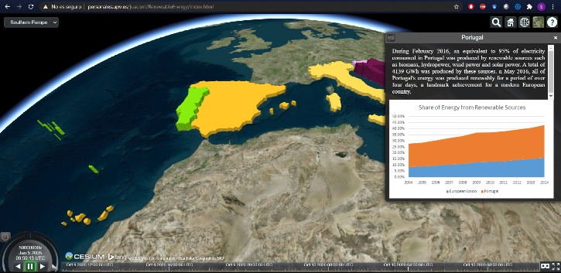
Figure 8. “Share of energy from renewable sources in the European Union” developed with Cesium. Source: (Carbonell-Rivera, 2016)

INSPIRE model
The INSPIRE directive refers to the use of the three-tier architecture as a standardised model for SDIs, but its terminology differs slightly (Figure 9).
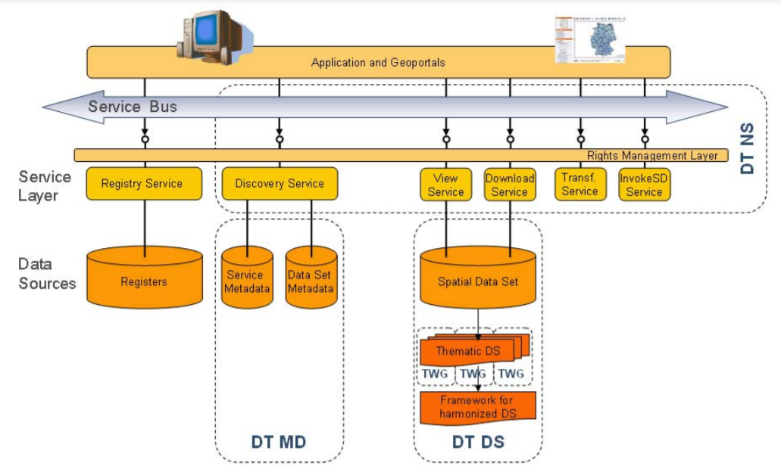
Figure 9. INSPIRE technical architecture overview. Source: (Network Services Drafting Team, 2008)
From the point of view of this directive, the architecture of an SDI is composed of the following tiers (Martínez Llario, 2018a):
- Data layer. This layer is identical to the data tier explained above.
- Service layer. The function of the service layer is the same as the business tier, overseeing and encapsulating all the logic corresponding to the functional capacities of the system. These capabilities are grouped thematically into services. This layer is shown in the form of a service bus (repository) that is offered to the clients.
- Application layer: This layer is identical to the presentation tier and includes any type of application that consumes any of the services provided by the SDI.

N-tier architecture
The number of tiers in an architecture will vary depending on the number of logical compartments. An example of this architecture would be as describe in Table 1.
Table 1. Example of 5-tier architecture. Source: personal compilation of Juan Pedro Carbonell Rivera
Tier | Task | Example
Graphic interface tier | Process the content of HTML documents to display them to the user. | Web browser
Presentation logic tier | Generates the HTML documents | Hypertext Preprocessor (PHP) module on a web server
Business logic tier | Solves the problems underlying the system's functionality using algorithms | Application server with Java Enterprise Edition
Data access tier | Business logic interface in its data access | Application server with Java Database Connectivity
Data tier | Storage and retrieval of data | Database PostgreSQL

OGC Standards
The OGC, as explained above is an organisation dedicated on creating and defining open standards for the geospatial community to permit interoperability between software, and data services. The OGC delivers open standard specifications with the objective to simplify and disseminate the use of these standards when programmers develop their own geospatial website, or geoportal providing data and services (Michaelis and Ames, 2012).
Some of the most used standards when creating geospatial content on the internet are WCS, WFS, WMS and WPS. These standards make information and services FAIR (Findable, Accessible, Interoperable and Reusable), allowing web clients to query and receive special information in the form of vector, raster images, or coverage data.

WMS
The international WMS specification defines a map as a representation of geographic information in the form of a digital image file, adapted for display on a computer screen. A map does not consist of the data itself, but of an image of the data (de La Beaujardiere, 2006).
WMS services allow the visualization of georeferenced geographic information through the internet. The information is represented in the form of layers of information. To generate a certain map, the layers are superimposed according to an established order and transparency value (Martínez Llario, 2018b).
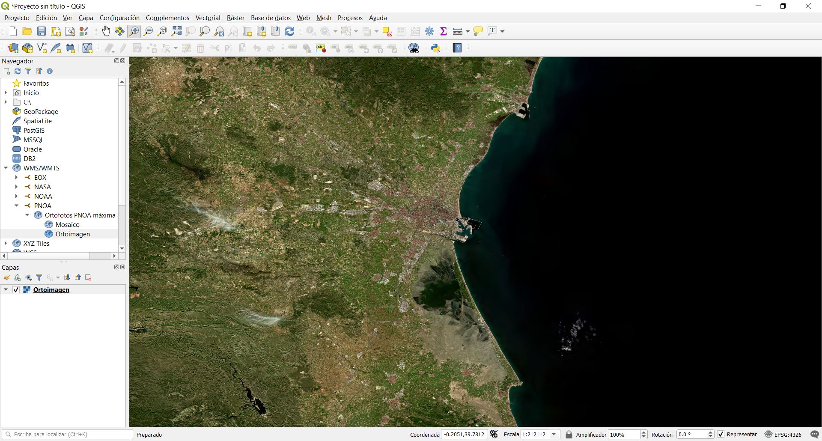
Figure 10. Visualisation in QGIS of the WMS from the Spanish National Plan for Aerial Orthophotography. Source: personal compilation of Juan Pedro Carbonell Rivera
The maps generated by WMS services can be visualised through thin clients or thick clients. WMS services have the capacity to read data in their original formats (shapefile, geotiff, ecw, etc.), through connections with databases (Postgis, Oracle Spatial, ESRI ArcGIS Server, etc.), generating an image as the final product. Figure 10 shows the retrieved image of a query to the service “http://www.ign.es/wms-inspire/pnoa-ma?”

WCS
“The OGC Web Coverage Service (WCS) supports electronic retrieval of geospatial data as “coverages.” Coverages are digital geospatial information representing space/time-varying phenomena, specifically spatio-temporal regular and irregular grids, point clouds, and general meshes.” (Baumann, 2010).The data obtained through this service is therefore a raster image that retains the values of each of its cells or pixels.
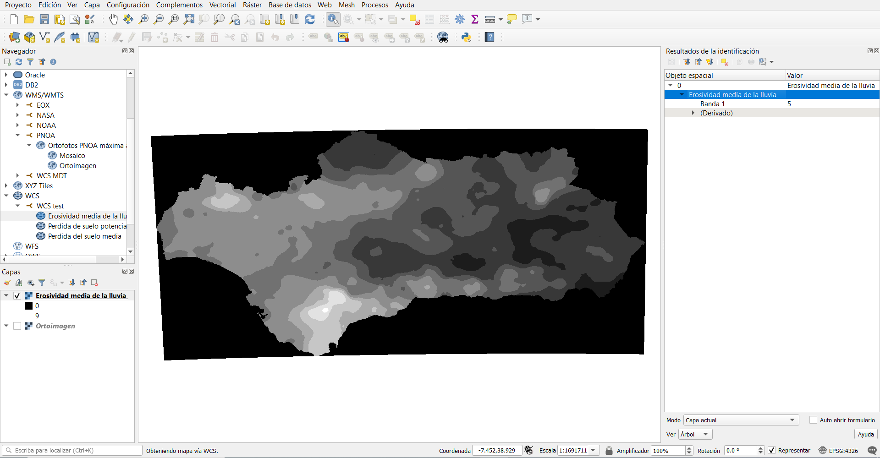
Figure 11. Visualisation in QGIS of potential erosion using a WCS from the environmental council of the Andalusian Community. Source: personal compilation of Juan Pedro Carbonell Rivera
In contrast, the WMS returns only an image of the data. As can be seen in Figure 11, a pixel has been selected, retrieving the information contained in this pixel. The direction of the service used in this example was “http://www.juntadeandalucia.es/ medioambiente/mapwms/REDIAM_WCS_erosion_suelo?”

WFS
“The Web Feature Service (WFS) represents a change in the way geographic information is created, modified and exchanged on the Internet. Rather than sharing geographic information at the file level using File Transfer Protocol (FTP), for example, the WFS offers direct fine-grained access to geographic information at the feature and feature property level.“ (Vretanos, 2010).
Making WFS requests to the server can be obtained information about individual geographical elements or objects (features), not served on an image type support, as in the standards described above.
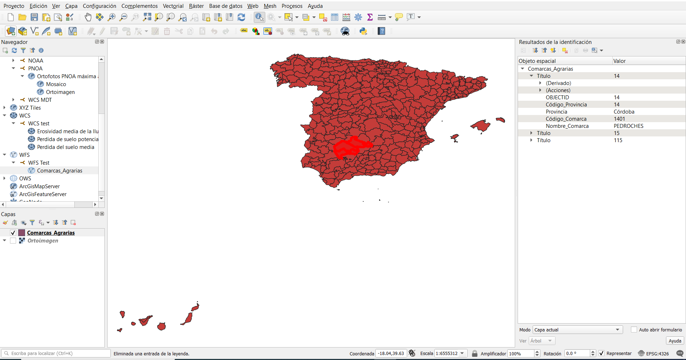
Figure 12. Visualisation in QGIS of a WFS of the Spanish agricultural districts. Source: personal compilation of Juan Pedro Carbonell Rivera
With this standard we can access not only the geometries of the elements but also the attributes of the objects or features themselves. Figure 12 shows vector information, and the result of carrying out the query on the information of a polygon. In that case the direction of the service used was https://wms.mapama.es/sig/WFS/ComarcasAgrarias/wfs.aspx

WPS
“The OpenGIS® Web Processing Service (WPS) Interface Standard provides rules for standardizing how inputs and outputs (requests and responses) for geospatial processing services, such as polygon overlay. The standard also defines how a client can request the execution of a process, and how the output from the process is handled. It defines an interface that facilitates the publishing of geospatial processes and clients’ discovery of and binding to those processes. The data required by the WPS can be delivered across a network or they can be available at the server.” (Open Geospatial Consortium, 2014).

Web architecture
On the Internet the most widely used architecture is the client-server architecture, which clients (web browser) request services (web server). Web servers process requests from the browsers using the HTTP protocol and return HTML pages.

Web server
A web server is a program that implements the HTTP protocol. Depending on the type of request received, the web server will either look for a web page or run a program on the server. Once the request has been processed, it will return the response to the client or web browser.
When the web browser makes a request to the server, the request is a request for a web page. The server must respond to the client by sending the HTML code of the page. Once the client receives the code, it interprets it and displays it on the screen.
The client is responsible for interpreting the HTML code, showing the fonts, colours, and layout of the texts and objects on the page. The server transfers the code of the page without carrying out any interpretation of it.

Web browser
A client program is required to access the World Wide Web. This program is called a web browser and is a software application that allows the user to retrieve and view web pages stored on web servers.
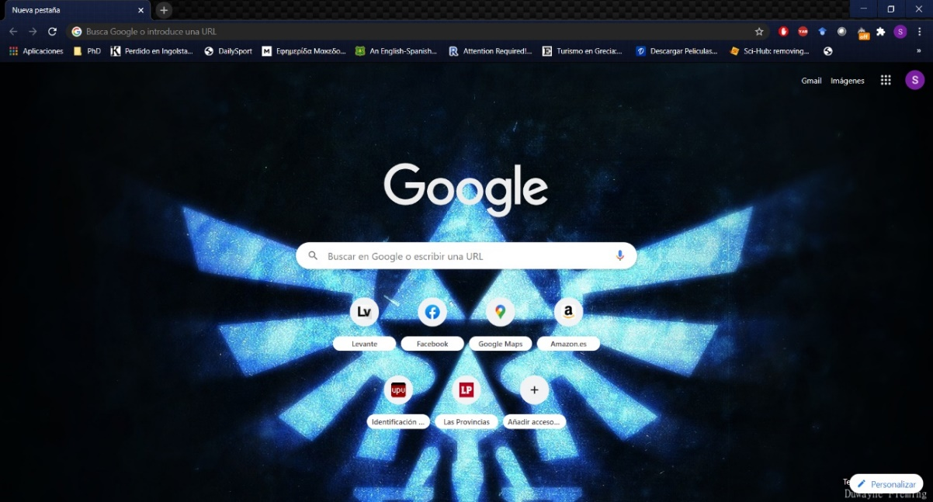
Figure 13. View of the Google Chrome web browser with a personalized skin. Source: personal compilation of Juan Pedro Carbonell Rivera
Web browsers offer a graphic interface that allows users to browse through Internet. Its basic functionality is to allow the visualization of web pages, multimedia resources, etc. Some examples of web browsers are Google Chrome, Opera, or Internet Explorer.

Logical tiers of a web architecture
As described above, the number of tiers in an architecture will depend on the number of its logical elements. Therefore, a web architecture system of 2, 3, or more layers can be established.

Internet protocols
The technical basis of the Internet is a set of network protocols that allow communication between computer equipment, combining their processing capabilities for troubleshooting.
These protocols are called the TCP/IP protocol stack and are a standard shared by the entire community of software and hardware manufacturers. There are several protocols in the stack.
Table 2. Internet protocols. Source: personal compilation of Juan Pedro Carbonell Rivera
Protocol | Role
TCP | The Transmission Control Protocol (TCP) protocol allows information packets to arrive reliably at their destination and information to travel between computers. Associated with TCP is the concept of port, a value number from 0 to 65535 that identifies a network connection point from a client application to a server application.
IP | The IP protocol is used to identify equipment, and recognize networks, routers and computers. There are currently two versions of IP in use: IPv4 and IPv6, expressed in 32-digit hexadecimal notation. There can be two types of IP, dynamic or static. The dynamic IP changes each time a reconnection is made, while the static IP remains unchanged over time.
HTTP | The HTTP protocol is resource oriented. This protocol defines the syntax and semantics utilized by the different elements of the web architecture (clients, proxies, servers …) to communicate.
URL | A URL is a sequence of characters representing the address of information resources available on the Internet. Web content can be accessed through the server's IP or through the URL. As an example, Figure 14 shows that the URL https://homeotech.gr/ coincides with the IP 95.216.21.28. This website can be accessed by either of the two parameters, introducing them in the address bar of any browser.
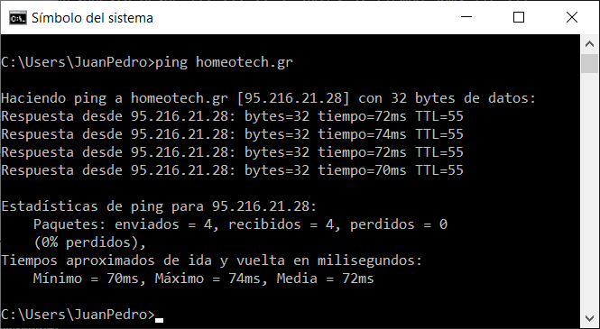
Figure 14. Ping command checking the website "homeotech.gr". Source: personal compilation of Juan Pedro Carbonell Rivera

Website loading cycle
The loading cycle of a web page can be divided into 5 steps:
- An address is introduced in the address bar of the web browser (e.g., https://homeotech.gr/)
- The computer automatically performs a query to the DNS name resolution protocol. The computer will obtain as a result of the query that the URL https://homeotech.gr/ is equivalent to the IP 95.216.21.28.
- The web browser makes an HTTP request to the IP address. It establishes a TCP connection to the remote server on port 80.
- The server receives the request and returns it through the TCP connection. If, in addition to the HTML document, there are additional resources such as images or JavaScript files, an HTTP request is sent for each of the resources.
- The client receives the result and displays it.

Languages for geoservices

XML
XML is a meta-language developed by the World Wide Web Consortium (W3C), an organization dedicated to the standardization of technologies linked to the web, especially regarding its writing and interpretation. This metalanguage allows the definition of languages to establish the structure and content of documents. XML is a simplification and adaptation of the Standard Generalized Markup Language (SGML) and allows the grammar of specific languages to be defined.
XML plays an important role in the exchange of information by structuring a wide variety of data, allowing compatibility between systems to share information structured, secure and reliable. XML was created to structure, store and send information. It is not only used on the web, but also in text editors, spreadsheets, databases, etc. (Figure 15)
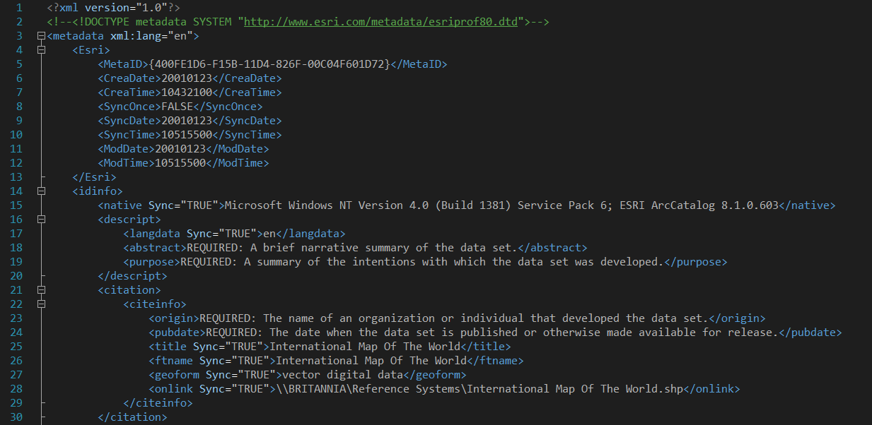
Figure 15. Example of XML file. Source: personal compilation of Juan Pedro Carbonell Rivera

HTML
HTML is a mark-up language used to create web pages. It is a standard that provides a reference for software related with the elaboration of web pages. This language defines a basic structure and a code for the definition of the content of a web page, such as images, games, text, videos, etc. It is a standard in charge of the W3C. HTML is the most important web language, being crucial in the form, expansion, and development of the World Wide Web. HTML is the standard that has been imposed on the display of web pages and is the language adopted by all current browsers.
The HTML language bases its development on differentiation. To add an external element to the webpage (images, videos, scripts, among others.), this is not directly embedded in the page code, only a reference to the location of that element is written in the code. (Figure 16).
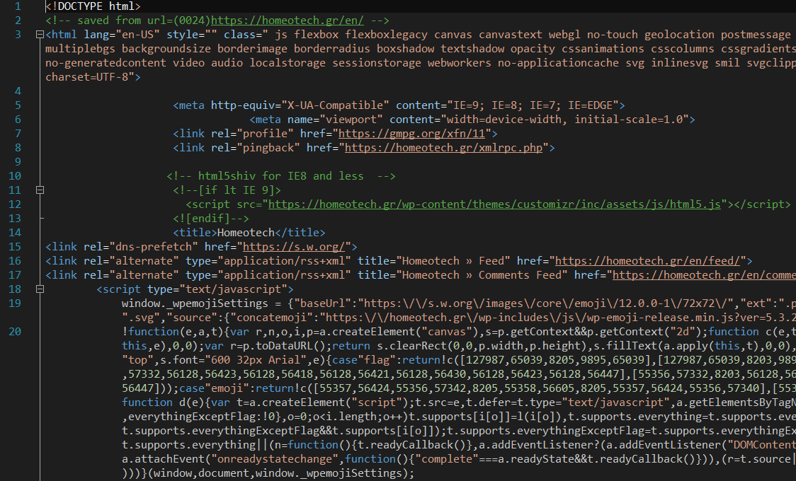
Figure 16. Part of the HTML code of the webpage “homeotech.gr”. Source: personal compilation of Juan Pedro Carbonell Rivera
In this regard, the webpage contains only text while it is up to the web browser to interprets the code and join all the elements, displaying the final page. As it is a standard, HTML search to be a language that allows any webpage written in a certain version to be interpreted in the same way by any updated web browser.

CSS
Cascading Style Sheets (CSS) is a graphic design language for defining and creating the presentation of a structured document written in a mark-up language.
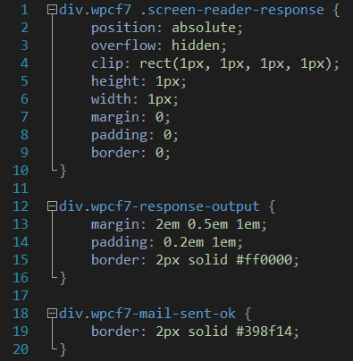
Figure 17. CSS code of the webpage "homeotech.gr". Source: personal compilation of Juan Pedro Carbonell Rivera
It is used to establish the visual design of web documents, and user interfaces written in HTML. In conjunction with HTML and JavaScript, CSS is a technology used by many websites to create visually appealing pages, user interfaces for web applications and GUIs for mobile applications.

JavaScript
JavaScript is a programming or scripting language (Figure 18) that allows complex functions to be implemented in web pages. The dynamic content of web pages such as interactive maps, 2D/3D graphics animation, video, etc., is usually implemented based on the JavaScript language.
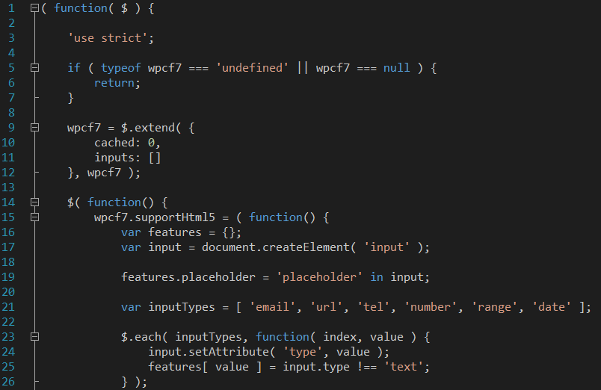
Figure 18. JavaScript code of the webpage "homeotech.gr". Source: personal compilation.

Platform architecture
In order to define the main characteristics of MAIL’s web GIS portal (that will rely on the thin client/server model), it is required first to describe the basic deployment desired for each one of the layers that compose the Spatial Data Infrastructure (data layer, service layer and application layer). Also, it is important to recall that this implementation should meet the specifications stated by INSPIRE directive.
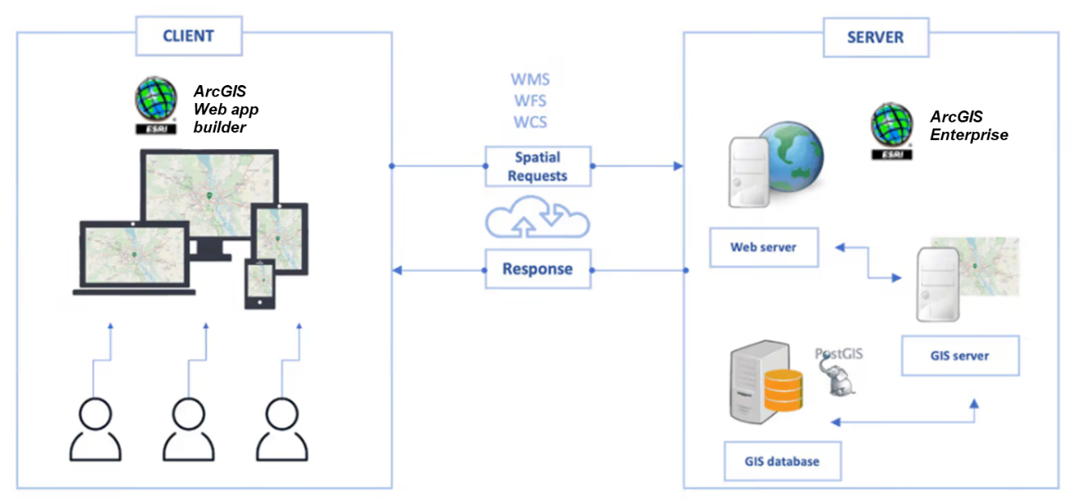
Figure 19. Diagram showing MAIL´s web GIS architecture. Source: personal compilation
The whole operation is broken down into client facing side and the server-side (Figure 19). The client will be a web browser and the server-side consist of a Web Server, Web GIS server (both developed by commercial software from ESRI) and a Database (managed by PostGIS). Web AppBuilder for ArcGIS can be used to create the GUI (Graphical user interface), ArcGIS Portal and Server acts as the middleware and PostgreSQL will be used as a backend database.

Data layer
A spatial open-source Database Management System as PosgreSQL and its geographical library PostGIS can be used to store all the project´s outcoming data. PostgreSQL is a powerful, open-source object-relational database system that has bindings for many programming languages such as C, C++, Python, Java, PHP, and Ruby. It runs on all major operating systems. PostGIS adds support to store geographic objects in the PostgreSQL database.

Service layer
ArcGIS Server is a back-end server software component of ArcGIS Enterprise that makes geographic information available. This is accomplished through web services, which allow a powerful server computer to receive and process requests for information sent by other devices.
On the primary deployment of ArcGIS Server, geographic data is made available through layers and web maps in the portal. Those items can then be consumed in a variety of apps, including browser-based web apps and native apps on mobile devices, with little to no custom development required.
ArcGIS Server requires a machine capable of running a 64-bit operating system. The ArcGIS Server architecture is scalable (meaning that multiple machines can be added if additional processing power is needed).

Interaction of AcGIS server with PostgeSQL and PostGIS
ArcGIS supports PostGIS geometry and geography types and Esri ST_Geometry spatial types in PostgreSQL databases. ArcGIS Server (and most ArcGIS applications) contain the PostgreSQL client libraries that are required to make a connection between the two software. In the table below are summarized the versions of PostgreSQL and PostGIS that are supported with the specified ArcGIS releases
Table 3. Correlation between releases (ArcGIS, PostgeSQL and PostGIS). Source: personal compilation of Alfonso Abad
ArcGIS release | PostgreSQL release
ArcGIS 10.8 and ArcGIS Pro 2.5 | - PostgreSQL 9.6.15 (64 bit)  - PostGIS 2.3  - PostgreSQL 10.12 (64 bit)  - PostGIS 3.0.1  - PostgreSQL 11.7 (64 bit)  - PostGIS 3.0.1
ArcGIS 10.8.1 and ArcGIS Pro 2.6 | - PostgreSQL 9.6.17 (64 bit)  - PostGIS 3.0.1  - PostgreSQL 10.12 (64 bit)  - PostGIS 3.0.1  - PostgreSQL 11.7 (64 bit)  - PostGIS 3.0.1  - PostgreSQL 12.2 (64 bit)  - PostGIS 3.0.1
ArcGIS Pro 2.7 | - PostgreSQL 10.14 (64 bit)  - PostGIS 3.0.1  - PostgreSQL 11.9 (64 bit)  - PostGIS 3.0.1  - PostgreSQL 12.4 (64 bit)  - PostGIS 3.0.1

Application layer
Web AppBuilder for ArcGIS is a module of Portal for ArcGIS. It assists to create web and mobile-friendly interactive GIS applications. It is an application tool which provides various templates and ready to use configurable widgets which adds diverse functionality in the application. AppBuilder is an intuitive what-you-see-is-what-you-get (WYSIWYG) application that allows to build web apps without writing a single line of code. It includes tools to configure fully featured HTML apps. The key features of AppBuilder are:
- Create HTML/JavaScript apps that run on any device.
- Build the apps using ready-to-use widgets.
- Customize the look of the apps with configurable themes.
- Host apps online or run them from the server.
- Create custom app templates.

Web GIS Client scope
The web GIS client shares the final goal of MAIL’s project i.e. to deliver a methodology and application set which will be valuable for policy makers, stakeholders or researchers. Developed methodologies, algorithms and techniques will be delivered in a web-application platform for on-demand production of thematic maps within Europe, where, beyond the categorization of MLs, alternative usages of these lands will be proposed with indicative cost analysis.

Functions
Web GIS client should provide the below capabilities:
- To experts: developed methodologies, algorithms and techniques for on-demand production of thematic maps within Europe.
- To land owners: MLs identification, Carbon sequestration capacity categorization and proposition of alternative usages of low productivity lands (sustainable utilization) through feasibility studies, so that they can make a profit in the emerging Carbon Markets.
Will allow even entry-level users to detect, visualize and monitor MLs within Europe. Through the incorporated Decision Support System (Task 3.4), it will also be possible to determine the best possible way to sustainably utilize MLs. In the table below (Table 4) are summarized the functions that shall be implemented in the web GIS client.
Table 4. Functions of the web GIS client
Functions | Function description
Display maps and raster layers | Viewer’s web GIS client shall display layers
Identification | Viewer’s web GIS client shall have a feature for identifying features
Measurements | The system shall be able to perform surface and length measurements
Area of interest selection | User shall be able to select an area of interest
Decision support system | User shall be able to perform geocoding processing
User registration | User shall be able to register having different capabilities according to its account privileges

Requirements
The minimum functional requirements are represented in the Table 5.
Table 5. Functional requirements of the web GIS client
Functions |  | Functional requirement description
Display maps and raster layers | Third party server | The system shall display Street Maps layer
 |  | The system shall display Earth Observation (imagery) layer
 | MAIL results | The system shall display Marginal Lands
 |  | The system shall display Marginal Lands Productivity
 |  | The system shall display Carbon Sequestration Capacity Groups (CSG Groups)
Identification |  | The system shall display a legend
 |  | The system shall display a popup or similar for the identification of MAIL project features’ information (% of marginality)
Marginality modifications |  | The system shall allow modify the methodology by activate/deactivate Hard Layers or by changing weights of Soft Layers (see D2.3)
Area of Interest selection (AOI) |  | The system shall allow the user to select an AOI by designing a polygon
 |  | The system shall allow the user to select an AOI by inserting a geometry
Decision Support System (DSS) |  | The system shall be able to perform geoanalysis considering:  - AOI  - CSC groups  - Potential Suitable species  - Carbon storage per species  - Type of afforestation (i.e., protective or productive)  - Afforestation cost

Web mapping
Web mapping is the process of using the maps created by GIS on the Internet, specifically in the World Wide Web. “Web mapping emphasizes geodata processing aspects more involved with design aspects such as data acquisition and server software architecture such as data storage and algorithms, than it does the end-user reports themselves” (Kraak and Brown, 2003). Currently it is possible to find a wide variety of different types of web maps. Some examples can be viewed in the following table (Table 6).
Table 6. Web map types. Source: personal compilation of Juan Pedro Carbonell Rivera
Web map | Description | Visualization
Animated and real-time | Animated and real-time maps show a phenomenon in close to real-time. These maps show changes in the map over time by including temporal variables. | Source: (Carbonell-Rivera, 2016)
Collaborative web maps | Collaborative web maps join users to collaborate creating and improving the geographic data. | 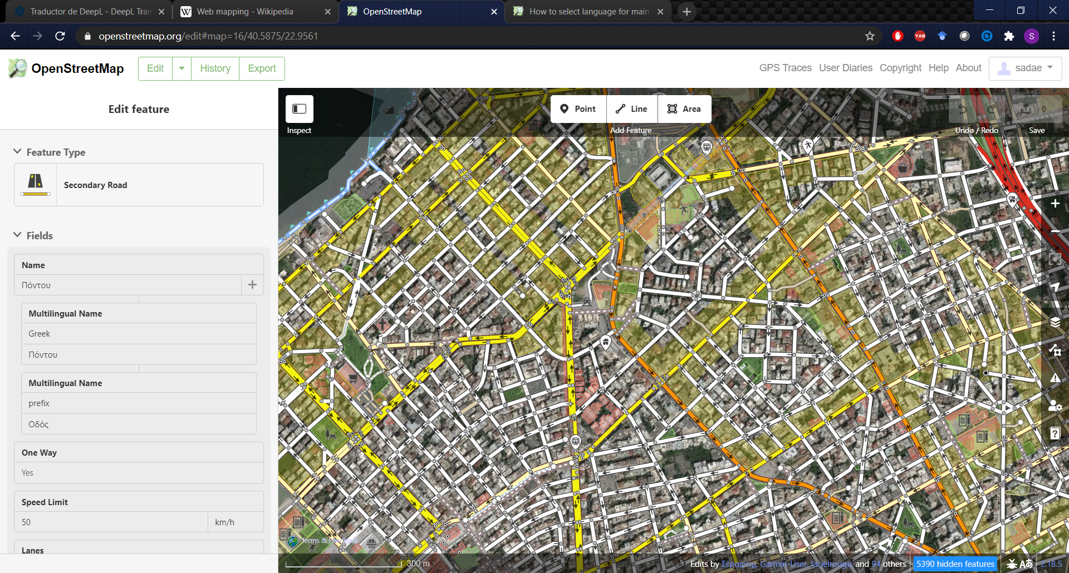  Source: https://www.openstreetmap.org/
Analytical | Analytical web maps represent a single geographical element. | 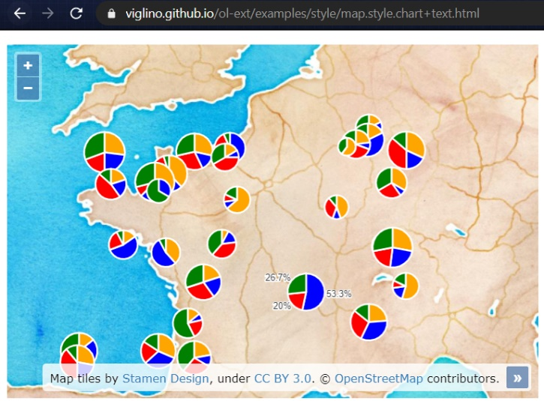  Source: https://viglino.github.io/ol-ext/examples/style/map.style.chart+text.html
Static web maps | These webs provide a view without the possibility of interaction or interactivity between the platform and the user. | 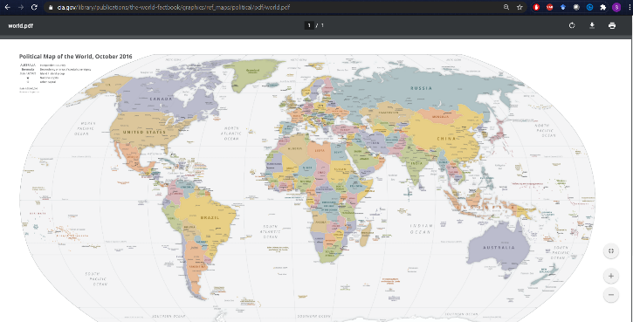  Source: https://www.cia.gov/library/publications/the-world-factbook/graphics/ref_maps/political/pdf/world.pdf
In recent years, the usual architecture of the geoportals has not been modified but there have been great advances in the presentation tier of those. In this respect, the evolution of web mapping has been linked to the evolution of different libraries based on JavaScript (OpenLayers, Leaflet, Cesium), which have allowed the development of open-source portals. But also, the commercial GIS industry has started to provide innovative solutions to users, reducing the development time of geoportals almost to zero, and implementing cloud solutions for the average user, without the need for programming. The most prominent examples of these commercial products are ArcGIS Online and CARTO.

Commercial solutions
In the context of visualising geographical information on the internet, there is a large gap between commercial products and open-source products. Mainly due to the adoption of commercial products of cloud storage and data processing solutions. This fact allows users and developers to carry out projects in a more agile and simple way, without having to hire external servers or carry out a long development process.

ArcGIS Online
ArcGIS Online “enables you to connect people, locations, and data using interactive maps. Work with smart, data-driven styles and intuitive analysis tools that deliver location intelligence. Share your insights with the world or specific groups.” (Esri, 2020). ArcGIS Online is a platform developed by ESRI in 2018 that promises the creation of geospatial web content without the need for programming. On this platform, maps can be created from vector or raster data that is uploaded to ESRI's servers. The symbology of these maps can be modified online or using ArcMap software. The maps created on the platform can be shared, and can also be used to create web apps, adding an interactive experience to the static maps. ArcGIS Online enables spatial analysis, allowing the user to perform many actions that could only be done through thick clients.
This tool is a Software-as-a-Service (SaaS), i.e. the software and data are hosted on servers of an information and communication technology company, in this case ESRI. Therefore, ESRI oversees software updates and maintenance. This platform includes different solutions focused on the security, authentication and privacy of users and data, offering a secure and long-term stable environment.
In order to develop advanced solutions, ArcGIS Online has different APIs and SDKs. “Developers can jump-start their work by leveraging the maps, analyses, and styles their mapping colleagues created. Extend and customize ArcGIS Online items and develop custom apps using the developer tools.” (Esri, 2020).
This platform also allows the creation of forms, allowing data to be taken using any type of device connected to the Internet via GNSS positioning.
The following figures show some geoportals created using ArcGIS Online. Figure 20 shows a portal with updated data about the situation regarding COVID-19 in the Valencian Community. This portal shows vectorial information (polygons) of the different municipalities in the community, indicating the impact on each of them. This portal also shows different graphs and tables based on the information provided.
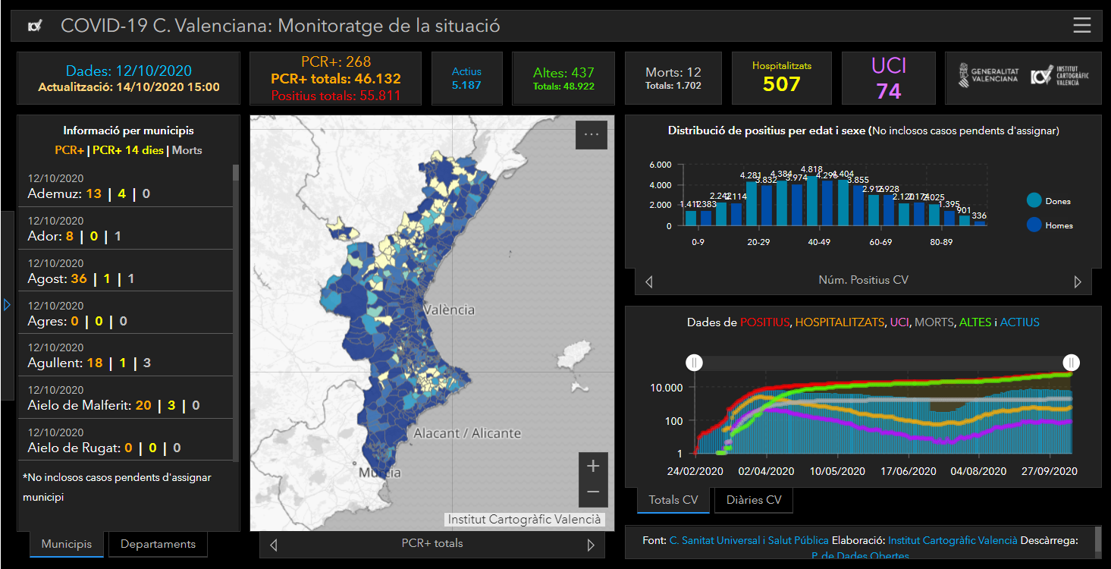
Figure 20. Monitoring of COVID-19 in the Valencian Community. Source: personal compilation of Juan Pedro Carbonell Rivera
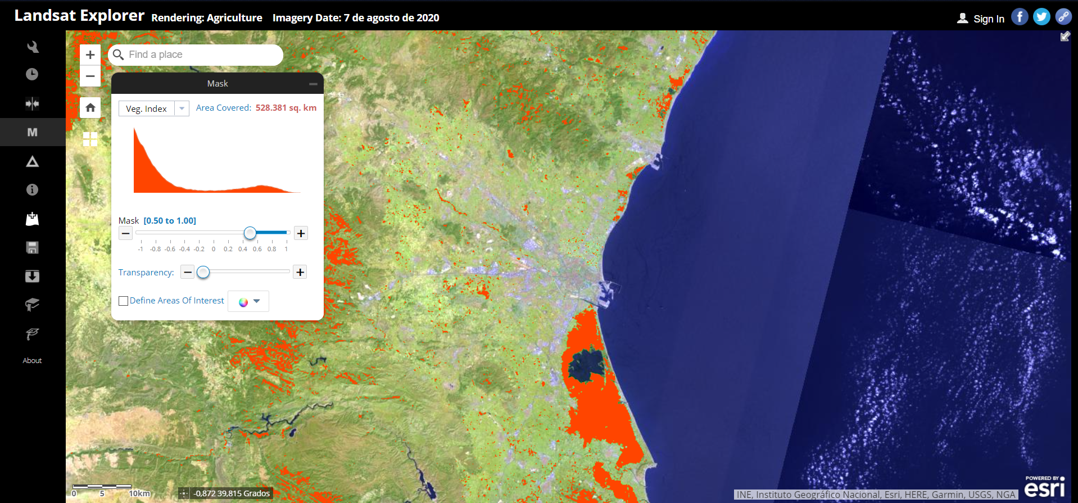
Figure 21. Landsat Explorer. Source: personal compilation of Juan Pedro Carbonell Rivera
Figure 21, on the other hand, shows raster information taken from the Landsat constellation. This portal allows some spatial analysis actions to be performed, such as the one shown in the image, where the vegetation index can be superimposed on the visualization.

ArcGIS Enterprise
ArcGIS Enterprise is the foundational software system for GIS, powering mapping and visualization, analytics, and data management. It is the backbone for running the Esri suite of applications and custom applications.
The four components of ArcGIS Enterprise work together to provide functionality for web mapping, image exploitation, real-time data handling, large-volume batch analysis, and spatial data science:
- ArcGIS Server powers mapping and analysis in your GIS, including several specialized server roles, and scales dynamically to support traffic.
- The ArcGIS Enterprise portal is the central hub where users create, share, and manage maps, apps, and spatial data, and share them with collaborators.
- ArcGIS Data Store provides nimble data storage for the hosting server used with your deployment.
- ArcGIS Web Adaptor integrates ArcGIS Server and Portal for ArcGIS with your existing web servers and your organization's security infrastructure.
ArcGIS Enterprise and ArcGIS Online are products that enable mapping, analysis, data management and sharing capabilities. While there are similarities between the two products, there are also differences in how they are deployed and the set of features and capabilities available.
ArcGIS Online is Esri's highly scalable software-as-a-service (SaaS) offering. It is hosted on Esri servers and completely scaled, managed, updated, and maintained by Esri. ArcGIS Enterprise is software that is installed on infrastructure that will be controlled and managed locally, whether in the cloud, on-premises, or on virtual machines. This gives the ability to design a highly customized system. Deployment of ArcGIS Enterprise components can be done in on one machine or scale out to many machines.

CARTO
CARTO, formerly CartoDB, “is an open, powerful, and intuitive platform for discovering and predicting the key insights underlying the location data in our world. Empower organizations to optimize operational performance, strategic investments, and everyday decisions with CARTO Engine and the new CARTO Builder, a drag and drop analysis tool. It was built to make it easier for people to tell their stories by providing them with flexible and intuitive ways to create maps and design geospatial applications.” (CartoDB, 2014).
CARTO users can use the free platform or deploy their own instance of the open source software (Figure 22). CARTO is a freemium service, where the user can create free accounts with a size limit. For larger accounts there is a cost that includes advanced features.
CARTO is an open-source software developed with PostGIS and PostgreSQL. It uses JavaScript tools in the front-end of web applications, Node.js in the API-based back end, and client libraries. It offers two main approaches:
- CARTO Builder: This is the web application where users can manage data, perform user-side analysis and design custom maps. CARTO Builder is focused on non-developer users and beginners who have access to advanced geospatial tools. In CARTO Builder advanced users can also access a web interface where they can use the SQL language to manipulate the data and also work with CartoCSS, a mark-up language for the definition of cartographic semiology, similar to CSS in web design.
- CARTO Engine: It is a set of APIs and libraries for developers that facilitate building custom map interfaces and data visualizations.
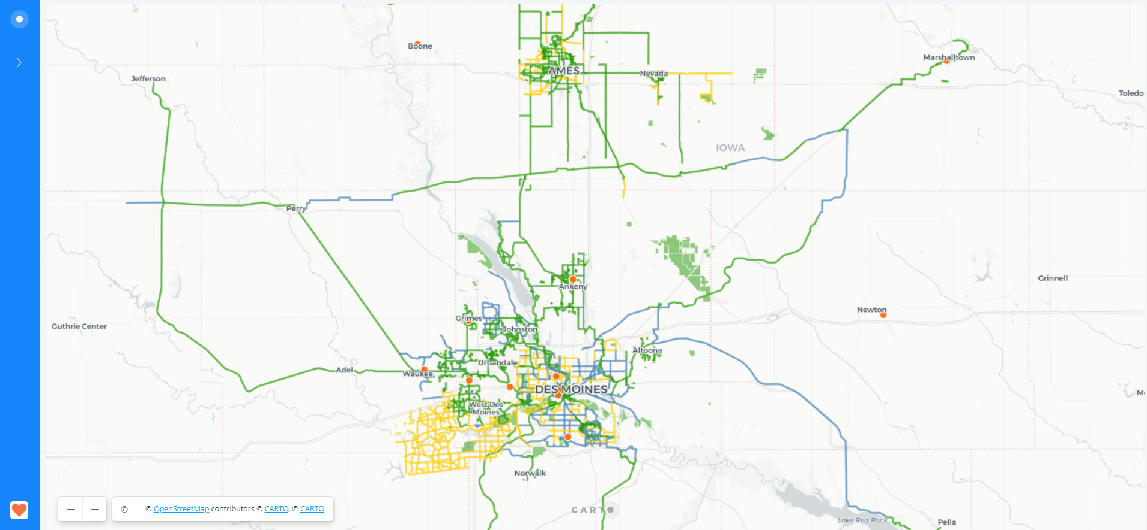
Figure 22. Portal created with CARTO. Source: (Hanson and Seeger, 2015)

Google Earth Engine
“Google Earth Engine is a cloud-based platform for planetary-scale geospatial analysis that brings Google's massive computational capabilities to bear on a variety of high-impact societal issues including deforestation, drought, disaster, disease, food security, water management, climate monitoring and environmental protection” (Gorelick et al., 2017).
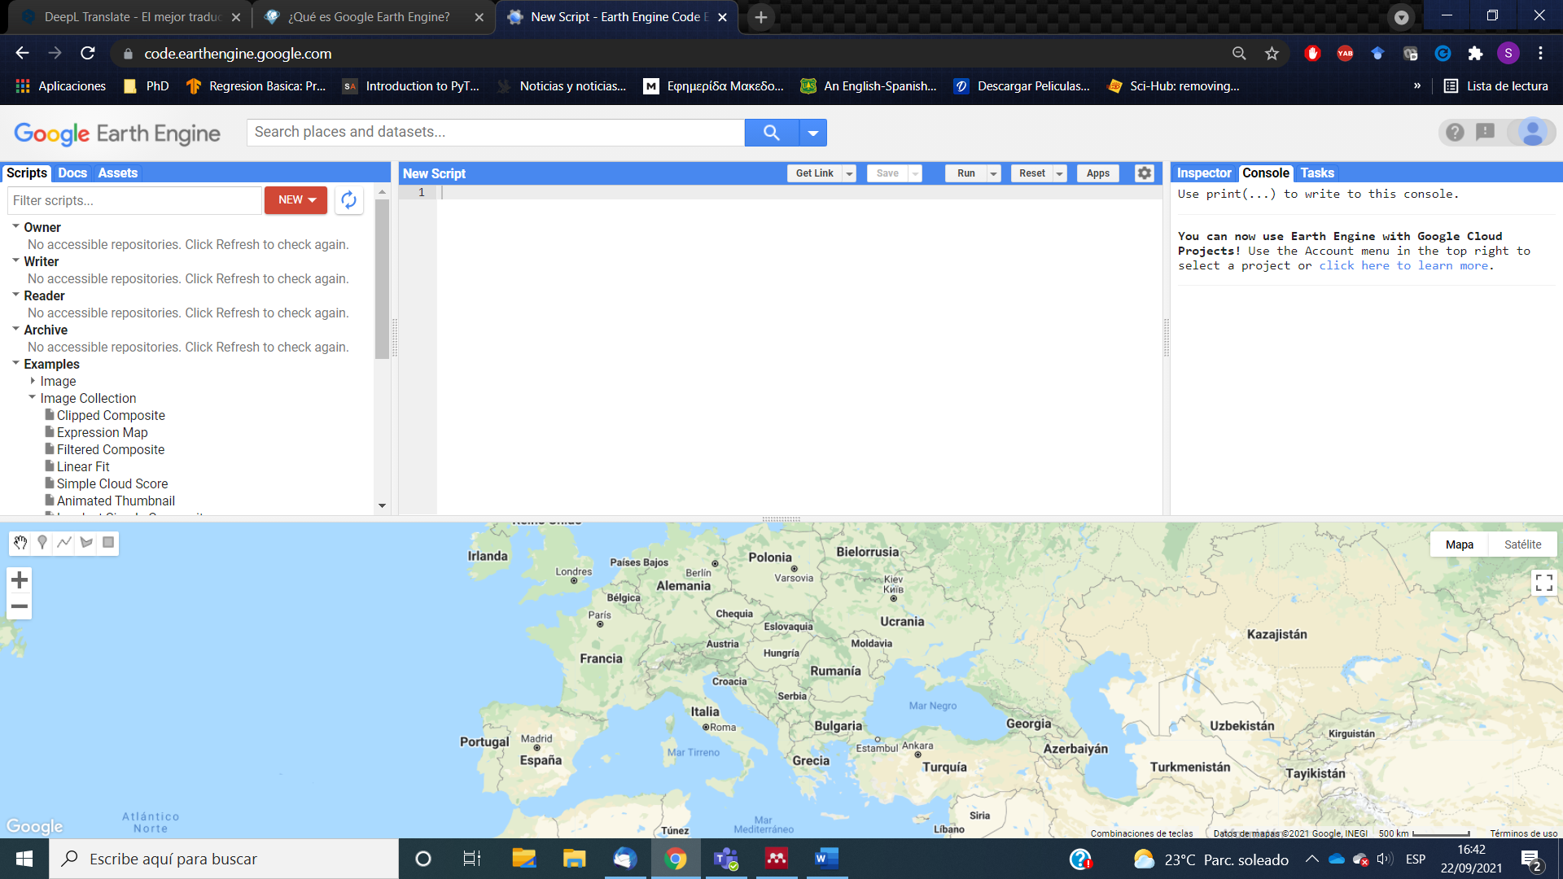
Figure 23. Google Earth Engine editor. Source: personal compilation of Juan Pedro Carbonell Rivera
Google Earth Engine (GEE) stores satellite imagery organises it and makes it available for global-scale data mining. The public archive of data includes historical images of the earth dating back more than forty years, and new imagery collected every day. GEE also provides JavaScript and Python APIs, as well as other tools, to enable analysis of large datasets.
The service uses cloud computing to enable access, exchange and integration of different data formats. Google has created an infrastructure with a capacity in the order of petabytes, but also APIs developed with JavaScript and Python languages that allow different data to be added and manipulated. By hosting a petabyte-scale catalogue of satellite imagery and geospatial datasets with planetary-scale analysis capabilities, and the tools needed to access, filter, run and export analyses in the same application, users can explore and scale spatial and temporal analyses without the difficulties traditionally associated with Big Data analysis. Continuous development and refinement has made GEE one of the most advanced and accessible cloud-based platforms for geospatial analysis. (Gorelick et al., 2017).

System architecture
GEE is built on a collection of different technologies that are available in Google's data centre environment, including the Spanner (Corbett et al., 2013) and the Bigtable (Chang et al., 2008) distributed databases; the Borg cluster management system(Verma et al., 2015); the FlumeJava framework for parallel execution (Chambers et al., 2010) and the Colossus (Google's file system) (Fikes, 2010; Ghemawat et al., 2003).
Earth Engine's code editor uses client libraries to send interactive queries to the system via a REST API. On-the-fly queries are handled by front-end servers that forward these queries to compute masters that manage the distribution of computations among a group of servers.
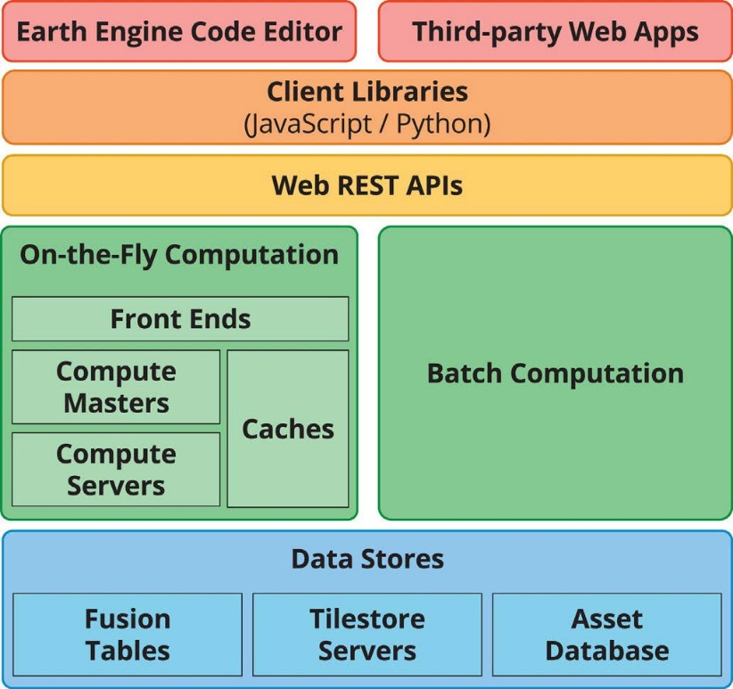
Figure 24. A simplified Google Earth Engine (GEE) system architecture diagram. Source: (Gorelick et al., 2017).
This computation system is supported by several data services, including an asset database that contains the metadata of each satellite image and provides efficient filtering capabilities. The Borg cluster management software manages each component of the system, distributing each service among several workers. Failure of a single worker simply causes the caller to reissue the query (Gorelick et al., 2017).

GEE app and layout
The layout and setup of GEE is shown in Figure 25. At the top, GEE has a search bar where users can find the available data collections by keywords or geographical locations of the different places. On the left side, users can find their own assets, scripts and sample scripts provided by GEE. In the middle is the main scripts area. On the right are located different outputs, the "Inspector" tab displays the band values of the images embedded at the bottom of the map, at the exact location of the cursor. The "Console" displays the output that the user has called with "print(...)”, visualising results, tables, metadata of images and image collection. “Tasks" shows tables and images called by "Export.toDrive()", "Export.toAsset()" or other export targets. This is mainly use for large computations, as the console has a maximum computation time of five minutes, while tasks have an unlimited computation time (Gorelick et al. 2017). Finally, the map at the bottom can be used to draw polygons, visualize results, or set geographic locations and boundaries.
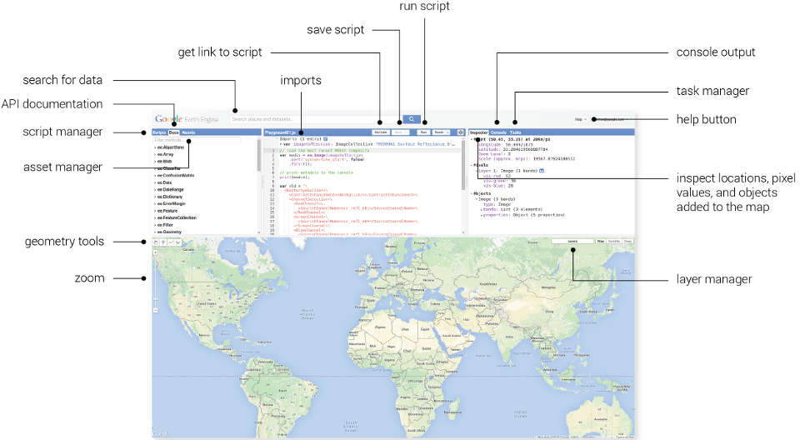
Figure 25. Google Earth Engine layout annotated. Source: https://earthengine.google.com/platform/
GEE is based on server-side requests. To this end, GEE has defined several objects, all found on the "Docs" tab, that begin with “ee.” and are managed exclusively by the server. These objects can be images, feature collections, image collections, arrays, or others. If an object needs to be managed on the client side, this can only be done by calling the command “.getlnfo”. GEE uses lazy programming on its servers, meaning that nothing is computed that is not required for output in the "console", "map", or "tasks" (Navarro 2017). This increases computation speed and prevents the quota of concurrent computation requests available to each user from being used up prematurely. Due to the focus on server-side computation and "objects," the use of GEE is significantly different from traditional JavaScript programming, increasing the time of understanding of GEE 's analysis methods. However, after this learning curve, GEE is a powerful tool and is therefore becoming increasingly popular with researchers.

GEE data collection
GEE allows the use of different types of datasets, including satellite imagery, geophysical, weather and climate, and demographic data (Table 7). GEE can also load personal raster and vector data.
The data catalogue hosts an extensive inventory of publicly available geospatial datasets. This inventory includes information from a wide variety of optical and non-optical wavelength imaging satellite systems, as well as environmental variables, retrospective weather and climate forecasts and projections, land cover, topography, and socio-economic datasets. GEE Data Catalog is a collection of several petabytes of widely used geospatial data. The bulk of the catalogue consists of remotely sensed imagery used for Earth observation, including the entire Landsat archive, as well as the complete Sentinel-1 and Sentinel-2 data archives (Gorelick et al., 2017). Related imagery, like all imagery produced, is grouped together, and presented as a "collection." Collections provide fast filtering and sorting capabilities that make it easy for users to sift through millions of individual images to select data that match specific spatial, temporal, or other criteria (Gorelick et al., 2017). One of the main advantages is that all data is pre-processed in a ready-to-use format, preserving the information, which allows efficient access, removing many barriers associated with data management (Gorelick et al., 2017). One of the most relevant advantages of GEE is the possibility to aggregate and use data and collections of each user while using Google's cloud resources for all processing (Mutanga and Kumar, 2019).
Table 7. Frequently used datasets in the earth engine data catalog. Source: (Gorelick et al., 2017)
 | Dataset | Spatial resolution | Spatial coverage | Temporal resolution | Temporal coverage
Imagery | Landsat 8 OLI/TIRS | 30 m | Global | 16 days | 2013–Now
 | Landsat 7 ETM+ | 30 m | Global | 16 days | 2000–Now
 | Landsat 5 TM | 30 m | Global | 16 days | 1984–2012
 | Landsat 4–8 surface reflectance | 30 m | Global | 16 days | 1984–Now
 | Sentinel 1 A/B ground range detected | 10 m | Global | 6 days | 2014–Now
 | Sentinel 2A MSI | 10/20 m | Global | 10 days | 2015–Now
 | MOD08 atmosphere | 1º | Global | Daily | 2000–Now
 | MOD09 surface reflectance | 500 m | Global | 1 day/8 day | 2000–Now
 | MOD10 snow cover | 500 m | Global | 1 day | 2000–Now
 | MOD11 temperature and emissivity | 1000 m | Global | 1 day/8 day | 2000–Now
 | MCD12 Land cover | 500 m | Global | Annual | 2000–Now
 | MOD13 Vegetation indices | 500/250 m | Global | 16 days | 2000–Now
 | MOD14 Thermal anomalies & fire | 1000 m | Global | 8 days | 2000–Now
 | MCD15 Leaf area index/FPAR | 500 m | Global | 4 days | 2000–Now
 | MOD17 Gross primary productivity | 500 m | Global | 8 days | 2000–Now
 | MCD43 BRDF-adjusted reflectance | 1000/500 m | Global | 8 day/16 day | 2000–Now
 | MOD44 veg. cover conversion | 250 m | Global | Annual | 2000–Now
 | MCD45 thermal anomalies and fire | 500 m | Global | 30 days | 2000–Now
 | L1 T radiance | 15/30/90 m | Global | 1 day | 2000–Now
 | Global emissivity | 100 m | Global | Once | 2000–2010
 | PROBA-V top of canopy reflectance | 100/300 m | Global | 2 days | 2013–Now
 | EO-1 hyperion hyperspectral radiance | 30 m | Global | Targeted | 2001–Now
 | DMSP-OLS nighttime lights | 1 km | Global | Annual | 1992–2013
 | USDA NAIP aerial imagery | 1 m | CONUS | Sub-annual | 2003–2015
Topography | Shuttle Radar Topography Mission | 30 m | 60°N–54°S | Single | 2000
 | USGS National Elevation Dataset | 10 m | United States | Single | Multiple
 | USGS GMTED2010 | 7.5” | 83°N–57°S | Single | Multiple
 | GTOPO30 | 30” | Global | Single | Multiple
 | ETOPO1 | 1’ | Global | Single | Multiple
Landcover | GlobCover | 300 m | 90°N–65°S | Non-periodic | 2009
 | USGS National Landcover Database | 30 m | CONUS | Non-periodic | 1992–2011
 | UMD global forest change | 30 m | 80°N–57°S | Annual | 2000–2014
 | JRC global surface water | 30 m | 78°N–60°S | Monthly | 1984–2015
 | GLCF tree cover | 30 m | Global | 5 years | 2000–2010
 | USDA NASS cropland data layer | 30 m | CONUS | Annual | 1997–2015
Climate | Global precipitation measurement | 6’ | Global | 3 h | 2014–Now
 | TRMM 3B42 precipitation | 15’ | 50°N–50°S | 3 h | 1998–2015
 | CHIRPS precipitation | 3’ | 50°N–50°S | 5 days | 1981–Now
 | NLDAS-2 | 7.5’ | North America | 1 h | 1979–Now
 | GLDAS-2 | 15’ | Global | 3 h | 1948–2010
 | NCEP reanalysis | 2.5º | Global | 6 h | 1948–Now
 | ORNL DAYMET weather | 1 km | North America | Annual | 1980–Now
 | GRIDMET | 4 km | CONUS | 1 day | 1979–Now
 | NCEP global forecast system | 15’ | Global | 6 h | 2015–Now
 | NCEP climate forecast system | 12’ | Global | 6 h | 1979–Now
 | WorldClim | 30” | Global | 12 images | 1960–1990
 | NEX downscaled climate projections | 1 km | North America | 1 day | 1950–2099
Population | WorldPop | 100 m | 2010–2015 | 5 years | Multiple
 | GPWv4 | 30” | 85°N–60°S | 5 years | 2000–2020

MAIL Map Portal
As a final solution for the developed Map Portal, Google Earth Engine was selected. Due to the extent, size, and resolution of the data, as well as for compatibility with the numerous different modules that developed during MAIL’s lifetime geoportal, this task was implemented on Google Earth Engine (GEE).
Furthermore, GEE as a cloud-based platform for planetary-scale geospatial analysis and massive computational capabilities allowed multiple developers (MAIL secondees) to collaborate easily and to avoid compatibility issues of different tools.
The final version of MAIL Map Portal was implemented in Google Earth Engine environment and contains 3 main parts:
- a searching window
- map
- tools panel
In the following subchapter, the main functionality of the portal will be described.
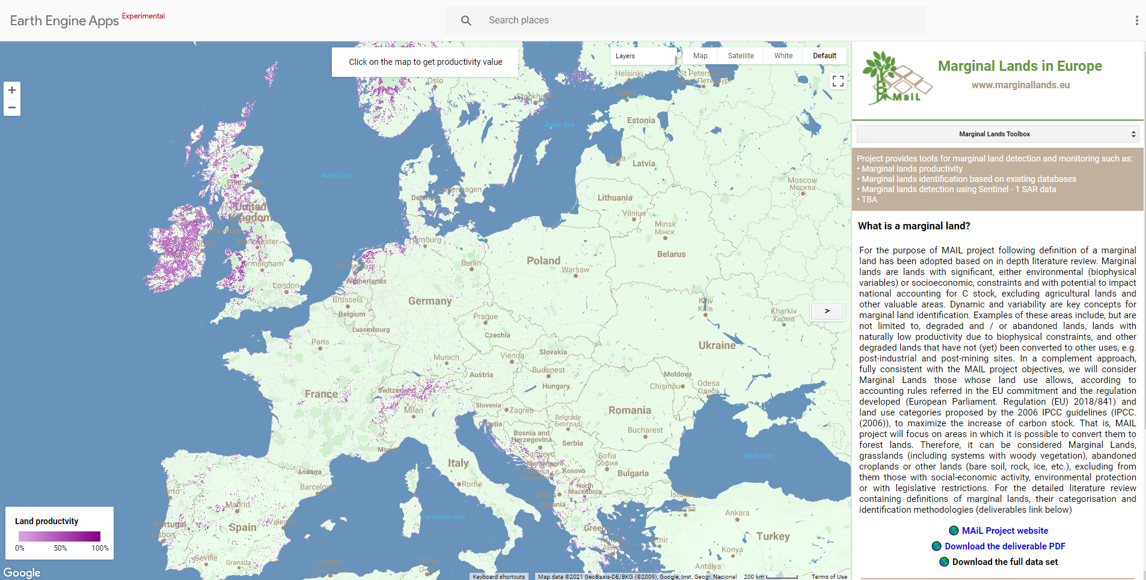
3
2
1
Figure 26. MAIL Map Portal components.

Basic functionality
Following the Panel with Map, the Tools panel and the searching window will be described.

Panel with Map

Productivity layer
The default layer which is displayed when user enters our portal contains the layer called “Marginal Lands productivity”. It’s pan-European layer, developed within Task 2.3. The only difference comparing to the original result is that in geoportal, values are scaled to the range 0-100%.
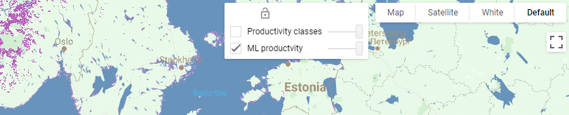
Figure 27. Layers available in MAIL Map Portal.

Productivity Classes
The second precomputed layer, available in geoportal is called “Productivity classes”. It contains the layer described in previous chapter, but the values are divided into 3 classes:
- Class 1: areas with high suitability for afforestation
- Class 2: areas with moderate suitability for afforestation
- Class 3: unsuitable areas
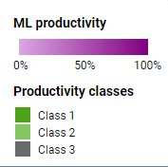
Figure 28. Legend with colours explanation for two layers available in MAIL Map Portal.

Carbon Sequestration Capacity Groups
Carbon Sequestration Capacity (CSC) Groups is the resulting layer from the development of the methodology regarding classification of MLs into CSC groups, as described in D2.6. From Group A to Group E, classification was done from higher to lower sequestration respectively. Through this classification we get a better understanding regarding the relative interconnections between groups and each one's potential trend. In Figure 29
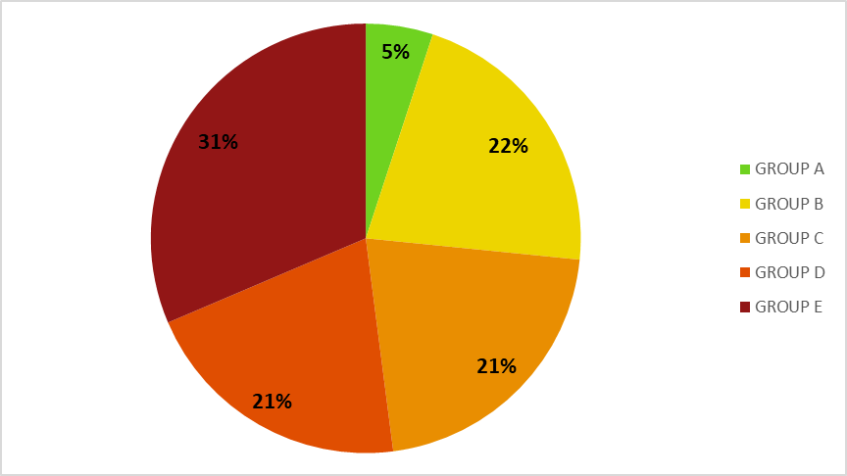 | 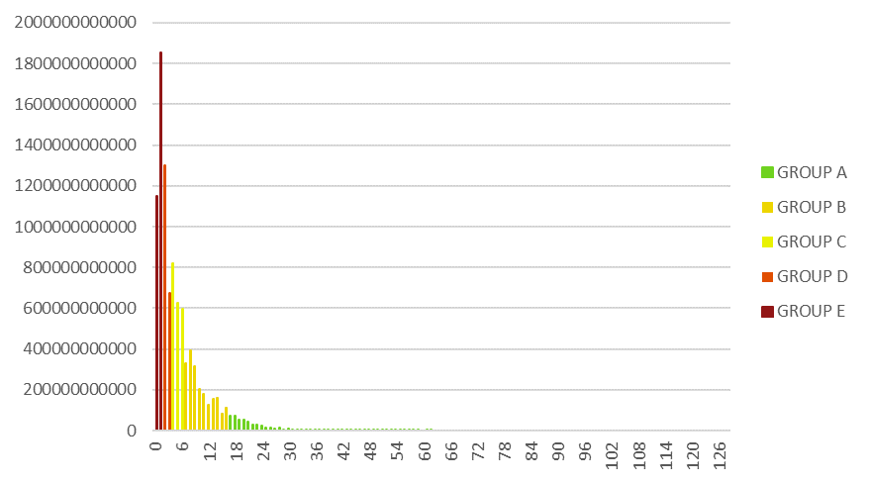
Figure 29. Relative Pie Chart and Histogram of 5 CSC classes for MLs of Europe.the percentage of the five CSC classes of all MLs of Europe are presented in a relative pie chart, followed the histogram.
Figure 29. Relative Pie Chart and Histogram of 5 CSC classes for MLs of Europe.
In the Figure 30 the results of an indicative Area of Interest are presented.
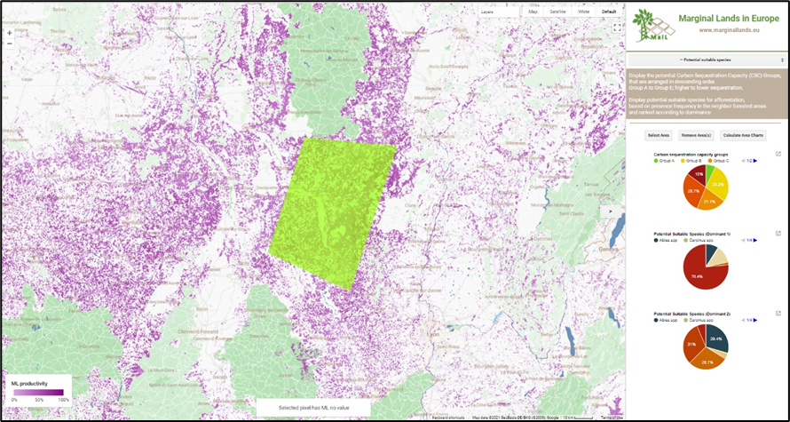
Figure 30. Example of Carbon Sequestration Capacity groups identified for selected Area of Interest.

Panel with Tools
The right part of MAIL Map Portal is dedicated for the tools related to identification of marginal lands and DSS. In the top-right (Figure 31), list of tools is available. Each tool has short description about its functionality. Detailed explanation how to use them is available in the form of pdf manual.
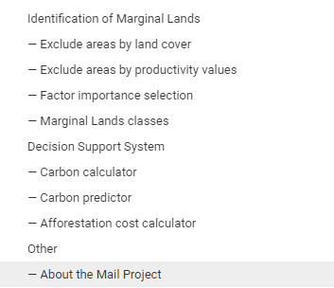
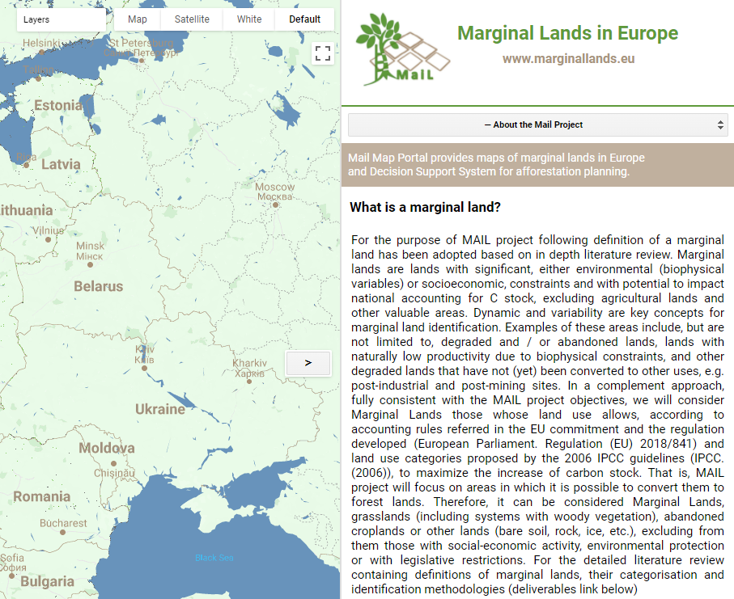
Figure 31. Panel with tools developed within MAIL project and available in MAIL Map Portal. (Demo mode, December 2021)

Searching window
The default extent of map contains the whole Europe. The user can manually zoom into specific area of interest or use searching window (Figure 32) and type geographical name to define the area to be displayed.
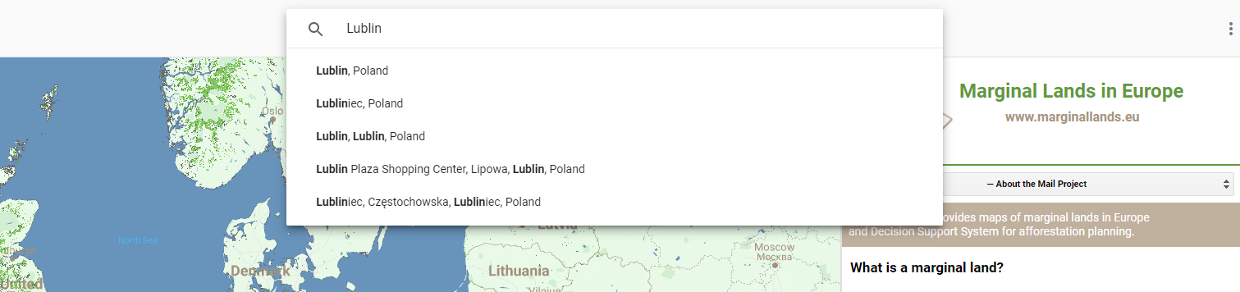
Figure 32. Searching window of MAIL Map Portal.

Identification of Marginal Lands

Exclude regions by land cover
Creating the final map, some land cover land use classes were excluded because by definition they can’t contain marginal lands. However, maybe, for some reason, the user doesn’t want to exclude for example protected areas or peatbogs. To change it, the user just chooses the tool called “exclude regions by land cover”.
This section allows for the generation of the “HardLayer mask” based on a list of land covers. The land cover list is composed by: forests, protected areas, changed areas, impervious, marshes, peatbogs, permanent snow-covered surfaces and water bodies. The Hard Layer mask is applied on the Soft layers and it can be dynamically operated using check boxes.
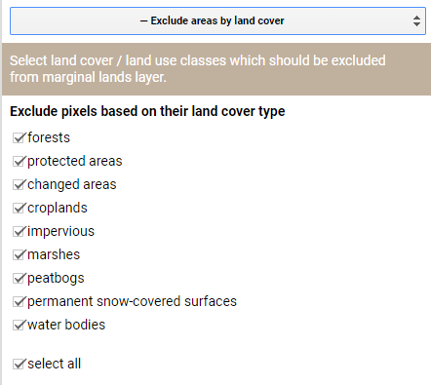
Figure 33. Tool for exclusion of land cover classes.

Exclude regions by value
Allows the user to filter marginal lands based on their productivity value. Productivity is obtained by calculating a weighted overlay for the weights and rankings applied for the soft layer variables. Both the weights and rankings are explained in the deliverable 2.3. Finally, productivity is standardized to get a relative scale (in %).
If the user wants to display only pixels with high productivity, let’s say above 50%, the user can do it here. The user can enter his/her threshold and click apply. The users can notice that now they can see fewer pixels than previously.
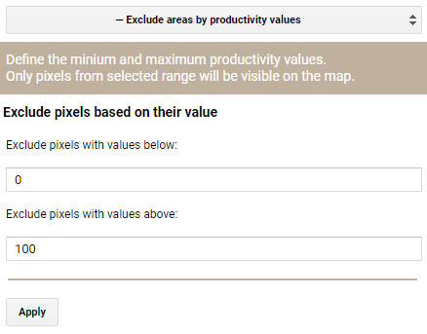
Figure 34. Tool for selection productivity values range.

Factor importance selector
Our product is based on 3 types of factors. The first relates to terrain and soil, the second to sustainability and the third to productivity. In each group there is a list of parameters. Here the users can decide how important they are for the final value. The users can modify them and click Apply or reset to the default values which are adjusted according to our methodology. More detailed explanation of parameters and their weights can be found in D2.3.
Here, the user can assign the weights to each soft layer and evaluate the overall relative importance over the rest of the variables. The value assignment can be done in 2 ways: individually (for each soft layer) or by groups of soft layers. The groups classify the soft layers in Terrain and Soil, Sustainability and Productivity. The default weights used for each variable are collected in Table 8.

Table 8: List of soft layers and associated weights applied for the area of Europe.
Groups | Variables | Weight
Terrain and Soil | Slope | 0.17
 | Depth available roots | 0.18
 | Stoniness (subsoil) | 0.03
 | Stoniness (topsoil) | 0.03
 | Texture (subsoil) | 0.045
 | Texture (topsoil) | 0.045
 | Clay (subsoil) | 0.015
 | Clay (topsoil) | 0.015
 | Sand (subsoil) | 0.015
 | Sand (topsoil) | 0.015
 | Total available water (subsoil) | 0.02
 | Total available water (topsoil) | 0.02
Sustainability | Soil acidity | 0.09
 | Soil erosion | 0.06
 | Flooding | 0.04
 | Sodicity | 0.03
 | Toxicity contamination | 0.03
 | Natural toxicity | 0.02
 | Dryness | 0.02
Productivity | Soil organic matter (subsoil) | 0.03
 | Soil organic matter (topsoil) | 0.03
 | Caption exchange capacity | 0.03
 | Productivity (forest) | 0.01
 | Productivity (grass) | 0.01

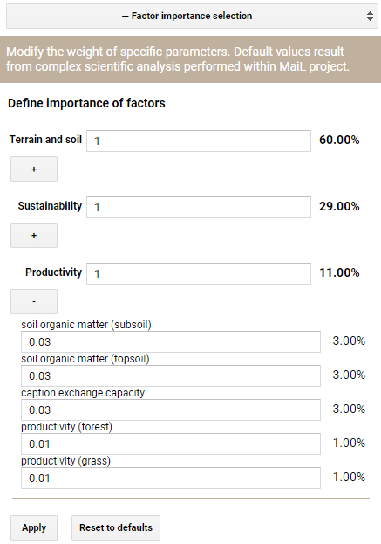
Figure 35. Factors importance selection tool. Layers are grouped into 3 categories.

Productivity classification
Here the users can choose how the final values are divided into 3 classes. They can enter the threshold values manually, use the percentiles in two ways or divide it equally into three zones. This tool has additional options. The division for a specific country or even specific region of the selected country can be performed. If the area of interest differs from official borders, it can be drawn manually using an option called “select area”.
The users can draw one or more polygons and click Apply. One additional feature is the histogram for the area which you selected.
On this figure the users can can see how often specific productivity values occurred in the area of interest. The plot can be downloaded as a vector or raster image or in the form of a table with values.
Marginal land Classes: Divides the marginal land productivity values in 3 classes assigning 2 thresholds defined in 4 different ways:
• Equal magnitude: takes the maximum productivity value and divides it by 3 and classifies the rest, using this value as the amplitude for each class
• 25th and 75th percentiles: uses as threshold values the 25th and 75th percentile of the productivity value distribution
• 33rd and 66th percentiles: uses as threshold values the 33rd and 66th percentile of the productivity value distribution
• Custom classes: the user inputs percentage values that will be use as the breaking values for the classes definition.
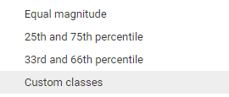
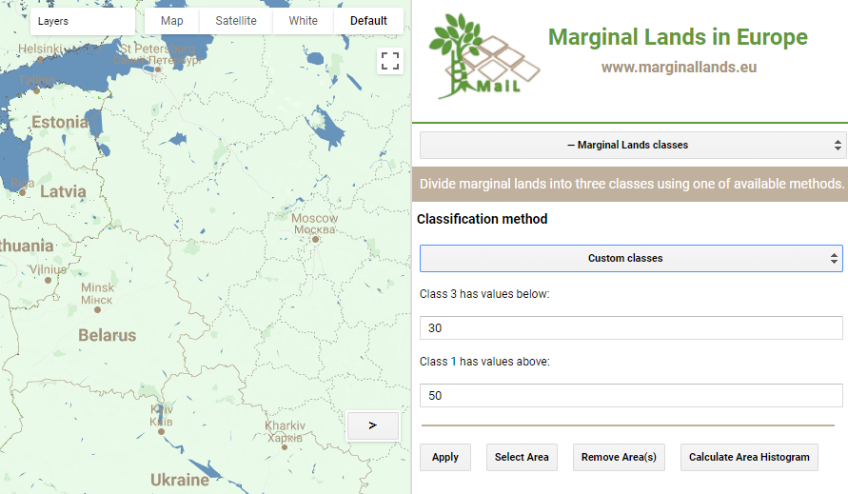
Figure 36. Classification of marginal lands tool.
Moreover, the classification can be run for all Europe or for custom areas, such as countries, or NUT 2 regions. After the classification is run, the user can evaluate the area of each class for the target area with the Calculate Area Histogram button.

Decision Support System
The Decision Support System is presented as a framework inside the tool in order to filter and select the most suitable marginal lands for a reforestation project. The selection is based on user inputs that defines the area of interest and the distances from or to land cover areas to carry out the reforestation.
First, the DSS work flow starts by defining an Area of interest. The user is given two options to select the area: the first one is selecting a NUTS3 area defined by a GAUL level 2 or defining a polygon.
Next step in the DSS is the identification of the marginal lands in the user defined area. at this step the user can choose between two options: The Marginal lands identified by the methodology proposed in task 2.3 (the output of the exclude by land cover areas and exclude by productivity values tools) and the MLs Enhanced Classification (task 2.8).
Continuing with the workflow in the DSS, after identifying the marginal lands distance filters are applied (to key land covers) to select target MLs suitable for reforestation. The user must select a type of reforestation and indicate the distance value close to a land cover type where the reforestation is to be performed. Additionally, it is given a checkbox to indicate that the distance introduced is regarded as distance further than the land cover of choice. Depending on the reforestation objective two sort of filters are applied: for protective reforestations feasibility and biodiversity filters are applied, whereas in the productive reforestation only feasibility filters are applied. The feasibility filters consider the distance to roads, crops and urban areas, on the other hand the biodiversity filters contemplate the distance to forest and protected areas. Considering the user defined distances, a distance mask is generated to mask the Marginal Lands
Once the reforestation areas are identified then these areas passed to the carbon tools to asses both a present carbon content (carbon content) or a future carbon content (carbon predictor).
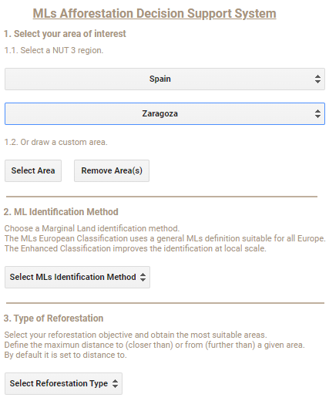
Figure 37. Overview of DSS tool within MAIL Map Portal.

Carbon Calculator
The Carbon Calculator Tool aims to provide a carbon estimation for the aboveground biomass components of a given area representing a forest plot of known density (number of trees per hectare) and mean breast height dimeter (in cm). Alternatively, it can be used to assess the Carbon fixed by a reforestation when a given diameter is reached. This tool performs the calculation for a mixture of maximum 3 species.
The carbon estimation is based on a compendium of generalized diameter-dependent aboveground biomass equations proposed by Forrester et al. 2017.
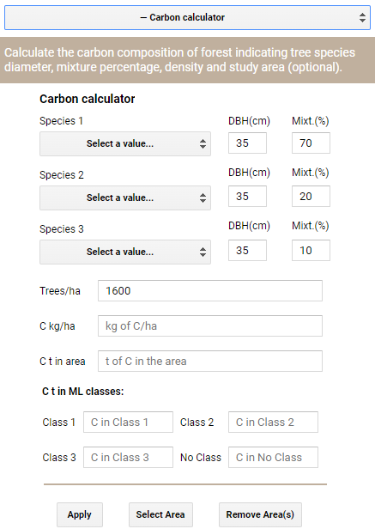
Figure 38. Carbon calculator tool.

Carbon Prediction
The carbon predictor tool’s main objective is to estimate the future carbon stock in a reforested plot. It can be applied both to a user delimited area or to a general area. If a user defined area is used then a diameter at breast height (hereafter as DBH) increment model is applied, if not the mean species increment coefficient is estimated. The tool uses one DBH increment model for each species that is parameterized using forest inventory, climatic and topographic data. Therefore, these models are area sensitive and the DBH increment will change depending on the user delimited area. The DBH increment models were extracted from ( Schelhaas, Hengeveld, & Heidema, 2018) Having estimated the growth and DBH for each species then generalized biomass equations from the carbon tool are applied to obtain biomass that is then converted to carbon using a 50% conversion factor.
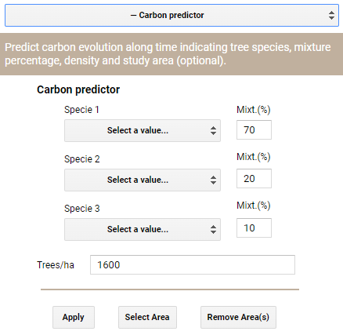
Figure 39. Carbon predictor tool.

Afforestation Cost Calculator
This tool applies an economical model created for calculating the cost of plantation of one single tree in Europe. This model takes into account specific factors that influence the cost of the plantation such as the soil texture, the slope of the area, the manual or the mechanical way of the plantation, the accessibility to cities and the labour cost level of the countries in Europe. The model calculates default base prices for forest plantation practices using as reference site the Spanish website ‘Tarifas Tragsa’. For the definition of the default base prices three basic operations as the opening a hole on the ground (manually or mechanically), the plantation of one tree and the covering of the ground hole were taken into account.
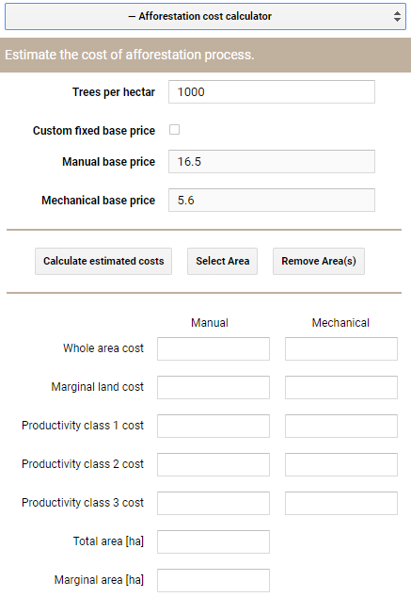
Figure 40. Afforestation cost calculator tool.

Potential Suitable Species
The purpose is to provide a general overview regarding Carbon Sequestration Capacity Groups (CSC Groups) and to suggest Potential Suitable Species for afforestation. The CSC groups are calculated based on the methodology applied for the whole Europe and Potential Suitable Species on presence frequency in the neighbour forested areas, ranked according to dominance.
The analysis occurs at a user’s defined level (student, stakeholder, etc.) by drawing or inserting a specified Area Of Interest (AOI; *.geojson). The AOI information is displayed on three relative pie charts, one for CSC Groups and another two for species, dominant 1 and dominant 2. In each relative pie chart, the results illustrate the participation percentages in the AOI.
There is specified limit in the AOI extend. However, the tool designed for parcel scale analysis. Therefore, it is suggested not to exceed 100,000 ha, as the accuracy is inversely proportional to the AOI.
The tool scope is a broader approach in European level. Thus, by no means can substitute an in situ analysis, that takes into account more aspects such as micro-climate, ecological zone, elevation, soil attributes, etc.

Identification of MLs using satellite images
The default map of potential marginal land areas in Europe is based on GIS analyses of various databases and presents information from 2017-2018 year. Using satellite images from Copernicus programme (Sentinel-1 and Sentinel-2), the user can generate an enhanced map for a selected moment in time. An enhanced map is generated for the selected area of interest. It means that it’s better adjusted to local conditions, comparing to pan-European approach. For farther analyses using the Decision Support System, the user can choose which of the two maps will applied – MLs European Classification or ML Enhanced Classification.

Multi-temporal Analysis
Marginal lands are a very dynamic phenomenon. For this reason, monitoring of their changes is very valuable. For multi-temporal analysis of marginal lands in Europe, we used the implementation of the Change Mapper Application. It allows for change monitoring over the last 20 years. Three possible scenarios which can be monitored this way are:
- deforestation detection (identification of year of occurrence and magnitude of change) – example on Figure 41
- forest areas monitoring
- afforestation/reforestation projects monitoring – example on Figure 42
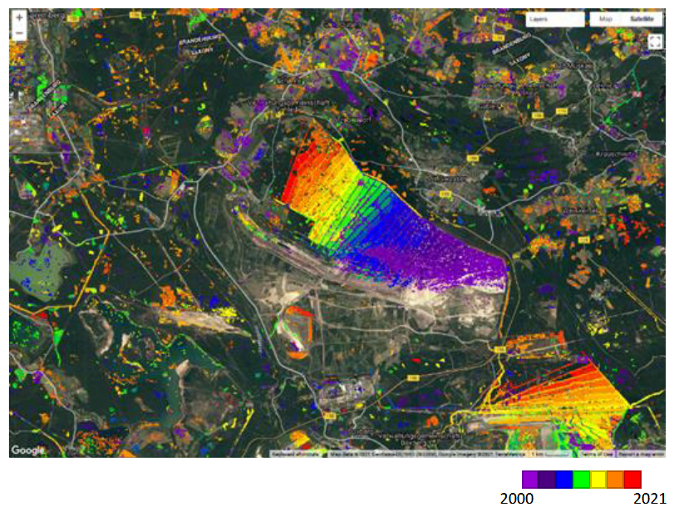
Figure 41. Detection of deforestation. Area of pit mine in Saxony (Germany). Different colours represent the time (year) of the biggest loss of vegetation. Personal compilation of Marta Milczarek
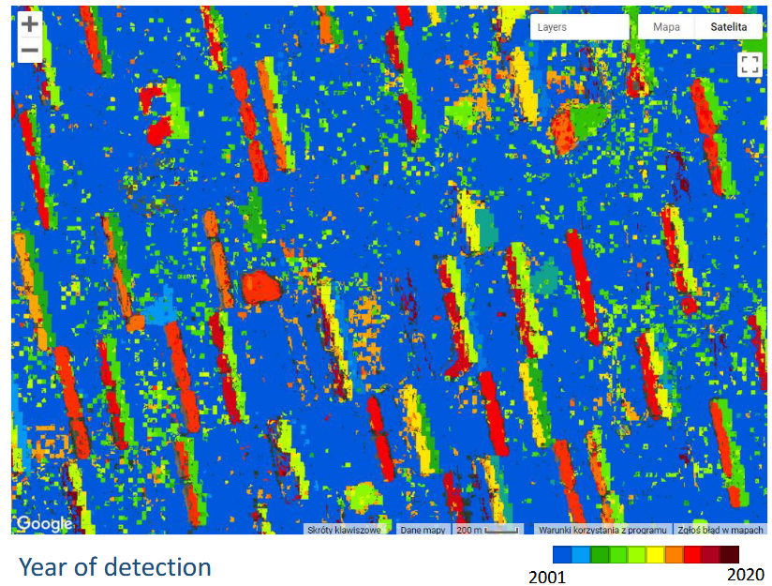
Figure 42. Example of afforestation activities monitoring. Different colours represent years of the biggest gain of vegetation. Location: Poland. Personal compilation of Marta Milczarek

Bibliography
- Bartha, G., Kocsis, S., 2011. Standardization of geographic data: The european inspire directive. Eur. J. Geogr. 2, 79–89.
- Baumann, P., 2010. Ogc wcs 2.0 interface standard-core. Open Geospatial Consort. Wayland, MA, USA.
- Carbonell-Rivera, J.P., 2017. ValenciaMonuments [WWW Document]. URL http://personales.upv.es/juacarri/ValenciaMonuments/index.html
- Carbonell-Rivera, J.P., 2016. Renewable energy in the European Union [WWW Document]. URL http://personales.upv.es/juacarri/RenewableEnergy/index.html (accessed 10.15.20).
- CartoDB, 2014. CartoDB [WWW Document]. URL https://github.com/CartoDB/cartodb (accessed 10.15.20).
- Cesium, 2014. CesiumJS [WWW Document]. URL https://cesium.com/cesiumjs/ (accessed 10.15.20).
- Chambers, C., Raniwala, A., Perry, F., Adams, S., Henry, R.R., Bradshaw, R., Weizenbaum, N., 2010. FlumeJava: easy, efficient data-parallel pipelines. ACM Sigplan Not. 45, 363–375.
- Chang, F., Dean, J., Ghemawat, S., Hsieh, W.C., Wallach, D.A., Burrows, M., Chandra, T., Fikes, A., Gruber, R.E., 2008. Bigtable: A distributed storage system for structured data. ACM Trans. Comput. Syst. 26, 1–26.
- Coleman, D.J., Nebert, D.D., 1998. Building a North American spatial data infrastructure. Cartogr. Geogr. Inf. Syst. 25, 151–160.
- Coll, E., Martínez-Llario, J.C., 2008. Local SDI: a need for the local administration, in: Proceedings of the 4th WSEAS International Conference on REMOTE SENSING (REMOTE’08). WSEAS Press, Venice (Italy)., pp. 31–34.
- Corbett, J.C., Dean, J., Epstein, M., Fikes, A., Frost, C., Furman, J.J., Ghemawat, S., Gubarev, A., Heiser, C., Hochschild, P., 2013. Spanner: Google’s globally distributed database. ACM Trans. Comput. Syst. 31, 1–22.
- de La Beaujardiere, J., 2006. OpenGIS® Web Map Server Implementation Specification. Version 1.3. 0.
- Esri, 2020. ArcGIS Online [WWW Document]. URL https://www.esri.com/en-us/arcgis/products/arcgis-online/overview (accessed 10.15.20).
- Fikes, A., 2010. Storage architecture and challenges. Talk Google Fac. Summit 2, 2.
- Forrester, D. I., Tachauer , I. H. H., Annighoefer , P., Barbeito , I., Pretzsch , H., Ruiz Peinado , R., ... & Sileshi , G. W. (2017). Generalized biomass and leaf area allometric equations for European tree species incorporating stand structure, tree age and climate. Forest Ecology and Management, 396, 160 175
- Ghemawat, S., Gobioff, H., Leung, S.-T., 2003. The Google file system, in: Proceedings of the Nineteenth ACM Symposium on Operating Systems Principles. pp. 29–43.
- Gonzalez, H., Halevy, A.Y., Jensen, C.S., Langen, A., Madhavan, J., Shapley, R., Shen, W., Goldberg-Kidon, J., 2010. Google fusion tables: web-centered data management and collaboration, in: Proceedings of the 2010 ACM SIGMOD International Conference on Management of Data. pp. 1061–1066.
- Gorelick, N., Hancher, M., Dixon, M., Ilyushchenko, S., Thau, D., Moore, R., 2017. Google Earth Engine: Planetary-scale geospatial analysis for everyone. Remote Sens. Environ. 202, 18–27.
- Hanson, B.A., Seeger, C., 2015. Online Mapping with CartoDB.
- Kraak, J.-M., Brown, A., 2003. Web cartography. CRC Press.
- Kuhn, W., 2005. Introduction to spatial data infrastructures. Present. held March 14, 2005.
- Martínez Llario, J.C., 2018a. Componentes de un Geoportal IDE.
- Martínez Llario, J.C., 2018b. Servicios de visualización (WMS/WMTS) en un SIG de escritorio.
- Martínez Llario, J.C., 2012. Postgis 2 Analisis espacial Avanzado.
- Michaelis, C.D., Ames, D.P., 2012. Considerations for Implementing OGC WMS and WFS Specifications in a Desktop GIS.
- Morales, A., 2015. Global Climate Monitor: Descarga de datos climáticos [WWW Document]. URL https://mappinggis.com/2015/05/global-climate-monitor-descarga-de-datos-climaticos/ (accessed 10.1.20).
- Mutanga, O., Kumar, L., 2019. Google earth engine applications.
- Network Services Drafting Team, 2008. INSPIRE Network Services Architecture.
- Nogueras-Iso, J., Zarazaga-Soria, F.J., Muro-Medrano, P.R., 2005. Geographic information metadata for spatial data infrastructures. Resour. Interoperability Inf. Retr.
- Open Geospatial Consortium, 2014. OGC WPS 2.0 Interface Standard. OGC Implement. Stand. OGC 14, 65.
- Schelhaas , MJ., Hengeveld , G.M., Heidema , et al. Species specific , pan European diameter increment models based on data of 2.3 million trees For . Ecosyst 5, 21 (2018).https://doi.org/10.1186/s40663 018 0133 3
- Sparavigna, A., 2008. The Pleiades: the celestial herd of ancient timekeepers. arXiv Prepr. arXiv0810.1592.
- Verma, A., Pedrosa, L., Korupolu, M., Oppenheimer, D., Tune, E., Wilkes, J., 2015. Large-scale cluster management at Google with Borg, in: Proceedings of the Tenth European Conference on Computer Systems. pp. 1–17.
- Vretanos, P.A., 2010. OpenGIS web feature service 2.0 interface standard. OpenGIS Proj. Doc. OGC.
- Wolodtschenko, A., Forner, T., 2007. Prehistoric and early historic maps in Europe: Conception of Cd-Atlas. e-Perimetron 2, 114–116.

Annex I: Table of figures
Figure 1. System view of the spatial data infrastructure components. Source: (Coleman and Nebert, 1998) 12
Figure 2. Client/Server architecture. Source: personal compilation of Juan Pedro Carbonell Rivera 13
Figure 3. Wikimedia Foundation servers. Source: Victor Grigas, distributed under a CC BY-SA 3.0 license. 15
Figure 4. Example of three-tier web GIS architecture. Source: (Morales, 2015). 17
Figure 5. Three-tier architecture software. Source: personal compilation of Juan Pedro Carbonell Rivera 17
Figure 6. OpenLayers example. Source: openlayers.org 20
Figure 7. “Monuments of Valencia” developed using Leaflet. Source: (Carbonell-Rivera, 2017) 20
Figure 8. “Share of energy from renewable sources in the European Union” developed with Cesium. Source: (Carbonell-Rivera, 2016) 21
Figure 9. INSPIRE technical architecture overview. Source: (Network Services Drafting Team, 2008) 22
Figure 10. Visualisation in QGIS of the WMS from the Spanish National Plan for Aerial Orthophotography. Source: personal compilation of Juan Pedro Carbonell Rivera 24
Figure 11. Visualisation in QGIS of potential erosion using a WCS from the environmental council of the Andalusian Community. Source: personal compilation of Juan Pedro Carbonell Rivera 25
Figure 12. Visualisation in QGIS of a WFS of the Spanish agricultural districts. Source: personal compilation of Juan Pedro Carbonell Rivera 26
Figure 13. View of the Google Chrome web browser with a personalized skin. Source: personal compilation of Juan Pedro Carbonell Rivera 27
Figure 14. Ping command checking the website "homeotech.gr". Source: personal compilation of Juan Pedro Carbonell Rivera 29
Figure 15. Example of XML file. Source: personal compilation of Juan Pedro Carbonell Rivera 30
Figure 16. Part of the HTML code of the webpage “homeotech.gr”. Source: personal compilation of Juan Pedro Carbonell Rivera 31
Figure 17. CSS code of the webpage "homeotech.gr". Source: personal compilation of Juan Pedro Carbonell Rivera 32
Figure 18. JavaScript code of the webpage "homeotech.gr". Source: personal compilation. 33
Figure 19. Diagram showing MAIL´s web GIS architecture. Source: personal compilation 33
Figure 20. Monitoring of COVID-19 in the Valencian Community. Source: personal compilation of Juan Pedro Carbonell Rivera 40
Figure 21. Landsat Explorer. Source: personal compilation of Juan Pedro Carbonell Rivera 41
Figure 22. Portal created with CARTO. Source: (Hanson and Seeger, 2015) 43
Figure 23. Google Earth Engine editor. Source: personal compilation of Juan Pedro Carbonell Rivera 43
Figure 24. A simplified Google Earth Engine (GEE) system architecture diagram. Source: (Gorelick et al., 2017). 45
Figure 25. Google Earth Engine layout annotated. Source: https://earthengine.google.com/platform/ 46
Figure 26. MAIL Map Portal components. 50
Figure 27. Layers available in MAIL Map Portal. 51
Figure 28. Legend with colours explanation for two layers available in MAIL Map Portal. 51
Figure 29. Relative Pie Chart and Histogram of 5 CSC classes for MLs of Europe. 52
Figure 30. Example of Carbon Sequestration Capacity groups identified for selected Area of Interest. 53
Figure 31. Panel with tools developed within MAIL project and available in MAIL Map Portal. (Demo mode, December 2021) 54
Figure 32. Searching window of MAIL Map Portal. 54
Figure 33. Tool for exclusion of land cover classes. 55
Figure 34. Tool for selection productivity values range. 56
Figure 35. Factors importance selection tool. Layers are grouped into 3 categories. 58
Figure 36. Classification of marginal lands tool. 59
Figure 37. Overview of DSS tool within MAIL Map Portal. 61
Figure 38. Carbon calculator tool. 62
Figure 39. Carbon predictor tool. 63
Figure 40. Afforestation cost calculator tool. 64
Figure 41. Detection of deforestation. Area of pit mine in Saxony (Germany). Different colours represent the time (year) of the biggest loss of vegetation. Personal compilation of Marta Milczarek 66
Figure 42. Example of afforestation activities monitoring. Different colours represent years of the biggest gain of vegetation. Location: Poland. Personal compilation of Marta Milczarek 66

Annex II: List of Tables
Table 1. Example of 5-tier architecture. Source: personal compilation of Juan Pedro Carbonell Rivera 23
Table 2. Internet protocols. Source: personal compilation of Juan Pedro Carbonell Rivera 28
Table 3. Correlation between releases (ArcGIS, PostgeSQL and PostGIS). Source: personal compilation of Alfonso Abad 35
Table 4. Functions of the web GIS client 36
Table 5. Functional requirements of the web GIS client 37
Table 6. Web map types. Source: personal compilation of Juan Pedro Carbonell Rivera 38
Table 7. Frequently used datasets in the earth engine data catalog. Source: (Gorelick et al., 2017) 47
Table 8: List of soft layers and associated weights applied for the area of Europe. 57

R = Report, P = Prototype, D = Demonstrator, O = Other
PU = Public, PP = Restricted to other programme participants (including the Commission Services), RE = Restricted to a group specified by the consortium (including the Commission Services), CO = Confidential, only for members of the consortium (including the Commission Services).

