

|  |  |
| --- | --- |
| D2.9 | Report on Webpage and Virtual Classroom |
|  | |
| **MAIL**: Identifying Marginal Lands in Europe and strengthening their contribution potentialities in a CO2 sequestration strategy | |

MAIL project has received funding from the European Union’s Horizon 2020 research and innovation programme under the Marie Skłodowska-Curie grant agreement No 823805; [H2020 MSCA RISE 2018]

|  |  |
| --- | --- |
| Project title | Identifying Marginal Lands in Europe and strengthening their contribution potentialities in a CO2 sequestration strategy |
| Call identifier | H2020 MSCA RISE 2018 |
| Project acronym | MAIL |
| Starting date | 01.01.2019 |
| End date | 31.12.2021 |
| Funding scheme | Marie Skłodowska-Curie |
| Contract no. | 823805 |
|  | |
| Deliverable no. | D2.9 |
| Document name | MAIL_D2.9.pdf |
| Deliverable name | Report on Webpage and virtual classroom |
| Work Package | 2 |
| Nature[1] | R |
| Dissemination[2] | PU |
| Editor | Juan Pedro Carbonell-Rivera, Jesús Torralba Pérez (UPV), Charalampos Georgiadis (AUTH) |
| Authors | Archontia Sakellariou, Lampros Papalampros, Ino Vasileia Korompoki (HOMEOTECH) |
| Contributors | All MAIL partners |
| Date | 28.12.2021 |

# MAIL Consortium

|  |  |
| --- | --- |
| Aristotle University of Thessaloniki (AUTH) Greece | Industrieanlagen Betriebsgesellschaft MBH (IABG) Germany |
| Gounaris N. – Kontos K. OE (HOMEOTECH) Greece | Centrum Badan Kosmicznych Polskiej Akademii Nauk (CBK PAN) Poland |
| Universitat Politècnica de València (UPV) Spain | Fundación Centro de Servicios y promoción FORestral y de su industria de Castilla y León (CESEFOR) Spain |

# Abbreviations

|  |  |
| --- | --- |
| **Term** | **Explanation** |
| CM | Content Management |
| CMS | Content Management Systems |
| CSS | Cascading Style Sheets |
| DPIA | Data Protection Impact Assessments |
| DPO | Data Protection Officers |
| GA | Grand Grant Agreement |
| GDPR | General Data Protection Regulation |
| HTML | Hypertext Markup Language |
| IPR | Intellectual Property Rights |
| IT | Information Technology |
| LMS | Learning Management System |
| ML | Marginal Land |
| MOOC | Massive Open Online Courses |
| R&I | Research and Innovation |
| RS | Remote Sensing |
| SCORM | Short for Sharable Content Object Reference Model |
| SEO | Search Engine Optimization |
| URL | Uniform Resource Locator |
| WCMS | Web Content Management Systems |
| WG | Work Group |

Contents

MAIL Consortium 3

Abbreviations 4

Executive Summary 6

1. Website 7

1.1 General 8

1.1.1 Targets 8

1.1.2 Target Audience 8

1.2 Available platforms 9

1.3 Essential utilities 12

1.4 Final Platform selection 13

1.5 Website structure 14

1.6 Further dissemination channels 24

2. Virtual Classroom 26

2.1 General 26

2.1.1 Targets 26

2.1.2 Target Audience 27

2.1.3 MOOC’s benefits 27

2.2 Final MOOC Platform selection 32

2.3 Material preparation 35

References 37

Annex I: GDPR in website and Virtual Classroom 41

Annex II: List of figures 42

Annex III: List of Tables 43

# Executive Summary

The task is led by UPV and has been implemented by HOMEOTECH secondees to UPV.

In order to create and disseminate knowledge among the MAIL partners and stakeholders the project’s webpage was based on the idea that all developed know-how will be exported in, as much as possible, public deliverables and will be available to interested parties. Setting these as a principle, MAIL takes into consideration the General Data Protection Regulation (GDPR), Intellectual Property Rights (IPR), Rules on dissemination and use, Access Rights, Liability, Confidentiality, and Indemnification arrangements.

According to GA, legislation, laws, and regulations are considering and applied among partners’ personal data, project’s outcomes, and dissemination. Consortium members are aware of this and maintain the confidentiality guidelines. GDPR is a European Union rule with a broad territorial reach that applies to the processing of personal data of EU citizens, regardless of whether the processing takes place in the EU or not. Some of the project’s research and management tasks require a personal data report, such as the usage of common file area that resides with the MAIL website. Thus, individuals whose personal data is processed have the right to view, revise, or verify their information. They can contact the data controller with any questions concerning the processing of their personal data via the contact information provided in the privacy statement(s) published on the Agency and Commission websites. The agreement with GDPR, rights and obligations according to the project are important in order to protect the rights of natural persons in relation to the processing of personal data and the free flow of such data for MAIL duration.

Furthermore, in the direction that MAIL creates and disseminates knowledge, efforts were concentrated to implement massive open online courses for the further education/training of any possible expert or nonexpert in Remote Sensing (RS), who is willing to acquire new skills regarding sustainable marginal lands (ML) management. At this stage, the work team, after a comparison of several different cases, selected the MOOC platforms for the implementation of the MOOC. The platforms are the one used by UPV, that is called UPVx and, according to quality development, it will be published in edX (UPV is a member), and AUTH’s open courses platform. They were chosen after precise research above available platforms with important utilities to MAIL objectives. As mentioned earlier, the GDPR and legislation for personal data and project outcomes protection, is maintained at this stage, too.

# Website

A website's web page (or webpage) is a hypertext document that is presented to a user through a web browser. (Definition of web page by The Free Dictionary, 2021). A website is often made up of several web pages that are connected together in a logical manner.

According to the Grant Agreement (GA), MAIL’s website is the main source of information about the project’s activities, objectives, partners involved, results achieved, and documents produced. It is composed by a public area accessible to all target users and visitors of the website and a private area only for project partners. The public area contains all relevant and updated information about the project’s activities but also about related initiatives and links. In addition, a media dedicated area contains downloadable articles, press releases for the general public, and scientific publications conducted mainly by the academic partners. The private area (intranet) is an easy to use and secure area where reports, minutes, documents, and deliverables are stored and act as a supporting tool for the partners’ daily work. The website will be regularly updated with relevant information collected from all the partners and revised in a way of making it comprehensible by the public at large. The main language is English.

The web-based system that it is developed, and offered through MAIL webpage provides/hosts the following:

1. General information regarding the project and the partners
2. Regular newsletter with MAIL results
3. Massive Online Open Course (MOOC)
4. Marginal land detection web-application platform

The web-based system developed and offered through MAIL’swebpage includes utilities where user registration is needed, and the respective service comply with the GDPR. The collected data will be used only for the purposes of the project and only if the users consent to that. In the following sections, the measures and workflows concerning personal data protection will be presented.

## General

A systematic approach, with a deep emphasis on interdisciplinary learning, was kept during MAIL to ensure the full utilization of participating organizations knowledge base. Thus, it’s essential to determine the website target and specific audience in order to ensure the desired impact.

### Targets

MAIL uses more than one strategy in order to increase knowledge sharing success. Straight forward, customized messaging for a variety of audiences, based on their unique knowledge-sharing requirements, in accordance with knowledge transmission multiple times and in multiple ways, increases the likelihood that a message will be heard and considered. The above-mentioned activities had the following impact:

* Inform the general public about the work achieved in MAIL
* Inform the scientific/technical community about MAIL results and promote their direct/indirect involvement
* Attract the interest of private investors, public and private MLs owners, plant breeders, farmers and foresters, harvest sector – producers and retailers, transport and storage sector, conversion sector
* Enhance local development opportunities deriving from exploitation of MLs
* Favor the engagement of policy makers and public planners in MAIL results
* Train scientists and provide capacity building through the organized workshops - seminars

### Target Audience

The website provides a "shop window" to general audiences, stakeholders, and the scientific community***.*** Additionally, newsletters, hot briefs and summary reports that were disseminated through the development of a mailing list are expected to have a real impact. According to GA, a diversity of network communication activities will be further employed, such as workshops/conferences, in order to provide useful face-to-face meetings which are more effective than electronic communications alone.

The website will be the main source of information about the project’s activities, objectives, partners involved, results achieved, and documents produced. It will be composed by a public area accessible to all target users and visitors of the website and a private area only for project partners.

It’s important to determine the target audience in order to ensure the fittest communication tools to spread the major outcomes to a large audience as: general information on project, its partners and main actors, results achieved and lessons learnt, specific aspects related to the project’s contents and know-how, customized messaging for a variety of audiences, based on their unique knowledge-sharing requirements. It will be carried out throughout the project’s lifetime in order to give proper visibility to the project. The communication strategy adopts a multilevel and multichannel approach based on specific communication tools.

## Available platforms

There are numerous open-source CMS options. Although each open-source CMS has its own set of benefits, just a handful, such as Joomla, Drupal, and WordPress, are widely used in the industry due to their superior functionality and assistance. (Patel, 2011).

Instead of storing web page text and publishing facts as HTML pages, WCMS is a server program that keeps them in a database (SiteLeads, 2011). These pages cannot be loaded until the client browser requests them, and they are produced on demand. Many sorts of the material may be managed and published using WCMS, and the layout, design, and structure of the site can be altered easily and rapidly thanks to the usage of templates, which separate content from presentation - unlike a traditional hard-coded site. If a user wishes to amend the content, they can do so online and it will be updated immediately (Patel, 2011). Plug-ins can be used to extend the functionality and capabilities of a program. Depending on the visitor's language or region, different content can be served to them. In comparison to a static or HTML site, visitor involvement can be boosted.

A CMS can be extended by adding features and functions, according to project’s needs, as it is a dynamic system (dynamicweb, 2021).

1. **Joomla**

**Joomla** is one of the most powerful open-source CMS. It's a free open-source content publishing system for quickly building highly interactive multilingual Web sites including online communities, media, portals, blogs, and e-commerce applications. Joomla is a free open-source CMS that may be used by anyone. Its universality refers to its ability to be adapted as desired. Bloggers frequently used the WordPress blogging platform. This is a natural choice; however, Joomla also allows users to blog. The page can be customized by choosing a free or premium template. There are also add-ons for additional functionality, as well as a large number of free and commercial extensions accessible at Joomla. Because Joomla is open source, the code of the website layout can be altered to suit the project's demands, primarily with the help of a web developer. (Pascal, 2010).

Main Characteristics (Open-Source Matters, Inc “Features Overview”, 2005-2010):

* User Management
* Media Manager
* Banner Management
* Contact Management
* Polls
* Search
* Web Link Management
* Content Management
* Syndication & Newsfeed Management
* Template Management
* Integrated Help System
* System Features
* Web Services
* Powerful Extensibility

1. **Drupal**

**Drupal** is an open-source platform for creating dependable and adaptable websites. The following are some of the most important facilities: Drupal is a CMS that allows users to update web pages without requiring technical knowledge and ensures that it follows the required process. Drupal is a flexible platform that will expand as the project's requirements change. Users may now discover web material in new ways thanks to features like sophisticated search, auto-tagging, and internationalization. Drupal may be implemented in a variety of languages, allowing administrators and users to view a site in the language of their choice. It can be customized to fit the needs of the content, users, and organizational characteristics that make it unique. Drupal has a big developer community that provides website support, security, testing, and documentation. (Byron A., 2009)

Core features (Drupal, 2021):

* Administer
* Build
* Collaborate
* Connect
* Create
* Design & Display
* Extend
* Organize & Find

1. **WordPress**

**WordPress** was created with the intention of serving as a blogging platform. WordPress has evolved into a useful CMS over the last few years. The enormous number of plug-ins offered by independent developers is one of WordPress' key advantages. In reality, WordPress plug-ins can now be used to manage every aspect of a website's design, organization, and search engine optimization. These plug-ins are actually add-ons that enhance the user interface's capabilities. With so many WordPress plugins accessible, it grows in popularity among the general population. Many folks are perplexed when it comes to choosing plug-ins to make a task easier. There is a vast WordPress community ready to help people learn how to utilize the CMS. (“Drupal vs WordPress - Comparing CMS Software”, 2010).

Core features (wordpress, features, 2021):

* Full standards compliance
* No rebuilding
* WordPress Pages
* WordPress Themes
* Cross-blog communication tools
* Spam protection
* Full user registration
* Password Protected Posts
* Easy Importing
* XML-RPC interface
* Workflow
* Intelligent text formatting
* Multiple authors

The above-mentioned CMS can offer functionality in websites for developers to edit or update content easily and to interact with the users directly. Each, has its own characteristics according to the number of plugins, SEO, the dynamic functionality according to usage. These features are important to develop and maintain a healthy and successful website. In the following figure (Figure 1) the capability of the three CMS according to the website’s must-have is reported.

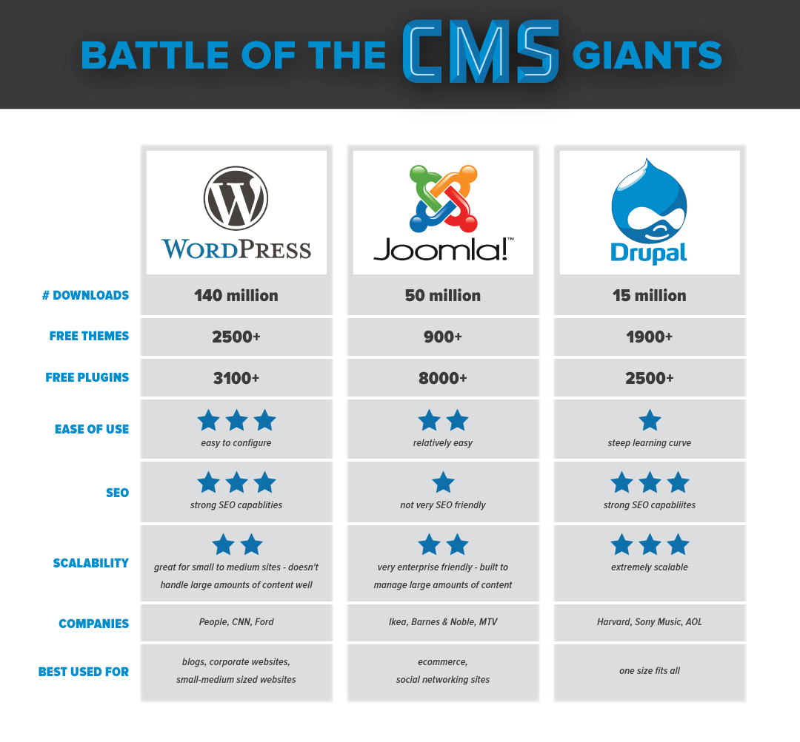

Figure 1. CMS platforms comparison. (itechnex, 2017)

## Essential utilities

According to GA and D1.1 “POPD - Requirement No.1” it’s necessary, for all utilities include user registration, to hold the respective service that will comply with the General Data Protection Regulation (GDPR). The collected data will be used only for the purposes of the project and only if the users consent to that.

In this section, the different approaches and measures that will be implemented in the various MAIL web services are going to be presented and analysed. More specifically the following web services are going to be presented:

1. The newsletter registration (for public)

The MAIL newsletter is part of the project’s dissemination and communication strategy. In total 6 e-newsletters are going to be published in the project’s lifetime. A part of the newsletter distribution strategy is the registration through the project’s dedicated webpage. In order to comply with the GDPR regulations, the procedure described in Subchapter 1.5 was implemented for the newsletter registration.

1. The Massive Online Open Course (MOOC) (for consortium members and public)

The MOOCs will be disseminated and made available to the general public through the Aristotle University of Thessaloniki Open Courses platform and the UPV’s MOOC platform. More information will be reported in Subchapter 1.5.

1. The common file area (for consortium members)

Taking into consideration the GDPR regulations procedure this utility is useful in managing the exchanged knowledge and know-how above all partners. It’s an easy-to-access service which is described further in Subchapter 1.5.

1. The dissemination utility (for public)

In the same logic and as described in the following Subchapter 1.5 Deliverables and Media will generate knowledge through MAIL website in an interactive interesting way following the GDPR regulations.

As a result, these webservises shaped a clear aprroach of choosing the best platform for MAIL website. In the following table (Table 1) are reported the similarities and differences among CMS but also the best one to choose according to MAIL webservices compatibility.

| CMS | **Joomla** | **Drupal** | **to** |
| --- | --- | --- | --- |
| similarities | add-ons in roughly the same price range | | |
| differences | developer-centered /HTML- PHP | | Easy to use – non developing expertise |
| Not so many refined add-ons and plugins | | The most add-ons and most user-facing plugins |
| archaic design | | modern and optimized design |
| newsletter registration | **✓** | **✓** | **✓** |
| MOOC | **✓** | **✓** | **✓** |
| common file area | **✓\*** | **✓\*** | **✓** |
| dissemination utility |  | **✓** | **✓** |

***\**** *Joomla and Drupal do have a common file area utility but their extends and modules are more difficult to use and need more time to integrate into the process.*

Table 1. Core features and essential utilities of Joomla, Drupal, WordPress

## Final Platform selection

MAIL website is built in **WordPress** softwarewhich is the best way to manage and expand the desired features, according to project’s essential utilities. More specifically, WordPress is released under an Open-Source license, which is free and constantly improved. Also, it’s an easy-to-learn and use platform, completely customizable and allows to change the layout, add features, photos and videos gallery, or a mailing list which updates a website to an interactive and user-friendly one. (what is wordpress, 2008-2021).

WordPress is simple to personalize with themes and plugins which are important for a website´s adaptation in actions according to specific audience and targets. WordPress themes are simple to edit because many of them include an options panel that allows the developer to change colors, upload logos, change the background, add sliders, and so on (Schäferhoff, 2021).

Also, plugins can be used to provide new functionality to MAIL site. WordPress plugins are website software that may be used to add sophisticated features like analytics, contact forms, and membership areas, among other things. By using plugins, the file common area for members was easy to build and use utility (Coleman, B. & Messenlehner, J., 2019).

Also, it is SEO friendly, which is useful for MAIL dissemination. WordPress is built with high-quality, standard-compliant programming that generates semantic markup. This, in layman's terms, makes Google and other search engines adore WordPress. This is why WordPress sites tend to rank higher in search engines than non-WordPress sites. WordPress can handle different media types which makes it an essential tool for website’s needs since the sections with Deliverables, Media, Newsletters and MOOCs are important means of communication with a specific audience or general public.

Finally, WordPress is developed with safety and security in mind, and it is regarded a very secure platform for running a website if you keep up with the required upgrades and use the right plugins (Kyle M. L. Jones, 2011).

## Website structure

Website structure refers to how to organise the website´s content. More specifically, MAIL website needed a well-organized information structure in order to present all the gained knowledge, know-how and results, while at the same time it needs to be an interactive tool for users. This means that a website needs to be functional, well-designed and desirable to the end-user. In the figure below (Figure 2) the website structure is presented by a hierarch diagram of its front-end architecture.

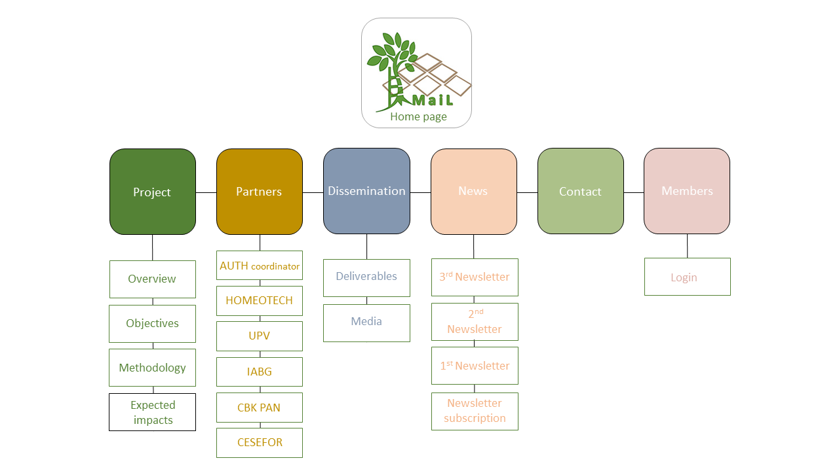

Figure 2. **MAIL** website hierarchy diagram

According to GA, one of the website’s main characteristics is that all generated knowledge, deliverables, and important information will be available for consortium users through a **common file area** that resides together with the website (Figure 3). This utility is useful in managing the exchanged knowledge and know-how, in controlling the deadlines and means of deliverables, in direct sharing the common dissemination and scientific material, and in supervising the general project process. In order to achieve this, the working team took the advantage of WordPress Plugins and installed the CM Download Manager.

As detected in WordPress main website, the CM Downloads Manager is a WordPress file sharing plugin that lets the admin control which users can post, manage, track, and support documents, media files, and more. The WordPress file management plugin arranges content in a directory listing structure that can be used and commented on by others.

This file management plugin offers a unique homepage for each file uploaded, complete with a file preview, support forums, and more. The WordPress downloads management plugin generates an index page that categorizes downloads (Figure 4). The visitor can go straight to all of the download files from this index page.

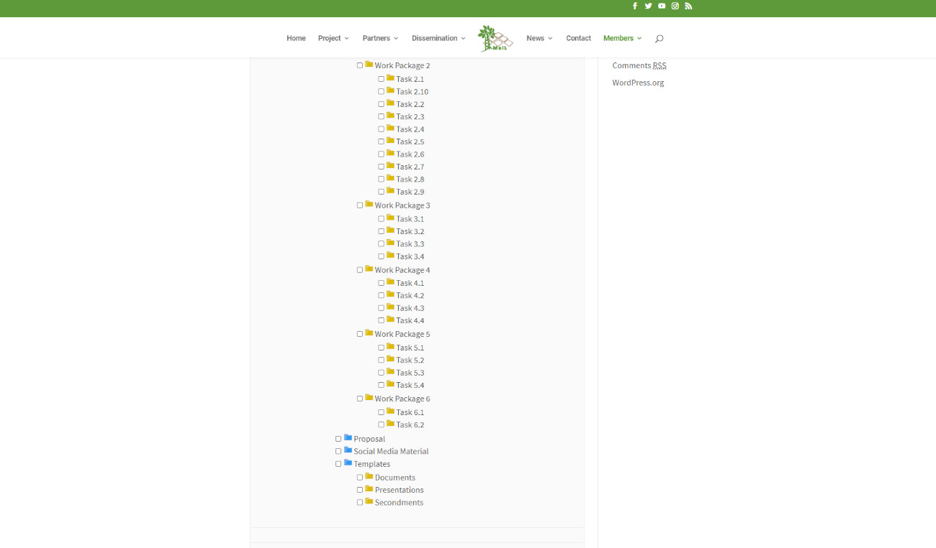

Figure 3. Common file area for consortium member

The website provides functionality for 2-role project membership and category based filesharing. The two roles are Project Member and Project Coordinator. Project Members can add and download files from a private Project based filesharing system. Project Coordinators can additionally manage all the files of the filesharing system, deleting and unpublishing without any constraints.

The premium version of this multi-file package allows users to password-protect files individually or in groups, as well as restrict access to specific people. Prior to actually downloading, the download manager plugin (Figure 4) offers preview choices for several file formats.

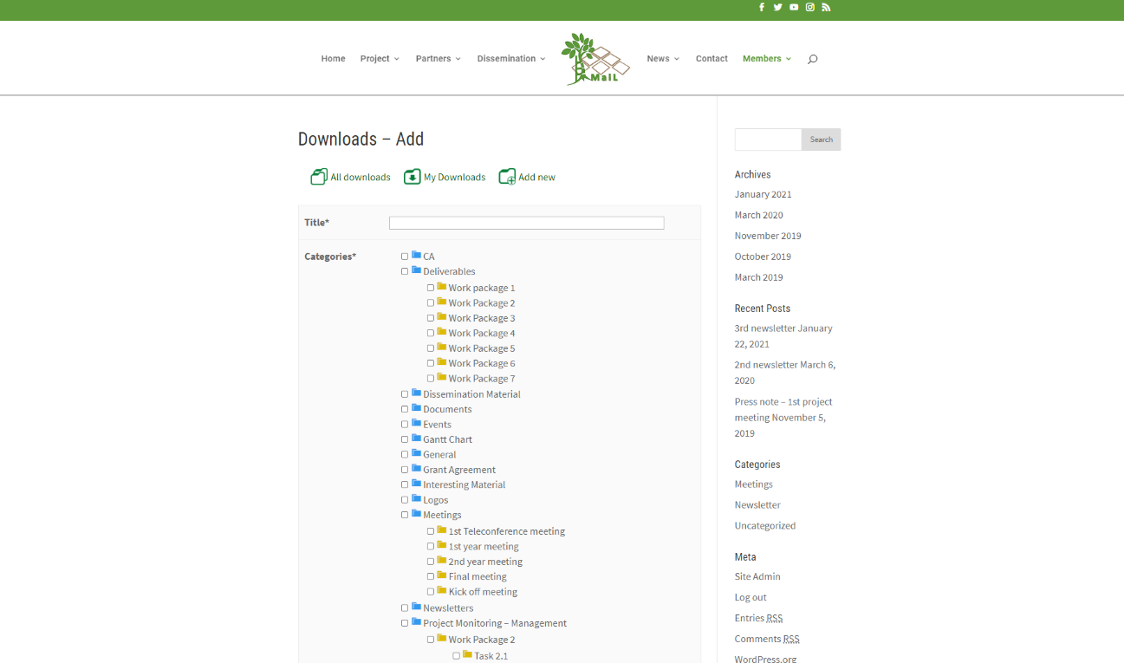

Figure 4. Downloads manager plugin organizes downloads by categories

The team established a file sharing directory with this download manager packages plugin, where users may upload and manage files, downloads, apps, add-ons, packages, plugins, and archives. (Figure 5).

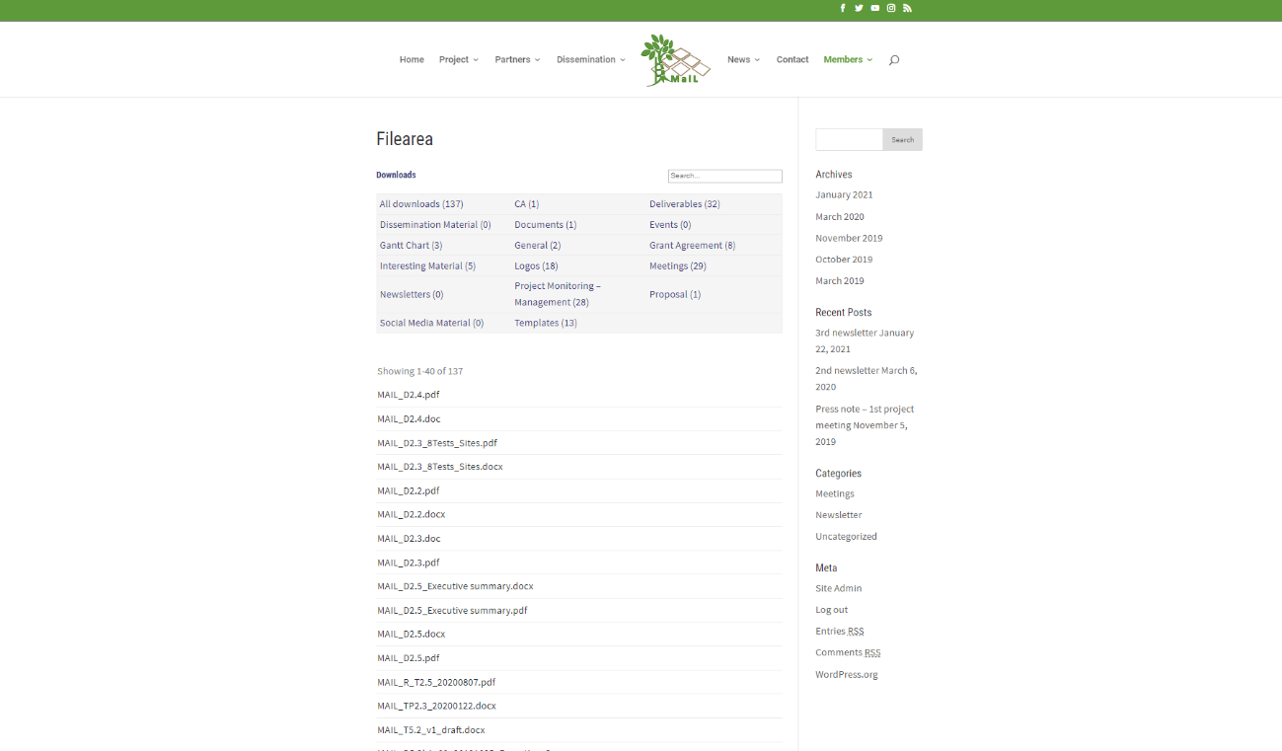

Figure 5. File sharing directory for consortium members. Here showing 20 out of 137 files

As stated in the GA, the development of a high-performance knowledge sharing network is a further goal. Participants of such networks learn or absorb knowledge more quickly after participating in a knowledge sharing network.

Taking this into consideration the working team developed another feature of MAIL website, which is the Dissemination field that includes a dropdown menu with Deliverables and Media. According to GA, the generated knowledge in different types of deliverables is available to all interested parties through MAIL webpage (Figure 6). The types of deliverables are either public for general audience, website users or virtual classrooms’ participants, or private for consortium members that manage the files. Some of them are Executive Summaries, which means that only a small part of the deliverable is public, and the others are Reports, which is a file that can be reviewed by any user.

In this way, it’s created a constantly updated website that is willing to interact with public and members as much as possible.

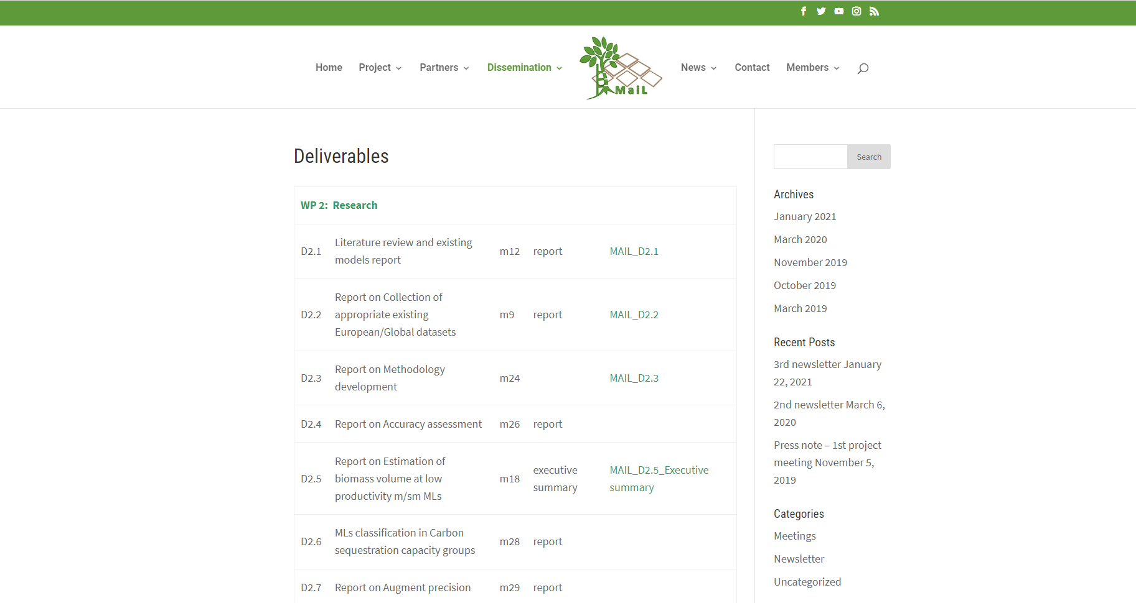

Figure 6. Public **MAIL** deliverables for the project’s process dissemination

Also, MAILhas planned for a regular flow of information through different channels, in order to raise awareness with news and media as well as with the scientific community, and foster interaction and dialogue. For this reason, the Media section in which MAIL secondees share their background, expertise, and experience in their exchange trip (Figure 7).

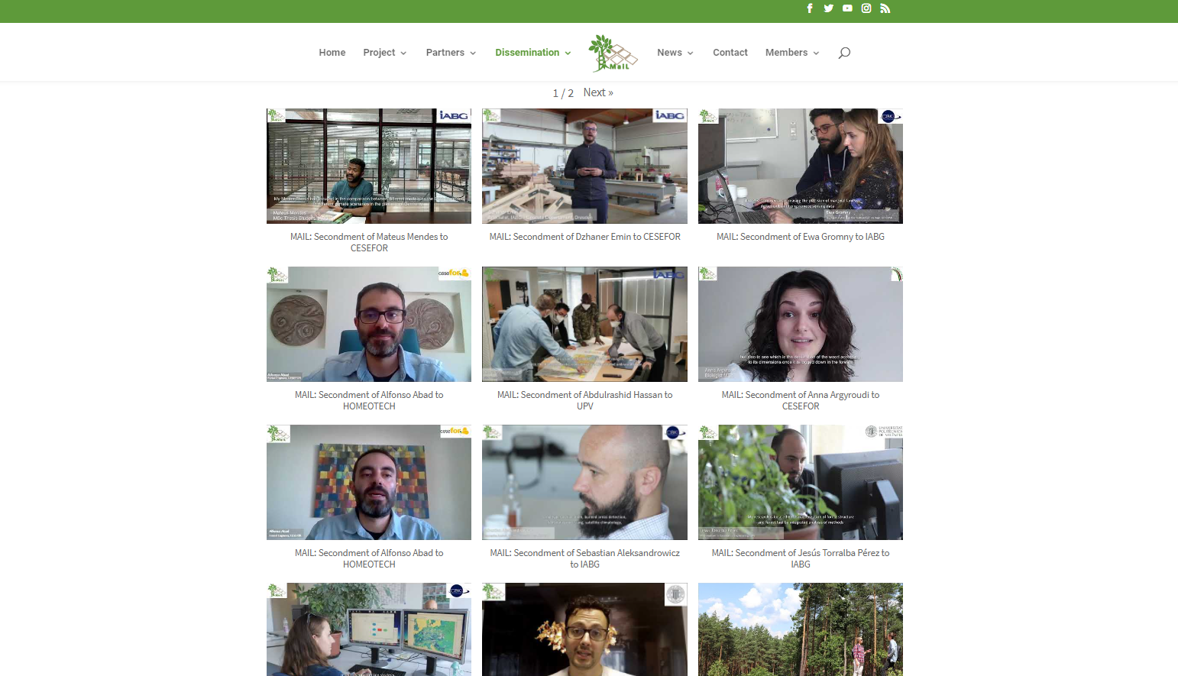

Figure 7. **MAIL** secondees’ testimonial video

The major outcomes, such as general information on the project, its partners and main actors, results achieved and lessons learned, and specific aspects related to the project's contents and know-how could be spread to a large audience using this communicative method, thereby improving the public's understanding of science.

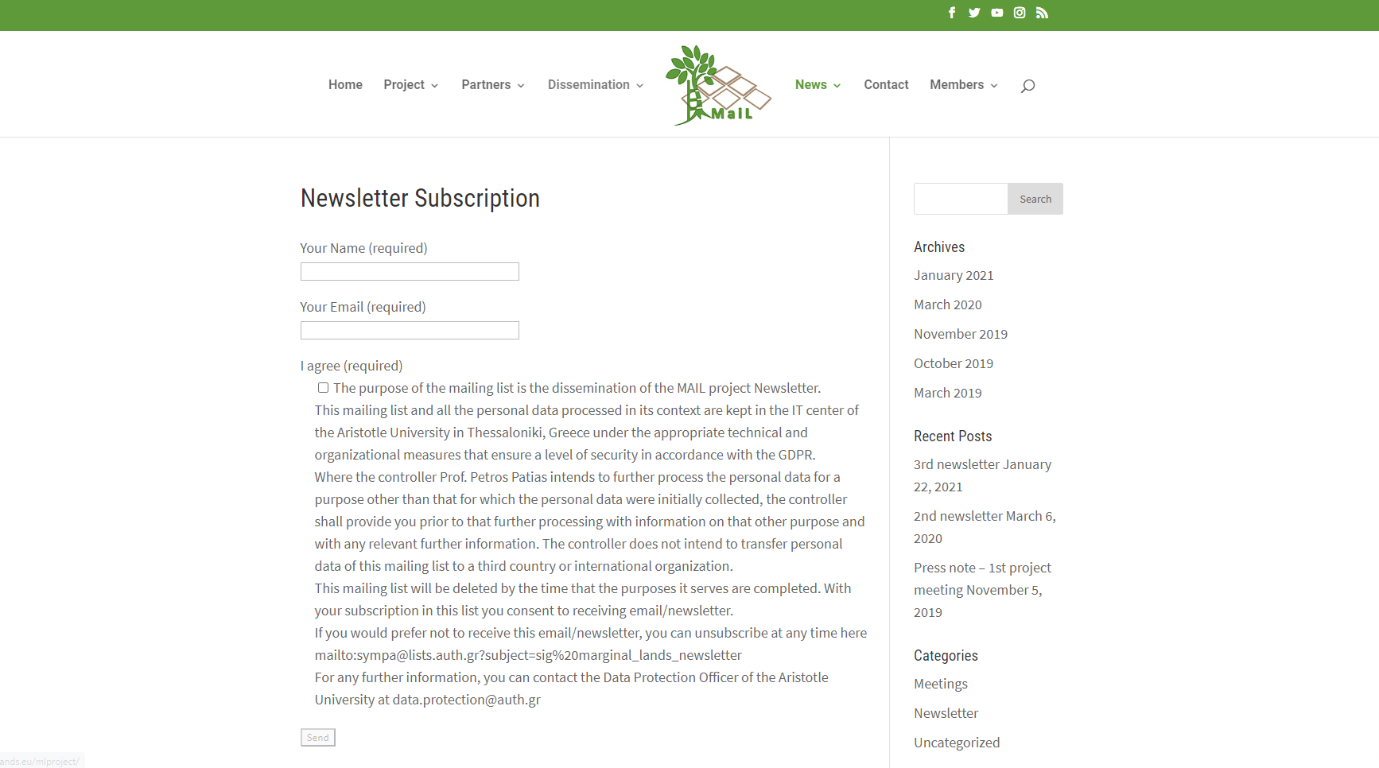

Figure 8. **MAIL’s** Newsletter Subscription website

Another core feature of MAIL website is the Newsletter Subscription field where any user can subscribe and watch the process of the project in an interactive and attractive way (Figure 8). The MAIL newsletter is part of the project’s dissemination and communication strategy. In total 6 e-newsletters are going to be published in the project’s lifetime. A part of the newsletter distribution strategy is the registration through the project’s dedicated webpage.

In order to comply with the GDPR regulations the following procedure was implemented for the newsletter registration. The purpose of the mailing list is the dissemination of the MAIL project Newsletter.

MAIL newsletter mailing list was created using the Aristotle University of Thessaloniki (AUTH) IT services. The mailing list is stored and managed through the central mailing list service of the University. The mailing list service is administered by the IT Center of the University which guarantees the appropriate technical and organizational measures that ensure a level of security in accordance with the GDPR. A newsletter subscription page was created in the project webpage (Figure 8).

In the newsletter registration section, the user that wants to register to the newsletter mailing list must enter its name and email and consent to the following:

“*The purpose of the mailing list is the dissemination of the MAIL project Newsletter.*

*This mailing list and all the personal data processed in its context are kept in the IT center of the Aristotle University in Thessaloniki, Greece under the appropriate technical and organizational measures that ensure a level of security in accordance with the GDPR.*

*Where the controller Prof. Petros Patias intends to further process the personal data for a purpose other than that for which the personal data were initially collected, the controller shall provide you prior to that further processing with information on that other purpose and with any relevant further information. The controller does not intend to transfer personal data of this mailing list to a third country or international organization.*

*This mailing list will be deleted by the time that the purposes it serves are completed. With your subscription in this list you consent to receiving email/newsletter.*

*If you would prefer not to receive this email/newsletter, you can unsubscribe at any time here mailto:sympa@lists.auth.gr?subject=sig%20marginal_lands_newsletter*

*For any further information, you can contact the Data Protection Officer of the Aristotle University at* [*data.protection@auth.gr*](mailto:data.protection@auth.gr)”.

More information about GDPR is reported in Annex Ι.

In addition to the core features that were described earlier, the general website utilities are structured in an informative and well-organized way in order to be an interesting and easy-to-use tool for, both, partners and general public (Figure 9).

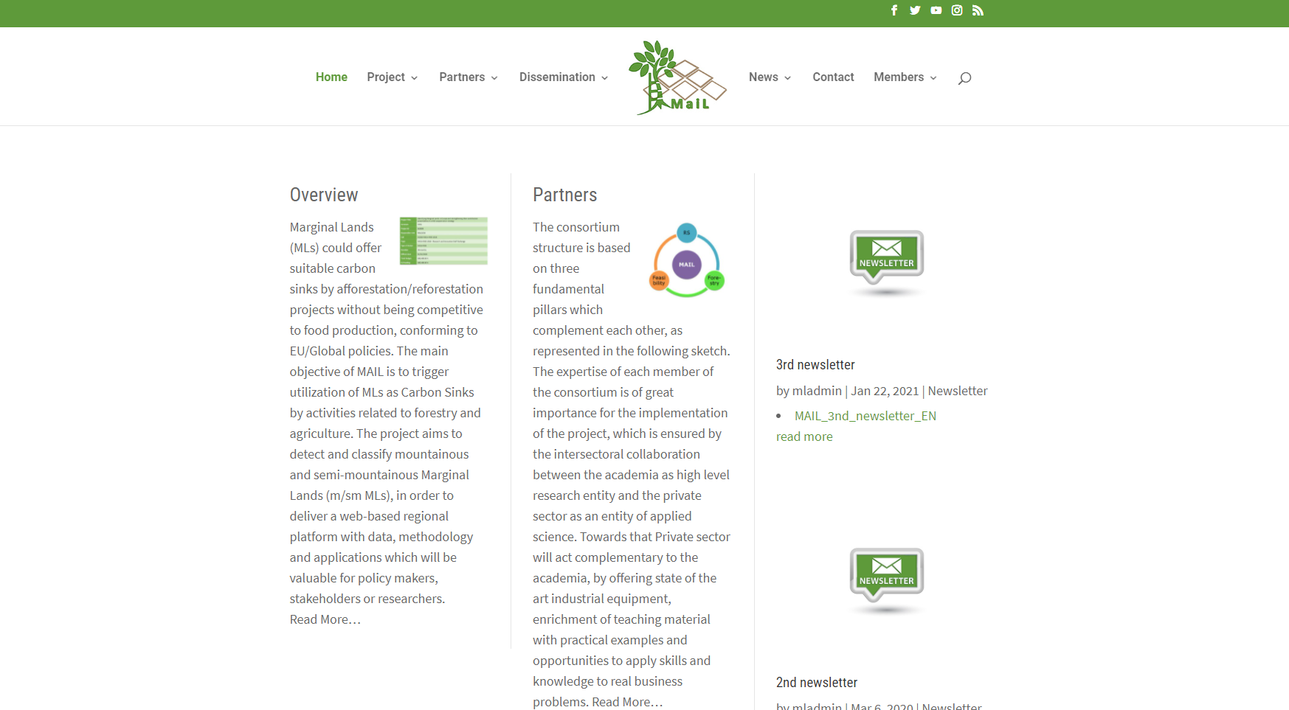

Figure 9. **MAIL** website main page

First, the Home page contains an overview about MAIL project, accurate information about the partners and a constantly updated section with News in order to maintain the users’ interest.

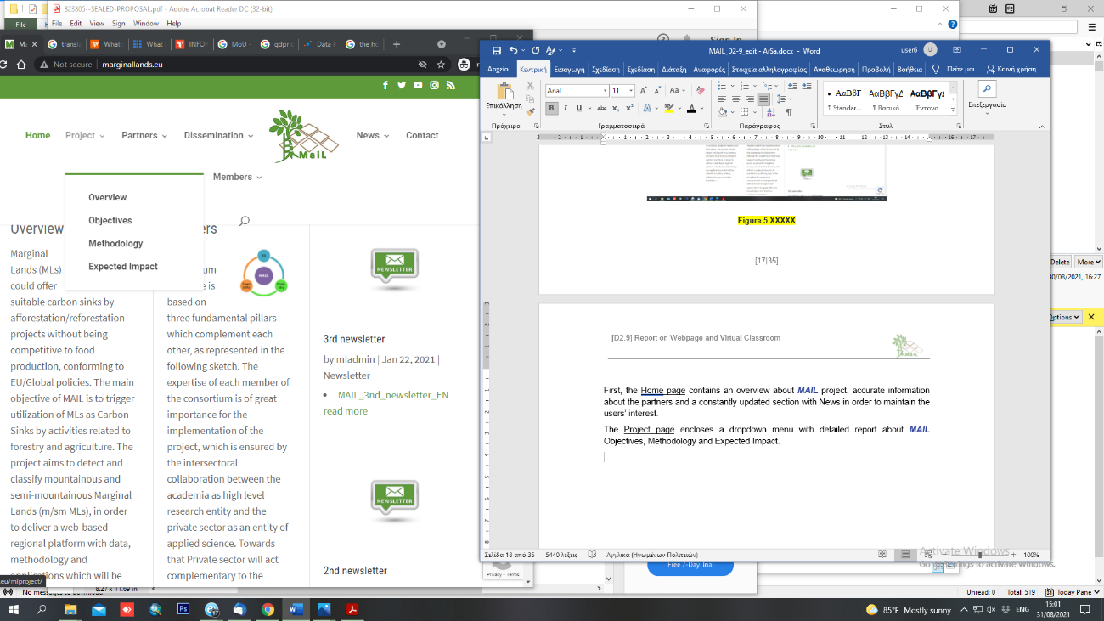The Project page encloses a dropdown menu with detailed report about MAIL Objectives, Methodology and Expected Impact (Figure 10).

Figure 10. Dropdown project’s menu in **MAIL** website

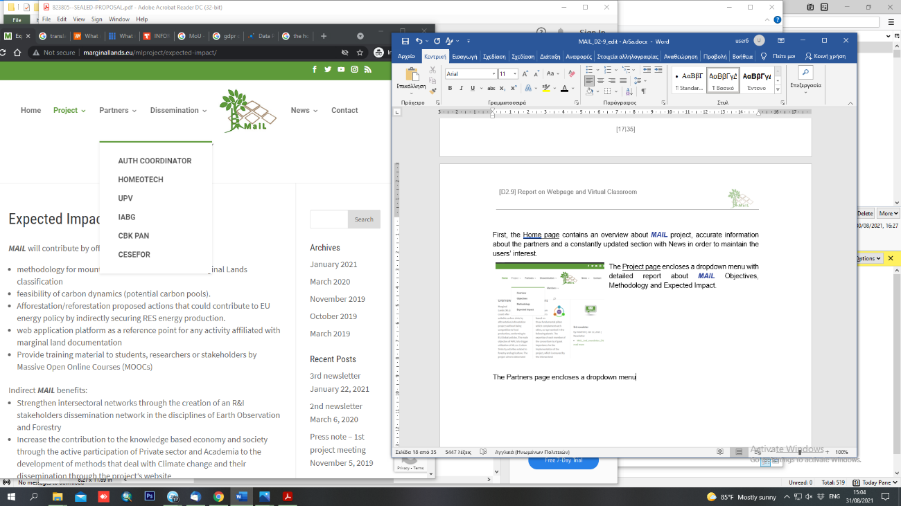The Partners page encloses a dropdown menu with the beneficiaries and their responsibilities for the project (Figure 11).

Figure 11. Dropdown partners’ menu in **MAIL** website

The Dissemination page, as already mentioned, encloses a dropdown menu with the Deliverables and Media. In the Media section, the uploaded videos are on YouTube channel and are verified to MAIL website by the URL link. This was created using a WordPress plugin that allows the admin to customize the embed, YouTube gallery (channel or playlist), and even YouTube livestream or premiere in a variety of ways. It prioritizes efficiency by deferring JavaScript and supplying minified CSS and JavaScript. (wordpress, plugins, 2021).

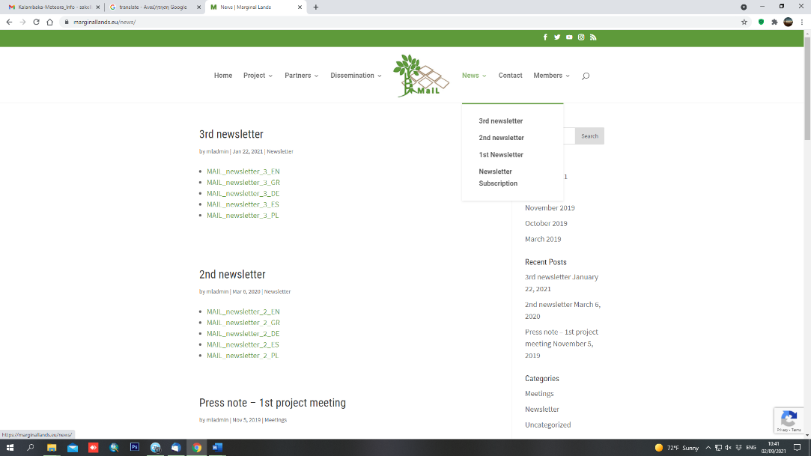The News page encloses a dropdown menu with the Newsletters and Subscription. This is the category where any user can find out anything about the project’s process (Figure 12).

Figure 12. Dropdown news’ menu in **MAIL** website

|  |  |
| --- | --- |
| Figure 13. MAIL website contact form | The Contact page is a form where the user, can contact MAIL (Figure 13). Apart from this, there are three project emails which are linked and shared in consortium partners in order to achieve the best communication in minimum time. This is happening with the usage of cPanel, which is a hosting control panel that helps the user manage hosted (or live) websites. It features a web-based, graphical interface that allows users to perform a variety of actions to site/server without needing to work on a command line. |

The emails are not visible in the contact page, but the form is linked with the main project email ([all@marginallands.eu](mailto:all@marginallands.eu)). It forwards to the emails of all the members of the project and its main role it to make the communication easier and in-time.

Additional emails are also used that have to do with project general information/queries([info@marginallands.eu](mailto:info@marginallands.eu)) and support regarding the webpage functionality ([support@marginallands.eu)](mailto:support@marginallands.eu)%20).

The last option is Members’ page, which is only about partners that have the permission to enter and make changes, according to the GA, or upload/download deliverables or generally material for exchange (Figure 14).

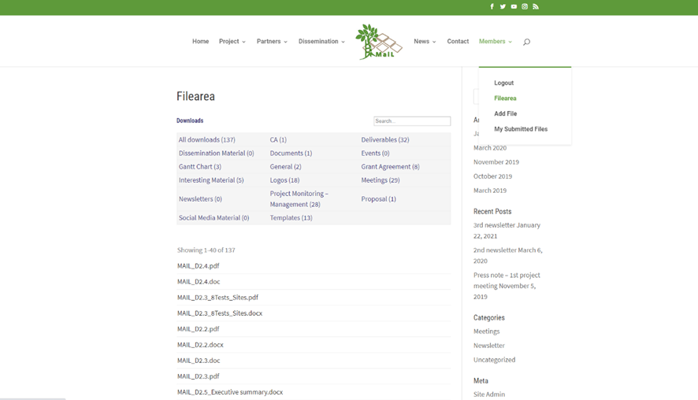

Figure 14. Common file area exchange for consortium members

The webpage's template was created with the Divi builder plugin, and when signed in to the WordPress dashboard, the user may navigate to any page on the front-end of your website and click the "Enable Visual Builder" button in the WordPress admin bar to open the visual builder.

## Further dissemination channels

As described, MAIL will use more than one strategy in order to increase knowledge sharing success. Straight forward, tailored messages for diverse audiences, based on their specific knowledge-sharing needs, in accordance with knowledge transmission in multiple times and in multiple ways, will increase the likelihood that a message will be heard and considered.

In order to demonstrate MAIL outcomes, on the top of the website´s layout there are the external links for the rest of social media:

* MAIL [Facebook](https://www.facebook.com/MarginalLands/)
* MAIL [Twitter](https://twitter.com/MarginalLands)
* MAIL [YouTube Channel](https://www.youtube.com/channel/UCbgyJ_cZ03V0KE4jU5QZaDw)
* MAIL [Instagram](https://www.instagram.com/marginal_lands/)

The purpose of developing a full package of social media is to:

* Inform the general public about the work achieved in MAIL
* Inform the scientific/technical community about MAIL results and promote their direct/indirect involvement
* Attract the interest of private investors, public and private MLs owners, plant breeders, farmers and foresters, harvest sector – producers and retailers, transport and storage sector, conversion sector
* Enhance local development opportunities deriving from exploitation of MLs
* Favor the engagement of policy makers and public planners in MAIL results
* Train scientists and provide capacity building through the organized workshops - seminars

# Virtual Classroom

In an online setting, a virtual classroom is a teaching and learning environment in which participants can interact, communicate, view and discuss presentations, and engage with learning resources while working in groups. The medium is frequently a video-conferencing application that allows numerous people to join at the same time through the Internet, allowing users to engage from virtually anywhere (techopedia, 2019).

According to GA, one of MAILproject objectives, is the creation of a knowledge base and a virtual web classroom for the training of participants in advanced classification RS techniques. More specifically, the formation of a virtual place where partners, stakeholders or the research community, could collaborate and find useful information regarding the training excellence, research activities, scientific publications, funding initiatives, etc.

## General

One of the most important goals of European Union Programs is not only to create but also to disseminate knowledge. Towards this direction MAIL efforts are concentrated, especially during the last period of the secondments in the academic institutes, to implement MOOC for the further education/training of any possible expert or non-expert in RS, who is willing to learn new for a better and sustainable MLs' management.

### Targets

According to GA, these efforts lead to actions that are expected to have the following impact:

* Strengthen intersectoral networks through the creation of an R&I stakeholders dissemination network in the disciplines of Earth Observation and Forestry
* Increase the contribution to the knowledge-based economy and society through the active participation of Private sector and Academia to the development of methods that deal with Climate change and their dissemination through the project’s website
* Promote Europe’s attractiveness as a leading destination for R&I by disseminating cutting-edge technologies and methodologies for Marginal Land identification, and classification at low productivity forested and non-forested areas.
* Provide the tools and methodologies for the creation of a stock exchange market for carbon transactions, initially in a regional level targeting to achieve penetration to the European level.
* Create new job and research opportunities by providing tools for the sustainable development of MLs, thus creating the need for their monitoring and entrance in a carbon transaction stock exchange market.
* Provide training material to scientists and interested parties through the MOOC.

Similarly, as stated in the international bibliography, Knowledge-sharing activities should make information more accessible, make it easier to communicate with colleagues, and stimulate participation in learning and decision-making (Tsui, 2006).

By allowing students and instructors to participate in remote learning communities utilizing personal computers, the construction of a virtual classroom promotes access to advanced educational experiences while also improving the quality and effectiveness of education (Siddiqui, 2013).

### Target Audience

MAIL considers the role that it can play in education and training, and therefore will offer MOOCs in the last months of the project, where learning and self-development opportunities will be available to a more advanced audience, such as university students or stakeholders with high expertise.

Attenders will be trained and get familiarized with the gathered material and the developed techniques. It is expected that about 30 to 50 persons to be trained from each University. The success of this action will be evaluated and further continuing of this action will be examined.

### MOOC’s benefits

According to GA, during the last period of the secondments, the web environment will host the MOOC for students, researchers and stakeholders as described in T3.1 and developed in T3.2.

In this direction:

* it will be provided training material to scientists and interested parties (students, stakeholders, etc.) through the MOOC
* the academic institutes supported by the seconded personnel will create tutorial material for the processing of Remote Sensing data to classify and monitor MLs. The tutorials will have the concept of MOOC and the objective will be disseminating the knowledge obtained by the seconded personnel to the wider public
* a Seminar-workshop will be organized through MOOC
* students, researchers and stakeholders will be trained in two thematic areas; RS as a tool to monitor and process MLs and Forestry as a tool to identify MLs and calculate their carbon sequestration capacity based on measuring/ sampling/ processing (T3.1, T3.2).

Considering the general impact of MOOCs, it seems that they consist of a great opportunity for professional and mental development. There are benefits such as:

* For instructors:

1. Instructors have the opportunity to better organize the learning process and structure the information.
2. Accessibility and social mobility
3. Professional hazards (risks to academics' reputations if they create an online course as a new educational product and market it globally) (Zakharova, 2018).

* For participants:

1. Gained knowledge essential to RS techniques and ML management
2. Information that helps to decide in which way the gained knowledge can be used and expanded
3. Improve admissions application for a range of scientific-educational programs
4. Life-changing job opportunity for general public that is not familiar with MAIL tools, techniques and results (Chen Zhenghao, 2015).

#### Synchronous & Asynchronous MOOCs

MOOCs frequently combine synchronous (in real time) and asynchronous (at any time) learning activities. There will be instances, for example, when the professor and students are both online at the same time, talking by voice or text. Other activities are designed to allow students to go online whenever it is convenient for them (Kinash, 2013).

According to (Clark, 2013) Synchronous MOOCs usually have a predetermined start date as well as set assessment and course assignment deadlines. Courses normally have set finish dates and are aligned with the academic calendar. The common consensus is that synchronous MOOCs are designed to help students stay motivated, form a cohort, and maximize instructor availability.

Asynchronous MOOCs are more flexible, with fewer or no set dates and hours for assignments and other course features. While some may find the format excessively free-flowing, others may find that it works better for people who require more flexibility for a variety of reasons, such as living in a different time zone than the university delivering the course, employment obligations, and so on.

In MAIL virtual classroom asynchronous MOOC will be used in order to manage the quality and quantity of knowledge that will be expanded. Asynchronous format provides the advantage of controlling the specific information that instructors will share with the participants per class, taking into consideration project process and results, in accordance with the knowledge level of participants. Also, it provides the flexibility to the participants to attend the class at their own pace. In this way, the gained knowledge will be predefined by instructors and easy to manage. Lastly, asynchronous way can offer a classroom structure that is always available. timelessness. A clearly defined design of a MOOC is a value for time for both instructors and participants, while both can use the asynchronous class as an appendix for the gained knowledge since it’s available at any time.

Available platforms

The fundamental core of gathered and produced knowledge will be the web application platform, which will be active for at least five years after the end of the project under the responsibility and the guidance of the coordinator. As stated earlier, MAIL outcomes will all be available for every student (MOOC/ taped lessons), researcher, stakeholder that is interested and as a reference point for any activity affiliated with marginal land documentation.

For educators and instructors who want to create their own MOOCs, there are numerous suitable possibilities. The following is a ranking of the five most popular and intriguing free MOOCs (and MOOC-like) platforms (Figure 15. The five free MOOC (and MOOC-like) sites being compared. Source: (John, 2014):

1. **edX**

It is a MOOC platform that provides online university-level courses. Harvard and MIT created edX in order to offer educational programs and series to worldwide students, with both charge or no charge (Inc., 2021). edX open-source platform consists of specific learning procedure and material which, in terms of functionality, can be expanded by letting users to use plug-ins. This, was one of the most important goal of edX creation, in order to act as the WordPress for MOOC platforms (Swope, 2014). The key features of edX are its speed and modern style, as well as its ability to handle enormous enrollments (Swope, 2014).

edX is a good fit for enterprises looking for a modern, adaptable, and reliable course administration platform. Despite the fact that it is open-source, it will require some investment in terms of installation and upkeep. However, in exchange, thousands of students would have access to best-in-class information via a platform (Swope, 2014).

1. **Moodle**

It's a free and open-source learning management system (LMS) that lets users create and provide online courses. It was designed for regular online classrooms rather than massive open online courses (MOOCs), which draw a large number of students. It's quicker to set up than edX, and there are hosted and one-click installation alternatives (Marchenko, 2017).

**Moodle** is a full-featured, customisable LMS that is ideal for enterprises. In terms of instructional tools, analytics, and SCORM compliance, the platform outperforms edX. The platform is almost ten years old as a trade-off. The sheer quantity of setup options can be overwhelming, and system performance degrades as the number of students increases (Swope, 2014).

1. **CourseSites by Blackboard**

It's a platform with a lot of sturdiness. It includes many of the same features as Moodle, such as rich teaching tools, reporting capabilities, and SCORM compliance. It's also a cloud-based system. Users may create a course in minutes and never have to worry about updating or maintaining it.

The service is now free for up to five live classes, with no indication that this will change. The cost appears to be that the programs are tagged with the Blackboard mark, and participants must enroll with Blackboard to participate in a course.

Individuals and businesses wishing to experiment with online classes without having to set up anything might consider **CourseSites.** The platform's application is limited due to the five-course cap and the inability to brand the course. **CourseSites**, on the other hand, is a good alternative because it has the lowest maintenance expenses and the most features.

1. **Udemy (free version)**

Udemy has specialized on private MOOCs since its inception. On the platform, instructors can create and host their own courses, which they can then offer to customers for free or for a fee (Swope, 2014).

**Udemy** is a platform for people who wish to quickly develop and commercialize fundamental courses. Coders, photographers, designers, as well as other professions, use the platform to provide their expertise in the form of an online course. The most distinguishing feature of Udemy is its 2,000,000 enrolled students. You may reach this range of possible students by creating a course on **Udemy** (Udemy, 2021).

1. **Versal (free version)**

**Versal** is a new platform with strong potential. Its main advantages are a simple, straightforward user interface and a powerful drag-and-drop feature. Without any coding skills, a user may sign up for free and then create a course that contains mathematical expressions, image drill-downs, and many more components. Users can integrate their published courses on other websites, such as personal blogs, as well. Itisn't really a MOOC platform because it lacks essential MOOC features. There is apparently neither discussion or debate feature available. Instead, think of it as a powerful educational environment (Swope, 2014).

Versal is best for people who wish to quickly create slick lessons, such as a teacher who creates an assignment for students and uploads it on a blog.

The team's decision on which platform to use is influenced by users’ assumptions about the course. On their websites, the majority of these systems have demos. It's beneficial to be able to play around with a course and envisage your content in a similar style. Finally, don't be concerned if your mind changes along the process. Because these platforms share a lot of the same material (YouTube videos, PDFs, etc.), moving a course halfway through the development process is simple.

In the following figure (Figure 15) they are reported the core features of each MOOC in order to make a wide comparison among them. All suggested MOOCs have capabilities that need to be compatible with MAIL website or with partners’ websites tools.

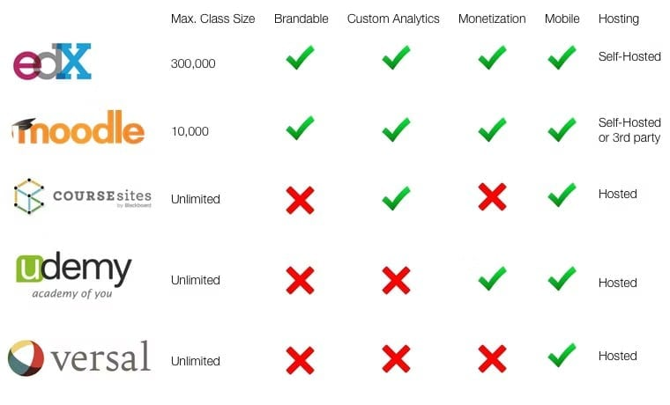

Figure 15. The five free MOOC (and MOOC-like) sites being compared. Source: (John, 2014)

## Final MOOC Platform selection

The platform MAIL team’s using is the one used by UPV, it is called **UPVx** and, when the quality passes minimum standards, will be published in edX (UPV is member). The MOOC will also be deployed in AUTH’s open courses platform. This doesn’t exclude that eventually can be published in other additional platforms.

The structure proposed will have 5 sections, each of it will have several subsections, each subsection with several learning materials (videos, screencasts, questions, readings, etc.), as described in T3.1.

The production of learning materials will be organized by working groups (1 WG per section) with a coordinator per WG.

The MOOC will be disseminated and available to the general public through the Aristotle University of Thessaloniki Open Courses platform (<https://opencourses.auth.gr/index.php?localize=en>) (Figure 16), and the UPVx platform. The UPV’s MOOC platform UPVx (<https://upvx.es/>). (Figure 17).

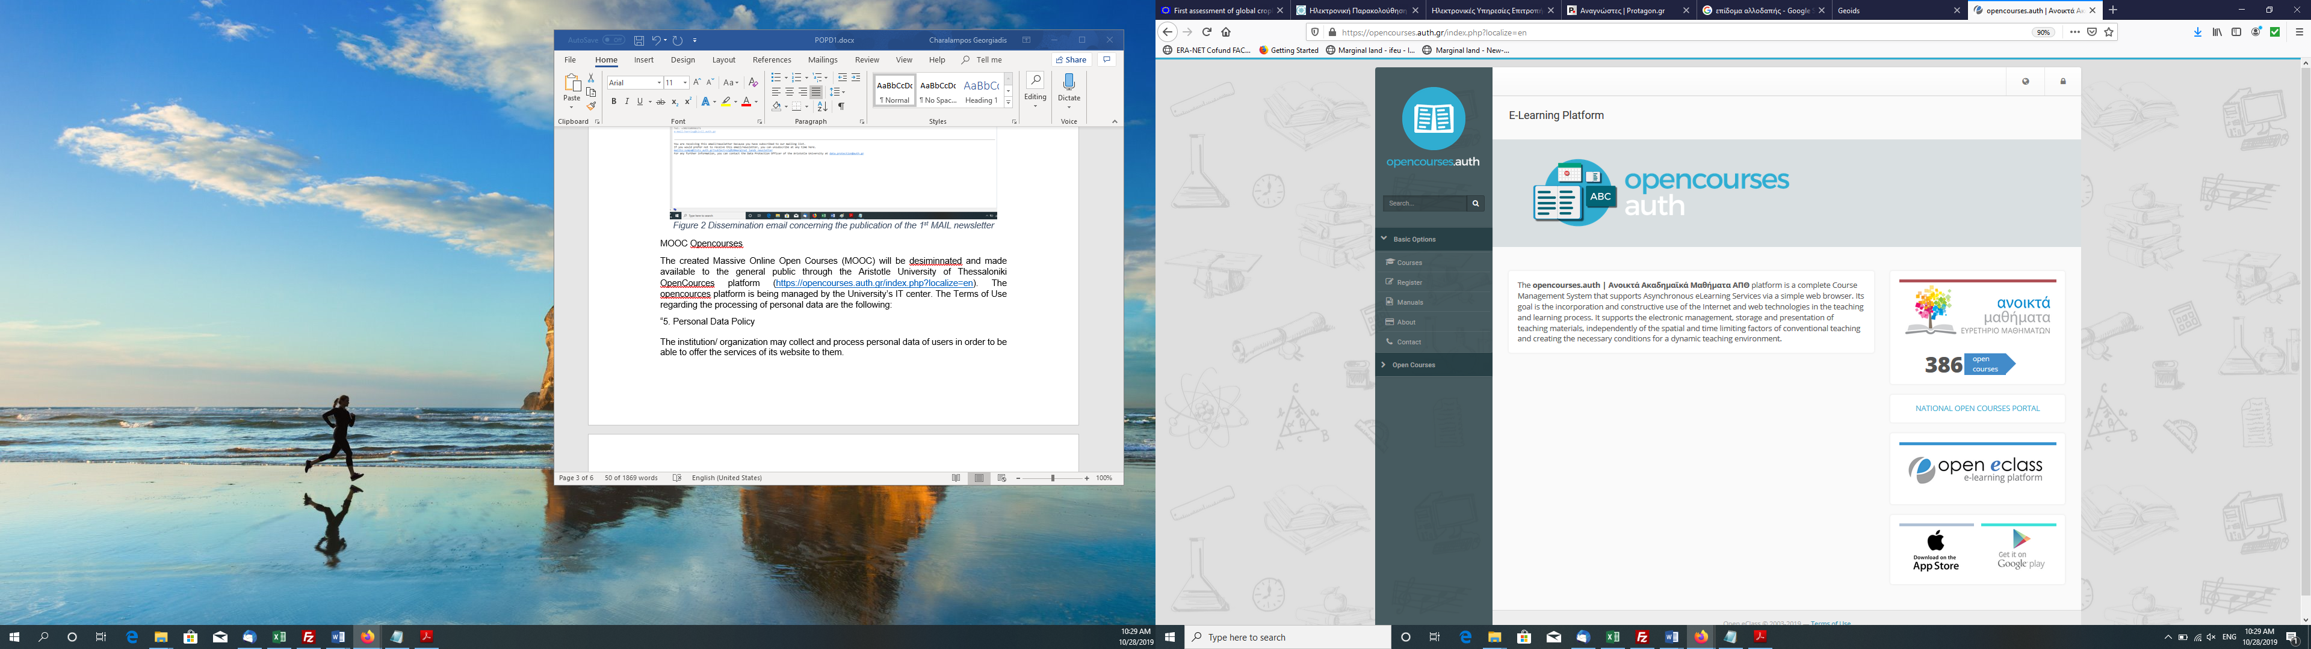

Figure 16 AUTH’s open courses platform



Figure 17. UPV’s open courses platform

The important detail here is that, if the course meets the quality requirements of edX (video quality, audio quality, structure) it will be possible to implement it in the main edX platform. This implementation would be done by the technical team of the UPV.

Also, following the GDPR regulation, if a user wants to use the website's services and help enhance them, he or she may be asked to supply personal information via the website's data collecting form. Personal data may be used by the institution/organization for informational reasons or to send e-mails or newsletters to enrolled users/visitors.

The institution/organization may collect all or part of the information submitted by users for statistical and operational functions. The user can contact the site operator to see if a personal record exists, as well as to update, change, or delete it.

AUTH’s open courses platform has the terms of use regarding the processing of personal data:

“5. Personal Data Policy

The institution/ organization may collect and process personal data of users in order to be able to offer the services of its website to them.

In each case, any processing:

* complies with the law
* is for specified purposes and for time disclosed to the person before processing started
* requires the consent of the person or happens for any other legitimate purposes specified by law.

In case the user wishes to access the services of the website and participate in the continuous improvement of them, may be asked to provide personal data through the data collection form of the website. The Institution/ organization may use personal data for informational purposes or send e-mails or newsletters to the registered user/visitor.

The Institution / organization does not transfer or publish personal data of users/visitors of the website to third parties, unless otherwise is provided by law or if it is a contractual obligation or it is necessary for the proper operation of the website and the accomplishment of its functions.

The Institution / organization may process all or part of the information sent by the users for statistical and improvement purposes of the given services-information. The user can contact with the site administrator in order to check for the existence of a personal record, to correct, change, or delete it.

During the use of the website, personal and non personal identification of users may be collected using technologies, such as cookies and/or monitoring ip addresses and other similar technologies such as those resulting from the contact of the browser with the server. The cookies are small text files on the user’s hard disk that don’t take note of any document or file from his computer nor led to the identification of the computer with any person. They are used to facilitate user access in the use of specific services and/or pages of the website and to determine the areas which are useful or popular.

Non personal information may also include the type of the browser used by the user, the type of the computer, the operating system, the provider of web services (ISP) and other such information. The user of the website can set his browser in such a way as to warn him for the use of cookies on certain services or to refuse to accept the use of cookies in any case. If the visitor/user of the services and pages does not want to use “cookies” to identify himself may have limited access to some of the services, uses or functions provided by this website. The collection of all data, which fall into the category of personal data received by the institution through this website, either being sent, where appropriate, by users or being collected during navigation browsing and use of the website, is in accordance with the Law 2472/1997 (the amendments of Law.3625/2007) and Law 3471/2006 on the protection of personal data.”

UPV’s open courses platform has the following terms of use regarding the processing of personal data:

“In compliance with the provisions of Organic Law 15/1999, of December 13, on the Protection of Personal Data, personal data (Name and surname, email, city, country, date of birth, sex and level of studies) will be incorporated into a file owned by UPV, in order to manage the User's participation in the WEBSITE, as well as to keep the User informed about UPV and UPV [X] news. The User may exercise the rights of access, rectification, cancellation and opposition, at the following address: admin@upvx.es

UPV may use cookies when a User browses the websites and web pages of the website. The cookies that can be used on the sites and web pages of the website are only associated with the browser of a specific computer (an anonymous User), and do not provide the name and surname of the User.”

## Material preparation

The content of the MOOC will be developed around five thematic sections (Figure 18). Each section will have a coordinator, who will spearhead their activities.

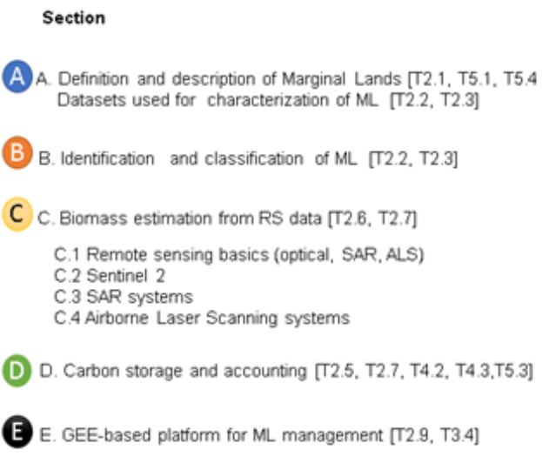

Figure 18. Thematic MOOC sections as shapes at the moment

Each section may have a typical duration of 1 hour of videos. The MOOC participant/student will need about 1 week to complete a section, meaning approximately 4 hours of homework. Each section will have different subsections. Each video will have a typical duration of 6 minutes for theoretical videos, or 10 minutes for practical videos. Reading materials (pdf, hyperlinks, etc.) will complement the theoretical videos and screencasts. Several reinforcement questions will be added in the subsections.

More details regarding the MOOC structure are described in D3.1 (WP3).

# References

1. *“Drupal vs WordPress - Comparing CMS Software”.* (2010, July 22). Retrieved from webhostingtop: https://webhostingtop.org/drupal-vs-wordpress/
2. (2005-2010). Retrieved from Open-Source Matters, Inc “Features Overview”: http://www.Joomla.org/core-features.html
3. Byron A., B. A. (2009). *Using Drupal.* Sebastopol: O'REILLY. Retrieved from evolvingweb: http://evolvingweb.ca/why-Drupal
4. Chatterjee, P. &. (2014). *Massive Open Online Courses (MOOCs) in Higher Education – Unleashing the Potential in India.* India: 2nd IEEE International Conference on MOOCs, Innovation and Technology in Education.
5. Chen Zhenghao, B. A. (2015, September 22). *Whos benefiting from moocs and why.* Retrieved from Harvard Business Review: https://hbr.org/2015/09/whos-benefiting-from-moocs-and-why
6. Clark, D. (2013, April 16). *MOOCs: Taxonomy of 8 types of MOOC.* Retrieved from http://donaldclarkplanb.blogspot.com/2013/04/moocs-taxonomy-of-8-types-of-mooc.html
7. Coleman, B. & Messenlehner, J. (2019). *Building Web Apps with WordPress: WordPress as an Application Framework.* Sebastopol: O'Reilly Media, Inc.
8. Commision, E. (2016). Regulation (EU) 2016/679 of the European Parliament and of the Council of 27 April 2016 on the protection of natural persons with regard to the processing of personal data and on the free movement of such data, and repealing Directive Directive 95/46/EC. Official Journal of the European Union.
9. *creating-dynamic-web-presence*. (2015). Retrieved from ontario: https://www.ontario.ca/page/creating-dynamic-web-presence
10. *Definition of web page by The Free Dictionary*. (2021, August 27). Retrieved from https://www.thefreedictionary.com/webpage#:~:text=web%C2%B7page,other%20documents%20on%20the%20Web.
11. Drupal. (2021, September). *project*. Retrieved from drupal: http://Drupal.org/features
12. dynamicweb. (2021). *content management*. Retrieved from dynamicweb: https://www.dynamicweb.com/products/content-management
13. European Commision, C. R. (2014). *europa.eu.* Retrieved from Guide to Financial Issues relating to FP7 Indirect Actions, Version 3/10/2014: https://ec.europa.eu/research/participants/data/ref/fp7/89556/financial_guidelines_en.pdf
14. European Commission, C. R. (2008). *europa.eu.* Retrieved from Guidance Notes on Project Reporting, Version 07/03/2008.: https://ec.europa.eu/research/participants/data/ref/fp7/89692/project-reporting_en.pdf
15. Inc., e. (2021). *About Us*. Retrieved from edX: https://www.edx.org/about-us
16. itechnex. (2017, June 27). *blog*. Retrieved from itechnex: http://itechnex.com/blog/post/3?fbclid=IwAR3wx0p2dRZFw7I5Su3uSv8v0pT7DvJULyC8QAEVVVRU7kW89h2imzHlq1Y
17. javatpoint. (2021). *features of joomla*. Retrieved from https://www.javatpoint.com/features-of-joomla
18. John, S. (2014, February 26). *comparison-five-free-mooc-platforms-educators*. Retrieved from edtechmagazine: https://edtechmagazine.com/higher/article/2014/02/comparison-five-free-mooc-platforms-educators
19. Kinash, S. (2013). MOOCing about MOOCs. *Learning and Teaching papers. Paper 70.* Retrieved from MOOCing about MOOCs: http://epublications.bond.edu.au/tls/70
20. Kyle M. L. Jones, K. M.-A. (2011). *Using WordPress as a Library Content Management System.* ALA TechSource, alatechsource.org, American Library Association.
21. Marchenko, O. (2017). *FUNCTIONAL COMPARISON OF OPEN EDX.* Kyiv: OPEN EDUCATIONAL E-ENVIRONMENT OF MODERN UNIVERSITY.
22. Pascal, J. (2010). Retrieved from “Advantages of Joomla Content Management System”: http://ezinearticles.com/?Advantagesof-Joomla-Content-Management-System&id=3854563
23. Patel, S. R. (2011). Performance Analysis of Content Management Systems - Joomla, Drupal and Wordpress. *International Journal of Computer Applications*.
24. Schäferhoff, N. (2021, March 08). *customize your theme*. Retrieved from elementor: https://elementor.com/blog/customize-your-theme/
25. Siddiqui, D. M. (2013). Virtual Classroom Learning for Higher Education: A Result of Information Technology . *International Journal of Management and Social Sciences Research (IJMSSR) ISSN: 2319-4421*, 84-87.
26. Simone Fischer-Hübner, L. M. (2018). A MOOC on Privacy by Design and the GDPR. *11th IFIP World Conference on Information Security Education (WISE)* (pp. 95-107). Poznan, Poland: hal.archives-ouvertes.fr.
27. SiteLeads. (2011). *“The advantages of a (Web) Content Management System (WCMS)”.* Retrieved from SiteLeads: http://www.siteleads.net/bm/blog/the-advantages-of-a-webcontent-management-system-.shtml
28. Swope, J. (2014). *A Comparison of Five Popular MOOC Platforms for Educators*. Retrieved from edtechmagazine: https://edtechmagazine.com/higher/article/2014/02/comparison-five-free-mooc-platforms-educators
29. *techopedia*. (2019). Retrieved from https://www.techopedia.com/definition/13914/virtual-classroom
30. Tsui, L. e. (2006). *A Handbook on Knowledge Sharing: Strategies and Recommendations for Researchers, Policymakers and Service Providers.* Community-University Partnership. Handbook.
31. Udemy. (2021, October). *teaching*. Retrieved from udemy: https://www.udemy.com/teaching/
32. *what is wordpress*. (2008-2021). Retrieved from wp101: https://www.wp101.com/tutorial/what-is-wordpress/
33. wordpress. (2021). *features*. Retrieved from wordpress: http://WordPress.org/ about/features
34. wordpress. (2021, August). *plugins*. Retrieved from wordpress: https://el.wordpress.org/plugins/youtube-embed-plus/
35. Zakharova, U. &. (2018). *https://www.researchgate.net/.* Retrieved from MOOCs in Higher Education: Advantages and Pitfalls for Instructors: https://www.researchgate.net/publication/335940766_MOOCs_in_Higher_Education_Advantages_and_Pitfalls_for_Instructors

# Annex I: GDPR in website and Virtual Classroom

The General Data Protection Regulation is the EU regulation that aims to protect the “fundamental rights and freedoms of natural persons and in particular, their right to the protection of personal data” and lays down “rules relating to the protection of natural persons with regard to the processing of personal data and rules relating to the free movement of personal data” (Commision, 2016). The legislation has a broad territorial reach and applies to the processing of personal data of EU citizens, regardless of whether the data is processed in the EU or not.

The GDPR was published in April 2016 and came into force on May 25th, 2018. National governments had to transfer the GDPR into legislation and organizations had to adapt to the rule during the two-year transition period between its adoption and enforcement. The GDPR requires businesses to designate a DPO to ensure that personal data is processed in accordance with the law in the instances mentioned. under art. 37– 39 GDPR. DPOs are chosen for their professional skills, such as expert knowledge of data protection law and the ability to provide advice and supervise the process of a DPIA, which is required by art. 35 of the GDPR and necessitates legal, technological, and organizational experience. As a result, the GDPR has sparked a surge in demand for qualified experts with expertise in technological, organizational, and legal elements of data protection (Simone Fischer-Hübner, 2018).

In order to follow this regulation, the GA refers to partners that will conform to the Directive 95/46/EC of the European Parliament and the Council of 24 October 1995, on the protection of individuals with regard to processing of personal data and on the free movement of such data.

# Annex II: List of figures

Figure 1. CMS platforms comparison. (itechnex, 2017) 12

Figure 2. *MAIL* website hierarchy diagram 15

Figure 3. Common file area for consortium member 16

Figure 4. Downloads manager plugin organizes downloads by categories 17

Figure 5. File sharing directory for consortium members. Here showing 20 out of 137 files 17

Figure 6. Public MAIL deliverables for the project’s process dissemination 18

Figure 7. *MAIL* secondees’ testimonial video 19

Figure 8. *MAIL’s* Newsletter Subscription website 19

Figure 9. *MAIL* website main page 21

Figure 10. Dropdown project’s menu in *MAIL* website 21

Figure 11. Dropdown partners’ menu in *MAIL* website 22

Figure 12. Dropdown news’ menu in *MAIL* website 22

Figure 13. MAIL website contact form 23

Figure 14. Common file area exchange for consortium members 24

Figure 15. The five free MOOC (and MOOC-like) sites being compared. Source: (John, 2014) 32

Figure 16 AUTH’s open courses platform 33

Figure 17. UPV’s open courses platform 33

Figure 18. Thematic MOOC sections as shapes at the moment 36

# Annex III: List of Tables

Table 1. Core features and essential utilities of Joomla, Drupal, WordPress 13

1. **R** = Report, **P** = Prototype, **D** = Demonstrator, **O** = Other (European Commission, 2008)
2. **PU** = Public, **PP** = Restricted to other programme participants (including the Commission Services), **RE** = Restricted to a group specified by the consortium (including the Commission Services), **CO** = Confidential, only for members of the consortium (including the Commission Services) (European Commision, 2014)